**NEST AWAY**

This application takes the input choice of the user which is symbolic of their area of choice in Pittsburgh. There are 6 choices for 6 localities in Pittsburgh. These are neighborhoods where students moving to Pittsburgh for attending CMU stay at. The 7th option is the Exit, this allows you to exit the application.  Additionally, the application also takes the inputs of your minimum and maximum budget for rent in USD, and the number of bedrooms.

1. **Main file**

group_7_nestaway_project.py

1. **Install and Run**
2. Run ‘pip install [X]’ on Anaconda (for windows, python -m pip install [X])

**NOTE: Install these only if using IDLE directly and not from anaconda prompt.**

**If you use idle through Anaconda Prompt SKIP this step.**

* 1. Run ‘pip install pandas’
  2. Run ‘pip install matplotlib’
  3. Run ‘pip install numpy’
  4. Run ‘pip install bs4’
  5. Run ‘pip install requests’
  6. Run ‘pip install soupsieve’
  7. Run ‘pip install image’
  8. Run ‘pip install googlemaps’
  9. Run ‘pip install lxml’
  10. Run ‘pip install PIL’

1. Download the zip and unzip
2. Open idle
3. Choose File -> Open -> Choose “python group_7_nestaway_project.py” in the unzip directory.
4. Choose Run -> Run Module, then the program starts.
5. **Demo**

Note: Please wait for approx. 1 minute for the file to execute

* 1. You should see the below on your screen:

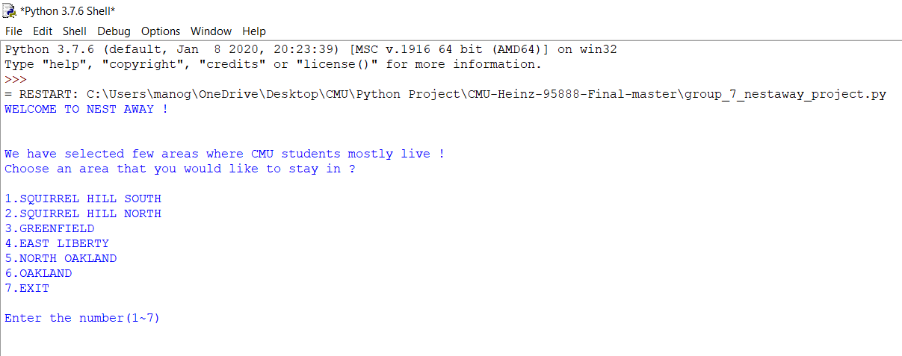

* 1. In this application you should input the number corresponding to the area in which you’d like to live, your minimum and maximum budget and the number of rooms you wish to rent.

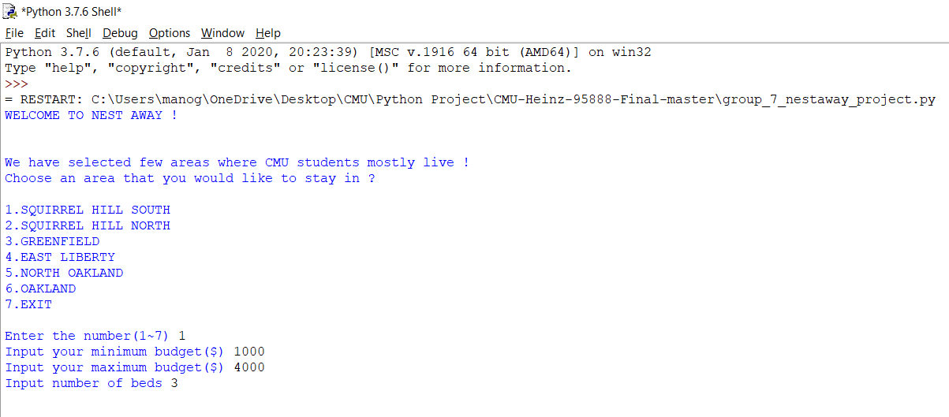

* 1. Based on your choice, you will get the results as per the output image below.

The application will provide general information on the location, the number of restaurants, bus routes, and grocery stores within a mile, the livability score of the area based on several factors, the crime statistics per 100k population in the past year in the area and the city.

The application further gives a list of maximum 5 houses listed for rent in this location, and the top 5 grocery stores in the neighborhood(grocery stores are a main factor for students moving to Pittsburgh) along with the links and links for them.

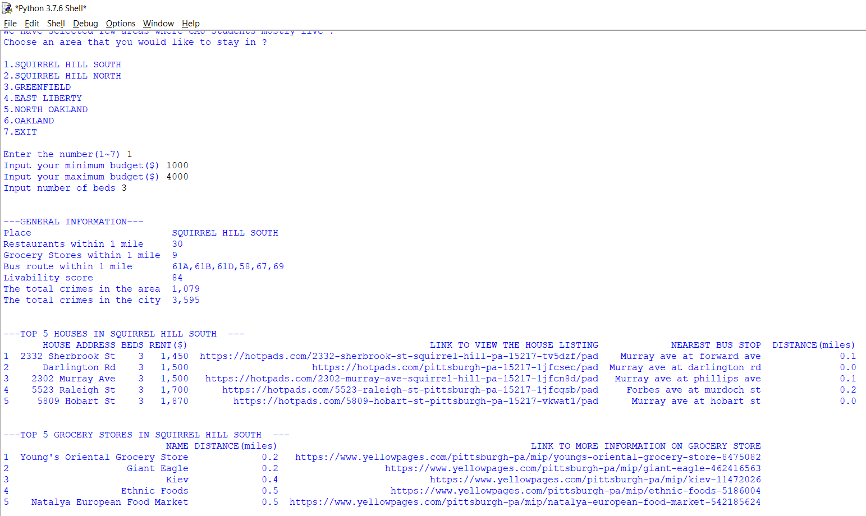

* 1. You will then see popups - first a popup will give the pie chart of crime stats in Pittsburgh, then the crime stats in the area, and the Google location of the houses listed in the provided area.

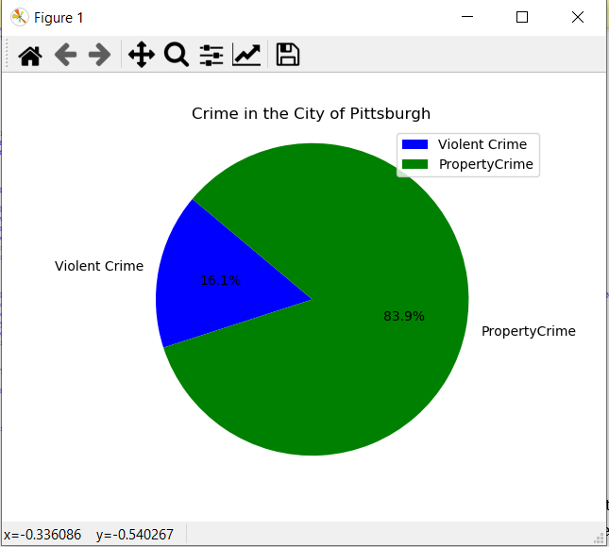

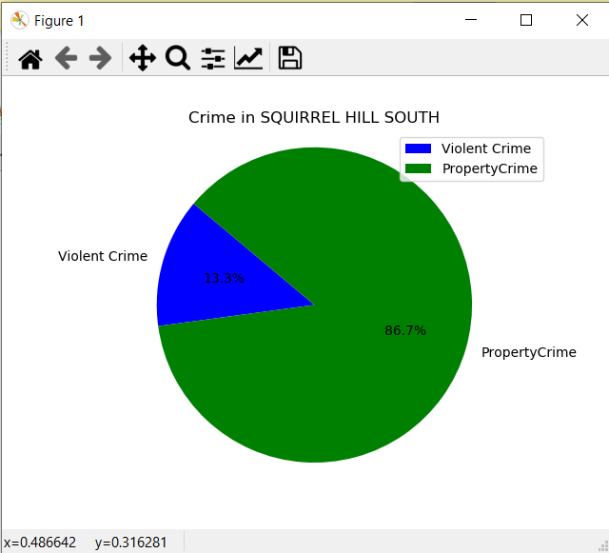

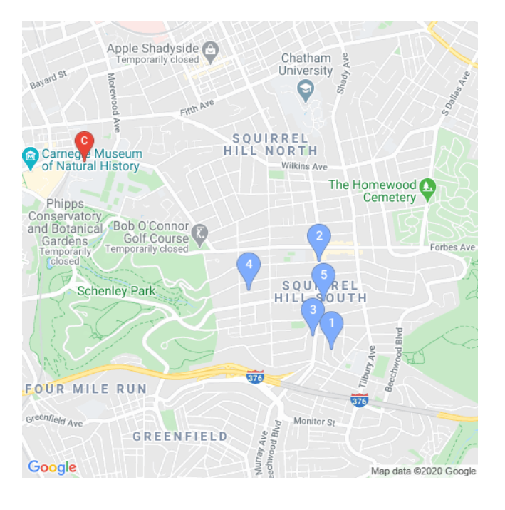

* 1. Finally, to exit the program enter 7.