Price Negotiating Chatbot with Text & Voice on E-commerce website

In this project we have designed E-commerce application where user can browse products list and then select Chatbot as Text or Voice and then negotiate with Chatbot. Chatbot will understand two types of voice command such as ‘first price’ which will give reasonable price to the customer and if customer not satisfy then it will ask for ‘final price’ and then Chatbot will add another 10% discount as final price and then serve to customer.

If say another word other than ‘first price’ or ‘final price’ then Chatbot will give error.

To display list of products we are using below dataset which contains list of products and prices

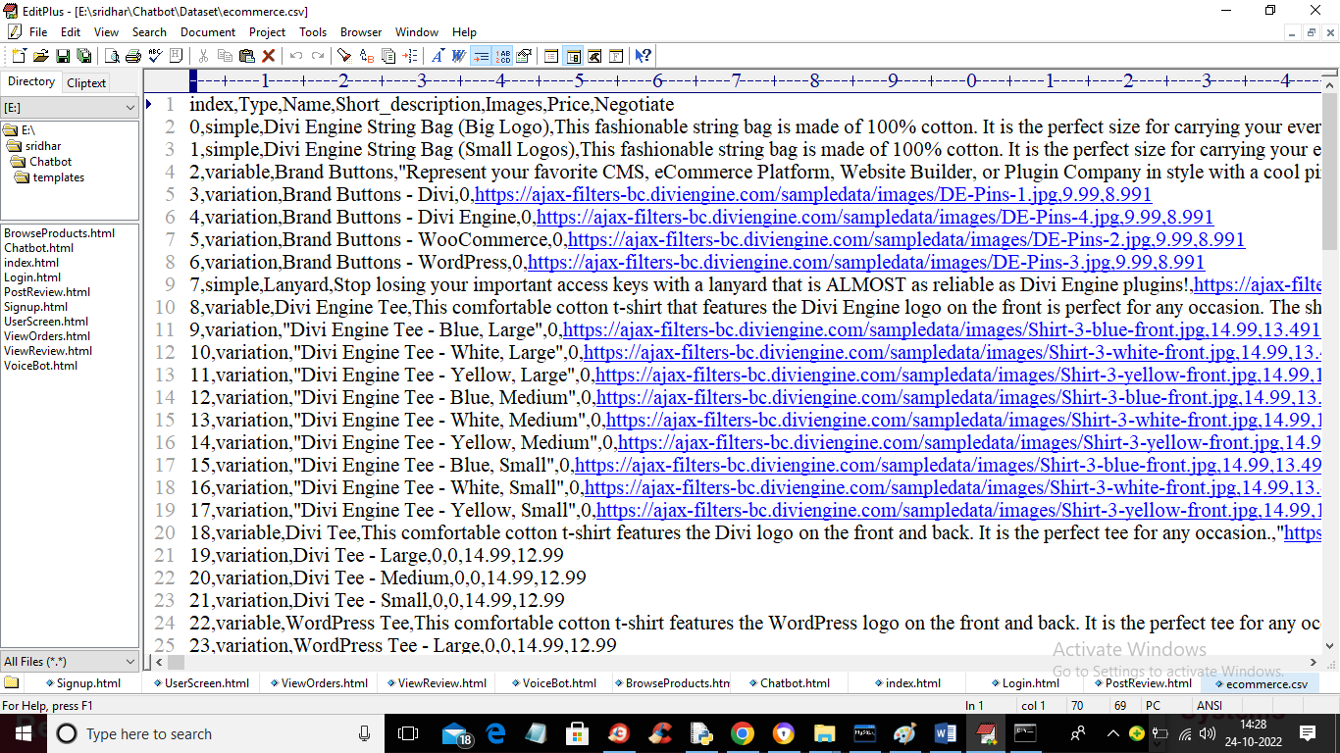

in above dataset we have list of products and its images and in last column we have Actual Price and negotiable price and using this list we will serve products to customers and Chatbot will use above dataset to get actual price and negotiable prices.

To run project double click on ‘run.bat’ file to get below screen

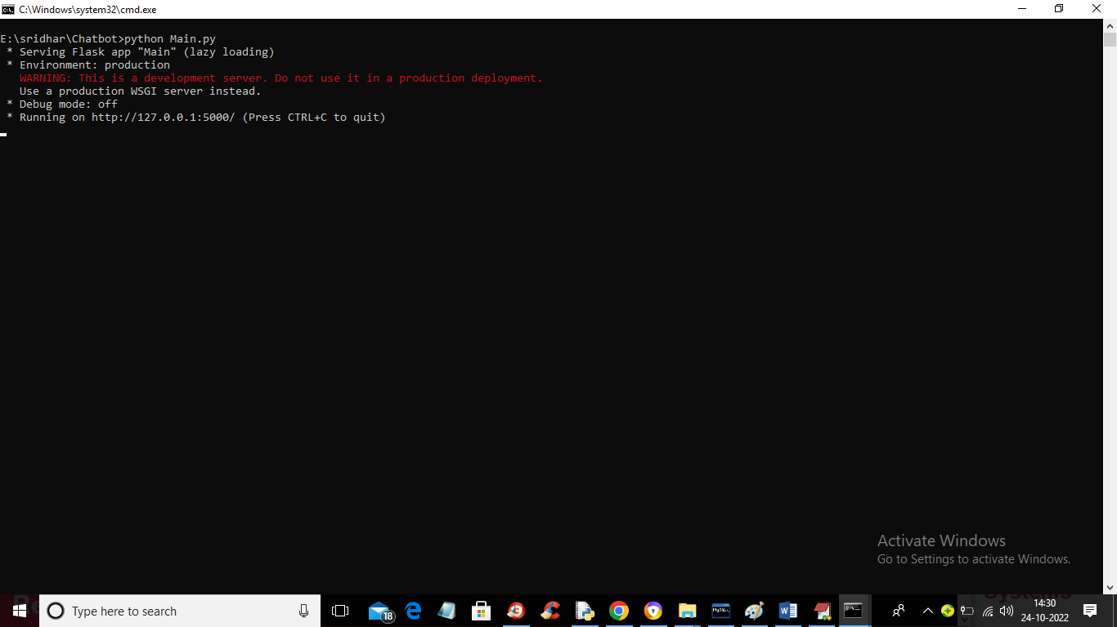

In above screen python Webserver started and now open browser and enter URL as ‘http://127.0.0.1:5000/index’ and press enter key to get below page

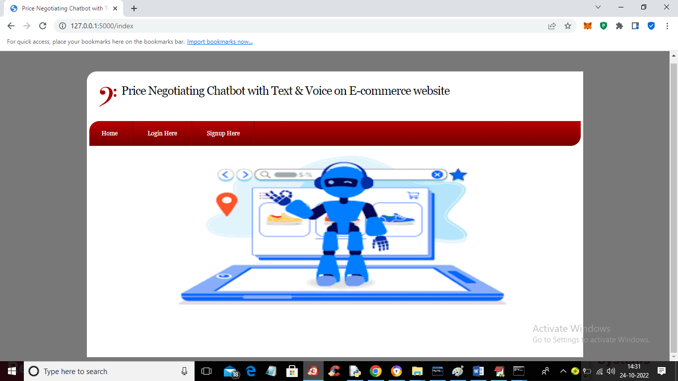

In above screen click on ‘Signup Here’ link to get below screen

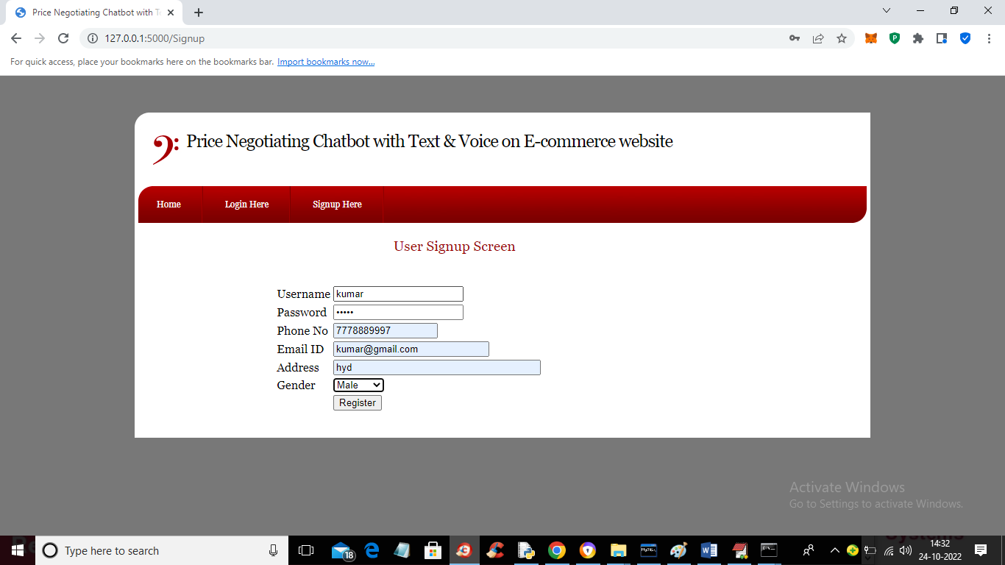

In above screen user is entering signup details and then click on ‘Register’ button to complete signup and get below output

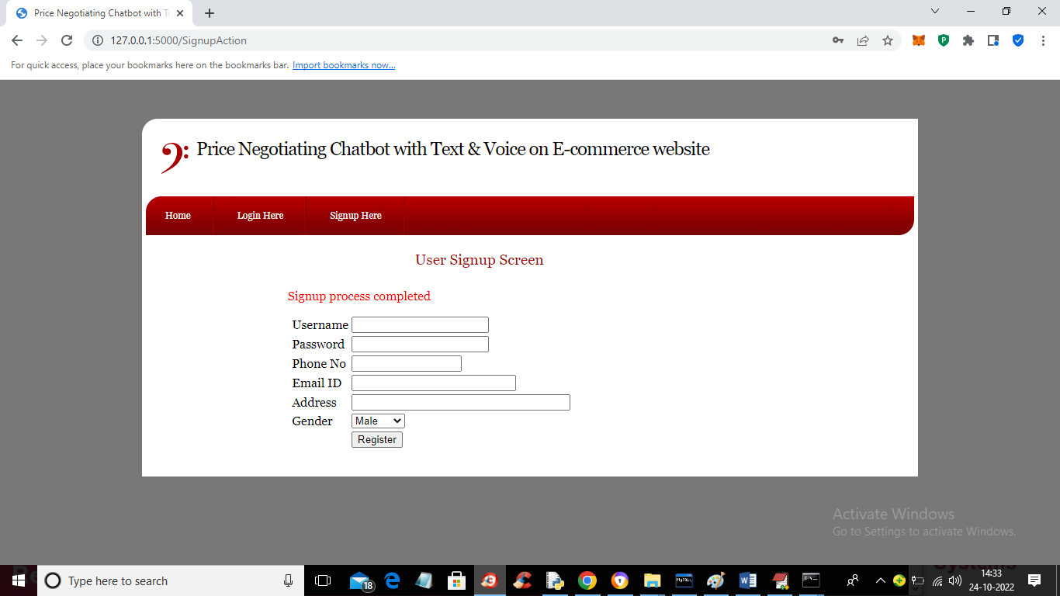

In above screen signup process completed and now click on ‘Login Here’ link to login as user

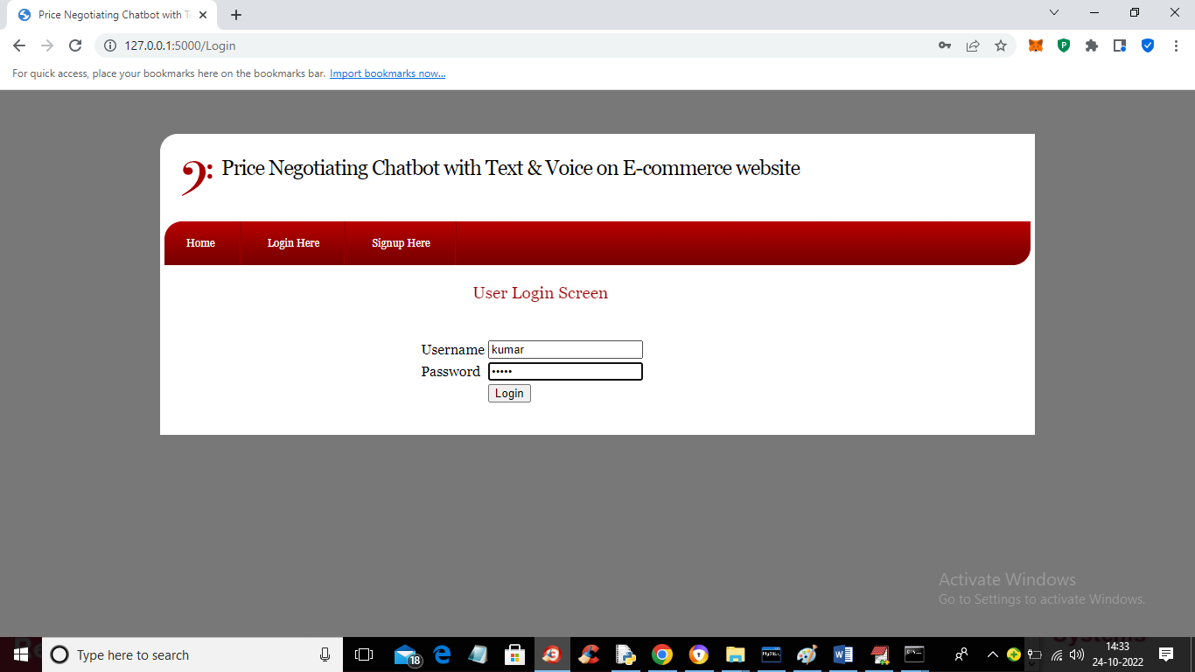

In above screen user is login and after login will get below screen

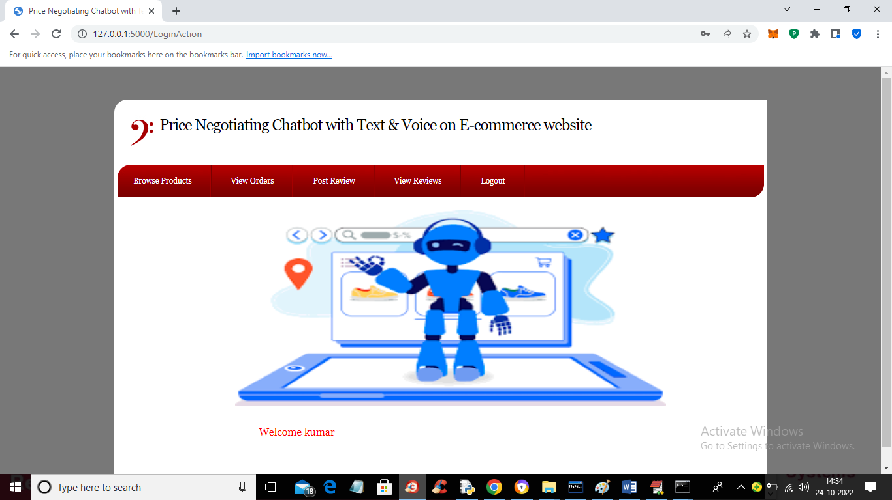

In above screen user can click on ‘Browse Products’ link to get list of products

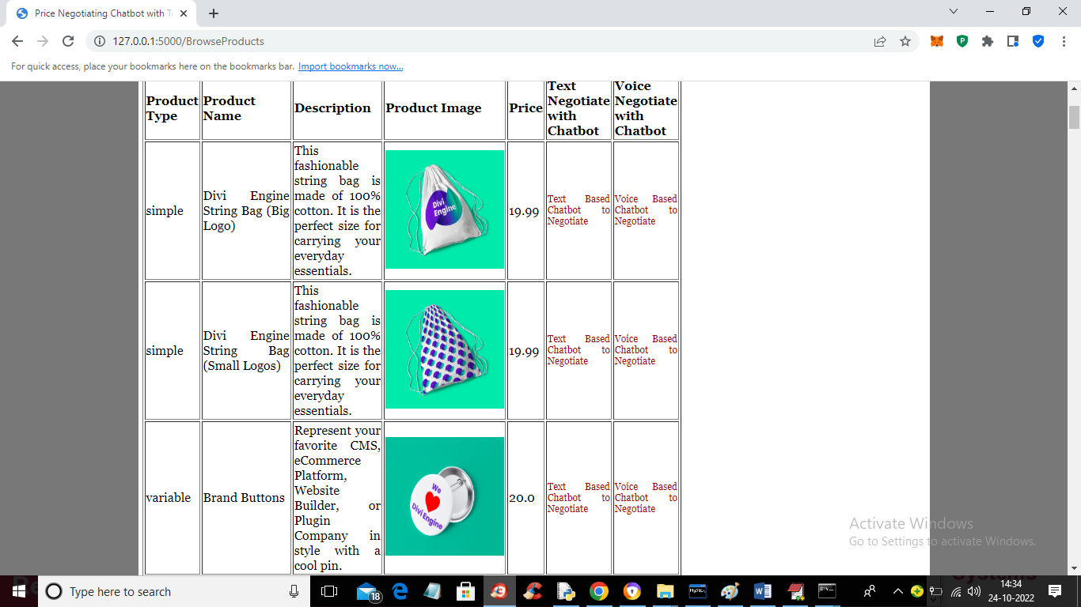

In above screen user can see list of products with actual prices and have red colour links to chat with Chatbot using text and voice and now I will click on ‘Text Chatbot Negotiate’ link to chat with text like below screen

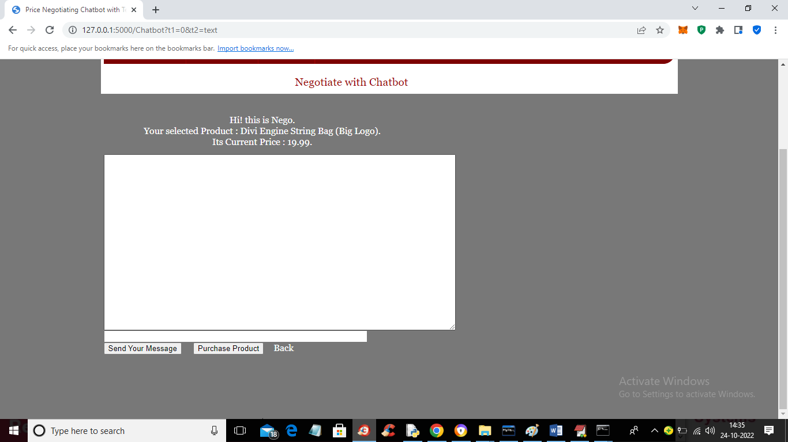

In above screen Chatbot displaying current product price in text field user will enter some text and press ‘Send Your Message’ button to get output from Chatbot

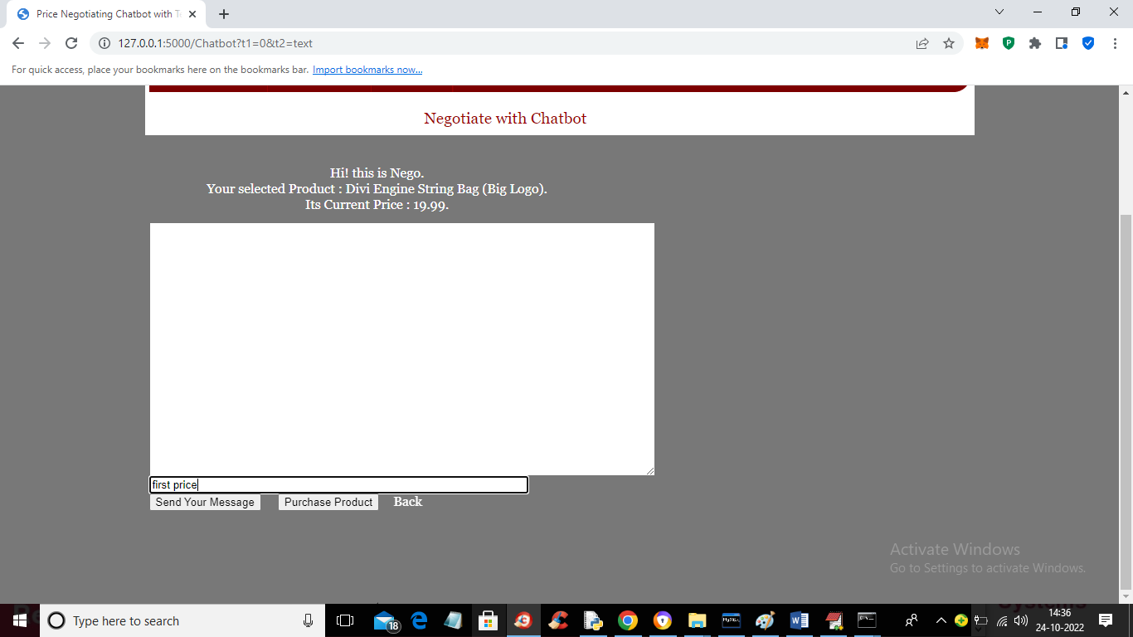

In above screen in text field I entered text as ‘first price’ and then press button to get below output

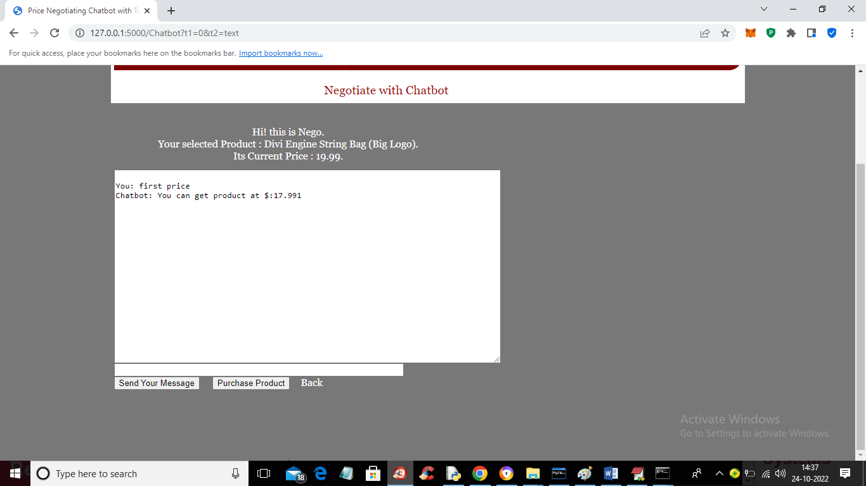

In above screen from Chatbot we got negotiate price as 17.99 from actual price 19.99 and now ask for final price and get below output

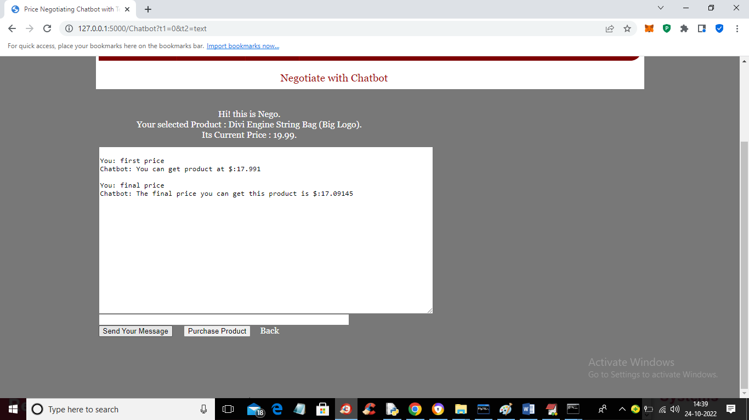

In above screen for final price Chatbot offer 17.09 and now if customer satisfy then click on ‘Purchase Product’ button to confirm order and get below output

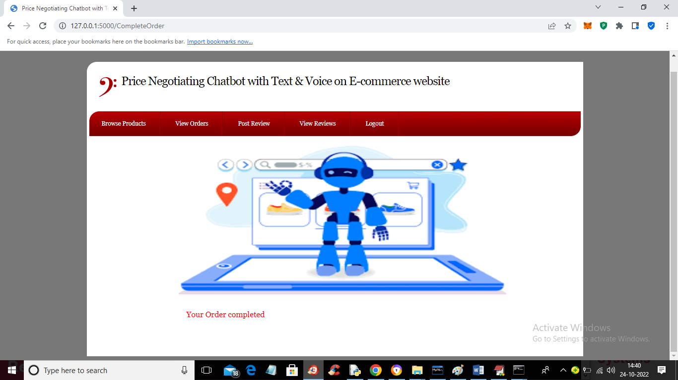

In above screen order is completed and now click on ‘View Orders’ link to view order

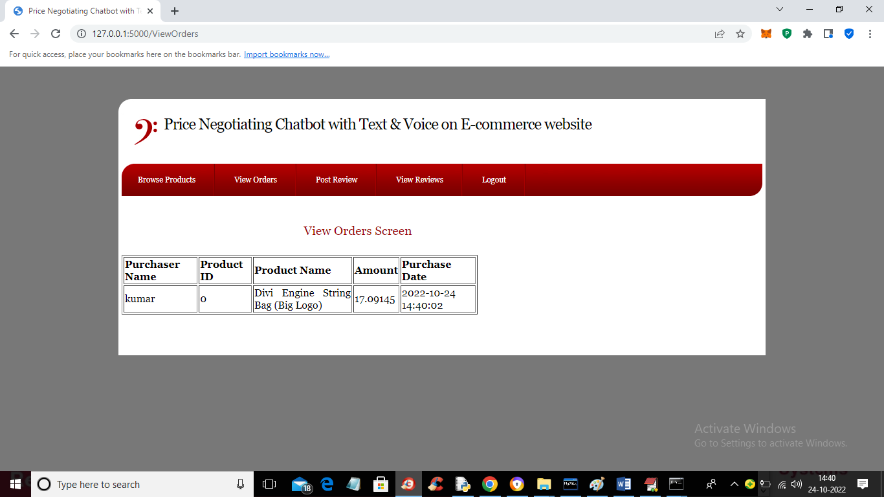

In above screen user can view his past order and now click on ‘Browse Products’ to view list of products and then Chat with Chatbot using Voice

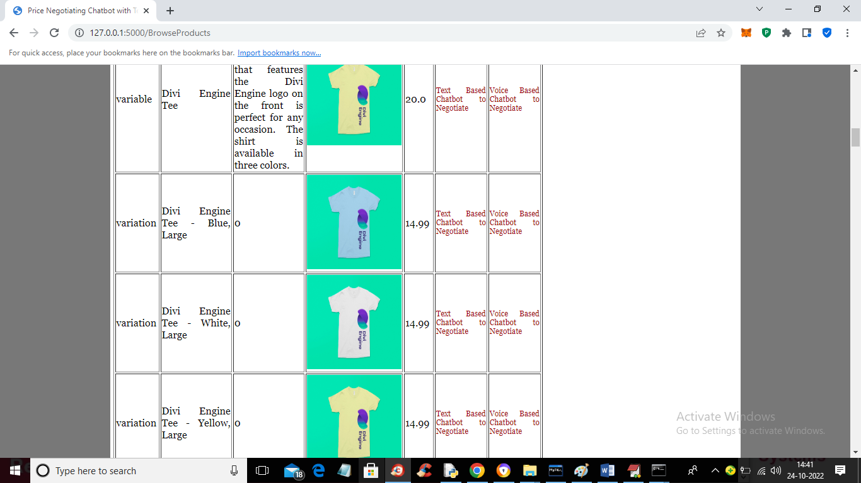

In above screen now user can click on ‘Voice Based Chatbot to Negotiate’ link to get below screen

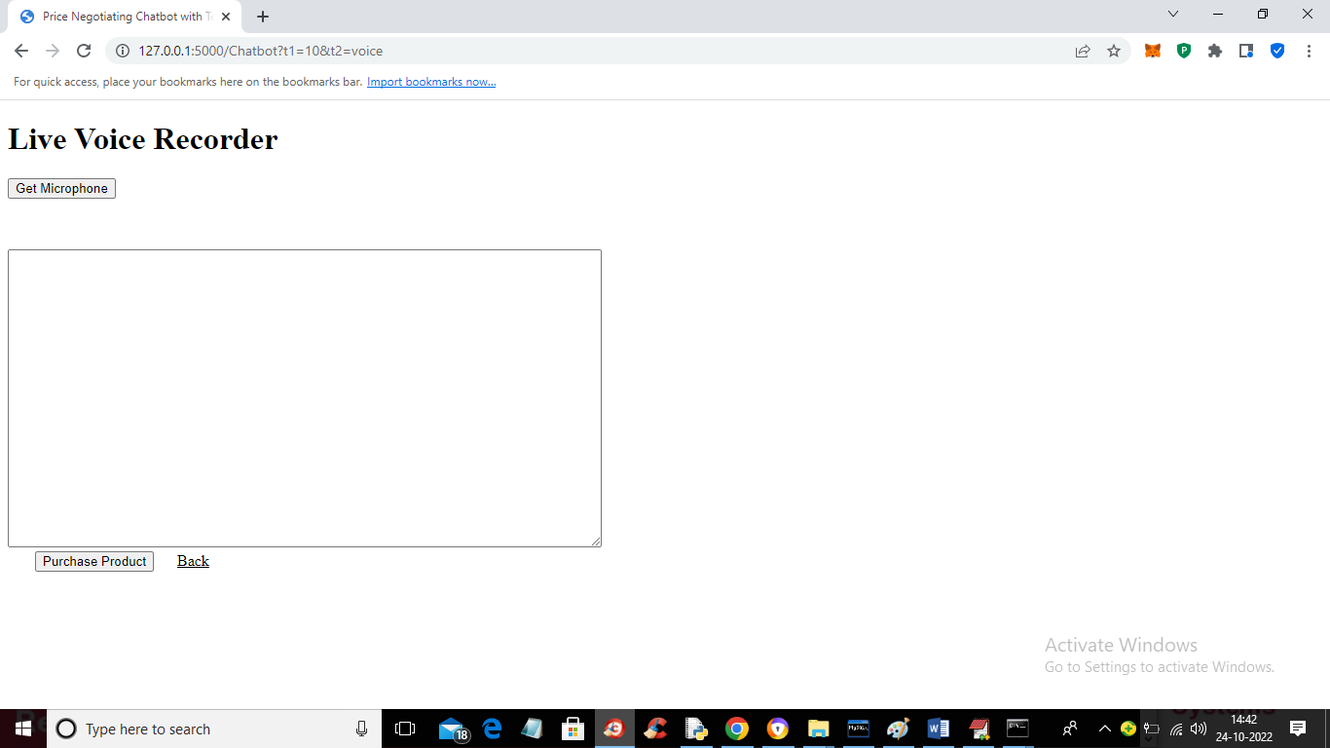

In above screen click on ‘Get Microphone’ button to connect to microphone and get below output

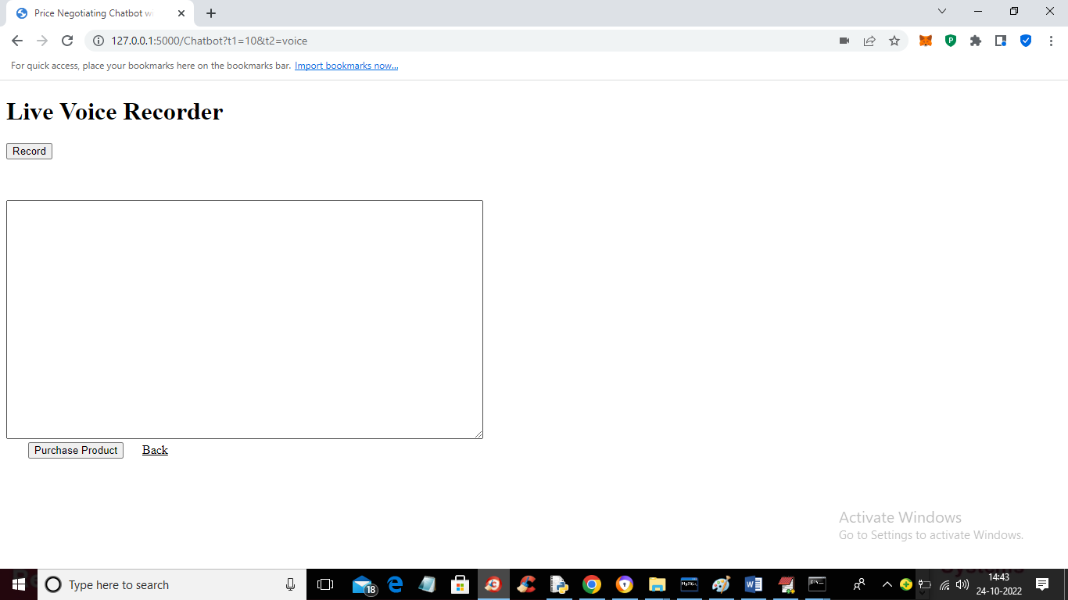

Now in above screen microphone connected and now click on ‘Recorder’ to record voice and then click on ‘Stop’ button to complete recording and send voice to Chatbot and get output

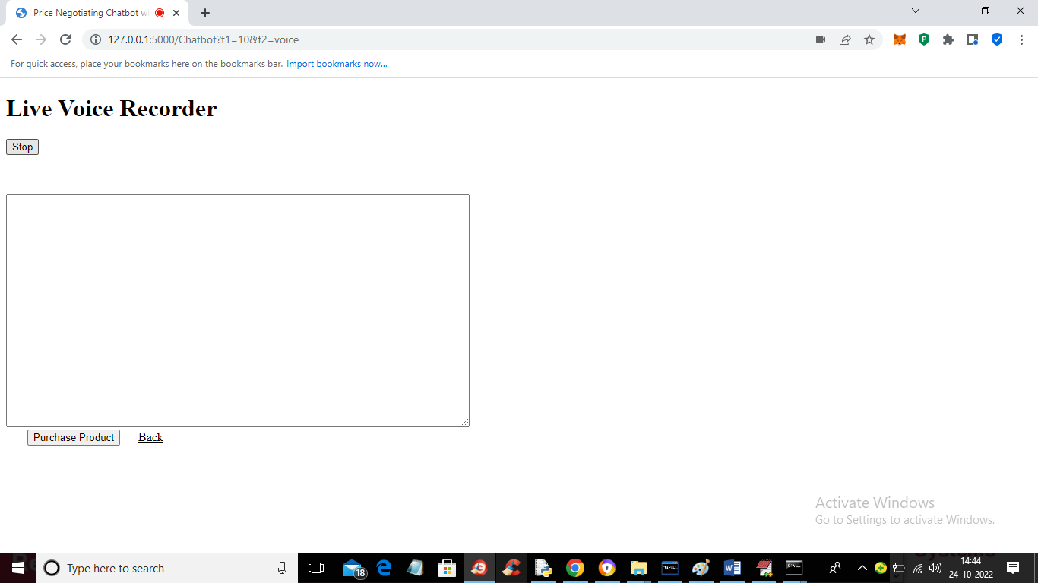

In above screen after recording click on ‘Stop’ button to complete recording and get below output

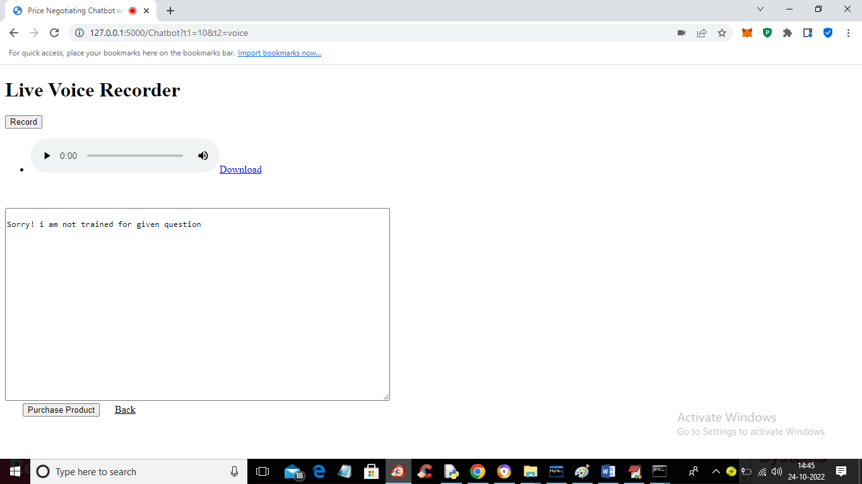

In above screen Chatbot saying ‘sorry not trained’ and now we will try again

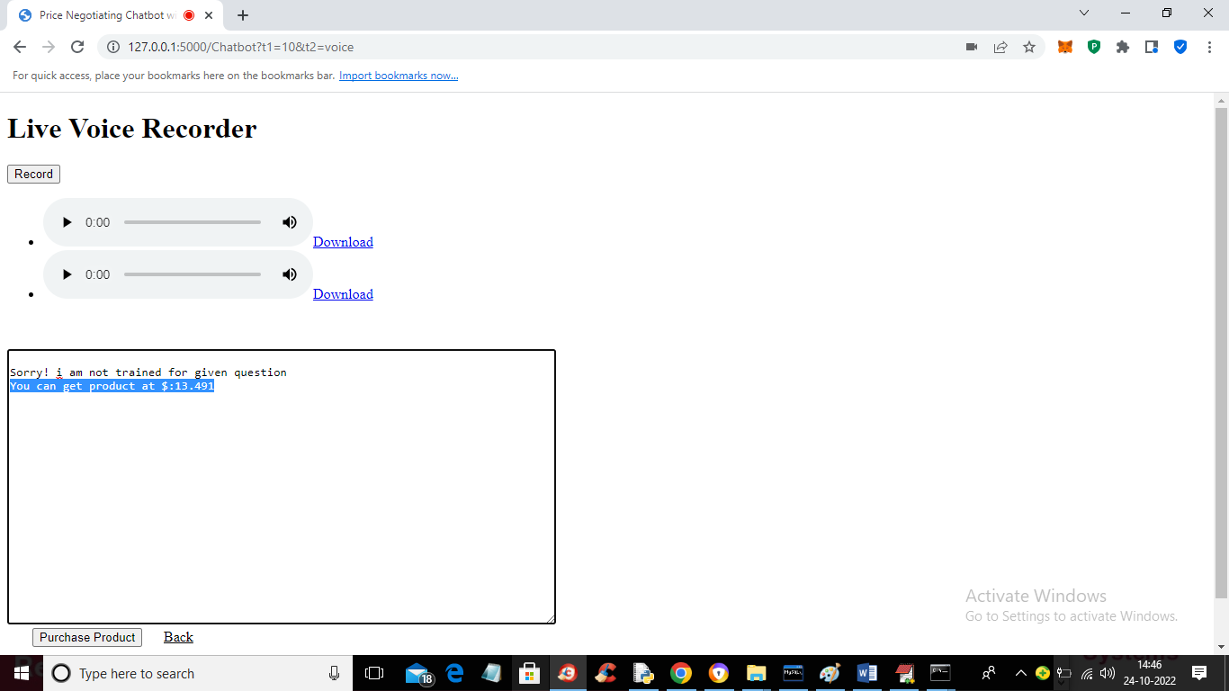

In above screen Chatbot understand query and then in blue colour text we can see output of Chatbot with negotiate price and now click on ‘Purchase Product’ button to confirm order and get below output

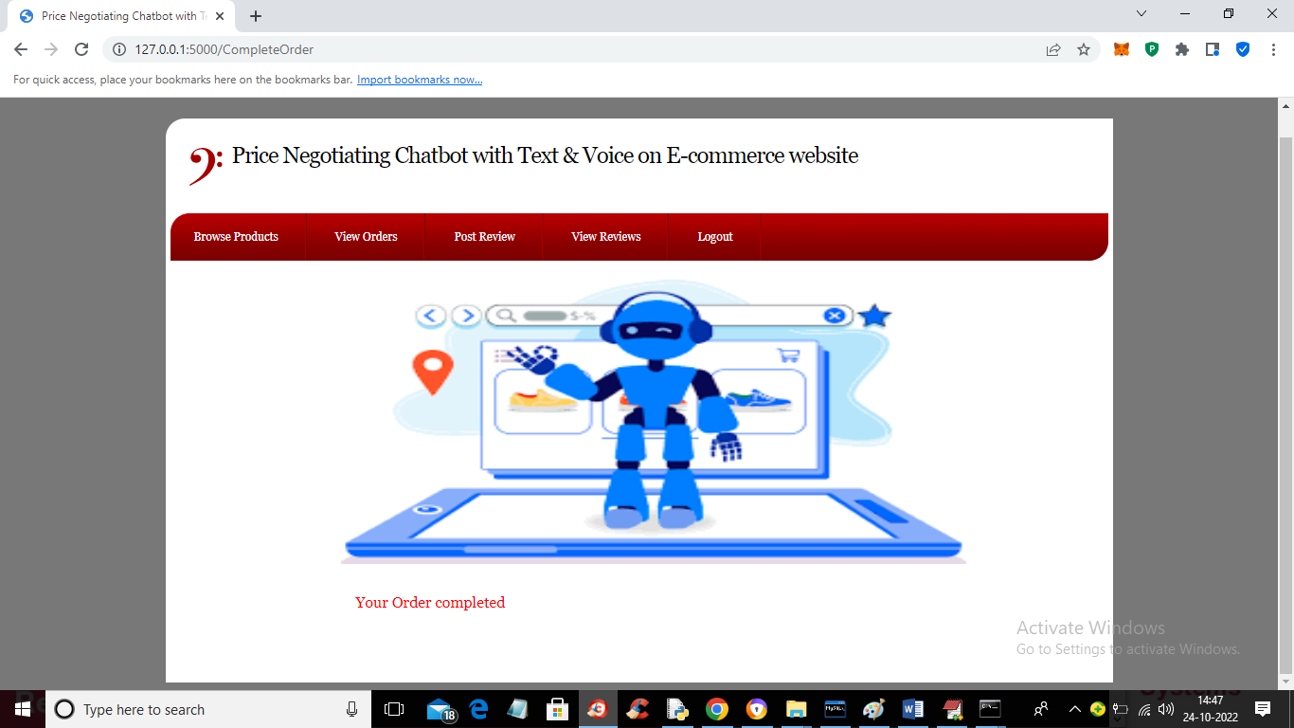

In above screen order is confirmed and now click on ‘View Orders’ link to get below output

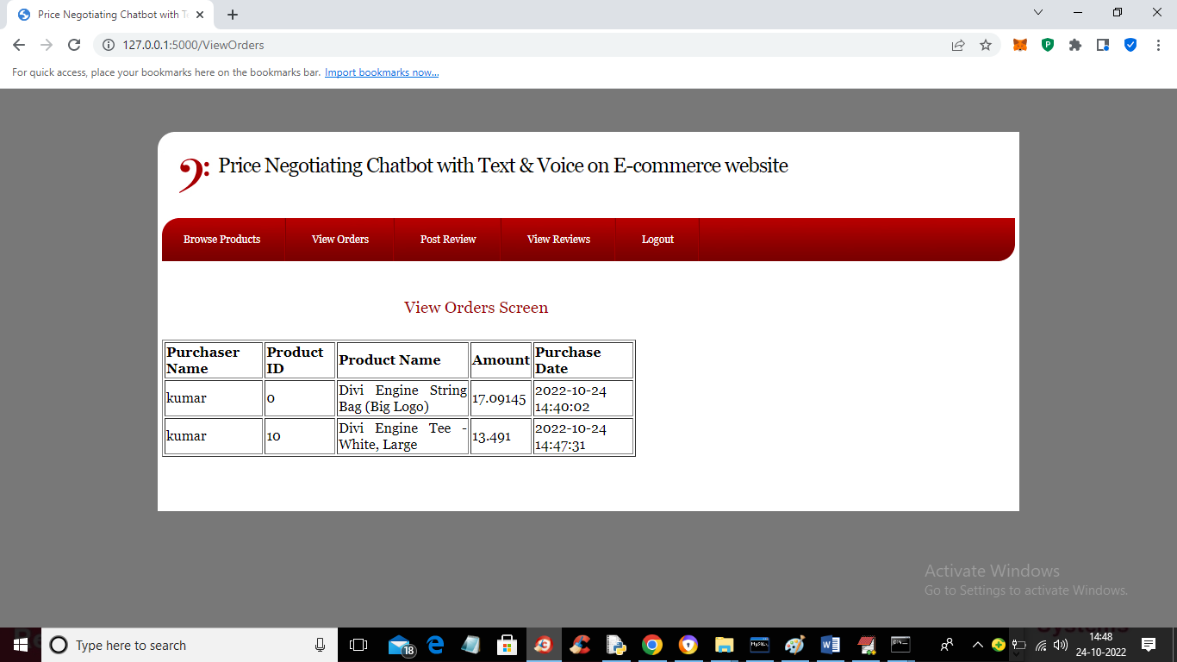

In above screen we can see the confirmed orders from user and now click on ‘Post Review’ link to get below output

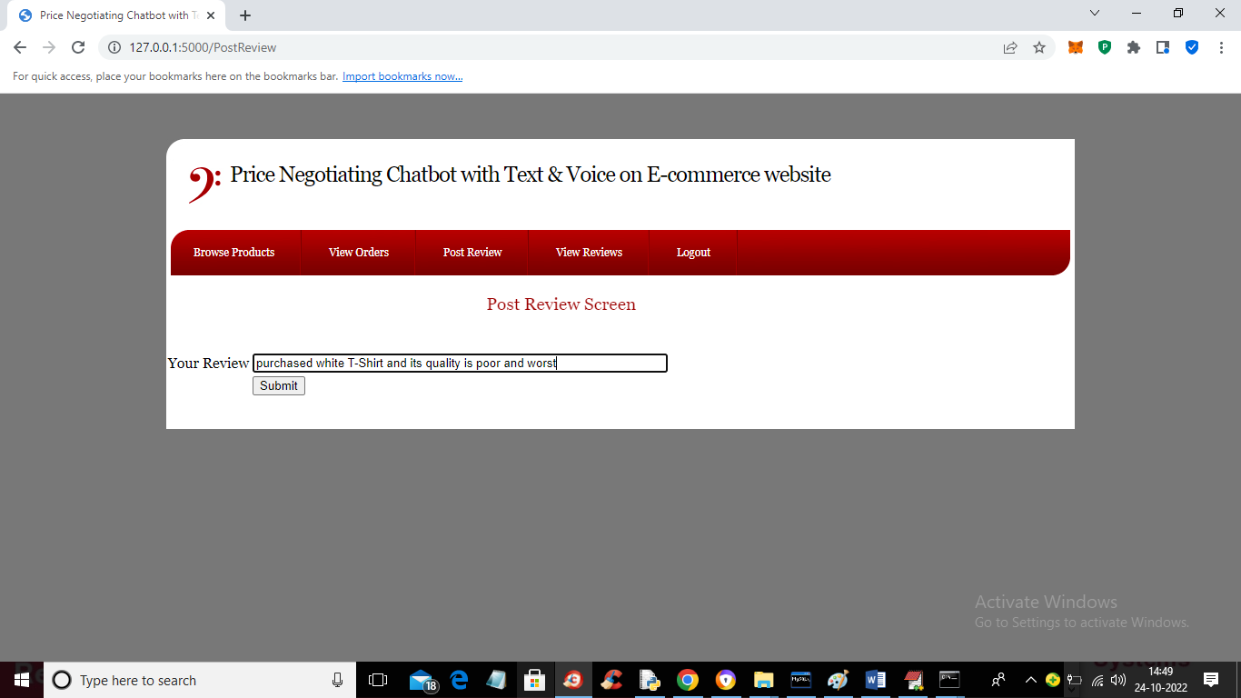

In above screen I entered some review and then click on ‘Submit’ button to get below output

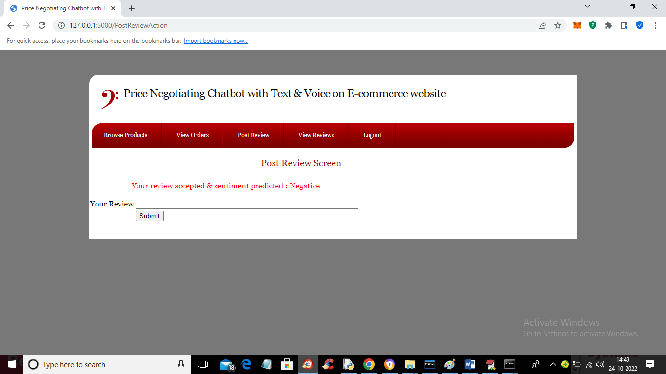

In above screen in red colour text we can see user review predicted as ‘Negative’ and now click on ‘View Reviews’ link to get below output

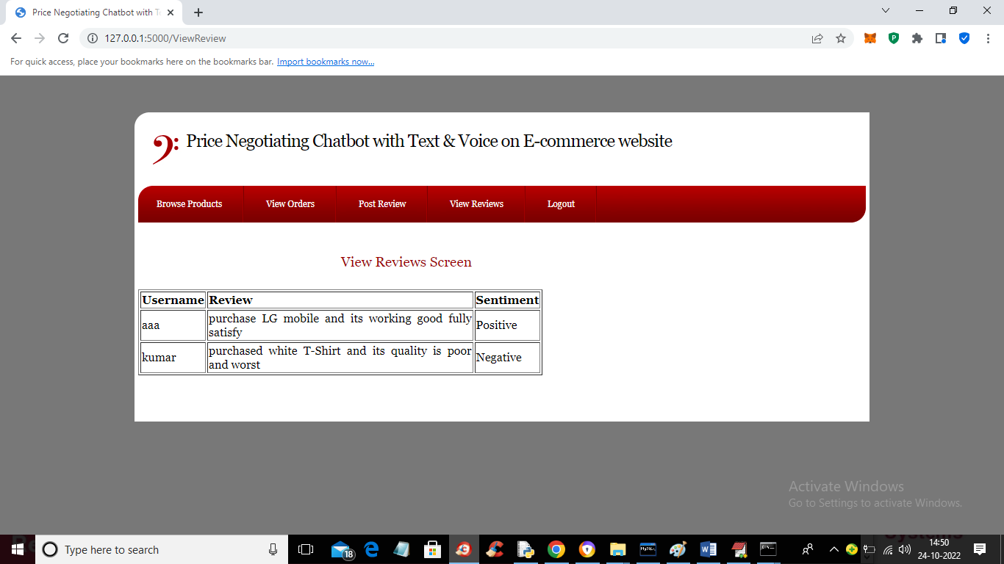

In above screen all users can view all reviews and their sentiments.

Similarly you can signup, login and view products list and negotiate with Chatbot using text and voice