BITS Pilani
Machine Learning Operations (MLOps) – AIMLCZG523
Heart Disease Risk Prediction
End-to-End ML Development, CI/CD and Production Deployment – Assignment 01
Item | Detail
Student | Your full name
Student ID | 2025AE05581
Code repository | https://github.com/Manohar-mtech/2025AE05581-MLOps-Assign-1
Dataset | UCI Heart Disease (Cleveland subset, 303 patients, 13 features + binary target)
Deployed API | Local Kubernetes: http://<EXTERNAL-IP>/docs – fill in after deployment
Demo video | Link to pipeline recording

1. Introduction and objective
The goal of this assignment is to build a classifier that predicts the presence of heart disease from routine patient measurements, and to wrap it in a reproducible, automated and monitored production workflow. The emphasis is on the MLOps lifecycle rather than on squeezing out the last point of accuracy: versioned code and data handling, experiment tracking, automated tests, continuous integration, containerisation, orchestration and observability.
Outcome in one view. A logistic-regression pipeline (median imputation, standardisation, one-hot encoding) reaches a cross-validated ROC-AUC of 0.902 and a hold-out ROC-AUC of 0.966. It is served through a FastAPI container, built and smoke-tested automatically by GitHub Actions, and deployed to Kubernetes with Prometheus and Grafana monitoring. The same code produced identical predictions on a Windows workstation and in a Linux CI container (probability of disease 0.1655 for the sample patient).

2. System architecture
Figure 1 shows the four stages of the solution. Training produces a single versioned artifact (model.joblib plus metadata.json). GitHub Actions lints, tests and retrains on every push, then builds the serving image from that artifact and smoke-tests the running container. The image is deployed to Kubernetes behind a LoadBalancer Service, and the API exposes Prometheus metrics that Grafana visualises.
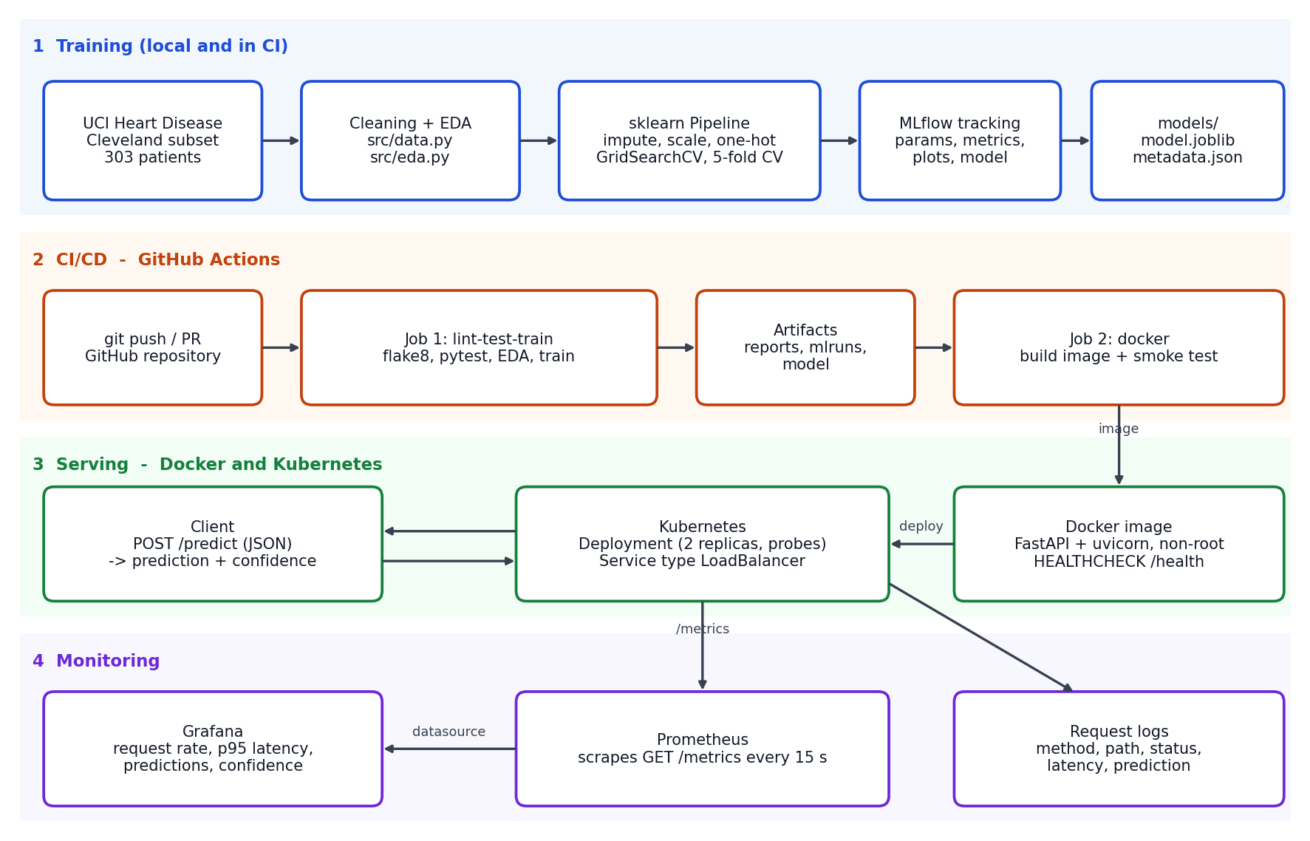
Figure 1 – Architecture: training, CI/CD, serving and monitoring.

3. Setup and installation
The project targets Python 3.11. All dependencies are pinned so that a clean environment reproduces the results. Three requirement files separate concerns: requirements.txt (full runtime including MLflow and plotting), requirements-serve.txt (slim inference set baked into the Docker image) and requirements-dev.txt (adds pytest, httpx and flake8).
python -m venv .venv
source .venv/Scripts/activate # Linux/macOS: .venv/bin/activate
pip install -r requirements-dev.txt
python scripts/download_data.py # skipped if data/raw is populated
python -m src.data # -> data/processed/heart_clean.csv
python -m src.eda # -> reports/figures/
python -m src.train # tune, track in MLflow, save model
mlflow ui --backend-store-uri ./mlruns
pytest && flake8 src api tests scripts
uvicorn api.app:app --reload # http://127.0.0.1:8000/docs
Repository layout: src/ (data, features, modeling, train, eda, predict), api/ (FastAPI app and schemas), tests/ (30 unit and API tests), k8s/ (Deployment, Service, Ingress, monitoring stack), monitoring/ (Prometheus config and Grafana dashboard), .github/workflows/ci.yml, Dockerfile, docker-compose.yml, reports/figures/ and screenshots/.

4. Data acquisition, cleaning and EDA

4.1 Dataset and cleaning
scripts/download_data.py downloads the UCI archive and extracts processed.cleveland.data, which contains 303 patients with 13 clinical features and num, a severity grade from 0 to 4. The cleaning step (src/data.py) applies four rules:
- Attach the standard column names and parse ? as missing. Only ca (4 rows) and thal (2 rows) contain missing values.
- Convert num to a binary target: 0 means no disease and 1–4 means disease. This matches the problem statement and yields 164 healthy and 139 diseased patients.
- Drop exact duplicates (none were found, so the cleaned shape is 303 × 14) and cast all features to float for a consistent schema.
- Missing values are not imputed here. Imputation is a step inside the modelling pipeline, so medians and modes are learned from training folds only (no leakage) and the identical logic runs at inference time.

4.2 Exploratory analysis
The classes are close to balanced (54.1 % vs 45.9 %), so accuracy is meaningful and no resampling is required. ROC-AUC, precision and recall are still reported because the cost of a missed patient is higher than that of a false alarm.
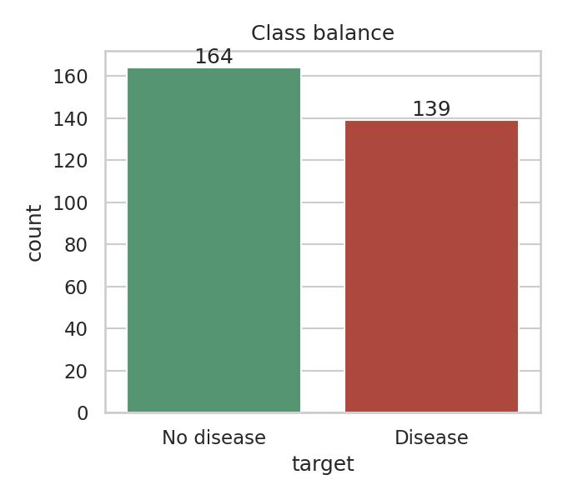 | 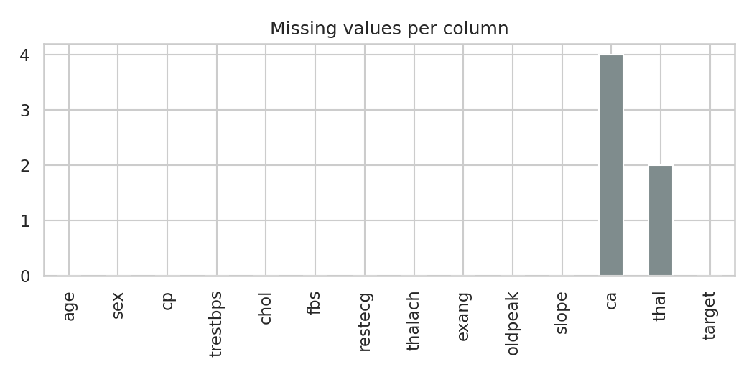
Figure 2 – Class balance (left) and missing values per column (right).
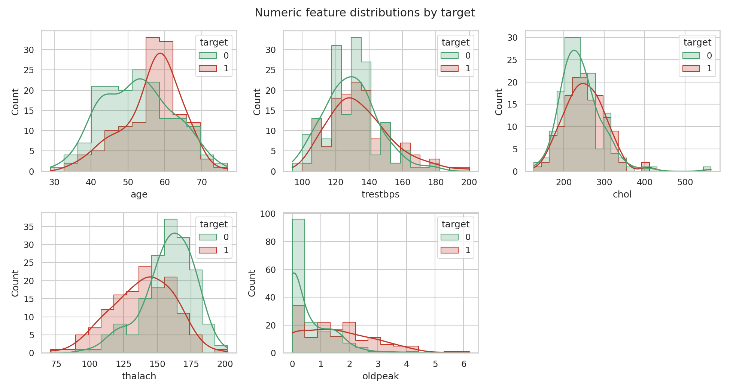
Figure 3 – Numeric feature distributions split by target.
Findings. Patients with disease are older on average, reach a lower maximum heart rate (thalach) and show larger ST depression (oldpeak). Cholesterol and resting blood pressure overlap heavily between the classes, so they carry little signal on their own. Figure 4 confirms this: the strongest correlations with the target are thal (0.53), ca (0.46), exang (0.43), oldpeak (0.43), cp (0.41) and thalach (−0.42), while fbs (0.03) and chol (0.09) are almost uncorrelated. No pair of predictors is strongly collinear, which supports using a linear model alongside tree ensembles.
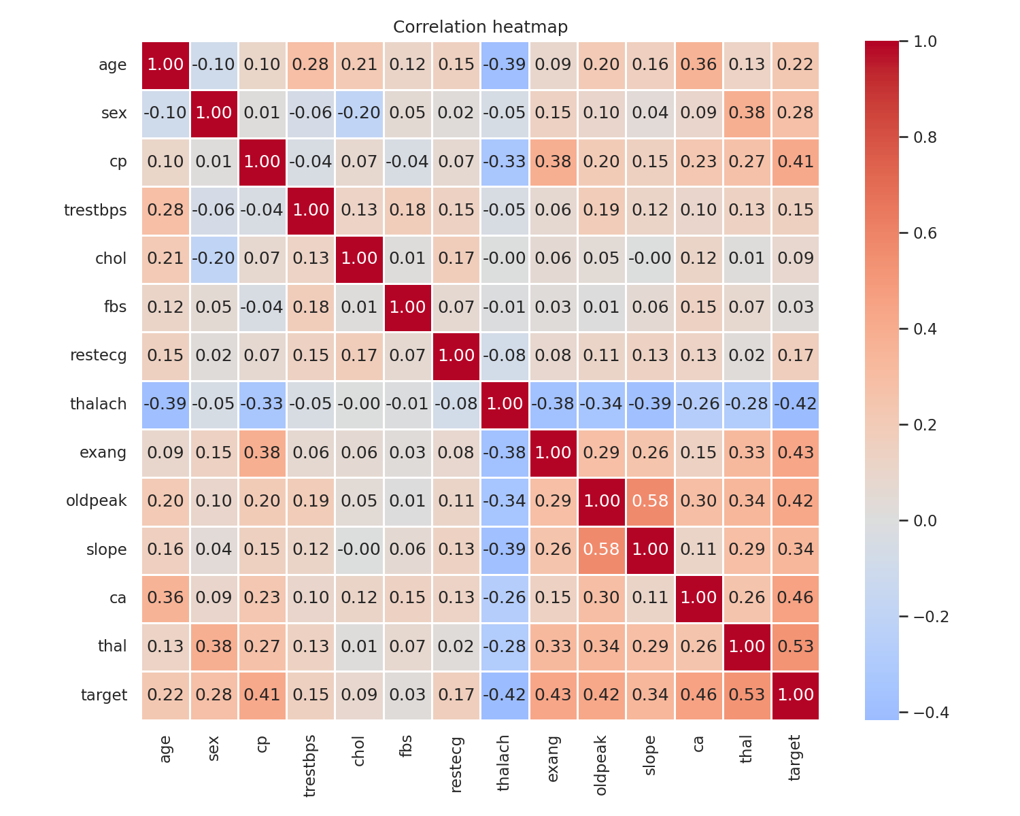
Figure 4 – Correlation heatmap including the binary target.

5. Feature engineering and model development

5.1 Preprocessing
A single ColumnTransformer (src/features.py) is the first step of every model pipeline, so the same transformations are applied in training, cross-validation and serving.
Feature group | Columns | Treatment
Continuous | age, trestbps, chol, thalach, oldpeak | Median imputation, then StandardScaler
Categorical / ordinal codes | sex, cp, fbs, restecg, exang, slope, ca, thal | Most-frequent imputation, then OneHotEncoder (handle_unknown=ignore so unseen codes never crash the API)

ca and thal are small integer codes with no meaningful numeric distance (for example thal 3, 6, 7), so one-hot encoding is more appropriate than treating them as continuous.

5.2 Candidate models and tuning
Three model families were trained to compare a simple linear baseline against ensembles. The data was split 80/20 with stratification (242 training and 61 test patients, seed 42). Each family was tuned with GridSearchCV, optimising ROC-AUC under stratified 5-fold cross-validation on the training split only.
Model | Hyper-parameter grid | Selected (CV)
Logistic Regression | C ∈ {0.01, 0.1, 1, 10} (4 combinations) | C = 1.0
Random Forest | n_estimators {100, 300} × max_depth {3, 5, None} × min_samples_leaf {1, 3} (12) | 100 trees, depth 5, leaf 3
Gradient Boosting | n_estimators {100, 200} × learning_rate {0.05, 0.1} × max_depth {2, 3} (8) | 100 trees, lr 0.05, depth 3

5.3 Evaluation and model selection
For each tuned pipeline the training split is cross-validated again to report mean accuracy, precision, recall, F1 and ROC-AUC, and the untouched 61-patient test set is scored once for reporting. The deployment model is chosen by cross-validated ROC-AUC only; the test set never influences selection.
Model | CV ROC-AUC | Test accuracy | Test precision | Test recall | Test ROC-AUC
Logistic Regression | 0.902 | 0.885 | 0.839 | 0.929 | 0.966
Random Forest | 0.901 | 0.869 | 0.833 | 0.893 | 0.947
Gradient Boosting | 0.875 | 0.885 | 0.839 | 0.929 | 0.951
Table 1 – Results from the CI training run (80/20 stratified split, seed 42).
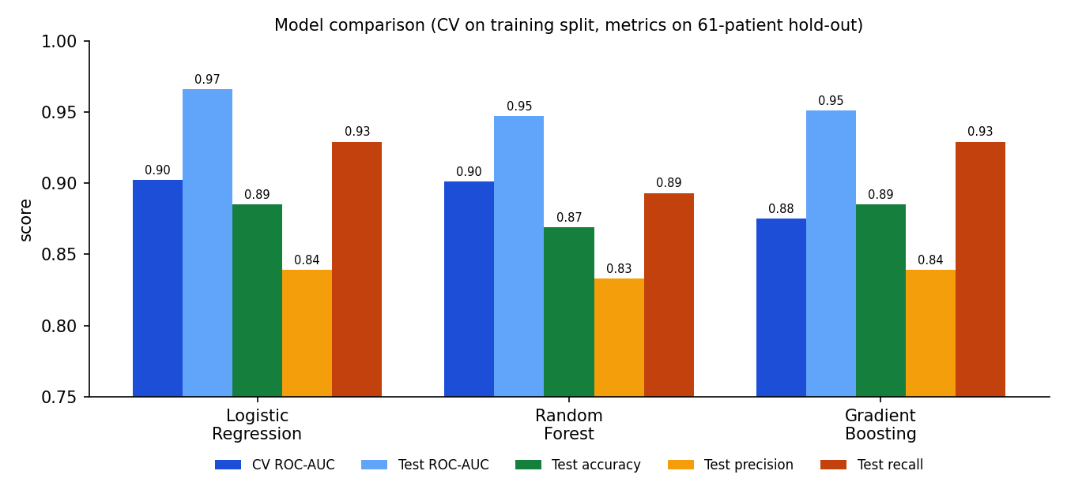
Figure 5 – Comparison of the three tuned models.
Decision. Logistic regression and random forest are effectively tied on CV ROC-AUC (0.902 vs 0.901), so the tie is broken on practical grounds: the linear model is smaller, faster, deterministic, and its coefficients are directly interpretable, which matters for a clinical-risk tool. It also achieves the joint-best recall (0.929). On the hold-out set it produced 26 true positives, 2 false negatives, 5 false positives and 28 true negatives.
Caveats. The hold-out set has only 61 patients, so a single misclassification moves accuracy by 1.6 points; the test ROC-AUC (0.966) being higher than the CV estimate (0.902) is partly split luck, and the CV figure is the more reliable guide. The Cleveland subset is also small and single-centre, so the model should be treated as a teaching exercise rather than a clinical device.

6. Experiment tracking with MLflow
src/train.py logs every run to a local MLflow file store (./mlruns, or any server via MLFLOW_TRACKING_URI). One parent run, training-session, records dataset sizes, the split seed and positive rate; each model family is a nested child run so the three runs can be compared side by side.
Logged item | Content
Parameters | model type, best hyper-parameters, grid size, CV folds, random state, test size, scikit-learn version
Metrics | CV mean and standard deviation for accuracy, precision, recall, F1, ROC-AUC; hold-out accuracy, precision, recall, F1, ROC-AUC; best CV score from the grid search
Plots | confusion matrix, ROC curve and feature-importance chart for each model (plots/)
Artifacts | full grid-search results CSV (tuning/), the cleaned dataset, the fitted pipeline with input example and signature (model/), and the final model.joblib and metadata.json
Tags | model_family, stage, and best_model on the parent run

The MLflow UI (mlflow ui --backend-store-uri ./mlruns) was used to compare the runs, sort by cv_roc_auc_mean and inspect the logged plots. Logistic regression and random forest sit within 0.001 of each other, while gradient boosting trails on CV ROC-AUC (0.875).
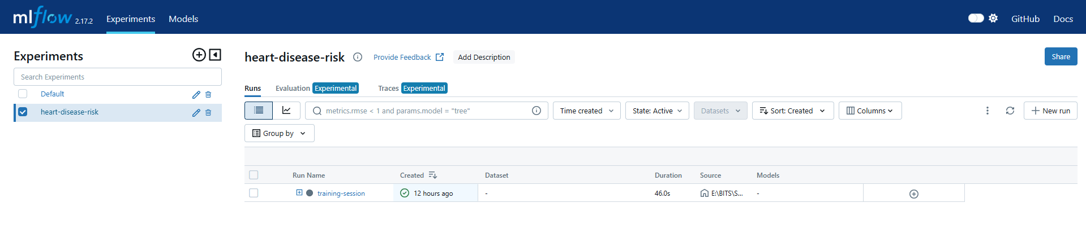
Figure 6 – MLflow experiment “heart-disease-risk” with the parent run training-session (child runs nested under the + icon).
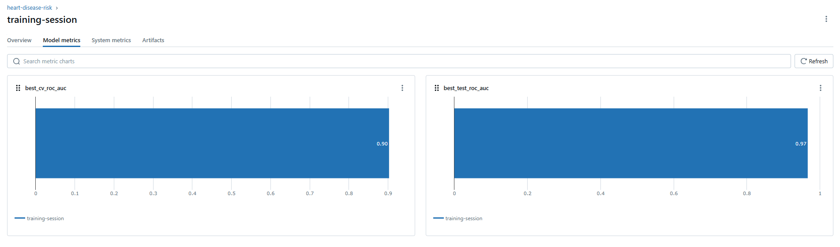
Figure 7 – Model-metrics tab of the parent run: best CV ROC-AUC 0.90 and best hold-out ROC-AUC 0.97.
[ Insert screenshot ]  Child runs expanded / compared (three models) | [ Insert screenshot ]  Artifacts of the logistic-regression run (ROC, confusion matrix)

7. Model packaging and reproducibility
- Format. The whole fitted Pipeline (preprocessor + classifier) is serialised with joblib to models/model.joblib. Because preprocessing travels with the model, the API never re-implements feature logic. The same pipeline is also logged to MLflow in its native sklearn flavour with a signature and input example.
- Metadata. models/metadata.json records the model name, best parameters, CV and test metrics, feature list, training timestamp and library versions. The API exposes it at GET /model-info.
- Determinism. All randomness uses seed 42 (data split, CV folds, random forest, gradient boosting); dependency versions are pinned.
- Clean-setup proof. The pipeline was executed from a fresh virtual environment on Windows (Python 3.11.9) and from a fresh Ubuntu runner in GitHub Actions (Python 3.11.17). Both produced the same prediction for the sample patient (probability of disease 0.1655, confidence 0.8345).

8. CI/CD pipeline and automated testing

8.1 Unit tests
The tests/ folder contains 30 pytest tests that all pass locally (2.5 s) and in CI. Synthetic fixtures with a planted signal keep model tests fast and independent of the real dataset.
Module | Tests | What is verified
test_data.py | 8 | Raw file shape and ? parsing, target binarisation, float casting, duplicate removal, missing-column and missing-file errors, stratified disjoint split
test_features.py | 3 | No NaNs after preprocessing, numeric columns standardised (mean 0, std 1), unseen categories ignored
test_modeling.py | 10 | At least two model families, tuning returns a fitted pipeline, all five CV metrics in range, hold-out metrics, sorted importances, save/load round-trip gives identical probabilities, prediction schema, None handling
test_api.py | 9 | /health, /predict response fields, optional ca/thal, 422 on invalid values (age, sex, cp, thal) and on missing fields, /metrics counters
Coverage measured in CI is 51 % overall. The core modules are well covered (schemas and features 100 %, modeling 95 %, predict 91 %, app 89 %, data 72 %). The 0 % entries are the command-line entry points train.py, eda.py and plots.py, which are exercised end-to-end by the workflow itself rather than by unit tests.

8.2 GitHub Actions workflow
.github/workflows/ci.yml runs on every push to main, on pull requests and on manual dispatch. Each step fails the job on error, and the logs identify the failing step.
Job | Step | Purpose
lint-test-train | flake8 | Style and static checks on src api tests scripts (zero warnings)
 | pytest | 30 tests with coverage; JUnit XML written to reports/
 | EDA | Regenerates the six EDA figures
 | Train | Tunes three models, logs to MLflow, saves the model; output tee’d to reports/train.log
 | Upload | Artifacts reports (154 files incl. mlruns) and model
docker | Build | Downloads the model artifact and builds the image from the Dockerfile
 | Run + smoke test | Starts the container and calls /health, /predict, /metrics; fails if any call fails or confidence is missing

A failure caught by the pipeline. The first run of the docker job failed at the smoke-test step with Permission denied (exit code 126). The script had been committed from Windows without the executable bit, which Linux runners enforce. This illustrates the requirement that the pipeline fails clearly on errors. The fix was to invoke the script explicitly (bash scripts/smoke_test.sh http://localhost:8000); the next run passed both jobs. On the green run, lint-test-train took 1 min 10 s (dependency install 31 s, tests 3 s, EDA 4 s, training 19 s) and the docker job 1 min 18 s.
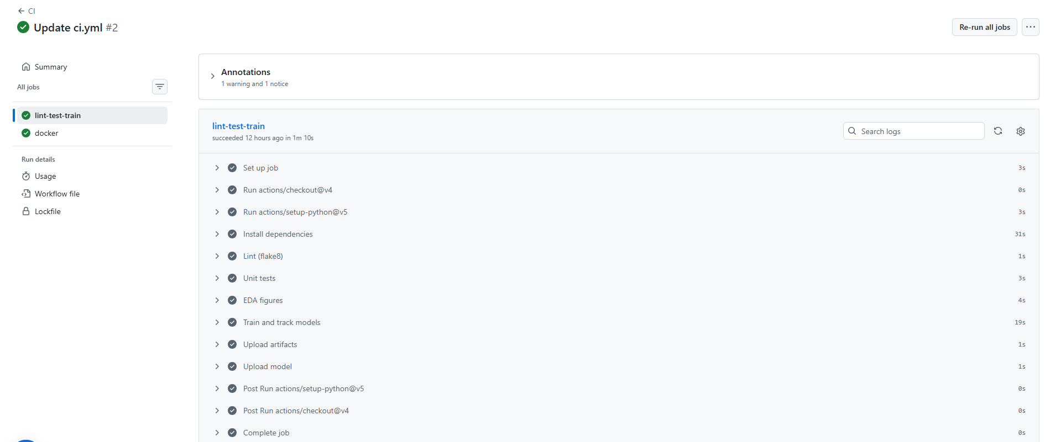
Figure 8 – GitHub Actions, job lint-test-train: every step green (install 31 s, lint 1 s, tests 3 s, EDA 4 s, training 19 s).
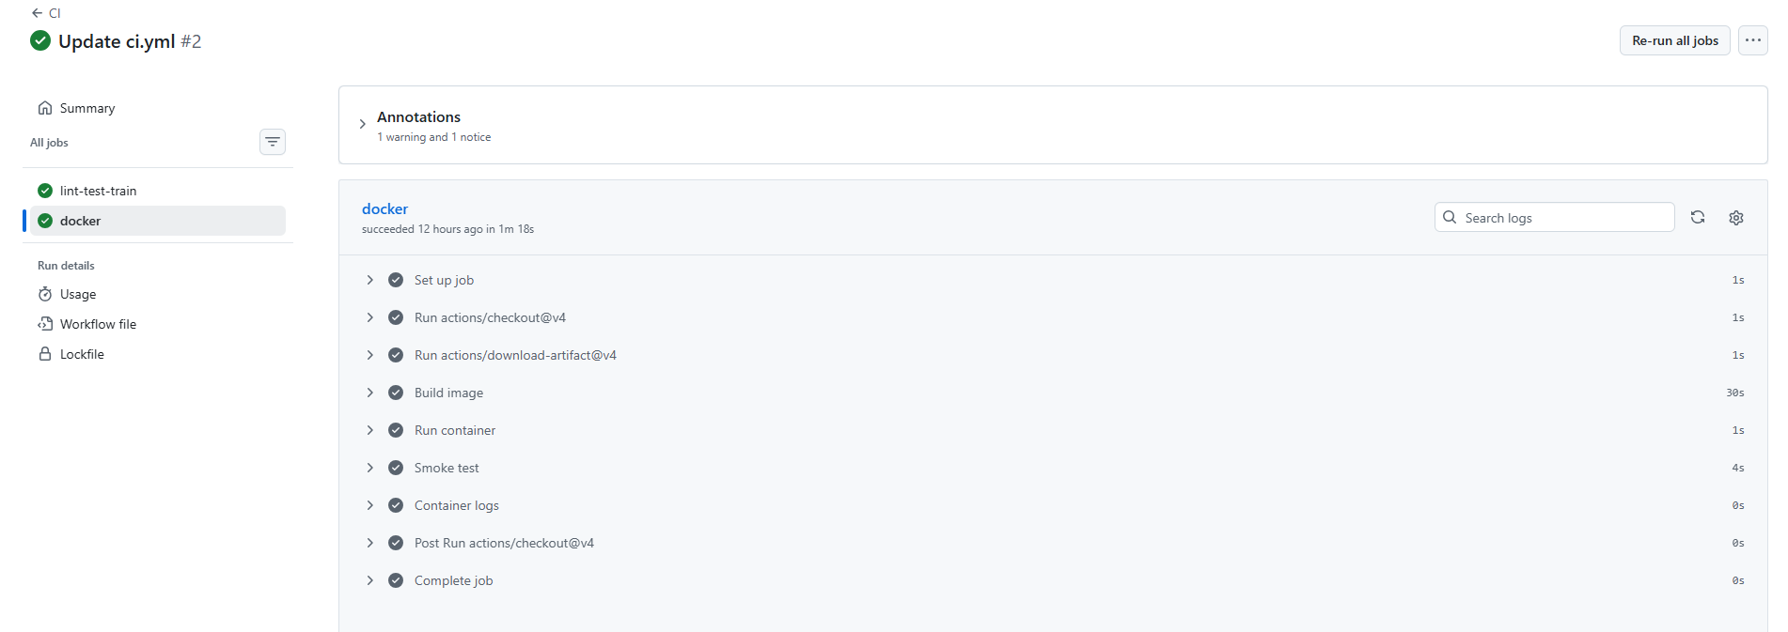
Figure 9 – GitHub Actions, job docker: image build 30 s, container start, smoke test 4 s, all green.
[ Insert screenshot ]  Failed docker job (exit code 126) – optional evidence | [ Insert screenshot ]  pytest output with 30 passed (local terminal)

9. Model containerisation
The serving API (api/app.py) is built with FastAPI and validated by pydantic. POST /predict accepts the 13 clinical fields as JSON (ca and thal may be null) and returns the predicted class, a label, the confidence of the predicted class and the raw disease probability. Range checks (for example cp 1–4, thal in {3, 6, 7}) return HTTP 422 for bad input.
POST /predict
{"age":63,"sex":1,"cp":1,"trestbps":145,"chol":233,"fbs":1,"restecg":2,
"thalach":150,"exang":0,"oldpeak":2.3,"slope":3,"ca":0,"thal":6}

200 OK
{"prediction":0,"label":"No heart disease",
"confidence":0.8345,"probability_disease":0.1655}
Dockerfile design choices: the python:3.11-slim base keeps the image small; only requirements-serve.txt is installed (no MLflow, matplotlib or seaborn), which shortens build time and reduces the attack surface; the model is copied into the image so a container is self-contained; the process runs as a non-root user; and a HEALTHCHECK polls /health using the Python standard library, so no extra tools are needed in the image.
docker build -t heart-disease-api:latest .
docker run -d --name heart-api -p 8000:8000 heart-disease-api:latest
scripts/smoke_test.sh http://localhost:8000
The container was built and tested inside the CI runner: the smoke test shows model_loaded: true, a correct prediction and the api_requests_total metric. Add one sentence on your local docker run once done.
[ Insert screenshot ]  docker build and docker run output | [ Insert screenshot ]  Smoke test / curl /predict response from the container

10. Production deployment on Kubernetes
The image is deployed to a local Kubernetes cluster (Minikube / Docker Desktop – state which one you used) using the manifests in k8s/:
- `deployment.yaml` – 2 replicas, RollingUpdate with maxUnavailable: 0 and maxSurge: 1 for zero-downtime updates, readiness and liveness probes on /health, resource requests (100m CPU, 256 Mi) and limits (500m, 512 Mi), and Prometheus scrape annotations.
- `service.yaml` – a LoadBalancer Service mapping port 80 to container port 8000. On Minikube this is exposed with minikube tunnel; on Docker Desktop it appears on localhost.
- `ingress.yaml` – an optional NGINX Ingress (heart.local) as an alternative entry point.
minikube start && eval $(minikube docker-env) # build in cluster daemon
docker build -t heart-disease-api:latest .
kubectl apply -f k8s/deployment.yaml -f k8s/service.yaml
kubectl get pods,svc # 2/2 pods Ready, EXTERNAL-IP assigned
minikube tunnel # run in a separate terminal
scripts/smoke_test.sh http://<EXTERNAL-IP>
After deploying, replace this sentence with your result: e.g. both pods reached Ready, the Service received an external IP, and /health, /predict and /metrics returned the expected responses.
[ Insert screenshot ]  kubectl get pods,svc,deployments | [ Insert screenshot ]  /docs or /predict call through the LoadBalancer

11. Monitoring and logging

11.1 Request logging
A middleware logs every request (method, route, status, latency, client) and each prediction with its confidence. Sample output captured from the local server:
INFO heart-api request method=GET path=/health status=200 latency_ms=2.7
INFO heart-api prediction=0 confidence=0.835
INFO heart-api request method=POST path=/predict status=200 latency_ms=17.5
The route template (not the raw URL) is used as the metric label, which prevents unbounded label cardinality from scanners or typos.

11.2 Prometheus and Grafana
Metric | Meaning and use
api_requests_total{method,path,status} | Traffic and error rate (4xx/5xx panel)
api_request_latency_seconds{path} | Histogram for p95 latency (histogram_quantile)
api_predictions_total{label} | Predicted-class mix over time; a sudden shift may indicate input drift
api_prediction_confidence | Histogram of confidence; falling mean confidence is an early warning signal

docker compose up --build starts the API, Prometheus (scraping /metrics every 15 s) and Grafana with the data source and the “Heart Disease API” dashboard provisioned automatically. For the cluster, k8s/monitoring.yaml deploys the same stack. The dashboard has five panels: requests per second by path, p95 latency, predictions by class, 4xx/5xx rate and mean confidence.
[ Insert screenshot ]  Prometheus: Status > Targets showing the API as UP | [ Insert screenshot ]  Grafana dashboard with live traffic

12. Conclusion and traceability
The project delivers a complete, reproducible path from raw UCI data to a monitored API. Key outcomes: a tuned logistic-regression pipeline (CV ROC-AUC 0.902, hold-out ROC-AUC 0.966, recall 0.929), 30 passing tests, a two-job CI pipeline that trains, builds and smoke-tests the container, and a Kubernetes deployment with request logging and Prometheus/Grafana monitoring.
Limitations and next steps. The dataset is small and single-centre, so external validation would be required before any clinical use. Natural extensions are a model registry with stage transitions, scheduled retraining triggered by drift alerts from the confidence histogram, pushing the image to a container registry from CI, and a Helm chart for parameterised deployments.
Assignment task | Evidence in the repository
1 Data and EDA | scripts/download_data.py, src/data.py, src/eda.py, reports/figures/
2 Features and models | src/features.py, src/modeling.py (3 models, grid search, CV)
3 Experiment tracking | src/train.py, mlruns/ (MLflow)
4 Packaging | models/model.joblib, metadata.json, requirements*.txt
5 CI/CD and tests | tests/, .github/workflows/ci.yml, .flake8
6 Containerisation | Dockerfile, api/, scripts/smoke_test.sh
7 Deployment | k8s/deployment.yaml, service.yaml, ingress.yaml
8 Monitoring | /metrics, docker-compose.yml, monitoring/, k8s/monitoring.yaml
9 Documentation | This report and README.md
Repository: https://github.com/Manohar-mtech/2025AE05581-MLOps-Assign-1

