Improved File Security System Using Multiple Image Steganography

In this project as per your instructions we have developed PVD (Pixel Value Differencing) based image steganography where user can upload multiple images folder and then upload text file which has to be slice and embed in all those uploaded images. All embed images will get saved inside ‘Encoded_Images’ folder with text slice data hidden inside it. While decoding we can upload desired folder from ‘Encoded_Images’ folder to extract text.

To embed text we are using below sample text file

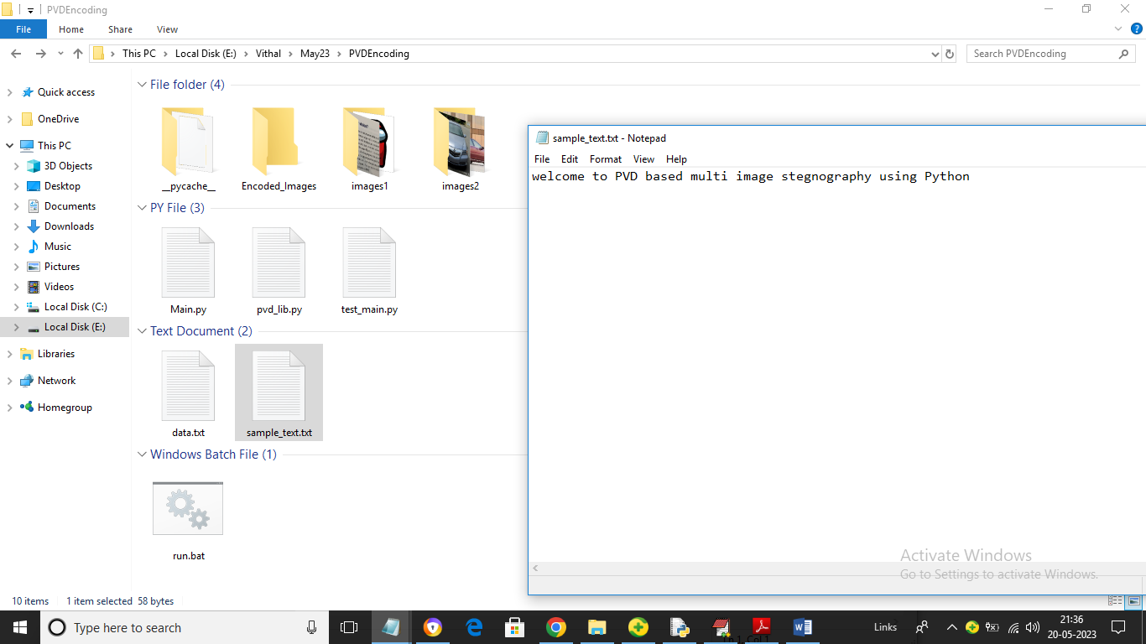

Above sample text will get sliced and hide inside multiple images

To run project double click on ‘run.bat’ file to get below output

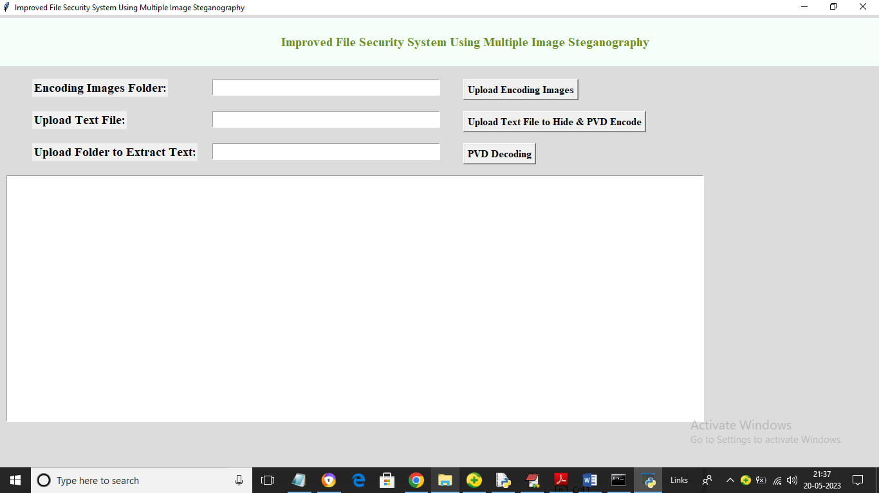

In above screen click on ‘Upload Encoding Images’ button to upload folder with multiple images like below screen

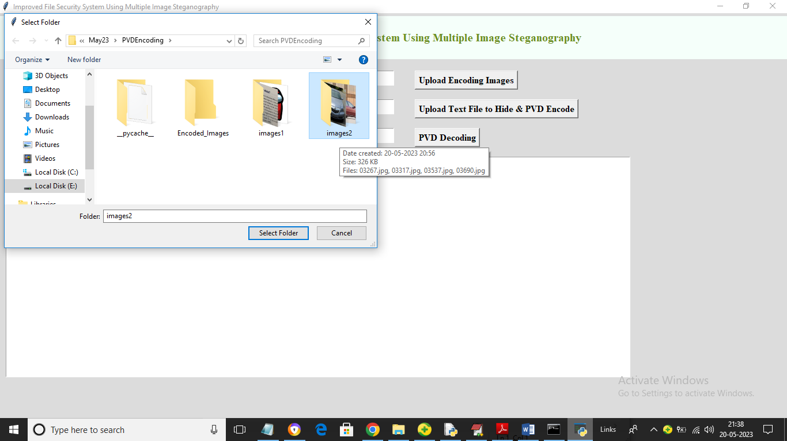

In above screen selecting and uploading ‘images2’ folder and then click on ‘Select Folder’ button to load images and get below output

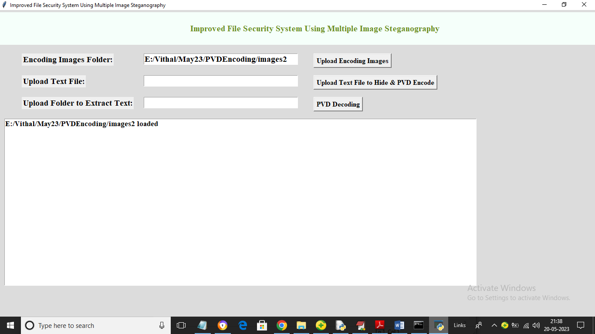

In above screen images uploaded and now click on ‘Upload Text File to Hide & PVD Encode’ button to upload sample text file to slice file and then embed in all images and get below output

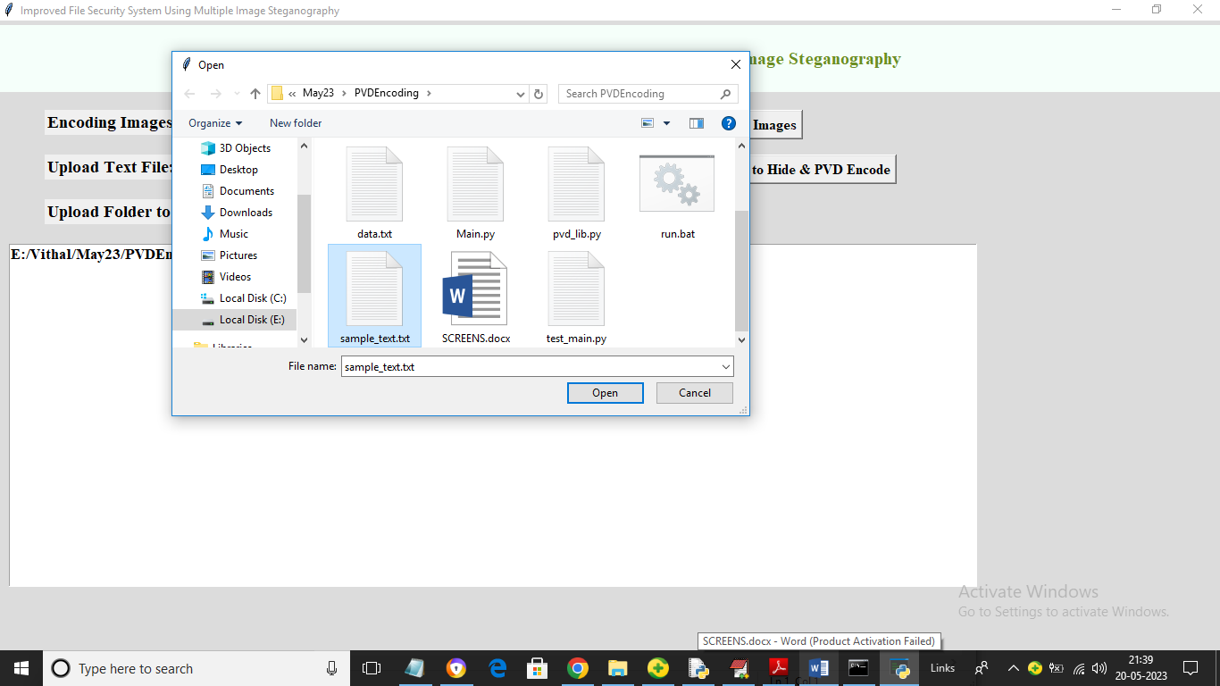

In above screen selecting and uploading ‘sample_text.txt’ file and then click on ‘Open’ button to get below output

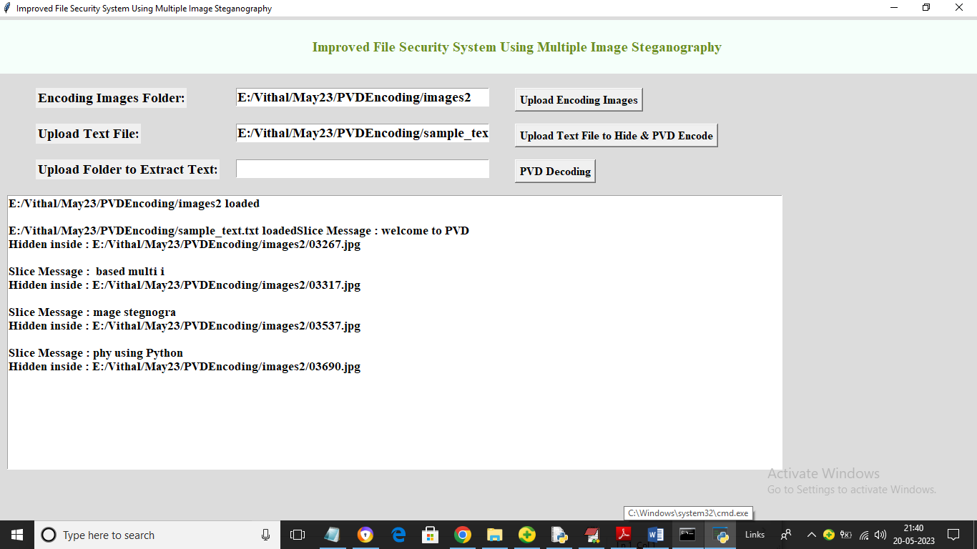

In above screen we can see in each line slice message and then can see image name which hide that slice message. In above screen in image we hide slice message as ‘welcome to PVD’ and in second image another slice message has hide and continue till all slice messages hidden inside all images. Now to extract text click on ‘PVD Decoding’ and then select desired folder from ‘Encoded Images’ folder to get below output

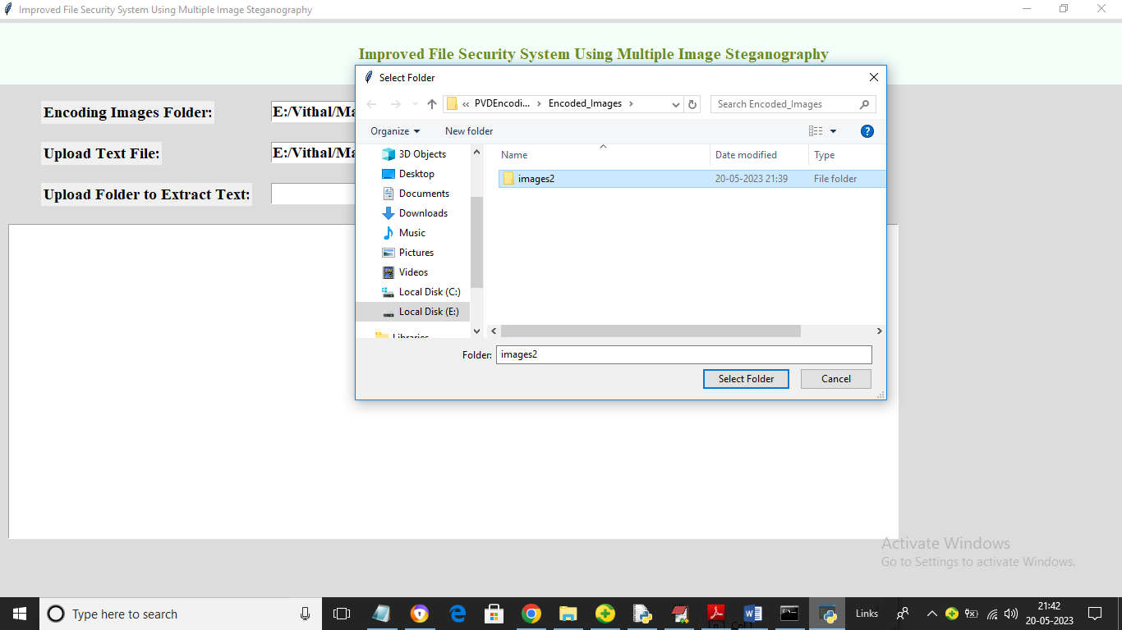

In above screen selecting and uploading ‘images2’ message encoded folder and then click on ‘Select Folder’ button to extract message and get below output

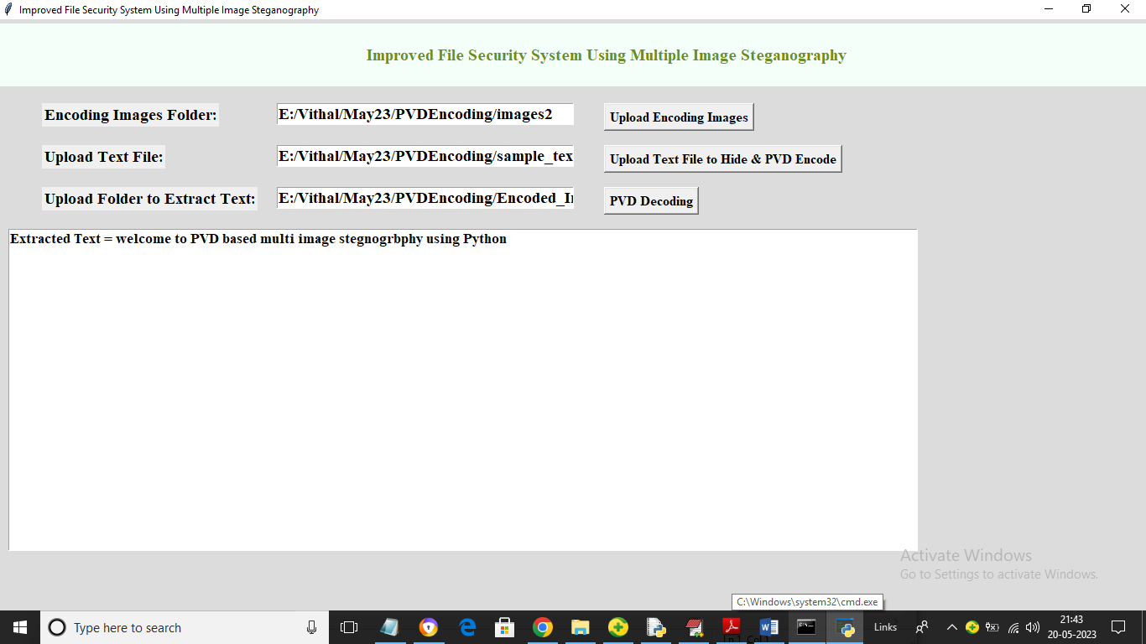

In above screen in text area we can see all hidden data extracted from all images and then displaying. Similarly you can upload images, text and then hide and extract text from them by following above screens