DGP-REPRODUCE · AMAZONVIDEO · NEIGHBOUR ANALYSIS OF 2026-10-17
Neighbours at K = 1, 2, 3 after Markov diffusion
What the Markov Diffusion Kernel keeps for each target review, before any classifier sees it. No end results (F1, AUROC) appear in this report.
Prepared 2026-10-18 from analysis/out/neighbors_k123/ (scripts in analysis/neighbors_k123/). 10,023 target reviews, Top-4 neighbours per metapath. Target labels were read for train and validation targets only; test targets contribute structure, distances, ratings and text only.

Summary
- Neighbour counts grow fast with K. A target keeps 11.9, 47.7 and 155.4 neighbour slots at K = 1, 2, 3 (3, 12 and 39 metapaths × 4). Many are repeats: 11.8, 32.6 and 51.0 distinct reviews, so 67% of the K = 3 slots repeat a node already kept.
- Measured against K = 3 as the base, K = 1 and K = 2 are partial. K = 1 keeps 8% of the K = 3 slots and finds 24% of its distinct neighbours; K = 2 finds 64%. Everything K = 1 keeps is also in K = 3, but only 53% of targets have all their K = 2 neighbours inside K = 3.
- Each hop adds new neighbours. K = 2 adds 20.8 new distinct reviews per target and K = 3 adds 19.1 more.
- For 1-hop paths diffusion changes nothing. RUR, RPR and RSR are unions of disjoint cliques. On a clique the diffused distance is a fixed multiple of the raw distance (largest relative error 7.6e-15), so the Top-4 equals the plain-distance Top-4 for 100% of audited targets at every K.
- On composite paths diffusion differs from raw distance about half the time. The two Top-4 sets are identical for 47% of 2-hop selections and 35% of 3-hop selections.
- The neighbours carry label signal. Fraud targets have a higher fraud share among their neighbours than benign targets at every K (gap 0.118, 0.097, 0.095). On a 400-target sample, diffusion and raw distance keep a larger gap (about 0.12) than text cosine (about 0.07) or a random pick (0.03 to 0.05), though the intervals of diffusion and text cosine overlap.
- The cached neighbours match a live recomputation. All 32,400 audited (target, metapath) selections (600 targets per metapath) recomputed live from the kernel match the cached Top-4.

1. What was inspected
DGP builds a review graph with three relations: RUR (reviews by the same user), RPR (reviews of the same product) and RSR (reviews with the same star rating in the same week). For a target review it enumerates metapaths of length up to K, which gives 3, 12 and 39 metapaths for K = 1, 2, 3. For each metapath, the Markov Diffusion Kernel Z(K) = (1/K) Σ T^k (k = 0..K, T = D⁻¹A) is applied to the node features (DeBERTa-v3 embedding concatenated with the rating, unscaled), and the four nearest candidates by diffused distance are kept (M = 4). Those kept reviews are what the language model later summarises.
The analysis ran in five steps:
- 1. Integrity: recompute the Top-4 live on an audit sample and compare it with the cache.
- 2. Structure: neighbours kept and distinct per target, repeats, and how the sets change from K to K + 1.
- 3. Selection: compare the diffusion Top-4 with the Top-4 by plain distance in the same feature space, by text cosine, and with a random pick from the same candidates.
- 4. Label signal: the fraud share among a target’s neighbours (train and validation targets).
- 5. Distance anatomy and four worked examples.

2. Integrity check
For every cached metapath, the Top-4 was recomputed from the diffusion kernel for 600 sampled targets (400 train or validation, 200 test; seed 0) and compared with the cached selection.
K | Metapath caches | Audited selections | Mismatches
K = 1 | 3 | 1,800 | 0
K = 2 | 12 | 7,200 | 0
K = 3 | 39 | 23,400 | 0
A selection is one target on one metapath. The gate passed before any other number in this report was computed.

3. How many neighbours each K keeps
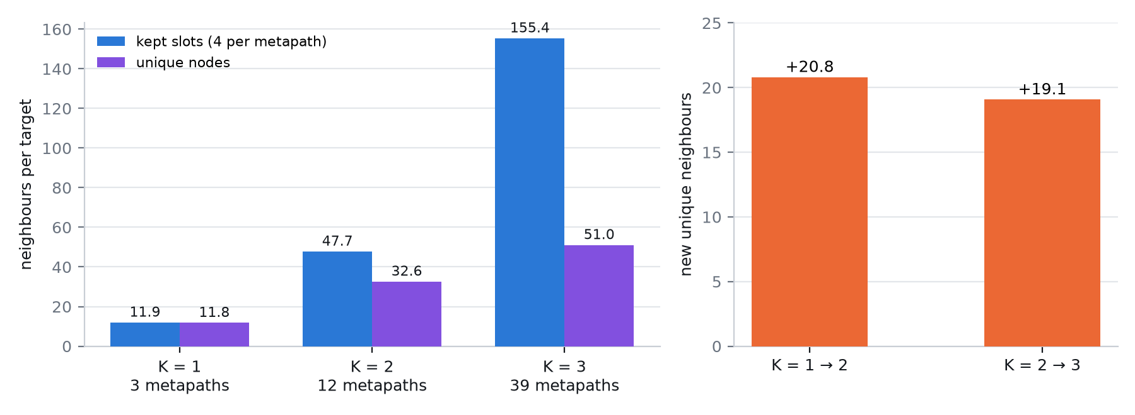
Figure 1. Left: neighbour slots kept and distinct reviews per target (mean over 10,023 targets). Right: new distinct reviews added by each extra hop.
K | Metapaths | Kept slots | Distinct nodes | Repeats | Raw tokens (distinct) | Earlier K inside
K = 1 | 3 | 11.9 | 11.8 | 1.1% | 1,623 | —
K = 2 | 12 | 47.7 | 32.6 | 31.7% | 5,164 | 100%
K = 3 | 39 | 155.4 | 51.0 | 67.2% | 8,978 | 53%
Raw tokens is the length of the distinct neighbour reviews before summarisation, which is what the bi-level summariser has to compress.
Distinct neighbours by path length: at K = 3, 11.8 come from 1-hop paths, 20.8 more from 2-hop paths and 18.4 more from 3-hop paths. The Jaccard overlap of the distinct sets is 0.36 between K = 1 and K = 2 and 0.63 between K = 2 and K = 3, so going from K = 1 to 2 changes the neighbourhood more than going from 2 to 3.
On 2,000 random targets, 37% of the distinct K = 2 neighbours and 25% of the K = 3 neighbours are directly linked to the target by a single RUR, RPR or RSR edge; the rest are reached only through longer paths.

4. Relative to the base, K = 3
K = 3 is the largest and the base here. The table shows how much of it K = 1 and K = 2 reproduce, target by target, then averages over the 10,023 targets.
 | Slots | Distinct | Raw tokens | K = 3 found | K = 3 missing | In K = 3 | Label gap − base [95% CI]
K = 1 | 8% | 23% | 18% | 24% | 39.3 | 100% | +0.022 [0.011, 0.034]
K = 2 | 31% | 64% | 58% | 64% | 19.1 | 98% | +0.002 [-0.004, 0.007]
K = 3 (base) | 100% | 100% | 100% | 100% | 0 | 100% | 0.095 (base)
Slots, distinct and raw tokens are shares of the K = 3 value. K = 3 found is the share of a target’s K = 3 distinct neighbours that this K also keeps; K = 3 missing is the mean number it lacks; In K = 3 is the share of this K’s own neighbours that K = 3 also contains. The label gap is the fraud-target minus benign-target gap of Section 6, with the paired difference to K = 3 from 2,000 bootstrap resamples of the 2,598 train and validation targets.
- K = 1 is a small subset of the base. It holds 8% of the K = 3 slots and 23% of its distinct neighbours, and finds only 24% of the K = 3 neighbourhood (39.3 distinct reviews missing per target). All of its neighbours are also in K = 3.
- K = 2 reproduces about two thirds of the base. It finds 64% of the K = 3 distinct neighbours with 58% of the raw text and misses 19.1 per target; 98% of its neighbours are in K = 3. On 2-hop paths its Top-4 is identical to the K = 3 Top-4 for 86% of selections (Jaccard 0.94); on 1-hop paths the Top-4 is identical at every K (100.00%).
- Against the base, the extra neighbours do not add label signal. The label gap of K = 1 is 0.022 higher than the base (interval excludes zero); K = 2 is 0.002 higher, which the interval [-0.004, 0.007] does not separate from zero. This measures how label-related the neighbours are, not classifier accuracy.

5. Does diffusion pick different neighbours than plain distance?
K | Path | Paths | Candidates | Top-4 identical to raw | Jaccard vs raw | Jaccard vs cosine | Text cosine kept / all
K = 1 | 1-hop | 3 | 89 | 100.0% | 1.00 | 0.83 | 0.968 / 0.944
K = 2 | 1-hop | 3 | 89 | 100.0% | 1.00 | 0.83 | 0.968 / 0.944
K = 2 | 2-hop | 9 | 1,772 | 47.5% | 0.71 | 0.56 | 0.974 / 0.939
K = 3 | 1-hop | 3 | 89 | 100.0% | 1.00 | 0.83 | 0.968 / 0.944
K = 3 | 2-hop | 9 | 1,772 | 46.0% | 0.69 | 0.55 | 0.974 / 0.939
K = 3 | 3-hop | 27 | 9,516 | 35.4% | 0.65 | 0.48 | 0.979 / 0.937
Candidates is the mean number of nodes reachable on the path. Jaccard is the overlap of the two Top-4 sets, averaged over targets and paths. Text cosine kept / all compares the mean cosine of the kept neighbours with that of all candidates.
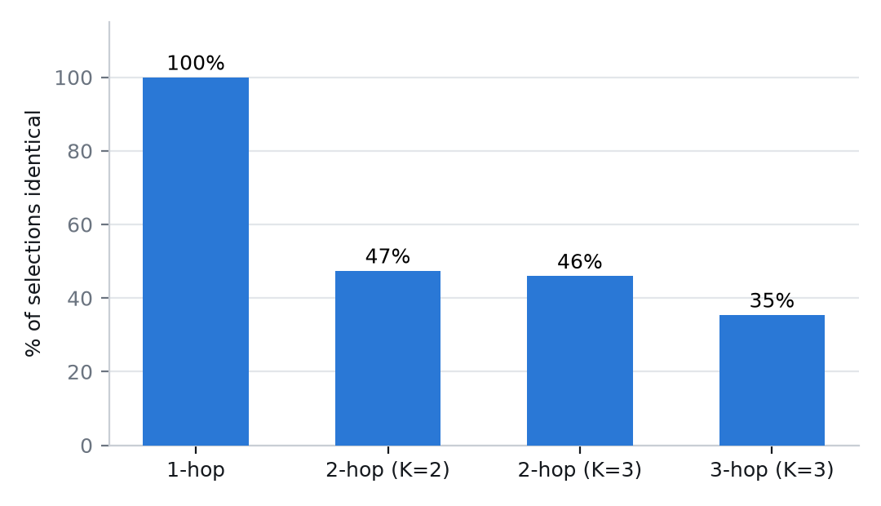
Figure 2. Share of selections where the diffusion Top-4 equals the plain-distance Top-4, by path length.

Why 1-hop paths are unchanged
Each 1-hop relation splits the nodes into disjoint cliques: every review of a product is linked to every other review of that product, and likewise for a user and for a rating-week. On a clique of n nodes, T = D⁻¹A has a closed form, and the diffused difference between two nodes is the raw difference times c_K(n) = |(1/K) Σ (−1/(n−1))^k| (k = 0..K), which depends only on n. Ranking by diffused distance is therefore the same as ranking by raw distance inside a clique. Numerically, the largest relative deviation from this proportionality over 119,000 node pairs is 2.7e-15 at K = 1, 4.2e-15 at K = 2 and 7.6e-15 at K = 3.
Relation | Cliques | Nodes in cliques | Largest clique | Median clique
RUR | 5,130 | 100% | 123 | 6
RPR | 1,685 | 100% | 455 | 10
RSR | 1,363 | 100% | 656 | 7
For RSR, 0.87% of nodes sit in a clique of size 1 and have no same-rating-week neighbours.
The practical consequence: the diffusion step, and the choice of K, affect which neighbours are kept only on composite (2- and 3-hop) paths. On 1-hop paths K = 1, 2 and 3 give the same neighbours, and the Jaccard overlap of each path’s Top-4 across K is 1.00. On 2-hop paths the Top-4 changes little between K = 2 and K = 3 (Jaccard 0.86 to 1.00 across the nine paths).

6. Do the neighbours carry label signal?
Using the 2,598 train and validation targets (306 fraud; base rate 11.8%), the fraud share among a target’s kept neighbour slots (repeated nodes counted each time) was computed separately for fraud and benign targets.
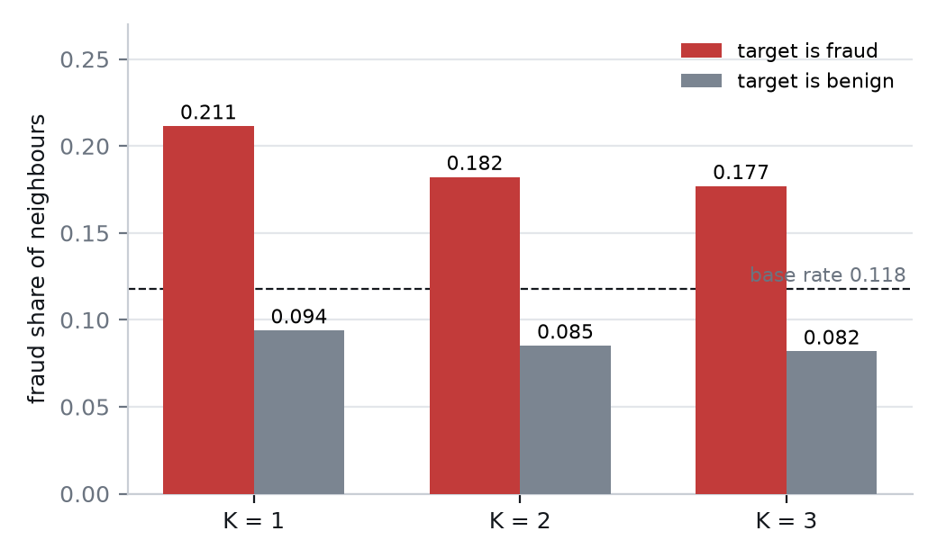
Figure 3. Fraud share of the neighbours, by target class and K. The dashed line is the dataset base rate.
K | Fraud share if target is fraud | Fraud share if target is benign | Gap | 95% interval of the gap
K = 1 | 0.211 | 0.094 | 0.118 | [0.101, 0.135]
K = 2 | 0.182 | 0.085 | 0.097 | [0.084, 0.110]
K = 3 | 0.177 | 0.082 | 0.095 | [0.082, 0.108]
Fraud and benign targets differ at every K, and the gap shrinks from 0.118 to 0.095 as longer paths are added. By path length, the 1-hop neighbours show the largest gap (0.118) and the added 2-hop and 3-hop neighbours a smaller one (0.090 and 0.094), so the longer paths add neighbours that are less label-related on average.

Which selector keeps the most signal
On a fixed sample of 400 train and validation targets (51 fraud), the same candidates were selected four ways and the gap computed for each.
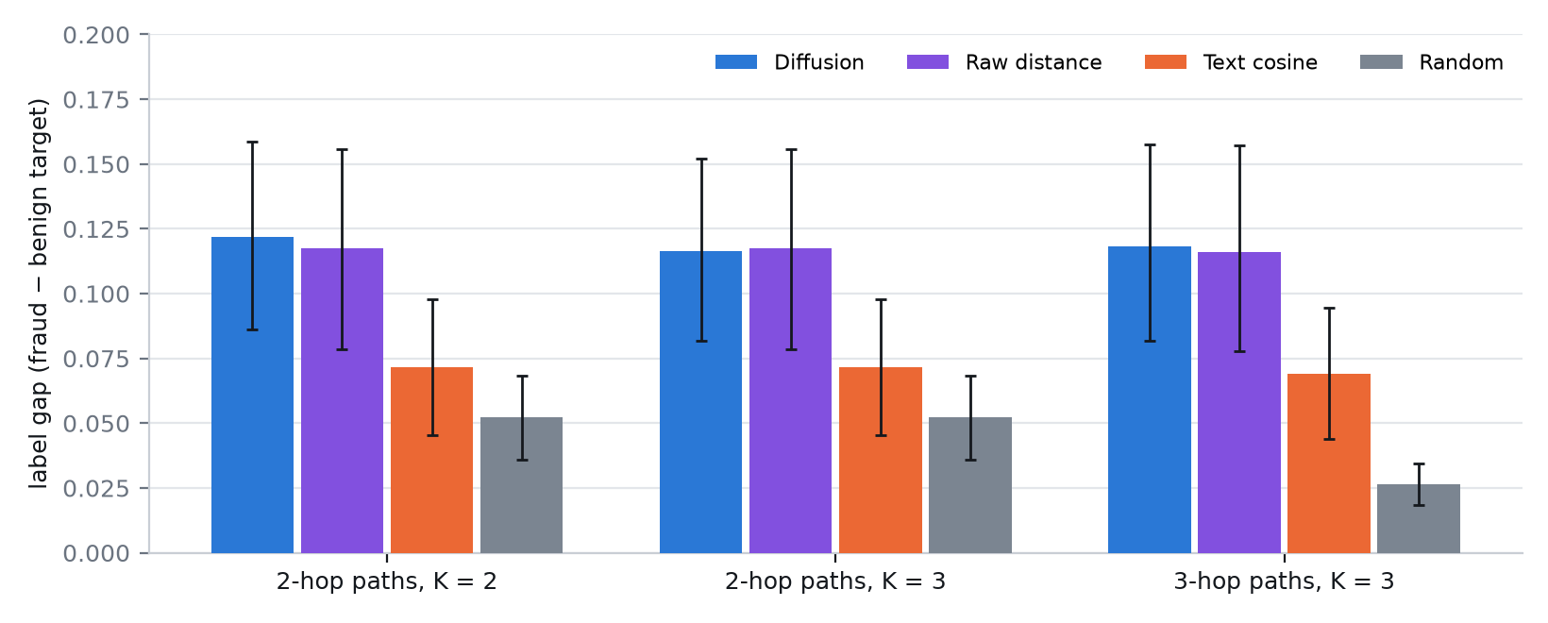
Figure 4. Label gap by selection method, for composite paths. Whiskers are 95% bootstrap intervals.
Selector | 2-hop, K = 2 | 2-hop, K = 3 | 3-hop, K = 3
Diffusion | 0.122 [0.086, 0.159] | 0.117 [0.082, 0.152] | 0.118 [0.082, 0.158]
Raw distance | 0.117 [0.079, 0.156] | 0.117 [0.079, 0.156] | 0.116 [0.078, 0.157]
Text cosine | 0.072 [0.045, 0.098] | 0.072 [0.045, 0.098] | 0.069 [0.044, 0.095]
Random pick | 0.052 [0.036, 0.068] | 0.052 [0.036, 0.068] | 0.026 [0.018, 0.034]
Cells show the gap and its 95% interval. The sample is small, so the intervals are wide: diffusion and raw distance are indistinguishable from each other, higher than a random pick, and higher than text cosine in the point estimate, but the interval of diffusion overlaps that of text cosine.
Selecting by feature distance keeps neighbours that are more label-related than selecting by text cosine. Why is not established here. One guess is that the Euclidean distance also reflects embedding norm and review length, which text cosine ignores; this was not tested.

7. What drives the distance
The feature vector is the 768-dimensional DeBERTa embedding with the star rating appended, unscaled. The mean embedding norm is 27.3 and the rating has a standard deviation of 1.12, so the rating accounts for only 2.1% of the squared distance. Selection is driven by text, and the share of kept neighbours with the same rating as the target is only moderately above the candidate average (for 2-hop paths at K = 2: 64% against 53% among all candidates). Rescaling the rating column would change this; that was not tried.

8. A worked example
Review 9288 (train, fraud, 3 stars) keeps 12, 36 and 66 distinct neighbours at K = 1, 2, 3. At K = 1 its neighbours come only from its user, product and rating-week cliques; K = 2 adds 24 reviews and K = 3 adds 31 more.
Added at | Path | Rank | Stars | Label | Review (first characters)
K = 1 | RUR | 1 | 3 | fraud | I think Gen is right on in her style- I appreciate the ecclectic blen…
K = 1 | RUR | 2 | 3 | benign | Interesting enough. Some of this was new to me, some not, but the sho…
K = 1 | RUR | 3 | 5 | benign | We also love it, when we need to unwind before bed with something soo…
K = 1 | RUR | 4 | 3 | benign | ...it is addicting. It is an unfortunate sociological study into the …
K = 2 | RPR-RSR | 1 | 5 | benign | This series was a real eye opener for me on the colonization of Kenya…
K = 2 | RPR-RSR | 2 | 5 | benign | I love that this is a series with an engaging anti-hero, wonderful ch…
K = 2 | RPR-RSR | 3 | 3 | benign | Good when it started but fading as writers imagination declines. I l…
K = 3 | RPR-RSR-RPR | 1 | 4 | benign | This series is a unique way of presenting a documentary film. The se…
K = 3 | RPR-RSR-RPR | 2 | 4 | benign | This is a short but mostly good ending for a great series, with Monk …
K = 3 | RPR-RSR-RPR | 3 | 3 | benign | Whoever thought two valley girl/ghetto types would ever be saving the…
A sample of the neighbours of this one target; the full lists for four targets are in the dashboard and in neighbors_k123_summary.json. Rank is the position within the metapath’s Top-4.

9. Reading the results
- K matters only through composite paths. Anything that changes with K in the final model comes from the 2- and 3-hop metapaths; the 1-hop neighbours are identical at all K.
- Larger K mostly adds repeats. Going to K = 3 triples the slots but adds only 19 new distinct reviews over K = 2, while raising the raw text to be summarised from about 5,200 to 9,000 tokens.
- Diffusion is not clearly better than plain distance. Both give the same label gap; diffusion is a different selection on about half of composite selections but not a more informative one on this sample.

Limits
- One dataset (AmazonVideo) and one feature set. The label-signal comparison between selectors uses 400 targets with 51 fraud; its intervals are wide.
- The fraud share of neighbours is a descriptive measure of label relatedness, not a prediction of classifier accuracy. The classifier results were not part of this analysis.
- The explanation for why distance-based selection beats text cosine on label signal is a hypothesis and was not tested.

