DGP-REPRODUCE · AMAZONVIDEO · RUNS OF 2026-10-15 TO 2026-10-16
Discriminative and residual text in DGP, FLAG style
Results of the dr_* study: four variants, five seeds each, against a baseline re-run on the same software stack.
Prepared 2026-10-17 from results/raw/dr_*, results/aggregated/dr_*.json and results/disc_resid/text_diagnostics.json. Metrics are test-set percentages; ± is the standard deviation over seeds (ddof = 0), as in the main README.

Summary
Adding FLAG-style discriminative text (and, in two variants, FLAG’s residual branch loss) to DGP moves every metric by less than about half a point. The ranking metric AUROC rises by 0.21 to 0.45 on all five seeds for every variant; the precision metric AUPRC does not change; Macro-F1 is mixed and gets noisier when the residual loss is used. No variant closes the gap to the paper.
Update 2026-11-04: This study is E6–E8 of the DGP experiment log (reports/2026-10-23-DGP-experiment-log.docx). Later studies found larger levers: Gemma-2-9B-it in place of Qwen3-8B raised AUPRC by about 2 points in every arm (E11), mostly as the classifier rather than as the text writer (E14, E18); and on YelpChi the paper's validation-loss stopping rule, not the text, is the main gap to the paper (E19). The numbers in this report are unchanged and re-tested in the seed-level standard (results/stats/all_comparisons.md): no dr variant survives the Holm correction.
- AUROC. Higher than R0 on 5 of 5 seeds for all four variants (+0.21 to +0.45). Only R1b has a 95% interval that excludes zero (+0.11 to +0.80). The September-to-R0 stack difference is already +0.10, so the effect is small.
- AUPRC. Between 0.00 and +0.15 on average, with the sign flipping across seeds. No gain.
- Macro-F1. R1b is best (65.33 against 64.74). R2 is lowest (64.28) with a standard deviation of 2.60 against 0.45 for R0, driven by seed 3.
- No-verdict prompt. FLAG’s own prompt makes the line a class verdict (9,258 of 10,023 lines name a class). Forbidding the verdict cuts that to 26 lines and keeps most of the text’s standalone signal. R1b is ahead of R1 on F1 and AUROC, within seed noise.
- Residual loss. R2 and R2b cost about 14% more wall time than R0 (1.17 h against 1.03 h per seed) and do not improve accuracy. The earlier extension arms E1 and E2 showed the same pattern.

1. What was tested
Every run uses the main DGP configuration (K = 2, M = 4, B = 10, Qwen3-8B with LoRA rank 8) and the same five seeds. Only the target review’s part of the prompt or the loss changes. The discriminative and residual lines are FLAG’s causal and non-causal prompts (BUPT-GAMMA/FLAG chat.py), adapted to one AmazonVideo review at a time and generated by Qwen3-8B at 40 tokens. The label never appears in a prompt. In this dataset “fraud” means an unhelpful review.
Run | Discriminative line in the prompt | Residual branch loss
R0 | None (original DGP prompt) | None
R1 | FLAG’s prompt as published (the line often states a verdict) | None
R1b | R1 plus “describe the cues only; do not state a verdict” | None
R2 | As R1 | KL to uniform + squared cosine, α = β = 0.1
R2b | As R1b | As R2
R0 is the September configuration re-run on this instance’s stack (torch 2.14, transformers 5.19). All comparisons below are against R0, seed by seed.

2. Base results
Run | Macro-F1 | AUROC | AUPRC
September baseline | 65.16 ± 0.52 | 75.07 ± 0.50 | 32.33 ± 0.65
R0 (re-run) | 64.74 ± 0.45 | 74.97 ± 0.51 | 32.37 ± 0.57
R1 | 64.79 ± 1.30 | 75.18 ± 0.56 | 32.42 ± 1.17
R1b | 65.33 ± 0.78 | 75.42 ± 0.58 | 32.41 ± 0.80
R2 | 64.28 ± 2.60 | 75.23 ± 0.47 | 32.52 ± 0.96
R2b | 64.78 ± 1.44 | 75.24 ± 0.51 | 32.37 ± 0.79
Paper (reported) | 66.91 ± 0.13 | 77.32 ± 0.11 | 34.63 ± 0.24
Macro-F1 uses the threshold that maximises validation F1. At a fixed 0.5 threshold it is far lower for every run (about 51 to 53), as in the main reproduction.

Per-seed results
Figure 1 shows every seed. The spread between seeds is as large as most differences between runs.
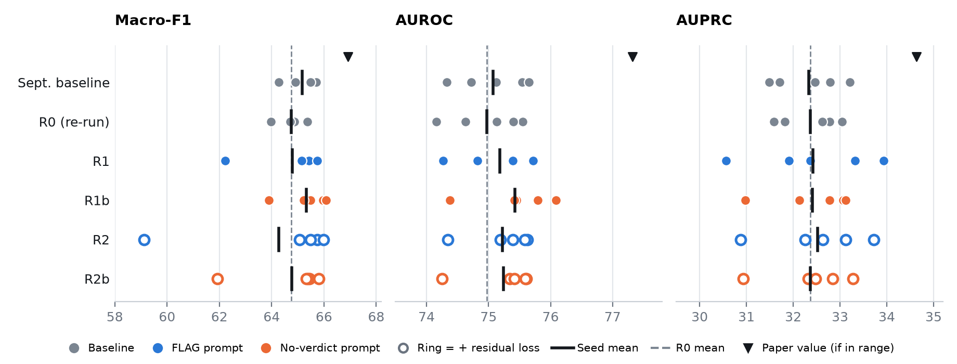
Figure 1. Test metrics for each of the five seeds. Ticks are seed means; the dashed line is the R0 mean. R2’s seed-3 Macro-F1 (59.12) is the lowest point in the study.
AUROC by seed | Seed 0 | Seed 1 | Seed 2 | Seed 3 | Seed 4
September | 75.13 | 75.54 | 74.72 | 74.33 | 75.65
R0 | 75.13 | 75.55 | 74.63 | 74.16 | 75.40
R1 | 75.39 | 75.71 | 74.82 | 74.27 | 75.72
R1b | 75.45 | 76.08 | 75.41 | 74.37 | 75.80
R2 | 75.19 | 75.62 | 75.39 | 74.34 | 75.58
R2b | 75.34 | 75.61 | 75.42 | 74.25 | 75.59

Macro-F1 by seed | Seed 0 | Seed 1 | Seed 2 | Seed 3 | Seed 4
September | 65.7 | 64.9 | 64.3 | 65.5 | 65.5
R0 | 64.8 | 65.4 | 64.0 | 64.9 | 64.7
R1 | 65.4 | 65.4 | 65.2 | 62.2 | 65.7
R1b | 66.0 | 66.1 | 65.5 | 63.9 | 65.2
R2 | 65.1 | 65.8 | 65.5 | 59.1 | 66.0
R2b | 65.4 | 65.8 | 65.4 | 61.9 | 65.3

AUPRC by seed | Seed 0 | Seed 1 | Seed 2 | Seed 3 | Seed 4
September | 32.8 | 32.5 | 31.7 | 31.5 | 33.2
R0 | 32.8 | 33.0 | 31.8 | 31.6 | 32.6
R1 | 32.4 | 33.9 | 31.9 | 30.6 | 33.3
R1b | 33.1 | 33.1 | 32.1 | 31.0 | 32.8
R2 | 32.6 | 33.7 | 32.3 | 30.9 | 33.1
R2b | 32.3 | 33.3 | 32.5 | 30.9 | 32.8

3. Paired change against R0
Each difference is the run minus R0 on the same seed and split. The shaded bars in Figure 2 are 95% bootstrap intervals of the seed-averaged difference, from 1,000 resamples of the 7,425 test reviews. They capture test-set sampling only, not variation between training runs. Macro-F1 has no interval because its threshold is re-selected for every run.
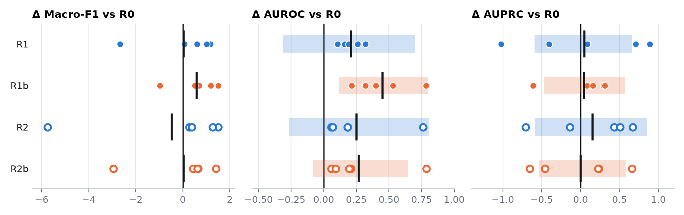
Figure 2. Per-seed differences from R0 (dots), their mean (tick) and the 95% interval (bar).
Run vs R0 | Δ Macro-F1 (seeds up) | Δ AUROC (seeds up) | 95% interval | Δ AUPRC (seeds up) | 95% interval | Label agree.
R1 | +0.04 (4/5) | +0.21 (5/5) | [−0.31, +0.70] | +0.05 (3/5) | [−0.59, +0.67] | 94.8%
R1b | +0.58 (4/5) | +0.45 (5/5) | [+0.11, +0.80] | +0.04 (4/5) | [−0.47, +0.57] | 95.8%
R2 | −0.47 (4/5) | +0.25 (5/5) | [−0.26, +0.80] | +0.15 (3/5) | [−0.58, +0.86] | 94.5%
R2b | +0.03 (4/5) | +0.27 (5/5) | [−0.09, +0.65] | +0.00 (3/5) | [−0.54, +0.58] | 92.8%
Sept. vs R0 | +0.42 | +0.10 | [−0.08, +0.29] | −0.04 | [−0.29, +0.20] | 94.6%
“Seeds up” counts the seeds on which the run beats R0. The last row is the original September run minus R0 and shows the size of the difference between two runs of the same configuration on different stacks. Label agreement is the share of test reviews that get the same predicted label as R0 at each run’s own threshold. With four variants and two ranking metrics, a single interval that excludes zero is weak evidence.

4. What the generated text carries
To check the text itself, a TF-IDF logistic regression reads only the generated line and predicts the label. It is trained and scored with 5-fold cross-validation on the 2,598 train and validation reviews (11.78% positive); test reviews are not used.
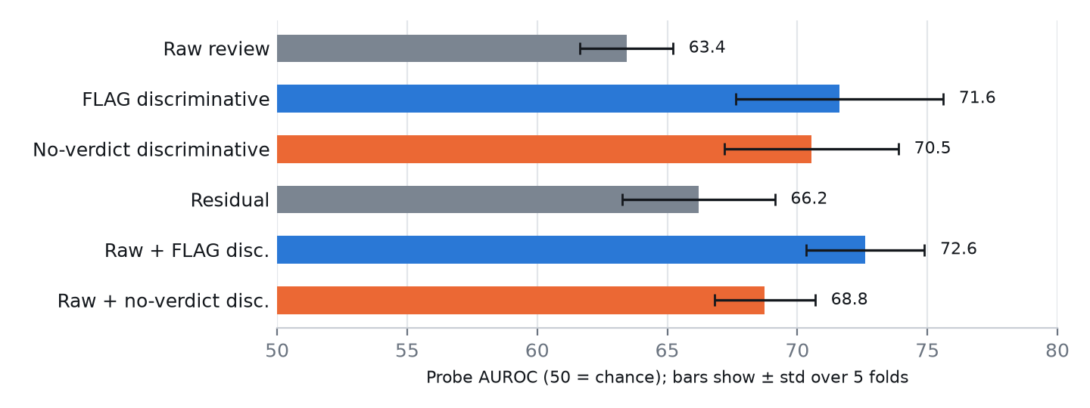
Figure 3. Probe AUROC by input text. Whiskers are the standard deviation over folds.
Generated text | Tokens mean / p95 | Lines naming a class | Overlap with raw | Probe AUROC | Probe AUPRC
Raw review | — | — | — | 63.4 ± 1.8 | 21.9 ± 3.0
FLAG discriminative | 30.7 / 41 | 9,258 | 0.091 | 71.6 ± 4.0 | 30.5 ± 4.5
No-verdict discriminative | 26.7 / 40 | 26 | 0.160 | 70.5 ± 3.4 | 26.6 ± 5.0
Residual | 22.6 / 37 | 1 | 0.182 | 66.2 ± 2.9 | 24.9 ± 4.1
Raw + FLAG disc. | — | — | — | 72.6 ± 2.3 | 30.3 ± 3.9
Raw + no-verdict disc. | — | — | — | 68.8 ± 1.9 | 25.9 ± 4.4
Coverage is 10,023 of 10,023 targets for every text, with no empty lines. FLAG’s line says “unhelpful” for 52.0% of positive and 18.5% of negative reviews in train + validation. In the pilot, 188 of 200 FLAG lines were class verdicts, 65% accurate on a 50/50 sample. The probe is trained on only 306 positive reviews, so its intervals are wide.
On its own, the FLAG line is a much better predictor than the raw review (AUROC 71.6 against 63.4), but that is mostly the verdict. DGP’s classifier already reads the raw review and the neighbour summaries, so the extra line adds little in the end.

5. Cost
Run | Prompt tokens mean / p95 / max | Wall time per seed | Peak GPU memory
R0 | 782 / 1206 / 1902 | 1.03 h | 19.7 GB
R1 | 815 / 1245 / 1981 | 1.08 h | 19.8 GB
R1b | 811 / 1244 / 1981 | 1.07 h | 19.8 GB
R2 | 815 / 1245 / 1981 | 1.17 h | 19.9 GB
R2b | 811 / 1244 / 1981 | 1.17 h | 19.9 GB
Wall time is the mean runtime_seconds of the five run manifests. All runs fit comfortably on one A100 80GB.

6. Reading the results
- The effect is real in sign and small in size. AUROC improves on every seed for every variant, but by 0.2 to 0.45 points. With five seeds and a stack difference of 0.10 between two runs of the same configuration, this does not support a claim of improvement.
- The text helps ranking, not precision. AUPRC is flat, so the ordering of the highest-scored reviews does not improve.
- Do not let the line state a verdict. FLAG’s prompt produces a class guess that was 65% accurate in the pilot. R1b is the best variant, but its margin over R1 is inside seed noise.
- The residual branch is not worth it here. It adds variance in Macro-F1 and about 14% training time, and the AUROC it reaches matches the variants without it.

Limits
- One dataset (AmazonVideo), five seeds, no hyperparameter search. None of these variants approaches the paper (66.91 / 77.32 / 34.63).
- Seed 3 is where Macro-F1 breaks down: R1, R2 and R2b are 2.7, 5.8 and 3.0 points below R0 there, while AUROC on that seed still rises. Macro-F1 depends on a threshold chosen on 1,299 validation reviews, so it is the least stable metric here. The cause was not traced.
- These runs use new dr_* prompts and caches and do not reuse the earlier extension study (arms B, C, D, E1, E2), so the two studies should not be pooled.
- results/disc_resid/deviation.md was written mid-run and covers only R0 seeds 0 to 1 and one seed of each variant. The numbers in this report come from all 25 finished runs. The main README has no section for this study yet, and the study’s files are not committed.

