README

Please follow the following steps to execute the project:

- Download and unzip the folder
- Open terminal and navigate to the location of the project folder.
- Execute the below commands one-by-one:
  - npm install
  - json-server --watch db.json --port 4000
  - npm start

Now, open the browser, go to http://localhost:3000/ and you should see the application up and running at this location.

Below are some of the screenshots of the application pages

Home Page:

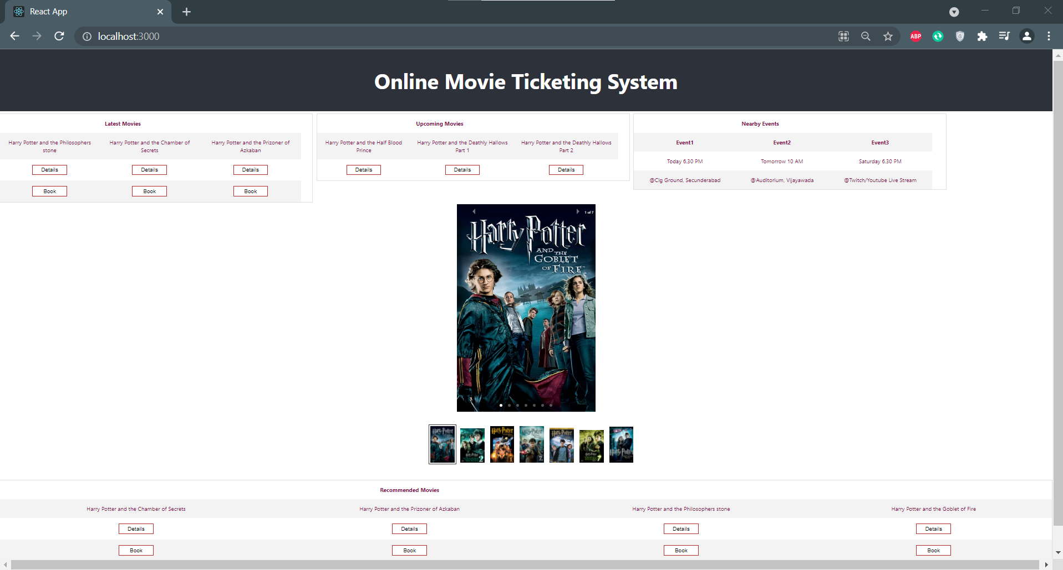

Details Page:

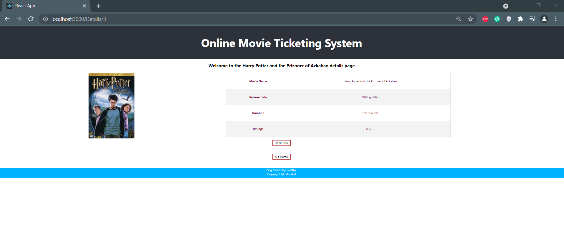
Ticket Booking Page:

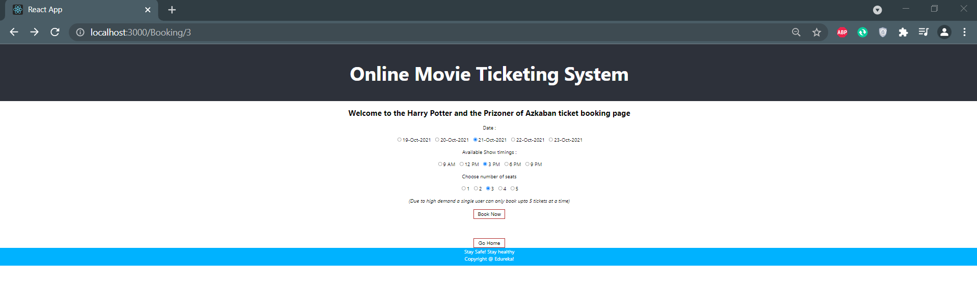

Ticket Confirmation Page:

