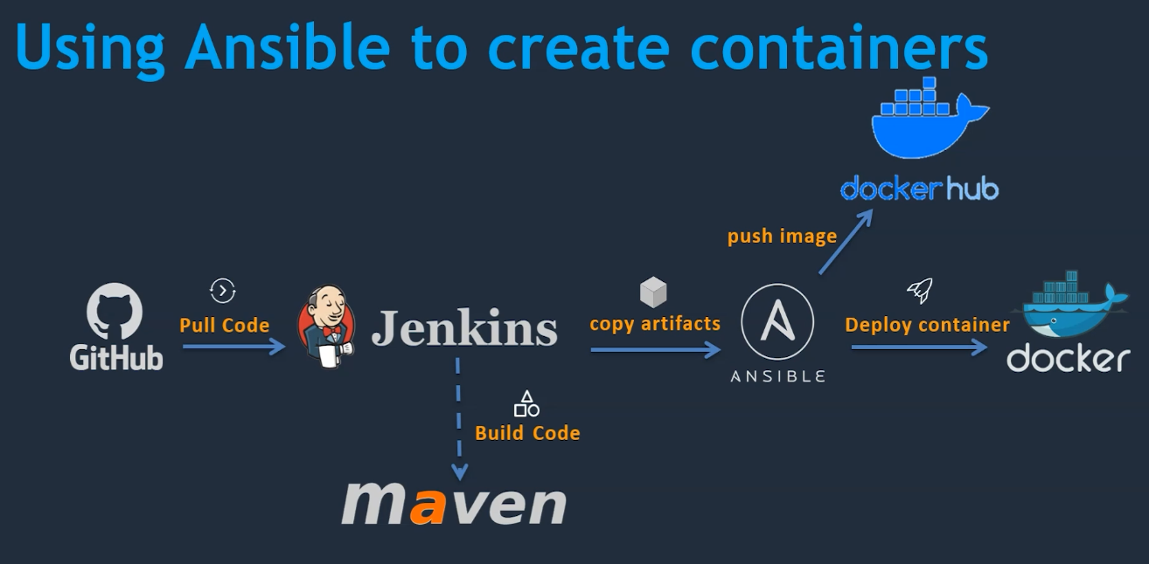

**Ansible Control Node - Setup**

* Setup EC2 Instance
* Setup Hostname
* Create ansadmin user
* Add user to sudoers file
* Generate ssh keys
* Enable Password Based Login
* Install Ansible

**Login to Server - Change the hostname**

vi /etc/hostname

ansible-server

**Create a User**

useradd ansadmin

passwd ansadmin

**Add User to Sudoer file**

## Same thing without a password

ansadmin ALL=(ALL) NOPASSWD: ALL

**Enable Password Based Authentication**

vim /etc/ssh/sshd_config

PasswordAuthentication yes

service sshd reload

**Generate SSH Keys – Login to the user**

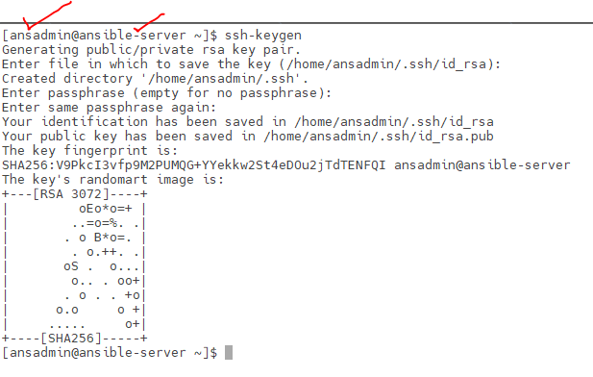

**Install Ansible - Redhat**

python --version

sudo dnf install -y ansible-core

dnf list ansible-core

dnf info ansible-core

ansible --version

**Install Anible – Amazon AMI**

sudo yum install update -y

amazon-linux-extras install ansible2

ansible --version

python --version

**Add Docker Host as a Managed Node**

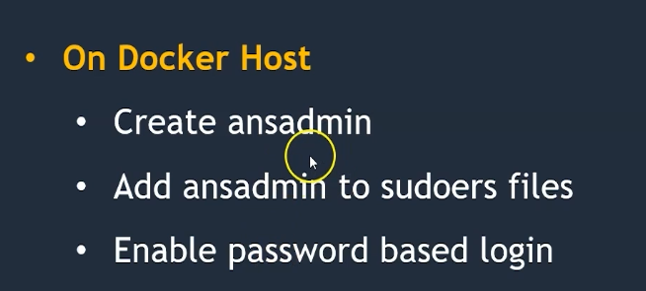

**Create a User**

adduser ansadmin

**Add user to sudo Group**

usermod -aG sudo ansadmin

**Check if PasswordAuthentication is yes**

grep Password /etc/ssh/sshd_config

**Login to Ansible Server – Add Dockerhost as a manged node in the inventory**

sudo su

vi /etc/ansible/hosts

10.100.1.70

**Copy the Public Key to Manged Node - Dockerhost**

su ansadmin

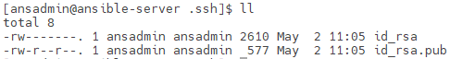

**Docker Host – Private IP**

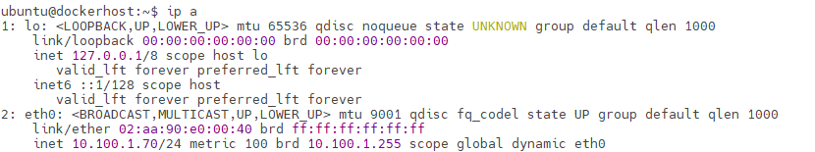

ssh-copy-id 10.100.1.70

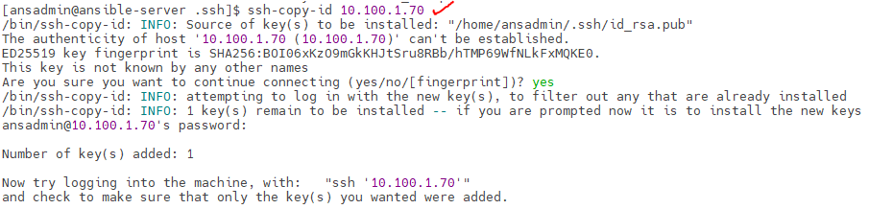

Public Key Copied – If private key copied – Any user can login with the username ansadmin in the ansible server. So keep it safe

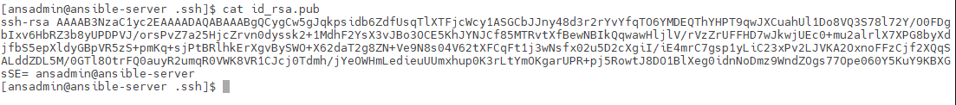

**Check & Login to ansadmin in dockerhost**

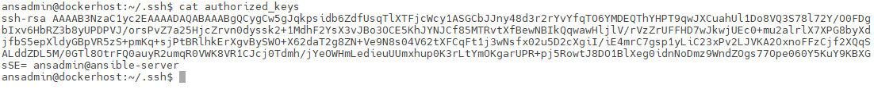

**Keys are Matching in ansadmin in ansible-server and ansadmin dockerhost**

**Own Ansible Host will be unable to communicate.**

* We need to add ssh key for self

ssh-copy-id 10.100.1.177

Check if the connection successful between controller and managed

ansible all -m ping

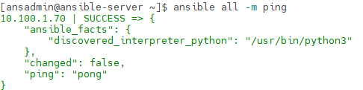

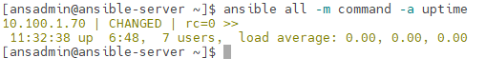

**Integrating Ansible with Jenkins**



Create a user

Allow PasswordAuthentication

Install Publish over SSH Plugin

Configure the system and Add Ansible System

* First three are already completed – Complete the fourth step

**Login to Jenkins**

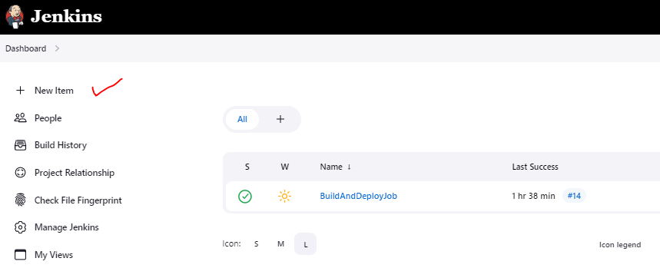

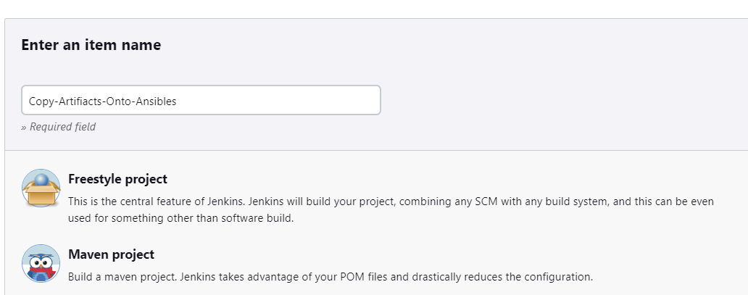

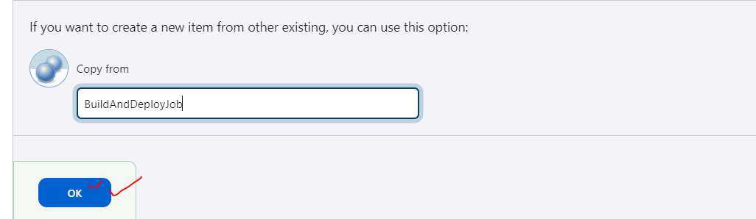

**Get to manage Jenkins -> System ->**

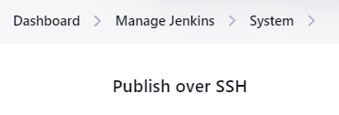

**Configure the server to connect over ssh**

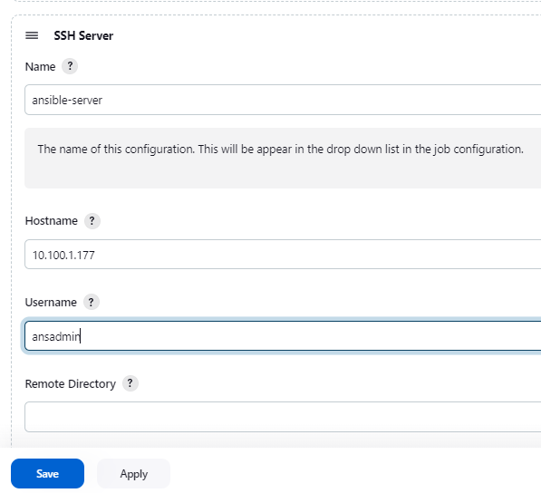

**Provide Anible Server – ansadmin password**

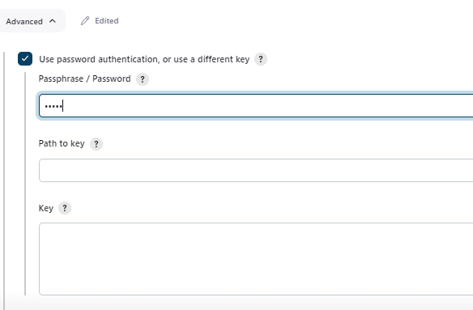

Create a New Job

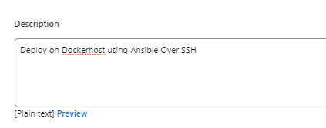

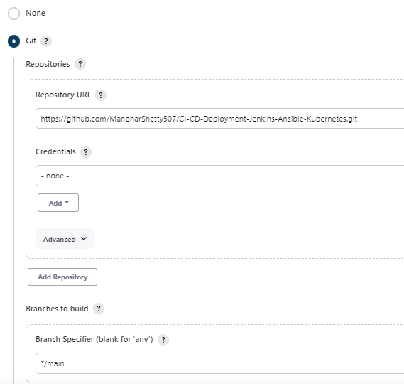

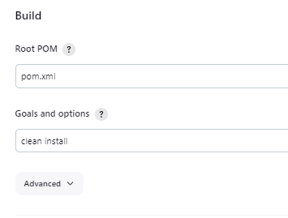

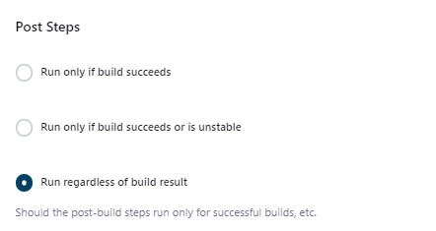

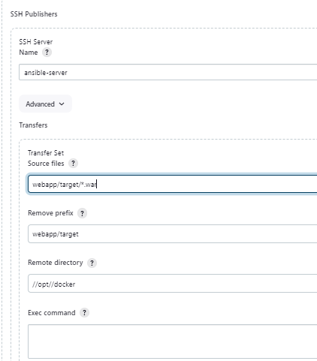

//opt/docker folder is not available on Ansible

cd /opt/

mkdir docker

sudo chown ansadmin:ansadmin docker

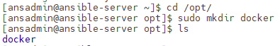

**Run the Pipeline**

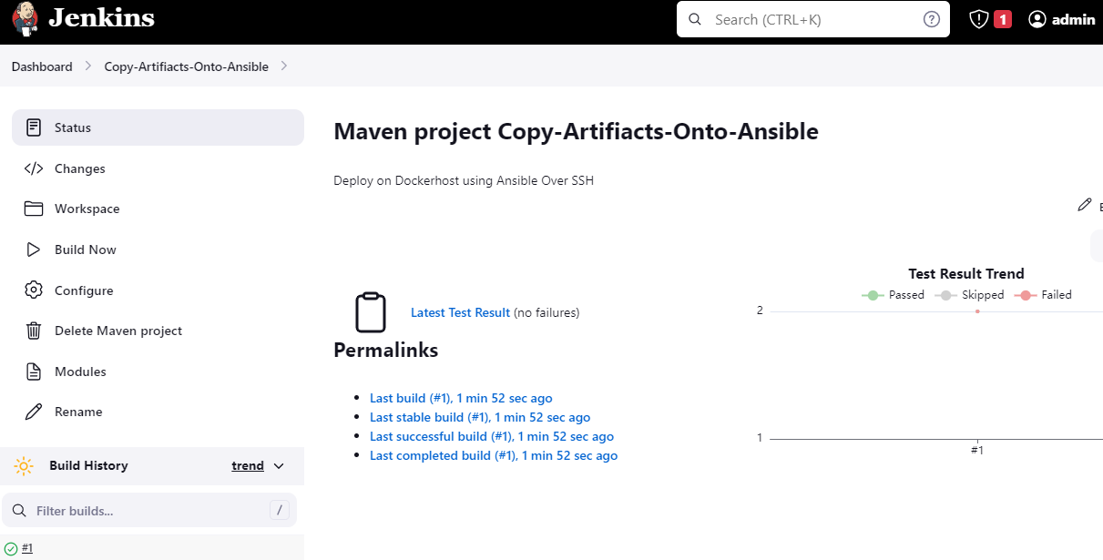

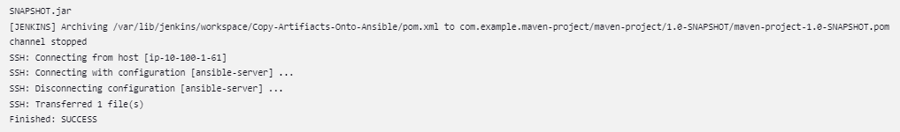

**War file created in Ansible**

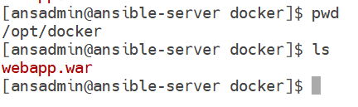

**Create a Docker Image and Run Containers on Ansible Server**

**Install Docker**

sudo yum install docker -y

**Add ansadmin to docker group – No Docker Group Found in Redhat**

cat /etc/passwd

cat /etc/group

sudo usermod -aG docker ansadmin

**Add Hosts to Ansible Inventory**

vim /etc/ansible/hosts

[dockerhost]

10.100.1.70

[ansible]

10.100.1.177

**Check if ansible is able to communicate**

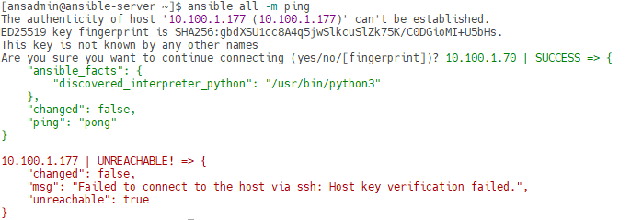

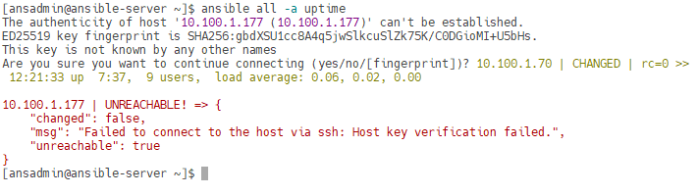

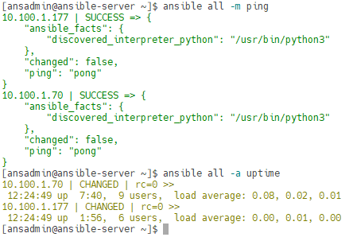

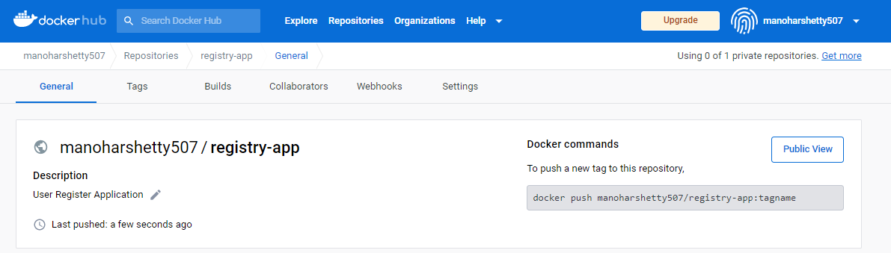

* Create Ansible Playbook – Create Docker Image and Push to Dockerhub

cd /opt/docker

vim register-app.yaml

---

- hosts: ansible

tasks:

- name: Create Docker Image

command: docker build -t registry-app:latest .

args:

chdir: /opt/docker

- name: Create Tag to Push Image into Dockerhub

command: docker tag registry-app:latest manoharshetty507/registry-app:latest

- name: Push Image to Dockerhub

command: docker push manoharshetty507/registry-app:latest

**Limit the playbook to specific IP or localhost**

ansible-playbook register-app.yaml --limit localhost

**Update the Jenkins Configuration**

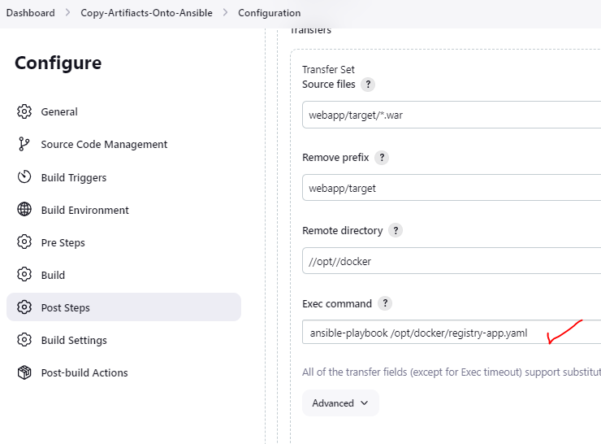

Run the Pipeline

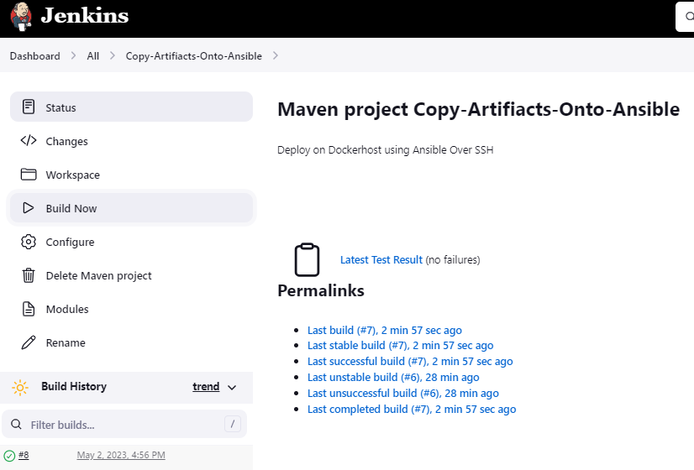

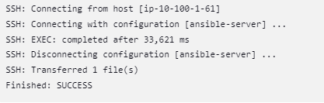

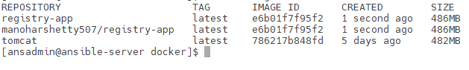

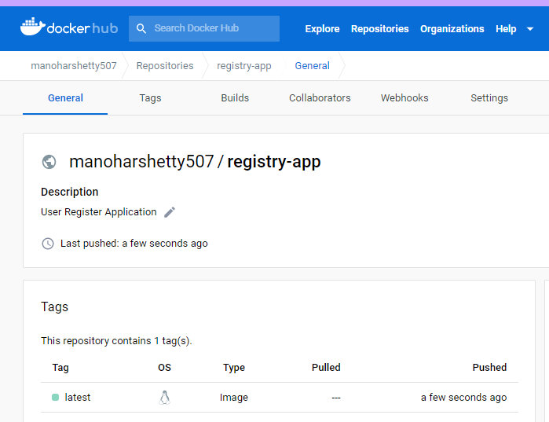

Jenkins -> Triggers the Pipeline -> Artifacts will be created and Copied to the Ansible Server - Ansible -> Creates and Push the Container Image -> Using the same ansible server -> Deployment will happen of application -> Dockerhost -> Ansible will deploy the application on docker host

**Deploy the Images to Docker Host**

**Ansible – Playbook for Pulling the image and running the container**

cd /opt/docker

vi docker-deployment.yaml

---

- hosts: dockerhost

tasks:

- name: stop existing container

command: docker stop registeration-app

ignore_errors: yes

- name: remove the container

command: docker rm registeration-app

ignore_errors: yes

- name: docker remove image

command: docker rmi manoharshetty507/registry-app:latest

ignore_errors: yes

- name: Create a Container

command: docker run -d --name registeration-app -p 8082:8080 manoharshetty507/registry-app:latest

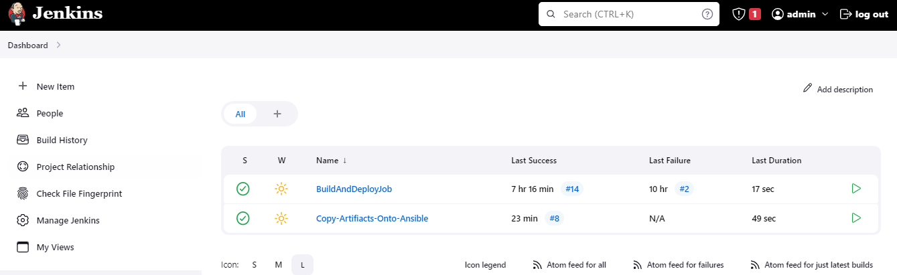

Add Configuration for running Ansible Playbook for Dockerhost – Pull the image and run the container

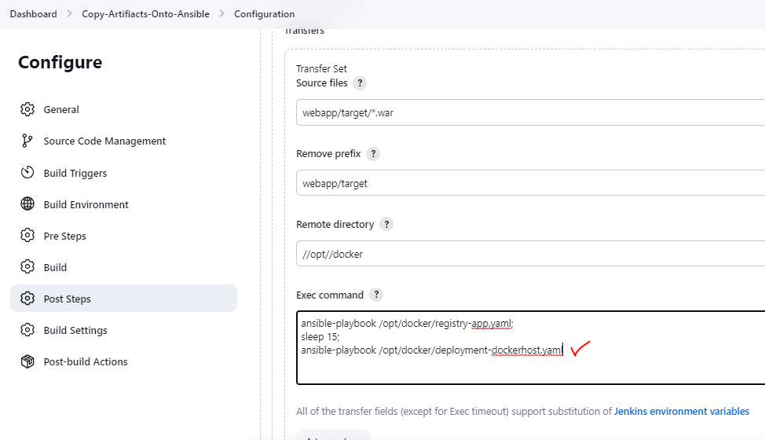

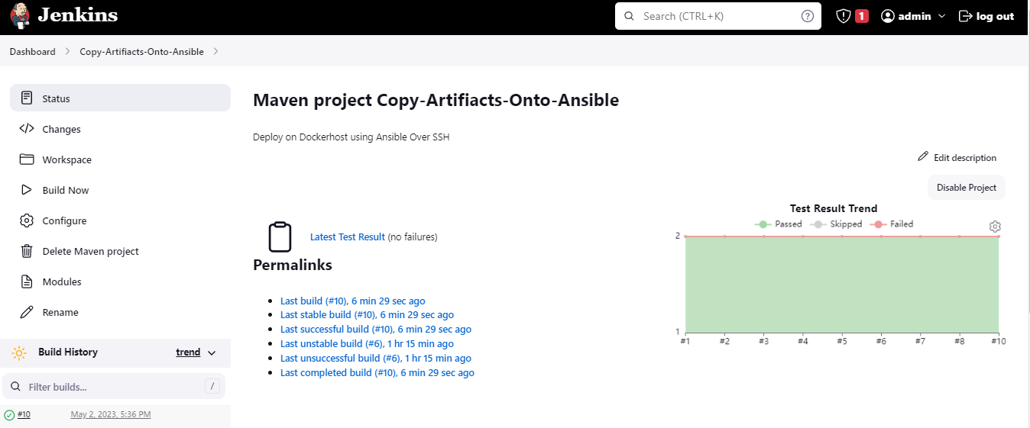

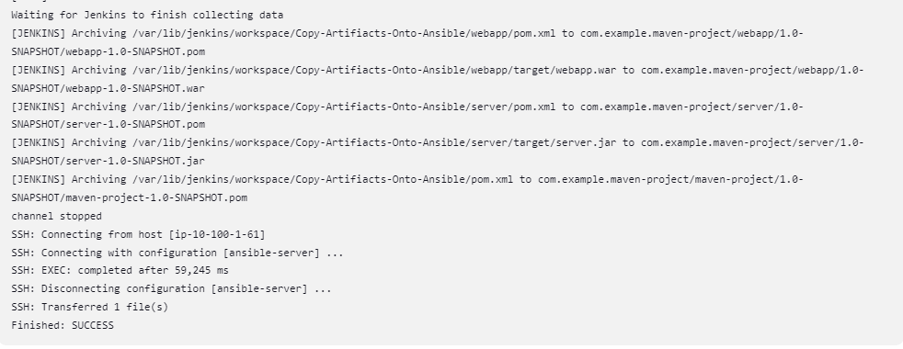

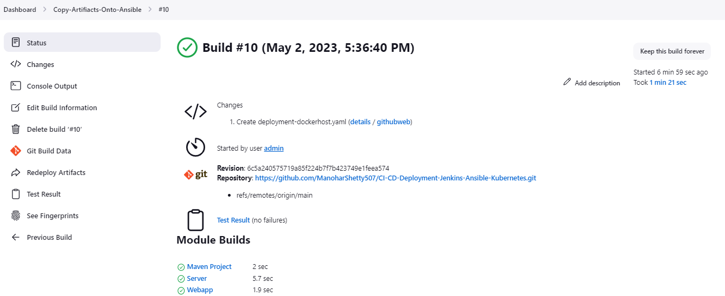

**Ansible Server – Artifacts Build and Copied by Jenkins – Container Image Build and Pushed to Dockerhub**

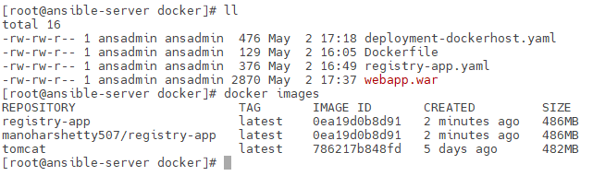

**Docker Host – Pulled Image from Dockerhub and run the container**

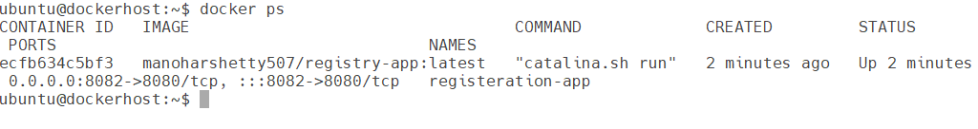

**Access the Browser**

