**Install Git**

sudo apt-get install git -y

**Install Java**

sudo apt update

sudo apt install openjdk-11-jre

java -version

**Install Jenkins**

curl -fsSL https://pkg.jenkins.io/debian/jenkins.io-2023.key | sudo tee \

/usr/share/keyrings/jenkins-keyring.asc **>** /dev/null

echo deb **[**signed-by**=**/usr/share/keyrings/jenkins-keyring.asc] \

https://pkg.jenkins.io/debian binary/ | sudo tee \

/etc/apt/sources.list.d/jenkins.list **>** /dev/null

sudo apt-get update

sudo apt-get install jenkins

**Set Up Maven in the Server**

$ wget https://mirrors.estointernet.in/apache/maven/maven-3/3.6.3/binaries/apache-maven-3.6.3-bin.tar.gz

$ tar -xvf apache-maven-3.6.3-bin.tar.gz

$ mv apache-maven-3.6.3 /opt/

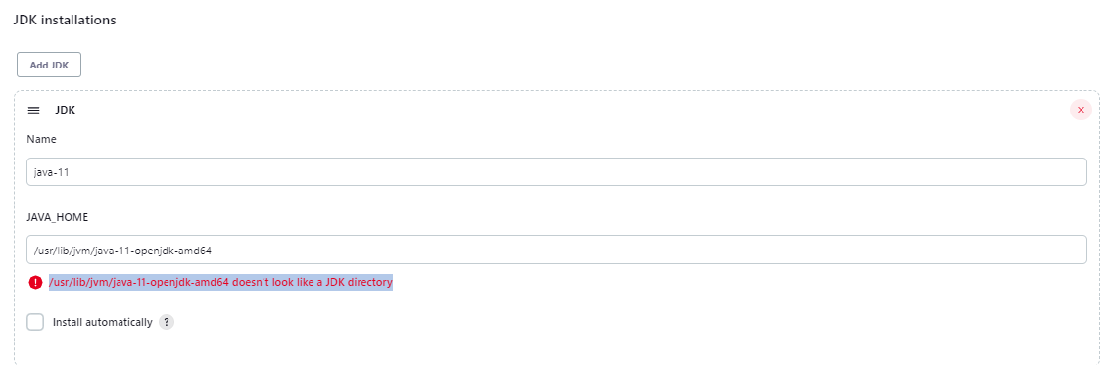

Leave this error like that

**Set Up Path for Java**

find / -name jvm

find / -name java-11*

export JAVA_HOME=/usr/lib/jvm/java-11-openjdk-amd64

echo $JAVA_HOME

export PATH=$PATH:$JAVA_HOME/bin

echo $PATH

**Setup M2_HOME and Path Variables**

M2_HOME='/opt/apache-maven-3.6.3'

PATH="$M2_HOME/bin:$PATH"

export PATH

**Add Maven Plugin and Integrate it with Jenkins**

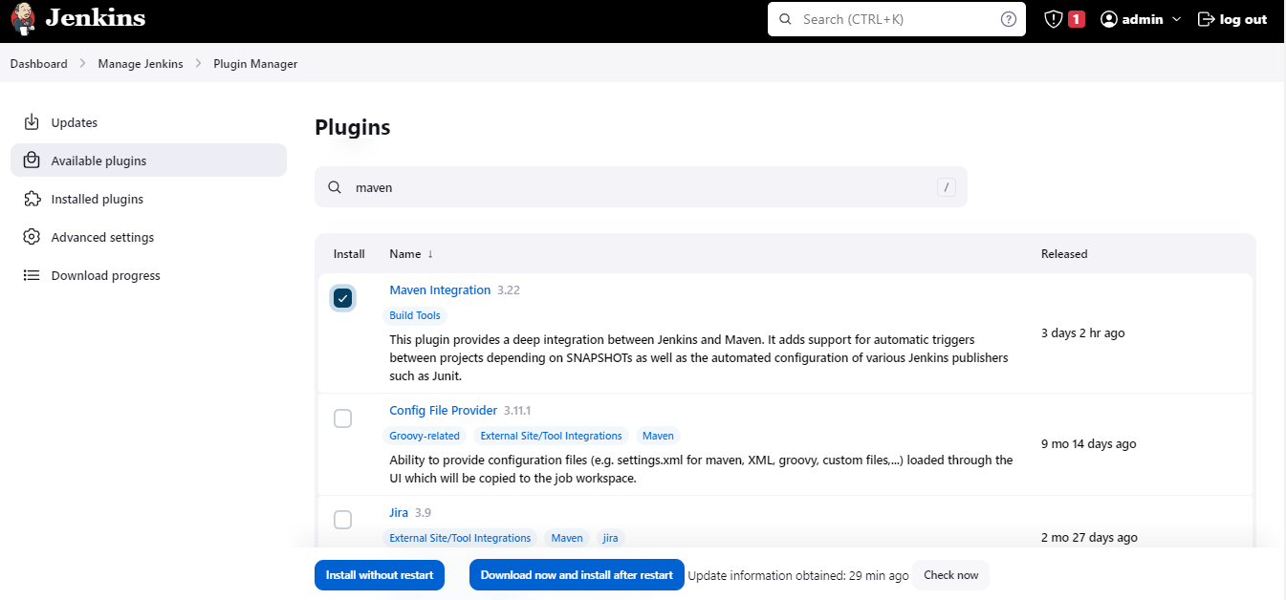

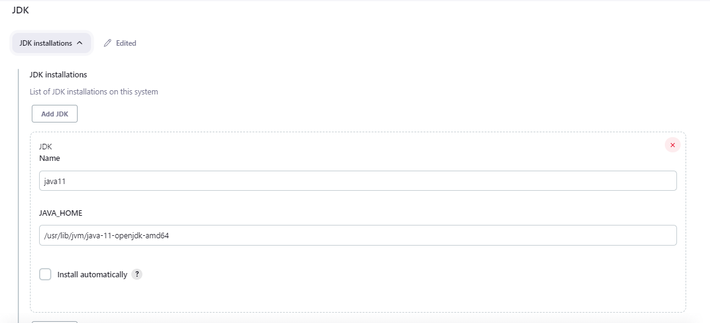

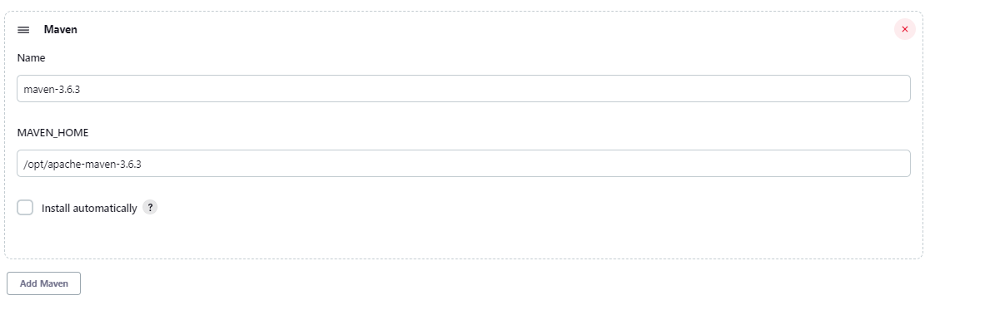

**Create New Item – Maven Project**

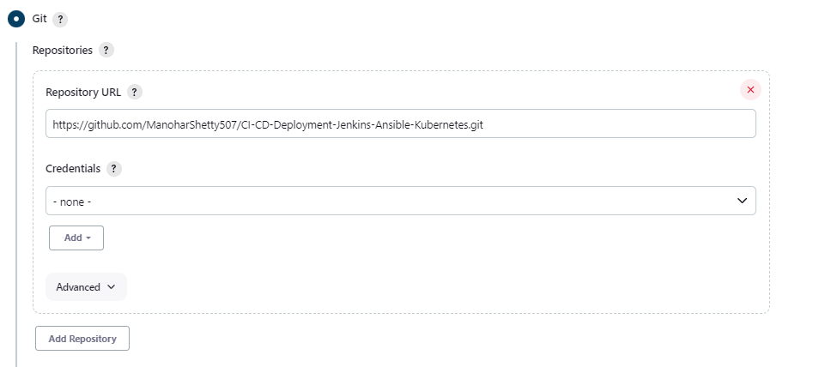

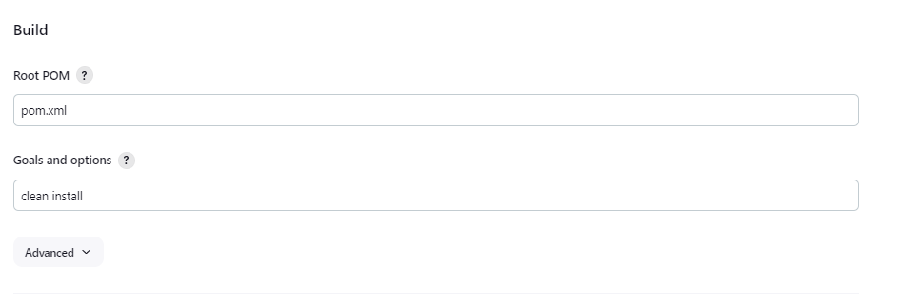

Build the Maven Project

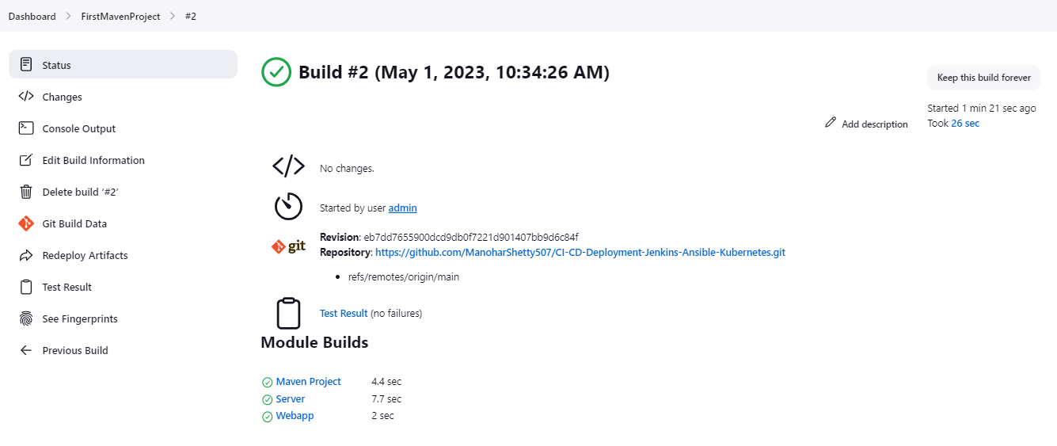

War File Saved

/var/lib/jenkins/workspace/FirstMavenProject/webapp/target

**We will Deploy the War file on the Tomcat Server - Install Tomcat**

<https://www.digitalocean.com/community/tutorials/how-to-install-apache-tomcat-10-on-ubuntu-20-04>

wget <https://dlcdn.apache.org/tomcat/tomcat-9/v9.0.74/bin/apache-tomcat-9.0.74.tar.gz>

**Integrate Tomcat with Jenkins**

Add Plugin – Deploy to Container

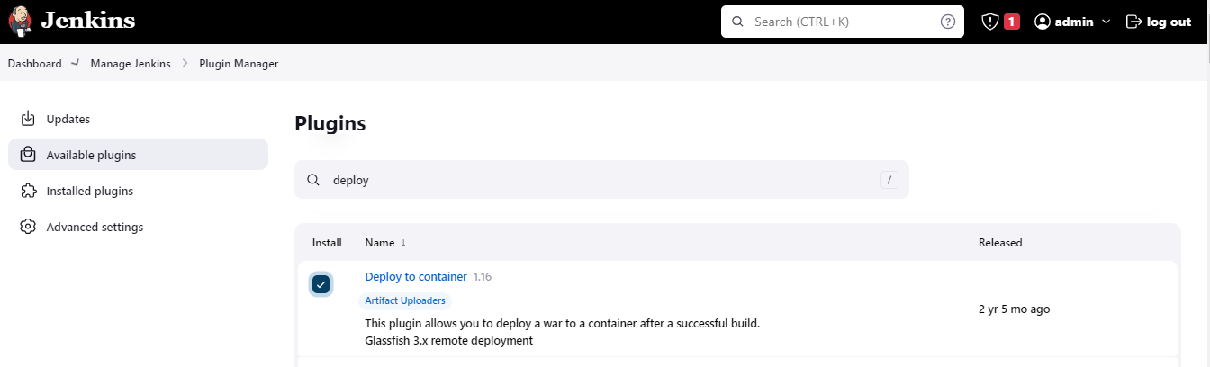

**Add Tomcat Credentials for Authentication**

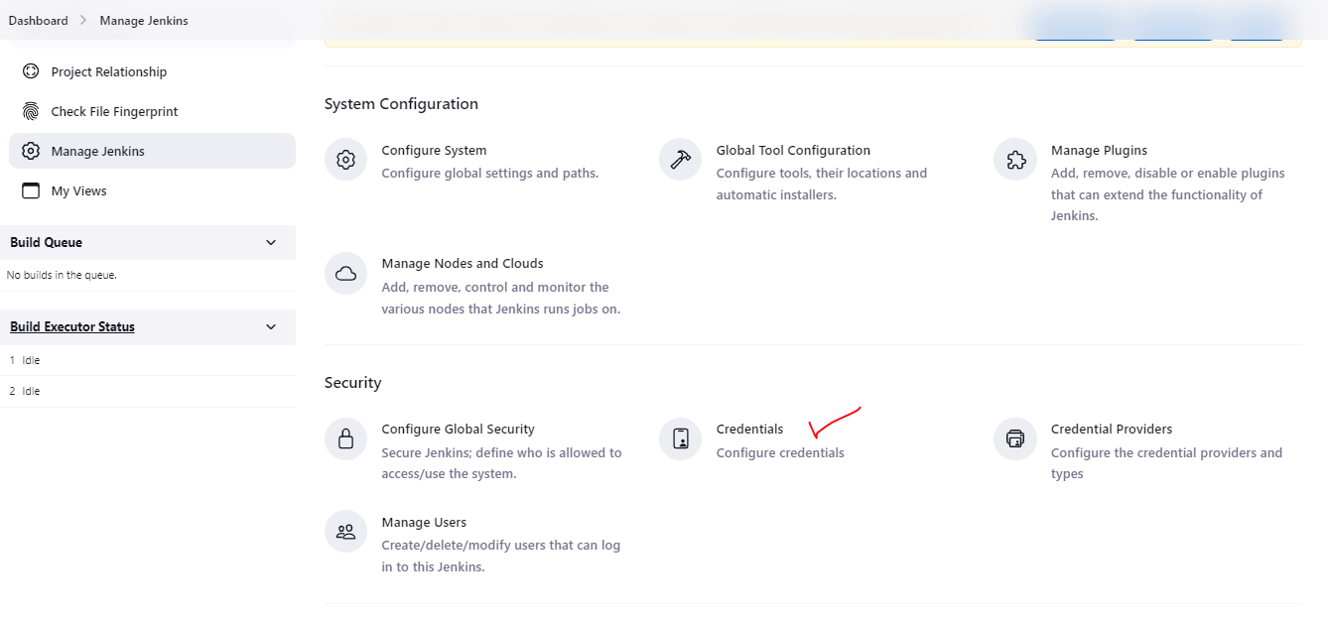

**Add Username & Password – Add users in Tomcat if not available**

Username: deployer

Password: deployer

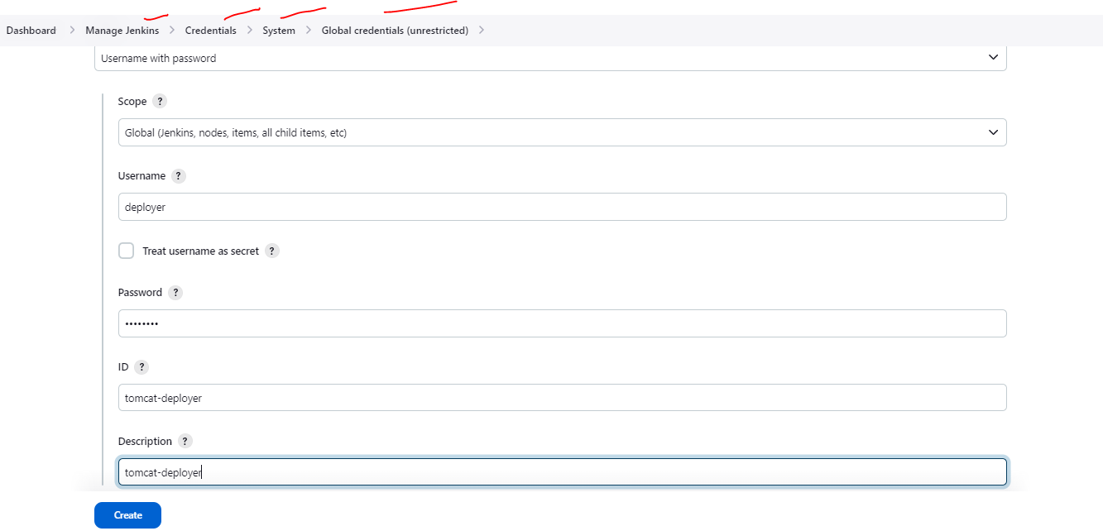

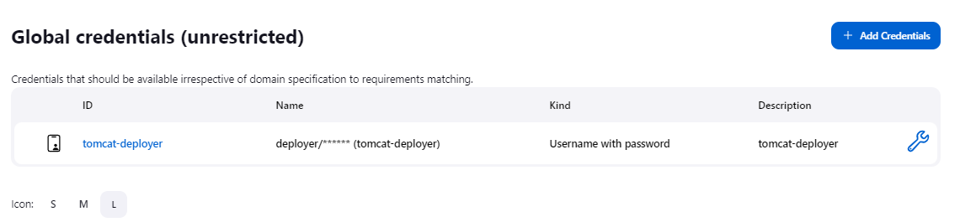

Create a New Job

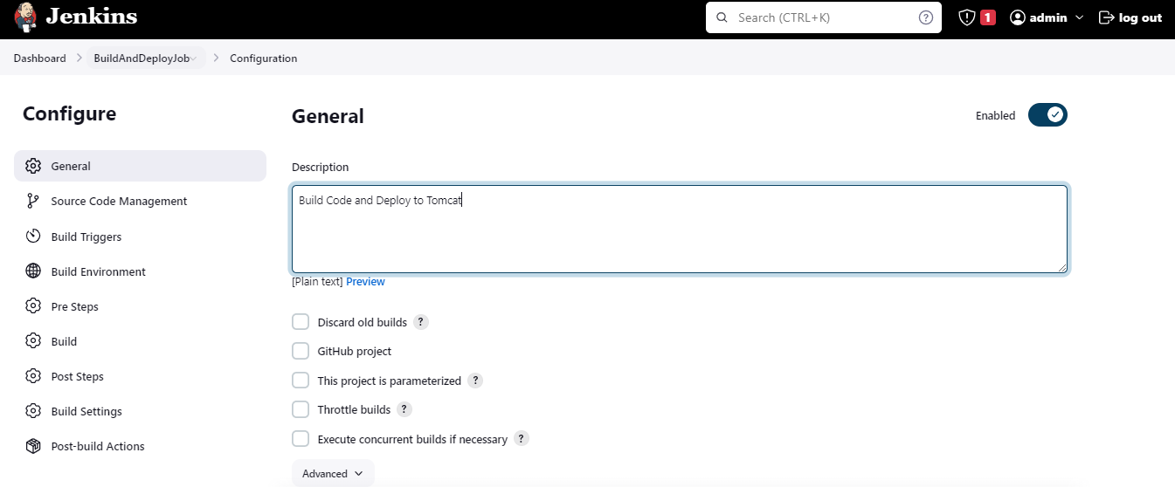

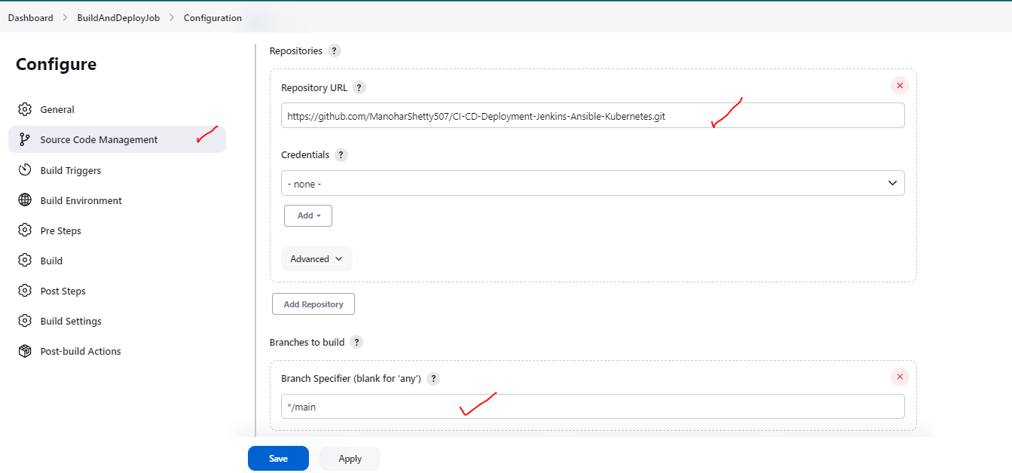

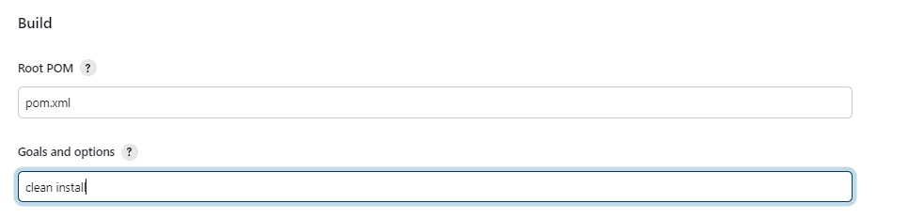

Now, to deploy to Tomcat – We need to choose post build attributes

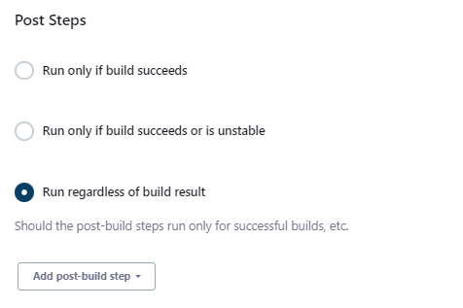

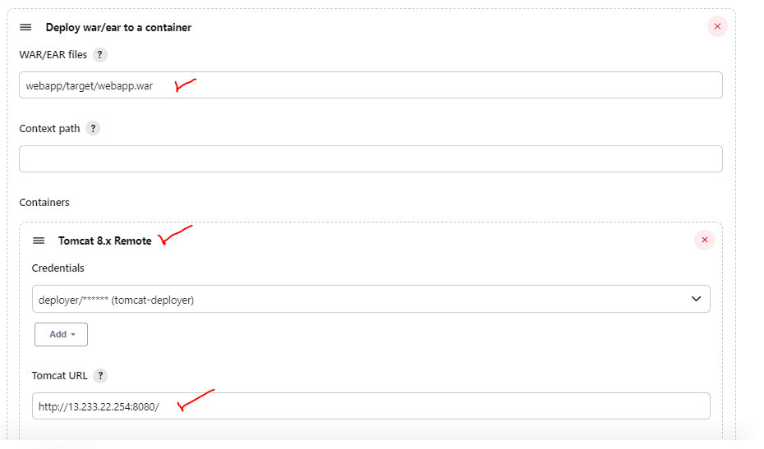

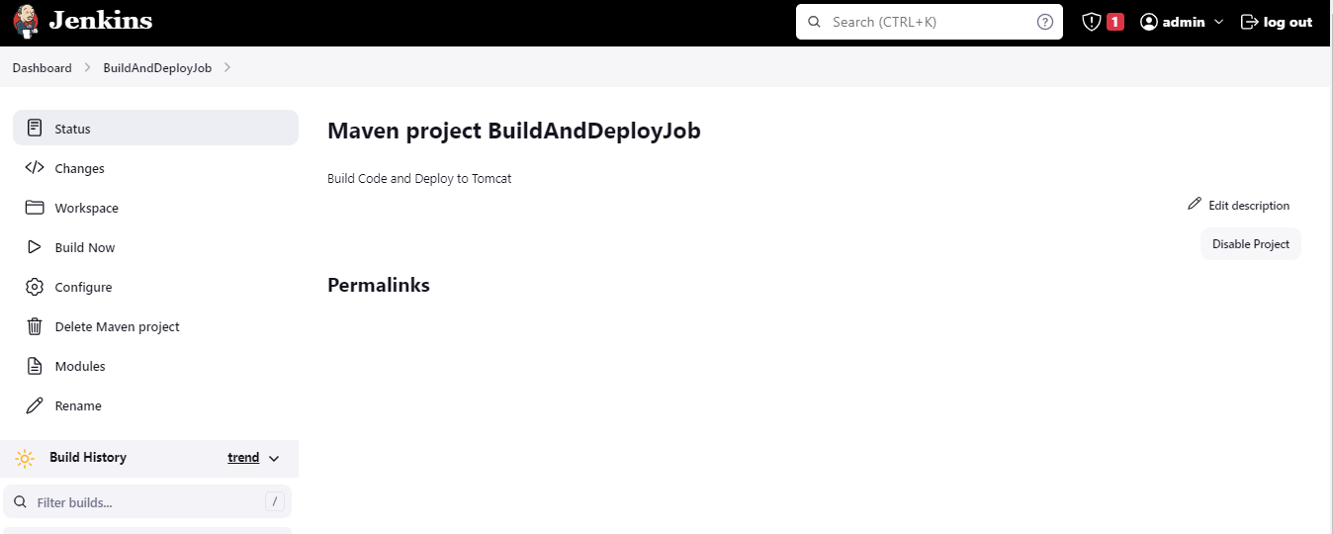

**Job Run**

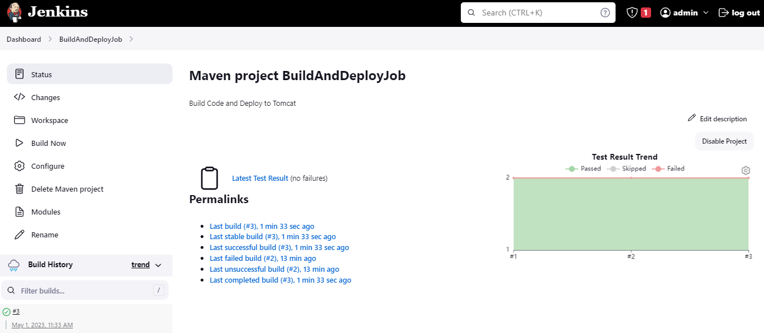

**War got deployed to Tomcat**

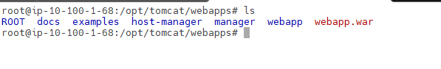

**View in the Browser**

Username: admin

Password: admin

