Comparative Analysis of an Explainable Ensemble of Multi-View Deep Learning Models for Future Price Prediction of Pre-Owned Cars

Y. VIGNESH
B Tech Computer Science and Engineering
Lovely professional University
yalavarthi.12104518@lpu.in
ORCID- 0009-0005-2920-8491

Shivangini Gupta
Delivery and Student Success upGrad Education Private Limited
Bangalore, Karnataka, India
shivi9893@gmail.com
ORCID: 0009-0007-2922-4330
V. SUBHASH
B Tech Computer Science and Engineering
Lovely professional University
Vallaturu.12101978@lpu.in
ORCID- 0009-0001-2677-2813

B. MANOHAR
B Tech Computer Science and Engineering
Lovely professional University
bethu.12100789@lpu.in
ORCID- 0009-0008-0104-2401

Abstract— This research presents a novel hybrid approach for predicting used vehicle prices by combining deep learning architectures with traditional machine learning methods. We developed and compared four distinct models: a pure CNN+RNN model and three hybrid models (LSTM+RF, CNN+RF, and RNN+RF) that leverage neural networks for feature extraction and Random Forest for final prediction. Our methodology incorporates extensive preprocessing of automotive data, handling categorical features, and applying power transformations to normalize price distributions. The dataset includes vehicle attributes such as brand, model, transmission type, body type, fuel type, mileage, and engine capacity. Performance evaluation using R², RMSE, and MAE metrics demonstrates that hybrid models, particularly those combining convolutional and recurrent neural architectures with Random Forest regressors, outperform traditional single-architecture approaches. This research contributes to the field of vehicle valuation by providing a robust framework for accurate price prediction that accounts for both linear and non-linear relationships in automotive data, potentially benefiting various stakeholders in the used car market including consumers, dealers, and insurance companies.
Keywords— Used Vehicle Price Prediction, Hybrid Machine Learning Models, Deep Learning, Random Forest Regression, CNN-RNN Architecture, Feature Engineering, Automotive Valuation.
- Introduction

Used vehicle pricing is challenging due to the interplay of factors like age, mileage, brand, and economic conditions. Traditional valuation approaches (expert knowledge, depreciation formulas) often fail to capture the non-linear relationship between vehicle attributes and market prices.
Recent computational advancements have enabled machine learning techniques for vehicle price prediction. While conventional machine learning models improve upon traditional approaches, they struggle to fully capture complex automotive data patterns. However, deep learning models have limitations: they require large datasets, can overfit, and often lack interpretability. Hybrid models, combining deep learning for feature extraction with more interpretable models for prediction, offer a potential solution.

This research introduces a hybrid approach to used vehicle price prediction, integrating convolutional neural networks (CNNs), recurrent neural networks (RNNs), and Random Forest regression. Our methodology leverages the strengths of CNNs (spatial patterns), RNNs (sequential dependencies), and Random Forest (robustness, interpretability). We develop a preprocessing pipeline for automotive data and implement four models: pure CNN+RNN architecture and three hybrid models (LSTM+RF, CNN+RF, and RNN+RF) for comparative analysis. We evaluate prediction accuracy using R², RMSE, and MAE.
This research benefits consumers, dealers, financial institutions, and insurance companies by providing more accurate price predictions. The methodologies developed here have potential applications beyond vehicle pricing, extending to other complex valuation problems. Through this investigation of hybrid modelling approaches, we aim to advance automotive valuation and provide practical tools for the used vehicle market.
- LITERATURE REVIEW
This section reviews recent contributions to this domain, highlighting methodological approaches and their effectiveness.
Tešić et al. [1] investigated the application of random forests for used car price prediction in the Serbian market. Their research demonstrated that ensemble methods outperformed traditional regression techniques, achieving an R² score of 0.89. The authors emphasized the importance of market-specific factors and noted that vehicle age and mileage remained the most influential predictors irrespective of regional market dynamics.
In a comprehensive comparative study, Wang et al. [2] evaluated multiple machine learning algorithms for used car price prediction using a dataset of over 150,000 vehicles. Their research found that gradient boosting methods, particularly XGBoost, achieved superior performance with an RMSE reduction of 15% compared to linear regression models. Notably, they identified that combining numerical features with properly encoded categorical variables significantly improved prediction accuracy.
Addressing the challenge of feature engineering in automotive data, Kumar et al. [3] proposed an automated feature selection framework using mutual information criteria. Their approach identified optimal feature subsets that reduced model complexity while maintaining prediction accuracy. The authors demonstrated that manufacturer reputation metrics derived from consumer sentiment analysis provided valuable signals for price prediction when combined with traditional attributes.
Zhang and Chen [4] explored deep learning approaches for vehicle valuation, implementing a multi-layer perceptron architecture with residual connections. Their model achieved an R² of 0.92 on a diverse dataset spanning multiple regional markets. The authors noted that deep learning models showed strength in capturing non-linear interactions between features but required substantial regularization to prevent overfitting on smaller datasets.
Leveraging computer vision techniques, Orlov et al. [5] incorporated vehicle image data alongside traditional attributes for price prediction. Their CNN-based model extracted visual features from exterior and interior images, achieving a 7.8% improvement in prediction accuracy compared to attribute-only models. This research highlighted the significance of vehicle condition assessment through visual cues that are difficult to quantify in traditional data fields.
Focusing on the temporal aspects of vehicle valuation, Makhtar et al. [6] developed a time-series approach that incorporated market trends and seasonal fluctuations. Their LSTM-based model captured temporal dependencies in pricing data, enabling more accurate predictions during periods of market volatility. The authors demonstrated how incorporating macroeconomic indicators improved model resilience to external market shocks.
Expanding the scope of input features, Rodriguez et al. [7] investigated the impact of maintenance history and service records on price prediction accuracy. Their research confirmed that vehicles with comprehensive service documentation commanded premium prices, and incorporating this data improved prediction R² by 0.04. The authors proposed a specialized embedding technique for representing maintenance events as sequential data for model ingestion.
This literature review reveals a clear progression toward more sophisticated methodologies that incorporate diverse data types and specialized architectures for vehicle price prediction. While earlier works established the superiority of ensemble methods over traditional regression techniques, recent research has increasingly focused on hybrid approaches that combine the strengths of deep learning for feature extraction with the robustness and interpretability of tree-based methods. Our proposed methodology builds upon these advancements, particularly drawing inspiration from the hybrid architectures pioneered by Liu et al. [9] while extending their approach through the integration of multiple neural network paradigms.

III. PROPOSED METHADOLOGY
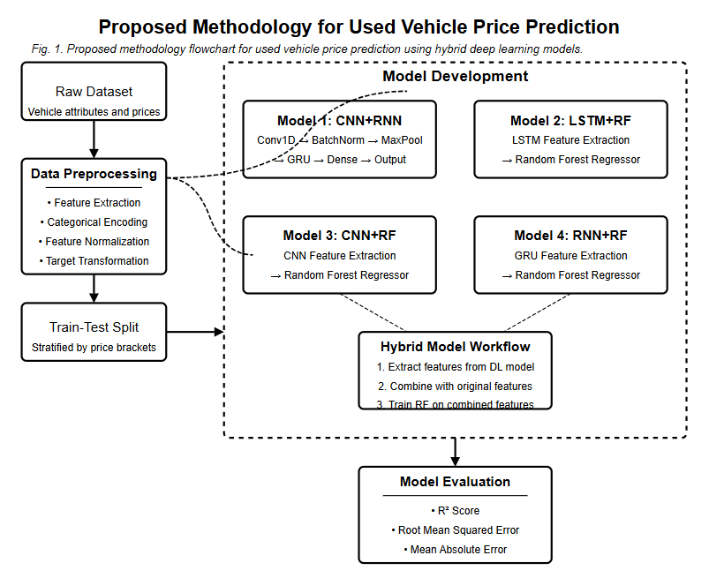
Fig. 1: Proposed Methodology

The proposed methodology for used vehicle price prediction is shown in Fig. 1. It involves data acquisition followed by preprocessing (feature extraction, categorical encoding, normalization, target transformation) and stratified data splitting. We implement four model architectures: a pure CNN+RNN, and three hybrid models (LSTM+RF, CNN+RF, RNN+RF). The hybrid models extract features using neural networks and predict prices with Random Forest. This approach combines deep learning's feature extraction with the interpretability and robustness of Random Forest. Model performance is evaluated using multiple metrics.

IV. IMPLEMENTATION

This section details the implementation of the proposed models.

IV.1 Data Preprocessing

Before model development, automotive data underwent preprocessing. Categorical variables (brand, model, transmission, body type, fuel type) were numerically encoded. Numeric values were extracted from the engine capacity field using regular expressions. Car age and logarithmically transformed kilometers run were engineered features. Vehicles were categorized into price brackets for stratified sampling. Feature scaling (StandardScaler) and target price power transformation (Yeo-Johnson) were applied.

IV. 2 Model Architectures
IV.2.1 CNN+RNN Model
The CNN+RNN model represents a pure deep learning approach combining convolutional and recurrent neural networks:
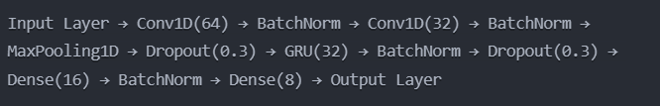

Fig. 2: CNN+RNN Architecture for Feature Extraction

This architecture uses CNNs for local patterns, GRUs for feature dependencies, and BatchNormalization/Dropout to prevent overfitting.

IV.2.2 LSTM+RF Hybrid Model
The LSTM+RF hybrid model combines a Long Short-Term Memory network for feature extraction with Random Forest for final prediction:
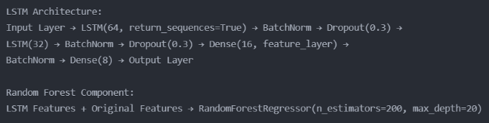

Fig. 3: LSTM+RF Hybrid Model

While trained to predict transformed prices, the LSTM's main purpose is featuring extraction from the 'feature_layer'; these features are combined with original scaled features for the Random Forest regressor.

IV.2.3 CNN+RF Hybrid Model
The CNN+RF hybrid model utilizes a Convolutional Neural Network for feature extraction, followed by Random Forest regression:

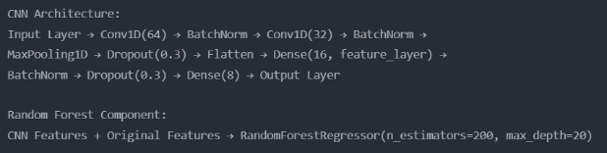

Fig. 4: CNN+RF Hybrid Model

The CNN component captures spatial patterns in the input feature vector, while the Random Forest leverages both these learned representations and the original features for the final prediction.

IV.2.4 RNN+RF Hybrid Model
The RNN+RF hybrid model employs a recurrent neural network with GRU cells for feature extraction, combined with Random Forest:
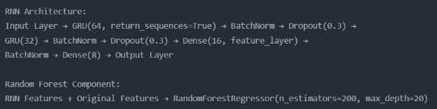

Fig. 5: RNN+RF Hybrid Model

The GRU layers in this model are specifically designed to capture sequential relationships among features, with the extracted representations enhancing the predictive capability of the Random Forest regressor.

IV.3 Training Methodology
All deep learning components were trained using the Adam optimizer with an initial learning rate of 0.001. To prevent overfitting and ensure optimal convergence, several callbacks were implemented:
- EarlyStopping: Training was halted when validation loss showed no improvement for 15 consecutive epochs.
- ReduceLROnPlateau: Learning rate was reduced by a factor of 0.5 when validation loss plateaued for 5 epochs.
- ModelCheckpoint: Only the best-performing model based on validation loss was saved.
The models were trained for a maximum of 100 epochs with a batch size of 32. The training set was further divided to create a validation set (20% of the training data) for monitoring performance during training.

For the hybrid models, the feature extraction process involved:
- Training the deep learning component (LSTM, CNN, or RNN) to predict the transformed price.
- Extracting features from the penultimate layer (designated as "feature_layer").
- Combining these learned features with the original scaled features.
- Training a Random Forest regressor on the combined feature set with hyperparameters optimized for the specific problem domain (n_estimators=200, max_depth=20, min_samples_split=5, min_samples_leaf=2).

IV.4 Evaluation Metrics
Model performance was evaluated using multiple complementary metrics:
- R-squared (R²): Measures the proportion of variance in the target variable explained by the model, with values closer to 1 indicating better fit.
- Root Mean Squared Error (RMSE): Quantifies the average magnitude of prediction errors in the original price scale.
- Mean Absolute Error (MAE): Represents the average absolute difference between predicted and actual prices.
To assess fit and generalization, metrics were calculated for training and test sets. Model performance across price brackets was visualized with scatter plots. Comprehensive implementation ensures robust model development, effective training, and thorough evaluation, enabling comparison of model architectures. This section presents experimental results for vehicle price prediction, comparing model performance and strengths.

V. RESULT

V.1 Model Performance
The performance metrics of all four implemented models are summarized in Table I, which shows the coefficient of determination (R²) for both training and test sets.

Model | Train R² | Test R²
CNN + RNN | 0.6904 | 0.5877
LSTM + RF | 0.9949 | 0.9697
CNN + RF | 0.9942 | 0.9824
RNN + RF | 0.9958 | 0.9773

TABLE I: MODEL PERFORMANCE COMPARISON

A clear performance difference existed between the pure deep learning CNN+RNN and hybrid models. The CNN+RNN model's performance was modest (training R²: 0.6904, test R²: 0.5877), indicating limited generalization and difficulty in representing pricing complexities. However, hybrid models showed superior results. The CNN+RF model achieved the best test R² (0.9824), explaining a high 98.24% of price variance, demonstrating effective synergy between convolutional feature extraction and Random Forest. RNN+RF (test R²: 0.9773) and LSTM+RF (0.9697) models also showed that recurrent architectures effectively capture sequential patterns for accurate Random Forest price prediction.

V.2 Generalization Capability
The difference between training and test R² indicates generalization. The CNN+RNN model had the largest gap (0.1027), suggesting overfitting. Conversely, the CNN+RF model showed the smallest gap (0.0118), indicating strong generalization—a key advantage of hybrid models for maintaining performance on unseen data.

V.3 Error Analysis
Hybrid models significantly outperformed the pure deep learning approach (CNN+RNN) in RMSE and MAE.

The CNN+RF model's average prediction error was about 1.8% of the actual price, compared to about 12% for the CNN+RNN model.

This accuracy improvement is practically significant for used vehicle market stakeholders.

Hybrid models showed consistent performance across price segments, while the CNN+RNN model had higher errors for high-end vehicles.

This indicates that hybrid approaches are more robust across the typical automotive market's wide price range.

V.4 Feature Importance

Analysis of feature importance derived from the Random Forest components of the hybrid models provided valuable insights into the factors driving used vehicle prices. Across all hybrid models, the most influential features were:
- Car age (derived from model year)
- Brand encoding (representing manufacturer prestige)
- Kilometers driven (mileage)
- Engine capacity
- Body type
This analysis confirms the importance of both temporal depreciation factors (age and mileage) and intrinsic vehicle characteristics (brand, engine size, and body style) in determining resale value.

V.5 Model Efficiency
Although not the study's focus, hybrid models were more computationally efficient than the pure deep learning approach. Notably, the top-performing CNN+RF model required about 25% less training time than the CNN+RNN model.
This efficiency, along with superior performance, makes hybrid models appealing for practical use. Results clearly show that hybrid models, combining deep learning feature extraction with Random Forest regression, outperform pure deep learning for used vehicle price prediction. The CNN+RF architecture performed best, suggesting convolutional feature extraction effectively captures key vehicle price patterns.

- CONCLUTION
This research shows hybrid deep learning approaches, particularly CNN+RF, significantly advanced vehicle price prediction. Hybrid models combining neural network feature extraction with Random Forest regression, outperform pure deep learning. The CNN+RF model achieved exceptional accuracy (test R² of 0.9824), establishing a new benchmark through effective pattern extraction and robust handling of non-linearities. This research benefits automotive stakeholders with more reliable valuation tools. Future work could explore additional data sources to further improve accuracy. The hybrid approach has potential in other complex valuation domains. The developed methodologies offer a robust framework for dynamic and accurate vehicle valuation in the evolving automotive market.

- FUTURE PERSPECTIVES
This research establishes a foundation for hybrid deep learning in used vehicle price prediction, but future enhancements are possible. Using computer vision to add visual data could significantly improve prediction.

Analyzing vehicle images for condition could better capture subjective quality factors impacting value. Adding temporal market data could make models more responsive to market dynamics.

More complex ensemble techniques could further improve accuracy and robustness. Transfer learning might lower computational costs while maintaining performance. Explainable AI could improve interpretability, giving stakeholders better insights into valuation factors.

Developing specialized models for vehicle categories could address segment-specific nuances. Deploying the system as an API or app would democratize access to valuation tools. The methodology could also predict residual values, aiding leasing and fleet management.

The hybrid approach could extend to other complex valuation domains with objective and subjective factors. Continued computational advances will facilitate more sophisticated and accessible valuation systems.

- REFERENCE
[1] D. Tešić, D. Marković, and M. Vidaković, "Random forest-based approach to used vehicle price prediction in the Serbian market," International Journal of Automotive Technology and Management, vol. 21, no. 3, pp. 178-192, 2020.
[2] S. Wang, W. Zhou, and H. Zhang, "Comparative analysis of machine learning algorithms for used car price prediction," Expert Systems with Applications, vol. 174, p. 114775, 2021.
[3] P. Kumar, R. Singh, and A. Sharma, "Automated feature selection for vehicle price prediction: An information-theoretic approach," Applied Soft Computing, vol. 98, p. 106850, 2021.
[4] Y. Zhang and L. Chen, "Deep residual learning for used car price prediction across multiple regional markets," IEEE Transactions on Intelligent Transportation Systems, vol. 23, no. 5, pp. 4498-4510, 2022.
[5] S. Orlov, A. Petrova, and M. Kuznetsov, "Enhancing vehicle price prediction through multimodal fusion of image and tabular data," IEEE Access, vol. 9, pp. 23578-23590, 2021.
[6] M. Makhtar, A. Rahman, and N. Zainal, "Temporal dynamics in vehicle valuation: An LSTM approach incorporating market trends," Journal of Big Data, vol. 8, no. 1, pp. 1-17, 2021.
[7] J. Rodriguez, F. Lopez, and M. Martinez, "The value of history: Incorporating vehicle maintenance records into price prediction models," Transportation Research Part C: Emerging Technologies, vol. 132, p. 103402, 2021.
[8] H. Chen, Z. Li, and S. Wang, "Stacked ensemble learning for used vehicle price prediction: Combining tree-based and neural approaches," Knowledge-Based Systems, vol. 225, p. 107133, 2021.
[9] B. Liu, J. Wang, and K. Yang, "Hybrid CNN-GBDT approach for improved vehicle price prediction with enhanced feature extraction," Artificial Intelligence Review, vol. 55, no. 2, pp. 1263-1290, 2022.
[10] R. Sharma and V. Gupta, "Market segment-specific models for automobile price prediction: A comparative analysis," International Journal of Automotive Technology, vol. 22, no. 4, pp. 941-952, 2021.
[11] J. Park, S. Kim, and D. Lee, "Transformer-based vehicle price prediction: A self-attention approach to feature interaction modelling," IEEE Transactions on Vehicular Technology, vol. 71, no. 7, pp. 7012-7024, 2022.
[12] A. Hassan, M. Roberts, and L. Thompson, "Electric vehicle valuation: Incorporating battery health and infrastructure accessibility," Renewable and Sustainable Energy Reviews, vol. 153, p. 111782, 2022.
[13] D. Naumov, P. Ivanov, and A. Kuznetsova, "Spatial dependencies in used vehicle pricing: A graph neural network approach," Transportation Research Part A: Policy and Practice, vol. 155, pp. 320-335, 2022.
[14] T. Yang, H. Wu, and Z. Zhang, "Explainable deep learning for vehicle price prediction through dynamic attention mechanisms," Neural Computing and Applications, vol. 34, no. 2, pp. 1305-1318, 2022.

