**Working with Variables**

**Step 1**

**Task Instructions**

In this activity, you will define a variable within a JavaScript function. You'll learn more about functions later. For now, we'll focus on variables.

**To accomplish this task, you need to do the following:**

Open the Variables-01 folder and add code to the variables01.js file to do the following:

* Create a variable called myFriend using one of the variable declarations described above.
* Set the variable you created to contain your friend's name.
* Inside the greetings function, return the string: "Greetings [your-friend's-name]."

*Note: The following line of code console.log('results: ', greetings()); will print the result of your code to the console. You will learn more about how this works later on in the course.*

When you are done, refresh the browser window and open the console to see the results.

**Task**

**Declare a variable containing your friend's name, then use that variable to create a greeting message.**

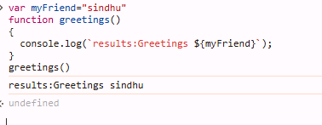

**Working with Variables**

**Step 2**

#### Task Instructions

Your task in this activity is to declare a variable named currentYear using let. This variable should have the current year as a value (ex. 1991).

*Note: This line of code console.log('current year result: ', currentYear); will print the value of your variable to the console.*

Task

Create the variable current Year using let and assign the current year as the value.



**Working with Variables**

**Step 3**

**Task Instruction**

In this activity, you will declare variables with let and const keywords. The function testBestFlavor needs to print the message: "Ana says, lacroix orange is a better flavor than lacroix grapefruit."

To make this function complete, you need to declare two constants:

* lacroix1: This needs to be declared **outside** the scope of the function testBestFlavor using const and it needs to have the value "grapefruit".
* lacroix2: This needs to be declared **inside** the scope of the function testBestFlavor using const and it needs to have the value "orange".

After you're done with your code changes, check the console to see if the printed message is correct. Then, submit the task.

Task

Given the function testBestFlavor, return a string with the word 'orange' in the sentence.

