**Functions - Step1**

**Task Instruction**

You task in this activity is to complete the implementation of the function add. This function needs to do the following:

* It takes two parameters x and y
* It returns the sum of the two parameters x and y.

*Note: You can calculate the sum of two numbers simply adding them: x + y*

Task

Write a function that adds 2 numbers.

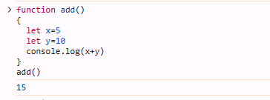

**Functions - Step 2**

#### Functions Practice

Now try writing a function that welcomes a friend.

To complete this task, you will need to implement the greet() function. This function needs to have a parameter called name and return a message that welcomes the person with that name.

For example, if you call the function as follow: greet("Dani"), the result should be: "Hello Dani" or "Greetings Dani'

Your code should be added to the greet.js file inside the functions-02 folder.

Task

Create a function call greet() with one parameter name which returns a string that welcomes the name passed in.

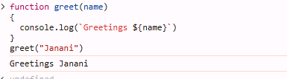

**Functions - Step 3**

**Task Instructions**

Your task in this activity is to create a function called isString that takes three arguments (a, b, c). This function does the following:

* It uses the typeof operator and strict equality comparison to check if the type of all three parameters a, b and c is string.
* If each argument is a string it returns the message strings.
* If any of the three parameters is not a string, then it returns the message not strings.

*Hint: Read about the typeof built-in function to help you solve the exercise.*

**Task**

Given the isString function inside functions-03, make use of the typeof method to check if all passed in arguments are strings. Otherwise, return a message. For more details check out the main.js file inside functions-03.

