DAY 5

1.

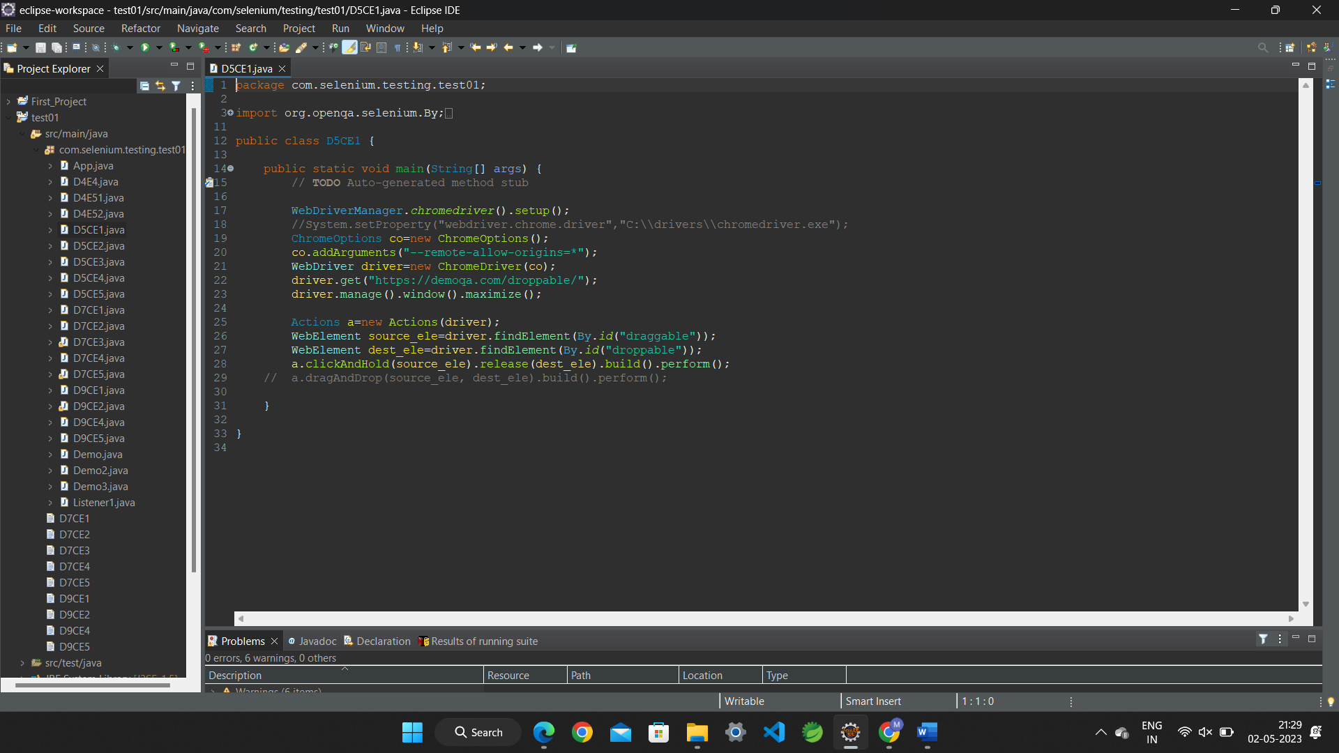

**CODING**

package com.selenium.testing.test01;

import org.openqa.selenium.By;

import org.openqa.selenium.WebDriver;

import org.openqa.selenium.WebElement;

import org.openqa.selenium.chrome.ChromeDriver;

import org.openqa.selenium.chrome.ChromeOptions;

import org.openqa.selenium.interactions.Actions;

import io.github.bonigarcia.wdm.WebDriverManager;

public class D5CE1 {

public static void main(String[] args) {

// TODO Auto-generated method stub

WebDriverManager.chromedriver().setup();

//System.setProperty("webdriver.chrome.driver","C:\\drivers\\chromedriver.exe");

ChromeOptions co=new ChromeOptions();

co.addArguments("--remote-allow-origins=*");

WebDriver driver=new ChromeDriver(co);

driver.get("https://demoqa.com/droppable/");

driver.manage().window().maximize();

Actions a=new Actions(driver);

WebElement source_ele=driver.findElement(By.id("draggable"));

WebElement dest_ele=driver.findElement(By.id("droppable"));

a.clickAndHold(source_ele).release(dest_ele).build().perform();

// a.dragAndDrop(source_ele, dest_ele).build().perform();

}

}

==================================================================================

2.

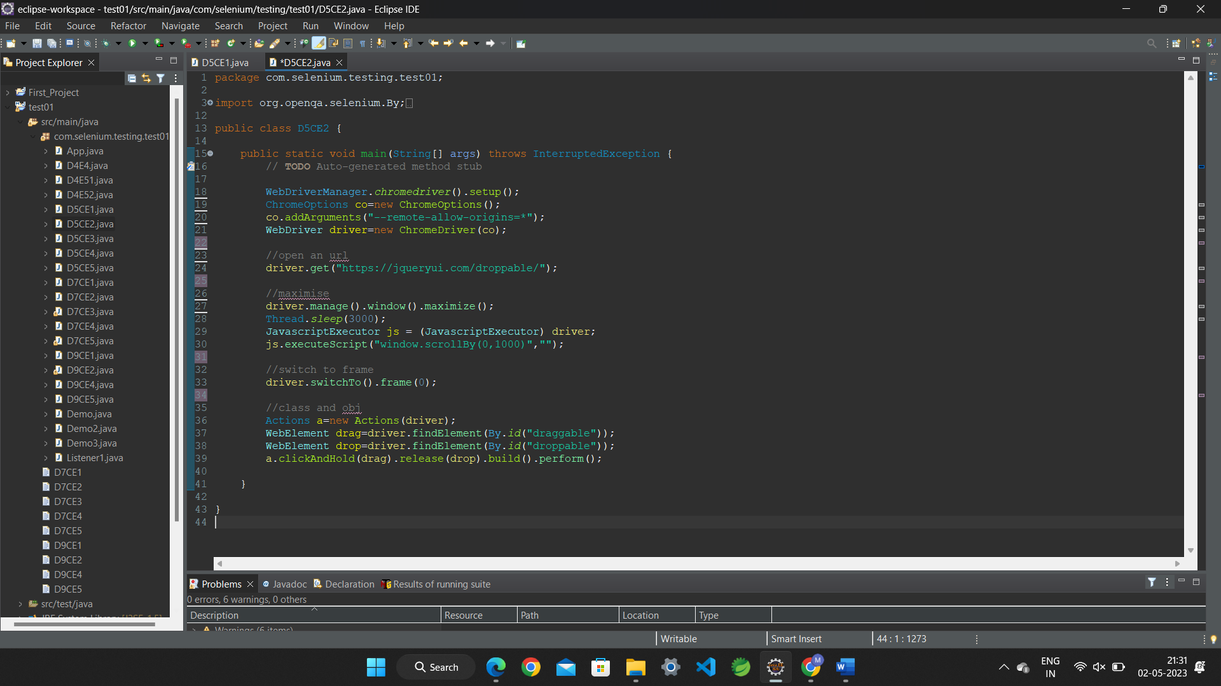

CODING:

package com.selenium.testing.test01;

import org.openqa.selenium.By;

import org.openqa.selenium.JavascriptExecutor;

import org.openqa.selenium.WebDriver;

import org.openqa.selenium.WebElement;

import org.openqa.selenium.chrome.ChromeDriver;

import org.openqa.selenium.chrome.ChromeOptions;

import org.openqa.selenium.interactions.Actions;

import io.github.bonigarcia.wdm.WebDriverManager;

public class D5CE2 {

public static void main(String[] args) throws InterruptedException {

// TODO Auto-generated method stub

WebDriverManager.chromedriver().setup();

ChromeOptions co=new ChromeOptions();

co.addArguments("--remote-allow-origins=*");

WebDriver driver=new ChromeDriver(co);

//open an url

driver.get("https://jqueryui.com/droppable/");

//maximise

driver.manage().window().maximize();

Thread.sleep(3000);

JavascriptExecutor js = (JavascriptExecutor) driver;

js.executeScript("window.scrollBy(0,1000)","");

//switch to frame

driver.switchTo().frame(0);

//class and obj

Actions a=new Actions(driver);

WebElement drag=driver.findElement(By.id("draggable"));

WebElement drop=driver.findElement(By.id("droppable"));

a.clickAndHold(drag).release(drop).build().perform();

}

}

==================================================================================

3.

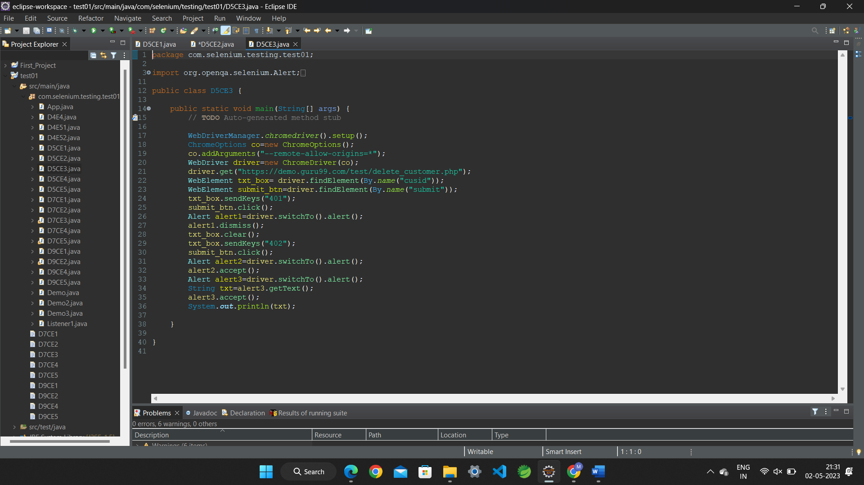

CODING:

package com.selenium.testing.test01;

import org.openqa.selenium.Alert;

import org.openqa.selenium.By;

import org.openqa.selenium.WebDriver;

import org.openqa.selenium.WebElement;

import org.openqa.selenium.chrome.ChromeDriver;

import org.openqa.selenium.chrome.ChromeOptions;

import io.github.bonigarcia.wdm.WebDriverManager;

public class D5CE3 {

public static void main(String[] args) {

// TODO Auto-generated method stub

WebDriverManager.chromedriver().setup();

ChromeOptions co=new ChromeOptions();

co.addArguments("--remote-allow-origins=*");

WebDriver driver=new ChromeDriver(co);

driver.get("https://demo.guru99.com/test/delete_customer.php");

WebElement txt_box= driver.findElement(By.name("cusid"));

WebElement submit_btn=driver.findElement(By.name("submit"));

txt_box.sendKeys("401");

submit_btn.click();

Alert alert1=driver.switchTo().alert();

alert1.dismiss();

txt_box.clear();

txt_box.sendKeys("402");

submit_btn.click();

Alert alert2=driver.switchTo().alert();

alert2.accept();

Alert alert3=driver.switchTo().alert();

String txt=alert3.getText();

alert3.accept();

System.out.println(txt);

}

}

==================================================================================

4.

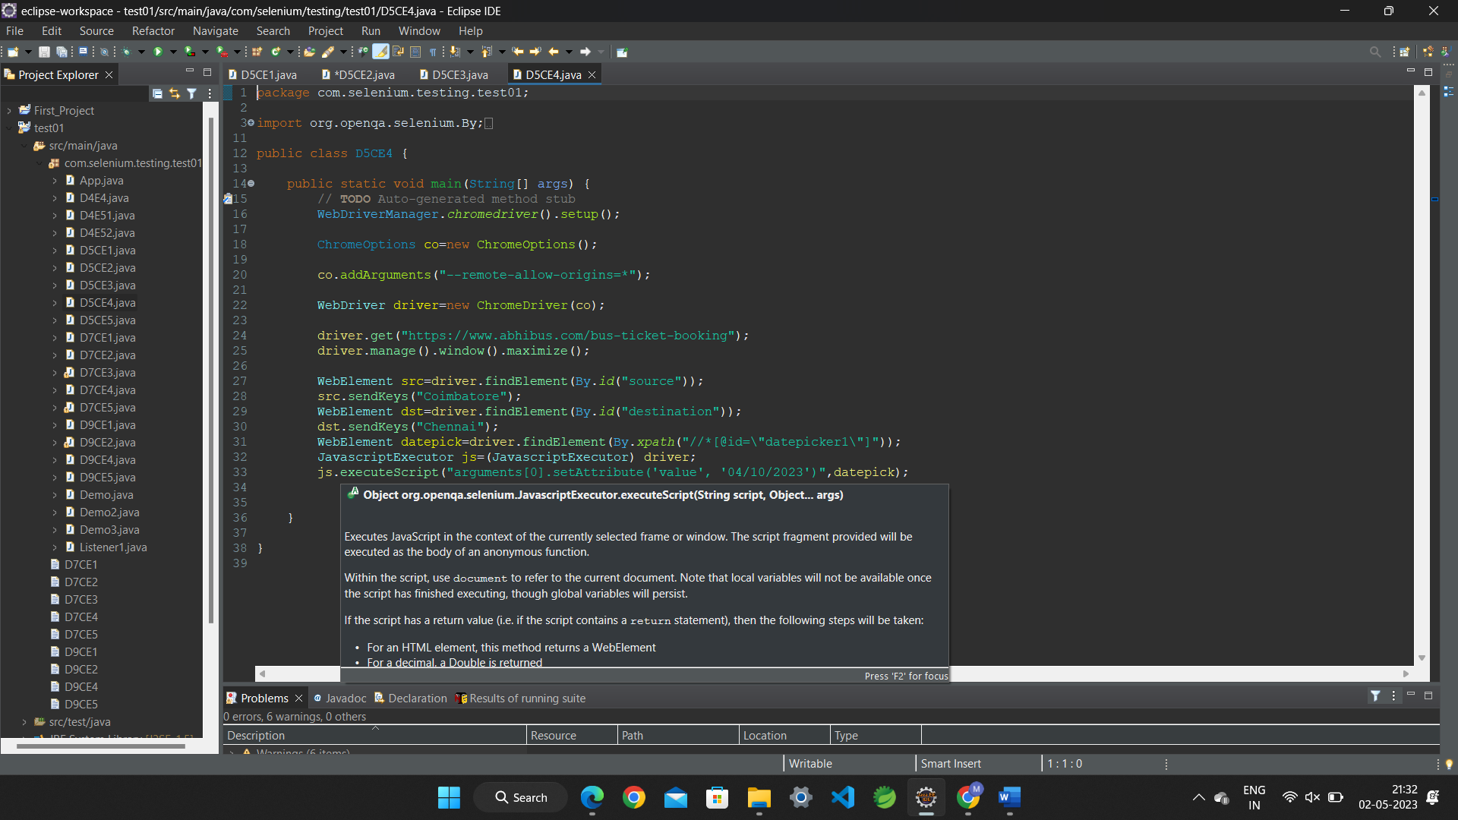

CODING:

package com.selenium.testing.test01;

import org.openqa.selenium.By;

import org.openqa.selenium.JavascriptExecutor;

import org.openqa.selenium.WebDriver;

import org.openqa.selenium.WebElement;

import org.openqa.selenium.chrome.ChromeDriver;

import org.openqa.selenium.chrome.ChromeOptions;

import io.github.bonigarcia.wdm.WebDriverManager;

public class D5CE4 {

public static void main(String[] args) {

// TODO Auto-generated method stub

WebDriverManager.chromedriver().setup();

ChromeOptions co=new ChromeOptions();

co.addArguments("--remote-allow-origins=*");

WebDriver driver=new ChromeDriver(co);

driver.get("https://www.abhibus.com/bus-ticket-booking");

driver.manage().window().maximize();

WebElement src=driver.findElement(By.id("source"));

src.sendKeys("Coimbatore");

WebElement dst=driver.findElement(By.id("destination"));

dst.sendKeys("Chennai");

WebElement datepick=driver.findElement(By.xpath("//*[@id=\"datepicker1\"]"));

JavascriptExecutor js=(JavascriptExecutor) driver;

js.executeScript("arguments[0].setAttribute('value', '04/10/2023')",datepick);

}

}

==================================================================================

5.

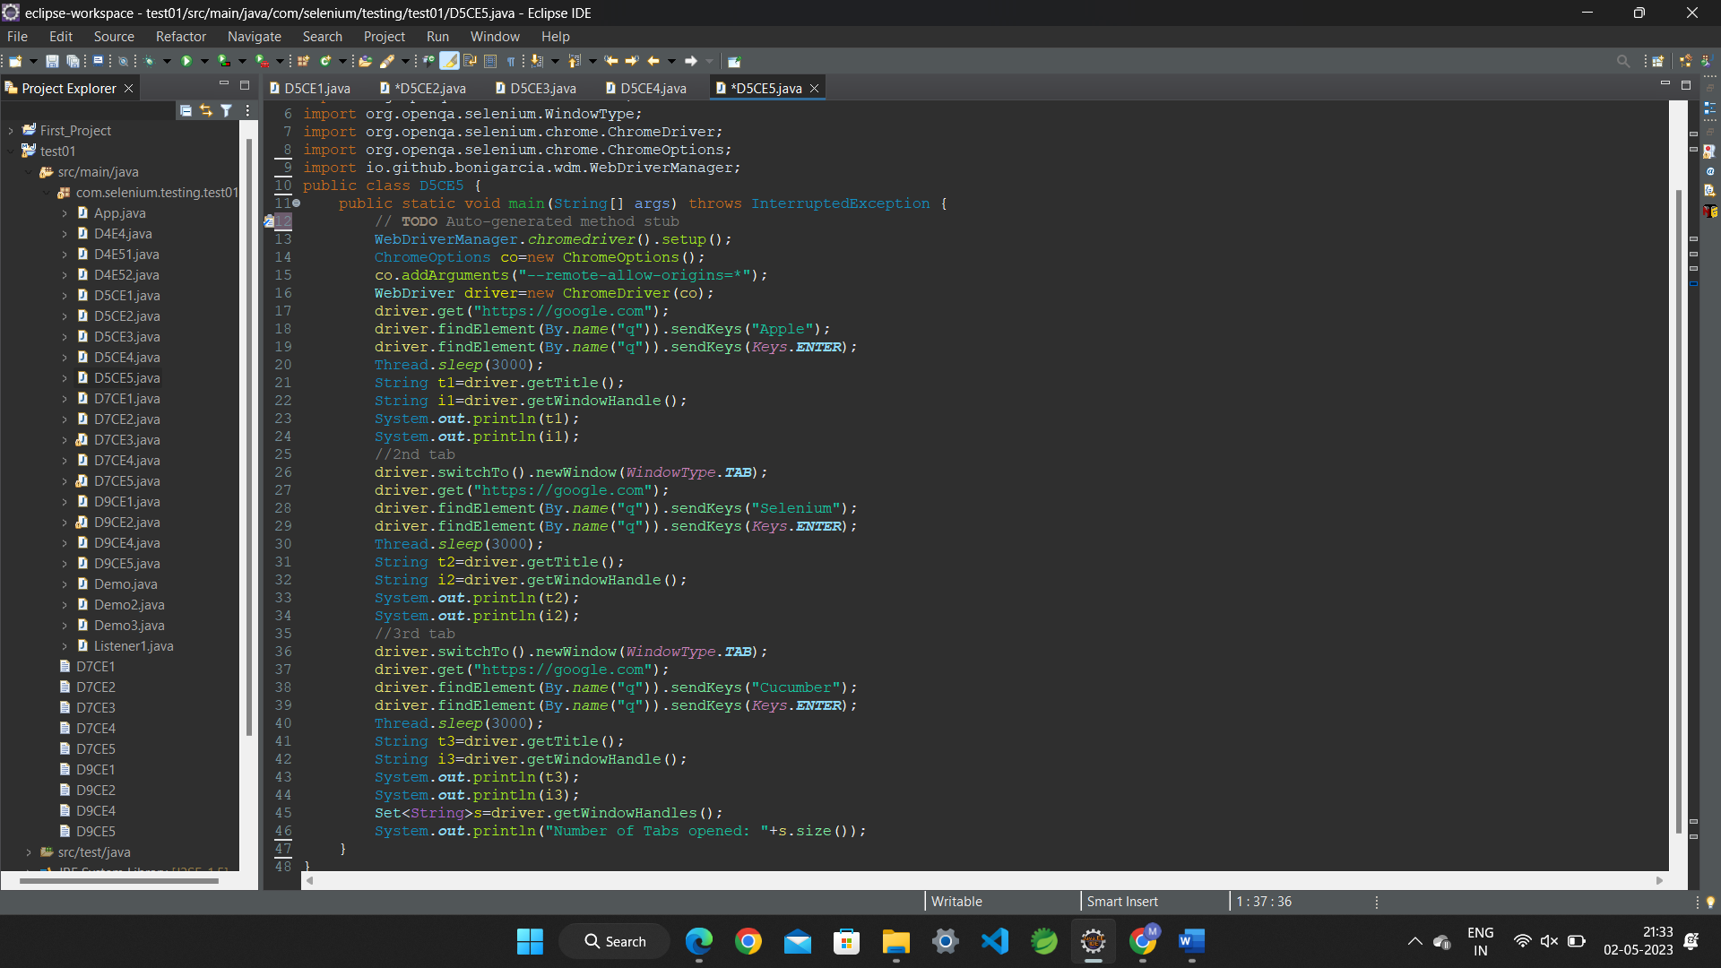

package com.selenium.testing.test01;

import java.util.Set;

import org.openqa.selenium.By;

import org.openqa.selenium.Keys;

import org.openqa.selenium.WebDriver;

import org.openqa.selenium.WindowType;

import org.openqa.selenium.chrome.ChromeDriver;

import org.openqa.selenium.chrome.ChromeOptions;

import io.github.bonigarcia.wdm.WebDriverManager;

public class D5CE5 {

public static void main(String[] args) throws InterruptedException {

// **TODO** Auto-generated method stub

WebDriverManager.*chromedriver*().setup();

ChromeOptions co=new ChromeOptions();

co.addArguments("--remote-allow-origins=*");

WebDriver driver=new ChromeDriver(co);

driver.get("https://google.com");

driver.findElement(By.*name*("q")).sendKeys("Apple");

driver.findElement(By.*name*("q")).sendKeys(*Keys*.***ENTER***);

Thread.*sleep*(3000);

String t1=driver.getTitle();

String i1=driver.getWindowHandle();

System.***out***.println(t1);

System.***out***.println(i1);

//2nd tab

driver.switchTo().newWindow(*WindowType*.***TAB***);

driver.get("https://google.com");

driver.findElement(By.*name*("q")).sendKeys("Selenium");

driver.findElement(By.*name*("q")).sendKeys(*Keys*.***ENTER***);

Thread.*sleep*(3000);

String t2=driver.getTitle();

String i2=driver.getWindowHandle();

System.***out***.println(t2);

System.***out***.println(i2);

//3rd tab

driver.switchTo().newWindow(*WindowType*.***TAB***);

driver.get("https://google.com");

driver.findElement(By.*name*("q")).sendKeys("Cucumber");

driver.findElement(By.*name*("q")).sendKeys(*Keys*.***ENTER***);

Thread.*sleep*(3000);

String t3=driver.getTitle();

String i3=driver.getWindowHandle();

System.***out***.println(t3);

System.***out***.println(i3);

Set<String>s=driver.getWindowHandles();

System.***out***.println("Number of Tabs opened: "+s.size());

}

}