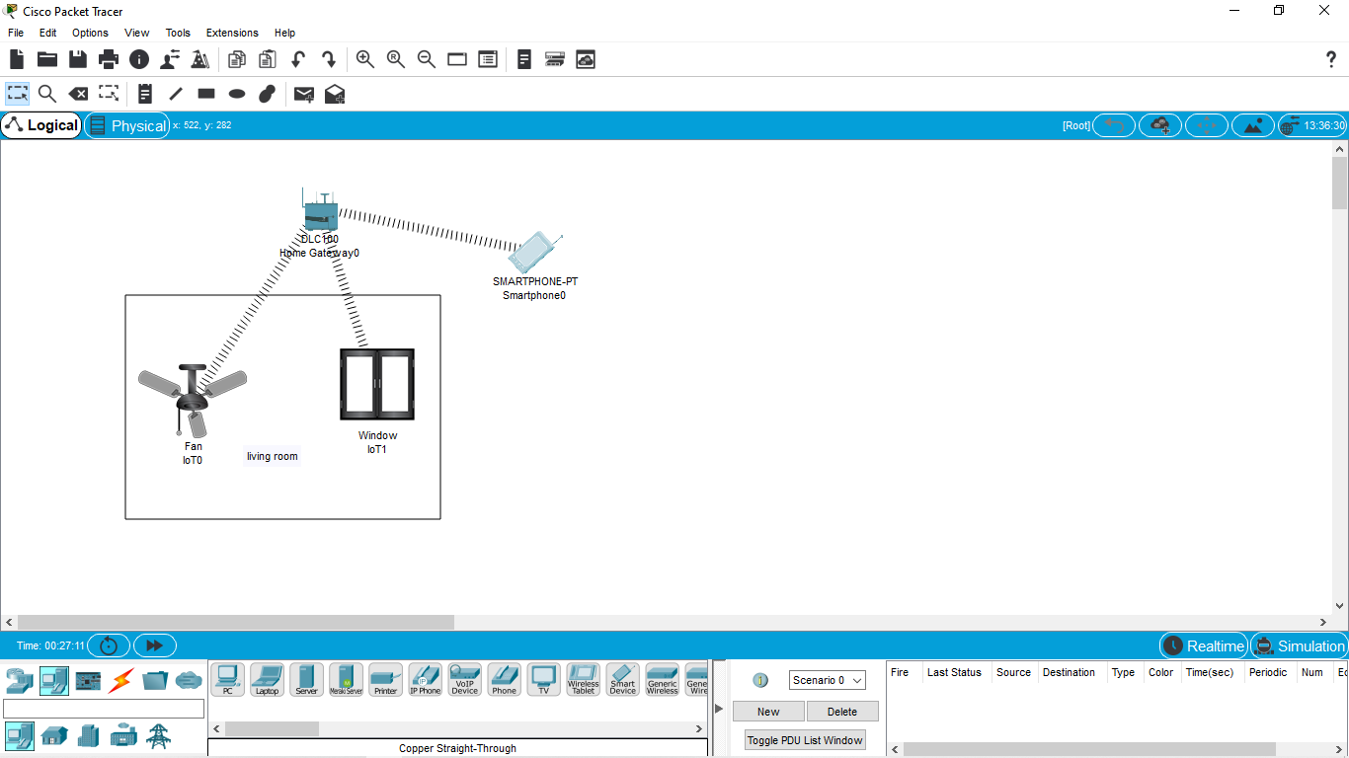

IOT Based Smart Home Using Cisco Packet Tracer