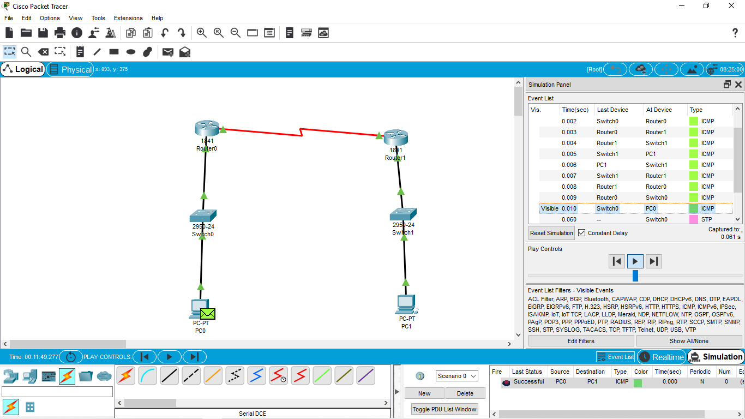

Dynamic Routing using Packet Tracer ( OSPF)