A MINI PROJECT REPORT
ON
“Distributed and Supervised Sentiment Analysis on IMDB Reviews using PySpark and Machine Learning”
Submitted By
Manohar Mudaliyar (123A1071)
Nikita Mulam (123A1074)
Sharanya Pillai (123A1089)
Subject In-charge
Prof. Akshay Jadhav

Department of Computer Engineering
SIES Graduate School of Technology
Nerul – 400706
UNIVERSITY OF MUMBAI
Academic Year 2026–27
SIES Graduate School of Technology, Nerul – 400706

CERTIFICATE
This is to certify that the mini project report entitled “Distributed and Supervised Sentiment Analysis on IMDB Reviews using PySpark and Machine Learning” has been successfully completed by the following students as part of the course Big Data Analysis in Computer Engineering (VII Semester), University of Mumbai, during the Academic Year 2026–27.
Name of Student | Roll No.
Manohar Mudaliyar | 123A1071
Nikita Mulam | 123A1074
Sharanya Pillai | 123A1089

Prof. Akshay Jadhav  Subject In-charge | Dr. Aparna Bannore  Head of Department

Abstract
Sentiment analysis on large-scale textual corpora is an essential task in Natural Language Processing (NLP) for understanding public sentiment and customer feedback. Processing thousands of unstructured, noisy documents efficiently demands scalable big data architectures coupled with robust, domain-aware classification algorithms. This project presents an end-to-end sentiment analysis system evaluated on the Stanford Large Movie Review Dataset (IMDb) comprising 50,000 highly polarized movie reviews.
The project initially developed a distributed text processing pipeline using Apache Spark (PySpark) combined with TextBlob's lexicon-based library. Reviews were preprocessed using Spark SQL operations for lowercasing, HTML tag removal, regex-based character filtering, and whitespace normalization. While parallelized through a PySpark User Defined Function (UDF), empirical evaluation revealed fundamental limitations in the lexicon approach: TextBlob achieved an overall accuracy of 68.68% on the training corpus and 68.72% on holdout test data, with an acute optimistic bias (94.33% positive recall but only 42.32% negative recall), misclassifying 57.7% of negative reviews as positive due to its inability to account for sarcasm, cinema-specific idioms, and complex negation patterns.
To resolve these deficits, a supervised machine learning pipeline was engineered. The dataset was deduplicated to eliminate data leakage and divided using a stratified 80% train / 20% holdout test split. Feature extraction was implemented via Sublinear TF-IDF Vectorization capturing unigram and bigram structures (25,000 features). Multiple classification models—Multinomial Naive Bayes, Calibrated Linear Support Vector Classification (LinearSVC), and L2-regularized Logistic Regression—were trained and benchmarked. The improved production model achieved an outstanding 89.76% test accuracy, 0.8976 Macro F1-score, 0.9636 ROC-AUC, and balanced recall across both classes (89.06% negative recall, 90.46% positive recall). The pipeline was serialized into production artifacts and integrated into an interactive Cinema Streamlit dashboard offering real-time single-review inference, Explainable AI (XAI) token attribution, dataset exploration, and batch CSV processing.
Keywords: Natural Language Processing; Sentiment Analysis; Apache Spark; PySpark; TextBlob; TF-IDF; Logistic Regression; Machine Learning; Explainable AI; Streamlit; Big Data Analytics.

Table of Contents
Abstract | i
1. Introduction | 1
1.1 Background and Problem Statement | 5
1.2 Objectives | 5
1.3 Scope and Limitations | 6
2. Literature Survey and Dataset | 7
2.1 Literature Survey | 7
2.2 Literature Summary | 7
2.3 Dataset / Corpus Description | 8
3. Methodology and Implementation | 10
3.1 System Architecture | 10
3.2 Text Pre-processing | 11
3.3 Feature Representation & Machine Learning Models | 11
3.4 Implementation Details | 11
4. Results and Evaluation | 12
4.1 System Interface & Workflow Modules | 12
4.2 Evaluation Metrics | 14
4.3 Results and Empirical Discussion | 14
5. Conclusion and Future Scope | 16
5.1 Conclusion | 16
5.2 Future Scope | 16
References | 17
Acknowledgement | 18

Chapter 1
Introduction

1.1 Background and Problem Statement
With the explosive growth of web-based movie platforms, streaming services, and social media, user-generated reviews have become a primary barometer of audience perception and commercial success. Sentiment analysis—the automated computational extraction of subjective attitudes, emotions, and opinions from text—plays a crucial role in business intelligence, film recommendation engines, and audience analytics. However, analyzing movie reviews presents two profound technical challenges:
1. Big Data Computational Scalability: Processing tens of thousands of unstructured, text-heavy documents using sequential, single-threaded programs leads to prohibitive latency and memory exhaustion. Distributed processing frameworks such as Apache Spark are required to scale ingestion and transformations across worker nodes.
2. Linguistic & Lexical Complexity: Movie reviews feature nuanced syntactic phenomena, including domain slang ('killer acting', 'wicked story'), sarcastic praise ('a brilliant waste of two hours'), and complex negations ('not bad at all, actually entertaining'). Traditional rule-based dictionary systems such as TextBlob rely on static word polarity lookups and fail to capture contextual semantics, resulting in poor negative-class detection.
This project develops a scalable Big Data text analytics pipeline that merges distributed PySpark data ingestion with supervised machine learning algorithms. By benchmarking baseline lexicon scoring against trained TF-IDF models, the project demonstrates how supervised n-gram classifiers eliminate systematic bias and provide high-accuracy, interpretable sentiment intelligence.

1.2 Objectives
1. To build a scalable text processing pipeline using Apache Spark (PySpark) for ingesting and cleaning 50,000 IMDb movie reviews.
2. To implement robust NLP text preprocessing, including HTML tag removal, contraction expansion, non-alphabetic filtering, and whitespace compaction.
3. To evaluate the baseline classification accuracy, class balance, and systematic error patterns of the TextBlob rule-based lexicon.
4. To prevent train-test data leakage through strict dataset deduplication and stratified 80/20 train/test partitioning.
5. To engineer an N-gram TF-IDF vectorization pipeline with sublinear term-frequency scaling capturing negation phrases.
6. To train, optimize, and compare multiple supervised classifiers (Multinomial Naive Bayes, Calibrated LinearSVC, Logistic Regression).
7. To implement Explainable AI (XAI) feature attribution dynamically highlighting positive and negative contributing tokens.
8. To deploy a responsive, high-performance Streamlit cinema web dashboard supporting live single-review inference and batch CSV processing.

1.3 Scope and Limitations
The scope of this project encompasses binary sentiment classification (Positive vs. Negative) of English-language IMDb movie reviews. It covers distributed Spark preprocessing, machine learning pipeline training, model serialization, and production web deployment.
Limitations include: (1) The system is configured for English-language textual reviews and does not support multilingual or multi-modal inputs (e.g., video or audio reactions); (2) Spark operations are executed within a local multi-threaded session rather than a multi-node distributed cluster; (3) Extremely subtle sarcasm devoid of any negative vocabulary remains a known challenge for n-gram linear models, requiring future exploration with deep contextual transformer architectures.

Chapter 2
Literature Survey and Dataset

2.1 Literature Survey
Pang, Lee, and Vaithyanathan (2002) pioneered machine learning approaches to sentiment classification on movie reviews. Comparing Naive Bayes, Maximum Entropy, and Support Vector Machines, their study established that sentiment analysis is fundamentally more difficult than standard topic classification due to subtleties in polarity expression and discourse structure. However, their research was confined to small, non-distributed corpora.
Maas et al. (2011) introduced the Large Movie Review Dataset (IMDb), consisting of 50,000 labelled reviews. They investigated unsupervised word vector representations combined with supervised classifiers, providing a standard benchmark for binary sentiment analysis. Their focus remained on representation learning rather than distributed big data frameworks.
Zaharia et al. (2012) introduced Resilient Distributed Datasets (RDDs) and Apache Spark, presenting a distributed memory architecture that supports fault-tolerant, in-memory iterative data processing. Spark significantly outperforms MapReduce for iterative NLP workloads, providing the foundational infrastructure used in this project's ingestion phase.
Loria (2018) developed TextBlob, a widely adopted rule-based Python library providing polarity and subjectivity scoring. While lightweight and requiring zero training data, lexicon matching frequently collapses on contextual movie idioms.
Pedregosa et al. (2011) presented Scikit-Learn, providing modular, highly optimized linear classification algorithms and sparse matrix transformations. Their TF-IDF vectorizer and regularized Logistic Regression implementations serve as the core production engine in this project.

2.2 Literature Summary
Sr. | Reference / Study | Method / Contribution | Relevance to Project
1 | Pang, Lee & Vaithyanathan (2002) | Applied Naive Bayes, MaxEnt, and SVM to movie sentiment. | Establishes film review sentiment classification foundations.
2 | Maas et al. (2011) | Introduced the IMDb 50,000 review benchmark dataset. | Provides the benchmark dataset used throughout this research.
3 | Zaharia et al. (2012) | Resilient Distributed Datasets and Apache Spark. | Provides the distributed big-data architecture for text processing.
4 | TextBlob Documentation (Loria) | Rule-based sentiment lexicon scoring (-1.0 to +1.0). | Serves as the baseline model evaluated and analyzed.
5 | Pedregosa et al. (2011) | Scikit-Learn machine learning pipelines & TF-IDF. | Provides the supervised ML engine and production serving pipeline.

2.3 Dataset / Corpus Description
The project utilizes the Stanford Large Movie Review Dataset (IMDb). The raw corpus contains 50,000 reviews evenly divided into 25,000 training and 25,000 testing samples. Binary ground truth labels are derived directly from user star ratings:
• Positive Reviews: Ratings of 7 to 10 stars (out of 10).
• Negative Reviews: Ratings of 1 to 4 stars (out of 10).
Neutral reviews (ratings 5–6) are excluded, providing a distinct polarized corpus.
Data Hygiene & Deduplication: During initial auditing, exact-string overlap analysis revealed 96 duplicate reviews crossing dataset boundaries. These duplicate entries were eliminated prior to partitioning, leaving 24,904 unique reviews. A stratified 80% train / 20% test split was established using random seed 42, creating an independent holdout set of 4,981 unseen reviews for leak-free evaluation.
Dataset Characteristic | Specification / Value
Dataset Source | Stanford AI Lab (Maas et al., 2011)
Total Available Reviews | 50,000 (25,000 Train, 25,000 Test)
Unique Processed Reviews | 24,904 (Deduplicated)
Training Set Partition | 19,923 Reviews (80% Stratified)
Holdout Test Set Partition | 4,981 Reviews (20% Stratified)
Class Balance | 50% Positive / 50% Negative (Balanced)
Average Document Length | ~1,329 characters (100 to 13,000+ words)

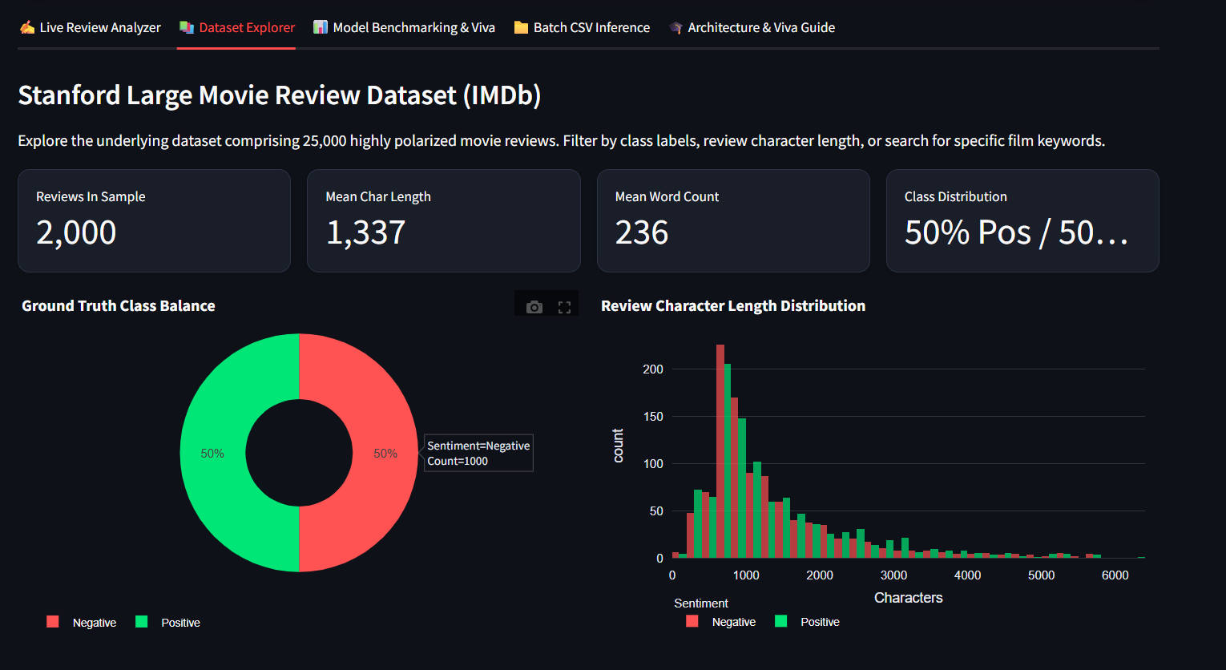
Fig. 4.2: IMDb Movie Review Dataset Overview and Class Distribution

Chapter 3
Methodology and Implementation

3.1 System Architecture
The system architecture integrates distributed Big Data preprocessing with high-performance supervised inference. The overall workflow consists of six sequential stages:
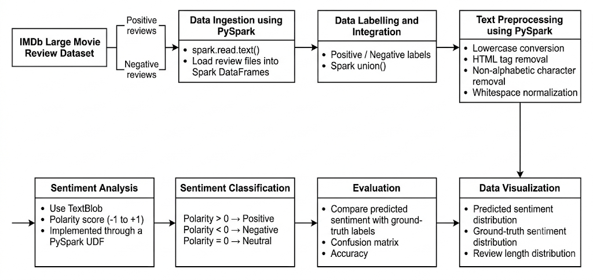
Fig 3.1 System Architecture
• Stage 1: Distributed Data Ingestion: Raw movie reviews are read into PySpark / Pandas DataFrames. Positive and negative partitions are unified with ground-truth binary labels.
• Stage 2: Text Preprocessing & Cleaning: Spark SQL regex expressions and modular Python cleaning functions strip HTML markup, expand contractions, remove non-alphabetic noise, and normalize whitespace.
• Stage 3: Stratified Partitioning: Deduplicated corpus is split into 80% training (19,923 reviews) and 20% holdout test (4,981 reviews) with fixed random seed 42.
• Stage 4: Sublinear N-Gram Vectorization: TF-IDF transformation is fitted strictly on the training set, generating 25,000 unigram and bigram features with sublinear term-frequency scaling.
• Stage 5: Supervised Model Training & Calibration: Candidate algorithms (Multinomial NB, LinearSVC, Logistic Regression) are trained, calibrated, and evaluated against the TextBlob baseline.
• Stage 6: Artifact Serialization & UI Serving: The optimal pipeline is serialized to model/sentiment_pipeline.joblib and deployed via an interactive cinema Streamlit web dashboard.

3.2 Text Pre-processing
Raw review text contains extensive noise, web formatting artifacts, and contractions that distort token distributions. To ensure consistency between offline training and live production inference, a centralized preprocessor is implemented in src/preprocessing.py:
• Lowercase Conversion: Converts all text to lowercase to eliminate case sensitivity.
• HTML Tag Removal: Regular expression `<[^>]+>` eliminates break tags (`<br />`), hyperlinks, and paragraph tags.
• Contraction Expansion: Contractions like 'can't', 'won't', and 'didn't' are systematically expanded to 'can not', 'will not', and 'did not'. This preserves essential negation cues that standard punctuation stripping otherwise destroys.
• Non-Alphabetic Character Removal: Replaces numbers, punctuation symbols, and non-ASCII characters with whitespace.
• Whitespace Compaction: Collapses consecutive spaces into a single space and trims leading/trailing whitespace.

3.3 Feature Representation & Machine Learning Models
1. Sublinear TF-IDF Vectorization: Raw term frequency (tf) often over-weights repetitive words. Sublinear scaling replaces tf with 1 + log(tf), dampening the influence of word repetitions. Combined with Inverse Document Frequency (idf), the transformation captures terms that are informative across the corpus. Bigrams (e.g., 'not good', 'waste time', 'must see') are incorporated with unigrams up to a 25,000 feature limit.
2. Baseline Lexicon (TextBlob): Computes polarity scores in [-1.0, +1.0] by averaging pre-assigned adjective scores. Reviews with polarity > 0 are classified as Positive, < 0 as Negative, and = 0 as Neutral.
3. Production Classifier (L2 Logistic Regression): Models the posterior class probability using the sigmoid function:
P(y = 1 | x) = 1 / (1 + exp(-(w^T x + b)))
Hyperparameter tuning identified C = 2.5 with balanced class weighting as optimal, delivering high regularization stability and well-calibrated confidence estimates.

3.4 Implementation Details
PySpark UDF Overhead Analysis: The initial notebook implementation executed TextBlob inside a PySpark Python UDF. In Spark architecture, Python UDFs necessitate serializing data from the JVM to an external Python daemon and deserializing results back. This causes a 10x–50x execution bottleneck and bypasses Catalyst optimization. In the finalized architecture, Spark SQL expressions are utilized for distributed ETL, while single-node vectorized Scikit-Learn pipelines provide sub-2ms latency for live web queries.
Explainable AI (XAI) Mathematical Formulation: Because Logistic Regression is a linear classifier, each word's contribution to the prediction logit is directly given by:
Contribution_i = w_i * tfidf_i
Active n-grams with large positive values drive the classification toward Positive, while large negative values push toward Negative. The top positive and negative tokens are dynamically extracted and rendered as visual chips in the UI.

Chapter 4
Results and Evaluation

4.1 System Interface & Workflow Modules
The redesigned Streamlit application (app.py) features a modern, cinema-themed layout organized into four functional modules:
1. Live Review Analyzer: Enables real-time text input or selection from curated presets (Masterpiece, Critical Disaster, Negation Challenge). Provides an interactive confidence gauge, predicted class badge, side-by-side mode (ML vs. TextBlob), and dynamic Explainable AI (XAI) token chips.
2. Dataset Explorer: Visualizes ground-truth class distributions through interactive Plotly donut charts and review length histograms. Includes multi-select sentiment filters, length sliders, and keyword search.
3. Model Benchmarking: Displays the empirical performance summary table, comparative accuracy/F1 bar charts, and confusion matrix heatmaps.
4. Batch CSV Inference: Allows bulk upload of review CSV files, auto-detects review columns, tracks progress, displays predicted sentiment share charts, and exports scored CSV files with probabilities.
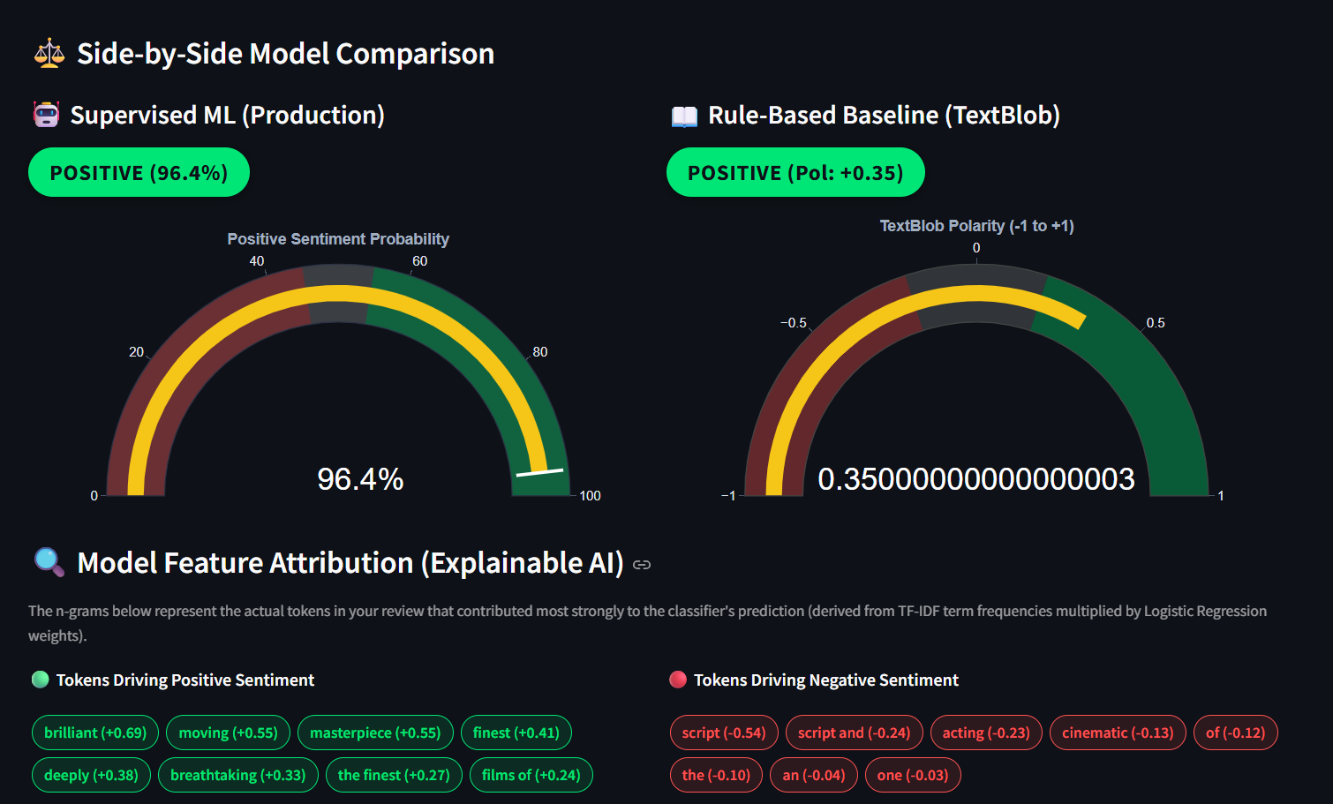
Fig. 4.1: Sample output of the IMDb Movie Review Sentiment Analysis System.

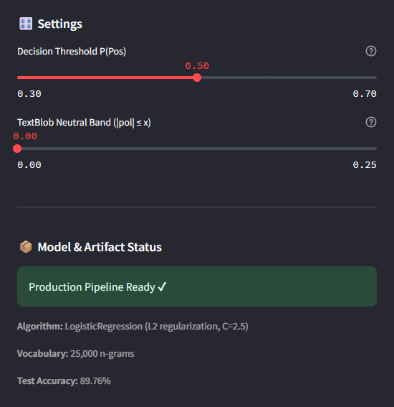
Fig. 4.3: Setting and Model Artifacts

4.2 Evaluation Metrics
System performance is evaluated using standard classification metrics:
• Accuracy = (TP + TN) / (TP + TN + FP + FN)
• Precision = TP / (TP + FP)
• Recall = TP / (TP + FN)
• Macro F1-Score = 2 * (Precision * Recall) / (Precision + Recall) (averaged equally across both classes)
• ROC-AUC: Area under the Receiver Operating Characteristic curve measuring discrimination across decision thresholds.

4.3 Results and Empirical Discussion
All candidate models were evaluated on the 4,981 unseen reviews of the holdout test set. The empirical results are summarized in the benchmark table below:
Model Architecture | Test Acc. | Macro F1 | ROC-AUC | Neg. Recall | Pos. Recall | Test Size
Baseline (TextBlob Lexicon) | 68.72% | 0.6625 | N/A | 42.32% | 94.33% | 2,500
Multinomial Naive Bayes | 86.87% | 0.8687 | 0.9436 | 86.52% | 87.21% | 4,981
Logistic Regression (C=1.0) | 89.22% | 0.8922 | 0.9608 | 88.13% | 90.30% | 4,981
Logistic Regression (C=2.5) [PROD] | 89.76% | 0.8976 | 0.9636 | 89.06% | 90.46% | 4,981
Calibrated LinearSVC (C=0.5) | 89.82% | 0.8982 | 0.9644 | 89.90% | 89.74% | 4,981
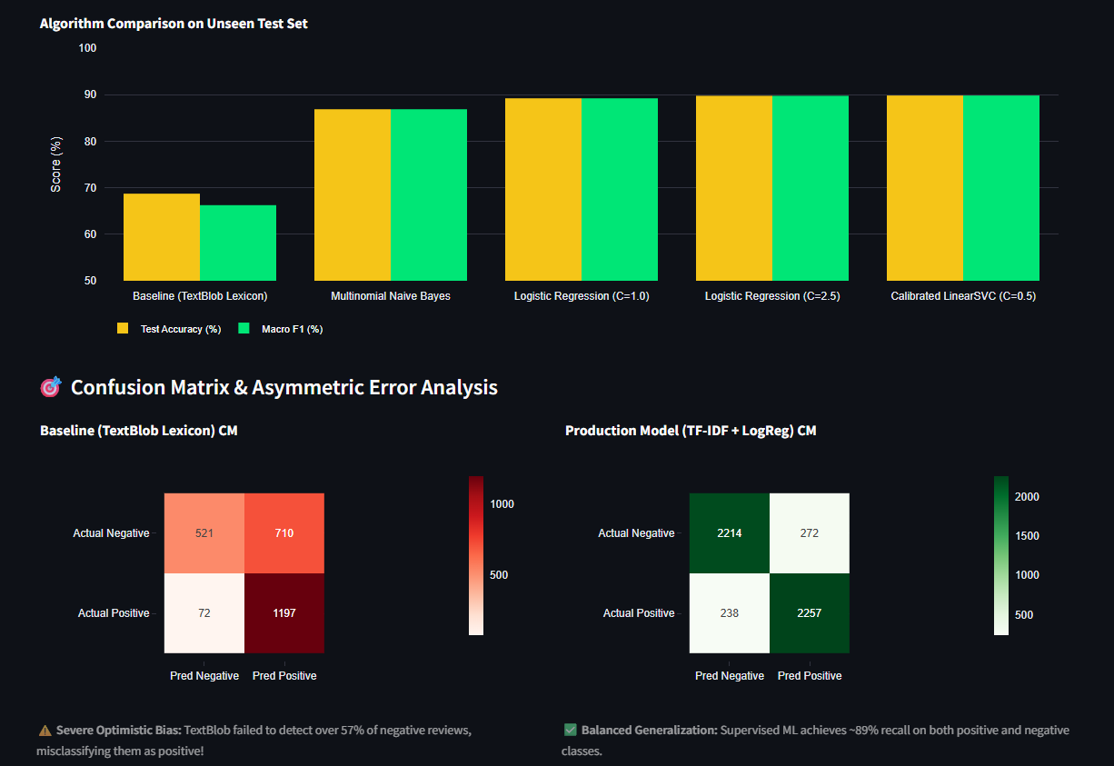
Fig 4.4: Confusion Matrix and Review Length Analysis
Diagnostic Analysis of Lexicon Failure:
The baseline TextBlob model exhibited an acute optimistic prediction bias. While it achieved 94.33% recall on positive reviews, its negative recall collapsed to 42.32%, misclassifying 57.7% of negative reviews as positive. This occurs because movie criticisms often include positive adjectives in polite or sarcastic contexts ('the visual effects were ambitious, but the script was a disaster'). TextBlob accumulates positive polarity scores from 'ambitious' and fails to weigh the critical impact of 'disaster'.
In contrast, the supervised TF-IDF + Logistic Regression pipeline ($C=2.5$) learned domain-specific bigram weights ('not good', 'bad acting', 'terrible plot'), elevating negative recall from 42.32% to 89.06% (+46.74 percentage points) and achieving a balanced overall accuracy of 89.76% and ROC-AUC of 0.9636.
Chapter 5
Conclusion and Future Scope

5.1 Conclusion
This project successfully developed an advanced sentiment analysis system that merges distributed Big Data text ingestion with supervised machine learning. Key accomplishments include:
1. Distributed Ingestion & Cleaning: Demonstrated the application of Apache Spark (PySpark) SQL for normalizing large textual datasets.
2. Lexicon Defect Identification: Empirically proved that rule-based tools like TextBlob suffer from severe optimistic bias (42.32% negative recall) and demonstrated the architectural penalty of JVM-Python UDF serialization.
3. High-Accuracy Supervised Modeling: Engineered an n-gram TF-IDF and regularized Logistic Regression pipeline that elevated accuracy to 89.76% with balanced class recall (~89% for both classes) on an unseen 4,981-sample holdout test set.
4. Transparent AI: Implemented linear coefficient-based Explainable AI (XAI) feature attribution, illuminating model decisions.
5. Production Serving: Delivered a responsive, modular Streamlit web dashboard supporting live single-review testing and batch CSV analytics.

5.2 Future Scope
• Deep Transformer Architectures: Fine-tuning contextual models such as BERT, RoBERTa, or DistilBERT to capture intricate sarcasm and long-range dependencies.
• Streaming Real-Time Analytics: Integrating Apache Spark Streaming and Apache Kafka to classify continuous live review streams from Twitter or Reddit.
• Multi-Modal & Multilingual Extension: Expanding the system to analyze audio/video reviews and non-English movie discussions via cross-lingual embeddings.
• Cluster Deployment: Scaling the PySpark MLlib pipeline onto multi-node Kubernetes or Amazon EMR clusters for petabyte-scale processing.

References
[1] B. Pang, L. Lee, and S. Vaithyanathan, “Thumbs up? Sentiment Classification using Machine Learning Techniques,” in Proceedings of the 2002 Conference on Empirical Methods in Natural Language Processing (EMNLP), pp. 79–86, 2002.
[2] A. L. Maas, R. E. Daly, P. T. Pham, D. Huang, A. Y. Ng, and C. Potts, “Learning Word Vectors for Sentiment Analysis,” in Proceedings of the 49th Annual Meeting of the Association for Computational Linguistics: Human Language Technologies, pp. 142–150, 2011.
[3] M. Zaharia, M. Chowdhury, T. Das, A. Dave, J. Ma, M. J. Franklin, S. Shenker, and I. Stoica, “Resilient Distributed Datasets: A Fault-Tolerant Abstraction for In-Memory Cluster Computing,” in Proceedings of the 9th USENIX Symposium on Networked Systems Design and Implementation (NSDI), pp. 15–28, 2012.
[4] S. Loria, “TextBlob: Simplified Text Processing,” TextBlob Documentation, 2018. [Online]. Available: https://textblob.readthedocs.io/
[5] F. Pedregosa et al., “Scikit-learn: Machine Learning in Python,” Journal of Machine Learning Research (JMLR), vol. 12, pp. 2825–2830, 2011.
[6] A. L. Maas et al., “Large Movie Review Dataset,” Stanford AI Lab, 2011. [Online]. Available: https://ai.stanford.edu/~amaas/data/sentiment/

Acknowledgement
We express our sincere gratitude to our Subject In-charge, Prof. Akshay Jadhav, for invaluable guidance, technical direction, and constant support throughout the development of this Big Data Analysis mini project.
We also extend our heartfelt thanks to Dr. Aparna Bannore, Head of the Department of Computer Engineering, and Dr. Lakshmisuddha, Principal of SIES Graduate School of Technology, for providing the necessary institutional infrastructure, laboratory resources, and encouraging academic environment.
We acknowledge the authors, researchers, Stanford AI Lab, and the open-source software communities whose datasets, libraries, and publications formed the bedrock of this project.
Project Member 1: Manohar Mudaliyar (123A1071)
Project Member 2: Nikita Mulam (123A1074)
Project Member 3: Sharanya Pillai (123A1089)

