**VISVESVARAYA TECHNOLOGICAL UNIVERSITY**

**BE****LAGAVI – 590018**



**Under guidance of**

BACHELOR OF ENGINEERING

IN

INFORMATION SCIENCE & ENGINEERING

**Submitted in partial fulfilment of the requirements of the award of degree of**

**Prof. N Nithaksha** Assistant Professor

Dept of IS&E

VVCE, Mysuru

**Dr. Md Mudassir**

Assistant Professor

Dept of IS&E

VVCE, Mysuru

**2021-2022**

**DEPARTMENT OF INFORMATION SCIENCE AND ENGINEERING**

**VIDYAVARDHAKA COLLEGE OF ENGINEERING**

**MYSURU-570002**

**Submitted By**

**Manoj M 4VV19IS045**

**Jeevan Dsouza 4VV19IS033**

**Harshitha N 4VV19IS029**

**Manohar S N 4VV19IS044**

**A MINI-PROJECT REPORT ON**

**“Leftover Food Management System”**



Department of Information science and Engineering

Gokulam 3rd Stage, Mysuru-560002

Vidyavardhaka College of Engineering

This is to certify the mini-project entitled “ **Leftover food management system** ” is a bona fide carried by out **Manoj M (4VV19IS045),Jeevan Dsouza (4VV19IS033), Harshitha N (4VV19IS029) and Manohar S N (4VV19IS045)** students of 5th semester Information Science and Engineering , **Vidyavardhaka College of Engineering, Mysuru** in partial fulfilment for the award of the **Degree of Bachelor of Engineering in Information Science & Engineering** of **Visvesvaraya Technological University , Belagavi**, during the academic year 2021-2022.It is certified that all the suggestion and corrections indicated for the internal assessment have been incorporated in the report deposited in department library. The report has been approved as it satisfies the requirements in respect of mini-project work prescribed for the said degree.

**CERTIFICATE**

**Signature of the Guide**

**Signature of the Guide**

**Signature of the HOD**

**(Dr. Rajendra A B)**

**(Prof. N Nithaksha)**

**(Dr. Md Mudassir)**

**Name of the Examiners**

**1)**

**2)**

**Signature with date**

## ACKNOWLEDGEMENT

**Manoj M 4VV19IS045**

**Jeevan Dsouza 4VV19IS033**

**Harshitha N 4VV19IS029**

**Manohar S N 4VV19IS044**

The Mini project would not have been possible without the guidance, assistance, and suggestions of many individuals. I would like to express our deep sense of gratitude and indebtedness to each one who has helped me to make this project a success.

We heartily thank our beloved Principal, **Dr. B Sadashive Gowda** for his wholehearted support and for his kind permission to undergo the mini project.

We wish to express our deepest gratitude to **Dr. Rajendra A B**, Head of Department, Information Science and Engineering, VVCE, for his constant encouragement and inspiration in taking up this mini project.

We gracefully thank our mini-project guides, **Dr. Md Mudassir,** Assistant Professor and **Prof. N Nithaksha,** Assistant Professor, Dept. of information Science and Engineering for their encouragement and advice throughout the course of the mini project work.

In the end, we are anxious to offer our sincere thanks to our family members and friends for their valuable suggestions and encouragement.

**ABSTRACT**

Food wastage is drastically increasing nowadays and has become a topic of concern primarily due to the negative impact it has on the economic and agricultural industry. Researches are being done to find effective ways to curb it. It has been identified as a primary issue in the sustainability of food production and consumption, in addition to the sustainability of food supply chains.

Leftover Food Management System is utilized to oversee these foods in a helpful manner. Restaurants or any events having food in surplus enters the details of the food on the website where the admin keeps the data of it. The donator at whatever point if they are having wastage of food, they can login and offer demand to the admin. Likewise the admin keeps the data of the NGOs and when he receives an offer from donor, he notifies the NGO, and they can accept the food and collect it.

This Web-based Leftover Food Management system can assist in collecting the leftover food from hotels & restaurants to distribute among those in need. NGOs that are helping poor communities to battle against starvation & malnutrition can raise a request for food supply from restaurants through this application. Once the request is accepted, the NGOs can collect the food from the restaurants for its distribution. In this way this food waste management system will help restaurants to reduce food waste and will help in feeding the poor and needy people.

The front-end part of this system is built using the technologies such as EJS, CSS, JavaScript and the back-end part is built using Node.js and Express.js framework, MySQL and phpMyAdmin for database management.

**Table of contents**

**CHAPTERS**

**PAGES**

**6. References**

**21**

**2. Requirement Specification**

2.1 Hardware requirement

02

2.2 Software requirement

02

2.3 Functional requirement

05

**02**

**3. Design and Implementation**

3.1 E R Diagram

06

3.2 Schema Diagram

07

3.3 Pseudocode

08

**06**

**4. Component Modules**

**09**

**5. Results and Conclusion**

5.1 Snapshots

10

5.2 Conclusion

21

**10**

**1. Introduction**

1.1 Problem Statement

01

1.2 Overview

01

1.3 Objective

01

1.4 Scope

01

**01**

**1.INTRODUCTION**

1.1 Problem Statement

A drastic increase can be seen in food waste. As per data given by Food and Agriculture Organization, 1/3rd of food produced for human consumption is wasted globally, which accounts for almost 1.3 billion tons per year. On the other hand, also as per WHO 20% of population face extreme food shortages. Hence there is a need to come up with a solution that can avoid food waste and can help the needy.

1.2 Overview

This web-based Food Waste Management System can assist in collecting the leftover food from hotels and restaurants to distribute among those in need. NGOs that are helping the poor communities to battle against starvation and malnutrition can raise a request for food supplies from restaurants through this application. Once the request is accepted, NGOs can collect the food from the restaurants for its distribution. In this way this application will help restaurants in reducing food wastage and will help in feeding the poor and needy people.

1.3 Objective

1.4 Scope

The main objective of this project is to reduce food wastage by facilitating food sharing using web technology in a useful way. It helps both the restaurant (reducing food wastage), and the needy. Keeps track of wastage of food for restaurant also.

Leftover food management system is a website designed to collect surplus food from the restaurants and distribute to those in need. If anyone have leftover foods, they can enter their food quantity details in that website and then the admin maintains the details of food donator.

The donator can create the account and whenever they are having leftover food, they can login and give request to the admin. And the admin also maintains the NGO details too.

The main scope of this project is to efficiently reduce wastage of food. While all the food that is being wasted, some families can barely afford proper meals. So, this is an initial step towards designing a better system to reduce daily food waste .

**2.REQUIREMENTS SPECIFICATION**

2.1 Hardware Requirement

* Processor: AMD FX 630 1200 or above
* CPU Speed: 2.0 GHz
* Storage Capacity: 30 GB
* Browser: Any modern browser
* RAM Capacity: 3 GB

2.2 Software Requirement

* Frontend: EJS, CSS, JavaScript.
* Backend: Node.js, Express.js
* Operating System: Windows or Linux or Unix based OS
* Database: MySQL
* Web Server: Xampp

2.2.1 Introduction to Frontend

**EJS**

EJS or Embedded JavaScript Templating is a templating engine used by Node.js. Template engine helps to create an HTML template with minimal code. Also, it can inject data into HTML template at the client side and produce the final HTML. EJS is a simple templating language which is used to generate HTML markup with plain JavaScript. It also helps to embed JavaScript to HTML pages.

The thing we need to do is to set EJS as our templating engine with Express which is a Node.js web application server framework, which is specifically designed for building single-page, multi-page, and hybrid web applications. It has become the standard server framework for node.js [1].

**CSS**

**JavaScript**

**Node.js**

Cascading Style Sheets, fondly referred to as CSS, is a simple design language intended to simplify the process of making web pages presentable. CSS handles the look and feel part of a web page. Using CSS, you can control the colour of the text, the style of fonts, the spacing between paragraphs, how columns are sized and laid out, what background images or colours are used, layout designs, variations in display for different devices and screen sizes as well as a variety of other effects. CSS is easy to learn and understand but it provides powerful control over the presentation of an HTML document [2].

Node.js is a platform built on Chrome's JavaScript runtime for easily building fast and scalable network applications. Node.js uses an event-driven, non-blocking I/O model that makes it lightweight and efficient, perfect for data-intensive real-time applications that run across distributed devices

Node.js is an open source, cross-platform runtime environment for developing server-side and networking applications. Node.js applications are written in JavaScript, and can be run within the Node.js runtime on OS X, Microsoft Windows, and Linux.

2.2.2 Introduction to Backend

JavaScript often abbreviated JS, is a programming language that is one of the core technologies of the World Wide Web, alongside HTML and CSS Over 97% of websites use JavaScript on the client side for web page behaviour, often incorporating third-party libraries. All major web browsers have a dedicated JavaScript engine to execute the code on users’ devices. JavaScript is a high-level, often just-in-time compiled language that conforms to the ECMAScript standard. It has dynamic typing, prototype-based object-orientation, and first-class functions. It is multi-paradigm, supporting event driven, functional, and imperative programming styles. It has application programming interfaces (APIs) for working with text, dates, regular expressions, standard data structures, and the Document Object Model [3].

**Express.js**

Node.js also provides a rich library of various JavaScript modules which simplifies the development of web applications using Node.js to a great extent.

Npm bundled with Node.js. It runs on the command npm. It is a package manager that downloads packages into a node_modules folders. You call the downloaded packages through const libraryModule = require(“libraryname”) [4].

Express is a fast, assertive, essential and moderate web framework of Node.js. You can assume express as a layer built on the top of the Node.js that helps manage a server and routes. It provides a robust set of features to develop web and mobile applications [5].

Core features of Express framework:

* It can be used to design single-page, multi-page and hybrid web applications.
* It allows to setup middleware’s to respond to HTTP Requests.
* It defines a routing table which is used to perform different actions based on HTTP method and URL.
* It allows to dynamically render HTML Pages based on passing arguments to templates.

2.2.3 Introduction to MySQL

The SQL Server is a database Server that implements as the name says Structured Query Language (SQL). It is a relational database management system from Microsoft. The system is designed and built to manage and store information. The system supports various business intelligence operations, analytics operations, and transaction processing.

It a database server by Microsoft. Microsoft SQL Server is a full-featured relational database management system (RDBMS) that offers a variety of administrative tools to ease the burdens of database development, maintenance and administration. In this article, we'll cover six of the more frequently used tools: Enterprise Manager, Query Analyser, SQL Profiler, Service Manager, Data Transformation Services and Books Online [6].

2.2.4 Introduction to Apache web server

Apache Server is a free and open-source web server that delivers web content through the internet. It is commonly referred to as Apache and after development, it quickly became the most popular HTTP client on the web. Apache is a cross-platform software, therefore it works on both Unix and Windows servers. It mainly establishes a connection between a Server and the browsers of website visitors (Such as Firefox, Google Chrome, Safari, etc.) while delivering files back and forth between the client-server structure. The primary platform for running Apache 2.4 is Windows 2000 or later. Most importantly we are using this since it incorporates with PHP/MySQL [7] .

2.2.5 Introduction to IDE

Visual Studio Code is a lightweight but powerful source code editor which runs on your desktop and is available for Windows, macOS and Linux. It comes with built-in support for JavaScript, TypeScript and Node.js and has a rich ecosystem of extensions for other languages (such as C++, C#, Java, Python, PHP, Go) and runtimes (such as .NET and Unity).

Instead of a project system, it allows users to open one or more directories, which can then be saved in workspaces for future reuse. This allows it to operate as a  language-agnostic code editor for any language. It supports many programming languages and a set of features that differs per language. Unwanted files and folders can be excluded from the project tree via the settings. Many Visual Studio Code features are not exposed through menus or the user interface but can be accessed via the command palette.

2.3 Functional Requirement

* An admin will login using his/her username and password.
* The Restaurants and NGOs login through their email and password.
* Restaurants place the order to collect the surplus food.
* The admin goes through the order and takes action accordingly.
* After the admin’s approval the NGOs accepts the order.
* Even guest users can donate food by providing their necessary identification and description of the food.
* Admin will keep the log of all the orders placed, delivered, or even rejected orders.

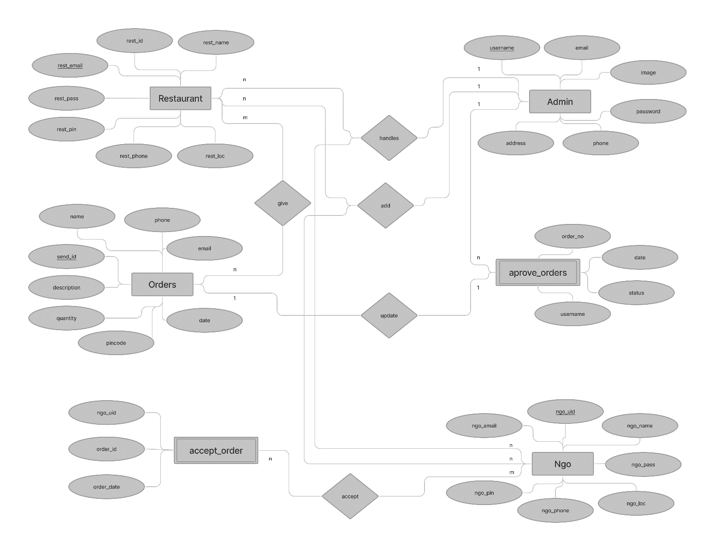

Fig 3.1: ER diagram (Entities: Admin, Restaurant, Ngo, Orders, Accepted orders, Approved orders)

3.1 ER Diagram

An ER diagram shows the relationship among entity sets. An entity set is a group of similar entities and these entities can have attributes. In terms of DBMS, an entity is a table or attribute of a table in database, so by showing relationship among tables and their attributes, ER diagram shows the complete logical structure of a database.

**3.DESIGN AND IMPLEMENTATION**

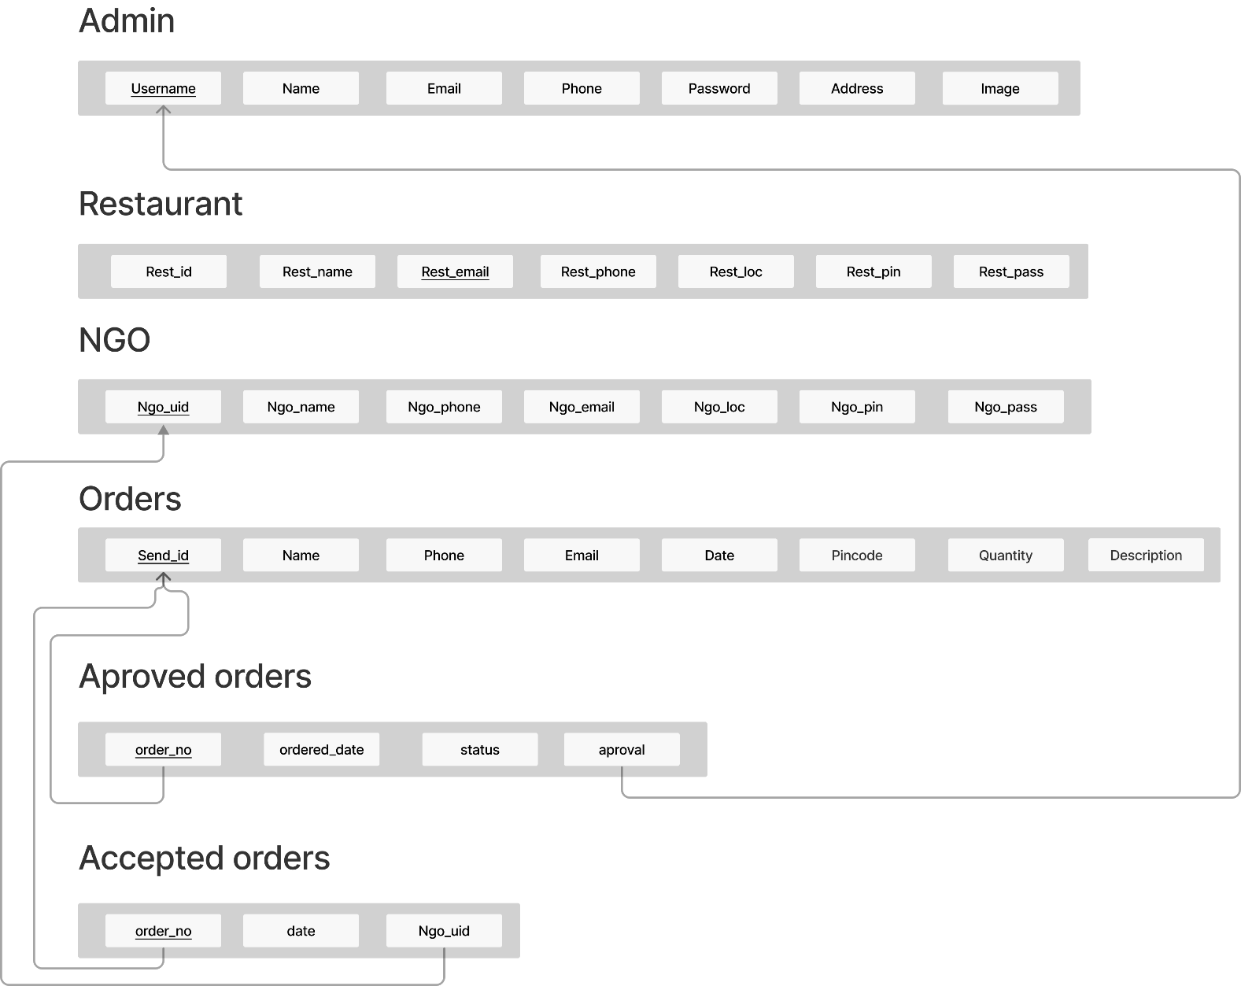

3.2 Schema Diagram

Fig 3.2: Schema diagram (The primary keys of each table are underlined and foreign keys are referenced to other tables using single headed arrows)

A schema diagram is a diagram which contains entities and the attributes that will define that schema. A schema diagram only shows us the database design. It does not show the actual data of the database. Schema can be a single table or it can have more than one table which is related.

|  |
| --- |
| 3.3 Pseudocode  **CREATE** **TABLE** `**admin**` (  `username` varchar(**50**) **NOT** **NULL**,  `name` varchar(**30**) **DEFAULT** **NULL**,  `email` varchar(**50**) **DEFAULT** **NULL**,  `pho_no` bigint(**11**) **DEFAULT** **NULL**,  `password` varchar(**255**) **NOT** **NULL**,  `address` varchar(**100**) **DEFAULT** **NULL**,  `img_path` varchar(**50**) **NOT** **NULL** **DEFAULT** 'admin.png'  );  **CREATE** **TABLE** `donors` (  `SEND_ID` int(**50**) **NOT** **NULL**,  `Name` varchar(**50**) **NOT** **NULL**,  `Phone` bigint(**100**) **NOT** **NULL**,  `Email` varchar(**100**) **DEFAULT** 'Not Mentioned',  `Date` datetime **NOT** **NULL** **DEFAULT** **current_timestamp**(),  `Quantity` int(**50**) **NOT** **NULL**,  `Pincode` int(**50**) **NOT** **NULL**,  `**desc**` text **DEFAULT** 'Not Mentioned'  );  **CREATE** **TABLE** `restaurant` (  `rest_name` varchar(**50**) **NOT** **NULL**,  `rest_email` varchar(**50**) **NOT** **NULL**,  `rest_phone` bigint(**100**) **NOT** **NULL**,  `rest_loc` varchar(**50**) **NOT** **NULL**,  `rest_pin` int(**50**) **NOT** **NULL**,  `rest_password` varchar(**50**) **NOT** **NULL** **DEFAULT** 'rest@123'  );  **CREATE** **TABLE** `ngo` (  `Name` varchar(**50**) **NOT** **NULL**,  `ngo_unique_id` varchar(**50**) **NOT** **NULL**,  `ngo_address` varchar(**100**) **NOT** **NULL**,  `ngo_pincode` int(**10**) **NOT** **NULL**,  `ngo_email` varchar(**50**) **NOT** **NULL**,  `ngo_phone` bigint(**20**) **NOT** **NULL**,  `ngo_password` varchar(**50**) **NOT** **NULL** **DEFAULT** 'ngo@123'  );  **CREATE** **TABLE** `orders` (  `ordered_Date` datetime **NOT** **NULL** **DEFAULT** **current_timestamp**(),  `order_no` int(**50**) **NOT** **NULL**,  `status` varchar(**100**) **NOT** **NULL** **DEFAULT** 'Waiting for Admin',  `aproved_admin` varchar(**100**) **DEFAULT** **NULL**  );  **CREATE** **TABLE** `log` (  `order_no` int(**50**) **NOT** **NULL**,  `date` date **NOT** **NULL** **DEFAULT** **current_timestamp**(),  `ngo_uid` varchar(**50**) **DEFAULT** **NULL**  ); |
|  |

**4.Component Modules**

* The System comprises of 3 major modules with their sub-modules as follows:

**Admin:**

1. **Login:** User can login to his personal account using his ID and Password
2. **Restaurant:**

* List all the restaurants available
* Add, Delete or Update new restaurant

1. **NGOs:**

* View all NGOs
* Add, Delete or Update new NGOs

**4. Log:**

* View History

**5. Orders:**

* Approve or Reject

**Restaurant:**

1. **Register:** Restaurants can register using their personal details.
2. **Login:** Restaurants can login to their account using ID and Password.
3. **Profile:** 
   * 1. View Profile/Restaurant details
     2. Change Password
4. **Log:**
   1. View Orders history
      1. Accepted
      2. Pending
      3. Confirmed
5. **Send food:**
   1. Quantity of Food
   2. Description

**NGOs:**

1. **Register:** NGOs can register using personal details.
2. **Login:** NGOs can login to their personal account using ID and Password.
3. **Dashboard:**
   * View details.
   * View food details sent by restaurant.
4. **Log:**

* View restaurant history

**5.Results and conclusion**

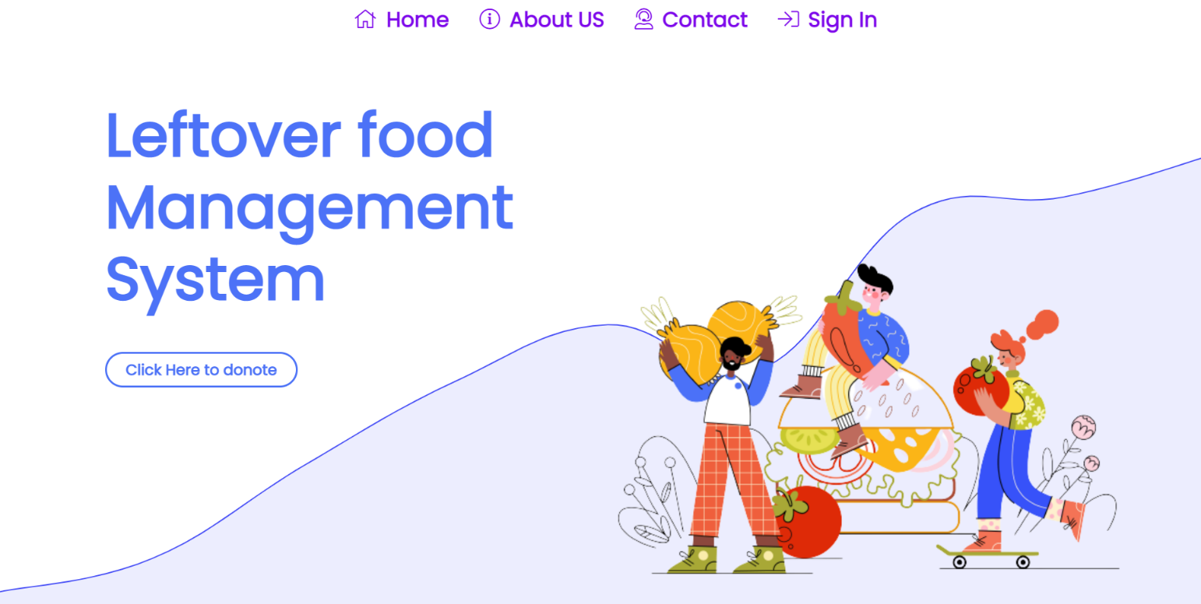

5.1 Snapshots

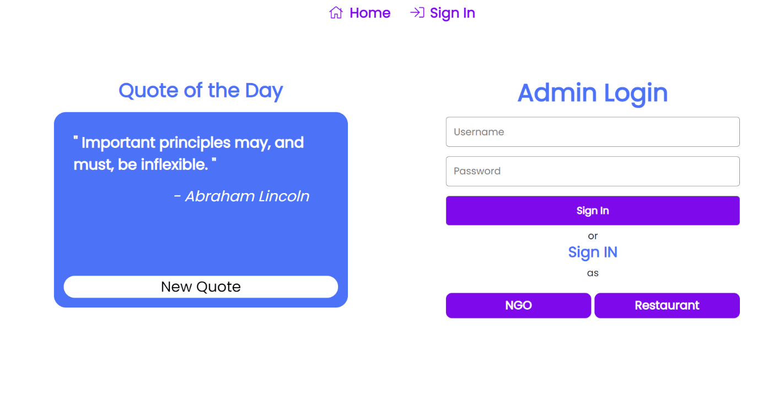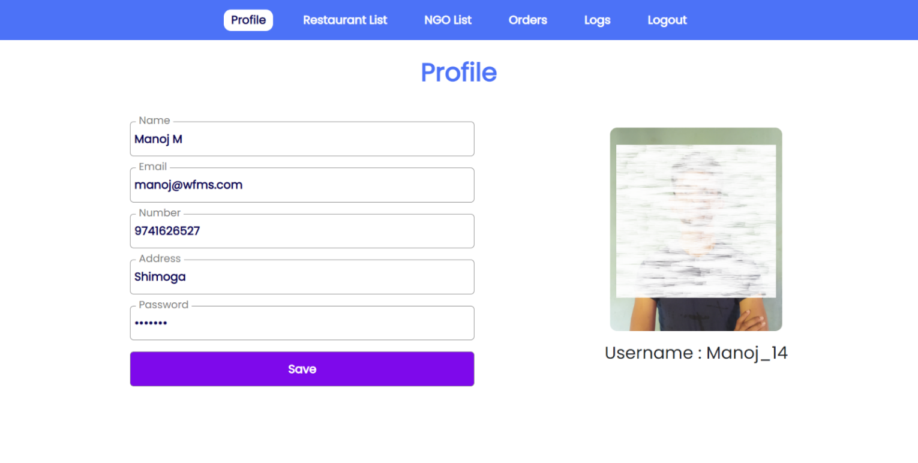

**Admin Module**

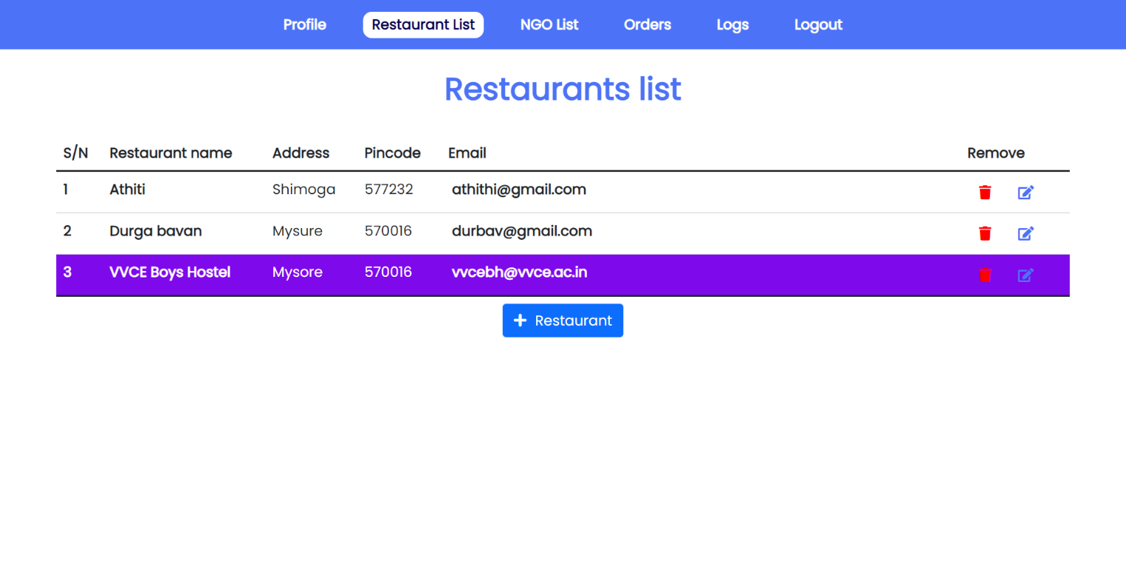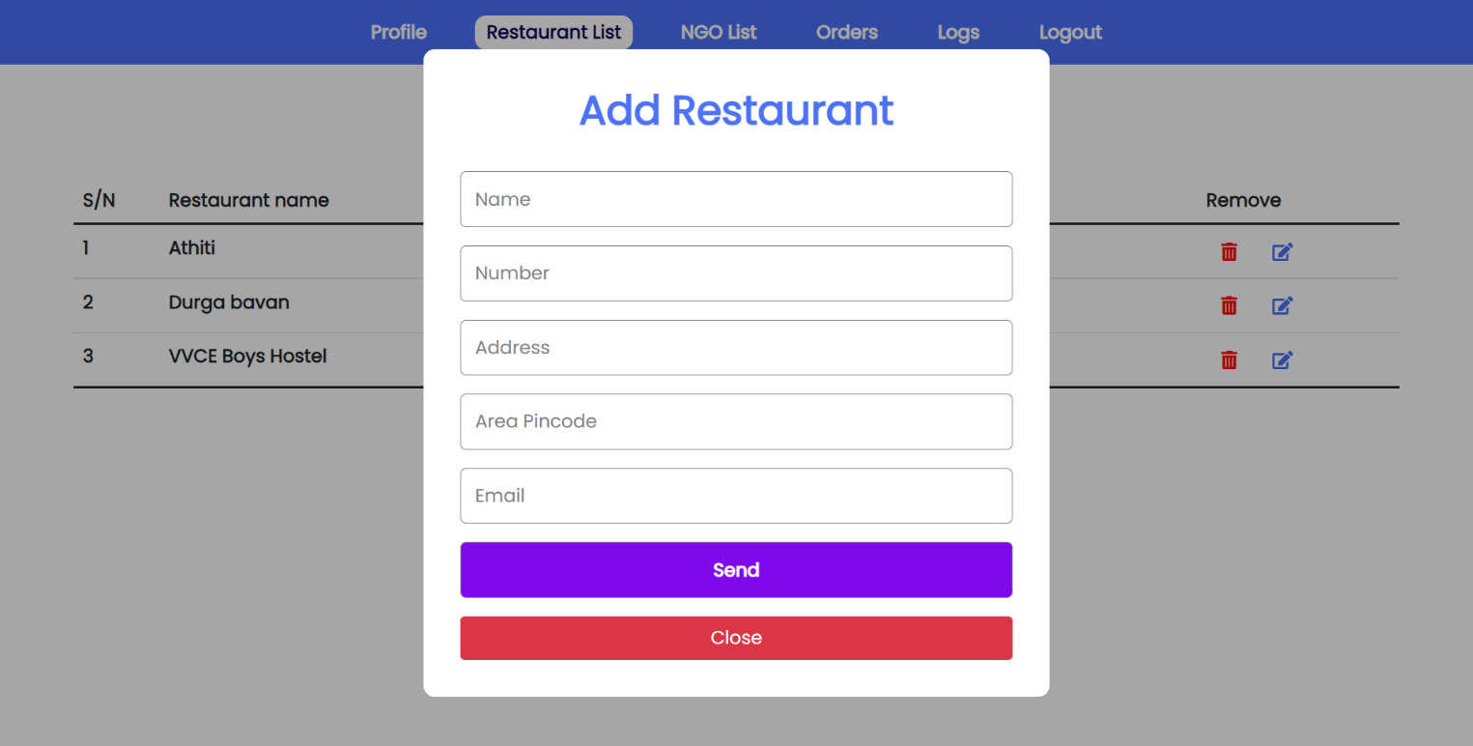

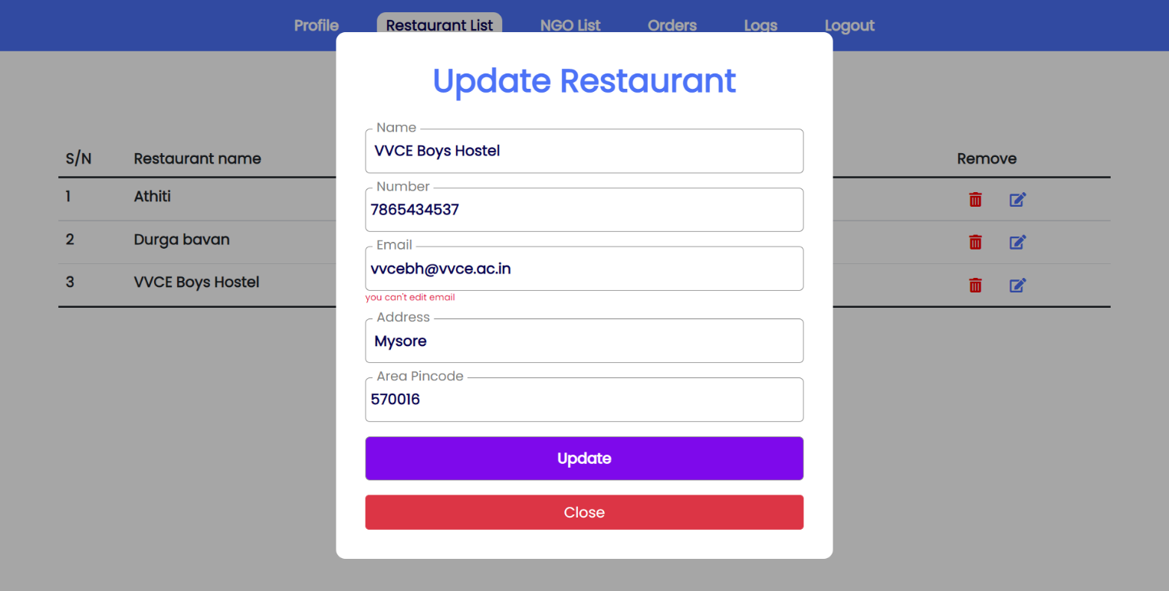

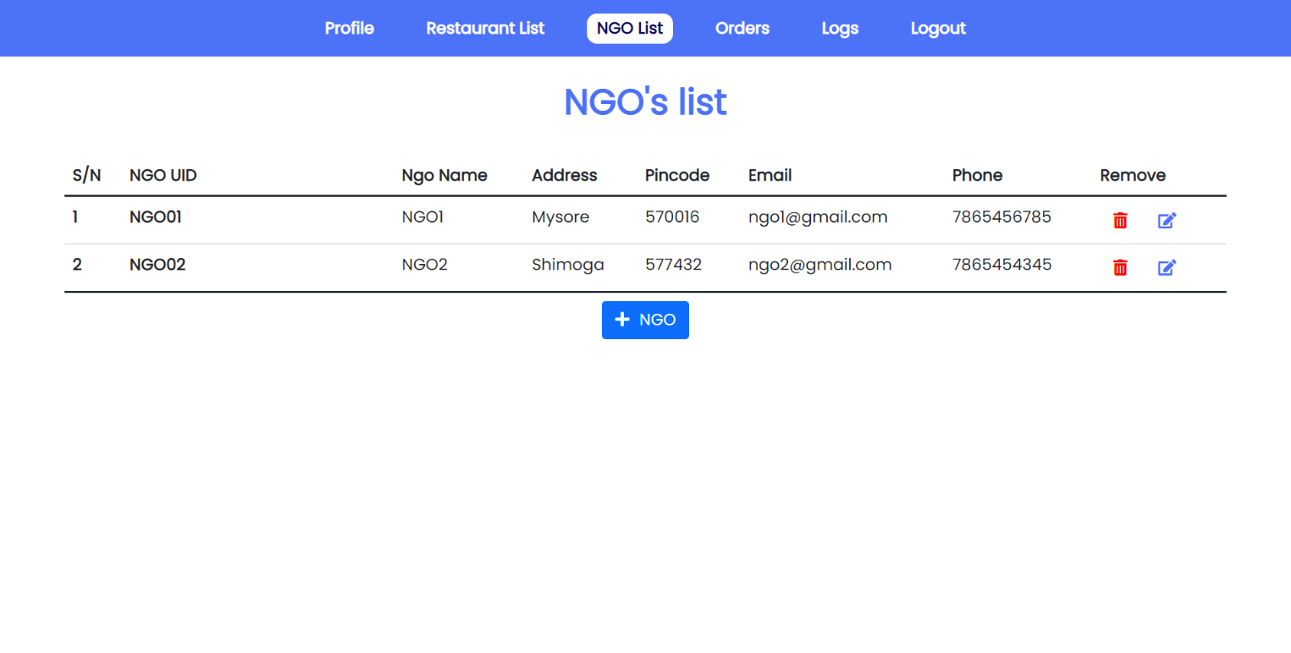

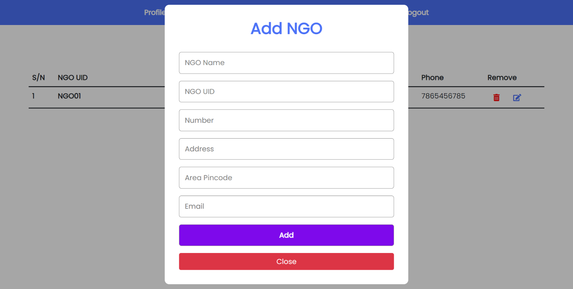

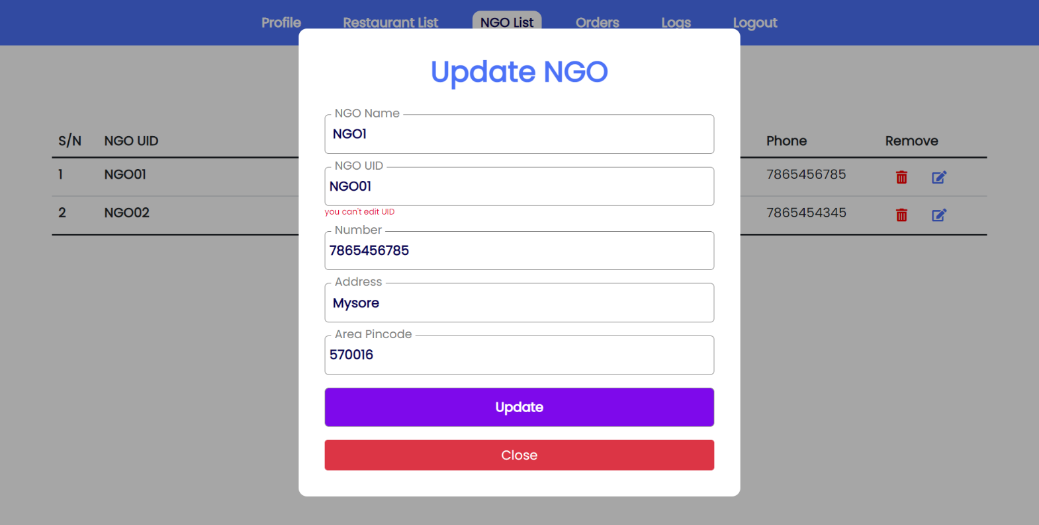

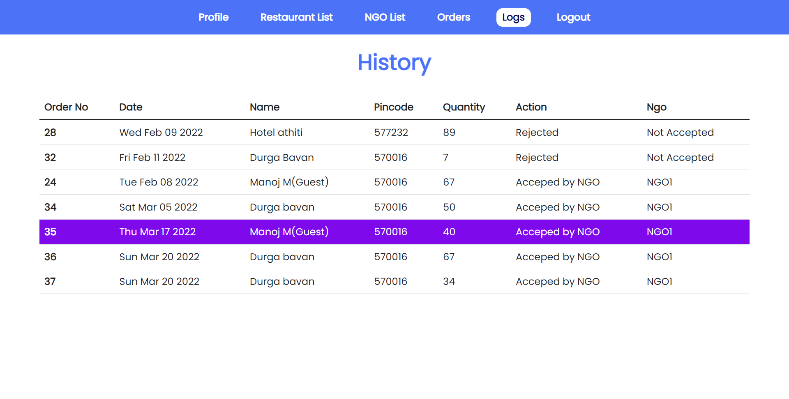

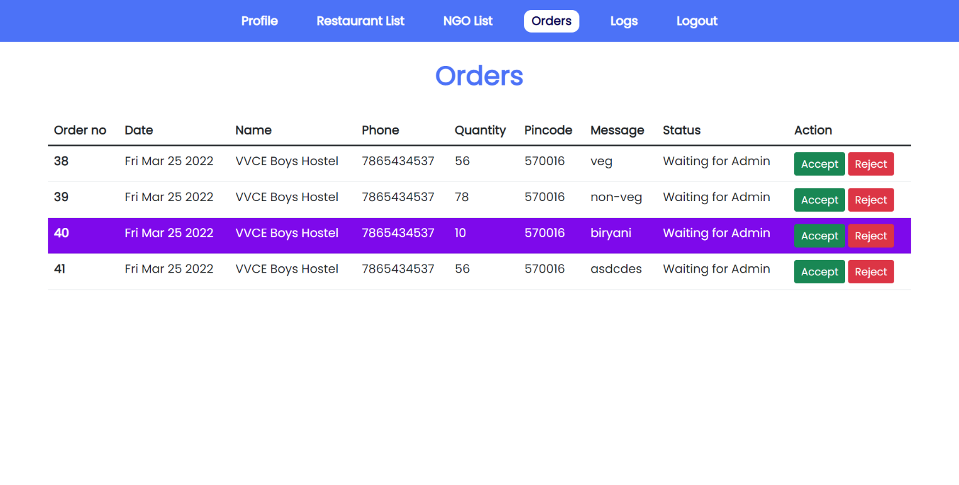

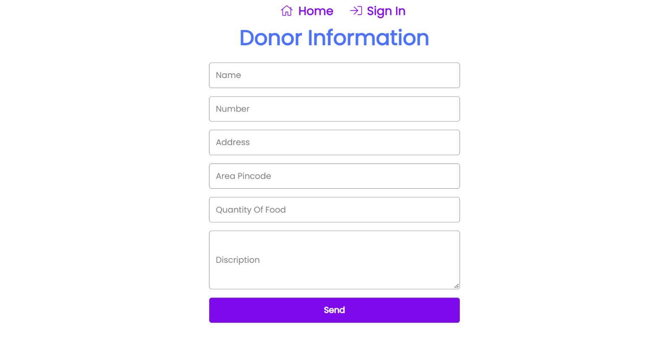

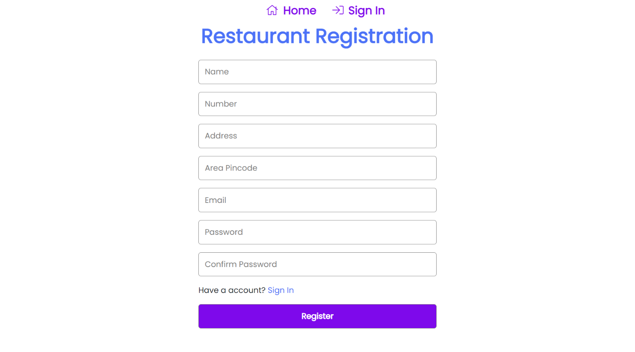

**Restaurant Module Module**

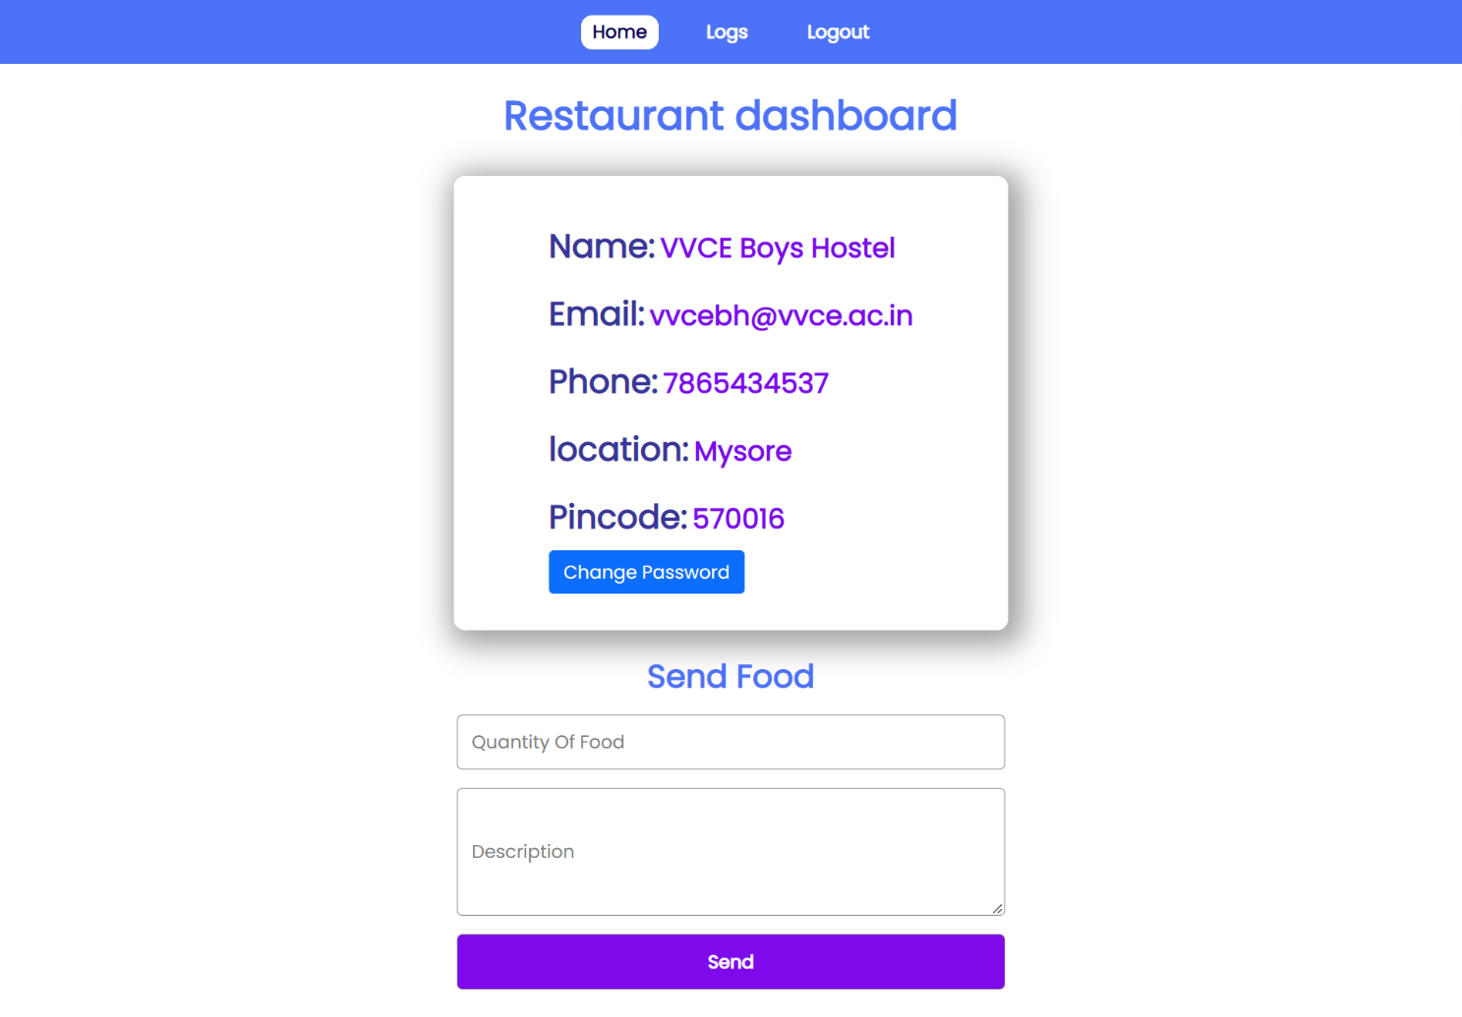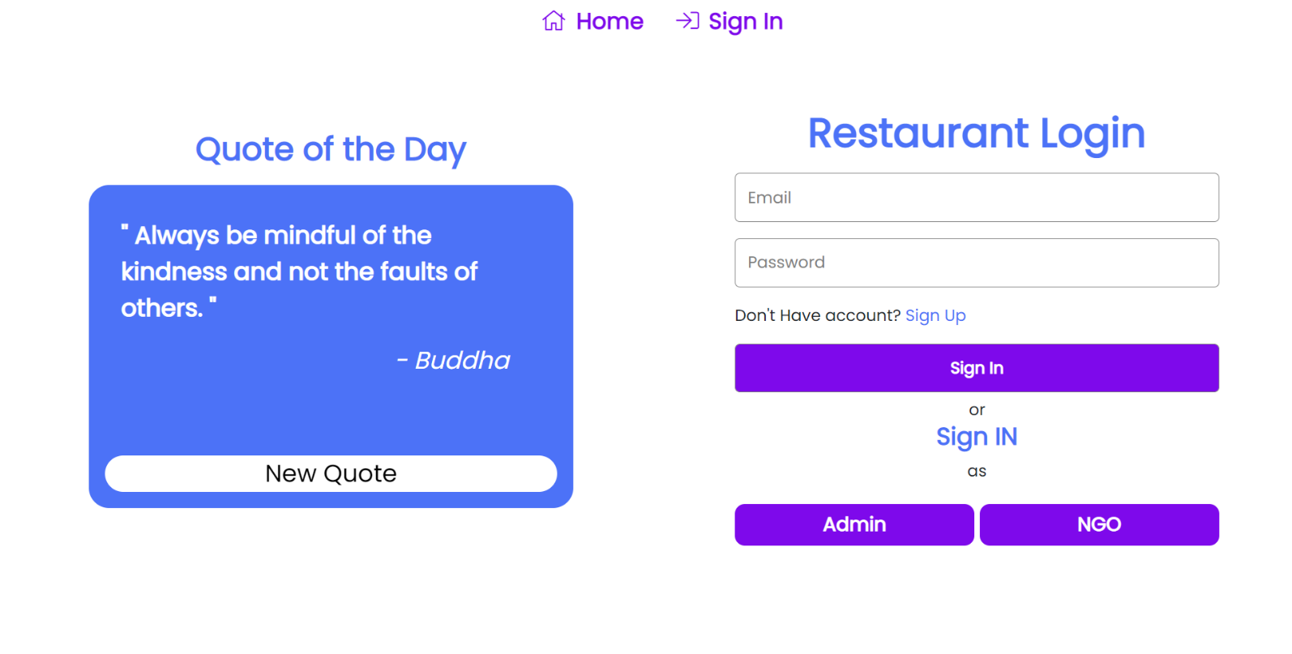

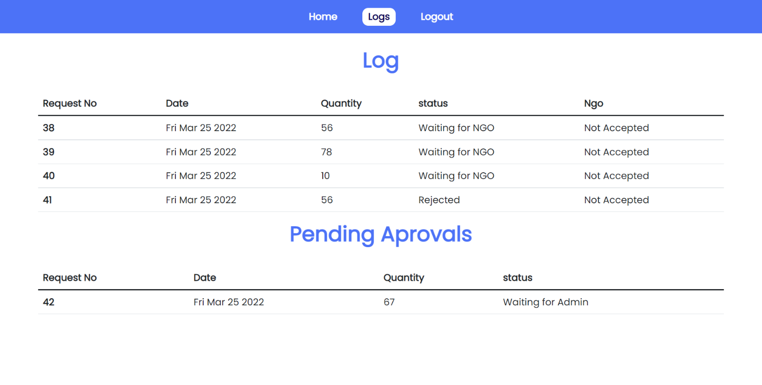

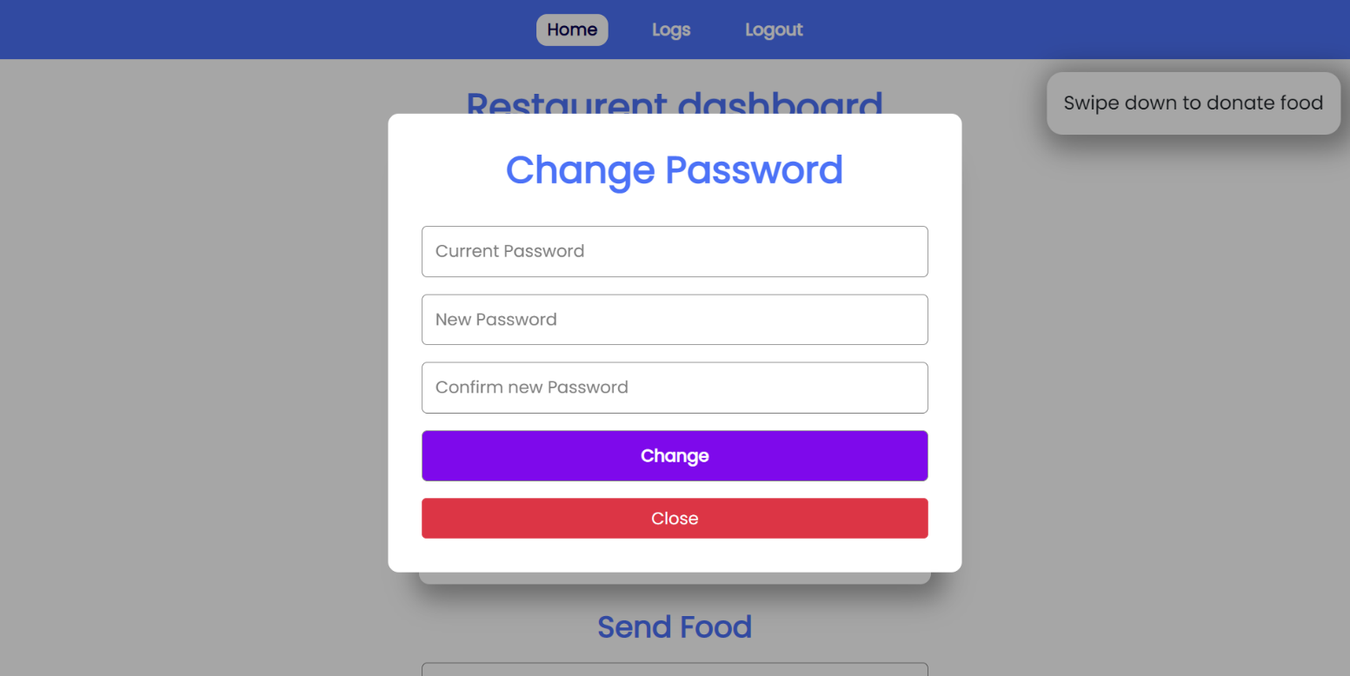

**NGO Module**

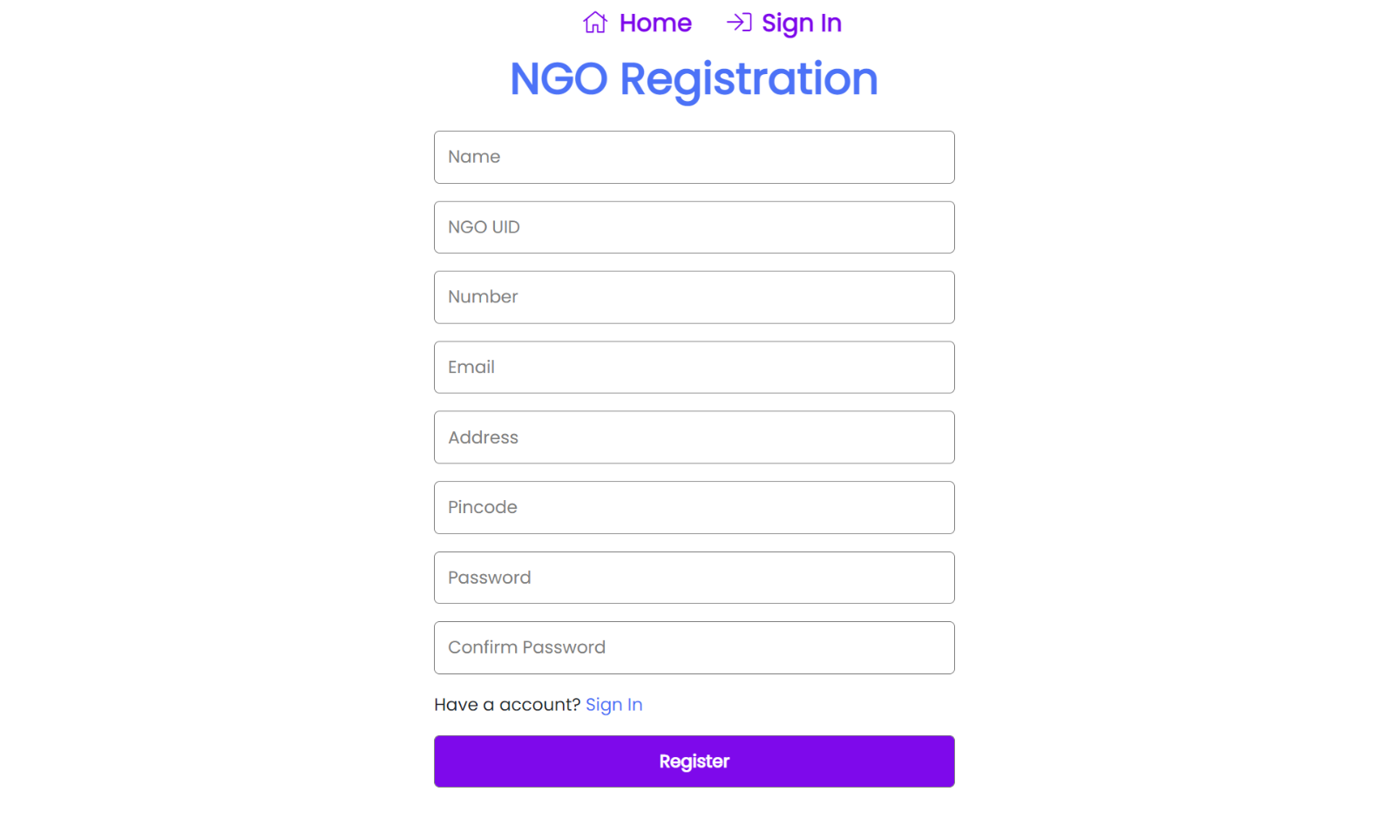

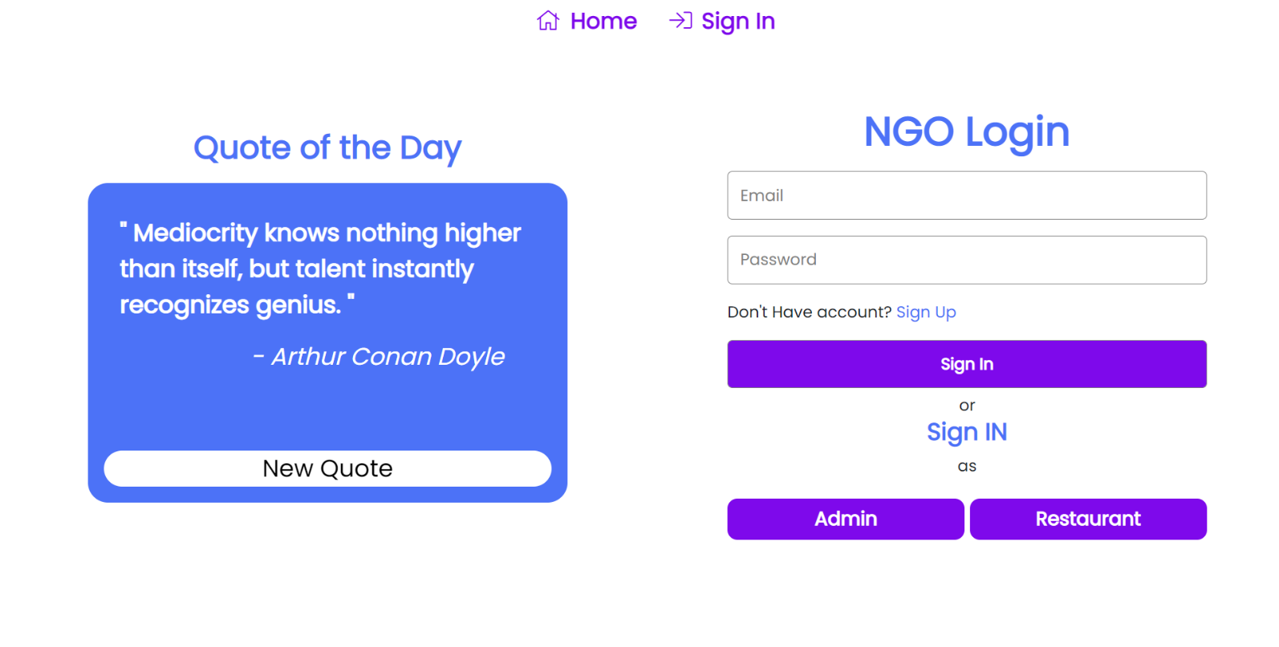

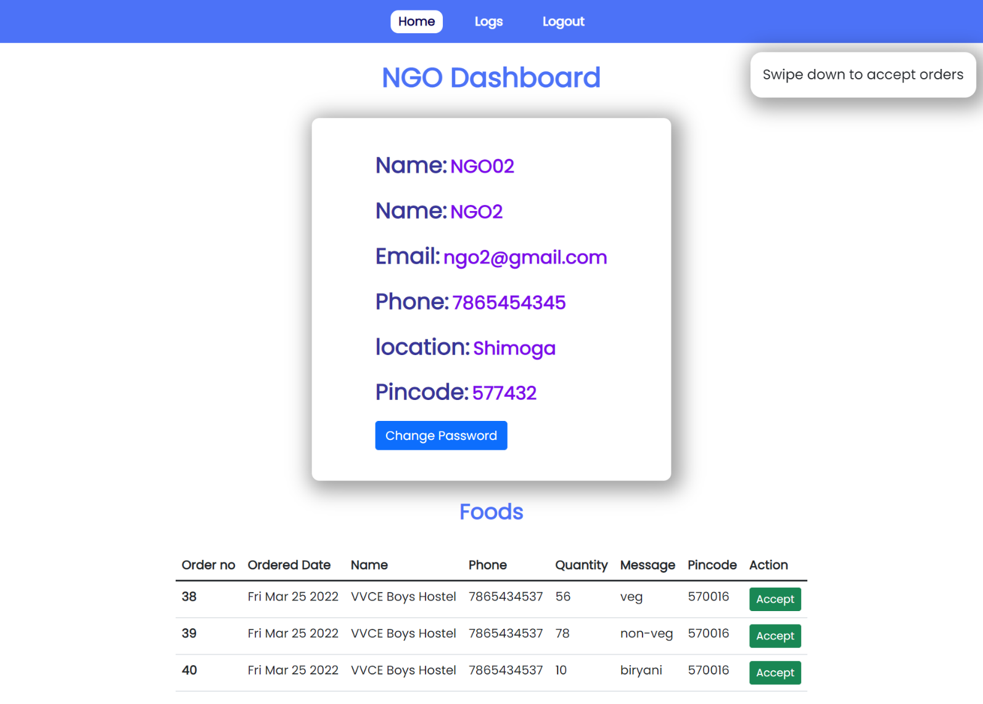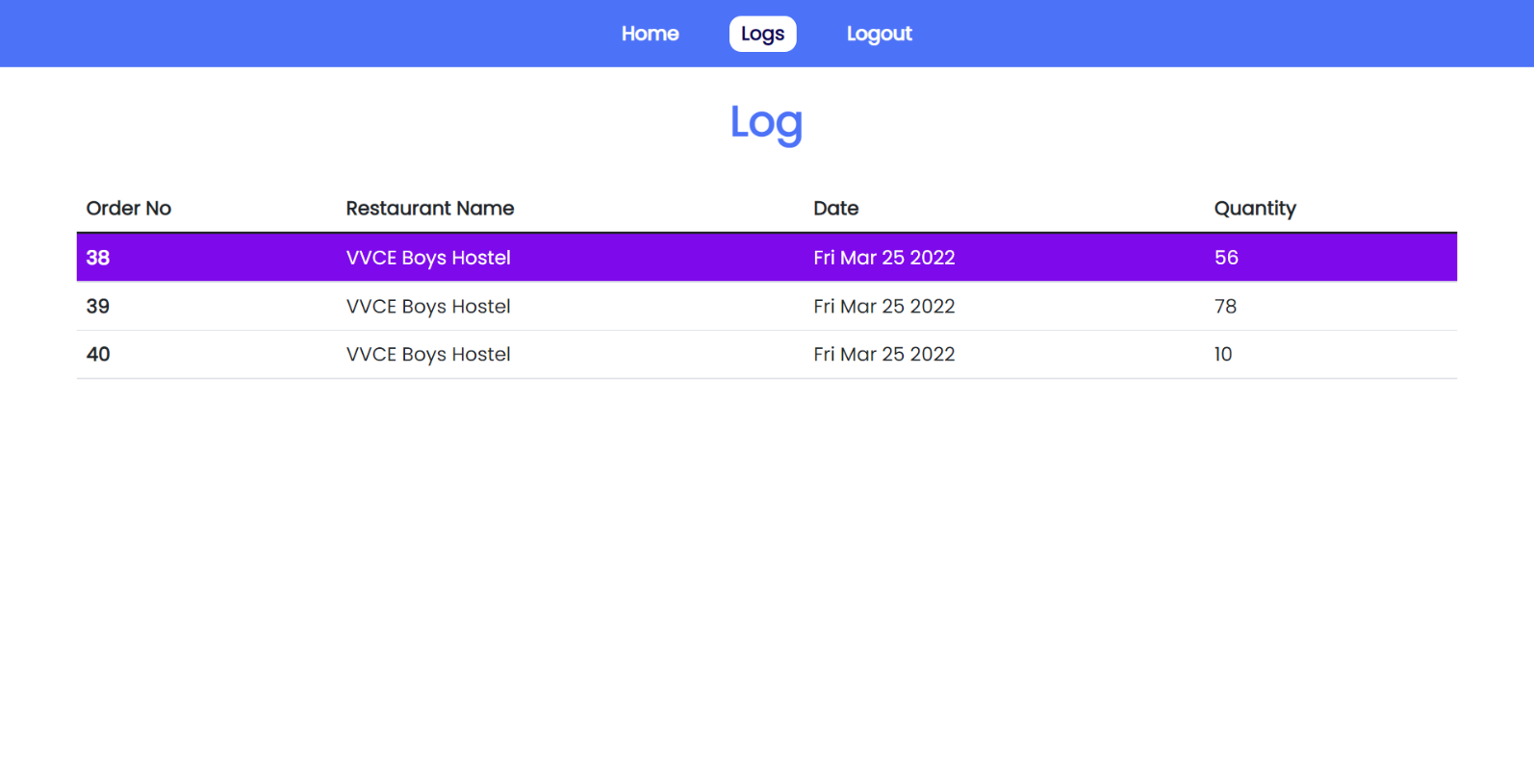

1. **EJS :** [**https://ejs.co/**](https://ejs.co/)
2. **CSS :** [**https://developer.mozilla.org/en-US/docs/Web/CSS**](https://developer.mozilla.org/en-US/docs/Web/CSS)
3. **JavaScript :** [**https://developer.mozilla.org/en-US/docs/Web/JavaScript**](https://developer.mozilla.org/en-US/docs/Web/JavaScript)
4. **Node.js :** [**https://nodejs.org/en/docs/**](https://nodejs.org/en/docs/)
5. **Express.js :** [**https://expressjs.com/en/guide/routing.html**](https://expressjs.com/en/guide/routing.html)
6. **MySQL :** [**https://dev.mysql.com/doc/**](https://dev.mysql.com/doc/)
7. **Apache server :** [**https://www.apachefriends.org/index.html**](https://www.apachefriends.org/index.html)

**6.References**

The complex reasons behind why nearly one-third of all food produced for human consumption is wasted are evident throughout the food supply chain, from production to consumption. While there are many practical strategies which have been discussed to reduce food waste (i.e., improving storage facilities, starting food waste awareness campaigns), these do not solve the underlying causes of why loss and waste still exist to such a large extent in today’s world. So, our main aim is to reduce these wastage of food by creating a website for the restaurant’s and other organizations who have food in excess to their needs and donate them to the needy in a positive and helpful manner. Thus, to truly put an end to food waste, citizens of the world must organise to reshape and rebuild local and global food systems in a way that nurtures health and wellbeing of people, and ensures the right to food for all people in a sustainable manner.

5.2 Conclusion