SKILL EXPERIMENT 1

DESIGNING A FOOD DELIVERY SOA SYSTEM

Course Title: SOA Programming and Microservices
Course Code: 24SDCS03 A/R
Academic Year: 2026–27
Name : Vikas Suthar
Roll No: 2420030504

1. Aim
To design and implement a basic Food Delivery System using Service-Oriented Architecture (SOA) by separating restaurant management and order processing into independent REST-based services.

2. Objectives
- Understand the fundamental principles of Service-Oriented Architecture.
- Identify appropriate service boundaries.
- Develop independent Restaurant and Order services.
- Define JSON-based service contracts.
- Design REST API endpoints using appropriate HTTP methods.
- Test the implemented APIs using sample requests and responses.
- Understand the differences between SOA and Microservices architecture.

3. Problem Statement
The food delivery startup initially uses a monolithic application in which restaurant listing, order processing, and customer management are tightly coupled.
As the number of users increases, this architecture creates several problems:
- Changes to one functionality may affect the entire application.
- Deployment becomes slow and risky.
- Individual functionalities cannot be scaled independently.
- Maintenance becomes difficult as the application grows.
To overcome these limitations, the system is redesigned using a Service-Oriented Architecture approach.

4. Proposed SOA Architecture
The application is divided into independent services:
Restaurant Service
Responsible for managing restaurant-related information.
Order Service
Responsible for processing customer orders.
The services communicate through REST APIs using JSON data formats.
Architecture Flow:
Client → Restaurant Service → Restaurant Data
Client → Order Service → Order Processing

5. Services Identified
Service | Responsibility | Example Operation
Restaurant Service | Manages restaurant information | Get all restaurants
Order Service | Handles customer orders | Place a new order

6. Service Contracts

6.1 Restaurant Service Response
{
"id": 1,
"name": "Food Palace",
"location": "Hyderabad"
}
The Restaurant Service returns the restaurant ID, restaurant name, and location.

6.2 Order Service Request
{
"userId": 101,
"restaurantId": 1,
"items": [
"Pizza",
"Burger"
]
}
The Order Service accepts the user ID, restaurant ID, and ordered items.

7. API Endpoints
HTTP Method | Endpoint | Purpose
GET | /restaurants | Retrieve all restaurants
POST | /orders | Place a new order

8. Restaurant Service Implementation
The Restaurant Service provides an independent REST API for retrieving restaurant information.
The controller handles HTTP GET requests through the /restaurants endpoint and returns sample restaurant data in JSON format.
Screenshot 1 – Restaurant Service Implementation

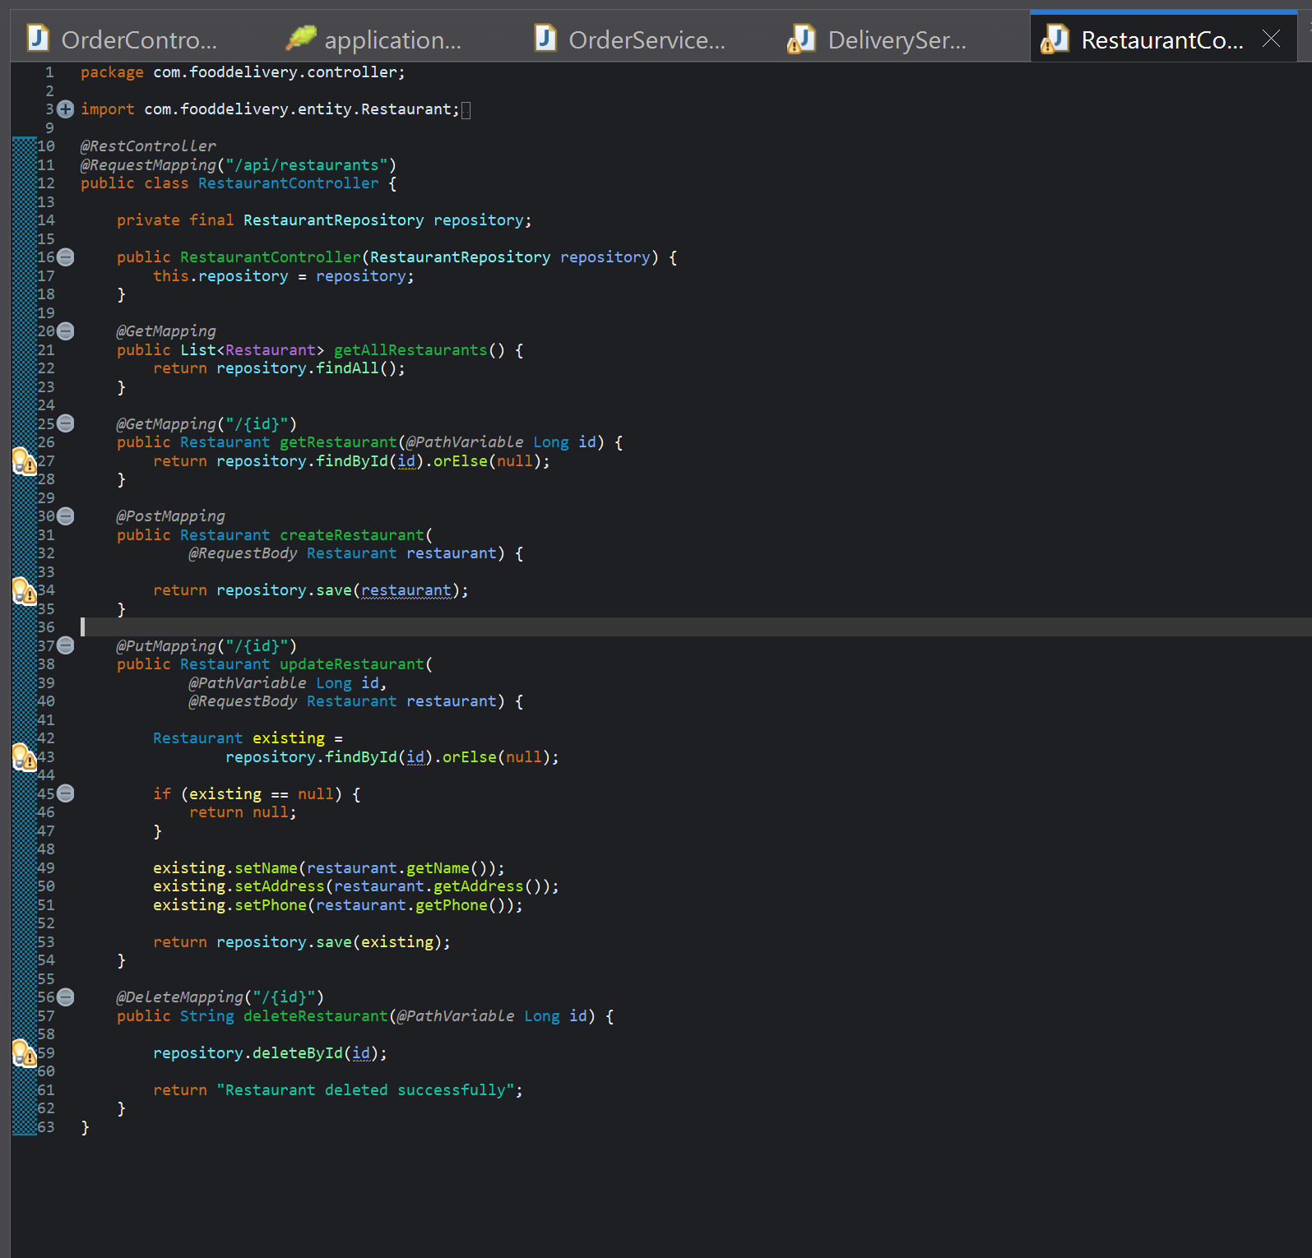

9. Order Service Implementation
The Order Service handles customer orders independently from the Restaurant Service.
The /orders endpoint accepts order information using an HTTP POST request and returns an appropriate JSON response.
Screenshot 2 – Order Service Implementation

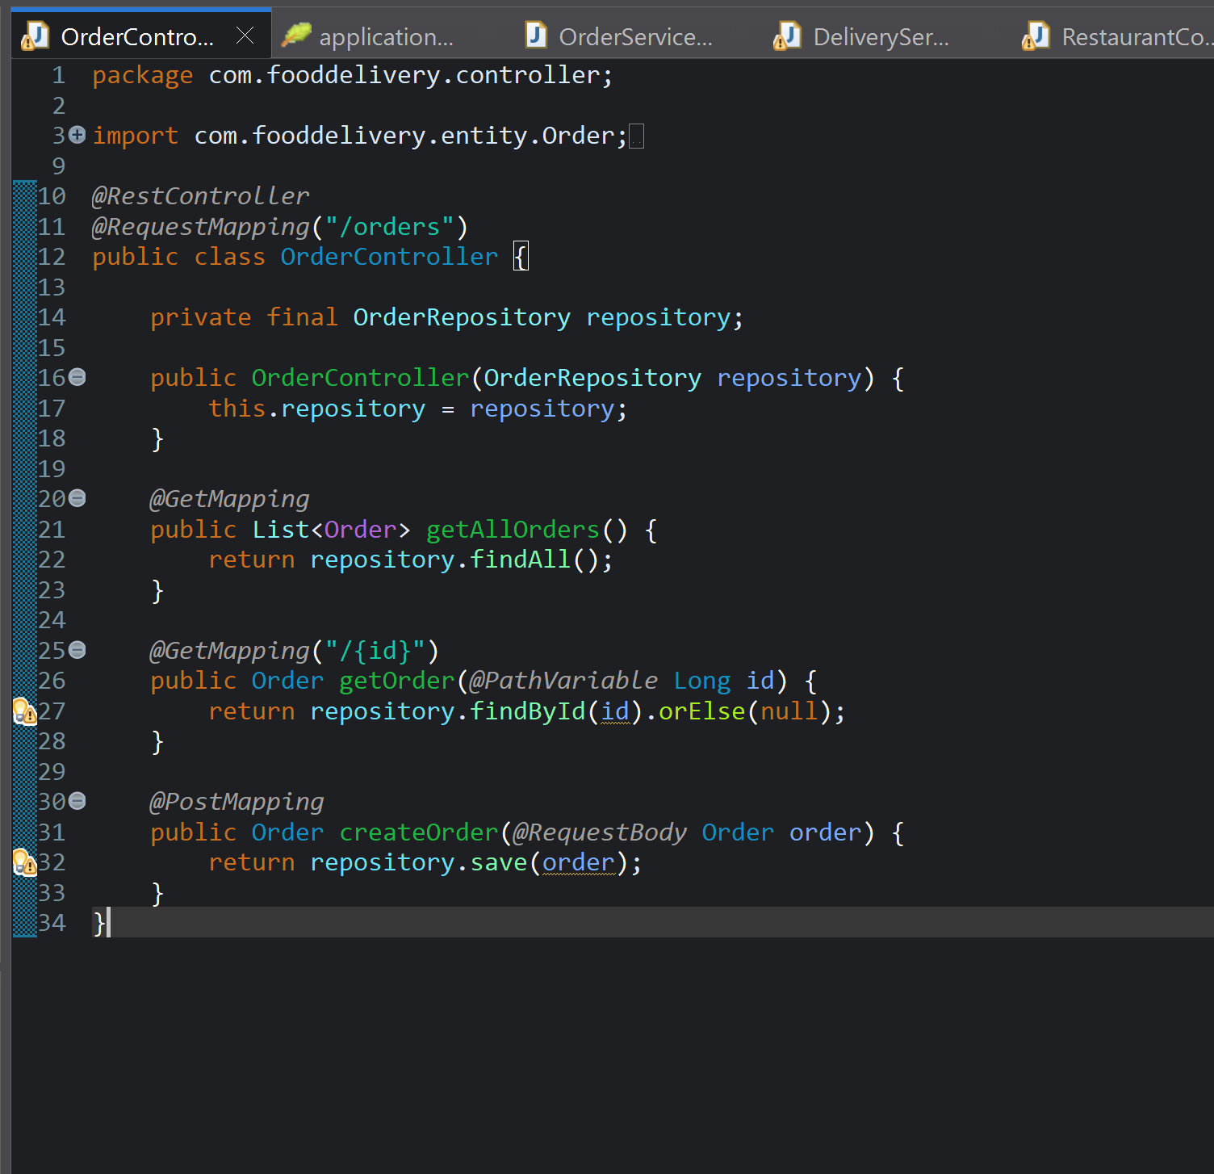

10. API Testing

10.1 Testing GET /restaurants
The Restaurant Service was tested using a REST API testing tool.
Request:
GET /restaurants
Expected Response:
[
{
"address": "Hyderabad",
"id": 1,
"name": "Food Palace",
"phone": "9876543210"
}
]
Screenshot 3 – GET /restaurants API Testing

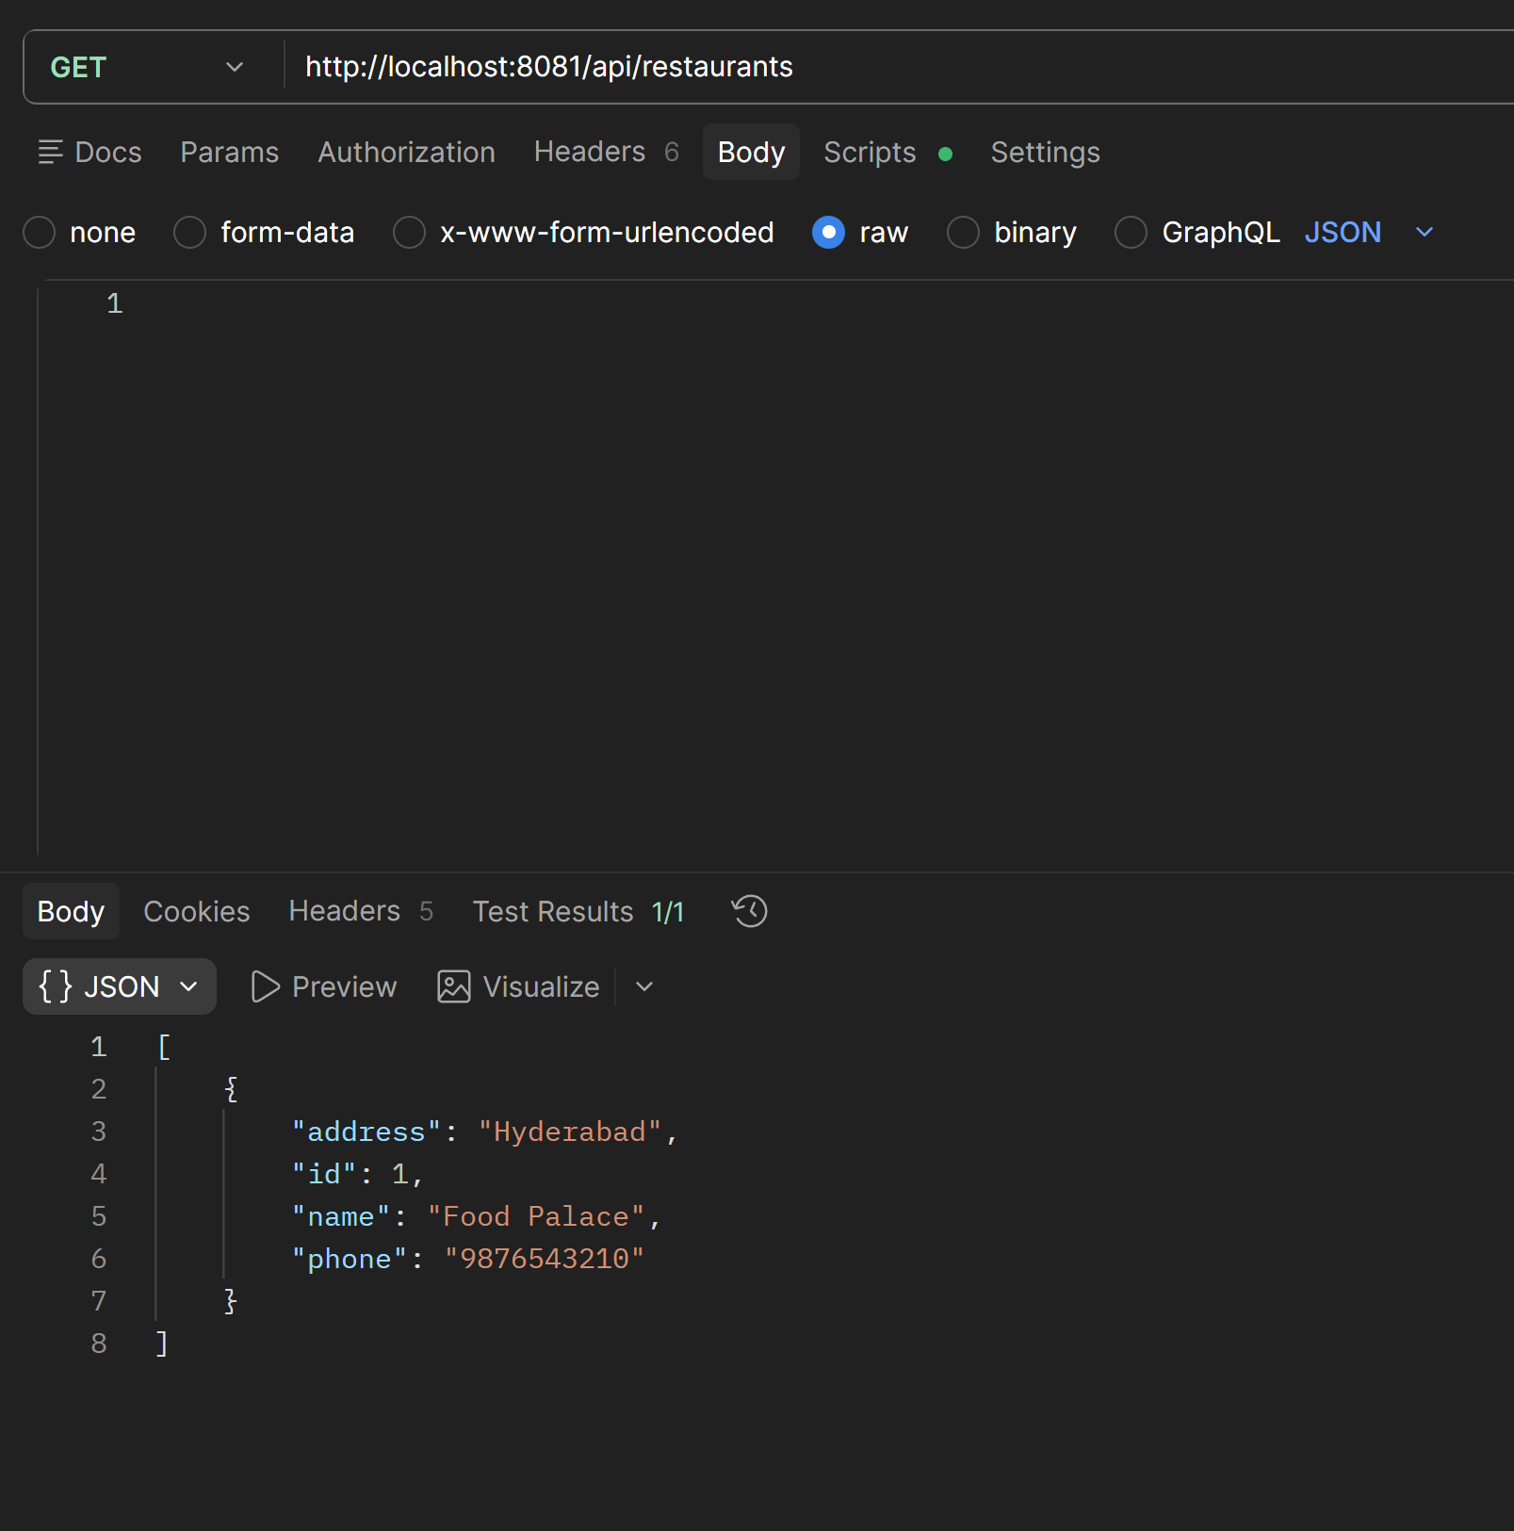

10.2 Testing POST /orders
The Order Service was tested by sending customer and order information in JSON format.
Request:
POST /orders
Request Body:
{
"userId": 101,
"restaurantId": 1,
"items": [
"Pizza",
"Burger",
"Cold Drink"
]
}
Screenshot 4 – POST /orders API Testing

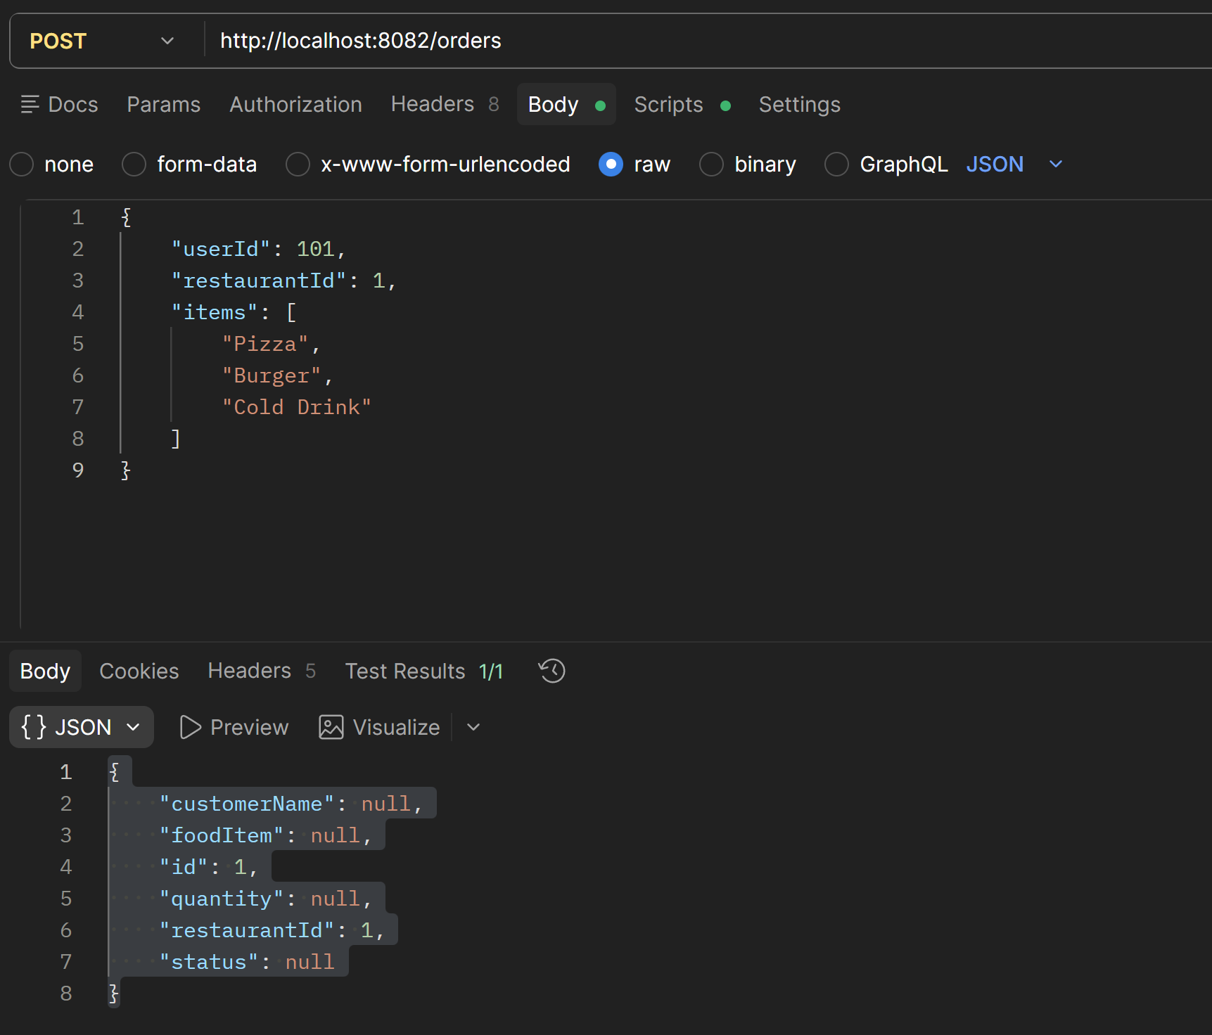

11. HTTP Methods Used
GET is used for retrieving restaurant information because it does not modify the server-side data.
POST is used for creating a new order because it sends data to the server for processing.

12. SOA Components

Service
A service is an independent functional unit that performs a specific business operation.
In this experiment:
- Restaurant Service manages restaurants.
- Order Service manages orders.

Service Contract
A service contract defines how clients communicate with a service. It specifies the request and response data format.
JSON was used as the communication format.

Endpoint
An endpoint is the URL through which a service can be accessed.
Examples:
GET /restaurants
POST /orders

13. Advantages of the Proposed SOA Design
- Loose Coupling: Services operate independently.
- Maintainability: Changes to one service can be made without modifying the entire application.
- Scalability: Individual services can be scaled according to demand.
- Reusability: Services can potentially be consumed by different applications.
- Independent Development: Different teams can work on different services.
- Easier Deployment: Services can be deployed separately.

14. Result
The Food Delivery System was successfully designed using the SOA approach. The Restaurant Service and Order Service were separated into independent services with clearly defined JSON contracts and REST API endpoints.
The APIs were successfully tested using sample requests and responses.

15. Conclusion
This experiment demonstrated how a monolithic food delivery application can be redesigned using Service-Oriented Architecture. By separating restaurant management and order processing into independent services, the system becomes more loosely coupled, maintainable, and scalable.
The experiment also provided practical understanding of REST API development, JSON service contracts, service boundaries, and the differences between SOA and Microservices.

