SKILL EXPERIMENT 2

API GATEWAY FOR E-COMMERCE ROUTING

Course Title: SOA Programming and Microservices
Course Code: 24SDCS03 A/R
Academic Year: 2026–27
Name: Vikas Suthar
Roll No.: 2420030504

1. Aim
To design and implement an API Gateway for an E-Commerce system that provides a single entry point for client requests and routes requests to multiple backend services such as Product Service and Cart Service.
The experiment also demonstrates routing, multiple service instances, and load balancing through the API Gateway.

2. Objectives
The objectives of this experiment are:
- To understand the role of an API Gateway in a microservices architecture.
- To develop independent Product and Cart backend services.
- To configure an API Gateway as a single entry point.
- To configure routing rules for different backend services.
- To run multiple instances of a service on different ports.
- To test request routing through the gateway.
- To observe load balancing between multiple service instances.
- To understand the advantages of using an API Gateway.

3. Problem Statement
An e-commerce application consists of multiple backend services such as Product Service and Cart Service.
Without an API Gateway, clients need to communicate directly with each backend service. This creates several problems:
- Increased complexity on the client side.
- Multiple network calls.
- Difficulty in managing service URLs.
- Increased security exposure.
- Difficulties in handling cross-cutting concerns such as authentication and logging.
To overcome these issues, an API Gateway is introduced as a single entry point for client requests.

4. Proposed Architecture
The proposed architecture consists of:
- Client
- API Gateway
- Product Service
- Cart Service
- Multiple Product Service Instances
The client sends all requests to the API Gateway instead of directly communicating with individual backend services.

Architecture Flow
┌─────────────────────┐
│ Client │
└──────────┬──────────┘
│
▼
┌─────────────────────┐
│ API Gateway │
│ Port 8080 │
└───────┬───────┬─────┘
│ │
/products/** │ │ /cart/**
│ │
┌────────────┘ └────────────┐
▼ ▼
┌───────────────────┐ ┌───────────────────┐
│ Product Service │ │ Cart Service │
│ Instance 1 │ │ Port 8083 │
│ Port 8081 │ └───────────────────┘
└───────────────────┘
▲
│
┌───────────────────┐
│ Product Service │
│ Instance 2 │
│ Port 8082 │
└───────────────────┘
The API Gateway routes /products/** requests to Product Service and /cart/** requests to Cart Service.

5. Backend Services

5.1 Product Service
The Product Service manages product-related operations.
Example endpoint:
/products
Example operations:
GET /products
POST /products
The Product Service can be executed on multiple ports to demonstrate load balancing.
For example:
Product Service Instance 1 → Port 8081
Product Service Instance 2 → Port 8083

Screenshot 1 – Product Service
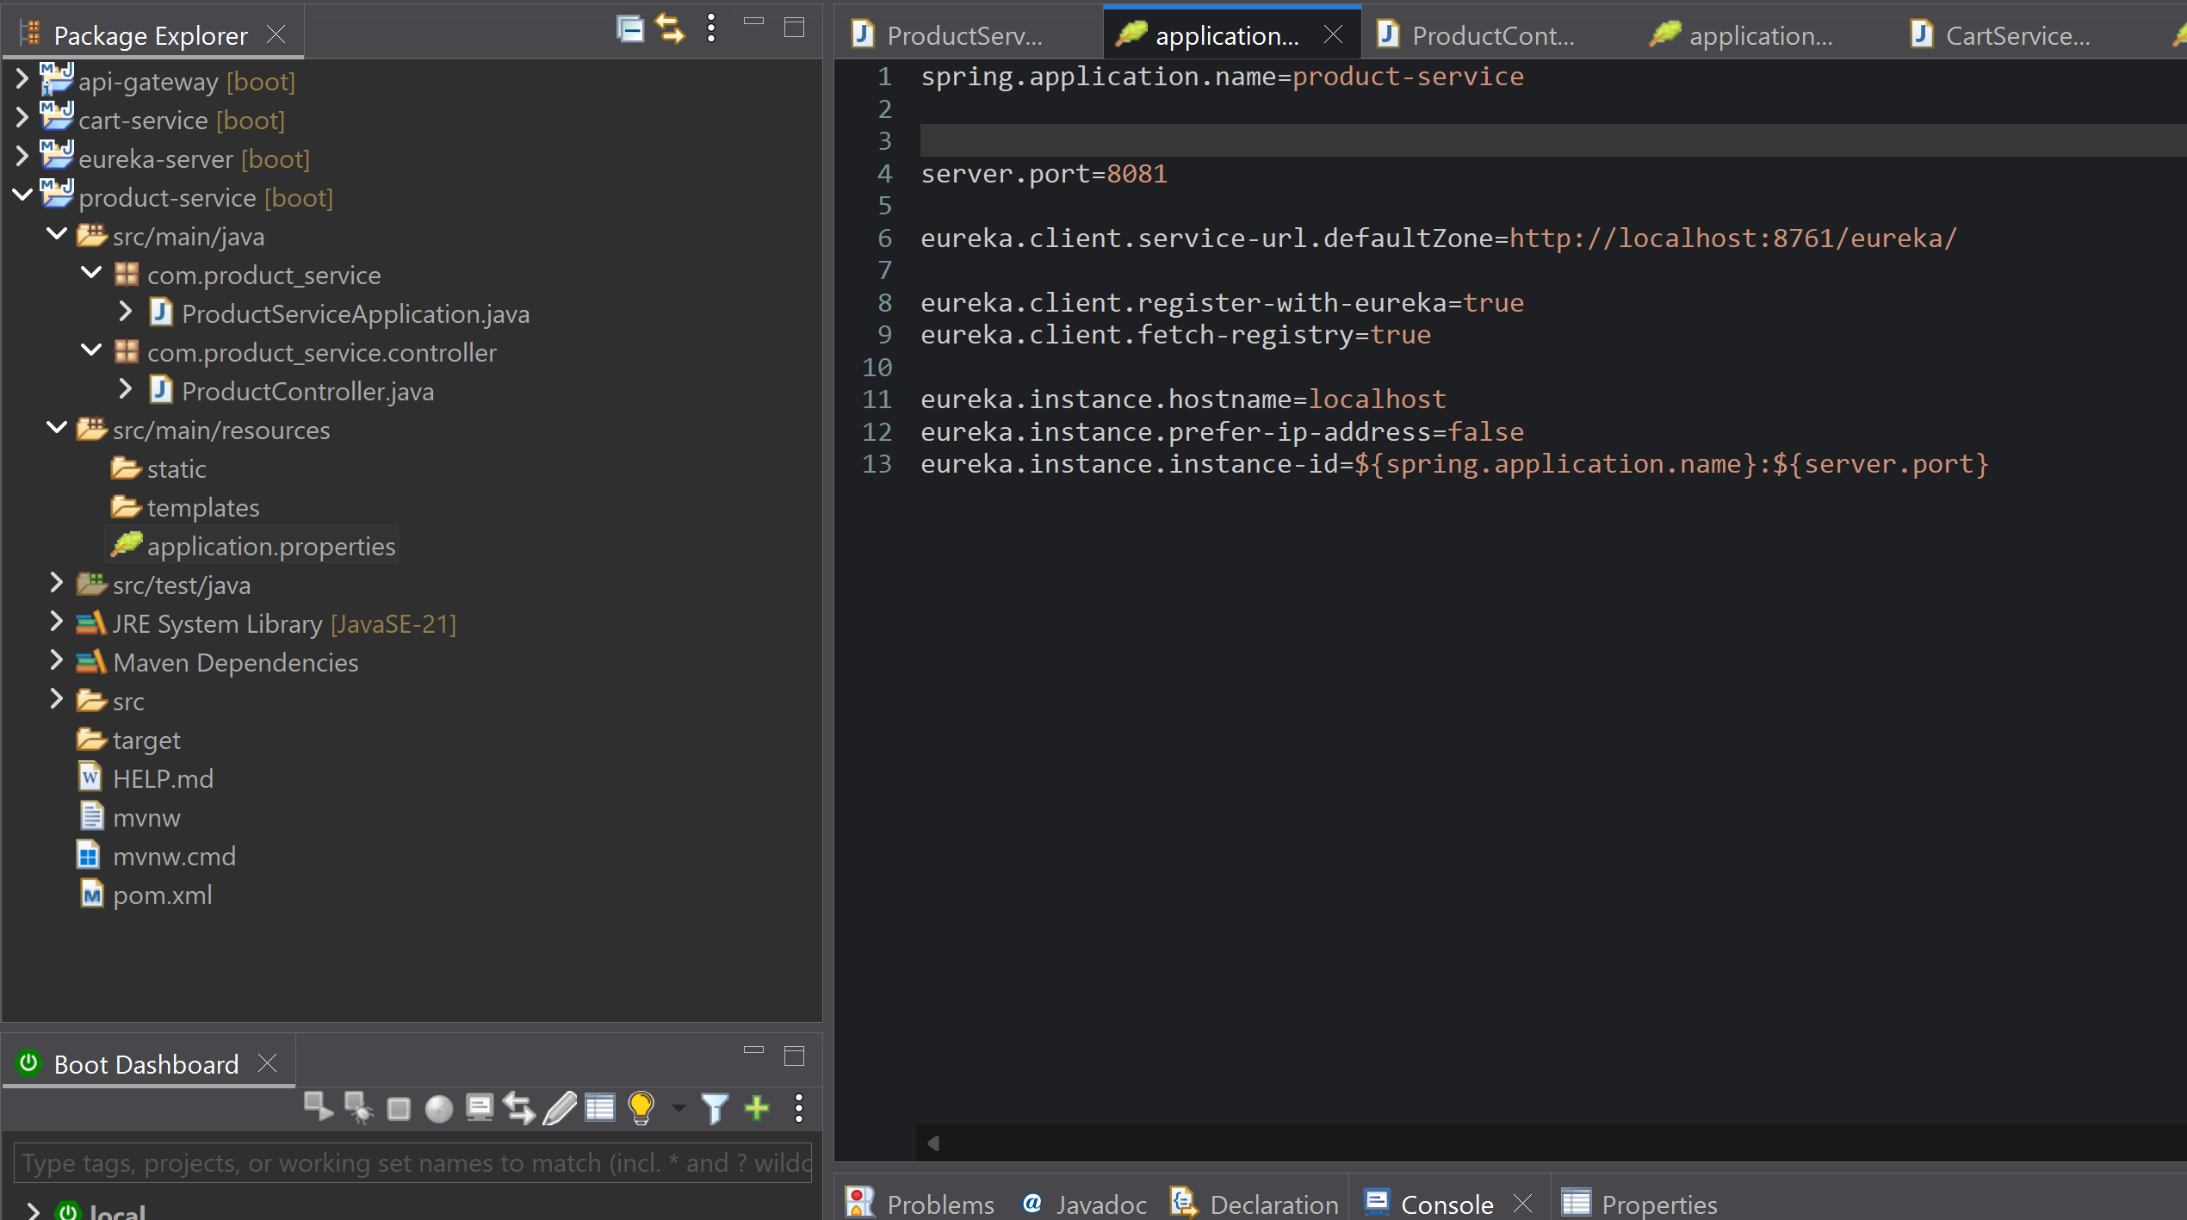

5.2 Cart Service
The Cart Service manages shopping cart-related operations.
Example endpoint:
/cart
Example operations:
GET /cart
POST /cart
The Cart Service runs independently from the Product Service.

Screenshot 2 – Cart Service
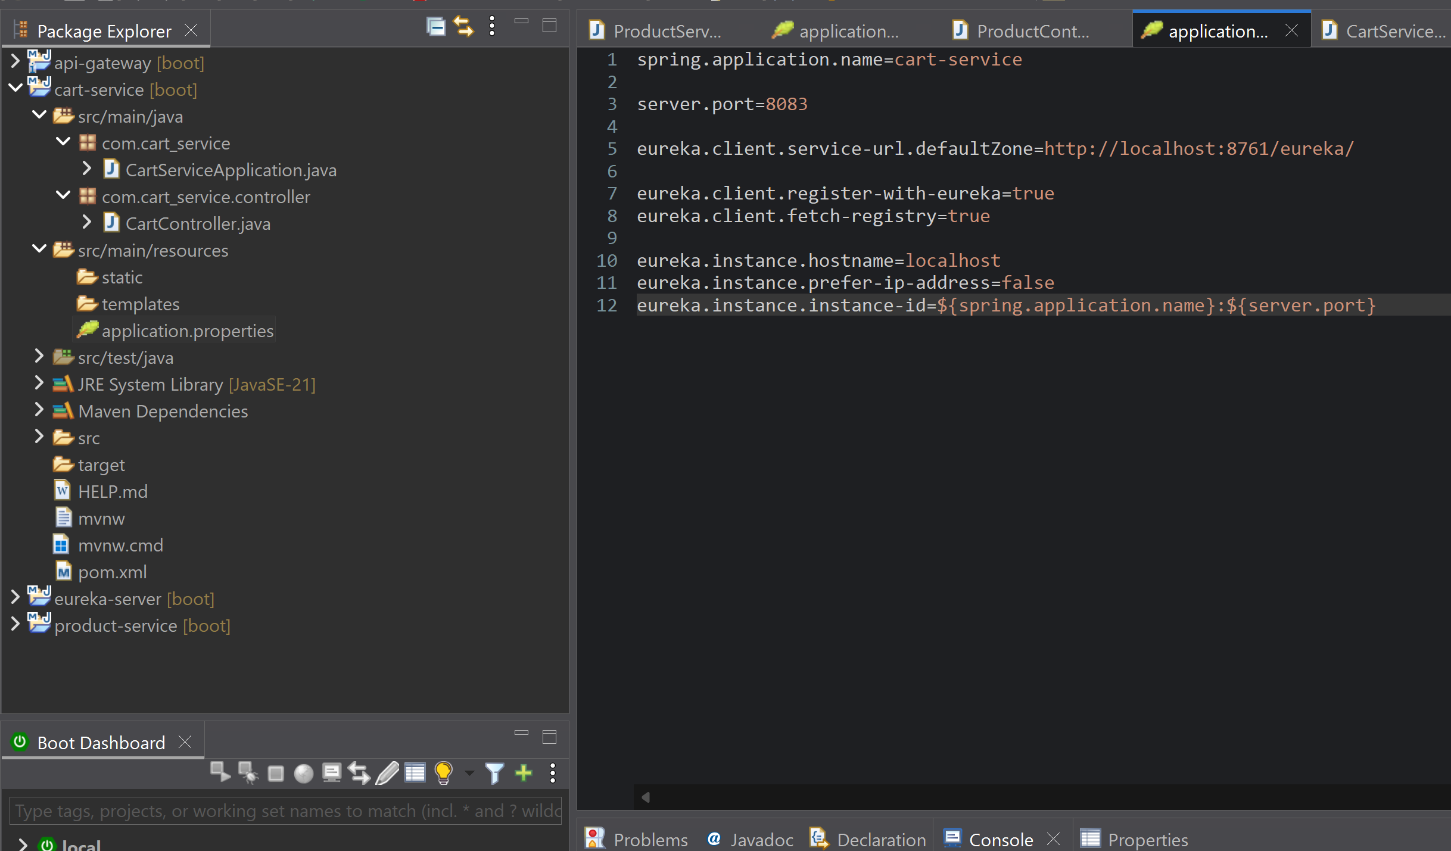

6. API Gateway
The API Gateway acts as a single entry point between the client and backend services.
Instead of accessing:
http://localhost:8081/products
http://localhost:8083/cart
the client accesses the gateway:
http://localhost:8080/products
http://localhost:8080/cart
The gateway forwards each request to the appropriate backend service.

7. Routing Configuration
The following routing rules were configured in the API Gateway.
Request Path | Destination
/products/** | Product Service
/cart/** | Cart Service

Product Route
/products/**
↓
Product Service

Cart Route
/cart/**
↓
Cart Service

Screenshot 3 – API Gateway Routing Configuration
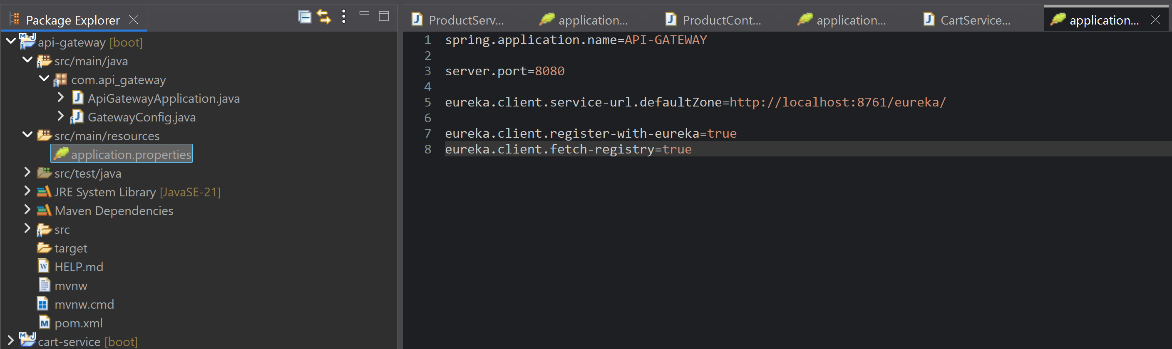

8. Gateway Configuration
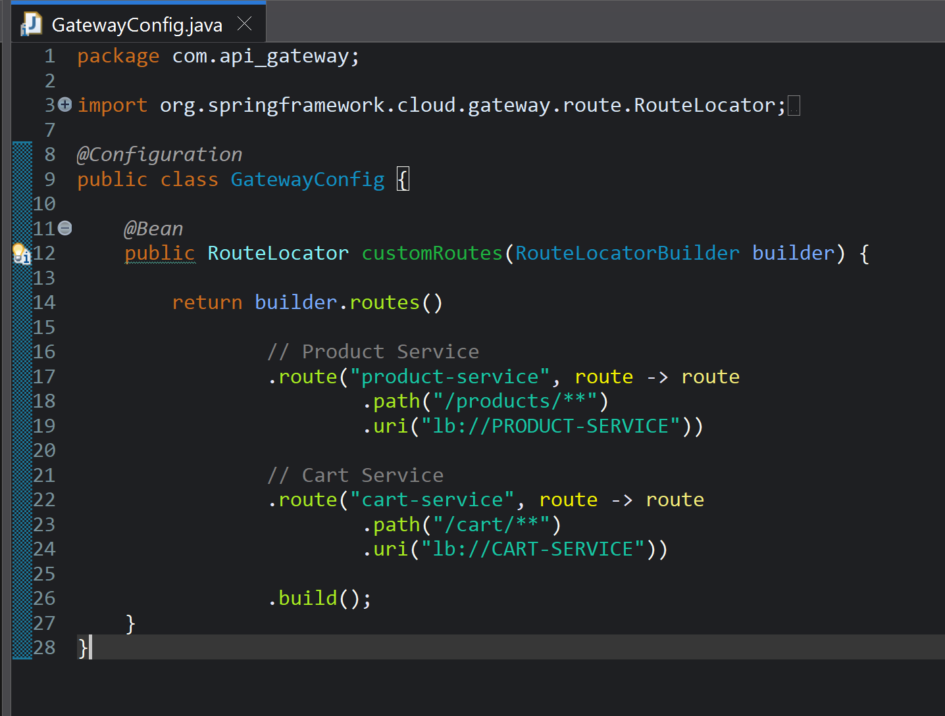This configuration tells the gateway where to forward requests.
For example:
GET http://localhost:8080/products
is forwarded to:
http://localhost:8081/products
Similarly:
GET http://localhost:8080/cart
is forwarded to:
http://localhost:8083/cart

9. Running Multiple Product Service Instances
To demonstrate load balancing, two instances of Product Service were executed on different ports.

Instance Configuration
Instance | Port
Product Service 1 | 8081
Product Service 2 | 8082
Both instances provide the same Product Service functionality.

Screenshot 4 – Multiple Product Service Instances
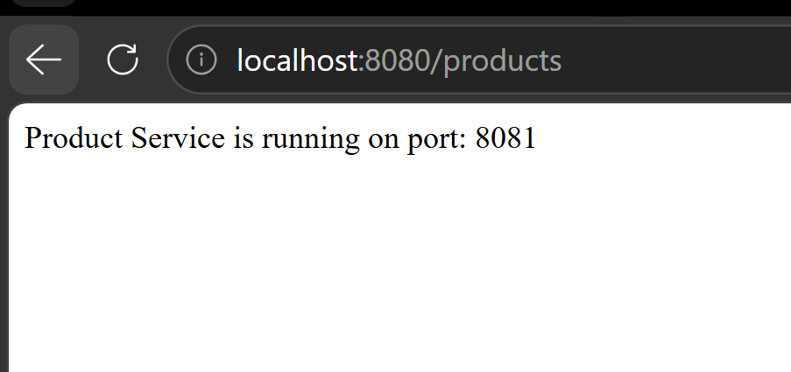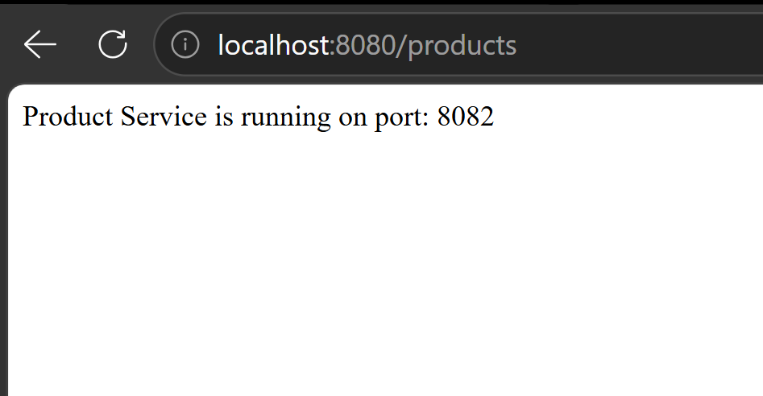

10. Load Balancing Configuration
When multiple instances of a service are available, the API Gateway can distribute incoming requests between those instances.
A load-balanced configuration can use:
lb://product-service
instead of directly specifying a single port.
Example:
spring:
cloud:
gateway:
routes:
- id: product-service
uri: lb://product-service
predicates:
- Path=/products/**
The Product Service instances can then be registered with the same service name.
Conceptually:
API Gateway
│
/products/**
│
┌──────────┴──────────┐
▼ ▼
Product Instance 1 Product Instance 2
Port 8081 Port 8082

11. Testing API Gateway Routing
The gateway was tested using Postman.

11.1 Testing Product Service Through Gateway
Request:
GET http://localhost:8080/products
The request is received by the API Gateway and forwarded to the Product Service.

Screenshot 5 – Product API Through Gateway
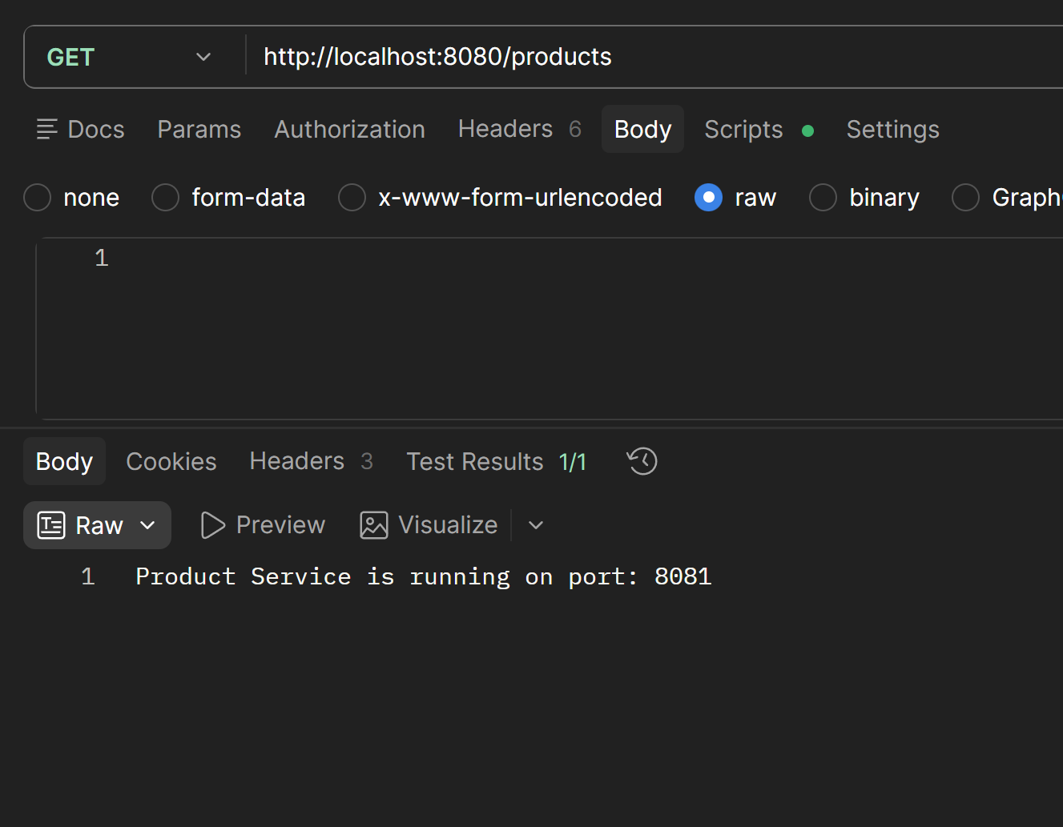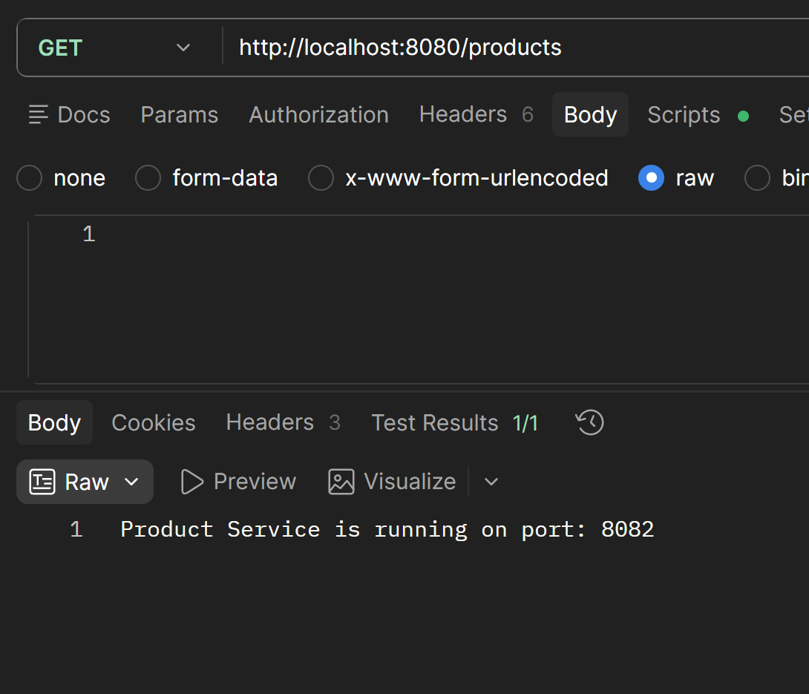

12. Testing Cart Service Through Gateway
Request:
GET http://localhost:8080/cart
The API Gateway forwards the request to the Cart Service.

Screenshot 6 – Cart API Through Gateway
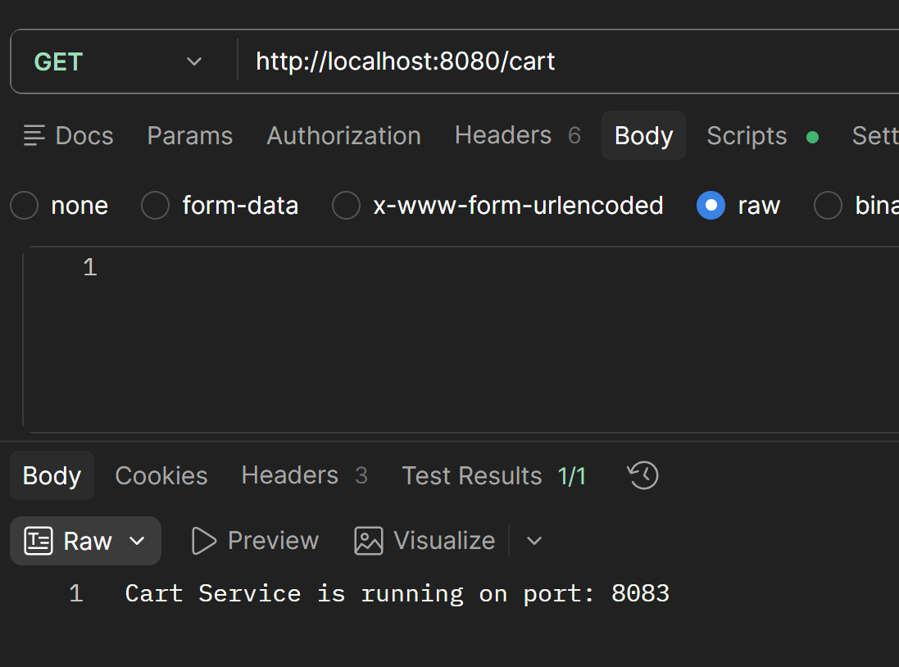

13. Observing Load Balancing
The Product Service was executed using two instances:
Instance 1 → Port 8081
Instance 2 → Port 8082
The gateway distributes requests among the available instances.
For easier observation, each instance can return a different identifier.
Example:
Instance 1 response:
{
"service": "Product Service",
"instance": "Instance-1"
}
Instance 2 response:
{
"service": "Product Service",
"instance": "Instance-2"
}
By sending multiple requests, the instance handling the request can be observed.

14. Routing Behavior
The API Gateway successfully acts as a single entry point.
The routing behavior is:
Client
│
▼
API Gateway
│
├── /products/** ──→ Product Service
│
└── /cart/** ──────→ Cart Service
Therefore, the client does not need to know the individual backend service locations.

15. Load Balancing Effectiveness
Load balancing improves the availability and scalability of the Product Service.
When multiple instances are available, requests can be distributed between them.

Benefits
- Prevents a single service instance from handling all requests.
- Improves scalability.
- Helps distribute workload.
- Provides better availability.
- Allows additional instances to be added when traffic increases.

16. Observations
The following observations were made during the experiment:
- The API Gateway successfully acted as a single entry point.
- /products/** requests were routed to the Product Service.
- /cart/** requests were routed to the Cart Service.
- Multiple Product Service instances could be executed on different ports.
- Requests could be distributed between available service instances.
- The gateway reduced the complexity of client-side communication.
- The architecture improved the scalability and manageability of the application.

17. Result
The API Gateway for the E-Commerce application was successfully designed and implemented.
The gateway successfully routed:
/products/** → Product Service
/cart/** → Cart Service
Multiple Product Service instances were also configured to demonstrate load balancing.
The experiment successfully demonstrated how an API Gateway simplifies client communication and provides centralized routing and service management.

18. Conclusion
This experiment demonstrated the implementation of an API Gateway for an E-Commerce application consisting of Product and Cart services.
The API Gateway provided a single entry point for clients and successfully routed requests to the appropriate backend services. Multiple Product Service instances were used to demonstrate load balancing and scalability.
The experiment showed that an API Gateway can reduce client-side complexity, hide internal service locations, centralize security and monitoring, and simplify communication in a microservices-based system.

