**Integrated Crop Protection Management**

## A PROJECT REPORT

***Submitted by,***

|  |  |  |
| --- | --- | --- |
| Sl. No. | Roll Number | Student Name |
| 1 | 20211CAI0154 | **MANOJ J R** |
| 2 | 20211CAI0068 | **VEERESH** |
| 3 | 20211CAI0100 | K SAINATH |
| 4 | 20221LCA0008 | **KUSHAL M P** |

### *Under the guidance of,*

**Dr.Mohammadi Akheela Khanum**

School of Computer Science, Presidency University, Bengaluru

***in partial fulfillment for the award of the degree of***

**BACHELOR OF TECHNOLOGY**

**IN**

**COMPUTER SCIENCE AND ENGINEERING, (AI&ML)**

**At**



**PRESIDENCY UNIVERSITY**

**PRESIDENCY UNIVERSITY**

**SCHOOL OF COMPUTER SCIENCE ENGINEERING**

**CERTIFICATE**

This is to certify that the Project report **Integrated Crop Protection Management** being submitted by "MANOJ J R, VEERESH B, K SAINATH , Kushal M P " in partial fulfillment of the requirement for the award of the degree of Bachelor of Technology in Computer Science and Engineering is a bonafide work carried out under my supervision.

|  |  |
| --- | --- |
| **Dr.Mohammadi Akheela Khanum**  School of CSE&IS  Presidency University | **Dr. Zafar Ali Khan /HOD**  **N-Asso. Prof – SCSE**  Presidency University |

|  |  |  |
| --- | --- | --- |
| **Dr. L. SHAKKEERA**  Associate Dean  School of CSE  Presidency University | **Dr. MYDHILI NAIR**  Associate Dean  School of CSE  Presidency University | **Dr. SAMEERUDDIN KHAN**  Pro-Vc School of Engineering  Dean -School of CSE&IS  Presidency University |

**PRESIDENCY UNIVERSITY**

**SCHOOL OF COMPUTER SCIENCE ENGINEERING**

**DECLARATION**

We hereby declare that the work, which is being presented in the project report entitled **Integrated Crop Protection Management** in partial fulfillment for the award of Degree of **Bachelor of Technology** in **Computer Science and Engineering(AI&ML)**, is a record of our own investigations carried under the guidance of **Dr.Mohammadi Akheela Khanum,** **School of Computer Science Engineering & Information Science, Presidency University, Bengaluru.**

We have not submitted the matter presented in this report anywhere for the award of any other Degree.

|  |  |  |  |  |  |  |  |  |  |  |  |  |  |  |  |  |
| --- | --- | --- | --- | --- | --- | --- | --- | --- | --- | --- | --- | --- | --- | --- | --- | --- |
| |  |  |  |  |  |  |  |  |  |  |  |  |  |  |  |  | | --- | --- | --- | --- | --- | --- | --- | --- | --- | --- | --- | --- | --- | --- | --- | --- | | |  |  |  | | --- | --- | --- | | NAME | ROLL NUMBER | SIGNATURE | | MANOJ J R | 20211CAI0154 |  | | VEERESH B | 20211CAI0068 |  | | K SAINATH | 20211CAI0100 |  | | Kushal M P | 20221LCA0008 |  | | |

**ABSTRACT**

Agriculture is the backbone of the Indian economy, employing more than half of the country’s workforce and contributing significantly to its GDP. However, the sector faces numerous challenges, including unpredictable monsoons, inefficient crop planning, poor soil management, and limited access to advanced agricultural tools. These issues often result in reduced productivity, higher costs, and lower profitability for farmers. To address these pressing concerns, AgroDoc is proposed as an innovative, mobile-based solution designed to revolutionize traditional farming practices

AgroDoc leverages the power of **Artificial Intelligence (AI)** and **Machine Learning (ML)** to provide farmers with predictive insights and actionable recommendations. The platform integrates several key functionalities to support farmers in optimizing their agricultural practices. It includes a monsoon prediction module for forecasting weather patterns, a soil health analysis module to assess nutrient levels and recommend fertilizers, and a smart crop recommendation system that factors in soil conditions, climate, and market trends. Real-time weather updates, market sentiment analysis, and warehouse location assistance further enhance its utility.

This intelligent, user-friendly application also addresses gaps in such as reliance on non-scientific soil analysis, lack of reliable weather predictions, and poor crop selection strategies. By equipping farmers with real-time data AgroDoc aims to improve decision-making, reduce risks from unpredictable weather, and increase overall yield and profitability.

The expected outcomes of AgroDoc include better crop planning, enhanced soil fertility management, reduced post-harvest losses, and higher farmer satisfaction. By bridging the gap between technology and traditional farming, AgroDoc not only promotes sustainability but also empowers farmers to achieve economic stability and improved livelihoods.

**ACKNOWLEDGEMENT**

First of all, we indebted to the **GOD ALMIGHTY** for giving me an opportunity to excel in our efforts to complete this project on time.

We express our sincere thanks to our respected dean **Dr. Md. Sameeruddin Khan**, Pro-VC, School of Engineering and Dean, School of Computer Science Engineering & Information Science, Presidency University for getting us permission to undergo the project.

We express our heartfelt gratitude to our beloved Associate Deans **Dr. Shakkeera L and Dr. Mydhili Nair,** School of Computer Science Engineering & Information Science, Presidency University, and “**Dr. Zafar Ali Khan”**, Head of the Department, School of Computer Science Engineering & (AI&ML) Presidency University, for rendering timely help in completing this project successfully.

We are greatly indebted to our guide **Dr.Mohammadi Akheela Khanum, Designation** and Reviewer **Dr. Alamelu J Mangai Designation**, School of Computer Science Engineering & Information Science, Presidency University for her inspirational guidance, and valuable suggestions and for providing us a chance to express our technical capabilities in every respect for the completion of the project work.

We would like to convey our gratitude and heartfelt thanks to the PIP2001 Capstone Project Coordinators **Dr. Sampath A K, Dr. Abdul Khadar A and Mr. Md Zia Ur Rahman,** department Project Coordinators “**Dr.Mohammadi Akheela Khanum**” and Git hub coordinator **Mr. Muthuraj.** We thank our family and friends for the strong support and inspiration they have provided us in bringing out this project.

**MANOJ JR**

**VEERESH B**

**K SAINATH**

**KUSHAL MP**

**TABLE OF CONTENTS**

|  |  |  |
| --- | --- | --- |
| **CHAPTER NO.** | **TITLE** | **PAGE NO.** |
|  | **ABSTRACT ACKNOWLEDGMENT** | **IV**  **V** |
| **1** | **INTRODUCTION** | 1 |
| **2** | LITERATURE SURVEY | 2 |
| **3** | RESEARCH GAP OF EXISTING  METHODS | 3-4 |
| **4** | PROPOSED MOTHODOLOGY | 5 |
| **5** | OBJECTIVES | 6 |
| **6** | SYSTEM DESIGN & IMPLEMENTION | 7-8 |
| **7** | TIMELINE FOR  EXCUTION OF PROJECT | 9 |
| **8** | OUTCOMES | 9 |
| **9** | FLOWCHART DIAGRAM | 10 |
| **10** | CONCLUSION | **11** |
| **11** | PSUEDOCODE | 12 |

**CHAPTER-1**

**INTRODUCTION**

## 1.1 General Background

Agriculture plays a pivotal role in India’s economy, employing over half of its workforce and contributing significantly to GDP. However, farmers face persistent challenges such as unpredictable monsoons, soil degradation, inefficient crop planning, and fluctuating market demands. These issues result in reduced yields, higher costs, and lower profitability. Traditional farming methods often lack scientific precision, relying on outdated practices for soil analysis and crop selection.

With advancements in technology, Artificial Intelligence (AI) and Machine Learning (ML) offer transformative solutions for agriculture. These technologies enable predictive analysis, personalized recommendations, and real-time insights to address the sector’s inefficiencies. **AgroDoc**, an innovative mobile application, integrates these tools to revolutionize farming. By providing monsoon predictions, soil health assessments, and crop suggestions, AgroDoc empowers farmers with data-driven decisions, enhancing productivity and sustainability.

.

## 1.2 Problem Statement

* **Agriculture is the backbone of India’s economy but faces significant challenges affecting productivity and profitability.**
* **Unpredictable monsoons** disrupt crop planning and lead to water shortages or flooding.
* **Inadequate soil management** practices, including non-scientific analysis, result in poor soil health and inefficient fertilizer us.
* technological solution like **AgroDoc** is needed to address these challenges by providing **AI/ML-driven insights** for better decision-making and resource optimization.

## 1.3 Objectives

1. Predict Monsoon Trends for Better Crop Planning
2. Improve Soil Health Management and Fertilizer Use
3. Empower Farmers with Real-Time Alerts and Updates
4. Increase Farmer Profitability and Yield

**CHAPTER-2**

**LITERATURE SURVEY**

**Technological Opportunities:**

**AI and Machine Learning** (ML): These technologies offer advanced tools for analyzing large datasets to provide actionable insights.

Examples include real-time weather forecasting, soil health assessment, and smart crop recommendation systems.

**Mobile Applications**: Platforms like AgroDoc can make these technologies accessible to farmers, even in remote regions.

**Existing Solutions and Their Drawbacks:**

* Current soil testing methods lack accessibility and precision.
* Available weather prediction systems are generalized and not tailored to specific regions or crops.
* Crop selection tools often do not integrate real-time data from multiple factors, such as weather, soil conditions, and market trends.
* Farmers lack tools that combine storage and supply chain optimization to reduce post-harvest losses.

**Conclusion of the Literature Review:** There is a pressing need for comprehensive tools like AgroDoc to bridge the gap between traditional farming practices and modern technological advancements. By integrating AI/ML, AgroDoc aims to address inefficiencies in agriculture, ensuring sustainability, profitability, and productivity for farmers.

**Significant Studies Referenced** :

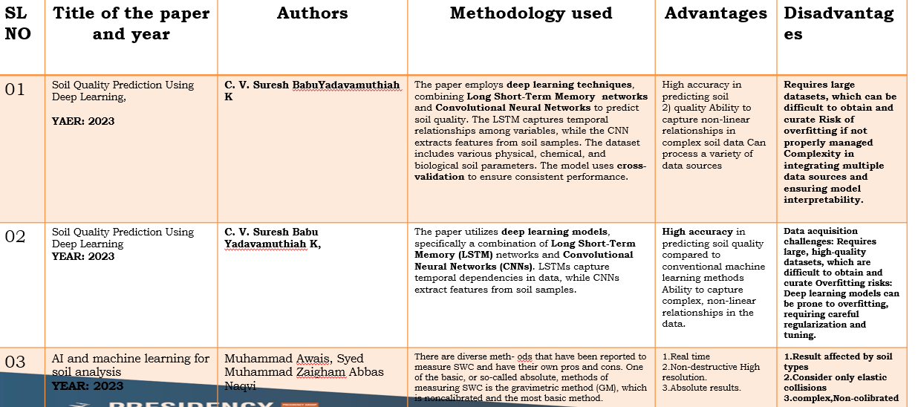

**CHAPTER-3**

**RESEARCH GAPS OF EXISTING METHODS**

**Inaccurate Monsoon Predictions**

* Existing weather prediction systems are often generalized and do not provide region-specific, real-time insights.
* Farmers lack reliable tools to plan crop cycles based on accurate monsoon forecasts.

**Non-Scientific and Limited Soil Analysis**

* Traditional soil testing relies on visual inspection or outdated manual methods, which fail to provide precise nutrient assessments.
* Farmers often do not have access to actionable soil health data, leading to inefficient fertilizer use and soil degradation.

**Lack of Integrated Crop Selection Tools**

* Existing methods for crop selection are not multi-factorial and do not consider real-time data such as soil type, weather conditions, and market demand.
* Poor crop recommendations result in suboptimal yields and financial losses.

**Low Technology Penetration in Rural Areas**

* Many existing solutions fail to cater to farmers in remote regions due to their lack of mobile compatibility, offline functionality, or multi-language support.
* This technological gap limits the adoption of advanced tools in small-scale and marginal farming.

**Limited Use of Artificial Intelligence (AI) and Machine Learning (ML)**

* Existing agricultural tools do not fully leverage the potential of AI and ML to analyze vast datasets and generate predictive insights for better farming decisions.
* Current systems are not adaptive to changing weather patterns, soil conditions, or market dynamics.

Addressing these research gaps through **AgroDoc** will provide farmers with an all-in-one, AI-powered platform that ensures data-driven decision-making, optimized resource use, and improved profitability.

**CHAPTER-4**

**PROPOSED MOTHODOLOGY**

The proposed method for AgroDoc integrates advanced technologies like Artificial Intelligence (AI) and Machine Learning (ML) to address the limitations of traditional farming practices

**Monsoon Trend Prediction Using AI and ML:**

***Machine Learning Algorithms:*** Use AI/ML to develop predictive models that analyze past and current weather trends to predict regional monsoon patterns and help farmers plan accordingly.

***Actionable Recommendations*:** Provide region-specific monsoon forecasts, helping farmers make informed decisions about sowing, irrigation, and crop planning.

**Soil Health Analysis and Fertilizer Recommendations :**

***Soil Data Input****:* Farmers can input data such as soil type, pH level, and moisture content

***AI-Based Soil Analysis****:* AgroDoc processes this data using AI models to evaluate soil health and predict nutrient deficiencies

***Fertilizer Recommendation*:** Based on soil analysis, the system suggests the appropriate fertilizers, minimizing the use of chemical fertilizers, reducing costs, and promoting environmental sustainability.

**Mobile App Interface and Real-Time Alerts:**

* ***User-Friendly Mobile Interface*:** Develop a mobile application with a simple, intuitive design to ensure ease of use, especially for farmers in rural areas.
* ***Multi-Language Support*:** Ensure that the app supports multiple languages to cater to diverse farmer communities.
* ***Offline Functionality*:** Enable offline capabilities so that farmers can access critical data and recommendations even in areas with limited internet connectivity.
* ***Push Notifications*:** Implement real-time alerts for weather changes, pest outbreaks, and fluctuations to keep farmers informed and proactive.

**Integration with External Systems**

* **Third-Party APIs:** Integrate with reliable weather, soil, and agricultural data sources to enrich the app’s recommendations.
* **Real-Time Data Streams:** Ensure that the system constantly receives updated data to enhance decision-making and provide the most accurate, actionable insights.

**OBJECTIVES**

1. **Predict Monsoon Trends for Better Crop Planning**
2. **Improve Soil Health Management and Fertilizer Use**
3. **Empower Farmers with Real-Time Alerts and Updates**
4. **Increase Farmer Profitability and Yield**
5. **Notify farmers of important events such as weather changes**
6. **Make advanced agricultural technologies, such as AI and ML, easily accessible and usable for farmers in remote areas through a simple mobile app interface.**
7. **Provide farmers with continuous updates and personalized recommendations to improve decision-making, productivity,**
8. **: Suggest the right type and quantity of fertilizers based on soil nutrient analysis to promote sustainable and cost-effective farming practices.**
9. **Recommend crops suited to current soil conditions, weather patterns, and market demand to maximize yield and financial returns.**

**CHAPTER-6**

**SYSTEM DESIGN & IMPLEMENTATION**

**System Architecture:**

***User Interface (UI) Layer***:  
The user interacts with the system through a mobile app. The mobile app is designed with a simple, intuitive interface that provides farmers with easy access to features like soil health analysis, crop recommendations, monsoon predictions, and real-time alerts.

***Application Layer:***  
This is the core of AgroDoc, where all the data processing takes place. It includes the AI/ML models for monsoon predictions, soil analysis, crop recommendations, and market insights. This layer also manages real-time alerts, notifications, and updates for farmers.

**User Interface (UI) Design**

The mobile app is designed to be **simple**, **intuitive**, and **user-friendly** to cater to farmers with varying levels of technological expertise. Key features of the app include:

* **Data Input**: A simple form to input soil and crop data.
* **Dashboard**: Displays key insights like monsoon predictions, soil health, fertilizer recommendations, and crop suggestions.
* **Alerts & Notifications**: Provides real-time alerts for weather changes, pest outbreaks, and market trends.
* **Multi-Language Support**: The app will support multiple regional languages to ensure it is accessible to a wide audience.

**Implementation Plan**

* **Phase 1**: **Requirement Gathering & Planning**:  
  Collect farmer needs, define project scope, and identify technology requirements.
* **Phase 2**: **System Design & Prototype**:  
  Design system architecture, UI/UX prototypes, and database schema. Develop a proof of concept (PoC) for core modules.
* **Phase 3**: **Development & Integration**:  
  Implement core features such as AI models, weather and market data integration, and the mobile app interface. Integrate APIs for real-time data.
* **Phase 4**: **Testing & Optimization**:  
  Conduct user testing, optimize AI models, and test the app for scalability and reliability. Address feedback from test users.
* **Phase 5**: **Deployment & Maintenance**:  
  Deploy the application for use by farmers, monitor performance, and provide ongoing updates and maintenance.

**CHAPTER-7**

**TIMELINE FOR EXECUTION OF PROJECT**

**(GANTT CHART)**

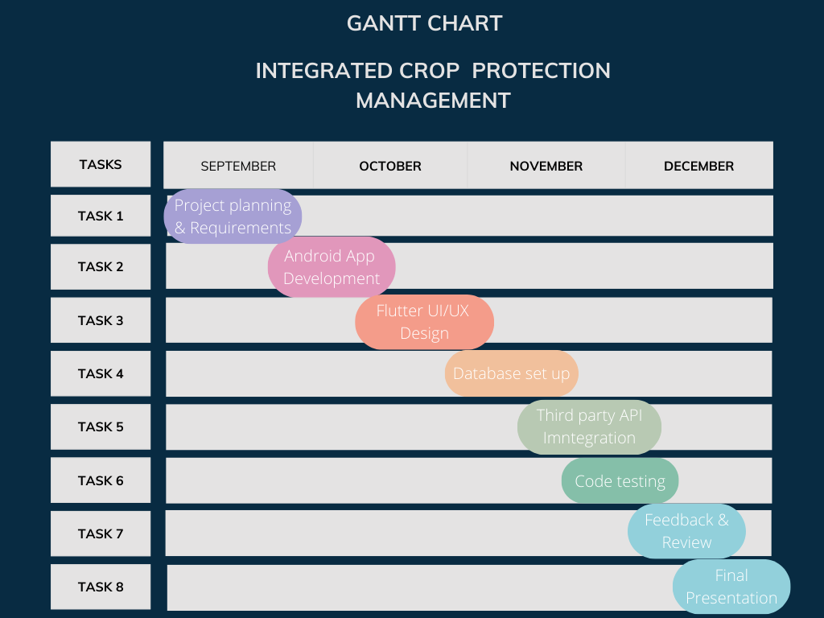

**CHAPTER-8**

**OUTCOMES**

**• Enhanced Agricultural Productivity**

* Increased crop yields through precise recommendations for crop selection, soil health improvement, and effective fertilizer usage**.**

**• Better Resource Management**

* Optimal utilization of land, water, and fertilizers by aligning farming practices with predicted monsoon trends and soil conditions**.**

**• Improved Profit Margins for Farmers**

* Higher profits due to strategic crop planning based on market trends, climate conditions, and resource availability.

**• Sustainable Farming Practices**

* Adoption of environmentally friendly and sustainable methods through data-driven guidance on soil health and fertilizer use.

**• Reduced Risk and Uncertainty**

* Lower dependency on guesswork, as farmers can anticipate monsoon behavior and market fluctuations with reliable predictions**.**

**• Increased Farmer Empowerment**

* Empowering farmers with technology to reduce vulnerabilities and make strategic decisions independently.

**CHAPTER-9**

**FLOWCHART DIAGRAM**

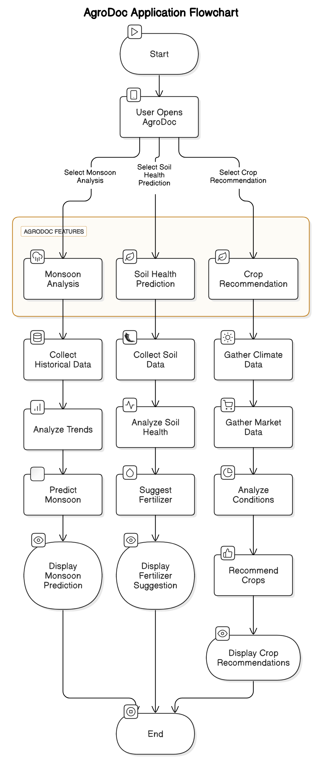

**CHAPTER-10**

**CONCLUSION**

The AgroDoc project represents a transformative step in modernizing agriculture through the integration of advanced technologies such as Artificial Intelligence (AI) and Machine Learning (ML). By addressing critical challenges faced by farmers, such as unpredictable monsoons, inefficient soil management, and inadequate crop planning, AgroDoc empowers farmers with data-driven insights and real-time recommendations.

The mobile application provides farmers with valuable tools to predict monsoon trends, optimize soil health, select the right crops, and improve market awareness. With the ability to analyze real-time data and continuously update recommendations, AgroDoc enables farmers to make informed decisions that enhance productivity, reduce resource wastage, and increase profitability.

Additionally, the integration of AI-based predictions for weather, soil conditions, and market trends helps mitigate risks related to unpredictable weather patterns and volatile markets. The smart crop recommendation system and fertilizer optimization module promote sustainable farming practices, reducing the dependency on harmful chemicals and supporting long-term soil health.

By providing real-time alerts and helping farmers find nearby storage facilities, AgroDoc also tackles post-harvest losses, which are a significant challenge for farmers. With its user-friendly interface, offline functionality, and multi-language support, the app ensures accessibility for farmers, especially in rural and remote areas.

Overall, AgroDoc has the potential to revolutionize farming practices in India and beyond. By integrating modern technological solutions with traditional farming practices, AgroDoc aims to enhance the economic stability of farming communities, promote sustainability, and contribute to the achievement of global Sustainable Development Goals (SDGs).

Through continuous updates, ongoing user feedback, and advanced data analytics, AgroDoc will evolve to meet the ever-changing needs of the agricultural sector, ensuring its long-term impact on improving the livelihoods of farmers and the future of agriculture.

**REFERENCES**

* [**https://www.researchgate.net/publication/372664253_Sustainable_Crop_Protection_via_Robotics_and_Artificial_Intelligence_Solutions/link/6580e9dc2468df72d3b70cbd/download**](https://www.researchgate.net/publication/372664253_Sustainable_Crop_Protection_via_Robotics_and_Artificial_Intelligence_Solutions/link/6580e9dc2468df72d3b70cbd/download)
* [**https://www.irjmets.com/uploadedfiles/paper//issue_1_january_2024/48795/final/fin_irjmets1705938824.pdf**](https://www.irjmets.com/uploadedfiles/paper/issue_1_january_2024/48795/final/fin_irjmets1705938824.pdf)
* [**https://ieeexplore.ieee.org/document/8409427**](https://ieeexplore.ieee.org/document/8409427)
* [**https://www.sciencedirect.com/science/article/abs/pii/S0167880997000261**](https://www.sciencedirect.com/science/article/abs/pii/S0167880997000261)
* [**https://www.taylorfrancis.com/chapters/edit/10.1201/9781351072717-2/integrated-crop-management-systems-pest-control-kamal-el-zik-raymond-frisbie**](https://www.taylorfrancis.com/chapters/edit/10.1201/9781351072717-2/integrated-crop-management-systems-pest-control-kamal-el-zik-raymond-frisbie)

[**IRJMETS - Low cost journal with DOI |Rs. 599 publication fees |In 4 hr fast paper publication| Engineering, Scientific journal**](https://www.irjmets.com/)

**APPENDIX-A**

**PSUEDOCODE**

**Monsoon Trend Analysis and Prediction**

Function MonsoonPrediction(historical_monsoon_data):

Preprocess historical_monsoon_data

Train AI/ML Model (e.g., Time Series Model, LSTM) with historical_monsoon_data

Predict monsoon trends for upcoming season

Return monsoon_prediction

**Soil Health Prediction and Fertilizer Recommendation**

Function SoilHealthAnalysis(soil_data):

Preprocess soil_data (e.g., pH, nitrogen, phosphorus, potassium levels)

Train ML Model to classify soil health

Analyze soil condition

Return soil_health_status

Function FertilizerRecommendation(soil_health_status, crop_type, land_area):

Map soil_health_status to appropriate fertilizers

Calculate required fertilizer quantity based on crop_type and land_area

Return fertilizer_suggestions

**APPENDIX-B**

**SCREENSHOTS**

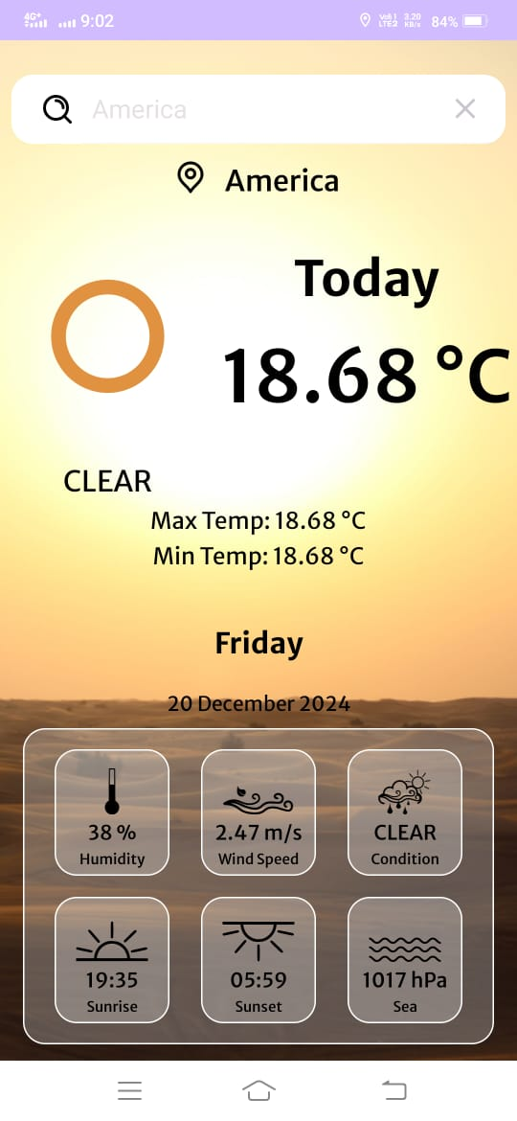 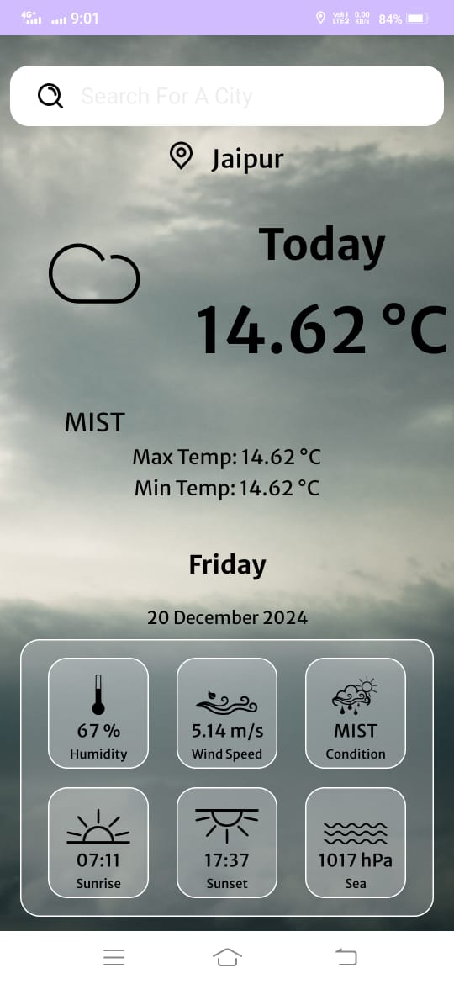

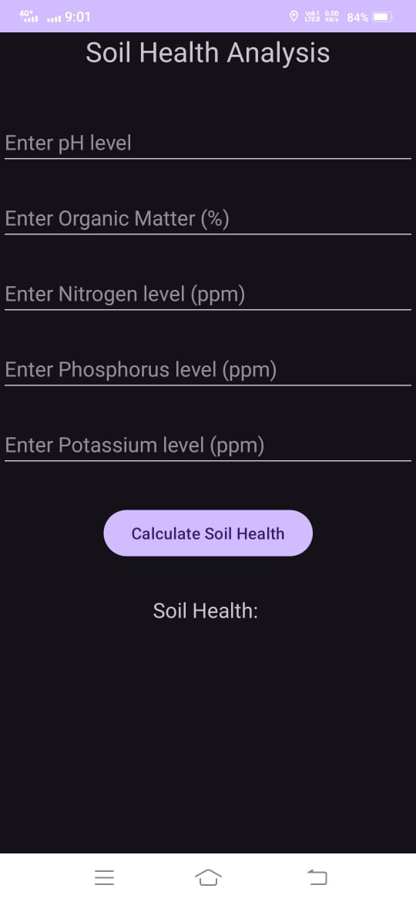

**APPENDIX-C**

**ENCLOSURES**

**1. Journal publication/Conference Paper Presented Certificates of all students.**

**2. Include certificate(s) of any Achievement/Award won in any project-related event.**

**3. Similarity Index / Plagiarism Check report clearly showing the Percentage (%). No need for a page-wise explanation.**

**4.** **Details of mapping the project with the Sustainable Development Goals (SDGs).**