**Integrated Crop Protection Management**

## A PROJECT REPORT

***Submitted by,***

|  |  |  |
| --- | --- | --- |
| Sl. No. | Roll Number | Student Name |
| 1 | 20211CAI0154 | **MANOJ J R** |
| 2 | 20211CAI0068 | **VEERESH** |
| 3 | 20211CAI0100 | K SAINATH |
| 4 | 20221LCA0008 | **KUSHAL M P** |

### *Under the guidance of,*

**Dr.Mohammadi Akheela Khanum**

School of Computer Science, Presidency University, Bengaluru

***in partial fulfillment for the award of the degree of***

**BACHELOR OF TECHNOLOGY**

**IN**

**COMPUTER SCIENCE AND ENGINEERING, (AI&ML)**

**At**



**PRESIDENCY UNIVERSITY**

**PRESIDENCY UNIVERSITY**

**SCHOOL OF COMPUTER SCIENCE ENGINEERING**

**CERTIFICATE**

This is to certify that the Project report **Integrated Crop Protection Management** being submitted by "MANOJ J R, VEERESH B, K SAINATH , Kushal M P " in partial fulfillment of the requirement for the award of the degree of Bachelor of Technology in Computer Science and Engineering is a bonafide work carried out under my supervision.

|  |  |
| --- | --- |
| **Dr.Mohammadi Akheela Khanum**  School of CSE&IS  Presidency University | **Dr. Zafar Ali Khan /HOD**  **N-Asso. Prof – SCSE**  Presidency University |

|  |  |  |
| --- | --- | --- |
| **Dr. L. SHAKKEERA**  Associate Dean  School of CSE  Presidency University | **Dr. MYDHILI NAIR**  Associate Dean  School of CSE  Presidency University | **Dr. SAMEERUDDIN KHAN**  Pro-Vc School of Engineering  Dean -School of CSE&IS  Presidency University |

**PRESIDENCY UNIVERSITY**

**SCHOOL OF COMPUTER SCIENCE ENGINEERING**

**DECLARATION**

We hereby declare that the work, which is being presented in the project report entitled **Integrated Crop Protection Management** in partial fulfillment for the award of Degree of **Bachelor of Technology** in **Computer Science and Engineering(AI&ML)**, is a record of our own investigations carried under the guidance of **Dr.Mohammadi Akheela Khanum,** **School of Computer Science Engineering & Information Science, Presidency University, Bengaluru.**

We have not submitted the matter presented in this report anywhere for the award of any other Degree.

|  |  |  |  |  |  |  |  |  |  |  |  |  |  |  |  |  |
| --- | --- | --- | --- | --- | --- | --- | --- | --- | --- | --- | --- | --- | --- | --- | --- | --- |
| |  |  |  |  |  |  |  |  |  |  |  |  |  |  |  |  | | --- | --- | --- | --- | --- | --- | --- | --- | --- | --- | --- | --- | --- | --- | --- | --- | | |  |  |  | | --- | --- | --- | | NAME | ROLL NUMBER | SIGNATURE | | MANOJ J R | 20211CAI0154 |  | | VEERESH B | 20211CAI0068 |  | | K SAINATH | 20211CAI0100 |  | | Kushal M P | 20221LCA0008 |  | | |

**ABSTRACT**

Agriculture is the backbone of the Indian economy, employing more than half of the country’s workforce and contributing significantly to its GDP. However, the sector faces numerous challenges, including unpredictable monsoons, inefficient crop planning, poor soil management, and limited access to advanced agricultural tools. These issues often result in reduced productivity, higher costs, and lower profitability for farmers. To address these pressing concerns, AgroDoc is proposed as an innovative, mobile-based solution designed to revolutionize traditional farming practices

AgroDoc leverages the power of **Artificial Intelligence (AI)** and **Machine Learning (ML)** to provide farmers with predictive insights and actionable recommendations. The platform integrates several key functionalities to support farmers in optimizing their agricultural practices. It includes a monsoon prediction module for forecasting weather patterns, a soil health analysis module to assess nutrient levels and recommend fertilizers, and a smart crop recommendation system that factors in soil conditions, climate, and market trends. Real-time weather updates, market sentiment analysis, and warehouse location assistance further enhance its utility.

This intelligent, user-friendly application also addresses gaps in such as reliance on non-scientific soil analysis, lack of reliable weather predictions, and poor crop selection strategies. By equipping farmers with real-time data AgroDoc aims to improve decision-making, reduce risks from unpredictable weather, and increase overall yield and profitability.

The expected outcomes of AgroDoc include better crop planning, enhanced soil fertility management, reduced post-harvest losses, and higher farmer satisfaction. By bridging the gap between technology and traditional farming, AgroDoc not only promotes sustainability but also empowers farmers to achieve economic stability and improved livelihoods.

**ACKNOWLEDGEMENT**

First of all, we indebted to the **GOD ALMIGHTY** for giving me an opportunity to excel in our efforts to complete this project on time.

We express our sincere thanks to our respected dean **Dr. Md. Sameeruddin Khan**, Pro-VC, School of Engineering and Dean, School of Computer Science Engineering & Information Science, Presidency University for getting us permission to undergo the project.

We express our heartfelt gratitude to our beloved Associate Deans **Dr. Shakkeera L and Dr. Mydhili Nair,** School of Computer Science Engineering & Information Science, Presidency University, and “**Dr. Zafar Ali Khan”**, Head of the Department, School of Computer Science Engineering & (AI&ML) Presidency University, for rendering timely help in completing this project successfully.

We are greatly indebted to our guide **Dr.Mohammadi Akheela Khanum, Designation** and Reviewer **Dr. Alamelu J Mangai Designation**, School of Computer Science Engineering & Information Science, Presidency University for her inspirational guidance, and valuable suggestions and for providing us a chance to express our technical capabilities in every respect for the completion of the project work.

We would like to convey our gratitude and heartfelt thanks to the PIP2001 Capstone Project Coordinators **Dr. Sampath A K, Dr. Abdul Khadar A and Mr. Md Zia Ur Rahman,** department Project Coordinators “**Dr.Mohammadi Akheela Khanum**” and Git hub coordinator **Mr. Muthuraj.** We thank our family and friends for the strong support and inspiration they have provided us in bringing out this project.

**MANOJ JR**

**VEERESH B**

**K SAINATH**

**KUSHAL MP**

**TABLE OF CONTENTS**

|  |  |  |
| --- | --- | --- |
| **CHAPTER NO.** | **TITLE** | **PAGE NO.** |
|  | **ABSTRACT ACKNOWLEDGMENT** | **IV**  **V** |
| **1** | **INTRODUCTION** | 1 |
| **2** | LITERATURE SURVEY | 2 |
| **3** | RESEARCH GAP OF EXISTING  METHODS | 3-4 |
| **4** | PROPOSED MOTHODOLOGY | 5 |
| **5** | OBJECTIVES | 6 |
| **6** | SYSTEM DESIGN & IMPLEMENTION | 7-8 |
| **7** | TIMELINE FOR  EXCUTION OF PROJECT | 9 |
| **8** | OUTCOMES | 9 |
| **9** | FLOWCHART DIAGRAM | 10 |
| **10** | CONCLUSION | **11** |
| **11** | PSUEDOCODE | 12 |

**CHAPTER-1**

**INTRODUCTION**

## 1.1 General Background

Agriculture is the lifeline of the Indian economy, employing more than half of the country’s population. Despite its significance, this sector faces multifaceted challenges that hinder productivity and profitability for farmers. Issues such as unpredictable monsoons, fluctuating market dynamics, improper crop planning, and a lack of scientific soil health analysis have compounded the hardships of farmers, reducing their income and leaving them vulnerable to economic instability. To tackle these challenges and empower farmers with modern technological tools, we present **AgroDoc**, a revolutionary mobile application that serves as a comprehensive solution to address the critical needs of today’s agricultural landscape.

AgroDoc leverages cutting-edge technologies like Artificial Intelligence (AI) and Machine Learning (ML) to provide farmers with actionable insights, enabling informed decisionmaking, optimizing yields, and enhancing profits.

**Abstract**

The agriculture sector, a cornerstone of the Indian economy, employs over half the nation’s population. However, farmers continue to face significant challenges such as unpredictable weather patterns, inadequate soil health analysis, and volatile markets. These issues often result in suboptimal yields and economic instability. AgroDoc, a revolutionary mobile application, seeks to address these challenges by integrating Artificial Intelligence (AI) and Machine Learning (ML) into a farmer-friendly platform. AgroDoc empowers farmers with accurate monsoon predictions, soil health assessments, crop recommendations, market sentiment analysis, and efficient storage solutions. By offering data-driven insights and actionable recommendations, AgroDoc aims to increase agricultural productivity, optimize costs, and enhance profitability, fostering a more resilient and sustainable farming community.

.

**Problem Statement**

Agriculture is the backbone of India’s economy, employing over 50% of the population and contributing significantly to the country’s GDP. Despite its critical role, the agricultural sector faces persistent and multifaceted challenges that hinder productivity, profitability, and sustainability. These challenges are exacerbated by the reliance on traditional farming practices and limited adoption of modern technological solutions. Key issues include:

1. **Unpredictable Monsoons and Weather Patterns**

* India’s agriculture is predominantly rain-fed, making it highly dependent on monsoons.
* Erratic rainfall patterns, delayed or excessive rains, and droughts significantly impact crop planning and productivity.
* Farmers lack access to reliable, region-specific weather predictions, resulting in poor preparedness and substantial crop losses.

2. **Inadequate Soil Health Management**

* Current soil testing methods are often non-scientific and limited in scope, relying on visual assessments or basic manual tools.
* These methods fail to provide accurate nutrient-level data, leading to overuse or underuse of fertilizers, which depletes soil fertility over time.
* Farmers lack awareness and access to data-driven recommendations for soil management, affecting long-term agricultural sustainability.

3. I**nefficient Crop Planning and Market Volatility**

* Crop selection often depends on tradition rather than scientific analysis, ignoring crucial factors like soil health, weather conditions, and market demand.
* Volatile market dynamics, including fluctuating crop prices and demand-supply mismatches, result in economic instability for farmers.
* Without tools to integrate these variables, farmers face financial losses due to poor crop selection and misaligned production strategies.

4. **Post-Harvest Losses and Storage Issues**

* Lack of proper storage facilities leads to significant post-harvest losses. Perishable crops, especially fruits and vegetables, are particularly vulnerable.
* Farmers often lack information about nearby warehouses or cold storage options, forcing them to sell produce at low prices immediately after harvest.

5. **Limited Access to Advanced Technology**

* Small-scale and marginal farmers, who form the majority, are often excluded from technological advancements due to poor infrastructure, high costs, and lack of awareness.
* Existing solutions, like weather prediction systems and soil testing kits, are not tailored for rural settings and fail to provide multilingual or offline functionality.
* The digital divide leaves farmers in remote regions at a disadvantage, reducing the adoption of innovative tools and techniques.

6. **Lack of Integration and Data-Driven Insights**

* Available solutions tend to address individual problems like weather prediction or soil analysis in isolation, without integrating multiple factors.
* Farmers require a comprehensive platform that combines weather data, soil health analysis, crop recommendations, and market insights for holistic decision-making.

**Need for a Technological Solution**

To address these pressing issues, there is a critical need for a comprehensive, user-friendly, and accessible platform that leverages modern technologies. AgroDoc is envisioned as a transformative solution to bridge the gap between traditional farming practices and modern advancements. The proposed application aims to:

1. **Empower Farmers with Predictive Insights:**
   * Provide accurate, region-specific monsoon and weather forecasts to aid in crop planning and irrigation management.
   * Offer real-time alerts for adverse weather events, pest outbreaks, and other agricultural risks.
2. **Enhance Soil Health Management:**
   * Use AI and ML to analyze soil data and predict nutrient deficiencies.
   * Recommend optimal fertilizer use, promoting cost efficiency and environmental sustainability.
3. **Optimize Crop Planning:**
   * Suggest the best crops based on soil health, climatic conditions, and market trends.
   * Enable strategic planning to maximize yields and profitability.
4. **Improve Market and Storage Access:**
   * Integrate tools to analyze market demand and price trends, empowering farmers to make informed selling decisions.
   * Identify and recommend nearby storage facilities to minimize post-harvest losses.
5. **Foster Accessibility and Inclusivity:**
   * Develop a multilingual mobile application with offline capabilities to ensure usability in rural and remote areas.
   * Design an intuitive interface to cater to farmers with varying levels of technological proficiency.
6. **Promote Sustainability:**
   * Encourage balanced fertilizer use and sustainable farming practices to preserve soil health and ecological balance.

**Objectives**

1. **Empower Farmers with Predictive Insights:** Provide accurate monsoon forecasts and soil health analyses to enable informed decision-making and optimize farming practices.
2. **Optimize Crop Planning:** Recommend suitable crops based on climatic conditions, soil properties, and market trends to maximize yield and profitability.
3. **Enhance Economic Stability:** Utilize market sentiment analysis to help farmers navigate price volatility and secure better returns for their produce.
4. **Facilitate Post-Harvest Management:** Identify nearby storage facilities to minimize post-harvest losses and ensure crop quality.
5. **Promote Sustainable Practices:** Encourage balanced fertilizer use and sustainable farming methods to maintain soil health and long-term productivity.
6. **Leverage Advanced Technology:** Harness the power of AI and ML to deliver precise, user-friendly solutions accessible to farmers, even in remote areas.
7. **Improve Accessibility and Inclusivity:** Design a mobile application optimized for low-bandwidth environments with multilingual support to reach a diverse user base.
8. **Foster Knowledge Sharing:** Create a platform for farmers to share experiences, access government schemes, and benefit from community-driven learning.

**CHAPTER-2**

**LITERATURE SURVEY**

**Technological Opportunities:**

**AI and Machine Learning** (ML): These technologies offer advanced tools for analyzing large datasets to provide actionable insights.

Examples include real-time weather forecasting, soil health assessment, and smart crop recommendation systems.

**Mobile Applications**: Platforms like AgroDoc can make these technologies accessible to farmers, even in remote regions.

**Existing Solutions and Their Drawbacks:**

* Current soil testing methods lack accessibility and precision.
* Available weather prediction systems are generalized and not tailored to specific regions or crops.
* Crop selection tools often do not integrate real-time data from multiple factors, such as weather, soil conditions, and market trends.
* Farmers lack tools that combine storage and supply chain optimization to reduce post-harvest losses.

**Conclusion of the Literature Review:** There is a pressing need for comprehensive tools like AgroDoc to bridge the gap between traditional farming practices and modern technological advancements. By integrating AI/ML, AgroDoc aims to address inefficiencies in agriculture, ensuring sustainability, profitability, and productivity for farmers.

**Significant Studies Referenced** :

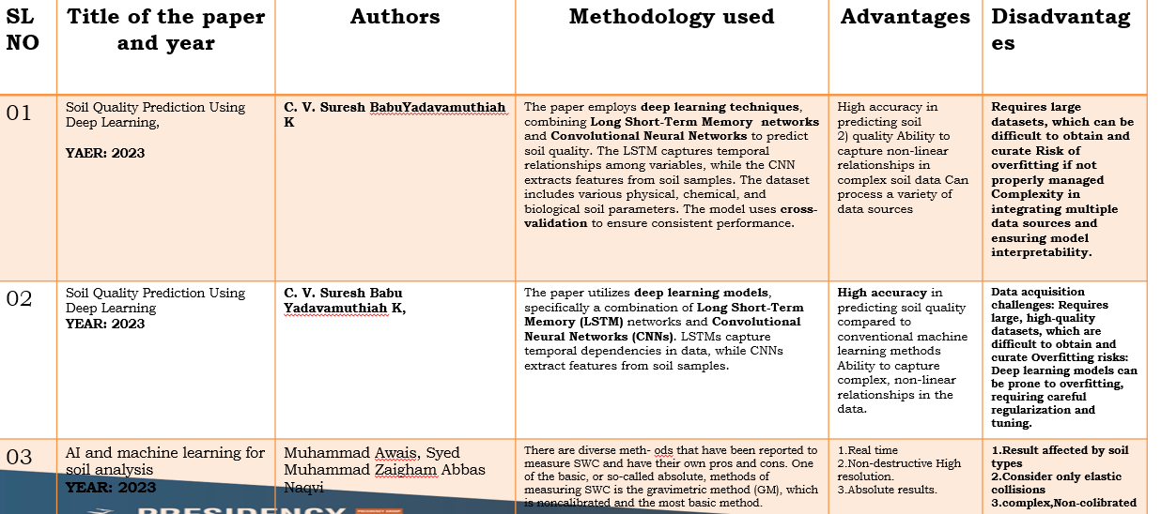

**CHAPTER-3**

**RESEARCH GAPS OF EXISTING METHODS**

Despite the advancements in agricultural technology, significant gaps remain in addressing the complex challenges faced by farmers, particularly in countries like India where agriculture is predominantly rain-fed. Existing methods and tools, while useful in specific scenarios, fail to offer comprehensive, integrated, and user-friendly solutions. These research gaps are detailed below:

**1. Inaccurate and Generalized Weather Predictions**

* Existing weather prediction systems often provide generalized forecasts that are not tailored to specific regions or crops.
* Farmers require highly localized and accurate monsoon predictions to plan sowing and irrigation schedules effectively.
* The lack of precision in forecasting weather events, such as unseasonal rains or droughts, often leads to crop losses and reduced productivity.
* Current systems do not integrate actionable insights, leaving farmers without practical advice on how to mitigate risks posed by unpredictable weather patterns.

**2. Non-Scientific and Limited Soil Analysis**

* Traditional soil analysis methods rely on visual inspection or basic chemical testing, which fail to provide a complete picture of soil health.
* Key soil parameters, such as nutrient deficiencies and microbial activity, are often overlooked, resulting in inefficient fertilizer use.
* Farmers lack access to real-time soil health data, making it difficult to determine appropriate fertilizer types and quantities.
* There is a need for AI-powered soil health assessment tools that can analyze diverse soil types and recommend sustainable nutrient management practices.

**3. Fragmented Crop Selection Tools**

* Current crop recommendation methods do not consider multi-factorial inputs such as soil composition, climatic conditions, and market demand.
* Static crop selection approaches fail to adapt to dynamic environmental factors like changing weather patterns and soil degradation.
* Farmers often rely on traditional knowledge for crop selection, which may not align with modern market demands or resource availability.
* Integrated tools that combine real-time data from multiple sources are needed to provide holistic crop planning advice.

**4. Limited Integration of Post-Harvest Management**

* Existing solutions rarely address post-harvest issues such as storage, transportation, and market access.
* Farmers face significant post-harvest losses due to inadequate storage facilities and a lack of awareness about nearby warehouses or cold storage options.
* There is a lack of tools to connect farmers with local storage facilities, leading to quality degradation and financial losses.
* Addressing this gap requires an integrated approach that includes post-harvest management as a core feature of agricultural platforms.

**5. Low Technology Penetration in Rural Areas**

* Most agricultural technologies are designed for urban or semi-urban users, ignoring the specific needs of rural farmers.
* Limited internet connectivity and low technological literacy in remote areas hinder the adoption of advanced tools.
* Existing mobile applications often lack offline functionality and multi-language support, making them inaccessible to a diverse farming population.
* The design of such tools must prioritize user-friendliness and inclusivity to ensure widespread adoption.

**6. Inadequate Use of AI and ML in Agriculture**

* While AI and ML have proven effective in other industries, their application in agriculture remains limited and fragmented.
* Existing tools often use outdated models that cannot adapt to rapidly changing weather, soil, or market conditions.
* There is a lack of platforms that leverage AI and ML to provide predictive insights and personalized recommendations tailored to individual farmers.
* Advanced algorithms capable of analyzing large datasets and providing real-time, actionable insights are essential for optimizing farming practices.

**7. Fragmented and Isolated Solutions**

* Current agricultural solutions address specific problems in isolation, such as weather forecasting or soil analysis, without offering an integrated approach.
* Farmers need a single platform that combines weather data, soil health assessments, crop recommendations, and market insights.
* The absence of such a unified solution results in inefficiencies, as farmers must rely on multiple tools that may not communicate with one another.

**8. Market Volatility and Lack of Financial Insights**

* Farmers lack tools to navigate volatile market conditions and price fluctuations, leading to suboptimal pricing and reduced income.
* Existing platforms do not integrate market sentiment analysis, which is crucial for helping farmers make informed decisions about selling their produce.
* There is a need for systems that provide real-time market trends and price predictions to enhance profitability.

**CHAPTER-4**

**PROPOSED MOTHODOLOGY**

The proposed methodology for AgroDoc integrates cutting-edge technologies such as Artificial Intelligence (AI), Machine Learning (ML), and user-friendly mobile application interfaces to address the challenges faced by farmers. The goal is to provide a comprehensive, accessible, and data-driven platform that empowers farmers to optimize their agricultural practices, increase productivity, and enhance profitability.

**1. Monsoon Trend Prediction Using AI and ML**

* **Historical Data Analysis**:  
  AgroDoc utilizes historical weather data, including rainfall patterns, temperature fluctuations, and humidity levels, to train predictive models.
* **Machine Learning Algorithms**:  
  Advanced algorithms, such as Long Short-Term Memory (LSTM) networks and time-series models, analyze past and current weather trends to predict regional monsoon patterns.
* **Actionable Insights**:  
  Farmers receive precise, region-specific forecasts, enabling them to plan sowing, irrigation, and harvesting schedules effectively. This minimizes risks associated with delayed monsoons or unseasonal rains.

**2. Soil Health Analysis and Fertilizer Recommendations**

* **Soil Data Input**:  
  Farmers can input data such as soil type, pH levels, moisture content, and nutrient availability through the mobile application.
* **AI-Based Soil Analysis**:  
  AgroDoc employs AI models to process this data, evaluate soil health, and identify nutrient deficiencies or imbalances.
* **Personalized Fertilizer Recommendations**:  
  Based on the analysis, the platform suggests appropriate fertilizers, their quantities, and application schedules. This reduces overuse of chemicals, lowers costs.

**3. Smart Crop Recommendation System**

* **Integrated Data Sources**:  
  The system integrates soil health data, weather predictions, and market trends to provide tailored crop recommendations.
* **Dynamic Decision-Making**:  
  By considering real-time environmental and economic factors, AgroDoc helps farmers select crops that maximize yield and profitability.
* **Market Demand Integration**:  
  Recommendations include insights into high-demand crops, helping farmers align production with market needs to secure better returns.

**4. Real-Time Alerts and Notifications**

* **Weather Updates**:  
  The platform sends real-time alerts for weather changes, including heavy rainfall, droughts, and temperature fluctuations.
* **Pest and Disease Outbreaks**:  
  AgroDoc alerts farmers to potential pest infestations and offers preventative measures, reducing crop losses.
* **Market Price Fluctuations**:  
  Notifications on price trends and market dynamics help farmers make informed decisions about selling their produce.

**5. User-Friendly Mobile Application**

* **Intuitive Interface**:  
  The app is designed with a simple, easy-to-navigate interface, ensuring accessibility for farmers with varying levels of technological proficiency.
* **Multi-Language Support**:  
  AgroDoc supports multiple regional languages, breaking linguistic barriers and reaching a diverse user base.
* **Offline Functionality**:  
  Farmers in remote areas can access critical features without continuous internet connectivity, ensuring uninterrupted utility.
* **Interactive Features**:  
  Tools such as a dashboard for monitoring key metrics, input forms for soil and crop data, and a resource library for agricultural best practices are integrated into the app.

**6. Post-Harvest Management Integration**

* **Warehouse Locator**:  
  AgroDoc identifies and recommends nearby storage facilities, including warehouses and cold storage units, to minimize post-harvest losses.
* **Quality Preservation Guidance**:  
  The app offers tips on crop storage and handling to maintain quality and increase shelf life.
* **Market Linkage**:  
  Farmers are connected with potential buyers and local markets, ensuring timely and profitable sales of their produce.

**7. Integration with Third-Party APIs and Real-Time Data**

* **Weather and Soil APIs**:  
  AgroDoc integrates with reliable external sources for real-time weather and soil data, enhancing the accuracy of its predictions and recommendations.
* **Dynamic Data Streams**:  
  Continuous updates ensure that farmers receive the most relevant and actionable insights for decision-making.

**8. Sustainability and Environmental Focus**

* **Balanced Fertilizer Use**:  
  The platform promotes sustainable farming practices by encouraging the optimal use of organic and chemical fertilizers.
* **Water Resource Management**:  
  Recommendations on irrigation schedules and water conservation techniques help reduce wastage and ensure efficient use of resources.
* **Long-Term Soil Health Preservation**:  
  AgroDoc emphasizes practices that improve soil fertility and structure over time, ensuring sustainable agricultural productivity.

**9. Implementation Plan**

* **Phase 1: Requirement Gathering and Planning**
  + Collect data on farmer needs, existing challenges, and technological infrastructure.
  + Define project scope, goals, and key performance indicators (KPIs).
* **Phase 2: System Design and Prototyping**
  + Develop a system architecture and design user interface prototypes.
  + Create proof-of-concept models for core features, including AI-based monsoon predictions and soil analysis.

**OBJECTIVES**

1. **Predict Monsoon Trends for Better Crop Planning**
2. **Improve Soil Health Management and Fertilizer Use**
3. **Empower Farmers with Real-Time Alerts and Updates**
4. **Increase Farmer Profitability and Yield**
5. **Notify farmers of important events such as weather changes**
6. **Make advanced agricultural technologies, such as AI and ML, easily accessible and usable for farmers in remote areas through a simple mobile app interface.**
7. **Provide farmers with continuous updates and personalized recommendations to improve decision-making, productivity,**
8. **: Suggest the right type and quantity of fertilizers based on soil nutrient analysis to promote sustainable and cost-effective farming practices.**
9. **Recommend crops suited to current soil conditions, weather patterns, and market demand to maximize yield and financial returns.**

**CHAPTER-6**

**SYSTEM DESIGN & IMPLEMENTATION**

The system design and implementation of AgroDoc focus on developing an integrated, scalable, and user-centric platform that leverages AI and ML to address key challenges in agriculture. The approach involves designing a robust architecture, creating a farmer-friendly interface, and ensuring seamless integration of data-driven modules to deliver actionable insights.

**1. System Architecture**

The AgroDoc system is structured into three main layers:

**1.1 User Interface (UI) Layer**

* **Mobile Application**:  
  A farmer-friendly mobile app serves as the primary interaction point for users.
* **Features**:
  + Input forms for soil data, crop preferences, and location details.
  + Dashboards displaying key metrics such as monsoon forecasts, soil health status, crop recommendations, and market insights.
  + Alerts and notifications for real-time updates on weather, pests, and market fluctuations.

**1.2 Application Layer**

* **Core Functional Modules**:  
  This layer hosts the AI and ML models responsible for:
  + Monsoon predictions.
  + Soil health analysis.
  + Fertilizer recommendations.
  + Smart crop selection.
  + Market price analysis.
* **Data Processing**:  
  The application processes inputs from users and external APIs to generate actionable insights.
* **Decision-Making Algorithms**:  
  Advanced algorithms ensure the output is personalized and region-specific, enhancing its utility for farmers.

**1.3 Data Layer**

* **Database Management System (DBMS)**:  
  A centralized database stores user data, historical weather trends, soil health records, and market information.
* **Integration with External APIs**:  
  The system incorporates reliable external data sources for weather, soil, and market trends to ensure accuracy.

**2. User Interface Design**

A key focus of the system design is to ensure that the mobile application is intuitive and accessible to farmers with varying levels of technological proficiency.

**2.1 Features of the UI**

* **Simplified Data Input**:  
  Farmers can easily input soil and crop data through simple forms.
* **Interactive Dashboard**:  
  Displays monsoon trends, soil health status, crop recommendations, and alerts in an easy-to-understand format.
* **Multi-Language Support**:  
  The app supports multiple regional languages to cater to a diverse farming population.
* **Offline Functionality**:  
  Key features remain accessible even in areas with limited internet connectivity.
* **Real-Time Notifications**:  
  Alerts farmers about critical events like weather changes, pest outbreaks, or market price surges.

**2.2 Accessibility Features**

* Optimized for low-bandwidth environments to ensure usability in remote rural areas.
* Designed with large icons and simple navigation for ease of use.

**3. Core Functional Modules**

**3.1 Monsoon Prediction**

* **AI/ML Models**:  
  Predicts regional weather patterns based on historical and real-time data.
* **Insights**:  
  Provides actionable information for crop planning, irrigation, and harvest scheduling.

**3.2 Soil Health Analysis**

* **Input Parameters**:  
  Includes soil type, pH, moisture, and nutrient levels.
* **AI-Based Analysis**:  
  Evaluates soil health and identifies nutrient deficiencies.
* **Fertilizer Recommendations**:  
  Suggests optimal fertilizers and their application schedules.

**3.3 Smart Crop Recommendations**

* Integrates soil health, climatic conditions, and market demand to recommend profitable crops.

**3.4 Market Price Analysis**

* Analyzes market trends to help farmers secure better prices for their produce.

**3.5 Post-Harvest Management**

* Recommends nearby storage facilities and offers guidance on crop handling and preservation.

**4. Implementation Plan**

The implementation plan is divided into multiple phases to ensure systematic development and deployment:

**4.1 Phase 1: Requirement Gathering & Planning**

* **Activities**:
  + Identify farmer needs through surveys and stakeholder consultations.
  + Define the scope of the project and key deliverables.
* **Output**:  
  A comprehensive project plan detailing timelines, resources, and expected outcomes.

**4.2 Phase 2: System Design & Prototyping**

* **Activities**:
  + Design the system architecture and database schema.
  + Create UI/UX prototypes for the mobile application.
  + Develop proof-of-concept models for core AI functionalities.
* **Output**:  
  A functional prototype demonstrating key features.

**4.3 Phase 3: Development & Integration**

* **Activities**:
  + Develop AI models for weather predictions, soil analysis, and crop recommendations.
  + Integrate external APIs for real-time weather and market data.
  + Build the mobile application and backend systems.
* **Output**:  
  A fully developed platform ready for testing.

**4.4 Phase 4: Testing & Optimization**

* **Activities**:
  + Conduct user testing to identify usability issues.
  + Optimize AI models for accuracy and reliability.
  + Test the application for scalability, performance, and security.

**CHAPTER-7**

**TIMELINE FOR EXECUTION OF PROJECT**

**(GANTT CHART)**

**Timeline for Execution of Project**

The execution timeline for the Integrated Crop Protection Management project is structured over four months, from September to December, with a detailed Gantt chart outlining eight distinct tasks. Each task is sequenced to ensure smooth progression and alignment with the project’s objectives. Below is an explanation of the tasks and their timeline**:**

**1. Project Planning & Requirements (Task 1)**

Duration: September  
The first step involves comprehensive planning and gathering requirements for the project. This includes defining the scope, identifying key features, and consulting stakeholders such as farmers, agricultural experts, and technical developers. This phase sets the foundation for the subsequent tasks.

**2. Android App Development (Task 2)**

Duration: October  
The primary development phase begins with building the Android application. The focus is on creating a scalable and robust backend and integrating essential features such as data input forms, dashboards, and real-time alerts.

**3. Flutter UI/UX Design (Task 3)**

Duration: October - November  
Simultaneously, the user interface and user experience (UI/UX) design phase is initiated. Flutter is used to develop a cross-platform design that is visually appealing, intuitive, and accessible to users. Key design considerations include multi-language support and ease of navigation**.**

**4. Database Setup (Task 4)**

Duration: November  
The next phase involves configuring a database to store essential data such as soil health metrics, weather trends, and market prices. This includes integrating reliable data sources and ensuring that the database is optimized for scalability and performance.

**5. Third-Party API Integration (Task 5)**

Duration: November  
External APIs for weather predictions, soil analysis, and market trends are integrated into the system. This step ensures real-time data retrieval and enhances the app's functionality, enabling accurate predictions and recommendations.

**6. Code Testing (Task 6)**

Duration: November - December  
Once development and integration are complete, rigorous testing is conducted to identify and resolve bugs, optimize performance, and ensure the app's reliability. This phase also involves validating the outputs from AI/ML models.

**7. Feedback & Review (Task 7)**

Duration: December  
Stakeholders, including farmers and technical experts, are invited to review the application and provide feedback. The review focuses on the app's usability, accuracy of recommendations, and overall performance.

**8. Final Presentation (Task 8)**

Duration: December  
The project concludes with a final presentation, where the system is demonstrated to stakeholders. The presentation highlights the app's features, functionalities, and benefits, along with its impact on modern agricultural practices.

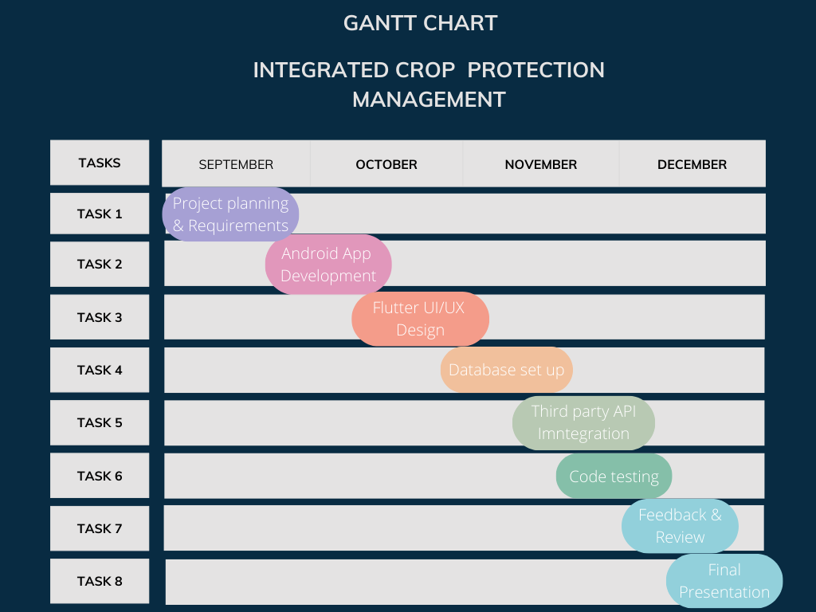

**CHAPTER-8**

**OUTCOMES**

The development and deployment of the **Integrated Crop Protection Management** system yield transformative outcomes for the agricultural sector. By leveraging advanced technologies such as AI, ML, and a robust mobile application, the project addresses critical challenges faced by farmers and delivers measurable benefits. The outcomes of this project can be categorized into technological, economic, environmental, and social impacts, ensuring holistic growth and sustainability.

**1. Technological Outcomes**

**1.1 AI-Powered Monsoon Predictions**

* Farmers receive highly accurate and localized monsoon forecasts, enabling better planning for sowing, irrigation, and harvesting.
* Reduces dependency on unpredictable weather patterns, mitigating risks associated with delayed rains or droughts.

**1.2 Data-Driven Soil Health Analysis**

* The system provides detailed soil health assessments, identifying deficiencies in nutrients and suggesting corrective actions.
* Recommendations for optimal fertilizer usage minimize overuse, improving both yield and soil sustainability.

**1.3 Smart Crop Recommendations**

* AI models analyze regional soil and climate conditions to suggest crops that promise maximum profitability and adaptability.
* Ensures crop diversification, reducing the risks associated with monoculture farming.

**1.4 Market Insight Tools**

* Farmers gain access to real-time market price trends, empowering them to make informed decisions regarding the sale of their produce.
* Reduces exploitation by middlemen and enhances market competitiveness for farmers.

**2. Economic Outcomes**

**2.1 Increased Productivity**

* By implementing data-driven recommendations for soil health, crop selection, and irrigation, farmers achieve higher yields.
* Efficient resource utilization, such as water and fertilizers, reduces input costs and improves overall profitability.

**2.2 Better Market Access**

* The integration of market trends into the app enables farmers to identify the best times and locations for selling crops, maximizing revenue.
* Access to nearby storage solutions reduces post-harvest losses, further boosting income.

**2.3 Cost Optimization**

* AI-powered analysis ensures judicious use of fertilizers and pesticides, leading to cost savings.
* Reduced dependence on costly traditional weather forecasting services or external consultants.

**3. Environmental Outcomes**

**3.1 Sustainable Farming Practices**

* Optimal fertilizer recommendations prevent overuse, protecting soil fertility and reducing water pollution caused by runoff.
* The system promotes crop rotation and diversification, which maintain ecological balance.

**3.2 Efficient Resource Utilization**

* The app aids in precise irrigation planning based on weather predictions, conserving water resources.
* Encourages minimal use of chemical inputs, reducing the carbon footprint of farming activities.

**3.3 Soil Preservation**

* Regular monitoring of soil health ensures timely interventions, preventing long-term degradation and ensuring sustainable farming for future generations.

**4. Social Outcomes**

**4.1 Empowerment of Farmers**

* By providing farmers with actionable insights and advanced tools, the app bridges the gap between modern technology and traditional farming.
* The system’s multilingual support ensures inclusivity, catering to diverse linguistic and literacy levels among farmers.

**4.2 Improved Livelihoods**

* Increased agricultural productivity and profitability directly translate into better living standards for farming communities.
* Reduced dependence on external loans due to increased income stability.

**4.3 Community Knowledge Sharing**

* Farmers become more knowledgeable about sustainable practices and can share their experiences and insights within their communities, fostering collective growth.

**5. Educational and Policy Impacts**

**5.1 Farmer Education**

* The platform indirectly educates farmers on best agricultural practices, including soil conservation, pest management, and sustainable cropping.
* Promotes awareness about climate change and its impact on farming, preparing communities for future challenges.

**5.2 Policy Formulation**

* Data collected by the system can serve as a valuable resource for policymakers to design farmer-centric schemes and subsidies.
* Insights from the platform may inform national strategies to enhance agricultural output and mitigate climate risks.

**Sustainable Farming Practices**

* Optimal fertilizer recommendations prevent overuse, protecting soil fertility and reducing water pollution caused by runoff.
* The system promotes crop rotation and diversification, which maintain ecological balance.

**CHAPTER-9**

**FLOWCHART DIAGRAM**

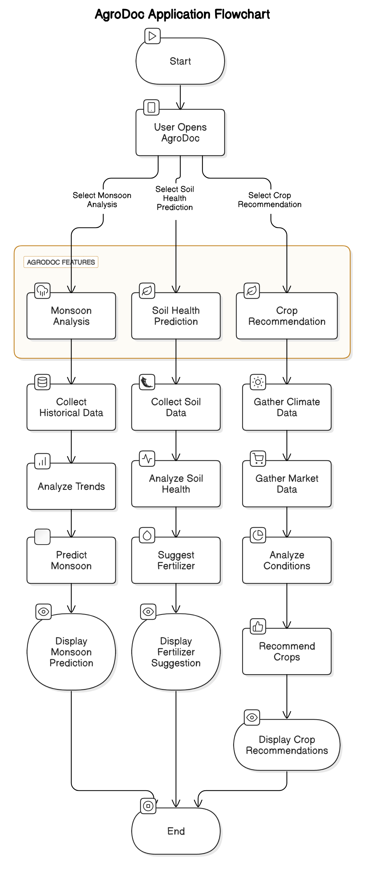

**Application Flow**

The AgroDoc application provides a streamlined and intelligent platform for farmers to access essential agricultural insights. The flowchart above illustrates the application's core functionalities, emphasizing a user-centric and systematic approach to solving critical farming challenges.

**1. Start**

* The user begins their interaction by opening the AgroDoc application. This initiates access to its key features.

**2. Main Features Selection**

* The application presents three primary features:
  + **Monsoon Analysis**
  + **Soil Health Prediction**
  + **Crop Recommendation**

The user selects the desired feature based on their immediate requirement.

**3. Monsoon Analysis**

* **Data Collection**: The system gathers historical weather data from reliable sources.
* **Trend Analysis**: Advanced algorithms analyze weather patterns and trends.
* **Monsoon Prediction**: Using AI, the app predicts the upcoming monsoon conditions.
* **Result Display**: The prediction is displayed to the user, aiding in irrigation and sowing decisions.

**4. Soil Health Prediction**

* **Soil Data Collection**: The user inputs soil test data, or it is collected via connected devices.
* **Soil Health Analysis**: The application evaluates nutrient levels, pH balance, and other key metrics.
* **Fertilizer Suggestion**: Based on the analysis, the app recommends specific fertilizers or soil amendments.
* **Result Display**: Farmers receive actionable recommendations to improve soil quality.

**5. Crop Recommendation**

* **Climate Data Gathering**: The system analyzes regional climatic conditions.
* **Market Data Collection**: Real-time market trends and demand for crops are integrated.
* **Condition Analysis**: AI algorithms evaluate all inputs to identify crops with the highest profitability and suitability.
* **Crop Suggestion**: The app recommends the best crops to cultivate.
* **Result Display**: Suggestions are presented in an easy-to-understand format for the user.

**6. End**

* The system consolidates all outputs and ensures the user receives comprehensive,

**CHAPTER-10**

**CONCLUSION**

Agriculture has always been the backbone of the Indian economy, employing over half of the population. However, despite its critical role, farmers often grapple with significant challenges such as unpredictable weather conditions, deteriorating soil health, and volatile market dynamics. These issues result in inconsistent yields and financial instability, further exacerbating the struggles of rural communities. The AgroDoc application addresses these challenges through a robust and innovative platform that integrates cutting-edge technologies like Artificial Intelligence (AI) and Machine Learning (ML) into the agricultural domain. The application aims to equip farmers with actionable insights that enhance productivity, optimize costs, and foster sustainability.

One of the core strengths of AgroDoc lies in its ability to deliver precise and actionable data through its key features—monsoon analysis, soil health prediction, and crop recommendations. The **monsoon analysis** feature provides farmers with reliable weather forecasts, enabling them to plan agricultural activities like sowing, irrigation, and harvesting with precision. By reducing the unpredictability of weather conditions, this feature significantly lowers the risks associated with climate variability. Similarly, the **soil health prediction** module allows farmers to monitor and assess the quality of their soil. By analyzing soil nutrient levels and structural health, the application recommends appropriate fertilizers and amendments, ensuring that crops receive the necessary nourishment without overuse of resources. This fosters a balance between maximizing yields and preserving soil fertility for long-term agricultural sustainability. Additionally, the **crop recommendation** feature leverages market trends, climatic conditions, and soil analysis to suggest the most suitable crops for cultivation. This not only ensures higher profitability for farmers but also minimizes losses associated with planting unsuitable crops.

AgroDoc also contributes significantly to the broader goals of environmental and economic sustainability. By promoting efficient resource management, such as the optimal use of water, fertilizers, and pesticides, the application minimizes environmental degradation. The reduction in chemical usage not only benefits the ecosystem but also reduces production costs for farmers, thereby increasing their profit margins. Furthermore, the emphasis on soil conservation ensures that agricultural lands remain fertile and productive for generations to come. The climate adaptation capabilities of the app empower farmers to make informed decisions amidst changing environmental conditions, reducing their vulnerability to climate-related risks.

The economic benefits of AgroDoc extend beyond the individual farmer to the larger agricultural community. By offering real-time insights and modern solutions, the application bridges the gap between traditional farming practices and modern technological advancements. This digital transformation creates opportunities for farmers to access previously unavailable tools, enhancing their ability to compete in an increasingly globalized market. Additionally, the increased productivity and profitability supported by AgroDoc contribute to improved living standards and financial stability for rural households. This has a cascading effect on the socio-economic development of the farming community, fostering a culture of innovation and resilience in agriculture.

In conclusion, AgroDoc stands as a transformative solution for modern agriculture, addressing long-standing challenges with innovative technology. By integrating data-driven insights with user-friendly features, the application empowers farmers to make better decisions, optimize their resources, and improve their livelihoods. AgroDoc not only enhances agricultural productivity and profitability but also promotes sustainable and eco-friendly farming practices. Its ability to combine environmental conservation with economic empowerment ensures that it serves as a catalyst for long-term growth and resilience in the agricultural sector. As AgroDoc continues to evolve, it holds the potential to revolutionize farming practices, contributing to a more secure and sustainable future for farmers and the global food supply chain.

**REFERENCES**

* [**https://www.researchgate.net/publication/372664253_Sustainable_Crop_Protection_via_Robotics_and_Artificial_Intelligence_Solutions/link/6580e9dc2468df72d3b70cbd/download**](https://www.researchgate.net/publication/372664253_Sustainable_Crop_Protection_via_Robotics_and_Artificial_Intelligence_Solutions/link/6580e9dc2468df72d3b70cbd/download)
* [**https://www.irjmets.com/uploadedfiles/paper//issue_1_january_2024/48795/final/fin_irjmets1705938824.pdf**](https://www.irjmets.com/uploadedfiles/paper/issue_1_january_2024/48795/final/fin_irjmets1705938824.pdf)
* [**https://ieeexplore.ieee.org/document/8409427**](https://ieeexplore.ieee.org/document/8409427)
* [**https://www.sciencedirect.com/science/article/abs/pii/S0167880997000261**](https://www.sciencedirect.com/science/article/abs/pii/S0167880997000261)
* [**https://www.taylorfrancis.com/chapters/edit/10.1201/9781351072717-2/integrated-crop-management-systems-pest-control-kamal-el-zik-raymond-frisbie**](https://www.taylorfrancis.com/chapters/edit/10.1201/9781351072717-2/integrated-crop-management-systems-pest-control-kamal-el-zik-raymond-frisbie)

[**IRJMETS - Low cost journal with DOI |Rs. 599 publication fees |In 4 hr fast paper publication| Engineering, Scientific journal**](https://www.irjmets.com/)

**APPENDIX-A**

**PSUEDOCODE**

**Monsoon Analysis:**

FUNCTION monsoonAnalysis()

DISPLAY "Collecting historical weather data..."

weatherData = FETCH_FROM_DATABASE("historical_weather")

currentConditions = FETCH_FROM_API("real_time_weather")

monsoonPrediction = PREDICT_MONSOON(weatherData, currentConditions)

DISPLAY "Predicted Monsoon Season: " + monsoonPrediction

END FUNCTION

**Soil Health Prediction:**

FUNCTION soilHealthPrediction()

DISPLAY "Enter soil parameters:"

soilData = {}

soilData["pH"] = GET_USER_INPUT("pH Level")

soilData["Nitrogen"] = GET_USER_INPUT("Nitrogen Level")

soilData["Phosphorus"] = GET_USER_INPUT("Phosphorus Level")

soilData["Potassium"] = GET_USER_INPUT("Potassium Level")

soilData["Moisture"] = GET_USER_INPUT("Moisture Content")

soilAnalysis = ANALYZE_SOIL(soilData)

fertilizerSuggestions = SUGGEST_FERTILIZER(soilAnalysis)

DISPLAY "Soil Analysis Results: " + soilAnalysis

DISPLAY "Recommended Fertilizer: " + fertilizerSuggestions

END FUNCTION

Crop Recommendation:

FUNCTION cropRecommendation()

DISPLAY "Gathering climate and market data..."

climateData = FETCH_FROM_API("climate_conditions")

soilData = FETCH_FROM_DATABASE("soil_profile")

marketData = FETCH_FROM_API("market_trends")

recommendedCrops = ANALYZE_CONDITIONS(climateData, soilData, marketData)

DISPLAY "Recommended Crops for Current Conditions: " + recommendedCrops

END FUNCTION

**Marketplace Integration:**

FUNCTION marketplace()

DISPLAY "Select an option: [1] Buy Crops, [2] Sell Crops"

marketChoice = GET_USER_INPUT()

IF marketChoice == 1 THEN

availableCrops = FETCH_FROM_DATABASE("market_inventory")

DISPLAY "Available Crops: " + availableCrops

ELSE IF marketChoice == 2 THEN

cropDetails = {}

cropDetails["Name"] = GET_USER_INPUT("Crop Name")

cropDetails["Quantity"] = GET_USER_INPUT("Crop Quantity")

cropDetails["Price"] = GET_USER_INPUT("Crop Price")

ADD_TO_DATABASE("market_inventory", cropDetails)

DISPLAY "Crop added to marketplace."

ELSE

DISPLAY "Invalid choice, returning to main menu."

END IF

END FUNCTION

**APPENDIX-B**

**SCREENSHOTS**

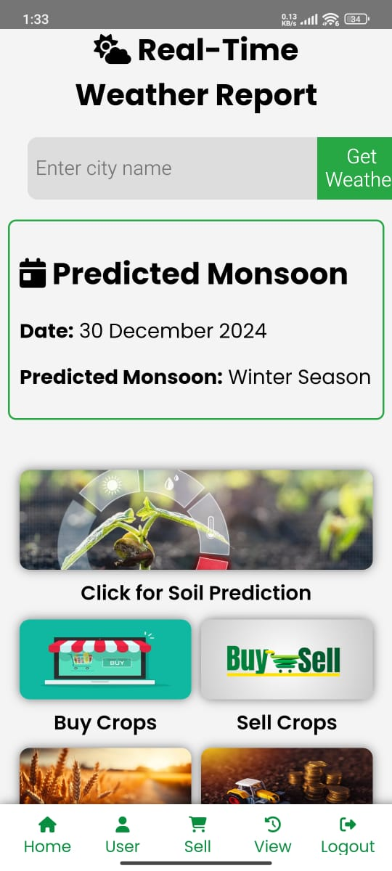 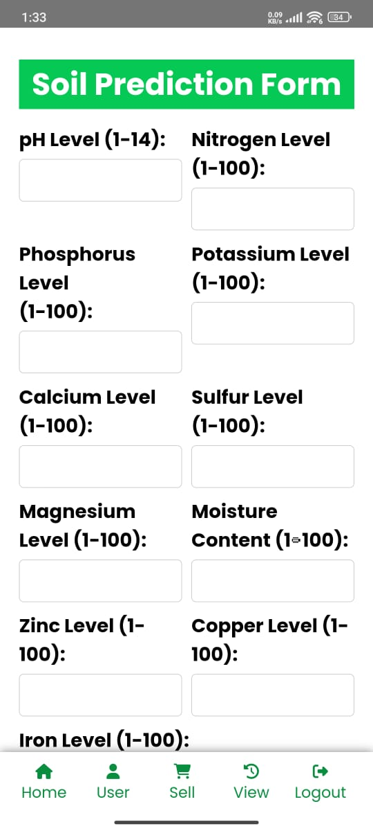

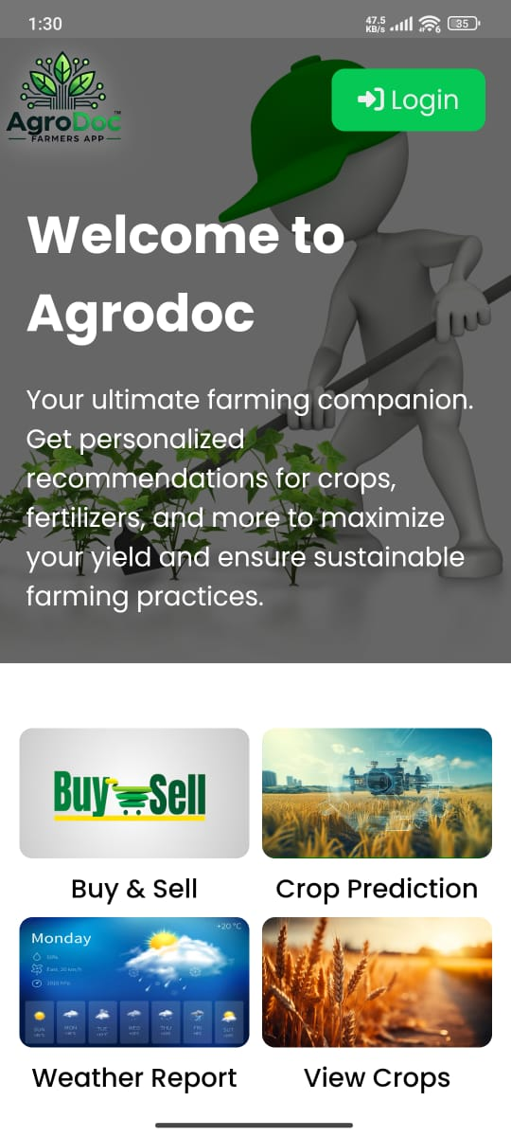

**Screenshot 1: Real-Time Weather Report**

* This screen highlights the weather prediction feature of AgroDoc.
* It provides real-time weather updates, including specific monsoon predictions for the selected city or region.
* Farmers can view critical information like the predicted monsoon season and access related features, such as soil prediction and the Buy/Sell marketplace.
* The layout is user-friendly, with an intuitive navigation bar at the bottom, offering options for home, user profile, soil prediction, and logout.

**Screenshot 2: Soil Prediction Form**

* This screen displays the Soil Health Prediction Form, where farmers can input detailed soil data.
* Parameters such as pH level, nitrogen, phosphorus, potassium, calcium, sulfur, magnesium, zinc, copper, iron, and moisture content are included.
* By filling out these fields, the app can analyze the soil health and provide specific recommendations for fertilizers and soil amendments.
* This feature ensures farmers receive tailored advice based on their field’s soil condition, promoting better yields and sustainable practices.

**Screenshot 3: Welcome Page**

* The Welcome Page introduces the user to AgroDoc’s primary functionalities.
* It emphasizes AgroDoc’s mission as a "farming companion," focusing on crop recommendations, fertilizer suggestions, and other tools to enhance yield and ensure sustainable farming.
* The bottom section contains interactive options such as:
  + Buy & Sell: A marketplace for trading crops or agricultural inputs.
  + Crop Prediction: Offers guidance on the best-suited crops based on the soil and weather data.
  + Weather Report: Direct access to real-time and predictive weather analytics.
  + View Crops: Detailed insights into available or recommended crops for cultivation.
* The clean and modern interface highlights ease of navigation and accessibility, ensuring the application is farmer-friendly.

**Design Overview**

* The app design emphasizes usability, with simple layouts and clear labels.
* The navigation bar at the bottom ensures quick access to key features like weather, soil prediction, marketplace, and logout.
* The color scheme (green and white) aligns with the theme of agriculture and environmental sustainability, providing a visually appealing and functional experience.

Overall, the screenshots depict AgroDoc as a comprehensive and intuitive platform designed to address the critical needs offarmers while fostering sustainability and profitability in agriculture.

**APPENDIX-C**

**ENCLOSURES**

**1. Journal publication/Conference Paper Presented Certificates of all students.**

**2. Include certificate(s) of any Achievement/Award won in any project-related event.**

**3. Similarity Index / Plagiarism Check report clearly showing the Percentage (%). No need for a page-wise explanation.**

**4.** **Details of mapping the project with the Sustainable Development Goals (SDGs).**