**Week 6 – Executions**

**ConvertPounds.java:**

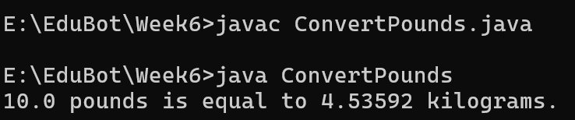

**OverloadCount:**

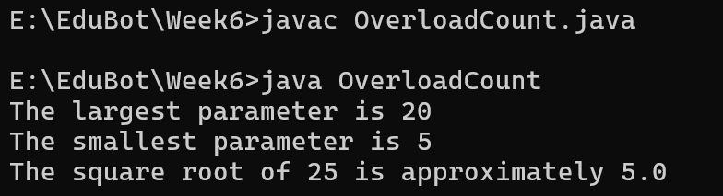

**OverloadType:**

