**Week 5: Executions**

**SumItUp:**

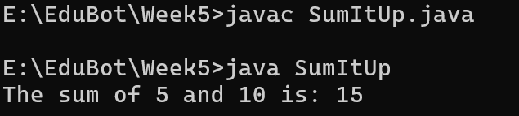

**MyCities:**

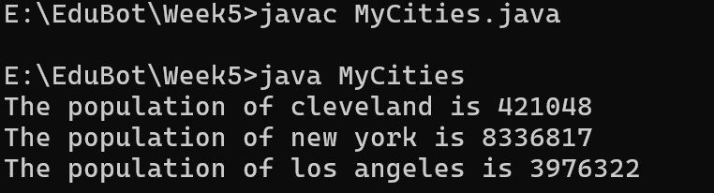

**MyFibonacci:**

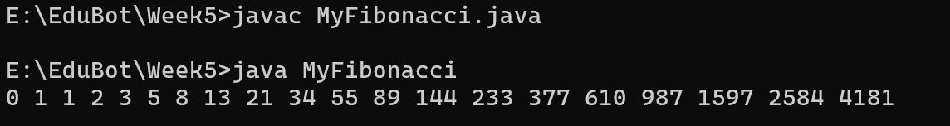

**Formatting:**

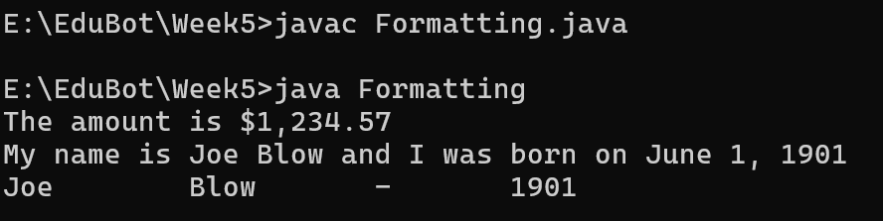

**CurrentDate:**

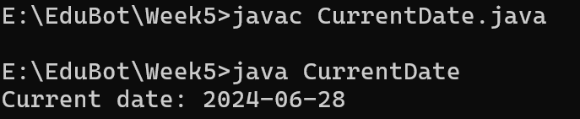

**RegularExpression:**

