**Week7 – Execution**

**EnterInfo.java:**

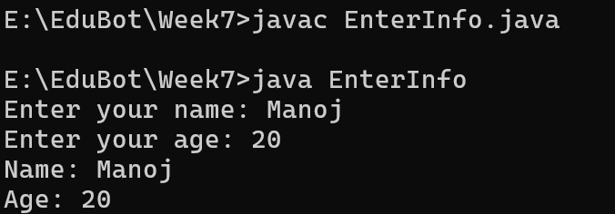

**ReadArray.java:**

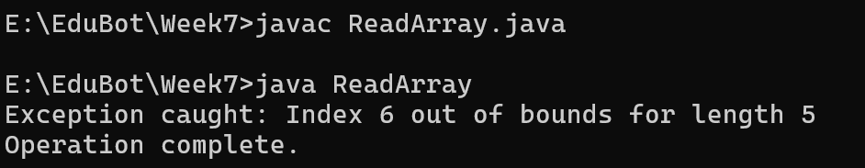

**CricketPlayer.java:**

