VEHICLE MASTER TRACKER
TECHNICAL DESIGN DOCUMENT (TDD)
Next.js + FastAPI + PostgreSQL
Client Requirements, Database Design, API Design, UI/UX, Excel Import, Testing & Deployment
Version 1.0 | 20 September 2026

1. Document Purpose
This document defines the complete technical design for the Vehicle Master Tracker application. It consolidates the requirements from the supplied Excel workbook and the implementation approach previously proposed, including project structure, technology stack, workflows, screen behavior, database relations, API contracts, Excel import, validation, testing, security, deployment, and future extensibility.
The primary business purpose is to maintain base vehicle model records and their variants, while allowing users to search the master list using any combination of Base Model Name, RLF ID, RM ID, IP ID, EVAP ID, PR ID, DF ID, OB ID, ER ID, PEMS ID, and Variant Name.

2. Source Excel Analysis
The uploaded workbook contains the following primary columns:
Column | Meaning / treatment
BASE VEHICLE MODEL | Parent/master vehicle record. A blank cell on subsequent rows means the previous base model continues.
VARIANT NAME | Child variant belonging to the current base vehicle model.
RLF ID | Base-model-level identifier.
RM ID | Base-model-level identifier; may be blank.
IP ID | Base-model-level identifier.
EVAP ID | Base-model-level identifier.
PR ID | Base-model-level identifier; may be blank.
DF ID | Base-model-level identifier; may be blank.
OB ID | Base-model-level identifier; explicitly allowed to repeat across vehicles.
ER ID | Base-model-level identifier; may be blank.
PEMS ID | Base-model-level identifier.
The workbook also contains a 'VIEW OPTIONS' section describing the intended interactions: selecting the base model shows the vehicle identifiers and variants; selecting an identifier filters the master list and shows related base models/variants.
The sample data contains two base-model groups, each with multiple variants. The '--' value should be normalized to NULL in the database rather than stored as a literal identifier.

3. Business Requirements
- Users can add vehicle details through master screens.
- Users can upload large Excel files containing many vehicle/base-model and variant rows.
- The database must store one base vehicle model and its RLF, RM, IP, EVAP, PR, DF, OB, ER and PEMS identifiers.
- A variants table must store all variants belonging to each base vehicle model.
- The master screen initially displays all records.
- The master screen provides filters for Base Model Name, RLF ID, RM ID, IP ID, EVAP ID, PR ID, DF ID, OB ID, ER ID, PEMS ID and Variant Name.
- Any populated filters are combined using AND semantics.
- A filter may return multiple base models when an identifier is shared, such as OB ID.
- If the combination uniquely identifies one vehicle, only that base model is displayed.
- If there are no matching records, the UI displays 'No records found'.
- Clicking a base-model row opens a detail dialog/page containing all IDs and the list of variants.
- The application must be responsive.
- The architecture must be suitable for future client features without a major rewrite.

4. Recommended Project Name
Recommended name: Vehicle Master Tracker
vehicle-master-tracker

5. Architecture
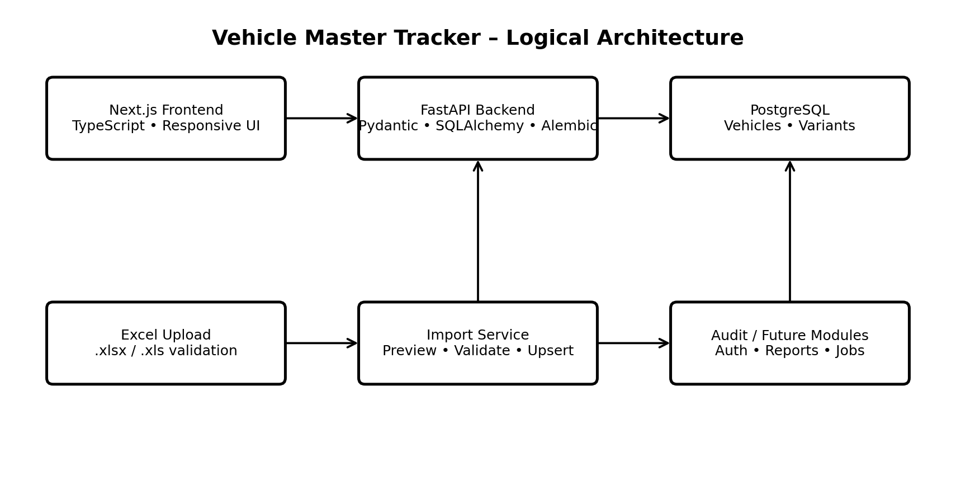
The architecture keeps the current solution intentionally simple: Next.js communicates with FastAPI over REST; FastAPI owns validation, filtering and import logic; PostgreSQL stores the normalized data. Redis, Kafka, Elasticsearch and other infrastructure are not required for the initial scope.

5.1 Architectural principles
- Keep the database relational and normalized around the base-model → variants relationship.
- Keep business rules in the service layer rather than React components or SQL strings embedded in routes.
- Use pagination so the browser never needs to load an entire large dataset.
- Use indexes for all searchable ID fields and variant names.
- Use transactional Excel imports so partial imports do not corrupt the master data.
- Separate preview/validation from the final import confirmation.
- Keep authentication, audit, reporting and background import jobs modular so they can be added later.

6. Technology Stack
Layer | Recommended technology | Purpose
Frontend | Next.js + React + TypeScript | Responsive application UI and routing
UI/Data | TanStack Query + responsive component/CSS layer | Server-state caching, loading, invalidation and pagination
Backend | Python 3.12 + FastAPI | REST APIs and application services
Validation | Pydantic v2 | Request/response validation
ORM | SQLAlchemy 2.x | Database access and relationships
Database | PostgreSQL 17 | Transactional relational storage
Migrations | Alembic | Versioned database schema
Excel | openpyxl | Read and validate .xlsx files
Containerization | Docker + Docker Compose | Consistent local/deployment environments
Testing | pytest + HTTPX; frontend tests as required | Unit, integration and API testing
CI/CD | GitHub Actions or client CI | Build, test and deployment automation

7. Complete Project Structure
vehicle-master-tracker/
├── backend/
│ ├── app/
│ │ ├── api/
│ │ │ ├── router.py
│ │ │ ├── vehicles.py
│ │ │ └── imports.py
│ │ ├── core/
│ │ │ └── config.py
│ │ ├── db/
│ │ │ ├── base.py
│ │ │ └── session.py
│ │ ├── models/
│ │ │ ├── __init__.py
│ │ │ └── vehicle.py
│ │ ├── schemas/
│ │ │ ├── vehicle.py
│ │ │ └── imports.py
│ │ ├── services/
│ │ │ ├── vehicle_service.py
│ │ │ └── import_service.py
│ │ └── main.py
│ ├── alembic/
│ │ ├── versions/
│ │ │ └── 0001_initial.py
│ │ └── env.py
│ ├── requirements.txt
│ ├── Dockerfile
│ ├── alembic.ini
│ └── .env.example
├── frontend/
│ ├── src/
│ │ ├── app/
│ │ │ ├── page.tsx
│ │ │ ├── layout.tsx
│ │ │ ├── globals.css
│ │ │ ├── import/page.tsx
│ │ │ └── vehicles/[id]/page.tsx
│ │ ├── components/
│ │ ├── lib/api.ts
│ │ └── types/vehicle.ts
│ ├── package.json
│ ├── next.config.ts
│ ├── Dockerfile
│ └── .env.example
├── docker-compose.yml
├── README.md
└── Vehicle_Master_Tracker_TDD.docx

8. End-to-End Workflow
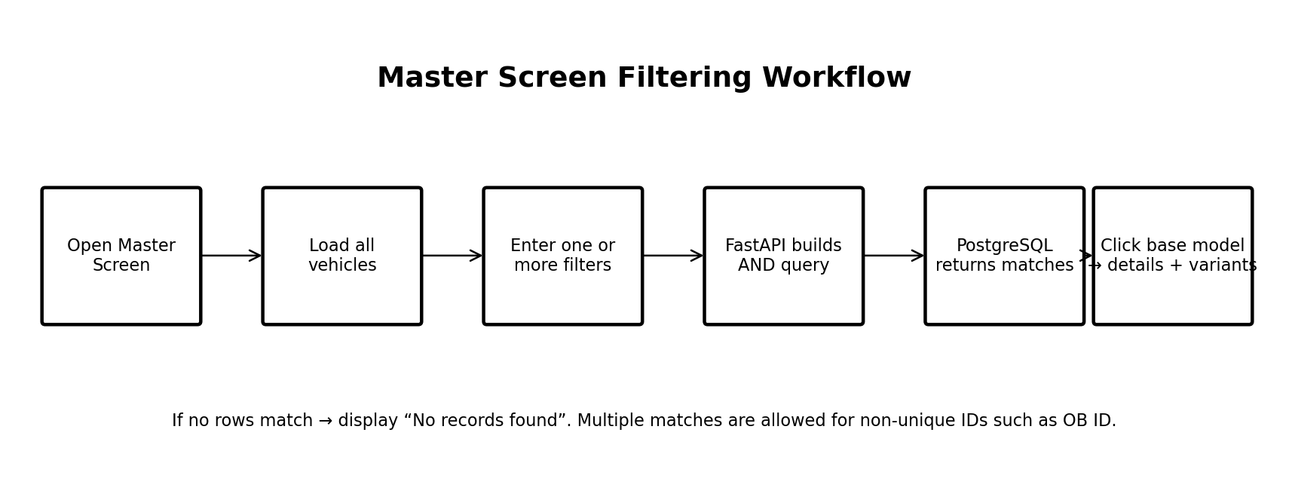

8.1 Normal master-screen flow
- User opens the master screen.
- Frontend calls GET /api/v1/vehicles without filters.
- Backend returns the first page of records with pagination metadata.
- User enters one or more filter values.
- Frontend sends only populated filters to the API.
- Backend applies AND semantics across populated master filters and an EXISTS condition for variant_name.
- PostgreSQL returns matching base-model records.
- Frontend displays the result list.
- If zero records are returned, the UI displays 'No records found'.
- User clicks a base model and the detail view loads the complete vehicle plus variants.

8.2 Excel import workflow
- User selects an Excel file.
- Frontend uploads the file to the preview endpoint.
- Backend validates file type, required headers, row structure and field lengths.
- Blank inherited BASE VEHICLE MODEL cells are filled from the latest non-blank base model.
- '--' and equivalent missing markers are normalized to NULL.
- Rows are grouped by base model.
- Variant names are validated and duplicates are detected.
- Preview response reports counts and validation errors without changing production data.
- User confirms the import.
- Backend performs an atomic upsert/replace operation in a transaction.
- Import result reports created, updated, skipped and failed records.

9. Database Design
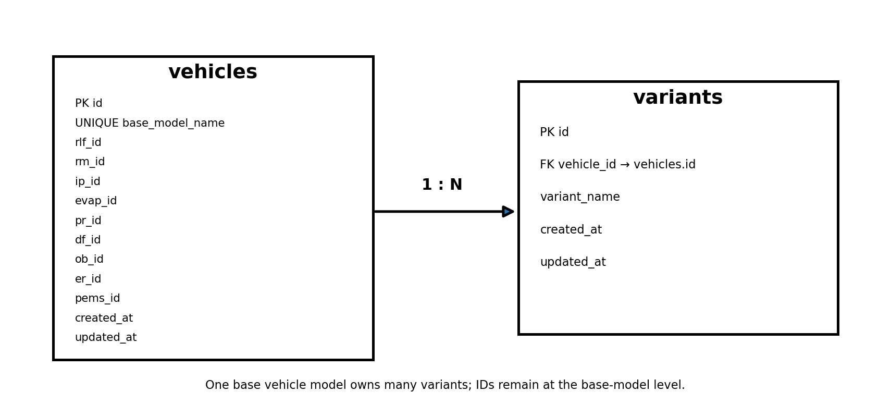

9.1 vehicles table
Column | Type | Constraints | Purpose
id | BIGINT | PK | Internal stable identifier
base_model_name | VARCHAR | NOT NULL, UNIQUE | Base vehicle master name
rlf_id | VARCHAR | NULL, indexed | RLF identifier
rm_id | VARCHAR | NULL, indexed | RM identifier
ip_id | VARCHAR | NULL, indexed | IP identifier
evap_id | VARCHAR | NULL, indexed | EVAP identifier
pr_id | VARCHAR | NULL, indexed | PR identifier
df_id | VARCHAR | NULL, indexed | DF identifier
ob_id | VARCHAR | NULL, indexed | OB identifier; may repeat
er_id | VARCHAR | NULL, indexed | ER identifier
pems_id | VARCHAR | NULL, indexed | PEMS identifier
created_at | TIMESTAMPTZ | NOT NULL | Creation timestamp
updated_at | TIMESTAMPTZ | NOT NULL | Last modification timestamp

9.2 variants table
Column | Type | Constraints | Purpose
id | BIGINT | PK | Variant identifier
vehicle_id | BIGINT | FK, NOT NULL | Parent vehicle
variant_name | VARCHAR | NOT NULL | Variant display name
created_at | TIMESTAMPTZ | NOT NULL | Creation timestamp
updated_at | TIMESTAMPTZ | NOT NULL | Last modification timestamp
Recommended constraint: UNIQUE(vehicle_id, variant_name). This prevents the same variant being inserted twice under one base model while allowing the same text to exist under different base models if the client needs that.

9.3 Relationship
vehicles 1 → N variants. A base model owns many variants; each variant belongs to exactly one base model.

9.4 Why the proposed normalization is preferred
- Base-level IDs are stored once instead of repeated for every variant.
- Changing an ID does not require updating dozens of variant rows.
- Variant filtering can still find the parent vehicle using EXISTS.
- OB ID can be repeated without violating uniqueness.
- The model remains easy to extend with additional child entities later.

9.5 Index strategy
CREATE INDEX ix_vehicles_rlf_id ON vehicles(rlf_id);
CREATE INDEX ix_vehicles_rm_id ON vehicles(rm_id);
CREATE INDEX ix_vehicles_ip_id ON vehicles(ip_id);
CREATE INDEX ix_vehicles_evap_id ON vehicles(evap_id);
CREATE INDEX ix_vehicles_pr_id ON vehicles(pr_id);
CREATE INDEX ix_vehicles_df_id ON vehicles(df_id);
CREATE INDEX ix_vehicles_ob_id ON vehicles(ob_id);
CREATE INDEX ix_vehicles_er_id ON vehicles(er_id);
CREATE INDEX ix_vehicles_pems_id ON vehicles(pems_id);
CREATE INDEX ix_variants_name ON variants(variant_name);
If the client later requires contains-search over very large datasets, PostgreSQL trigram indexes (pg_trgm) can be considered after measuring actual query performance. Do not add them prematurely.

10. Filtering Semantics
Every populated filter is combined with AND. A single filter can return multiple base models.
User input | Backend behavior | Expected result
OB ID = OB-456 | WHERE ob_id matches OB-456 | All base models having that OB ID
IP ID = IP-123 + OB ID = OB-456 | WHERE ip_id matches AND ob_id matches | Only records satisfying both
Variant Name = HTX 7 | EXISTS child variant matching HTX 7 | Parent base models containing that variant
No filters | No WHERE filters | First page of all vehicles
No match | Query returns zero rows | 'No records found'
For text filtering, ILIKE with normalized input is appropriate for the initial version. Exact matching can be added later as an explicit search mode if required.

11. Master Screen UI
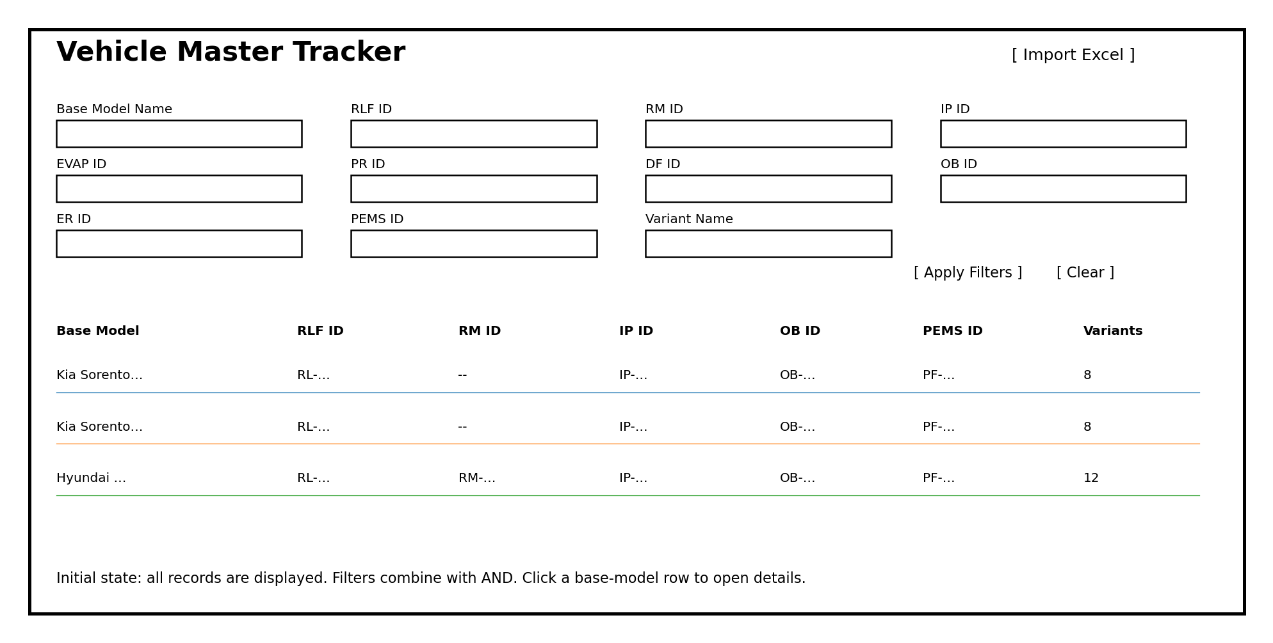
Figure 1. Example responsive master screen. This is a functional design mockup, not a final visual specification.
- All records are shown on initial load.
- Filter fields are visible and clearly labeled.
- Apply Filters submits the current filter state.
- Clear removes all filters and reloads the first page.
- Results are paginated.
- Base model name is clickable.
- Variant count can be shown as a convenience column.
- Loading, error and empty states must be explicit.

12. Vehicle Detail Screen
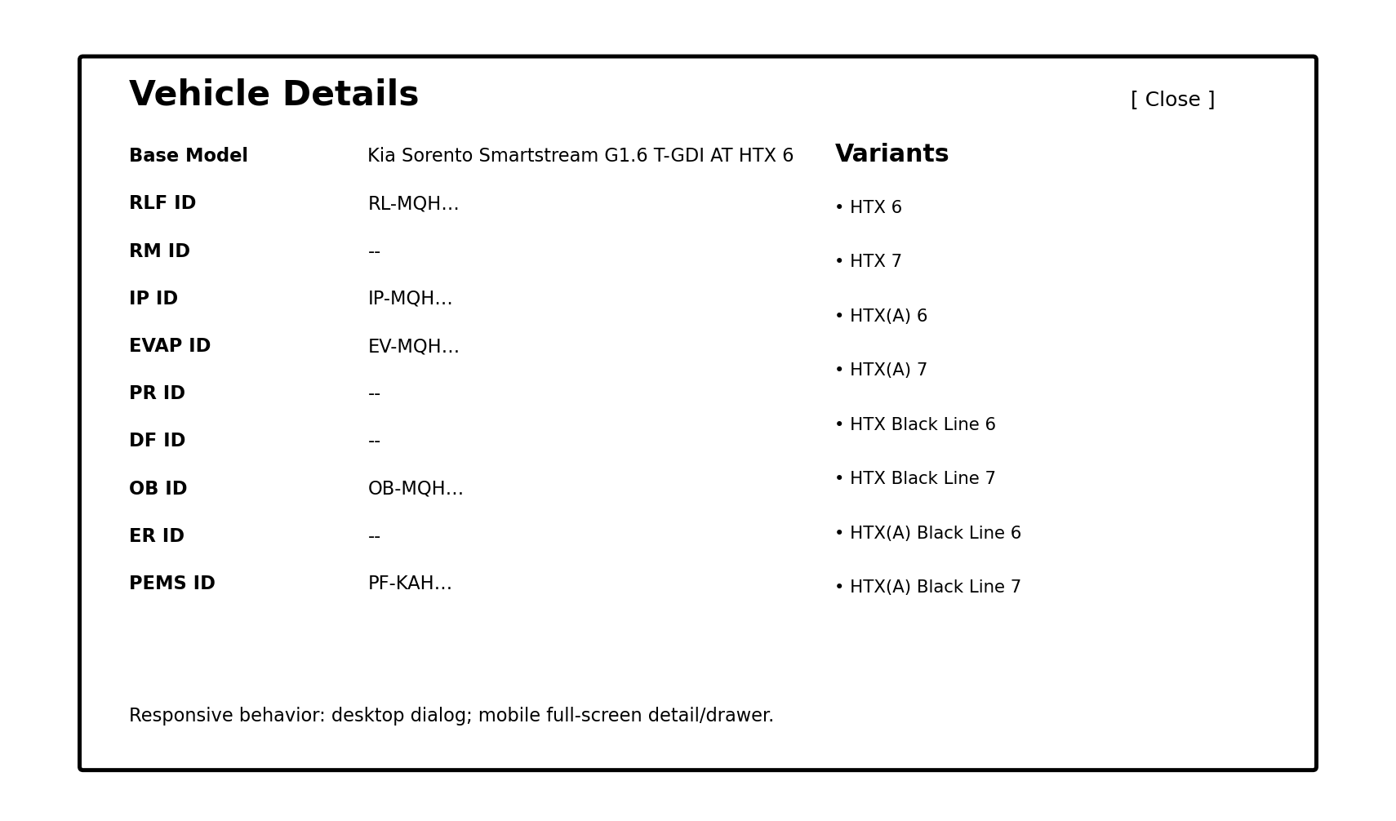
Figure 2. Example detail dialog/page. On small screens this should become a full-screen detail view or drawer.
- Display base model name.
- Display every requested ID including null/missing values as a clear placeholder such as '--'.
- Display the complete variant list.
- Allow future Edit/Delete actions to be added without redesigning the information layout.

13. API Design
Method | Endpoint | Purpose
GET | /api/v1/vehicles | List/search vehicles with filters and pagination
GET | /api/v1/vehicles/{id} | Get complete vehicle details and variants
POST | /api/v1/vehicles | Create a base vehicle with variants
PUT | /api/v1/vehicles/{id} | Update base vehicle and variant set
DELETE | /api/v1/vehicles/{id} | Future/optional delete or soft-delete
POST | /api/v1/imports/vehicles/preview | Validate Excel and return preview without DB changes
POST | /api/v1/imports/vehicles | Commit validated Excel import
GET | /api/v1/health | Health/readiness endpoint

13.1 Search endpoint
GET /api/v1/vehicles?page=1&page_size=25&base_model_name=Sorento&ip_id=IP-123&ob_id=OB-456&variant_name=HTX
The API should reject invalid page/page_size values, trim input, normalize blank strings, and return stable pagination metadata.

13.2 Example list response
{
"items": [
{
"id": 1,
"base_model_name": "Kia Sorento Smartstream G1.6 T-GDI AT HTX 6",
"rlf_id": "RL-MQH16149A64YN00-XXX",
"rm_id": null,
"ip_id": "IP-MQH16149A64YN00-MZB",
"evap_id": "EV-MQH16149A62YN00-MZB",
"pr_id": null,
"df_id": null,
"ob_id": "OB-MQH16149A64YN00-MZB",
"er_id": null,
"pems_id": "PF-KAH16149A62YN00-MZB",
"variant_count": 8
}
],
"page": 1,
"page_size": 25,
"total": 1,
"total_pages": 1
}

13.3 Example detail response
{
"id": 1,
"base_model_name": "Kia Sorento Smartstream G1.6 T-GDI AT HTX 6",
"rlf_id": "RL-MQH16149A64YN00-XXX",
"rm_id": null,
"ip_id": "IP-MQH16149A64YN00-MZB",
"evap_id": "EV-MQH16149A62YN00-MZB",
"pr_id": null,
"df_id": null,
"ob_id": "OB-MQH16149A64YN00-MZB",
"er_id": null,
"pems_id": "PF-KAH16149A62YN00-MZB",
"variants": [
{"id": 1, "variant_name": "Kia Sorento Smartstream G1.6 T-GDI AT HTX 6"}
]
}

14. API Query Design
The vehicle search service should build the query using parameterized SQLAlchemy expressions. Conceptually:
SELECT v.*
FROM vehicles v
WHERE
(:base_model_name IS NULL OR v.base_model_name ILIKE '%' || :base_model_name || '%')
AND (:rlf_id IS NULL OR v.rlf_id ILIKE '%' || :rlf_id || '%')
AND (:rm_id IS NULL OR v.rm_id ILIKE '%' || :rm_id || '%')
AND (:ip_id IS NULL OR v.ip_id ILIKE '%' || :ip_id || '%')
AND (:evap_id IS NULL OR v.evap_id ILIKE '%' || :evap_id || '%')
AND (:pr_id IS NULL OR v.pr_id ILIKE '%' || :pr_id || '%')
AND (:df_id IS NULL OR v.df_id ILIKE '%' || :df_id || '%')
AND (:ob_id IS NULL OR v.ob_id ILIKE '%' || :ob_id || '%')
AND (:er_id IS NULL OR v.er_id ILIKE '%' || :er_id || '%')
AND (:pems_id IS NULL OR v.pems_id ILIKE '%' || :pems_id || '%')
AND (
:variant_name IS NULL OR EXISTS (
SELECT 1 FROM variants vr
WHERE vr.vehicle_id = v.id
AND vr.variant_name ILIKE '%' || :variant_name || '%'
)
)
ORDER BY v.base_model_name
LIMIT :page_size OFFSET :offset;
In the actual application, SQLAlchemy expression builders should be used rather than constructing raw SQL strings from user input.

15. Excel Import Design
The client can maintain a master workbook using the supplied structure. The importer must understand inherited base-model values.
Excel condition | Processing rule
BASE VEHICLE MODEL has a value | Start/update the current base-model group.
BASE VEHICLE MODEL is blank | Assign the row to the most recent non-blank base model.
VARIANT NAME has a value | Create/update a child variant.
ID contains '--' | Normalize to NULL.
Required header missing | Reject preview with a header error.
Duplicate variant in same base model | Report validation error or skip according to configured import policy.
Same OB ID on multiple base models | Allow; never treat OB ID as unique.
Invalid/unsupported file type | Reject before parsing.

15.1 Preview-before-import
The preview endpoint is a critical safeguard for large client uploads. The response should contain total Excel rows, base models detected, variants detected, new records, records to update, duplicate rows, validation errors, and warnings.

15.2 Import modes
Mode | Behavior | Recommendation
UPSERT | Create missing vehicles/variants and update existing records. | Default
REPLACE | Treat uploaded workbook as authoritative and replace the affected variant collections. | Use only after explicit client confirmation

15.3 Large files
For very large files, do not keep the entire workbook and all parsed objects in memory. Use streaming/read-only workbook processing where practical, stage validation results, and move the final import to a background job when the size or processing time justifies it.

16. Frontend Design
- Next.js App Router.
- TypeScript strict mode.
- Central API client in src/lib/api.ts.
- Typed vehicle and API response models.
- TanStack Query for server state.
- URL query parameters for filters so searches are shareable/bookmarkable.
- Debounce text filters where live-search is desired; otherwise use Apply Filters.
- Responsive table that converts to cards or horizontal scrolling on small screens.
- Accessible labels, keyboard navigation and dialog focus management.
- Explicit loading, empty, validation-error and server-error states.

17. Backend Configuration
DATABASE_URL=postgresql+asyncpg://user:password@db:5432/vehicle_master
APP_ENV=development
CORS_ORIGINS=http://localhost:3000
LOG_LEVEL=INFO
MAX_PAGE_SIZE=100
EXCEL_MAX_FILE_SIZE_MB=50
Production secrets must be supplied through the hosting platform's secret/environment mechanism and must not be committed to Git.

18. Frontend Configuration
NEXT_PUBLIC_API_BASE_URL=http://localhost:8000/api/v1
For production, point this variable to the deployed API origin. Do not embed database credentials or private secrets in NEXT_PUBLIC variables.

19. Docker / Deployment
services:
db:
image: postgres:17
environment:
POSTGRES_DB: vehicle_master
POSTGRES_USER: vehicle_user
POSTGRES_PASSWORD: ${POSTGRES_PASSWORD}
volumes:
- postgres_data:/var/lib/postgresql/data
backend:
build: ./backend
environment:
DATABASE_URL: ${DATABASE_URL}
depends_on:
- db
frontend:
build: ./frontend
environment:
NEXT_PUBLIC_API_BASE_URL: ${NEXT_PUBLIC_API_BASE_URL}
depends_on:
- backend
volumes:
postgres_data:
For production, managed PostgreSQL is preferable to running the database inside the same application host. The Docker Compose configuration is primarily useful for local development, testing and small controlled deployments.

20. Production Deployment
- Build and test backend and frontend in CI.
- Run Alembic migrations during a controlled deployment step.
- Deploy FastAPI behind HTTPS/reverse proxy.
- Deploy Next.js using the chosen Node/Next.js hosting model.
- Use managed PostgreSQL with automated backups.
- Configure CORS to only the required frontend origins.
- Set health/readiness endpoints.
- Enable structured application logs.
- Monitor API latency, database errors, import failures and resource usage.
- Keep secrets outside source control.
- Establish backup restoration testing, not only backup creation.

21. Security Requirements
- Authentication should be introduced before exposing write/import endpoints to external users.
- Use role-based authorization for future Admin/Viewer/Importer roles.
- Validate uploaded file type, size and content.
- Never trust Excel formulas, hyperlinks or macros as application data.
- Use parameterized database access through SQLAlchemy.
- Rate-limit or protect large import endpoints.
- Log who performed imports/updates once authentication exists.
- Use HTTPS in all non-local environments.
- Do not expose database credentials to the browser.

22. Error Handling
HTTP status | Scenario | Example response intent
400 | Invalid query/filter/file request | Explain validation issue
401 | Unauthenticated request | Authentication required
403 | Authenticated but unauthorized | Insufficient permission
404 | Vehicle not found | Requested ID does not exist
409 | Business conflict | Duplicate base model or variant conflict
413 | Excel file too large | File exceeds configured limit
422 | Pydantic validation failure | Invalid request fields
500 | Unexpected server error | Generic error + server-side log/correlation ID

23. Testing / TDD Strategy
The application should be developed test-first or test-alongside-development, with tests mapped directly to business requirements.

23.1 Database tests
- Create vehicle with all IDs.
- Create vehicle with NULL IDs.
- Allow repeated OB ID across vehicles.
- Reject duplicate base_model_name.
- Allow many variants for one vehicle.
- Reject duplicate variant_name under the same vehicle.
- Allow the same variant text under different vehicles if business rules permit.

23.2 API tests
- GET vehicles with no filters returns paginated data.
- Each individual filter works.
- Multiple filters use AND semantics.
- OB-only filter can return multiple vehicles.
- IP + OB returns only records satisfying both.
- Variant filter returns the correct parent vehicles without duplicate parents.
- No results returns an empty items array and valid pagination metadata.
- GET detail returns all IDs and variants.
- POST/PUT validation rejects invalid payloads.
- Excel preview catches missing headers and malformed rows.
- Excel import is atomic on fatal validation failure.

23.3 Frontend tests
- Initial page loads records.
- Apply filters sends expected query parameters.
- Clear filters resets the list.
- Zero-result state displays 'No records found'.
- Clicking a row opens the correct details.
- Variants are displayed.
- Excel preview displays validation errors.
- Import confirmation refreshes master data.
- Mobile layout remains usable.

24. Acceptance Criteria
- All requested master columns are persisted correctly.
- Each base model can have multiple variants.
- OB ID is not required to be unique.
- All records are shown when no filter is supplied.
- Each requested filter can independently restrict results.
- Multiple filters combine with AND.
- An identifier that occurs on multiple vehicles returns all matching base models.
- Variant-name filtering identifies parent base models correctly.
- Zero results show 'No records found'.
- Base-model selection displays all IDs and variants.
- Excel upload can represent inherited base-model values.
- Excel preview reports validation results before database mutation.
- Successful import is transactional.
- The UI works on desktop and mobile.
- The API is paginated and indexed for scalable search.
- The project can be deployed using environment-specific configuration.

25. Future Extensibility
The client indicated that additional requirements may be added later. The following modules should therefore be treated as extension points:
Future module | Purpose
Authentication / RBAC | Admin, importer and read-only roles
Audit logs | Track who changed which vehicle and when
Import jobs | Background processing and progress for large Excel files
Import error reports | Download row-level validation failures
Soft delete | Retain historical records without physical deletion
Vehicle history | Track ID/model changes over time
Exports | Export filtered master results to Excel/CSV
Reports | Counts by model, identifier, variant and import history
Notifications | Notify users about completed/failed imports
Advanced search | Exact/contains modes, saved filters and search presets

25.1 Import jobs table for future scale
import_jobs
-----------
id
file_name
status
total_rows
processed_rows
created_records
updated_records
failed_rows
started_at
completed_at
created_by

26. Implementation Plan
Phase | Module | Scope
Phase 1 | Backend foundation | Project setup, configuration, PostgreSQL, SQLAlchemy, Alembic, models, health API.
Phase 2 | Vehicle APIs | CRUD, pagination, filter query builder, variant filtering and detail API.
Phase 3 | Excel processing | Preview, normalization, validation, upsert transaction and error reporting.
Phase 4 | Frontend master | Responsive list, filters, pagination, loading/empty/error states.
Phase 5 | Frontend details/import | Detail dialog/page, variants, Excel upload and preview/confirmation.
Phase 6 | Testing | Backend unit/integration tests and frontend behavior tests.
Phase 7 | Production hardening | Auth/RBAC, logging, monitoring, CI/CD, backups and security configuration.

27. Recommended Initial Scope
The first production release should remain intentionally focused:
- Vehicle master list.
- All requested filters.
- Vehicle detail with variants.
- Manual create/update through master screens.
- Excel preview and import.
- Pagination.
- PostgreSQL indexes.
- Validation and error states.
- Responsive design.
- Dockerized deployment.
Avoid adding Kafka, Redis, Elasticsearch or microservices in the first release unless an actual measured requirement appears. The application is simple enough to be robustly implemented as one FastAPI service plus one Next.js application and PostgreSQL.

28. Design Decisions and Rationale
Decision | Rationale
One vehicles table for all nine IDs | The IDs are attributes of the base vehicle model in the supplied requirement. Splitting every ID into separate tables would add joins and complexity without a stated business need.
One variants child table | Variants are explicitly a one-to-many list against a base model.
OB ID not unique | The client requirement explicitly states that the same OB ID can occur on multiple vehicles.
AND filter semantics | The example IP ID + OB ID requires intersection of criteria.
Variant filter through EXISTS | Prevents duplicate base-model rows when multiple child variants match.
Pagination | Protects browser/API/database performance as data grows.
Preview before Excel commit | Prevents accidental bulk corruption and gives the client visibility into import errors.
PostgreSQL | Strong fit for relational data, indexing and transactional imports.
Modular monolith | Provides simpler deployment now while retaining clear boundaries for future growth.

29. Final Recommended Solution
The recommended solution is a responsive Next.js application backed by a modular FastAPI service and PostgreSQL. The database should contain a vehicles master table and a one-to-many variants table. All requested IDs remain attributes of the base vehicle record, while variants remain normalized child records. The master screen initially displays all vehicles and supports independent or combined filters. Combined filters use AND semantics; repeated identifiers such as OB ID remain searchable and non-unique. Excel imports should use a preview → validation → confirmation → transactional import workflow. Pagination and indexes provide a scalable foundation without prematurely introducing additional infrastructure.
This design incorporates the requirements and implementation guidance from the previous response and expands them into a formal TDD suitable for development, review with the client, testing and deployment planning.

30. Appendix A – Suggested API Query Examples
# All vehicles
GET /api/v1/vehicles?page=1&page_size=25
# OB ID may return multiple base models
GET /api/v1/vehicles?ob_id=OB-MQH16149A64YN00-MZB
# Multiple filters use AND
GET /api/v1/vehicles?ip_id=IP-MQH16149A64YN00-MZB&ob_id=OB-MQH16149A64YN00-MZB
# Variant search
GET /api/v1/vehicles?variant_name=HTX%207
# Detail
GET /api/v1/vehicles/1
# Excel preview
POST /api/v1/imports/vehicles/preview
# Excel commit
POST /api/v1/imports/vehicles

31. Appendix B – Developer Checklist
- Create repository and branch strategy.
- Create backend virtual environment.
- Configure PostgreSQL.
- Create SQLAlchemy models.
- Create Alembic migration.
- Implement Pydantic schemas.
- Implement filter service.
- Implement vehicle CRUD.
- Implement Excel parser.
- Implement preview endpoint.
- Implement transactional import.
- Add backend tests.
- Create Next.js application.
- Implement typed API client.
- Implement master screen.
- Implement filters and pagination.
- Implement detail view.
- Implement Excel import UI.
- Add frontend tests.
- Create Dockerfiles and Compose.
- Configure CI/CD.
- Configure production database and secrets.
- Run acceptance tests against client sample Excel.

