**WEEK_6  
REACT_JS_4TH EXERCISE**

1. Create a new react application using *create-react-app* tool with the name as “blogapp”
2. Open the application using VS Code
3. Create a new file named as **Post.js** in **src folder** with following properties.

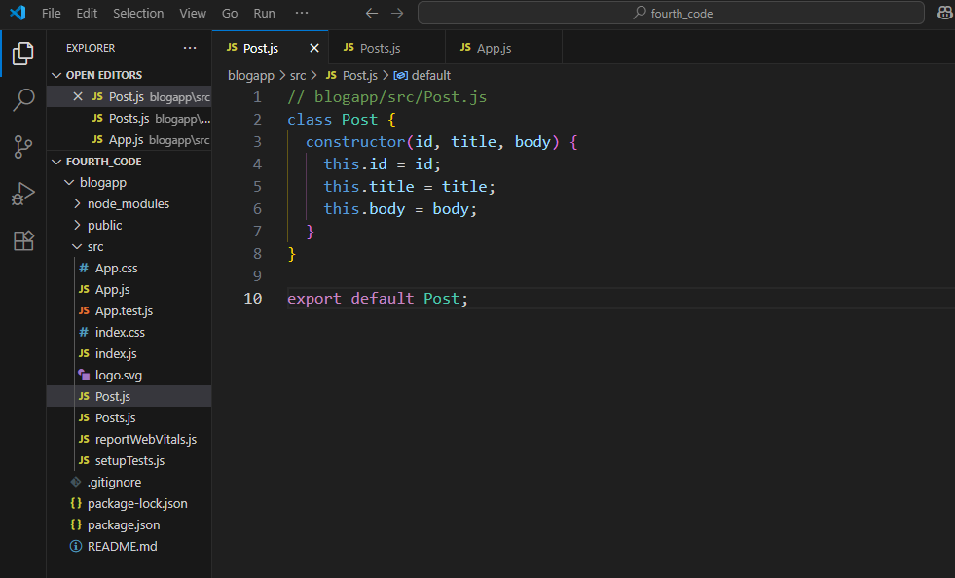

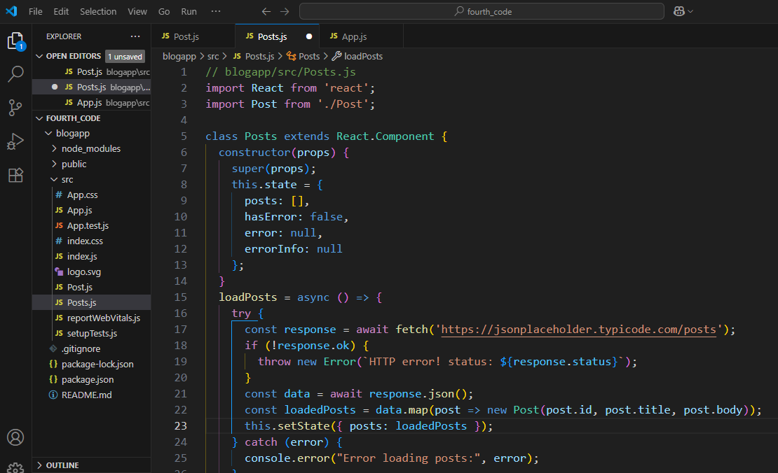

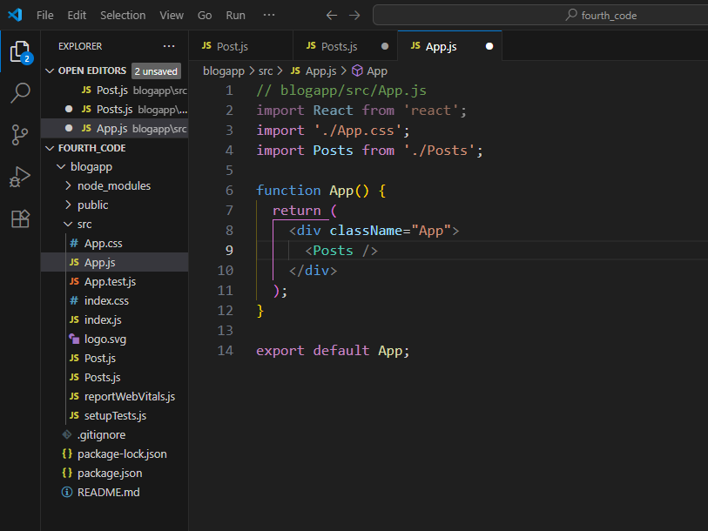

OUTPUT:

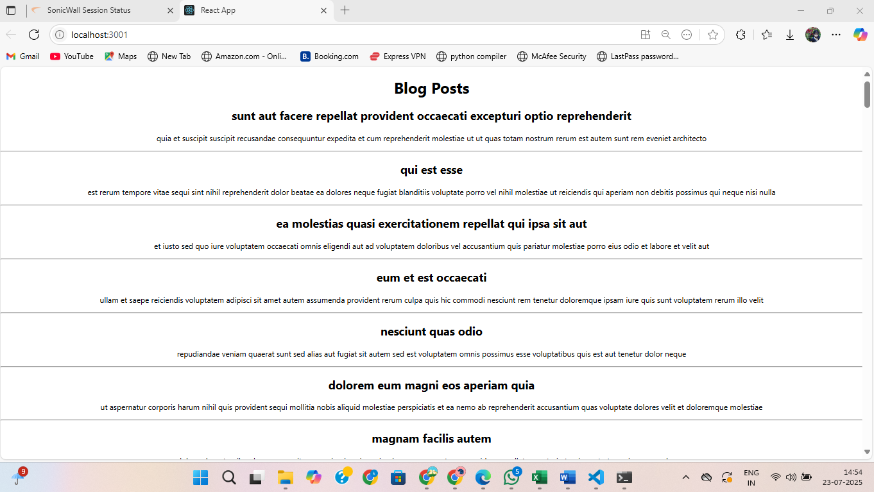

NAME – KONDURU KAVYA

SUPER SET ID - 6374347