**WEEK_6**

**React- 1. ReactJS-HOL**

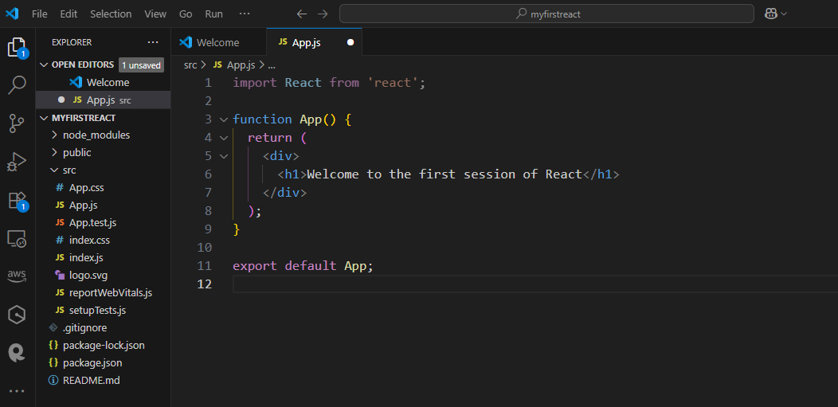

**OUTPUT:**

**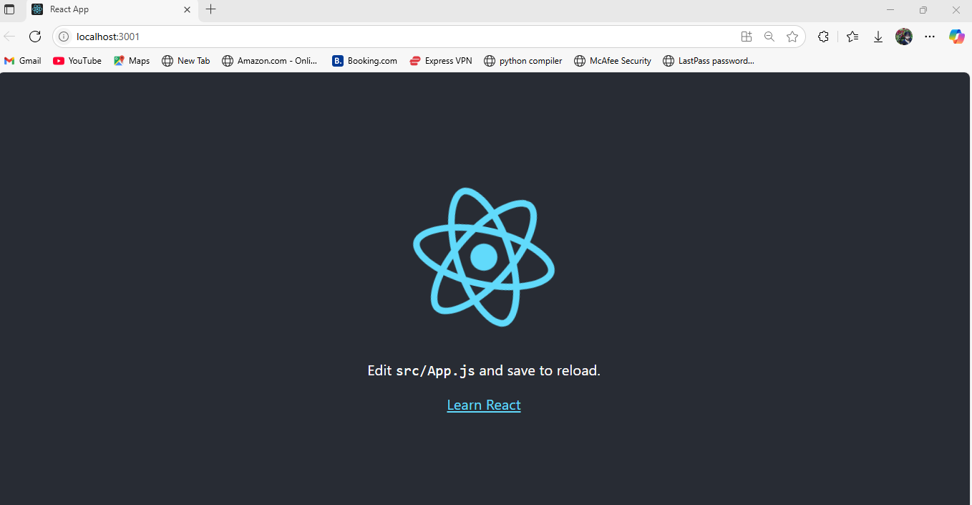  
  
 NAME-Manoj Krishna**

**SUPERSET-ID-6314712**