WEEK_6  
REACT_JS_3RD  
Create a react app for Student Management Portal named scorecalculatorapp and create a function component named “CalculateScore” which will accept Name, School, Total and goal in order to calculate the average score of a student and display the same.

React.js  
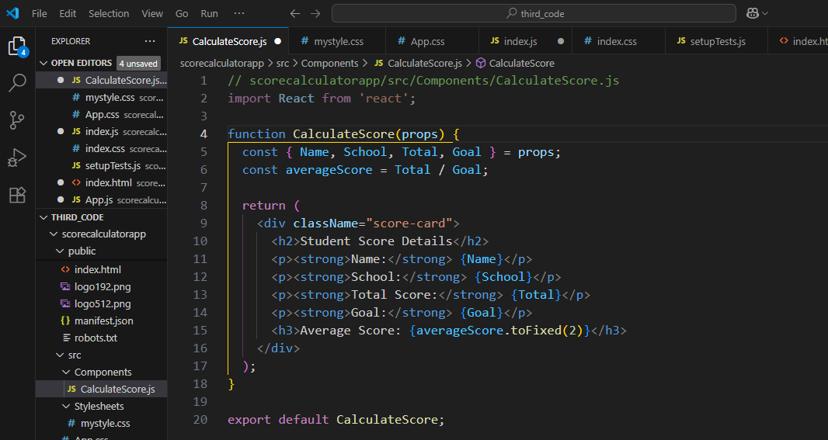

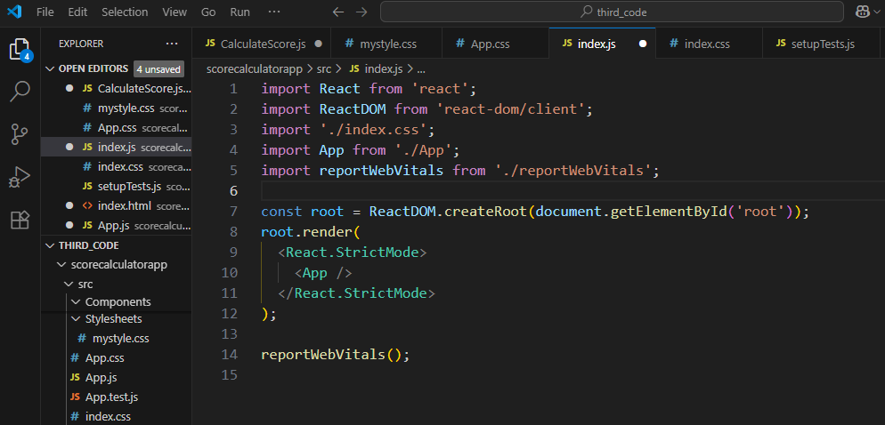

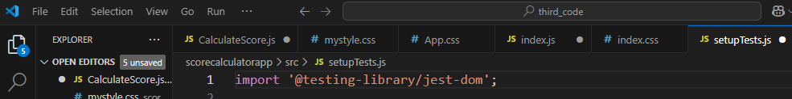

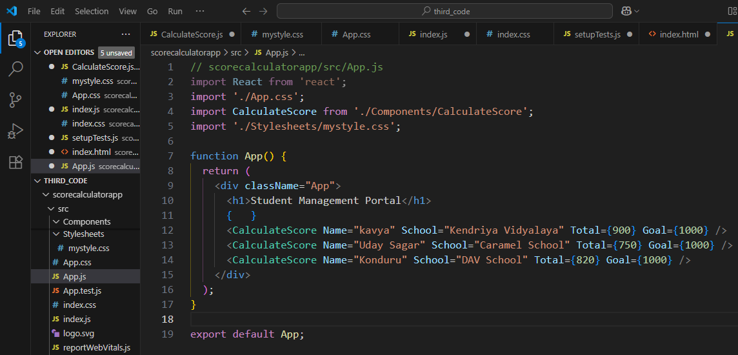

HTML:  
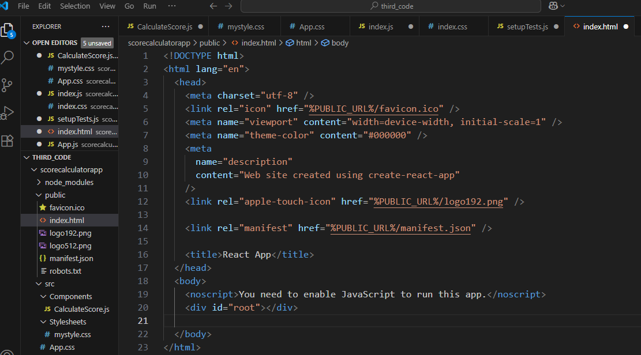

CSS: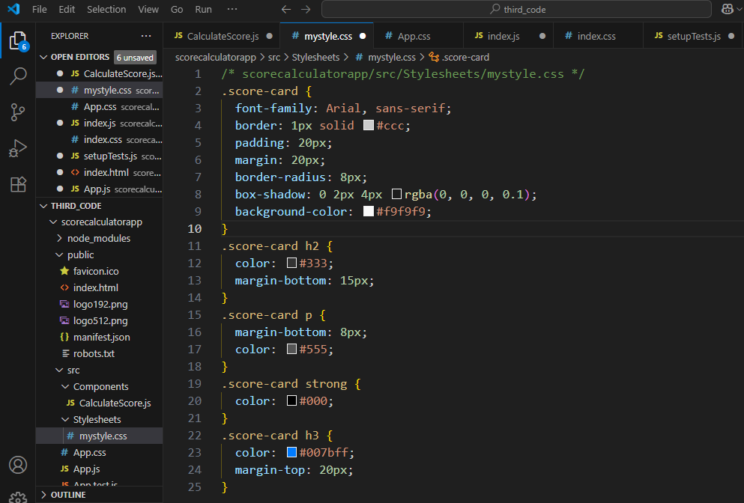

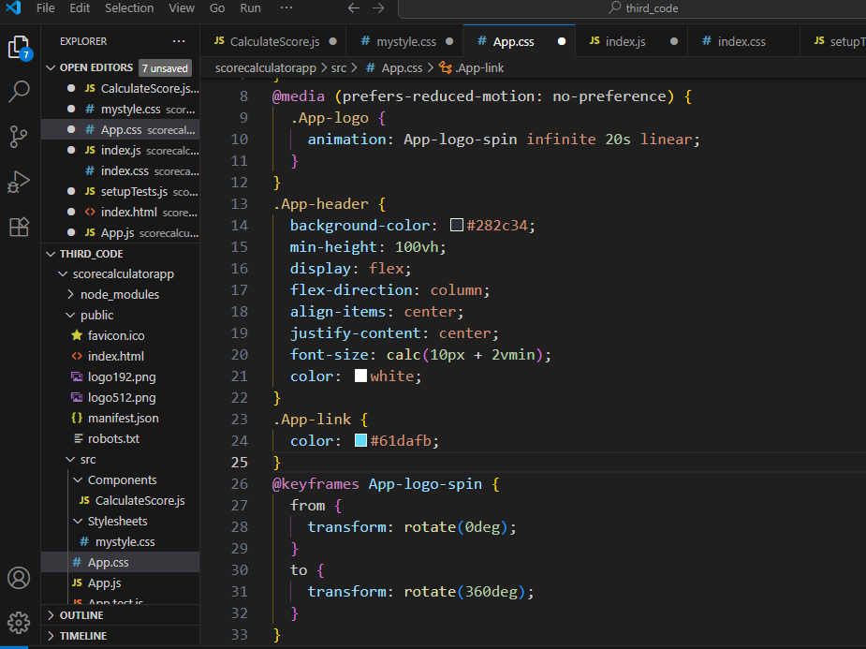

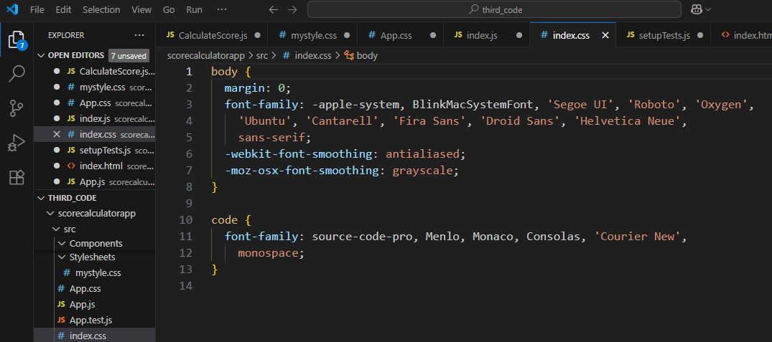

OUTPUT:

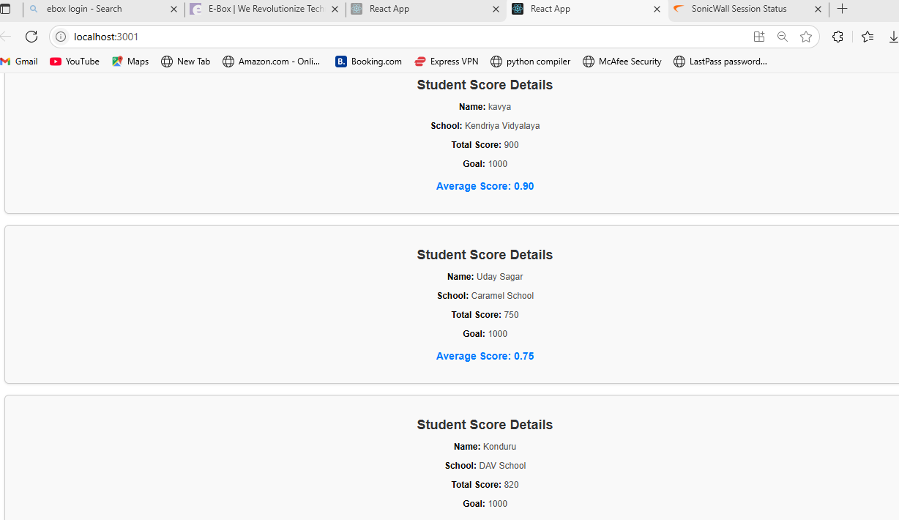

NAME –Manoj Krishna

SUPER SET ID- 6314712