**WEEK_6  
REACT_JS_4TH EXERCISE**

1. **Create a new react application using *create-react-app* tool with the name as “blogapp”**
2. **Open the application using VS Code**
3. **Create a new file named as Post.js in src folder with following properties.**

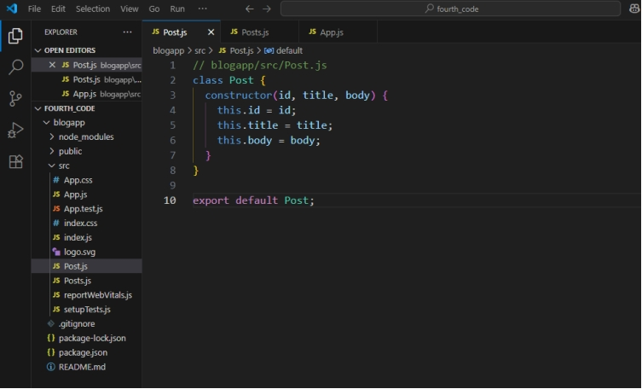

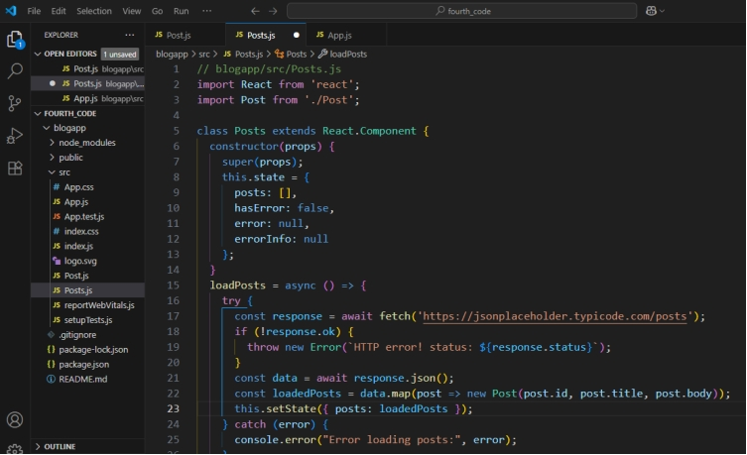

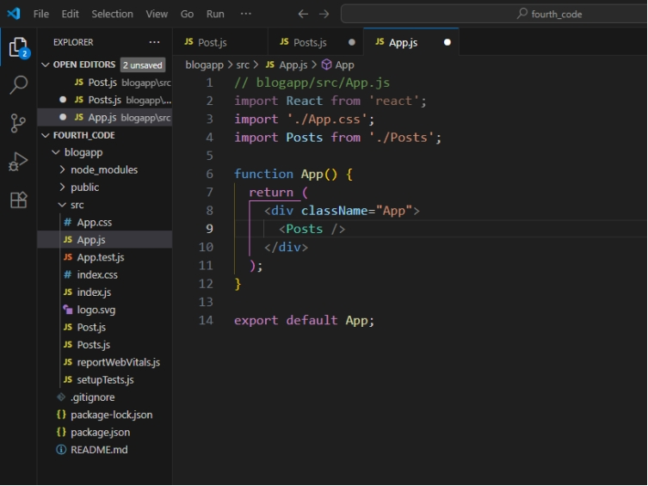

**OUTPUT:**

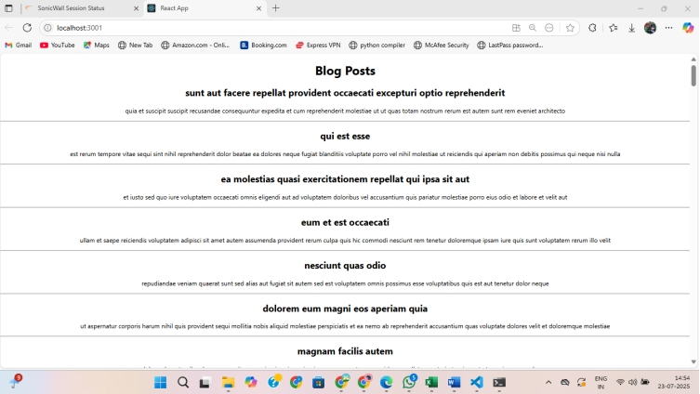

**NAME –Manoj Krishna SUPER SET ID - 6314712**