**WEEK_6  
5. ReactJS-**

My Academy team at Cognizant want to create a dashboard containing the details of ongoing and completed cohorts. A react application is created which displays the detail of the cohorts using react component. You are assigned the task of styling these react components.

Download and build the attached react application.

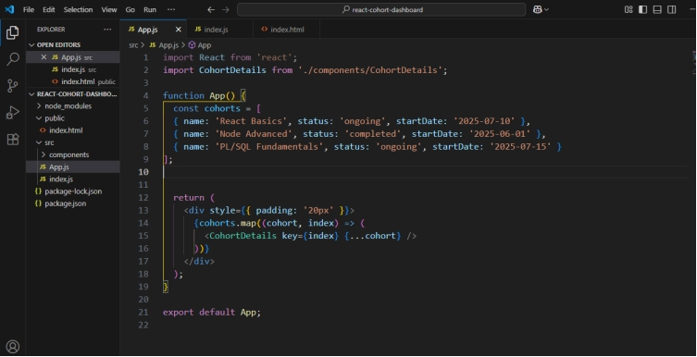

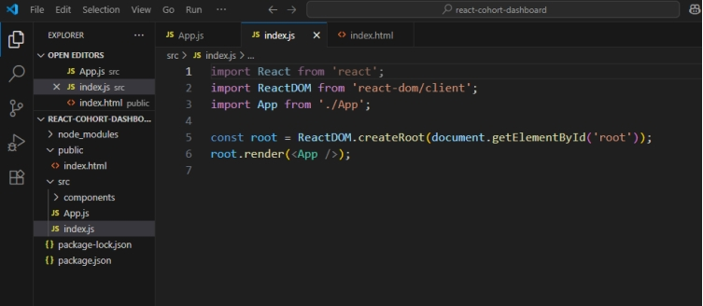

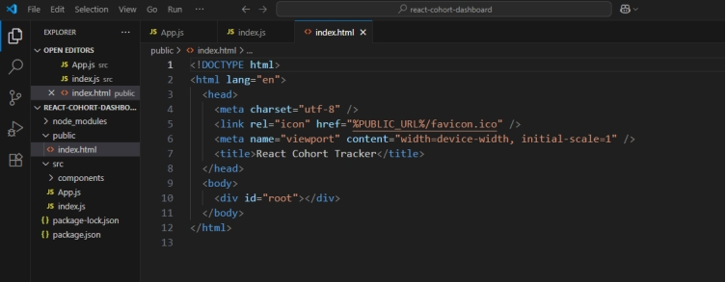

**OUTPUT:**

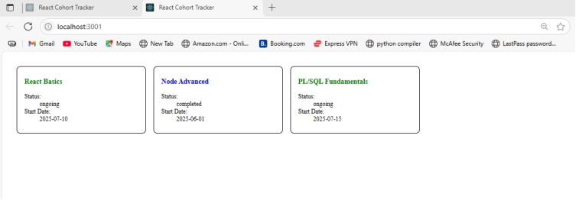

**NAME – Manoj Krishna**

**SUPERSET ID – 6314712**