# Topic: Forecasting – Time Series

**Instructions**

Please share your answers filled in-line in the word document. Submit code separately wherever applicable.

Please ensure you update all the details:

**Name:**

**Batch ID:**

**Topic: Forecasting – Time Series**

**Guidelines:**

**1. An assignment submission is considered complete only when correct and executable code(s) are submitted along with the documentation explaining the method and results. Failing to submit either of those will be considered an invalid submission and will not be considered as correct submission.**

**2. Ensure that you submit your assignments correctly and in full. Resubmission is not allowed.**

**3. Post the submission you can evaluate your work by referring to keys provided. (will be available only post the submission).**

**Hints:**

1. **Business Problem**
   1. **What is the business objective?**
   2. **Are there any constraints?**

**2. Work on each feature of the dataset to create a data dictionary as displayed in the below image:**

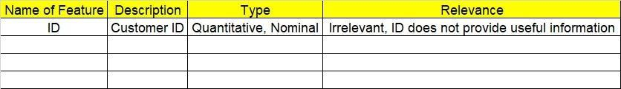**Make a table as shown above and provide information about the features such as its data type and its relevance to the model building. And if not relevant, provide reasons and a description of the feature**

1. **Data Pre-processing**

**3.1 Data Cleaning, Feature Engineering, etc.**

**3.2 Outlier Treatment**

1. **Exploratory Data Analysis (EDA):**
   1. **Summary**
   2. **Identify the trend**
   3. **Identify seasonality**
2. **Model Building:**
   1. **Perform Forecasting on the given datasets (both data driven and moving averages)**
   2. **Apply techniques like exponential smoothing, model-based approach, and ARIMA**
   3. **Briefly explain the output in the documentation for each step (as explained in the class)**
3. **Write about the benefits/impact of the solution - in what way does the business (client) benefit from the solution provide****d**

**Problem Statement: -**

1. The dataset consists of monthly totals of international airline passengers from 1995 to 2002. Our main aim is to predict the number of passengers for the next five years using time series forecasting. Prepare a document for each model explaining how many dummy variables you have created and also include the RMSE value for each model.

## File: - Airlines.xlsx

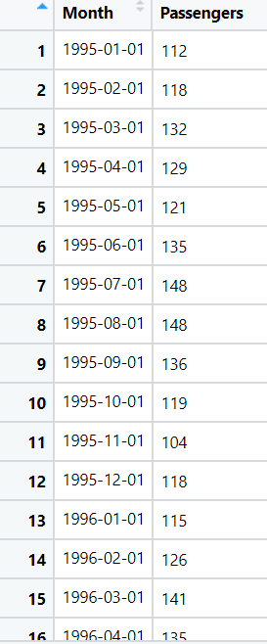

1. The dataset consists of quarterly sales data of Coca-Cola from 1986 to 1996. Predict sales for the next two years by using time series forecasting and prepare a document for each model explaining how many dummy variables you have created and also include the RMSE value for each model.

**File:- CocaCola_Sales_RawData.xlsx**

**Problem Statement: -**

1. A plastics manufacturing plant has recorded their monthly sales data from 1949 to 1953. Perform forecasting on the data and bring out insights from it and forecast the sale for the next year.

Plastic Sales.csv

**Problem Statement: -**

1. Solar power consumption has been recorded by city councils at regular intervals. The reason behind doing so is to understand how businesses are using solar power so that they can cut down on nonrenewable sources of energy and shift towards renewable energy. Based on the data, build a forecasting model and provide insights on it.

Solarpower.csv

