Project title:

Mice Protein Expression

By INeuron

Team Members:

* Abhishek M Ganjigatti
* Manoj Kendri

Date : 19-01-2024

**Project link GitHub:** [**https://github.com/abhishek-ganjigatti/Mice-protein-expression-ml-project**](https://github.com/abhishek-ganjigatti/Mice-protein-expression-ml-project)

**WireFrame:**

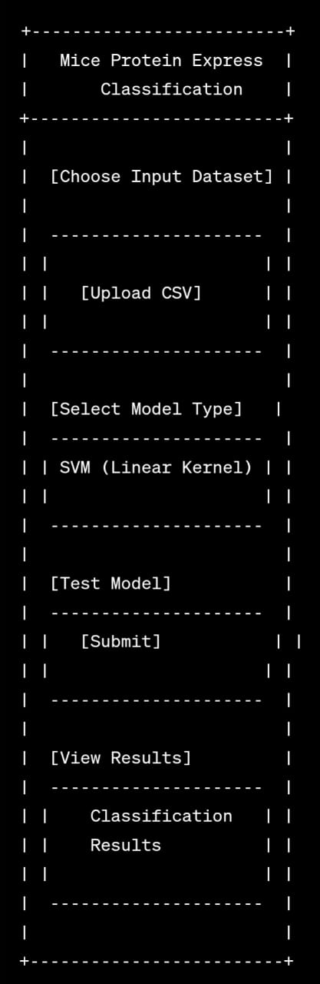

**Explanation:**

1. **Choose Input Dataset:**

Option to upload the dataset for testing the model.

1. **Upload CSV:**

Button to upload a CSV file containing the dataset.

1. **Select Model Type:**

Dropdown or radio buttons to choose the type of machine learning model (e.g., SVM with a linear kernel).

1. **Test Model:**

Button to initiate the testing process with the selected model.

1. **Submit:**

Button to submit the testing request.

1. **View Results:**

Section to display the results of the classification.

1. **Classification Results:**

Area to showcase the detailed results, possibly including accuracy, precision, recall, and other relevant metrics.

This wireframe provides a basic visual representation of the user interface for interacting with the Mice Protein Expression Classification model. The actual design and components may vary based on the specific requirements and features you plan to implement. Consider using wireframing tools or software for a more detailed and interactive representation.

**References:**

Citations for any external resources, datasets, or libraries used.

* Siddhardhan (YouTube channel) - https://youtu.be/WLwjvWq0GWA?si=cDnYtO46e0cR-xtt