**STOCK MARKET DATA ANALYSIS**

**A PROJECT REPORT**

###### *Submitted by*

**Telugunti Akhil(20MIP10045)**

**Jahnavi Gadipudi(20MIP10040)**

**Sreeprada Chintaginjala(20MIP10049)**

**Vivek kumar Sahu(20MIP10042)**

**Manoj Kumar Sen(20MIP10022)**

*in partial fulfilment for the award of the degree*

*of*

##### **BACHELOR OF TECHNOLOGY**

**In**

**Computer Science and Engineering**



**SCHOOL OF COMPUTING SCIENCE AND ENGINEERING**

**VIT BHOPAL UNIVERSITY**

**KOTHRIKALAN, SEHORE**

**MADHYA PRADESH – 466114**

**DECEMBER 2021**

**VIT BHOPAL UNIVERSITY, KOTHRIKALAN, SEHORE**

**MADHYA PRADESH – 466114**

**BONAFIDE CERTIFICATE**

Certified that this project report titled **“Stock Market Data Analysis”** is the bonafide work of **“Telugunti Akhil (20MIP10045),**

**Jahnavi Gadipudi (20MIP10040), Sreeprada Chintaginjala (20MIP10049), Vivek Kumar Sahu (20MIP10042), Manoj Kumar Sen (20MIP10022)”** who carried out the project work under my supervision. Certified further that to the best of my knowledge the work reported at this time does not form part of any other project/research work based on which a degree or award was conferred on an earlier occasion on this or any other candidate.

**PROGRAM CHAIR PROJECT GUIDE**

Dr. Pon Harshavardhan, Senior Assistant Professor Dr. Venkat Prasad Padhy, Associate Professor

School of Computer Science and Engineering School of Computer Science and Engineering

VIT BHOPAL UNIVERSITY VIT BHOPAL UNIVERSITY

The Project Exhibition I Examination is held on _______________

**ACKNOWLEDGEMENT**

First and foremost, I would like to thank the Lord Almighty for His presence and immense blessings throughout the project work.

I wish to express my heartfelt gratitude to DR. Pon Harshavardhan, Head of the Department, School of Computer Science and Engineering for much of his valuable support encouragement in carrying out this work.

I would like to thank my internal guide Mr. Venkat Prasad Padhy, for continually guiding and actively participating in my project, giving valuable suggestions to complete the project work.

I would like to thank all the technical and teaching staff of the School of Aeronautical Science, who extended directly or indirectly all support.

Last, but not least, I am deeply indebted to my parents who have been the greatest support while I worked day and night for the project to make it a success.

**ABSTRACT**

In this report, we have presented the detailed development and implementation of our project Stock Market Data Analysis in Python.

Where we have imported the historical data for stocks from yahoo finance website of a specific time and plot their data though various graphs using python language and analyse it’s performance through various trends like, continuous ups/downs on daily basis, monthly basis and yearly basis. In this we have also analysed the foreign stocks like Google, Facebook, Netflix etc. and evaluated the risk in investing the stock, also calculated the profit or loss it can give in upcoming period. This project also gives an insight in to the different aspects of Python programming.

**TABLE OF CONTENTS**

|  |  |  |
| --- | --- | --- |
| **CHAPTER NO.** | **TITLE** | **PAGE NO.** |
|  | List of Figures and Graphs  List of Tables, Abstract | ***II*** |
| ***1.*** | **PROJECT DESCRIPTION AND OUTLINE** Introduction 1.2 Summary | ***III*** |
| ***2.*** | **CHAPTER-2:**  **RELATED WORK INVESTIGATION**  2.1 <Core area of the project>  2.2 Existing Approaches/Methods  2.2.1 Approaches/Methods -1  2.2.2 Approaches/Methods -2  2.3.3 Approaches/Methods -3  investigation |  |
| ***3.*** | **CHAPTER-3:**  **REQUIREMENT ARTIFACTS**  3.1 Introduction  3.2 Hardware and Software requirements  3.3 Specific Project requirements  3.3.1 Data requirement  3.3.2 Functions requirement  3.3.3 Performance and security requirement  3.3.4 Look and Feel Requirements  3.3.5 ………  3.4 Summary |  |
| ***4.*** | **CHAPTER-4:**  **DESIGN METHODOLOGY AND ITS NOVELTY**  4.1 Methodology and goal  4.2 Functional modules design and analysis  4.3 Software Architectural designs  4.4 Subsystem services  4.5 User Interface designs  4.5 ………………..  4.6 Summary |  |
| ***5.*** | **CHAPTER-5:**  **TECHNICAL IMPLEMENTATION & ANALYSIS**  5.1Outline  5.2 Technical coding and code solutions  5.3 Working Layout of Forms  5.4 Prototype submission  5.5 Test and validation  5.6 Performance Analysis(Graphs/Charts)  5.7 Summary |  |
| ***6.*** | **CHAPTER-6:**  **PROJECT OUTCOME AND APPLICABILITY**  6.1Outline  6.2 key implementations outlines of the System  6.3 Significant project outcomes  6.4 Project applicability on Real-world applications |  |
| ***7.*** | **CHAPTER-7:**  **CONCLUSIONS AND RECOMMENDATION**  7.1Outline  7.2 Limitation/Constraints of the System  7.3 Future Enhancements  7.4 Inference |  |
|  | References |  |

**Chapter 1**

**Project Description and Outline**

* The Stock Market Data and Analysis in Python Project is a development project, it encapsulates three activity streams, each of which is based on stock market and programming platforms.
* Our project presents the utilization of direct relapse and strategic relapse for stock forecast and stock examination, plot the stock market data and analyze the performance.

**Chapter 2**

**Related work investigation**

* Stock market is the bone of fast emerging economies such as India. Major of capital infusion for companies across the country was made possible only thru shares sold to people. So our country growth is tightly bounded with the performance of our stock market. Almost all the developing nations rely on their stock market for further strengthening of their economy. Any way in developing economies less than 10% of people are engaging themselves with stock market investment fearing the volatile nature of stock market. Many people felt that buying and selling of shares is an act of gambling which is a wrong notion. Majority of financial researchers agree that stock market is the only place where investor are getting consistent inflation beaten returns for so many years. Considering the fact of lack of knowledge and awareness across the people stock market prediction techniques plays a very crucial role in bringing more people into market as well as to retain the existing investors. Also the prediction techniques must be treated like astrology or gambling. The applied techniques must yield consistent accurate results with certain level of accuracy always in order change the mindset of passive investors.

1) Future stock price prediction

2) To generate effective patterns of past data for further analysis.

3) To optimally utilize the capital of share holders.

4) For the growth of country economy.

5) To bring more investors to stock market who are lacking in analysis

6) To stabilize the market.

7) To increase transparency in the market.

8) To check corruptive practices.

9) To bring more lazy and tech savvy investors into market.

**Investigation**

Prediction of stock price variation is a very challenging task and the price movement behaves more like a random walk and time varying. In recent times, researchers have used various types of AI techniques to make trading decisions. Here, we present a brief review of some of the significant researches. A Shet has used Takagi-Sugeno (TS) technique to develop fuzzy models for two nonlinear processes. They were the software effort estimation for a NASA software projects and the prediction of the next week S&P 500 for stock market. The development of the TS fuzzy model can be achieved in two steps

1) the determination of the membership functions in the rule antecedents using the model input data;

2) the estimation of the consequence parameters. They used least-square estimation to estimate these parameters. The results were promising.

**Chapter 3**

**Requirement Artifacts**

Analysis artifacts can take many forms, from text elements, through supplementary data series, to new custom shapes and visual constructs. It’s difficult to overestimate the value of visualization in data analysis. Visual representations of data should not be considered the results of an analysis process, but rather the essential tools and methods that should be applied at every stage of working with data. When dealing with specific data and questions, we often find it useful to add non-standard visual elements that are adapted to characteristics of the data, goals of analysis tasks or individual and organizational requirements. We refer to such new elements as analysis artifacts, which can be defined as visual products of analysis methods, general or specific for domain and scenario, providing additional context for the results or the analysis process. There may be various goals identified for specific analysis artifacts, but their general role is to make the analysis user experience more accessible, adaptable and available. Some others are specific for a domain and/or type of an analysis task, and may be closely integrated with methods implemented in related analysis templates. In practice, we can think about different types of analysis artifacts in terms of tasks used in analysis decision support.

**Chapter 4**

***Design methodology and its novelty***

Methodology and Goal We can investigate any of the quantities in the data acrossany date range and look for correlations with real-world events

We have used yahoo finance to get the fundamental data. The first step is to set the ticker and then call the appropriate properties to get the right stock market data.

**Chapter 5**

**Technical Implementations and Analysis**

**Performance Analysis (Graphs)**

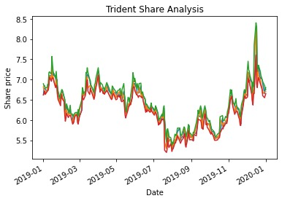

Here we have shown you the analysis of Trident Limited share where we have plotted the ups and downs of time period 1/1/2019 to 1/1/2020 with its closing price, opening price.

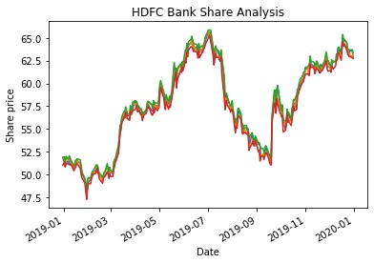

In this graph analysis we have shown you the analysis of HDFC Bank share where we have plotted the ups and downs of time period 1/1/2019 to 1/1/2020 with its closing price, opening price.

In this graph analysis we have shown you the analysis of Reliance Industries Limited share where we have plotted the ups and downs of time period 1/1/2019 to 1/1/2020 with its closing price, opening price.

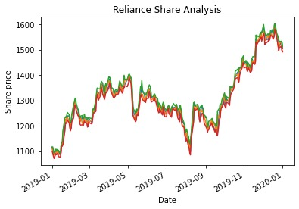

In this graph analysis we have shown you the analysis of Reliance Industries Limited share, Trident Limited share, HDFC Bank share where we have plotted the ups and downs of time period 1/1/2019 to 1/1/2020 with its opening price. 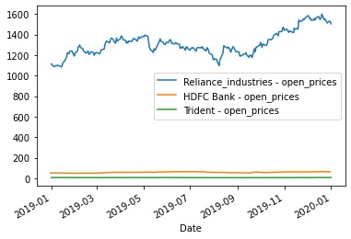

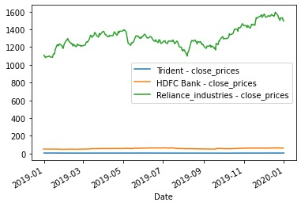

In this graph analysis we have shown you the analysis of Reliance Industries Limited share, Trident Limited share, HDFC Bank share where we have plotted the ups and downs of time period 1/1/2019 to 1/1/2020 with its closing price.

In these graphs we have done the comparison between all the shares so that we can find any pattern or similarities between the graphs. This method can be very useful for finding the right stock when you are thinking of investing inn buying the same capital stock like large cap, mid cap, small cap or can say penny stocks

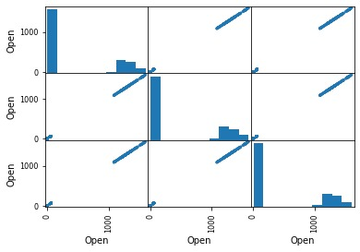

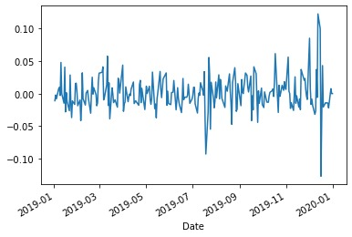

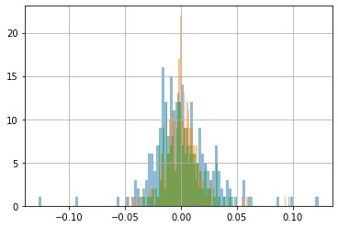

In these graphs we have sone the traded amount of quantity for the stocks which help users in identifying the stocks in demand because when the market is being

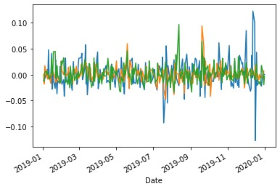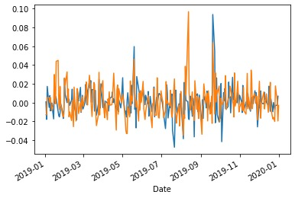

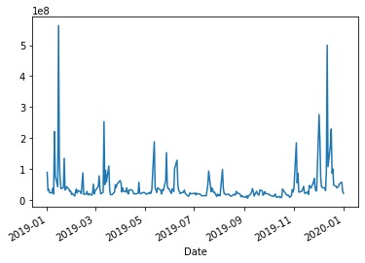

**Test & Validation**

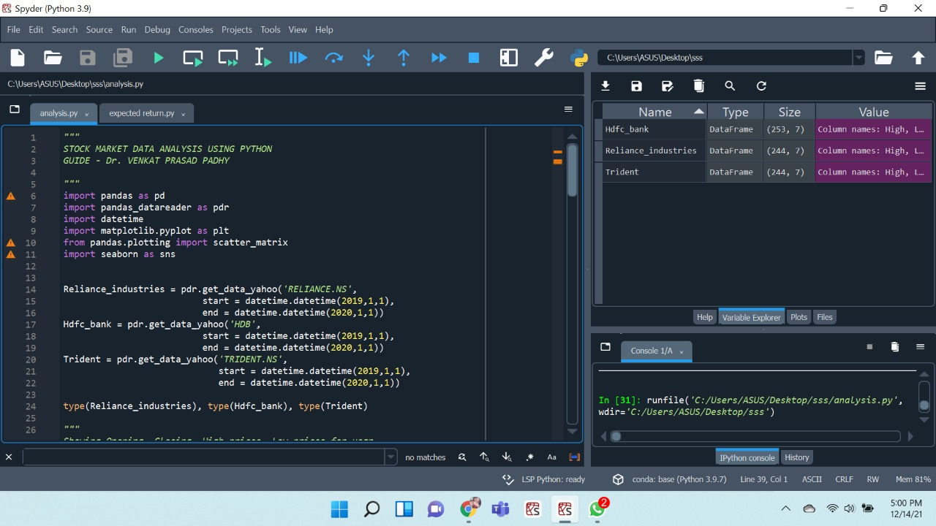

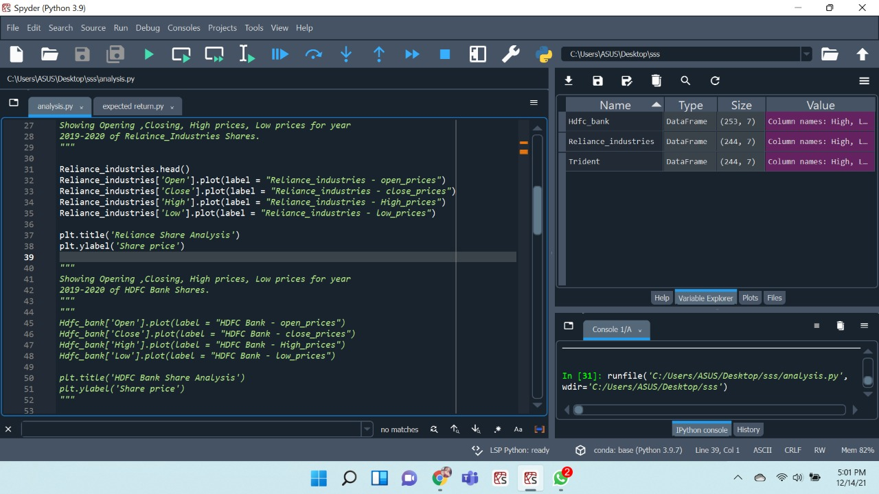

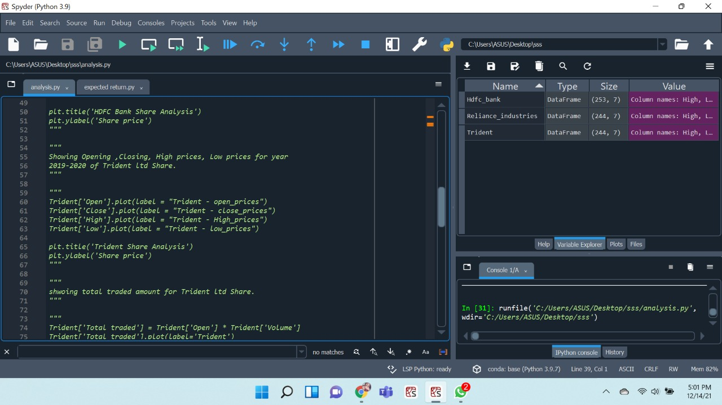

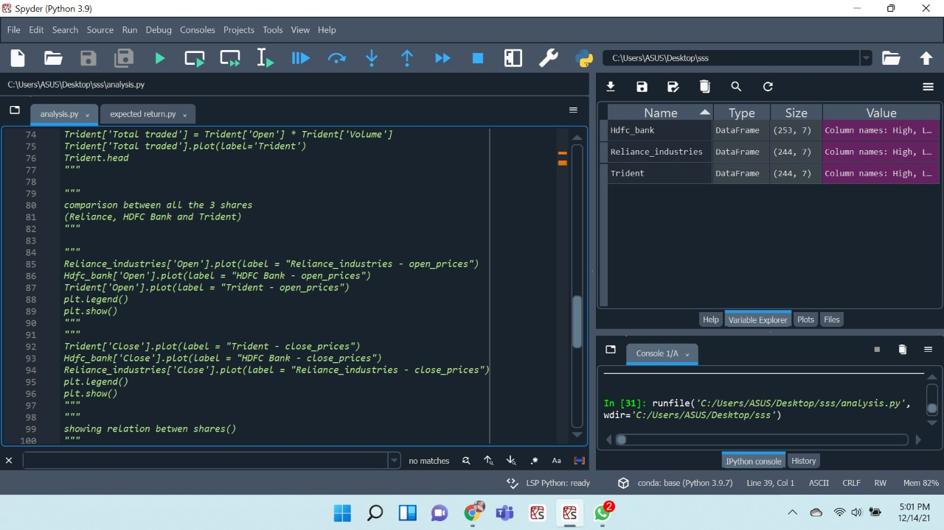

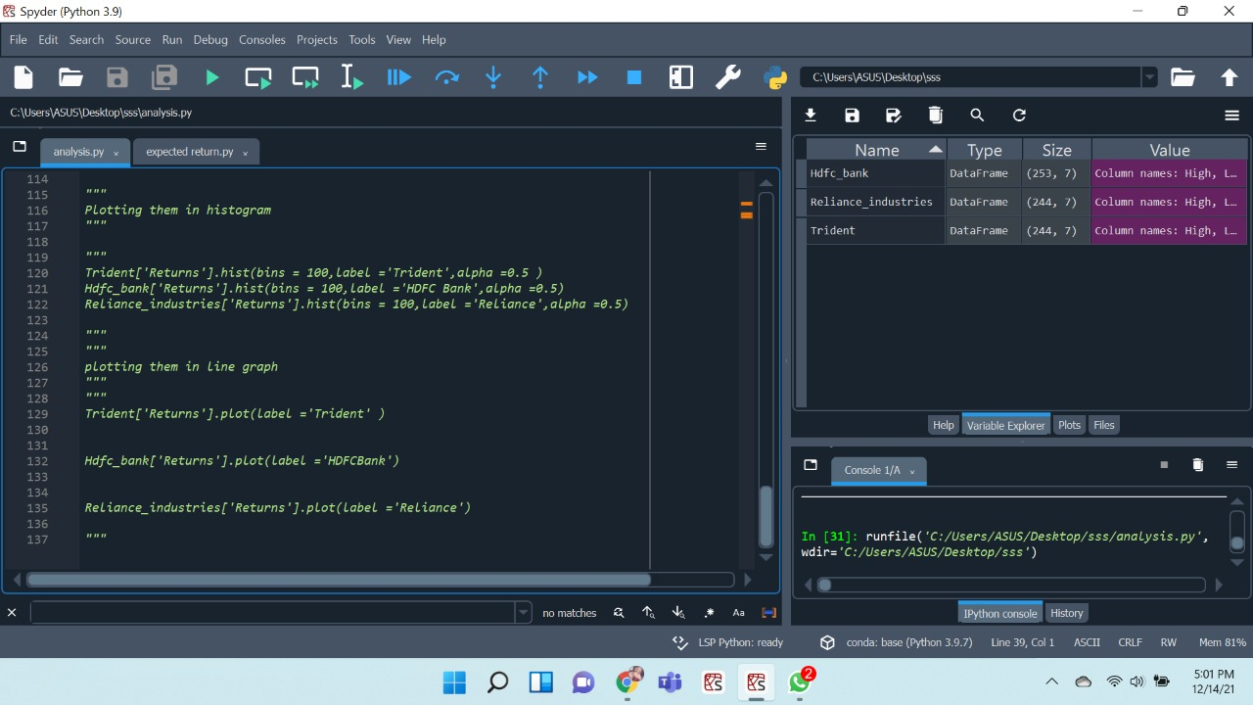

**Chapter 6**

**PROJECT OUTCOME AND APPLICABILITY**

Make http requests in python via requests library.

Use chrome dev tools to see where data is on a page.

Scrape data from downloaded pages when data is not available in structured form using Beautiful Soup library.

Parse data like tables into python 2D array.

Scraping function to get data in form of a dictionary.

First, this project will focus on technical analysis, measuring stock price data for movement (volatility) and volume.

Second, I plan to expand this project in the future, to include abranch withfundamental analysis, to look more in depth at financial statement analysis.

Third, I am interested in expanding the analysis to include Python for cryptocurrencies, such as financial and investment analysis for ICOs, and predicting crypto prices.

**Chapter 7**

**CONCLUSION**

As per the discussed works above basically two types of prediction methods are implemented by several researches to generate useful extracts. They are fundamental approaches and technical indicator based approaches. Many researchers adopted technical indicator approaches only. Limited work is done with fundamental approaches which give plenty of opportunity for further research. Since the stock data is highly volatile and unpredictable it needs the intelligence of human for effective prediction. Also it needs rigorous training of old data for analysis. This temperament of stock data makes data mining and AI techniques as suitable once. Back propagation algorithm for training and suitable AI technique applied on some fundamental approaches may render promising results survey.

**Project Technical Summary**

**Back end language: Python (the version used here is Python 3.7.6)**

**Dataset:** csv, stock price data via Yahoo Finance

**Packages:** Pandas/NumPy; Scikit-learn for Machine Learning inPython; Matplotlib (and mpl finance) for data manipulation and visualization.

**Overview**

***Step 1: Intro to Using Python for Finance***

***Step 2: Handling and Graphing Data***

***Step 3: Stock Data Manipulation***

***Step 4: Data Resampling***

***Step 5: S&P500 List Automation***

***Step 6: Getting S&P500 Stock Price Data***

***Step 7: Combine Data Frames for S&P500 List and Stock Price Data***

***Python for Machine Learning***

***Step 8: Building S&P500 Correlation Table***

***Step 9: ML: Pre process Stock Market Data***

***Step 10: ML: Create Target Function***

***Step 11: ML: Create Labels***

***Step 12: ML Algorithm: Mapping Relationships for Stock Prices***

***REFERENCES***

* **The Python Bible Volume 5: Python For Finance (Stock Analysis, Trading, Share Prices).**
* **Inspector (Dev Tools).**
* **https://towardsdatascience.com/stock-market-analysis-in-python-part-1-getting-data-by-web-scraping-cb0589aca178**
* [**https://medium.com/@patrick.collins_58673/stock-api-landscape-5c6e054ee631**](https://medium.com/@patrick.collins_58673/stock-api-landscape-5c6e054ee631)
* **www.blogquantsti.com**
* **www.analyticsvidhya.com**
* **www.towardsdatascience.com**
* **www.alpharithms.com**