LAB 2: AGILE BACKLOG CREATION & SPRINT SIMULATION IN JIRA

Test Case TC-03 — Post-Interview Scorecard Recording

Project: Mock Interview Management

Name: K R Manoj
SRN: PES1UG24AM125
Section: C

1. Epic Creation
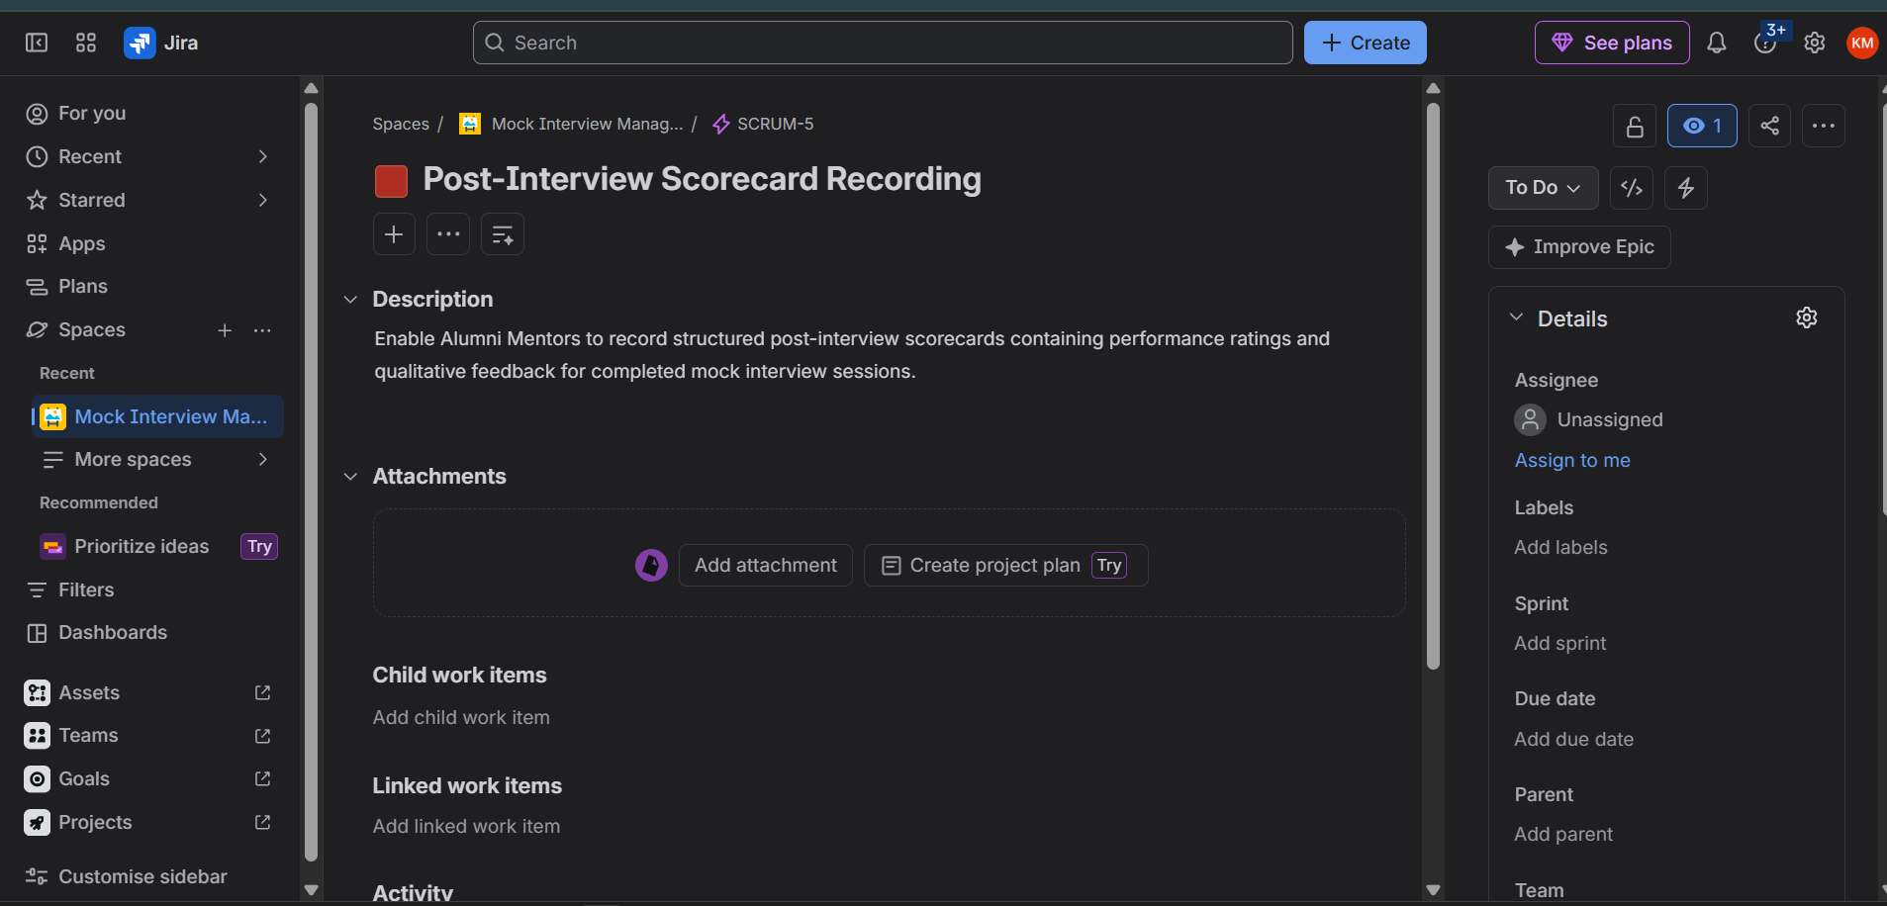
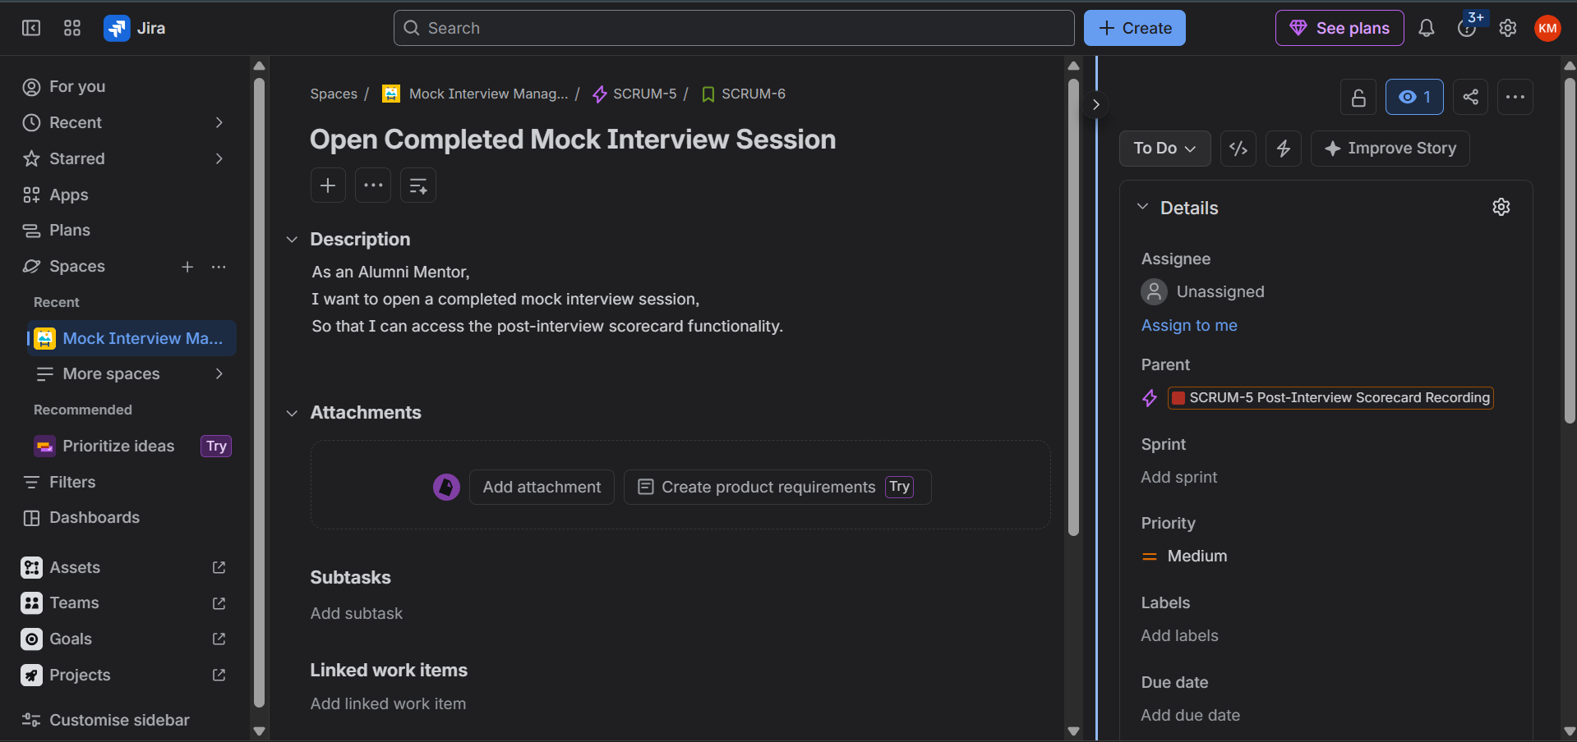
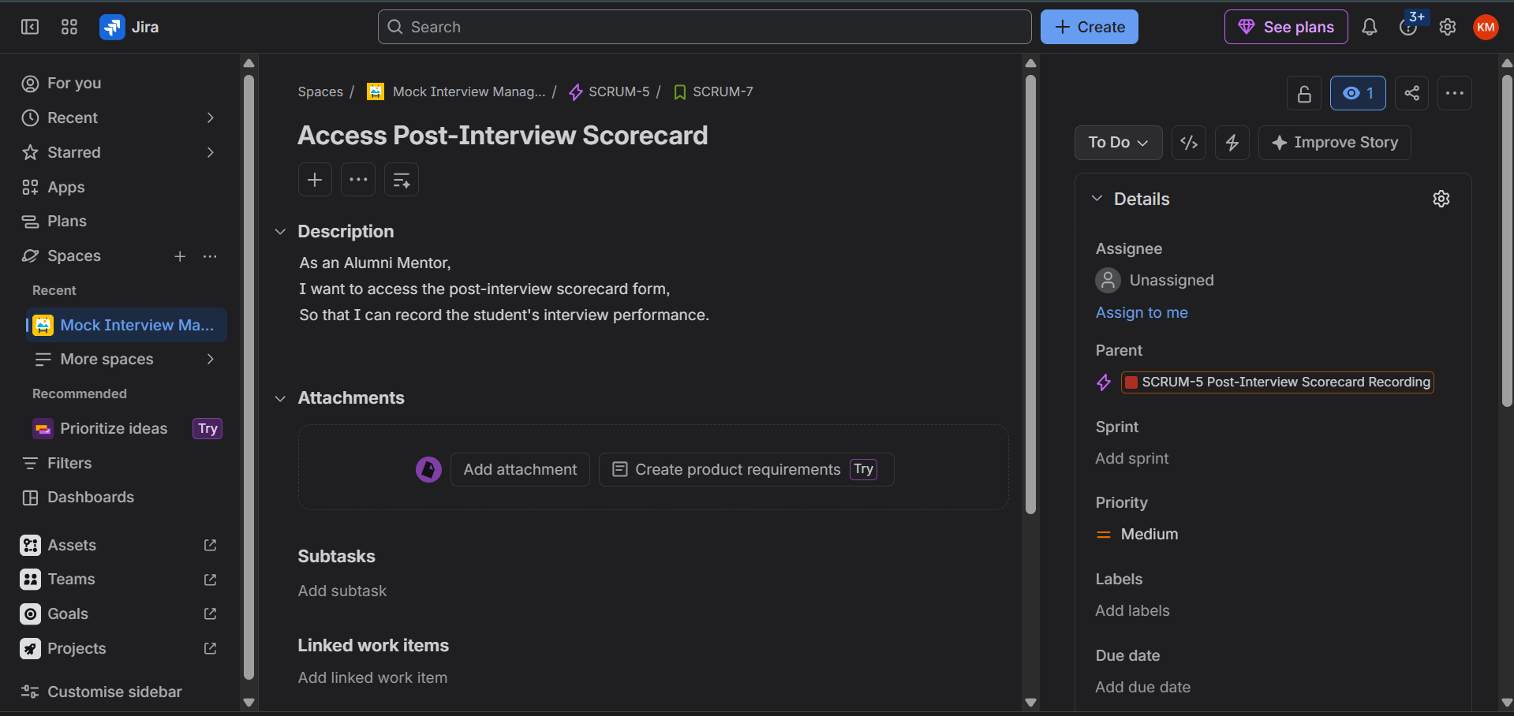
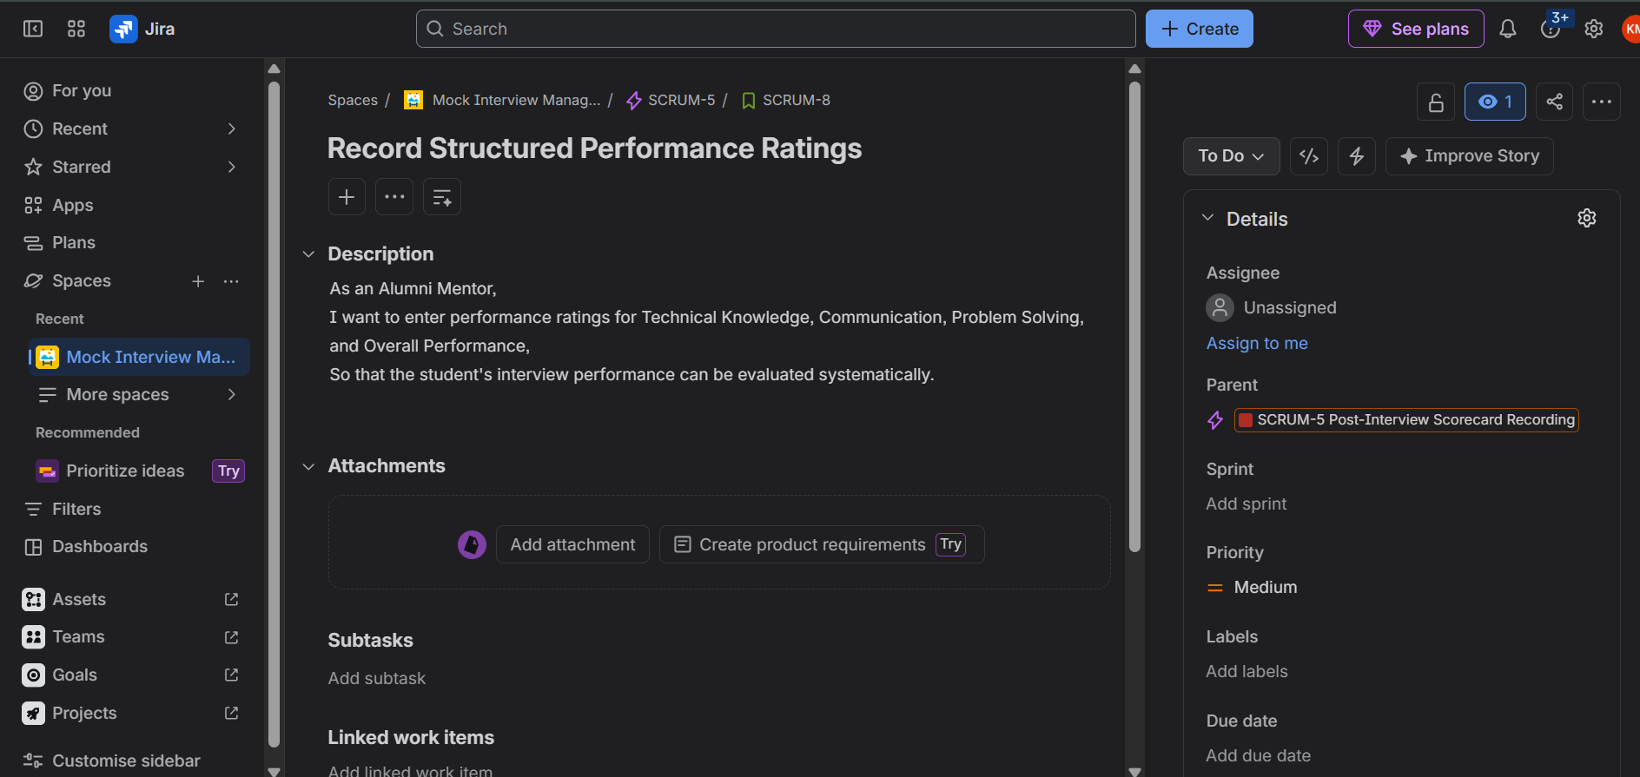
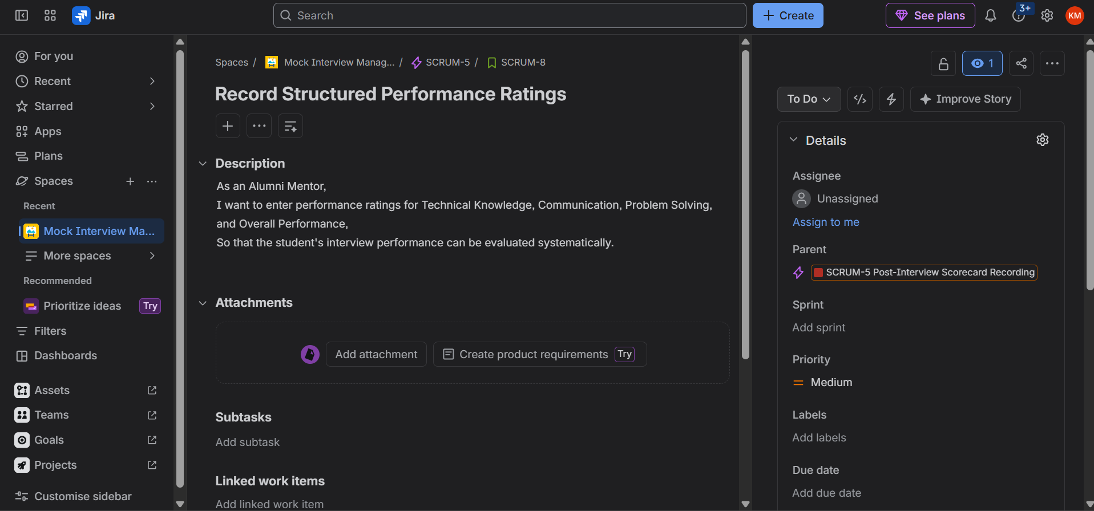
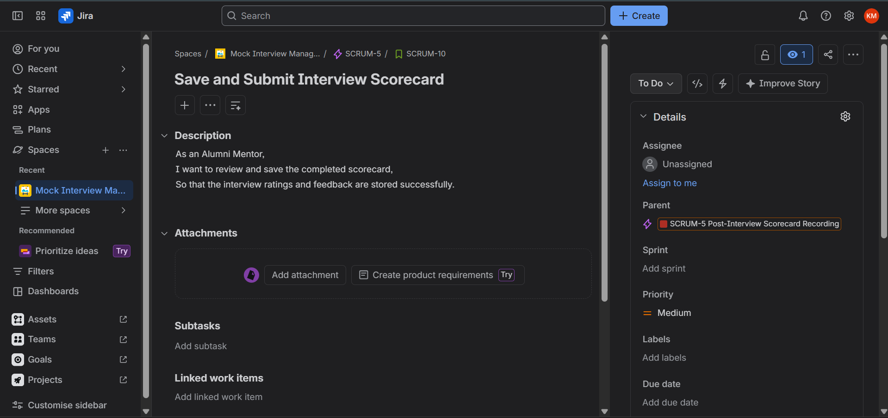

2. Backlog Prioritization
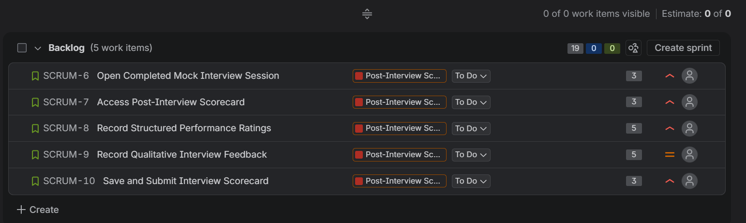

3. Story Point Estimation
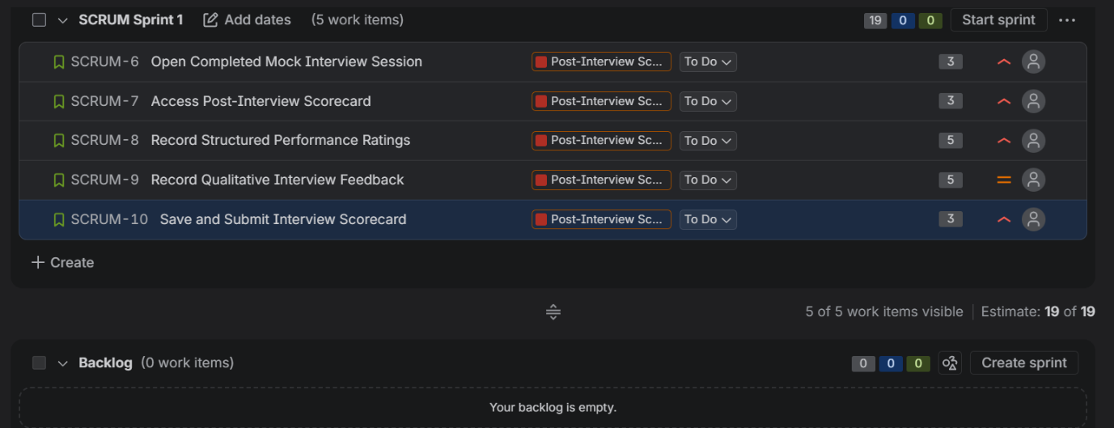

4. Sprint Planning
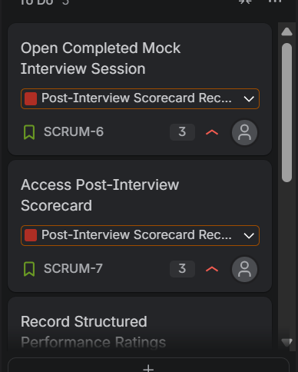

5. Sprint Execution
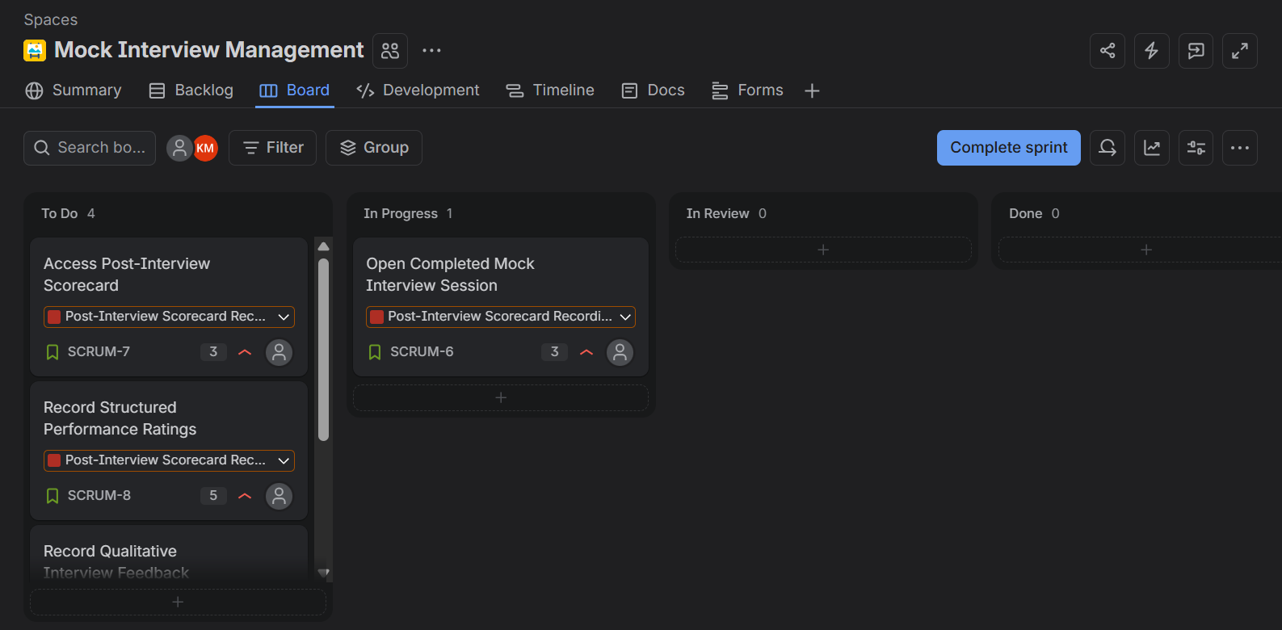
Figure: Sprint 1 with SCRUM-6 moved from To Do to In Progress
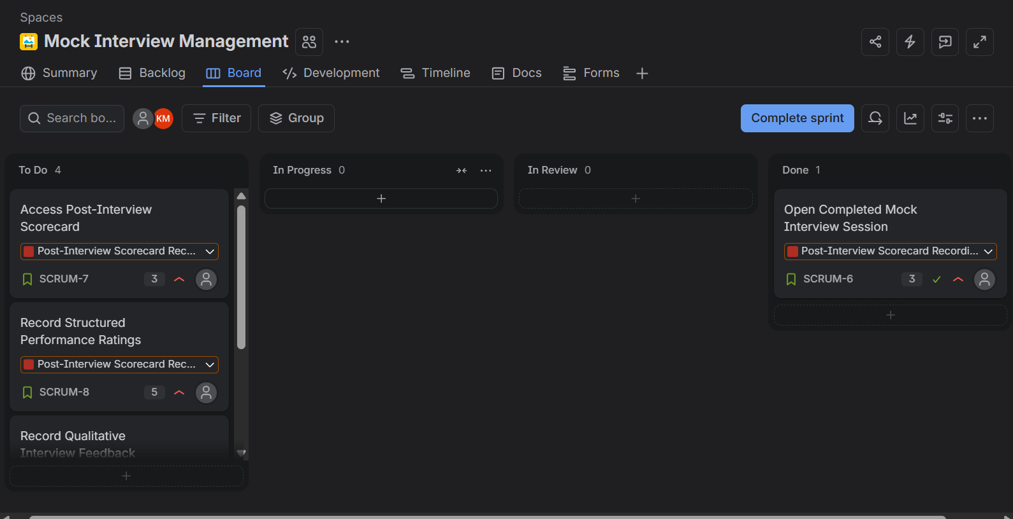
Figure: SCRUM-6 completed and moved to Done
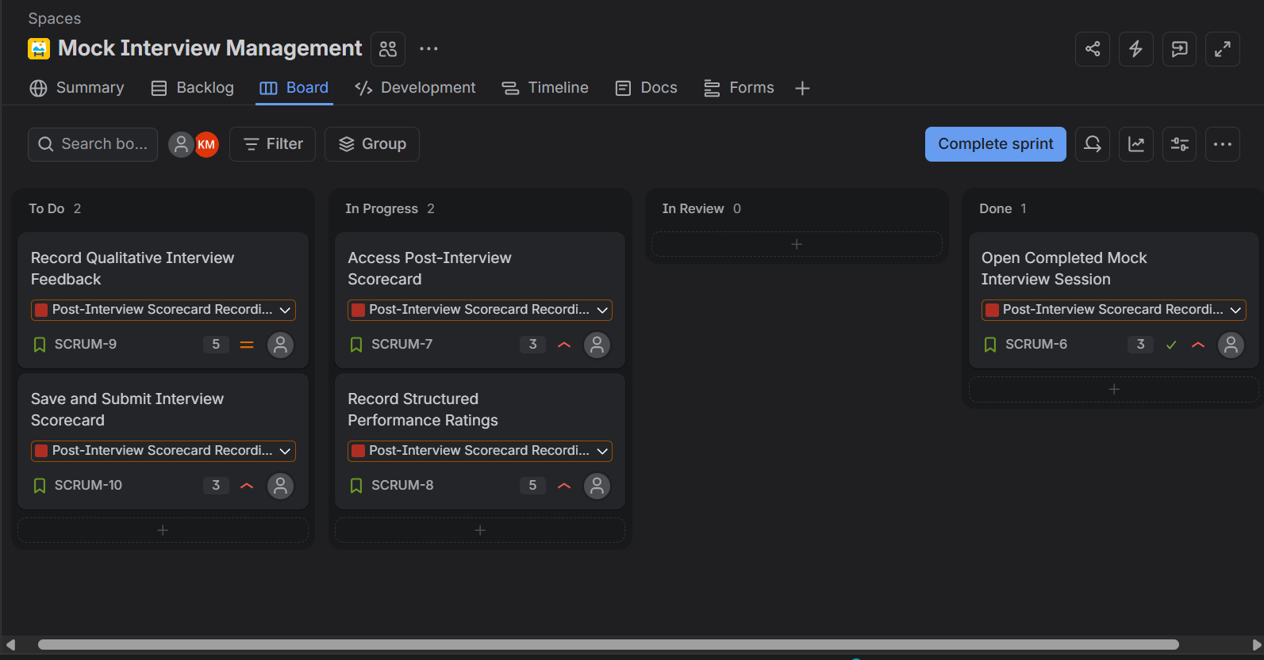
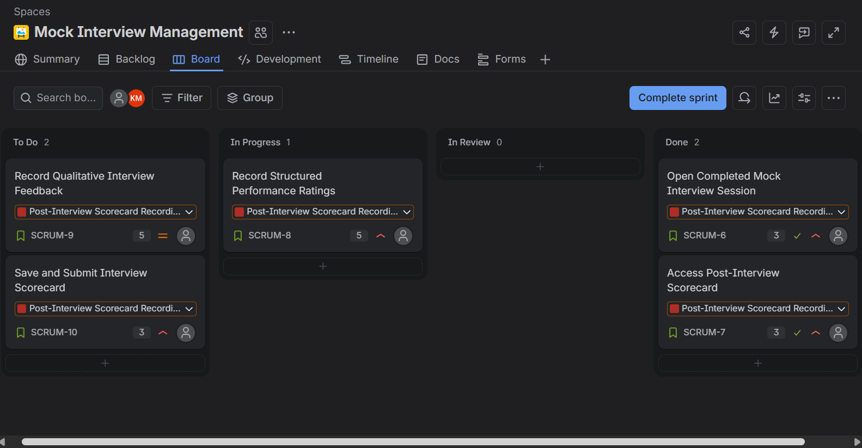
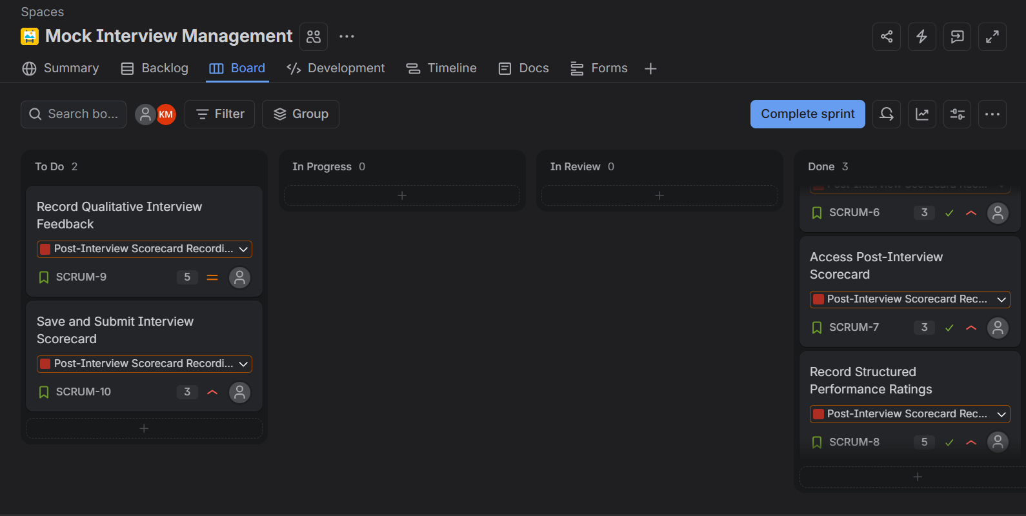
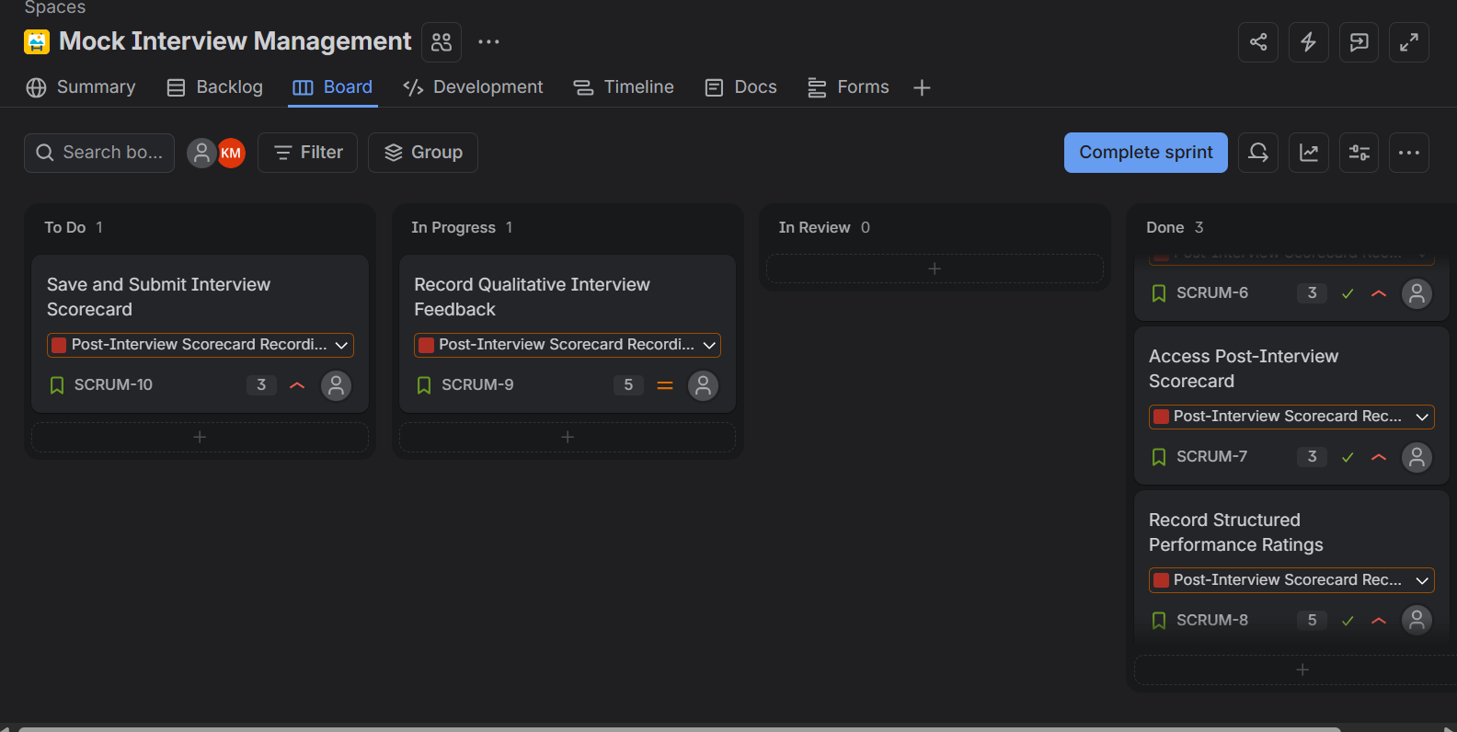
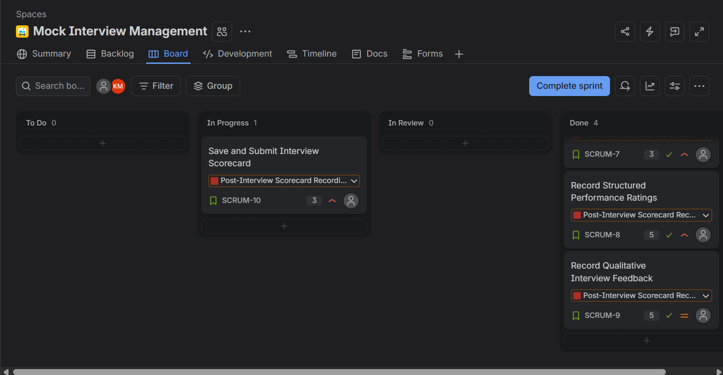
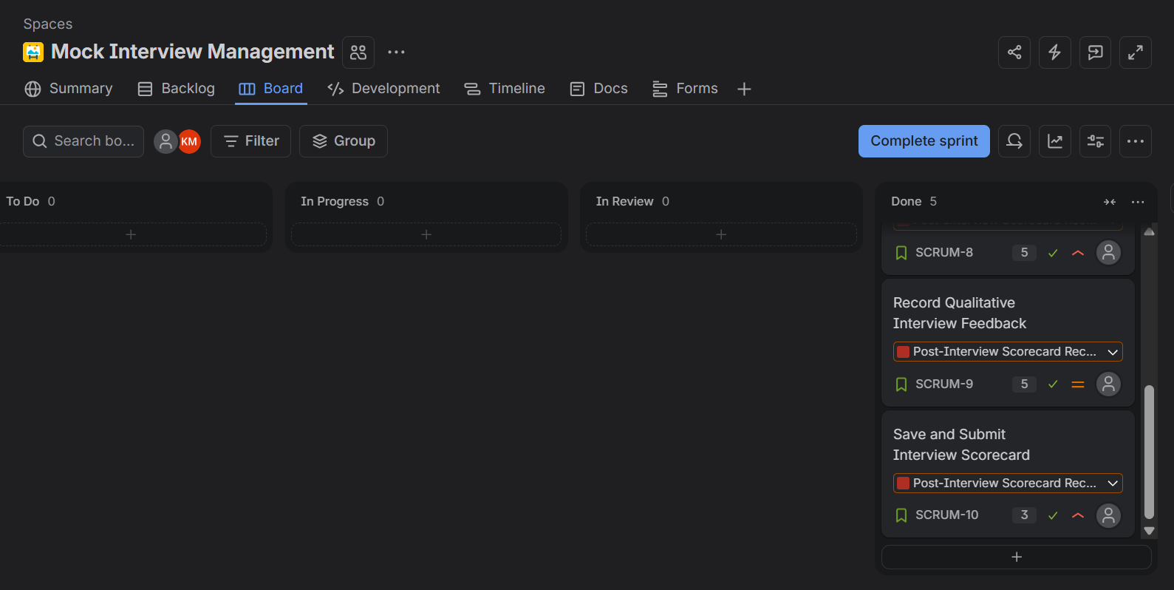
Figure: Sprint 1 completed with all five User Stories moved to Done

6. Sprint Completion
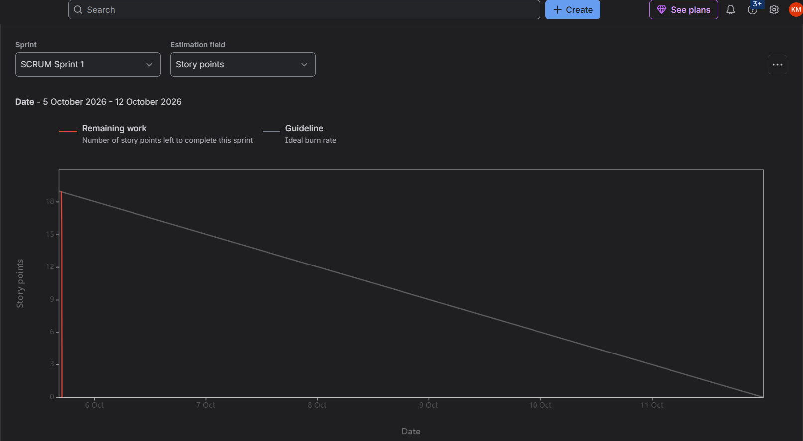
Figure X: Sprint 1 Burndown Chart
The Sprint Burndown Chart was generated for Sprint 1 using story points as the estimation field. The Sprint started with a total workload of 19 story points corresponding to the five planned User Stories. As the User Stories were completed, the remaining workload decreased to 0 story points. The chart therefore indicates that all planned Sprint work was completed successfully. The ideal guideline shows a gradual decrease from 19 to 0 story points over the one-week Sprint period, while the actual remaining-work line decreases sharply because the Sprint was simulated by completing the stories within a short period.

7. Reflection Questions
1. Did your estimations reflect the actual effort?
The estimates reasonably represented the relative complexity of the tasks. The simpler access and navigation stories were assigned 3 points, while recording structured ratings and qualitative feedback were assigned 5 points because they involve more fields and input handling.
2. Was your backlog well-prioritized?
Yes. The backlog was prioritized around the core scorecard workflow. Accessing the completed interview, recording the performance ratings, and saving the scorecard were treated as High-priority activities, while qualitative feedback was assigned medium priority.
3. How did your simulated Sprint align with your plan?
The simulated Sprint followed the planned workflow. All five selected User Stories were placed in SCRUM Sprint 1 and progressed through To Do, In Progress, and Done. The Sprint was completed after all planned stories reached Done.
4. What insights did the burndown chart give about your team's capacity?
The Burndown Chart indicates that the selected workload of 19 story points was completed within the Sprint. The remaining-work value reached zero, showing that all planned work was completed. Because the Sprint was simulated, the sharp decrease in actual remaining work should be interpreted as a result of the simulation rather than as evidence of a real team's sustained delivery rate.

