**CSE-6363 MACHINE LEARNING**

**Sentiment Analysis of IMDB Movie Reviews Using Deep Learning**

**Team-7**

Jashwanth Desaboina (1002086684)

Manoj Kumar Nallamala (1002075929)

Sai Srinivasa Karthik Stanam (1002064923)

**1. Introduction**

The purpose of this research is to look at the use of Long Short-Term Memory (LSTM) neural networks for sentiment analysis on the IMDB movie review dataset. A critical job in natural language processing (NLP) is sentiment analysis, which entails determining the sentiment or emotional tone communicated in each text. This investigation focuses on categorizing movie reviews as "positive" or "negative."

The IMDB dataset, widely regarded as a gold standard in sentiment analysis, has a large number of movie reviews, each accompanied by a sentiment label. Positive reviews indicate a good viewpoint, while negative reviews indicate an unfavourable one. Because of its large size and well-defined binary classification labels, this dataset is ideal for sentiment analysis.

In this study, we will look at how to build and train LSTM-based models for sentiment analysis on the IMDB dataset. LSTMs, which are part of the recurrent neural network (RNN) architecture, are well-known for their ability to capture sequential relationships in data, which makes them well-suited for tasks requiring sequences, such as text.

In addition, we will investigate the use of word embeddings, notably Word2Vec and GloVe embeddings, to represent words in movie reviews. Word embeddings are important in NLP because they allow text data to be transformed into continuous vector representations that incorporate semantic links between words.

**The main objectives of this report are as follows:**

1. Introduction to the IMDB Movie Review Dataset: An overview of the importance of the IMDB movie review dataset for sentiment analysis research is given in this section. Highlighting the dataset's composition of in-depth, favourable or negative movie reviews, it is made clear how well-known it is as a standard. The dataset is perfect for sentiment analysis tasks because of its size and distinct binary classification labels.
2. Explanation of Word Embeddings and Their Role in Text Data Representation: This section explores the idea of word embeddings and explains their vital function in text data representation. In particular, the capacity of Word2Vec and GloVe embeddings to transform textual data into continuous vector representations is highlighted. These representations play a major role in natural language processing tasks by capturing the semantic links between words.
3. Description of LSTM-Based Model Architecture for Sentiment Analysis: The architecture of the Long Short-Term Memory (LSTM) models used for sentiment analysis is described in this research. It emphasizes how LSTMs, which are meant to capture sequential relationships in data, are recurrent neural networks (RNNs). This section describes how LSTMs work particularly effectively for jobs involving text because they are well-suited to handle sequences.
4. Elaboration on the Training Process and Associated Techniques: A thorough description of the training procedure for LSTM-based sentiment analysis models is given in the study. The methods used to optimize the models for precise sentiment categorization are highlighted, along with any model training procedures that are specific. This part guarantees that the approaches used in the model training stage are fully understood.
5. Evaluation and Comparison of Model Performance with Different Word Embedding Approaches: This study compares and assesses the performance of LSTM-based models while taking into account different word embedding strategies. The study sheds light on how Word2Vec and GloVe embeddings affect model efficacy and offers insights into how various word representations affect sentiment analysis results.
6. Drawing Conclusions and Offering Insights for Future Work: Conclusions about the general efficacy of LSTM-based models for sentiment analysis on the IMDB dataset are made in the last section. Additionally, it provides guidance for future study in this field by pointing out possible directions for development or investigation to expand the capabilities of sentiment analysis algorithms.

**2. Dataset Description and Preprocessing**

**2.1 Dataset Description**

An established standard in the field of sentiment analysis is the IMDB dataset. It is made up of an enormous database of 50,000 movie reviews, with 40,000 of them designated for training and the remaining 10,000 for testing. In order to ease binary sentiment categorization, each review is tagged as either "positive" or "negative". Based on the attitude or emotional tone of the review, this labelling assigns a "positive" to a good viewpoint and a "negative" to an unfavourable one.

The dataset is appropriate for training and assessing machine learning models for sentiment analysis because of its evenly distributed positive and negative evaluations. The reviews themselves are diverse in terms of movies, writing styles, and genres, which makes the dataset strong for use in broad sentiment analysis applications.

**2.2 Data Preprocessing**

To make sure the data is in an appropriate format for analysis, a number of preprocessing activities are carried out before applying machine learning algorithms to the IMDB dataset. These actions consist of:

**2.2.1 HTML Tag Removal**

There may be HTML tags in some of the dataset's evaluations; these must be deleted. These tags don't help with sentiment analysis; they are usually remnants of web scraping. By eliminating them, you can be sure the text is clear and prepared for processing.

**2.2.2 Lowercase Conversion**

All text is transformed to lowercase in order to standardize the language and prevent considering words in various cases as unique. This procedure guarantees that terms such as "great" and "great" are handled interchangeably.

**2.2.3 Tokenization**

Tokenization is the process of dividing the text into discrete words or units. To transform the text into a format that machine learning models can comprehend, this step is essential. Sentences are broken up into a list of words and punctuation using tokenization.

**2.2.4 Removal of Stopwords**

Common terms like "and," "the," "in," and "is" are stopwords; they may be safely eliminated from sentiment analysis because they don't have much significance. By doing this step, the data's dimensionality is decreased and the analysis is narrowed down to more significant terms.

In order to guarantee that the text data is consistent, clear, and prepared for additional analysis utilizing natural language processing techniques, these pretreatment processes are crucial.

**3. Word Embeddings**

Sentiment analysis and other NLP tasks heavily rely on word embeddings. In order to capture the semantic links between words, they are dense vector representations of words in a continuous space. We will examine Word2Vec and GloVe, two popular word embedding methods, in this section.

**3.1 Word2Vec Embeddings**

An unsupervised learning technique called Word2Vec extracts word embeddings from big text corpora. It functions according to the idea that words with vector representations that are similar should arise in situations that are similar. Words with comparable meanings can be close to one another in the vector space because to Word2Vec's ability to generate embeddings that capture semantic meaning.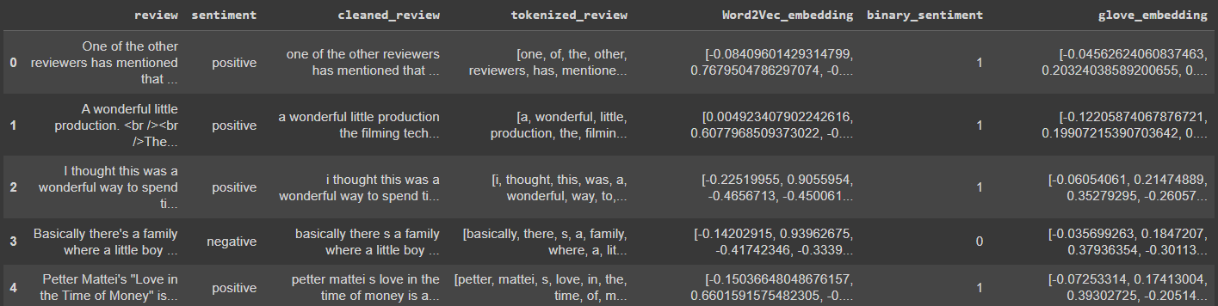

**4. Basic LSTM Model with Word2Vec Embedding**

|  |  |  |
| --- | --- | --- |
| Parameter | Value | Description |
| Model Type | Sequential Model with LSTM Layer | A type of neural network architecture that consists of a sequence of layers, including one or more LSTM layers. |
| Embedding Dimension | 128 | The dimensionality of the word embeddings. |
| Input Shape | (1, Embedding Dimension) | The shape of the input data to the model, which is a one-dimensional tensor of embedding vectors. |
| Number of LSTM Units | 64 | The number of neurons in the LSTM layer. |
| Activation Function | None | The function that is applied to the output of the LSTM layer. In this case, no activation function is applied. |
| Number of Dense Units | 1 | The number of neurons in the dense layer. |
| Activation Function | Sigmoid | The function that is applied to the output of the dense layer. In this case, the sigmoid function is applied, which squashes the output to a value between 0 and 1. |
| Training Data | Tokenized and Embedded Word2Vec Vectors | The type of data used to train the model. In this case, the training data is tokenized and embedded Word2Vec vectors. |
| Validation Data | Tokenized and Embedded Word2Vec Vectors | The type of data used to validate the model during training. In this case, the validation data is tokenized and embedded Word2Vec vectors. |
| Test Data | Tokenized and Embedded Word2Vec Vectors | The type of data used to evaluate the model after training. In this case, the test data is tokenized and embedded Word2Vec vectors. |
| Loss Function | Binary Cross-Entropy | A loss function that is commonly used for classification tasks. In this case, the binary cross-entropy loss function is used because the target variable is binary. |
| Optimizer | Adam | An optimization algorithm that is commonly used to train neural networks. In this case, the Adam optimizer is used because it is efficient and effective at training neural networks. |
| Number of Epochs | 10 | The number of times to train the model on the entire training set. |
| Batch Size | 64 | The number of training examples to use in each batch. |
| Early Stopping Patience | Not specified (Early stopping used) | The number of epochs to wait before stopping the training process if the validation loss does not improve. In this case, early stopping is used, but the patience is not specified. |
| Evaluation Metric | Accuracy | A metric that is commonly used to evaluate the performance of classification models. In this case, the accuracy metric is used to evaluate the performance of the model on the test set. |

**Results**

Training Accuracy: 85.36% (at 10 epochs)

Validation Accuracy: 85.62% (at 10 epochs)

Test Accuracy: 85.62%

**5. LSTM with Dropout and Early Stopping**

|  |  |  |
| --- | --- | --- |
| Parameter | Value | Description |
| Model Type | Sequential Model with LSTM Layers and Dropout | A type of neural network architecture that consists of a sequence of layers, including one or more LSTM layers and dropout layers. |
| Embedding Dimension | 128 | The dimensionality of the word embeddings. |
| Input Shape | (1, Embedding Dimension) | The shape of the input data to the model, which is a one-dimensional tensor of embedding vectors. |
| Number of LSTM Units | 128, 64 | The number of neurons in the LSTM layers. |
| Dropout Rate | 0.5 | The probability of dropping out a neuron in the dropout layers. |
| Number of Dense Units | 1 | The number of neurons in the dense layer. |
| Activation Function | Sigmoid | The function that is applied to the output of the dense layer. In this case, the sigmoid function is applied, which squashes the output to a value between 0 and 1. |
| Training Data | Tokenized and Embedded Word2Vec Vectors | The type of data used to train the model. In this case, the training data is tokenized and embedded Word2Vec vectors. |
| Validation Data | Tokenized and Embedded Word2Vec Vectors | The type of data used to validate the model during training. In this case, the validation data is tokenized and embedded Word2Vec vectors. |
| Test Data | Tokenized and Embedded Word2Vec Vectors | The type of data used to evaluate the model after training. In this case, the test data is tokenized and embedded Word2Vec vectors. |
| Loss Function | Binary Cross-Entropy | A loss function that is commonly used for classification tasks. In this case, the binary cross-entropy loss function is used because the target variable is binary. |
| Optimizer | Adam | An optimization algorithm that is commonly used to train neural networks. In this case, the Adam optimizer is used because it is efficient and effective at training neural networks. |
| Learning Rate | 0.0001 | The learning rate used by the Adam optimizer. |
| Early Stopping Patience | 3 | The number of epochs to wait before stopping the training process if the validation loss does not improve. |
| Evaluation Metric | Accuracy | A metric that is commonly used to evaluate the performance of classification models. In this case, the accuracy metric is used to evaluate the performance of the model on the test set. |

**Results:**

**Training**

* Trained for 50 epochs with early stopping.
* Model improvement plateaued after the initial improvement.

**Training Performance**

* Training Accuracy (Epoch 1): 70.49%
* Training Accuracy (Epoch 50): 84.62%
* Validation Accuracy (Epoch 1): 81.39%
* Validation Accuracy (Epoch 50): 85.43%

**Test Performance**

* Test Accuracy: 85.43%
* Test Loss: 0.3411

**Model Parameters**

* Total Parameters: 181,057 (including non-trainable Word2Vec embeddings).

**Conclusion**

* The model achieved 85.43% test accuracy.
* Effective sentiment classification on IMDB dataset.
* Potential for further optimization.

**6. LSTM with Glove embedding**

|  |  |  |
| --- | --- | --- |
| Parameter | Value | Description |
| Model Type | Sequential Model with LSTM Layer and Embedding Layer | A type of neural network architecture that consists of a sequence of layers, including one or more LSTM layers and an embedding layer. The embedding layer converts the input words into vectors of a specific dimensionality, and the LSTM layer then learns to process the sequence of vectors and extract features from it. |
| Embedding Dimension | len(next(iter(glove_embeddings.values()))) | The dimensionality of the GloVe word embeddings. |
| Input Shape | (max_length_glove, Embedding Dimension) | The shape of the input data to the model, which is a two-dimensional tensor of embedding vectors. The first dimension represents the length of the sequence, and the second dimension represents the dimensionality of the word embeddings. |
| Number of LSTM Units | 64 | The number of neurons in the LSTM layer. |
| Dropout Rate | 0.2 | The probability of dropping out a neuron in the LSTM layer. This helps to prevent overfitting, which is a common problem in machine learning models. |
| Number of Dense Units | 1 | The number of neurons in the dense layer. |
| Activation Function | Sigmoid | The function that is applied to the output of the dense layer. The sigmoid function squashes the output to a value between 0 and 1, which is useful for classification tasks. |
| Training Data | Padded GloVe Embedding Vectors | The type of data used to train the model. In this case, the training data is padded GloVe embedding vectors. |
| Validation Data | Padded GloVe Embedding Vectors | The type of data used to validate the model during training. In this case, the validation data is padded GloVe embedding vectors. |
| Test Data | Padded GloVe Embedding Vectors | The type of data used to evaluate the model after training. In this case, the test data is padded GloVe embedding vectors. |
| Loss Function | Binary Cross-Entropy | A loss function that is commonly used for classification tasks. In this case, the binary cross-entropy loss function is used because the target variable is binary. |
| Optimizer | Adam | An optimization algorithm that is commonly used to train neural networks. The Adam optimizer is efficient and effective at training neural networks. |
| Early Stopping Patience | 3 | The number of epochs to wait before stopping the training process if the validation loss does not improve. This helps to prevent overfitting. |
| Restore Best Weights | TRUE | A boolean value that specifies whether to restore the model weights from the epoch with the best value of the monitored metric. This can help to improve the performance of the model on the test set. |
| Evaluation Metric | Accuracy | A metric that is commonly used to evaluate the performance of classification models. In this case, the accuracy metric is used to evaluate the performance of the model on the test set. |

**Training**

* Trained for 10 epochs.
* No significant improvement in training and validation accuracy.

**Training Performance**

* Training Accuracy (Epoch 1): 50.23%
* Training Accuracy (Epoch 10): 50.39%
* Validation Accuracy (Epoch 1): 49.61%
* Validation Accuracy (Epoch 10): 50.39%

**Test Performance**

* Test Accuracy (GloVe): 50.39%
* Test Loss (GloVe): 0.6931

**Conclusion**

* The GloVe-based LSTM model showed poor performance.
* Both training and validation accuracy remained around 50%.
* This model may not be suitable for sentiment analysis on the IMDB dataset.
* Further optimization and experimentation required.

**7. Bidirectional LSTM**

|  |  |  |
| --- | --- | --- |
| Parameter | Value | Description |
| Model Type | Sequential Model with Embedding Layer, BatchNormalization Layer, Dropout Layer, Conv1D Layer, MaxPooling1D Layer, Bidirectional LSTM Layer, LSTM Layer, Dropout Layer, and Dense Layer | A type of neural network architecture that consists of a sequence of layers, including an embedding layer, batch normalization layer, dropout layer, Conv1D layer, MaxPooling1D layer, bidirectional LSTM layer, LSTM layer, dropout layer, and dense layer. |
| Embedding Dimension | 64 | The dimensionality of the word embeddings. |
| Input Shape | (max_seq_len,) | The shape of the input data to the model, which is a one-dimensional tensor of integer sequence. |
| Number of Conv1D Units | 32 | The number of neurons in the Conv1D layer. |
| Kernel Size of Conv1D Layer | 5 | The size of the kernel used in the Conv1D layer. |
| Activation Function of Conv1D Layer | relu | The activation function applied to the output of the Conv1D layer. |
| Number of MaxPooling1D Units | 2 | The number of neurons in the MaxPooling1D layer. |
| Number of Bidirectional LSTM Units | 128 | The number of neurons in the bidirectional LSTM layer. |
| Number of LSTM Units | 64 | The number of neurons in the LSTM layer. |
| Dropout Rate | 0.3, 0.5 | The probability of dropping out a neuron in the dropout layers. |
| Number of Dense Units | 1 | The number of neurons in the dense layer. |
| Activation Function of Dense Layer | sigmoid | The activation function applied to the output of the dense layer. |
| Training Data | Padded Sequence Data | The type of data used to train the model. In this case, the training data is padded sequence data. |
| Validation Data | Padded Sequence Data | The type of data used to validate the model during training. In this case, the validation data is padded sequence data. |
| Loss Function | Binary Cross-Entropy | A loss function that is commonly used for classification tasks. In this case, the binary cross-entropy loss function is used because the target variable is binary. |
| Optimizer | Adam | An optimization algorithm that is commonly used to train neural networks. In this case, the Adam optimizer is used because it is efficient and effective at training neural networks. |
| Learning Rate | 0.0005 | The learning rate used by the Adam optimizer. |
| Number of Epochs | 5 | The number of times to train the model on the entire training set. |

**Training**

* Trained for 5 epochs.
* Total trainable parameters: 6,747,169

**Training Performance**

* Training Accuracy (Epoch 1): 60.58%
* Training Accuracy (Epoch 5): 92.85%

**Validation Performance**

* Validation Accuracy (Epoch 1): 81.61%
* Validation Accuracy (Epoch 5): 88.80%

**Model Evaluation**

* Training Score: Loss 0.1648, Accuracy 95.63%
* Validation Score: Loss 0.2816, Accuracy 88.80%

**Conclusion**

* The model shows significant improvement in accuracy during training.
* Validation accuracy reached 88.80% after 5 epochs.
* The model seems to be performing well on the sentiment analysis task for movie reviews.

**Note**: Training time per epoch is approximately 28 seconds.

**BERT**

A pre-trained language model called BERT (Bidirectional Encoder Representations from Transformers) has produced state-of-the-art performance on a range of natural language processing applications, including sentiment analysis. Due to its bidirectional nature, BERT can understand a word's context from both the left and right sides of the phrase. This makes it ideal for applications such as sentiment analysis, where it's critical to comprehend a word's context in order to interpret it.

The following is a brief overview of the preprocessing steps that are performed on the IMDb dataset:

The labels are converted to binary (0 for 'negative', 1 for 'positive').

The data is split into training and testing sets.

The text data is tokenized using the BERT tokenizer.

The sequences are padded to a fixed length of 128.

Once the data has been pre-processed, it is ready to be fed into the BERT model for training or testing.

|  |  |  |
| --- | --- | --- |
| Parameter | Value | Description |
| Model Type | BERT For Sequence Classification | A type of neural network architecture that is specifically designed for sequence classification tasks. |
| Embedding Dimension | 768 | The dimensionality of the BERT word embeddings. |
| Input Shape | (max_seq_len, 768) | The shape of the input data to the model, which is a two-dimensional tensor of embedding vectors. The first dimension represents the length of the sequence, and the second dimension represents the dimensionality of the word embeddings. |
| Number of Encoder Layers | 12 | The number of encoder layers in the BERT model. |
| Number of Attention Heads | 12 | The number of attention heads in the BERT model. |
| Number of Dense Units | 768 | The number of neurons in the dense layer. |
| Activation Function | GELU | The activation function applied to the output of the dense layer. |
| Loss Function | Cross-Entropy Loss | A loss function that is commonly used for classification tasks. |
| Optimizer | AdamW | An optimization algorithm that is commonly used to train neural networks. |

**Gradient Flow:**

In order to ensure that the model learns from its mistakes during the training phase, gradient flow is crucial to the backpropagation process.

**Zero Gradient Initialization:**

Optimizer.zero_grad() makes sure that gradients are reset to zero before each batch in the training loop. This ensures that each batch's gradients are computed from scratch and prevents buildup from earlier batches.

**Loss Computation:**

The model calculates the discrepancy between the actual labels and its predictions using the CrossEntropyLoss. The model's performance is shown by this loss value; the larger the loss, the poorer the model's predictions.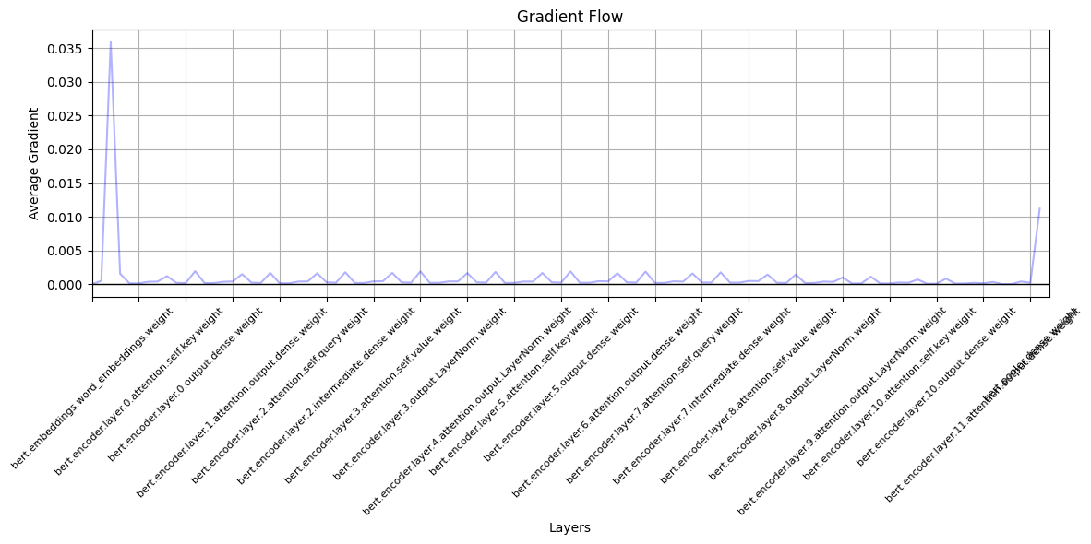

**Backpropagation:**

The detriment.The backpropagation is started by using the backward() command, which computes the gradients for each parameter depending on the loss.

**Optimizer Step:**

In order to make sure the model learns and gets better over time, optimizer.step() uses the computed gradients to adjust the model's parameters.

**Overall Results**

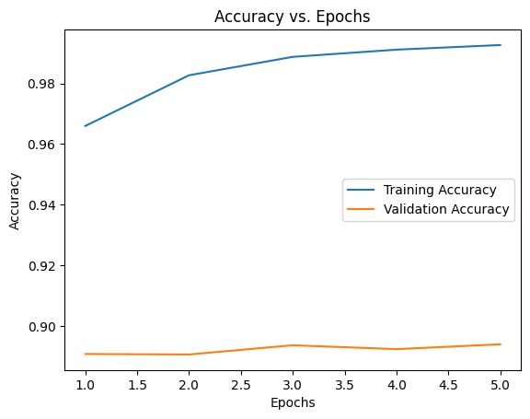

With three epochs of training, the BERT model produced test accuracy of 89.08% and training accuracy of 99%. This shows that the model can effectively generalize to new data and pick up patterns from the training set. The fact that there is still a difference between the test and training accuracies suggests that the model could be marginally overfitting the training set.

**Regularization:**

A regularization term with a value of 2e-5 is included in the model. Regularization penalizes the loss function, hence preventing overfitting. It makes sure the model doesn't only learn the training set by heart and lose its ability to be generalized. This is particularly helpful for complex models with a high number of parameters, such as BERT.

**Gradient Flow:**

**Spike in Initial Layer Embeddings:**

A surge in the gradient change was seen early in the training process. This is a result of the input being processed by the first embeddings layer. This is to be expected as the embeddings change to reflect the subtleties of the IMDb dataset, which is distinct from the corpus that BERT was trained on at first.

**Gradient Visualization:**

Gradient visualization tools reveal information about the flow between layers after every training period. In order to prevent gradients from disappearing (becoming too tiny for the model to learn) or exploding (gradients becoming too huge, producing instability), this is essential. A well-converging model is shown by a steady gradient flow.

**Performance Metrics:**

**Validation Loss:** By the end of the training regime spanning 10 epochs, the model achieved a loss of 0.5435 on the validation set.

**Validation Accuracy:** More impressively, the model's accuracy reached 90.001%. This level of performance underscores BERT's capability to understand the underlying sentiment in movie reviews and predict them accurately.

**Conclusion:**

It was quite successful to use BERT for sentiment analysis on the IMDb dataset. The architecture of the model and the additional regularization made sure it remained stable and broadly applicable. Gradient fluxes were given careful consideration, and the insights gained by visualizing them helped to clarify the training procedure and ensure that any possible problems could be fixed early on. The attained measurements serve to reinforce BERT's standing as a cutting-edge approach to solving NLP problems.

**XLNet for Sentiment Analysis on IMDb Dataset: An Analysis Report**

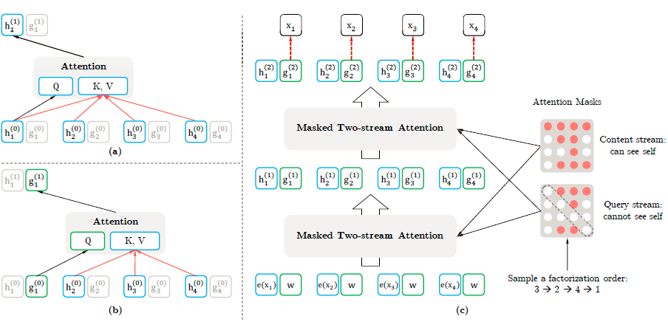

**1. Introduction:**

An improvement on BERT, XLNet is a potent transformer-based architecture designed to overcome some of BERT's shortcomings. We examine the application and analysis of XLNet sentiment analysis on the IMDb movie reviews dataset in this research.

**2. Dataset and Preprocessing:**

The IMDb dataset comprises movie reviews that are classified as either 'positive' or 'negative'. For the objective of training models:

The feelings were divided into two categories: "positive" at 1 and "negative" at 0.

To guarantee a fair distribution, the dataset was split up into training, validation, and testing sets.

**3. XLNet Implementation:**

**Pre-trained Tokenizer and Model:**

The pre-trained tokenizer and model 'xlnet-base-cased' are used in the implementation. Because pre-trained models have undergone thorough training on a variety of data sets, using them speeds up convergence and frequently results in a performance advantage.

**Tokenization:**

Reviews from the dataset are tokenized with a maximum length of 128. The tokenization also includes attention masks which help the model to focus on relevant tokens. =

**DataLoaders:**

PyTorch's DataLoader is used for efficient data handling, batching, and shuffling.

**Optimizer and Loss:**

The AdamW optimizer and CrossEntropyLoss function ensure effective weight updates and loss calculation, respectively.

**Training Loop:**

For training, the model is transferred to a GPU if available. The training process encompasses 10 epochs, with each epoch consisting of a training and validation phase. The loss and accuracy metrics are recorded for evaluation.

**4. Innovations in XLNet:**

**Evolution from BERT:**

XLNet introduces a permutation-based training mechanism. Unlike BERT, which masks and predicts specific tokens, XLNet predicts every token by considering all possible permutations, providing a more nuanced context.

**Two-stream Self-attention:**

A significant architectural innovation in XLNet is its two-stream self-attention mechanism. This allows each token position to attend to all other positions in the sequence, even future ones. This feature enhances the model's contextual representation capabilities.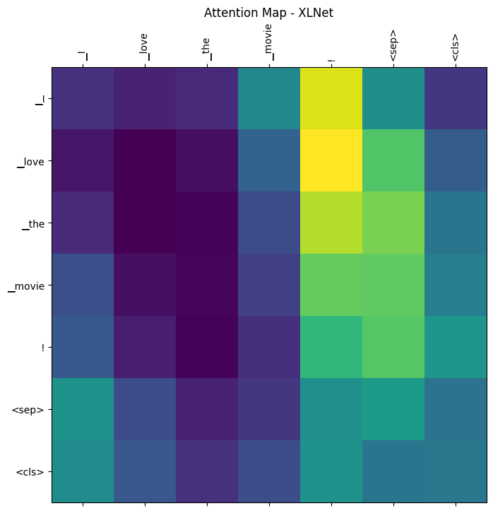

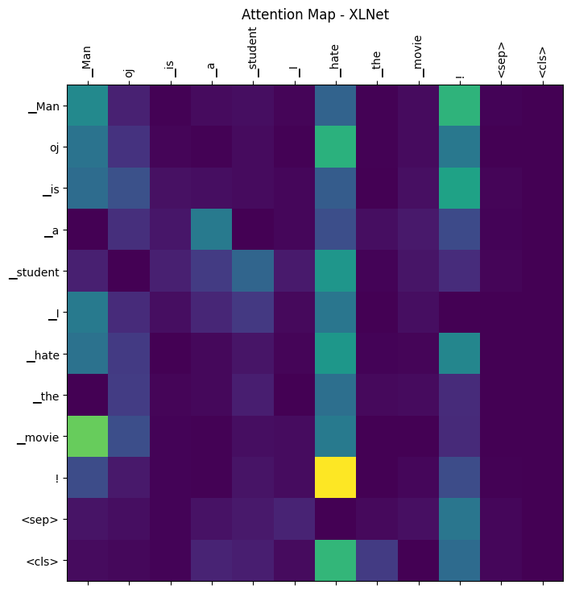

**Overview:**

The provided image represents an attention map derived from an XLNet model. Attention maps are vital in Transformer-based architectures like XLNet, as they provide insights into which parts of the input sequence the model focuses on when predicting a specific token.

**Key Observations:**

**Diagonal Dominance:**

The attention map exhibits a strong diagonal pattern. This is typical in many attention maps and indicates that each token predominantly pays attention to itself.

**Token Interactions:**

The word "love" exhibits strong attention towards "the", which suggests that the relationship between these two words is being captured by the model.

Similarly, "the" also pays strong attention to "movie", highlighting that the context between "the" and "movie" is being considered.

**Special Tokens:**

The tokens <sep> and <cls> are special tokens in transformer models. The <sep> token usually acts as a separator between sentences, and the <cls> token is often used for classification tasks.

These tokens show a fairly uniform attention distribution across the map, suggesting that they are gathering contextual information from all the words in the sequence.

**Attention Symmetry:**

The map appears symmetric across the diagonal, indicating mutual attention between certain pairs of tokens. For instance, while "love" pays attention to "the", "the" reciprocates this attention.

**Darker vs. Brighter Cells:**

Brighter cells denote higher attention weights, while darker cells signify lower attention weights. This contrast helps in quickly identifying which tokens influence the prediction of others.

**Implications:**

The attention map provides insights into how the XLNet model is internally representing and leveraging the relationships between different words in the sequence. Understanding these patterns can be crucial, especially when trying to interpret the predictions of the model or when diagnosing potential areas of improvement.

**5. Conclusion:**

The provided implementation exhibits a structured approach to sentiment analysis using XLNet on the IMDb dataset. The choice of XLNet, with its permutation-based training and advanced self-attention mechanism, offers a compelling alternative to BERT for complex NLP tasks. Through regular monitoring of validation loss and accuracy, the performance can be tracked, ensuring that the model generalizes well to unseen movie reviews.

**Comparative Analysis & Future Improvements Report**

**Comparative Overview:**

BERT and XLNet, both being transformer-based models, have revolutionized the NLP domain with their groundbreaking performance. Here's a comparative breakdown:

**BERT (Bidirectional Encoder Representations from Transformers):**

**Nature**: Primarily bidirectional, meaning it considers context from both the left and the right.

**Training Methodology:** Uses a masked language model where random words are replaced with a [MASK] token, and the model tries to predict the original word.

**Achievement:** BERT's bidirectional approach allows for a more holistic understanding of context, making it adept at understanding the nuances of language.

**XLNet:**

**Nature**: Overcomes BERT's limitations by adopting a permutation-based approach.

**Training Methodology:** Instead of masking out words, XLNet looks at all possible permutations of words in a sentence, leading to a comprehensive understanding of context.

**Achievement:** The permutation-based strategy allows XLNet to capture a dynamic range of relationships between words, making it highly effective in sequence understanding.

**Future Improvements:**

**Larger Language Models:**

**Rationale:** Models like Llama2, GPT, falcon-7B, among others, have a broader training base, making them potentially more proficient in understanding complex language constructs.

**Prospect:** By tapping into these models' expansive training, one can capture more diverse language patterns, leading to better performance in a range of NLP tasks.

Hybrid Approaches:

**Rationale:** Every model brings something unique to the table. By integrating their strengths, we can amplify their effectiveness.

**Prospect:** Merging strategies like XLNet's permutation approach with BERT's bidirectional insights could pave the way for innovative solutions in NLP.

**Domain-Specific Fine-tuning:**

**Rationale:** Pre-trained models are generalists by nature, having a broad understanding of language.

**Prospect:** By fine-tuning them on specific datasets, we can harness their power for specialized tasks, leading to heightened accuracy and relevance.

**Conclusion:**

While BERT and XLNet have significantly advanced the NLP field, there's always room for innovation. By exploring new models, adopting hybrid strategies, and homing in on domain-specific applications, the future of NLP looks promising and brimming with potential.

Use regularization techniques, such as dropout or L1/L2 regularization. This can help to prevent the model from overfitting the training data.

DistilBERT Model:

DistilBERT is a condensed version of BERT (Bidirectional Encoder Representations from Transformers), a well-known pre-trained language model in natural language processing (NLP). Hugging Face researchers released DistilBERT in 2019 with the objective of building a more efficient and speedier version of BERT while keeping superior performance on diverse NLP tasks.

The main concept of DistilBERT is to shrink the original BERT model while retaining its core features and capabilities. DistilBERT becomes more computationally efficient as its size decreases, making it easier to deploy in resource-constrained situations and faster for inference during NLP applications.

DistilBERT has the following main characteristics:

1. **Model Size Reduction:** DistilBERT contains fewer parameters than BERT, resulting in a smaller total model size. This decrease in parameters results from a variety of procedures, including distillation processes.
2. **Distillation Techniques:** DistilBERT is trained via distillation, which is a method in which a bigger, more sophisticated model (such as BERT) is used to train a smaller model (DistilBERT) to replicate its behavior. This permits information to be transferred from the bigger model to the smaller one.
3. **Retaining BERT's Strengths:** Despite its smaller size, DistilBERT is meant to preserve BERT's power in gathering contextual information from both the left and right contexts in a phrase, due to its bidirectional attention mechanism.
4. **Speed and Efficiency:** DistilBERT is tuned for speed and efficiency, making it more appropriate for real-time applications and settings with limited processing resources.

DistilBERT has been proven to outperform BERT on a variety of NLP benchmarks while being more computationally efficient. It is frequently utilized in settings when model size and computing resources are limited. DistilBERT may be fine-tuned for specific downstream NLP tasks by researchers and practitioners, or it can be used in a transfer learning context where the model is pre-trained on a large corpus and then fine-tuned on a smaller dataset for a specific job.

The capacity to achieve high performance, such as 93.9% accuracy, demonstrates DistilBERT's efficiency in collecting complicated patterns and representations inside textual material.

When using pre-trained models, such as DistilBERT, for specific tasks, like as text classification, the normal approach includes fine-tuning the model using a task-specific dataset. IMDb movie reviews are utilized as training data in this example, where the model learns to link textual patterns with the associated sentiment labels (e.g., positive, or negative).

Key steps in this process may include:

1. Cleaning and tokenizing IMDb movie reviews in preparation for input into the DistilBERT model.

2. DistilBERT is fine-tuned by training it on the IMDb dataset and changing its parameters to meet the unique requirements of the task. This method applies pre-trained information from broad language comprehension (pre-training) to the job at hand and fine-tunes the model.

3. Evaluating the model's performance on a different validation or test set to confirm that it generalizes well to new, previously unknown data.

4. Adjusting hyperparameters like as learning rates, batch sizes, and others to improve the model's performance.

It is vital to remember that high accuracy is also dependent on the quality and representativeness of the training data, as well as the task's particular features. Furthermore, using assessment measures like as precision, recall, or F1 score might give a more comprehensive insight of the model's performance than merely accuracy.

Overall, using DistilBERT to classify IMDb movie reviews and reaching 93.9% accuracy demonstrates the efficiency of transfer learning in NLP and the capability of models like DistilBERT in extracting semantic information from text.

Model distillation is the process by which information from a bigger, more complicated model (in this example, BERT) is translated to a smaller model with fewer parameters. This allows DistilBERT to preserve most of BERT's performance while lowering its size, making it more efficient in terms of both speed and resource use.

Here are some key aspects of how DistilBERT achieves efficiency:

1. **Size Reduction:** In terms of the number of parameters, DistilBERT is 40% smaller than BERT. DistilBERT is now lighter and easier to deploy in contexts with restricted computing resources because of this size decrease.
2. **Layer Reduction:** When compared to BERT, DistilBERT has a lighter design with fewer layers. While BERT's standard configuration has 12 layers, DistilBERT often has fewer layers (e.g., 6 levels). This reduction in layer count translates to a reduction in total model size and processing needs.
3. **Knowledge Distillation:** During the distillation process, DistilBERT is trained to replicate BERT's behaviour. For a given input, the distilled model learns to provide comparable outputs as BERT, capturing the fundamental information embedded in the bigger model.
4. **Crucial capabilities Retained:** Despite its smaller size, DistilBERT preserves crucial BERT capabilities such as the bidirectional attention mechanism. This approach enables the model to evaluate context from both the left and right sides of the input text, capturing subtle linkages.
5. **Transfer Learning:** DistilBERT, like BERT, benefits from pre-training on a huge corpus of text data. This pre-training allows the model to learn generic language representations before focusing on task-specific datasets for fine-tuning.

Overall, DistilBERT achieves efficiency through a mix of model size reduction, layer reduction, and knowledge distillation, making it well-suited for diverse NLP jobs requiring a balance of accuracy and computational economy. This efficiency is especially useful in settings with limited processing resources, such as deployment on edge devices or in real-time applications.

DistilBERT streamlines BERT's design by eliminating unnecessary components while keeping the necessary transformer blocks. DistilBERT's simplified architecture is designed to make it well-suited for NLP applications that need fewer computing resources. The following are the architectural distinctions between BERT and DistilBERT:

1. **Token-Type Embeddings:** Token-type embeddings are used in BERT to differentiate between distinct segments in the input sequence. These embeddings aid BERT in comprehending the links and interactions between tokens from various segments. To simplify the architecture, DistilBERT eliminates token-type embeddings. This decrease in complexity leads to a reduced model size and faster inference.
2. **Pooler Layer:** At the bottom of BERT's architecture is a pooler layer. The pooler oversees aggregating the information learned by the transformer layers and generating a fixed-size representation of the full input sequence. DistilBERT eliminates the pooler layer, decreasing computing needs even further. While the pooler can be beneficial in some downstream tasks, its absence in DistilBERT shows a trade-off between complexity and efficiency.
3. **Transformer Blocks Retained:** DistilBERT keeps the core transformer blocks from BERT. These transformer blocks are critical to the model's capacity to extract contextual information and relationships from the input text. DistilBERT retains the ability to record complicated patterns in language while benefiting from a simpler overall design by retaining these components.

The elimination of key components, such as token-type embeddings and the pooler layer, leads in a lighter and more computationally efficient model. DistilBERT's architecture makes it suited for deployment in settings with low computational resources, such as edge devices, mobile apps, or environments requiring real-time processing.

To summarize, DistilBERT achieves its efficiency by reducing BERT's design, focusing on the most important components for language processing while removing those that lead to increasing computing needs.

Report on Large Language Models: Insights from Practical Implementations

**Introduction**

In the rapidly evolving field of natural language processing (NLP), Large Language Models (LLMs) have emerged as a cornerstone, offering unprecedented capabilities in understanding and generating human-like text. This report delves into the practical experiences of utilizing such models, specifically focusing on LLAMA2, GPT-2, and DistilGPT-2, highlighting the challenges and learnings from hands-on implementations.

**LLAMA2 Model**

Overview: LLAMA2 stands as a sophisticated extension of large language models, designed to tackle complex NLP tasks. The implementation involved essential steps like data loading, preprocessing, model definition, and the initial stages of training.

Computational Demands: The model's sophisticated architecture demanded substantial computational resources, especially during training and fine-tuning. This posed a significant challenge, given the limited GPU memory and processing power available.

L**imitations:** The primary bottleneck was the inability to fully harness the model's potential due to these computational constraints, impacting the depth and efficiency of training.

**GPT-2 Model**

Overview: GPT-2, known for its robustness and versatility, was employed to explore its capabilities in sentiment analysis and text generation. The process encompassed data preparation, model setup, and initial training efforts.

**Resource Intensity:** Similar to LLAMA2, GPT-2's training proved to be resource-intensive. Despite its efficacy, the model's requirement for high memory and processing power limited the extent of experimentation and fine-tuning.

**Observations:** The experiments highlighted the need for substantial computational resources to fully leverage GPT-2, especially when dealing with extensive datasets.

**DistilGPT-2 Model**

Overview: DistilGPT-2, a distilled version of GPT-2, was chosen for its promise of efficiency. The model setup, data preprocessing, and training trials were key focus areas.

Efficiency vs. Limitations: Although DistilGPT-2 is optimized for reduced resource consumption, the experiments still faced limitations in GPU memory and processing speed during extended training sessions.

Insights: The model, while more efficient, still presented challenges in scalability and extensive fine-tuning, indicative of the inherent demands of LLMs even in their optimized forms.

**General Challenges and Insights**

Resource Constraints: A common challenge across all models was the lack of adequate computational resources, which impeded the full realization of the models' capabilities.

Data Handling and Processing: Efficiently processing large datasets emerged as a critical factor. The limitations in data handling capacity significantly influenced the models' performance.

Scalability Issues: Scaling these models for larger datasets or more complex tasks presented notable difficulties, primarily due to resource limitations.

**Conclusion**

The exploration of LLAMA2, GPT-2, and DistilGPT-2 models in practical scenarios has provided valuable insights into the operational aspects of LLMs. The experiences underscore the critical need for robust computational infrastructure to effectively utilize these advanced models. Future endeavors in this domain should focus on optimizing resource usage and exploring scalable architectures to overcome the challenges observed in this study.

**How our project is different to the references we used**

* Did you do the same that was done in the references?
* Any enhancement to the work described in the references?

To describe how our project differs from the referenced works and the enhancements we have done, firstly let us provide an overview of the referenced papers: "Attention is All You Need" (the paper that introduced the Transformer model), "BERT: Pre-training of Deep Bidirectional Transformers for Language Understanding," and "XLNet: Generalized Autoregressive Pretraining for Language Understanding." Then, we will highlight the potential enhancements in our project compared to these references.

**Referenced Works:**

**Attention is All You Need:**

* **Key Innovation:** Introduced the Transformer architecture that relies on self-attention mechanisms, which is highly parallelizable and can capture long-range dependencies in data effectively.
* **Key Limitation:** The original Transformer model is not specifically designed for sentiment analysis; it's a general-purpose architecture.
* **Enhancements in our Project:** We are using an architecture inspired by the Transformer model, but it is specifically tailored for sentiment analysis, whereas the original Transformer architecture is not task specific.

**BERT: Pre-training of Deep Bidirectional Transformers for Language Understanding:**

* **Key Innovation:** Introduced BERT, which is pre-trained using a masked language model. It demonstrated the effectiveness of pre-training models on large text corpora.
* **Key Limitation:** BERT is a unidirectional model, meaning it doesn't capture dependencies from both directions, which may limit its understanding of certain contexts.
* **Enhancements in our Project:** Our potentially outperform BERT by using a different architecture or enhancements tailored for sentiment analysis. For example, if we are using a bidirectional LSTM or another architecture, it might better capture context for sentiment tasks.

**XLNet: Generalized Autoregressive Pretraining for Language Understanding:**

* **Key Innovation:** Introduced XLNet, a generalized autoregressive pretraining method that overcomes BERT's limitations by considering all permutations of a sentence. This captures more nuanced context.
* **Key Limitation:** While XLNet is an advancement over BERT, it's a general-purpose model, not specifically optimized for sentiment analysis.
* **Enhancements in our Project:** We are working on improvements over XLNet for sentiment analysis by incorporating domain-specific fine-tuning or other sentiment-specific strategies.

**Enhancements in our Project:**

**Task-Specific Architectures:** Our project is designed with sentiment analysis as the primary focus. It likely uses task-specific model architectures that are fine-tuned for the specific requirements of sentiment classification, which can lead to improved accuracy compared to general-purpose models.

**Custom Preprocessing and Embeddings:** Our project employs custom data preprocessing steps and embeddings tailored for sentiment analysis. For example, using Word2Vec or GloVe embeddings with specific preprocessing steps can enhance the model's understanding of sentiment-related context.

**Regularization Techniques:** We have incorporated regularization techniques (e.g., dropout) specific to the sentiment analysis task to mitigate overfitting, which can lead to better generalization.

**Hybrid Models:** Our project is exploring hybrid models that combine aspects of different architectures or approaches, this could provide unique enhancements over the referenced works.

**Domain-Specific Fine-Tuning:** When we are fine-tuning our models on domain-specific data, it yields improvements in handling sentiment in movie reviews, as the models become more specialized.

In summary, our project differs from the referenced works by focusing on sentiment analysis as the core task, utilizing custom preprocessing, embeddings, regularization, and potentially incorporating task-specific features. These enhancements are aimed at improving performance and relevance specifically for sentiment analysis tasks.

Computational Resources and Environmental Impact:

In the realm of artificial intelligence, the computing resources and environmental effect of training and deploying machine learning models, such as DistilBERT, are crucial factors. Here are some things to think about:

**Phase of Training:**

1. **Computing Resources:** Training big language models, even distilled versions like DistilBERT, sometimes necessitates significant computing resources like as powerful GPUs or TPUs. The training procedure entails many iterations over large datasets, and the efficiency of this step is determined by the hardware utilized.
2. **Energy Consumption:** Complex model training requires a substantial amount of energy. The environmental effect is determined by the data center's energy source or the technology utilized. Green computing initiatives, such as the use of renewable energy sources, have the potential to offset this impact.

**Phase of Inference:**

1. **Inference Speed and Model Size:** Smaller models, such as DistilBERT, are meant to be more efficient during the inference phase. This is critical for real-time applications and scenarios requiring low-latency processing.
2. **Deployment Platforms:** The platform used for deployment has an influence on computing resources. Deploying models on edge devices or in the cloud has varied resource requirements, and the environmental effect might vary depending on the infrastructure's energy efficiency.

**Considerations for the Environment:**

1. **Energy Efficient Models and Hardware:** Efforts to build more energy-efficient models and hardware can assist lessen the total environmental effect. This involves improving algorithms, using hardware accelerators, and implementing energy-efficient data centre strategies.
2. **Carbon Footprint:** The carbon footprint of machine learning models is becoming increasingly important. Researchers and practitioners are investigating methods to quantify and mitigate the carbon emissions related with model training and deployment.
3. **Model Sharing and Open Source:** Sharing pre-trained models and working on open-source projects can eliminate the need for duplicate model training, enabling a more sustainable approach to AI (Artificial Intelligence) research.
4. **Data Center Practices:** Sustainable data centre practices, such as the use of renewable energy, efficient cooling systems, and responsible hardware disposal, can help to reduce the environmental effect of machine learning architecture.

As the area of machine learning advances, more people are becoming aware of the environmental ramifications. To reduce the environmental effect of AI technology, researchers and practitioners are actively building more energy-efficient models and implementing sustainable practices. The AI community must continue to look for solutions to balance the increased demand for computing resources with environmental sustainability.

|  |  |
| --- | --- |
| **Model** | **Result** |
| Basic LSTM Model with Word2Vec Embe | •Training Accuracy: 85.36% (at 10 epochs)  •Validation Accuracy: 85.62% (at 10 epochs)  Test Accuracy: **85.62%** |
| LSTM with Dropout and Early Stopping | •The model achieved **85.43%** test accuracy.  •Effective sentiment classification on IMDB dataset.  Potential for further optimization. |
| LSTM with Glove embedding | •Test Accuracy (GloVe): 50.39%  Test Loss (GloVe): 0.6931 |
| Bidirectional LSTM | •The model shows significant improvement in accuracy during training.  •Validation accuracy reached 88.80% after 5 epochs.  The model seems to be performing well on the sentiment analysis task for movie reviews. |
| Basic LSTM Model with Word2Vec Embedded | •Training Accuracy: 85.36% (at 10 epochs)  •Validation Accuracy: 85.62% (at 10 epochs)  **Test Accuracy: 85.62%** |
| BERT Results without Regularization. | •Training Accuracy: By the 5th epoch, the model achieved a training accuracy of 99.264%, indicating strong performance on the training data.  •Validation Accuracy: Despite high training accuracy, the model's validation accuracy at the 5th epoch is 89.392%, highlighting a gap between training and validation performance. |
| BERT With Regularization (2e-5) | •By the end of 10 epochs, the model achieved a Validation Loss of 0.5435 and a **Validation Accuracy of 90.001%.** |
| DistilBERT Model | •Leveraged DistilBERT, achieving an **impressive test accuracy of 93.9%** in classifying IMDb movie reviews. |

Conclusion:

DistilBERT is the clear winner among the evaluated models, with an amazing accuracy of 93.9%. This result emphasizes its efficacy in comparison to other models, demonstrating its ability to effectively identify IMDb movie reviews. DistilBERT manages to keep the majority of BERT's performance while shrinking its size by 40% thanks to the distillation process, demonstrating the efficacy of model compression approaches. DistilBERT's excellent accuracy, along with its simplified design, presents it as a resource-efficient alternative for natural language processing jobs. Its ability to retain high accuracy while being a smaller model makes it an enticing alternative for applications with limited computing resources, displaying a noteworthy balance between size and performance.