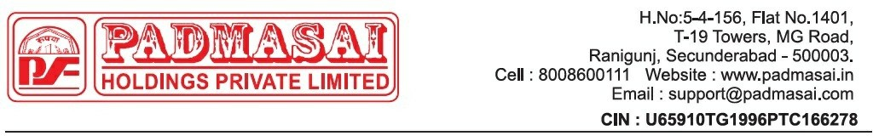
DUE NOTICE - LOAN RECALL NOTICE – PRE SEIZING NOTICE

Date: {{notice_date}}
To

{{borrower_name}} ,
H NO –{{borrower_address}}
Ph: {{borrower_name}}.

Subject: Notice of Arrears on Vehicle Loan – Request for Payment of Vehicle No: {{vehicle_no}} , Loan No:{{loan_account}}
Dear {{borrower_name}} ,
This notice is issued pursuant to the loan agreement executed between you and Wheels (Used) executed by Padma Sai Holdings Pvt Ltd. We wish to inform you that you are currently in arrears concerning the repayment of the loan amount extended under the referenced agreement.
The financier has extended a loan under the above-mentioned loan agreement. We regret to note that you are irregular in repayment of the dues.

Due installments | Rs. {{dues}}.00/-
Other expenses: | Rs. {{vas}}.00/-

*Kindly note that the above-mentioned amount pertains only to EMI dues. For details regarding the Total outstanding amount, kindly contact concerned zonal collection manager or visit our registered office.
*Kindly note per day default interest will be charged on daily basis till the date of receipt of full & final payment.

We hereby demand that you remit the total arrears amounting to total amount within seven (7) days from the date of this notice or we hereby inform you that the above loan facility granted to you can be recalled herewith and the entire loan amount with interest is immediately due and payable by you.

Failure to make payment within this timeframe will compel us to take necessary actions as per the terms of the loan agreement, including but not limited to, the repossession of the vehicle.

Please ensure that payments are made directly at the office of Padma Sai Holdings Pvt Ltd and obtain an acknowledgment receipt for the same or make a payment by using your loan account number via All UPI Mobile applications (Ex: PhonePe >> Loan Repayment option >> Padma Sai Finance Ltd >> Loan Account Number: {{loan_account}}) After making payments, please notify us at 8008600111.
Important Note: If an executive requests payment, make sure to get a receipt. If there's no receipt, do not proceed with the EMI payment. The receipt can be a WhatsApp screenshot or an SMS confirmation from PSH. Please be informed that no payments should be made to any individual executive's personal account. Management will not take responsibility for such payments.

For any clarifications or to resolve this matter promptly, you may contact our customer service at 8008600111 or visit the nearest branch at your earliest convenience. Please note that failure to address this notice may lead to serious legal consequences.

We urge you to treat this matter with the highest priority and look forward to your immediate compliance. Thanking You,
Padma Sai Holdings Private Limited
Note: This is a system generated letter. Hence, it does not require any signature or stamp.

