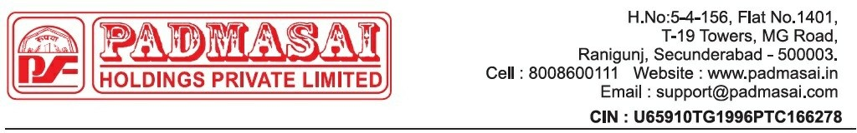

Post-Sale for Vehicle & Loss on Repo Notice

Date: {{date}}

To,

{{name}},
{{address}}
Ph: {{number}}.

Dear {{name}},

Subject: Post Sale and loss Repo Notice Regarding Sale of Vehicle Reg No: {{vehicle_no}}

This is a formal legal notice to provide you with a detailed summary of the sale of your vehicle, [{{company}} – {{class_name}} – {{year}}, {{vehicle_no}} ], following the repossession process due to your non-payment of the loan.

1. Background
As per the terms of the agreement signed by you, failure to make the scheduled payments constitutes a breach of the loan terms. Regrettably, as no payments were received despite multiple notices, we were compelled to repossess the vehicle {{vehicle_no}} in accordance with the agreement.
After providing you with a reasonable period to rectify the situation and with no resolution forthcoming, the vehicle was auctioned to recover the outstanding loan amount.

Details of Sale and Deductions

- Sale Price of the Vehicle
The vehicle was sold for [Sale Price: {{sale_price}} ].

Seizing Charges and Deductions
The following fees were deducted from the sale proceeds:
RepossessionFees: {{rep_fee}}
Yard Fees: {{yard_fee}} Auction Fees: {{auction_fee}}

Repairs/Preparation Costs (if applicable): {{repair_cost}}
Others: {{others}}

Total Deductions: {{total_deductions}}
- Remaining Balance After Sale: {{remaing_blc}}

Action Required

You are hereby instructed to clear the outstanding amount of {{final_amount}} within 7 days from the date of receipt of this notice.

Please ensure that payments are made directly at the office of Padma Sai Holdings Pvt Ltd and obtain an acknowledgment receipt for the same or make a payment by using your loan account number via All UPI Mobile applications (Ex: PhonePe >> Loan Repayment option >> Padma Sai Finance Ltd >> Loan Account Number: {{loan_no}}) After making payments, please notify us at 8008600111.

Important Note: If an executive requests payment, make sure to get a receipt. If there's no receipt, do not proceed with the EMI payment. The receipt can be a WhatsApp screenshot or an SMS confirmation from PSH. Please be informed that no payments should be made to any individual executive's personal account. Management will not take responsibility for such payments.

Failure to comply with this notice will compel us to initiate appropriate legal proceedings to recover the outstanding amount, including any additional legal expenses, interest, and costs incurred during the recovery process.

Thanking You,

Padma Sai Holdings Private Limited

Note: This is a system generated letter. Hence, it does not require any signature.

