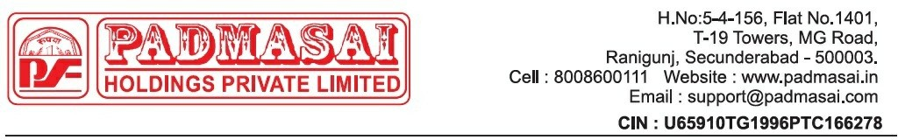

SEIZING AND PREAUCTION NOTICE
Date {{notice_date}}
To,

{{borrower_name}},

H.No:-{{borrower_address}}
Ph: {{borrower_mobile}}.

Subject: Pre-Auction Notice for Vehicle Repossession Details:
- Customer Name: {{borrower_mobile}},

Vehicle Number: {{vehicle_no}}
- Loan Number: {{loan_account}}
Dear {{borrower_name}},,
This notice is to formally inform you about the initiation of the pre-auction process for the vehicle associated with your loan account {{loan_account}}.
Despite our prior communications and attempts to reach a resolution, the outstandingbalance on your loan remains unpaid. Consequently, as per the terms stipulated, the vehicle has been seized due to non-payment, and we are proceedingwith the pre-auction process.
The scheduled to take place within in 30 days from the date of seizing. We strongly encourage you to contact our Collections Department immediately to discuss possible alternatives and settle the outstanding dues to prevent the auction process from movingforward.
Please note that this notice serves as a final opportunity to address the overdue amount and avoid the auction of your vehicle. We remain committed to assisting you in finding an amicable solution to resolve this matter promptly.
For any clarifications related to payment, you may contact our customer service at 8008600111 or visit the Head Office at your earliest convenience. Please note that failure to address this notice may lead to serious legal consequences
Please ensure that payments are made directly at the office of Padma Sai Holdings Private Limited and obtain an acknowledgment receipt for the same or make a payment by using your loan account number via All UPI Mobile applications (Ex: PhonePe >> Loan Repayment option >> Padma Sai Finance Ltd >> Loan Account Number: {{loan_account}}) After making payments, please notify us at 8008600111.
Important Note: If an executive requests payment, make sure to get a receipt. If there's no receipt, do not proceed with the EMI payment. The receipt can be a WhatsApp screenshot or an SMS confirmation from PSH. Please be informed that no payments should be made to any individual executive's personal account. Management will not take responsibility for such payments.

Thank you for your urgent attention to this matter. Sincerely,
Padma Sai Holdings Private Limited
Note: This is a system generated letter. Hence, it does not require any signature.

