**1. Git-HOL**

**2. Git-HOL**

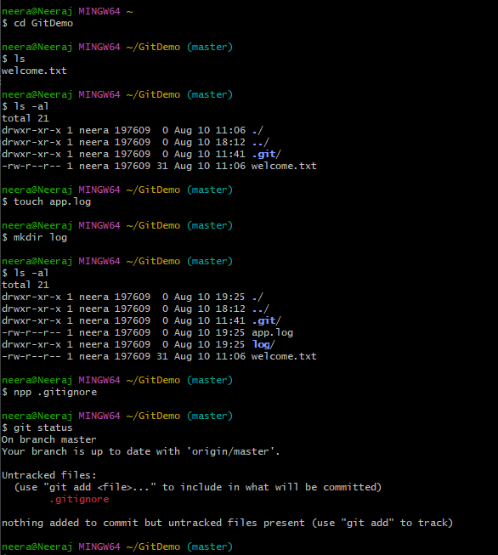

**3. Git-HOL**

Branching

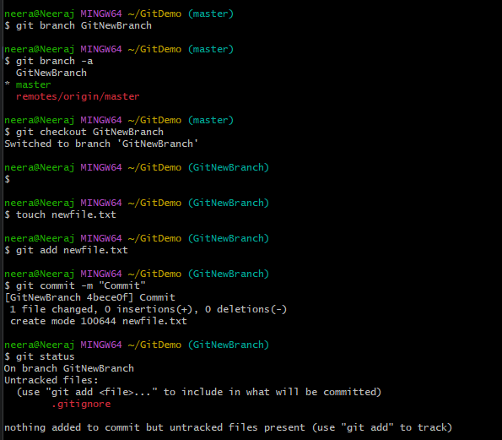

Merging

**4. Git-HOL**

