VPC – Virtual Private Cloud
Steps : first create the vpc -- cidr block – 10.0.0.0/16
Create the subnet public(10.0.1.0/24 = 256 ip’s) and private(10.0.2.0/24 = 256 ip)
Create the Internet gateway.
Create Routing table.

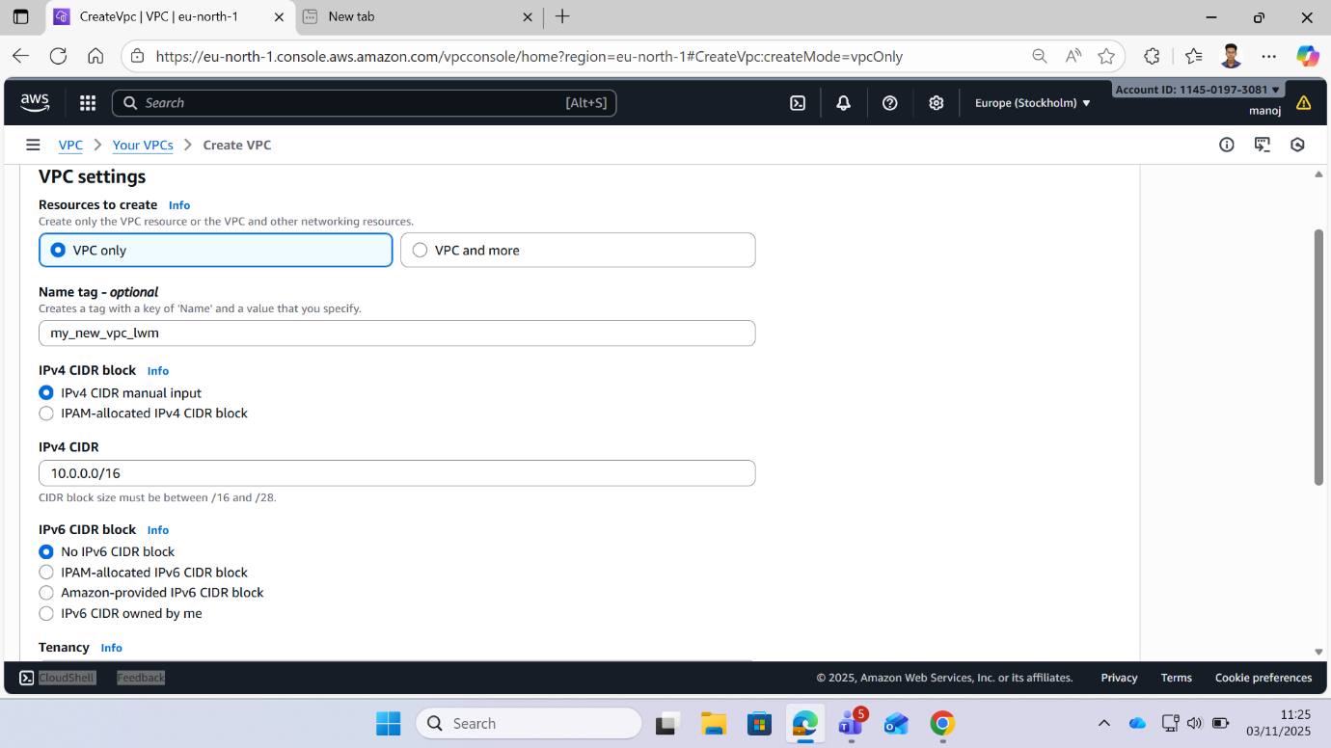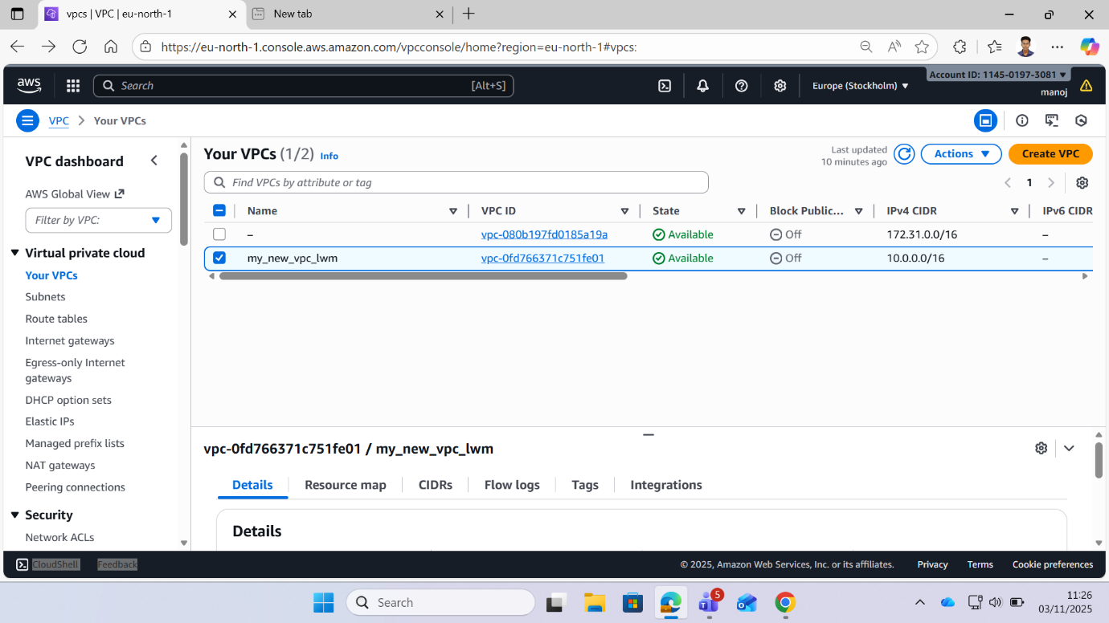

Subnets Creations
i)Public Subnet
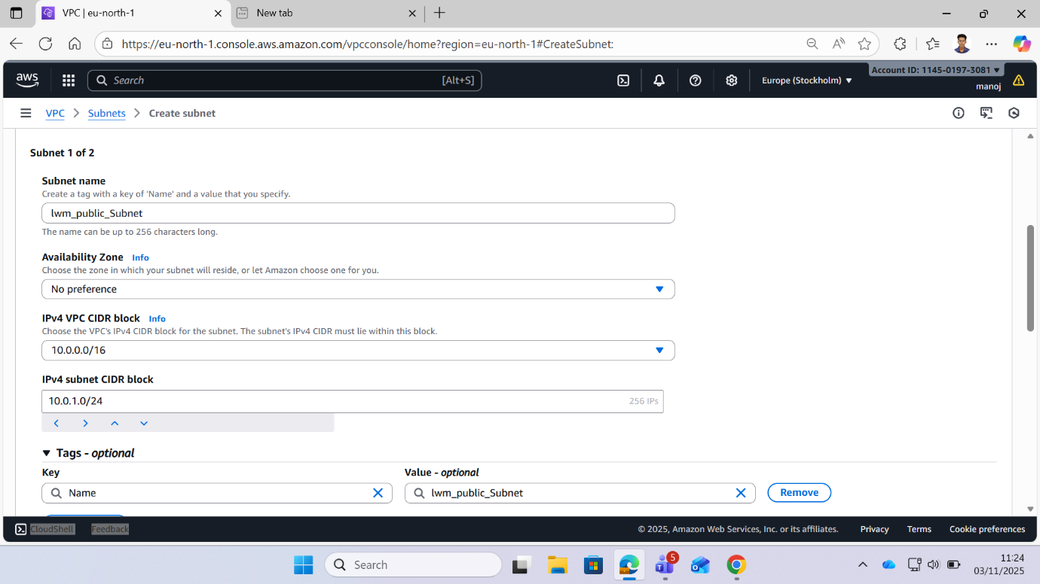

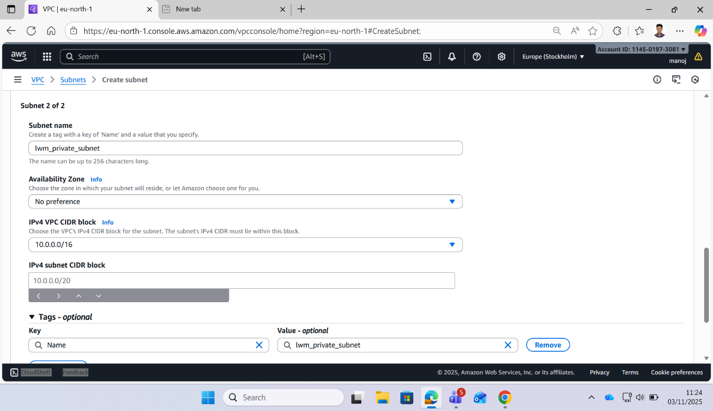
Private Subnet :

Internet Gateway :
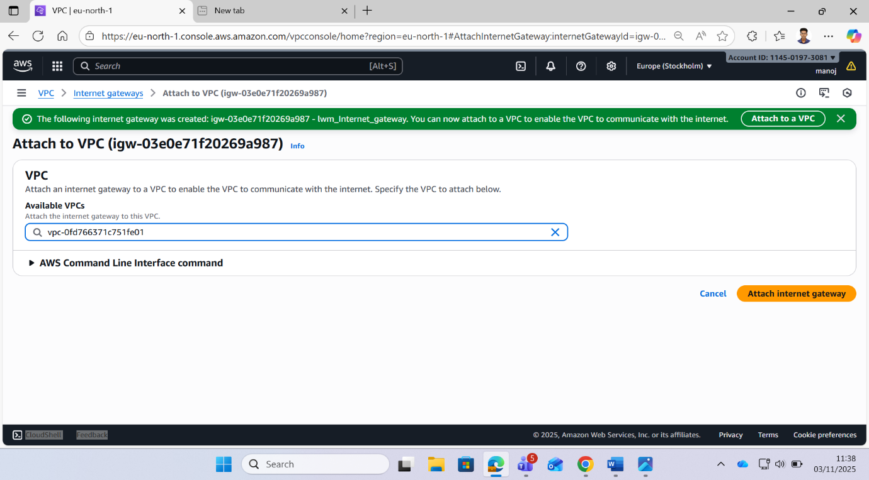
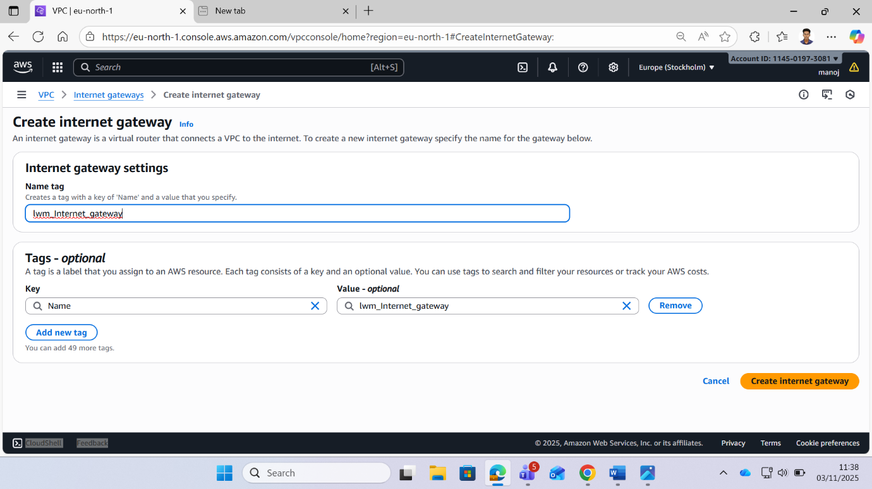
Attach to Vpc :

Public Route Table :
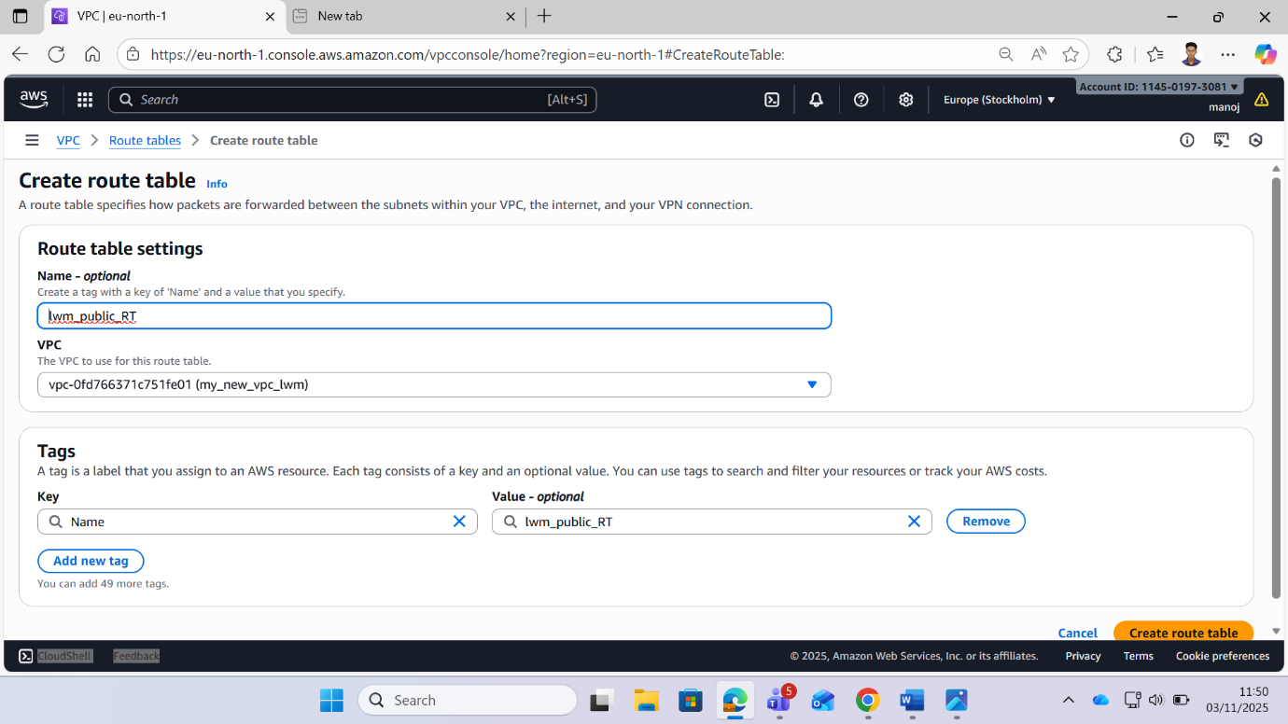

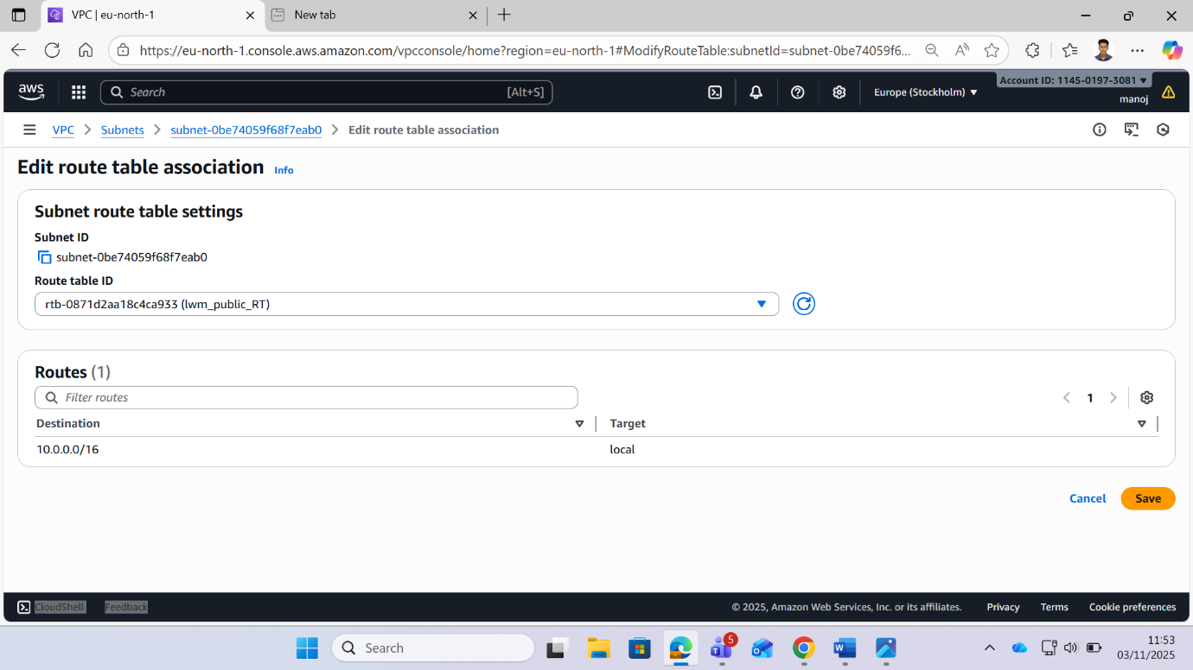

Attach public route tab to internet gateway:
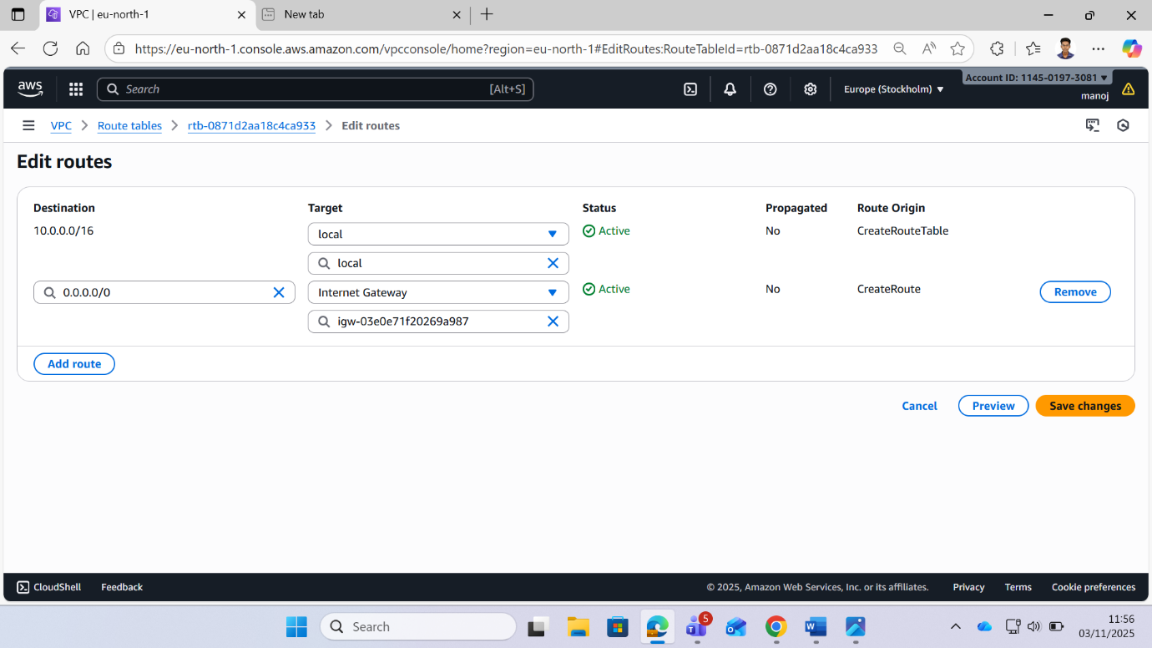

Create a Security grp enable rdc :
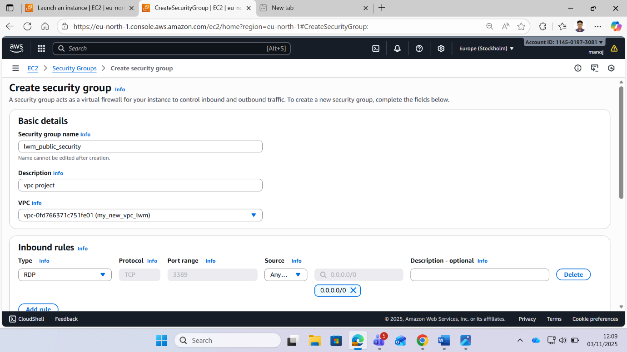
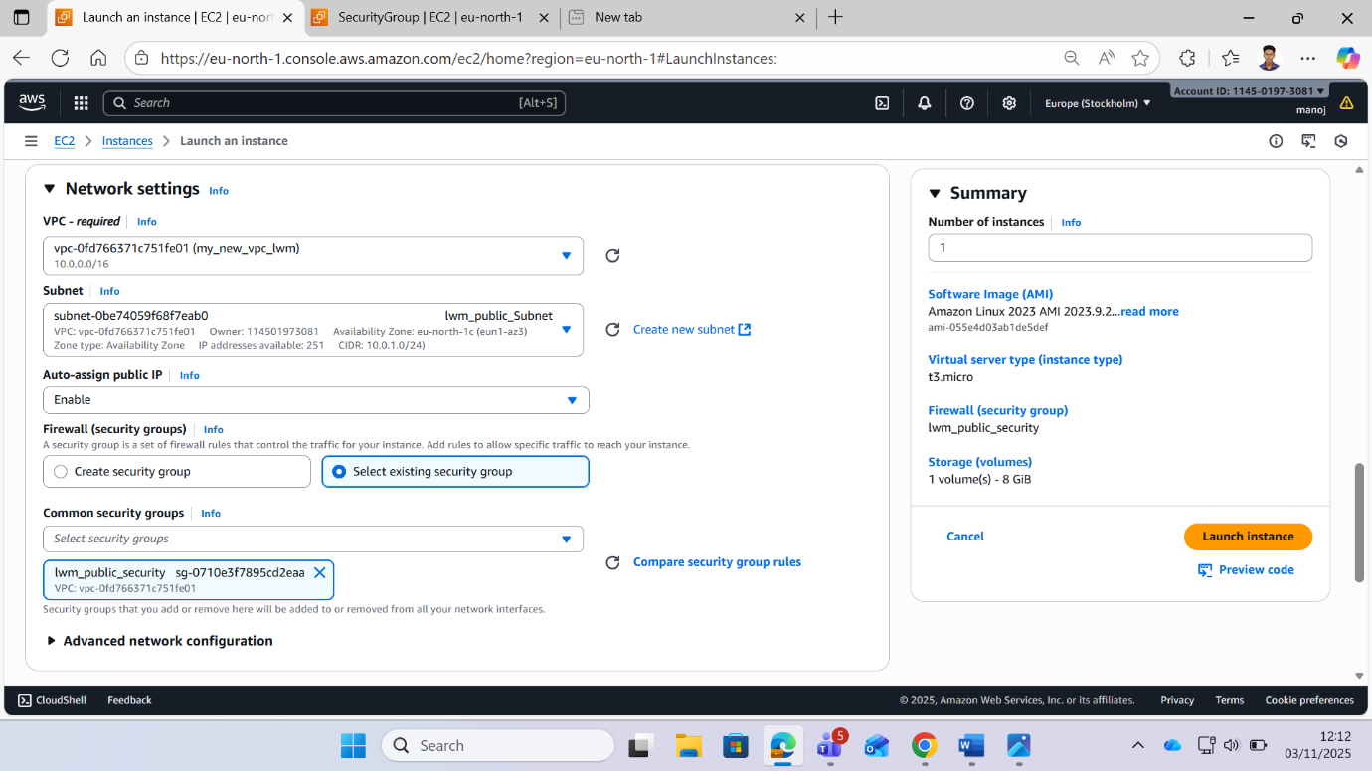
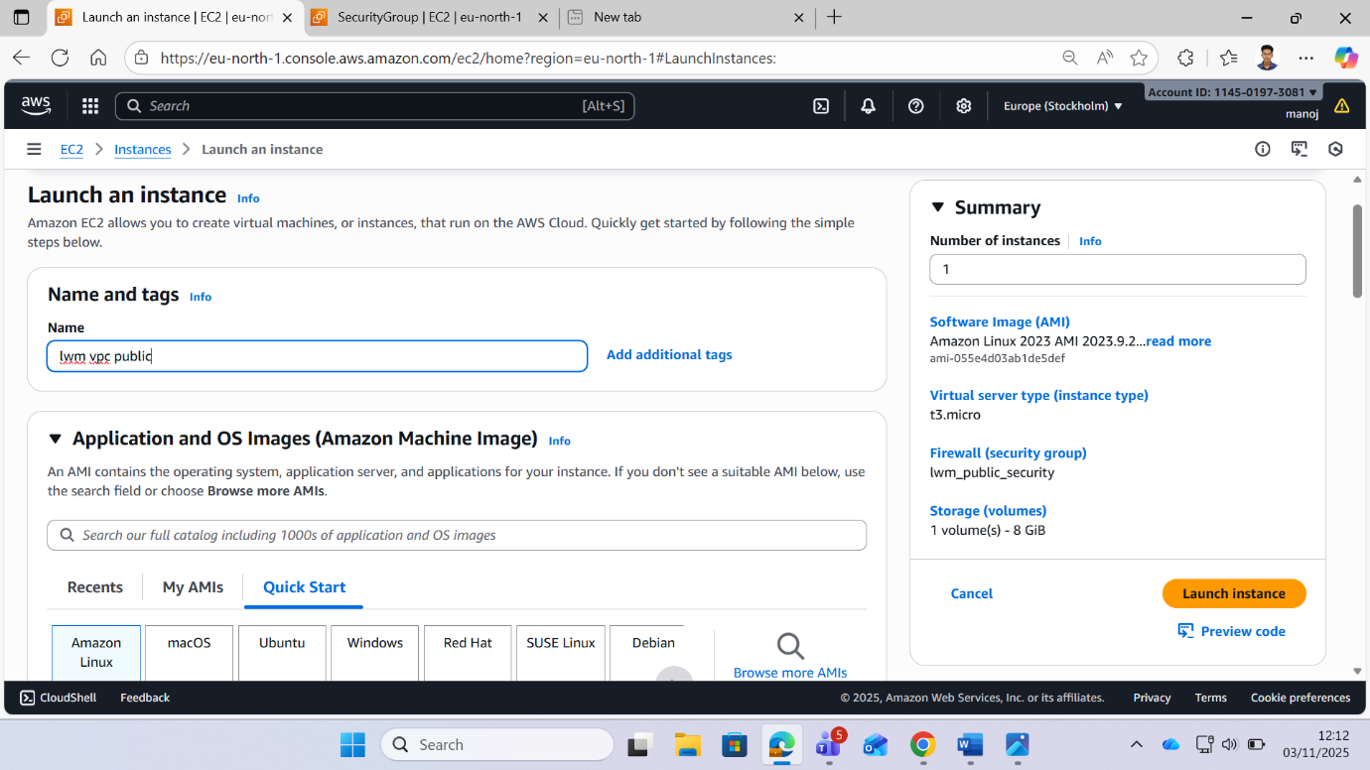

Check the internet Connectivity :
