## AUTOMATION OF DAILY STOCK MOVEMENTS

**WITH SELENIUM**

**A PROJECT REPORT**

***Submitted by***

## MANOJ G [REGISTER NO: 211418104147] MAHENDRA BABU R [REGISTER NO: 211418104208] KARTHIK GUPTHA K V [REGISTER NO: 211418104135]

***in partial fulfillment for the award of the degree***

***of***

**BACHELOR OF ENGINEERING**

***In***

**COMPUTER SCIENCE AND ENGINEERING**



**PANIMALAR ENGINEERING COLLEGE**

**(**An Autonomous Institution, Affiliated to Anna University, Chennai**) MAY 2022**

**PANIMALAR ENGINEERING COLLEGE**

**(**An Autonomous Institution, Affiliated to Anna University, Chennai**)**

**BONAFIDE CERTIFICATE**

Certified that this project report “Automation of Daily Stock Movements with Selenium” is the bonafide work of “MANOJ G, MAHENDRA BABU R, KARTHIK GUPTHA K V” who carried out the project work under my supervision.

**SIGNATURE SIGNATURE**

**Dr. S MURUGAVALLI,M.E, Ph.D Dr. S BALAJI,B.Tech,M.E,Ph.D HEAD OF THE DEPARTMENT ASSOCIATE PROFESSOR**

DEPARTMENT OF CSE, DEPARTMENT OF CSE,

PANIMALAR ENGINEERING COLLEGE, PANIMALAR ENGINEERING COLLEGE, NASARATHPETTAI, NASARATHPETTAI,

POONAMALLEE, POONAMALLEE,

CHENNAI-600 123. CHENNAI-600 123.

Certified that the above mentioned students were examined in End Semester project Viva-Voice held on........................…

**INTERNAL EXAMINER EXTERNAL EXAMINER**

**DECLARATION BY THE STUDENT**

We **MANOJ G [REGISTER NO: 211418104147], MAHENDRA BABU R [REGISTER NO: 211418104208], KARTHIK GUPTHA K V [REGISTER NO:**

**211418104135],** hereby declare that this project report titled “**Automation of Daily Stock Movements with Selenium**” , under the guidance of **Dr. S BALAJI** is the original work done by us and we have not plagiarized or submitted to any other degree in any university by us.

III

#### ACKNOWLEDGEMENT

We would like to express our deep gratitude to our respected Secretary and Correspondent **Dr.P.CHINNADURAI, M.A., Ph.D.** for his kind words and enthusiastic motivation, which inspired us a lot in completing this project.

We express our sincere thanks to our Directors **Tmt.C.VIJAYARAJESWARI**, **Dr.C.SAKTHI KUMAR,M.E.,Ph.D** and **Dr.SARANYASREE SAKTHI KUMAR**

**B.E.,M.B.A.,Ph.D.,** for providing us with the necessary facilities to undertake this project.

We also express our gratitude to our Principal **Dr.K.Mani, M.E., Ph.D.** who facilitated us in completing the project.

We thank the Head of the CSE Department, **Dr. S.MURUGAVALLI , M.E.,Ph.D.,**

for the support extended throughout the project.

We would like to thank our **Project Guide Dr. S BALAJI** and all the faculty members of the Department of CSE for their advice and encouragement for the successful completion of the project.

## MANOJ G MAHENDRA BABU R

**KARTHIK GUPTHA K V**

IV

**ABSTRACT**

In this project we attempt an automated approach for simplifying the process of stock value movements in order for the user to help cope with the ever-changing market of stocks and help keep track of multiple invested stocks with ease.

The Automation of Daily Stock Movements works on the concepts of selenium and web drivers. Here the stock values are sent to a per-loaded list of E-MAILS in an excel sheet. The stock price is scored from a government or widely recognized websites one such website being National Stock Exchange maintained and regulated by the Government of India and the values like Stock starting value, previous value, closing value are considered. The values are made into simpler and understandable tabular form. The client or the organization will get a table with the stock values taken from the National Stock Exchange (NSE). Thus, making a tedious and hectic process of crawling though web for every invested stock into a much simpler and manageable process.

V

## TABLE OF CONTENTS

|  |  |  |
| --- | --- | --- |
| **CHAPTER NO.** | **TITLE** | **PAGE NO.** |
|  | **ABSTRACT** | V |
|  | **LIST OF FIGURES** | VIII |
|  | **LIST OF ABBREVIATIONS** | IX |
| **1.** | **INTRODUCTION** |  |
|  | 1.1 General Profile | 1 |
|  | 1.2 Problem Definition | 3 |
| **2.** | **LITERATURE SURVEY** |  |
|  | 2.1 Introduction | 4 |
|  | 2.2 Purpose of Survey | 4 |
|  | 2.3 Scope of the Study | 5 |
|  | 2.4 Methodology | 5 |
|  | 2,5 Bibliography | 6 |
| **3.** | **SYSTEM ANALYSIS** |  |
|  | 3.1 Existing System | 9 |
|  | 3.2 Proposed system | 9 |
|  | 3.3 Feasibility Study | 10 |
|  | 3.4 Hardware Environment | 10 |
|  | 3.5 Software Environment | 11 |
| **4.** | **SYSTEM DESIGN** |  |
|  | 4.1. UML Diagrams | 12 |
|  | 4.2 ER Diagram | 21 |
| **5.** | **SYSTEM ARCHITECTURE** |  |
|  | 5.1 Overview | 23 |

|  |  |  |
| --- | --- | --- |
| **CHAPTER NO.** | **TITLE** | **PAGE NO.** |
|  | 5.2 Module Description | 24 |
| **6.** | **SYSTEM IMPLEMENTATION** |  |
|  | 6.1 Client-Code | 25 |
| **7.** | **SYSTEM TESTING / PERFORMANCE ANALYSIS** |  |
|  | 7.1 Unit Testing | 30 |
|  | 7.2 Integration Testing | 31 |
|  | 7.3 Test Cases & Reports | 32 |
| **8.** | **CONCLUSION** |  |
|  | 8.1 Results & Discussion | 34 |
|  | 8.2 Conclusion and Future Enhancements | 34 |
|  | **REFERENCES** | 35 |
|  | **APPENDICES** |  |
|  | A.1 Sample Screens | 37 |
|  | A.2 Publications | 38 |

VII

**LIST OF FIGURES**

|  |  |  |
| --- | --- | --- |
| **FIGURE NO** | **TITLE** | **PAGE NO** |
| 4.1 | Use Case Diagram | 14 |
| 4.2 | Sequence Diagram | 16 |
| 4.3 | Activity Diagram | 18 |
| 4.4 | Flow Chart | 20 |
| 4.5 | Entity Relationship Diagram | 22 |
| 5.1 | System Architecture  Overview | 23 |

VIII

**LIST OF ABBREVIATIONS**

**NSE** National Stock Exchange

**SMTP** Simple Mail Transfer Protocol

**ATS** Automated Trading System

IX

**CHAPTER 1**

**INTRODUCTION**

* 1. **General Profile**

The financial market is a dynamic and composite system where people can buy and sell currencies, stocks, equities and derivatives over virtual platforms supported by brokers. The stock market allows investors to own shares of public companies through trading either by exchange or over the counter markets. This market has given investors the chance of gaining money and having a prosperous life through investing small initial amounts of money, low risk compared to the risk of opening new business or the need of high salary career. Stock markets are affected by many factors causing the uncertainty and high volatility in the market. Although humans can take orders and submit them to the market, automated trading systems (ATS) that are operated by the implementation of computer programs can perform better and with higher momentum in submitting orders than any human. However, to evaluate and control the performance of ATS, the implementation of risk strategies and safety measures applied based on human judgments are required.

**INDIAN SCENARIO:**

The rapid spread of the unprecedented COVID‐19 pandemic has put the world in jeopardy and changed the global outlook unexpectedly. Initially, the SARS‐CoV‐2 virus, which caused the COVID‐19 outbreak triggered in Wuhan city, Hubei province of China in December 2019, and with time it spread all over the globe. This pandemic is not only a global health emergency but also a significant global economic downturn too. As many countries adopt strict quarantine policies to fight the unseen pandemic, their economic activities are suddenly shut down. Transports being limited and even restricted among countries have slowed down global economic activities. Most importantly, consumers and firms have prevented their usual consumption patterns due to the creation of panic among them and created market abnormality. Uncertainty and risk created due to this pandemic, causing significant economic impact all over the globe affecting both advanced and emerging economies such as the United States, Spain, Italy, Brazil, and India. In this context, the financial market has responded with dramatic movement and adversely affected. Economic turmoil associated with COVID‐19 has affected the financial market severely which includes both stock and bond markets. Due to this pandemic, there is a large fall in the price of oil and a large increase in the price of gold. Firzli (2020), refers to this pandemic as “the greater financial crisis.” In many countries, businesses are highly indebted, weak companies are further destabilized, and corporate debt stands at a very high level. The global financial market risk has increased substantially in response to the pandemic (Zhang et al., 2020). Investors are suffering sufficient losses due to fear and uncertainty. For example, due to the impact of this pandemic, the global stock market has struck out

about US$6 trillion in 1 week from 24 to 28 February (Ozili & Arun, 2020). The market value of standard & poor (S&P) 500 indexes declined to 30% since the COVID‐19 outbreak. According to Azimili (2020) increased uncertainty affects the required rate of return and thus the current market value of stocks.

Russia’s invasion of Ukraine has rattled markets around the world. Russia and Ukraine constitute less than 2% of global trade, but in many commodities, they have a sizable share — 37% of global palladium supply, 17% of natural gas, 13% of wheat, 12% of oil, and 9% of nickel is from the region. The barrage of sanctions imposed on Russia along with the supply chain inter linkages is bound to impact global trade and finance.

This steep fall in global economy comes unprecedented and, in any shareholder, would interest in a system they would update them with stock values at any given point in a day and this where this program comes into play.

## The Stock Market and Investment:

The research work done by Manh Ha Duong Boriss Siliverstovs. Investigating the relation between equity prices and aggregate investment in major European countries including France, Germany, Italy, the Netherlands and the United Kingdom. Increasing integration of European financial markets is likely to result in even stronger correlation between equity prices in different European countries. This process can also lead to convergence in economic development across European countries if developments in stock markets influence real economic components, such as investment and consumption. Indeed, our vector auto regressive models suggest that the positive correlation between changes equity prices and investment is, in general, significant. Hence, monetary authorities should monitor reactions of share prices to monetary policy and their effects on the business cycle.

## What is stock market volatility?

Stock market volatility is a measure of how much the stock market's overall value fluctuates up and down. Beyond the market as a whole, individual stocks can be considered volatile as well. More specifically, you can calculate volatility by looking at how much an asset's price varies from its average price. Standard deviation is the statistical measure commonly used to represent volatility.

Stock market volatility can pick up when external events create uncertainty. For example, while the major stock market typically don't move by more than 1% in a single day, those indices routinely rose and fell by more than 5% each day during the beginning of the COVID-19 pandemic. No one knew what was going to happen, and that uncertainty led to frantic buying and selling.

## Insights on Volatility:

Some stocks are more volatile than others. Shares of a blue chip company may not make very big price swings, while shares of a high flying tech stock may do so often. That blue-chip stock is considered to have low volatility, while the tech stock has high volatility. Medium volatility is somewhere in between. An individual stock can also become more volatile around key events like quarterly earnings reports.

Volatility is often associated with fear, which tends to rise during bear markets, stock market crashes, and other big downward moves. However, volatility doesn't measure direction. It's simply a measure of how big the price swings are. You can think of volatility as a measure of short-term uncertainty.

Historical volatility is a measure of how volatile an asset was in the past, while implied volatility is a metric that represents how volatile investors expect an asset to be in the future. Implied volatility can be calculated from the prices of pull and call options.

## Measuring stock market volatility:

For individual stocks, volatility is often encapsulated in a metric called beta.

Beta measures a stock's historical volatility relative to the **S&P 500 index**.

A beta of more than one indicates that a stock has historically moved more than the S&P 500. For example, a stock with a beta of 1.2 could be expected to rise by 1.2% on average if the S&P rises by 1%. On the other hand, a beta of less than one implies a stock that is less reactive to overall market moves. And, finally, a negative beta (which is quite rare) tells investors that a stock tends to move in the opposite direction from the S&P 500.

For the entire stock amrket, the Chicago Board Options Exchange (CBOE) Volatility Index, known as the VIX, is a measure of the expected volatility over the next 30 days. The number itself isn't terribly important, and the actual calculation of the VIX is quite complex. However, it's important for investors to know that the VIX is often referred to as the market's "fear gauge." If the VIX rises significantly, investors could be worried about massive stock price movements in the days and weeks ahead.

#### PROBLEM STATEMENT:

The stock market is influenced in many ways and there are various weak areas that are easily manipulated and this led to fluctuation in the stock movements which the investor may not be aware of or the investor may not take into consideration of

small changes that may be crucial in future. Many unethical practices prevalent in The weak areas in Indian stock markets in India are many more than what we have tried to briefly touch upon below. Many unethical practices are prevalent in Indian stock markets and are not uncommon even in far more complex markets of USA & Europe. Prices of shares are artificially increased by circular trading may change numerous times a day. These manipulations and changes if gone unnoticed or not intervened with might lead to losses. Stock values of a company may undergo various changes from the time stock market open till it closes in a single day. This depends on various factors like social, geopolitical, war, amongst many others. These may affect the stock value drastically and having to keep tabs on this various stock information might not be ideal for those who’ve invested in multiple companies and on their own clock.

Thus, to resolve this manual, time consuming process a system is developed to automate, scrape and mail the important stock information to the client or the said individual. This helps not only to reduce the time to go through the tedious process of opening a web-browser, visit the website on which stocks are monitored and search for the stock information on those the user is invested on, but also helps to keep track of important information of stocks on daily basis from the time market opens till it closes.

## CHAPTER 2

## LITERATURE SURVEY

* 1. **INTRODUCTION:**

We consider a financial market model with a large number of interacting agents. Investors are heterogeneous in their expectations about the future evolution of an asset price process. Their current expectation is based on the previous states of their “neighbors” and on a random signal about the “mood of the market.” But, having to manually search and analyze the data of stock market to the previous one and to keep tabs on the difference between for every investment is not an easy task to hand. We analyze the asymptotic of both previous prices and asset prices. We give sufficient information so as to keep track of all the important attributes of the stock and its related values. This helps an average user to reduce the time drag and effort to extract the information from stock monitoring websites and a literature has to be planned before the start of the project.

## PURPOSE OF THE LITERATURE SURVEY:

The literature review plays a very important role in the research process. It is a source from where research ideas are drawn and developed into concepts and finally theories. It also provides the researcher a bird’s eye view about the research done in that area so far. Depending on what is observed in the literature review, a researcher will understand where his/her research stands. Here in this literature survey, all primary, secondary and tertiary sources of information were searched.

The study of literature on “Automation of Daily Stock Movements with Selenium” in general and in the field of library and information science particularly revealed several efforts made by the scholars in different discipline. The purpose of the literature survey is to collect a plethora of journal’s article about stock movements and stock volatility on “Automation of Daily Stock Movements with Selenium” with abstract. The main aim of this collection is to provide a guideline and brief information of researcher, user and other individuals who want information about stock investments

1. know who writes, what and where about “Automation of Daily Stock Movements with Selenium”;
2. identify the tools and sources of “Automation of Daily Stock Movements with Selenium”, and
3. prepare the relevant bibliographic entries with abstract of the related topic.

## SCOPE OF THE STUDY:

The survey is a recognized and accepted part of the modern society. It is one of the means by which society keeps it informed, away of bringing under central situations of increasing size and complexity of obtaining perceptive and standard of com parison. A survey gives an oversight of a field and is thus distinguishing from a sort of study which consists of a microscopic examination of a turf ; it is a m ap rather than a detailed plan. The survey must be planned before a start is made.

The literature survey is confuted though an extensive period, the information is collected from various sources like the stock market database and other stock related articles and journals which is then analyzed to produce the desired results. And other databases are used to complete review of literature for the proposed study on stock market flow, including search on e-journals websites and other internet sources. In addition to above searches, bibliography of journal article are also reviewed for more sources as well as websites and consulted various report from eminent experts in the said field of study. This information is pooled tother so as to expedite the results and see through the stock fluctuations.

## METHODOLOGY:

For preparing of this literature survey following steps are taken to collect the articles about the stock market volatility and changes in the stock values. To begin with,

data collection started with us defining what the literature survey is and what are the steps involved for preparing it. We chose the domain and the topic “Stock market value fluctuation” for the base survey of the project. Polled by the collection of numerous articles from journals on the chosen topic. Then for further reference, electronic resources were consulted for collecting articles such as emerald, JCCC@UGC In fonet, Open-gate, Directory of Open Access Journals (DOAJ), etc. After the cross- referencing of the entries of the articles to the considered databases final report on the literature is produced.

## BIBLIOGRAPHY:

* 1. **: Stock Market Volatility.**

### Authors: LUIGI GUISO and TULLIO JAPPELLI

University of Sassari, Ente Luigi Einaudi for Monetary, Banking and Financial Studies, and CEPR; University of Salerno, CSEF, and CEPR

### Abstract:

The paper documents lack of awareness of financial assets in the 1995 and 1998 Bank of Italy Surveys of Household Income and Wealth. It then explores the determinants of awareness, and finds that the probability that survey respondents are aware of stocks, mutual funds and investment accounts is positively correlated with education, household resources, long-term bank relations and proxies for social interaction. Lack of financial awareness has important implications for understanding the stockholdings puzzle and for estimating stock market participation costs.

## : Stock markets and economic growth of India – a study on Impact of market capitalization on GDP

### Authors: M. Madhuri Devi and Anjali Hinduja

Dept. of Commerce, Bhilai Mahila Mahavidyalaya, Bhilai, CG, India Pt.Ravishankar Shukla University.

Abstract:

The two-fold policies of Indian economic system i.e., fiscal and monetary policy has been resulted into the efficient survival of economy of India after the inheritance of almost NEP (liberalization, privatization and globalization) later on. Stock market is the mostpromising sector for raising the financial system of the Indian economy.

After the phase of liberal competing with the economies of foreign countries. After the commencement of the stock market in the year 1875, contributed significantly towards strengthening of the economy by proving as an investor.

## : Automation of Stock Management Process.

Authors: KATENDE KENNETH KIDONGE

B.COM (DR.B.R Ambedkar University, Agra, India)

Department of Computer Science, Faculty of Computing and Information Technology.

Abstract:

Stock management is one aspect of business that enhances a company is business performance so as to reap big from the business venture being undertaken. Victoria Ins glass Ltd use a manual inventory record systems which have inconsistencies like entering products onto stock cards, increase in volumes of stationery, making it hard for the workers to identify stock cards in time.

## : What Triggers Stock Market Jumps?

Authors: Scott R. Baker, Nicholas Bloom, Steven J. Davis & Marco C.

Sammon

Abstract:

We examine next-day newspaper accounts of large daily jumps in 16 national stock markets to assess their proximate cause, clarity as to cause, and the geographic source of the market-moving news. Our sample of 6,200 market jumps yields several findings. First, policy news – mainly associated with monetary policy and government spending – triggers a greater share of upward than downward jumps in all countries. Second, the policy share of upward jumps is inversely related to stock market performance in the preceding three months. This pattern strengthens in the postwar period. Third, market volatility is much lower after jumps triggered by monetary policy news than after other jumps, unconditionally and conditional on past volatility and other controls. Fourth, greater clarity as to jump reason also foreshadows lower volatility. Clarity in this sense has trended upwards over the past century. Finally, and excluding U.S. jumps, leading newspapers attribute one-third of jumps in their own national stock markets to developments that originate in or relate to the United States. The U.S. role in this regard dwarfs that of Europe and China.

## CHAPTER 3

## SYSTEM ANALYSIS:

* 1. **Existing System:**

This project provides an example of how you can utilize this program to save time in your analysis process. Since the “analysis process” is different for every investor, we won’t spend too much time focusing on my analysis here.

The on-balance volume technical indicator that we are calculating in my analysis is used to relate the volume and price of a stock. It is a relatively simple calculation. First, you decide the amount of time that you want to observe the stock. I chose to look at the last ten days of data for each stock. If the day’s opening price for a company is higher than its closing price it will add the day’s volume to the total. If it’s less, the volume is subtracted from the total. By the end of the ten days, you have a picture of each stocks cumulative volume.

In order to better compare each stock, we are also normalizing the volume before adding or subtracting it. The last step in this process is to create a CSV of all of the stocks ranked by their OBV value. This is important, as it is the information that is included in the report to be emailed every morning.

There are various types analysis that are currently in use with most of the industry and those are wither paid for or used for advertisement purposes. They evaluate recent trading movements and trends to attempt to determine what’s next for a company’s stock price. Generally, technical analysts pay less attention to the fundamentals underlying the stock price. Technical analysts rely on stock charts to make their assessment of a company’s stock price. For example, technicians may look for a support level and resistance level when assessing a stock’s next move. A support level is a price level at which the stock might find support and below which it may not fall. In contrast, a resistance level is a price at which the stock might find pressure and above which it may not rise.

## Proposed System:

Compared to the existing project we did a lot of changes in this current project. In our project, we will analysis the company stock website and scrapping the values. Not only one company like that how many companies you want we can do that. After getting the data the information that is included in the report is to be emailed every morning or any particular time.

In the existing project, it will analyze the ranking of the company .it will consider only volume price value for ranking. here we are getting closed price value, Buy Quantity, Sell Quantity, Previous Close, Open Price, Change value, and along with the calculation of volume price

This system or program is designed in such a way as to link the user need into the bulk of the system and provide with the needed details of a complex stock market into a simple and constant flow of information to the necessary users on daily basis.

A system is developed to automate, scrape and mail the important stock information to the client or the said individual. This helps not only to reduce the time to go through the tedious process of opening a web-browser, visit the website on which stocks are monitored and search for the stock information on those the user is invested on, but also helps to keep track of important information of stocks on daily basis from the time market opens till it closes.

## Feasibility Study:

* + - Python being one of the best and easily understandable language is used here so as to help both the team and the future users to easily manipulate and customize the code to ones own utility.
    - Selenium as a framework helps integrate perfectly with python and work flawlessly in scraping and producing desired output.
    - The entire project is processed keeping in mind on current and future requirements and allowing it to be FOSS from the ground.

## Hardware Environment:

This project can run on commodity hardware. We ran the entire project on an Intel I5, Ram 8GB, 4GB NVIDIA Graphic Card. It also has cores which run at 1.7 GHz and 2.1 GHz respectively. The code may take a minute or two in the beginning to process the location of the web-drivers and other libraries, but the second time code will require some seconds for it to process and structure the data into the table.

|  |  |  |
| --- | --- | --- |
| * RAM | :: | 4 GB |
| * Storage | :: | 256GB |
| * CPU | :: | 1.7 GHz or Faster |
| * Architecture | :: | 32-bit or 64-bit |

## Software Environment:

* Python 3.5 in PyCharm or any other supported IDE enable to process and import all the required libraries.
* Operating System : Windows 10 or Higher, Linux and MacOS

## CHAPTER 4

**SYSTEM DESIGN**

**4.1 UML Diagrams**

A UML diagram is a partial graphical representation (view) of a model of a system under design, implementation, or already in existence. UML diagram contains graphical elements (symbols) - UML nodes connected with edges (also known as paths or flows) - that represent elements in the UML model of the designed system. The UML model of the system might also contain other documentation such as use cases written as templated texts.

The kind of the diagram is defined by the primary graphical symbols shown on the diagram. For example, a diagram where the primary symbols in the contents area are classes is class diagram. A diagram which shows use cases and actors is use case diagram. A sequence diagram shows sequence of message exchanges between lifelines.

UML specification does not preclude mixing of different kinds of diagrams, e.g. to combine structural and behavioral elements to show a state machine nested inside a use case. Consequently, the boundaries between the various kinds of diagrams are not strictly enforced. At the same time, some UML Tools do restrict set of available graphical elements which could be used when working on specific type of diagram.

UML specification defines two major kinds of UML diagram: structure diagrams and behavior diagrams.

Structure diagrams show the static structure of the system and its parts on different abstraction and implementation levels and how they are related to each other. The elements in a structure diagram represent the meaningful concepts of a system, and may include abstract, real world and implementation concepts.

Behavior diagrams show the dynamic behavior of the objects in a system, which can be described as a series of changes to the system over time.

## Use Case Diagram:

In the Unified Modelling Language (UML), a use case diagram can summarize the details of your system's users (also known as actors) and their interactions with the system. To build one, you'll use a set of specialized symbols and connectors. An effective use case diagram can help your team discuss and represent:

* Scenarios in which your system or application interacts with people, organizations, or external systems.
* Goals that your system or application helps those entities (known as actors) achieve.
* The scope of proposed system.

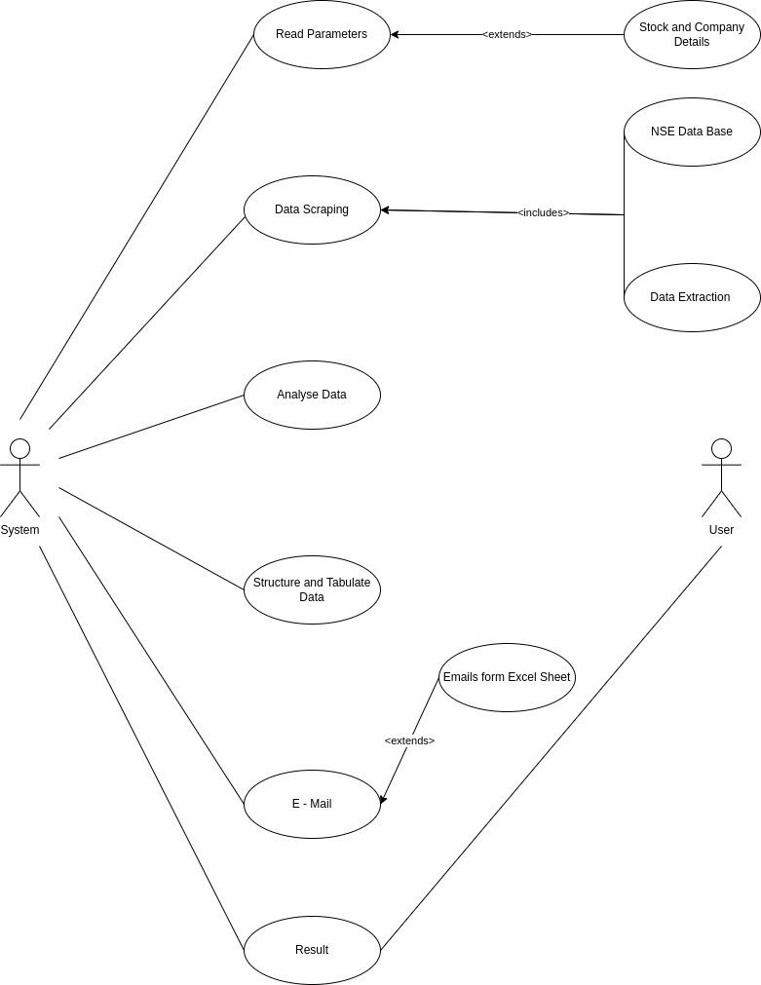

**Figure : 4.1** Use Case Diagram for proposed system

## Sequence Diagram

A sequence diagram is a type of interaction diagram because it describes how and in what order a group of objects works together. These diagrams are used by software developers and business professionals to understand requirements for a new system or to document an existing process. Sequence diagrams are sometimes known as event diagrams or event scenarios.

Sequence diagrams can be useful references for businesses and other organizations. Try drawing a sequence diagram to:

* Represent the details of a UML use case.
* Model the logic of a sophisticated procedure, function, or operation.
* See how objects and components interact with each other to complete a process.
* Plan and understand the detailed functionality of an existing or future scenario.

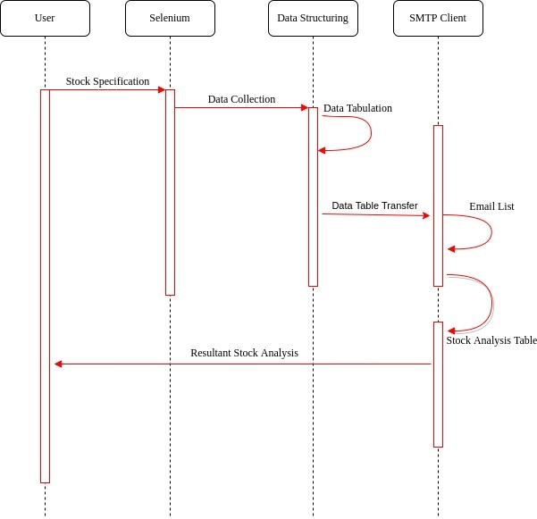

**Figure 4.2** Sequence Diagram of The Automated System

## Activity Diagram

We describe or depict what causes a particular event using an activity diagram. UML models basically three types of diagrams, namely, structure diagrams, interaction diagrams, and behavior diagrams.An activity diagram is a behavioral diagram i.e. it depicts the behavior of a system. An activity diagram portrays the control flow from a start point to a finish point showing the various decision paths that exist while the activity is being executed. They are used in business and process modelling where their primary use is to depict the dynamic aspects of a system.

It is also suitable for modeling how a collection of use cases coordinate to represent business workflows.

* + - Identify candidate use cases, through the examination of business workflows
    - Identify pre- and post-conditions (the context) for use cases
    - Model workflows between/within use cases
    - Model complex workflows in operations on objects
    - Model in detail complex activities in a high level activity Diagram

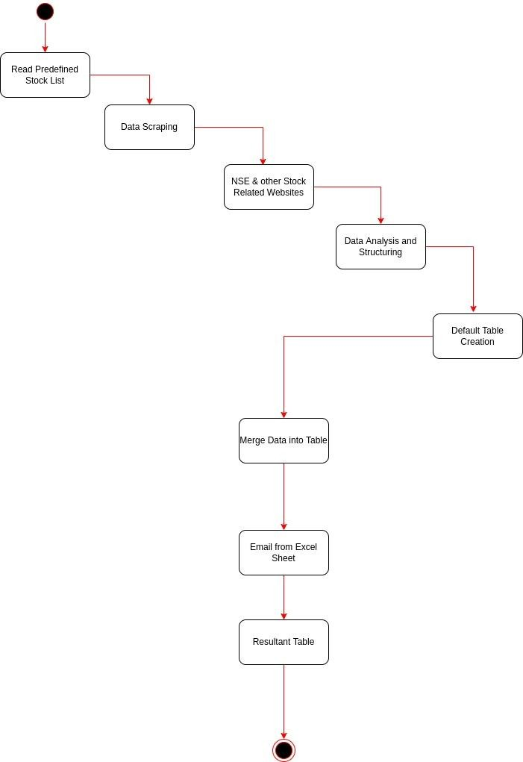

**Figure 4.3** Activity Diagram

## Flow Chart

A flowchart is a type of diagram that represents a workflow or process. A flowchart can also be defined as a diagrammatic representation of an algorithm, a step- by-step approach to solving a task. The flowchart shows the steps as boxes of various kinds, and their order by connecting the boxes with arrows. A flowchart is a diagram that depicts a process, system or computer algorithm. They are widely used in multiple fields to document, study, plan, improve and communicate often complex processes in clear, easy-to-understand diagrams. Flowcharts, sometimes spelled as flow charts, use rectangles, ovals, diamonds and potentially numerous other shapes to define the type of step, along with connecting arrows to define flow and sequence.

Beyond computer programming, flowcharts have many uses in many diverse fields. In any field:

* Document and analyze a process.
* Standardize a process for efficiency and quality.
* Communicate a process for training or understanding by other parts of the organization.
* Identify bottlenecks, redundancies and unnecessary steps in a process and improve it.

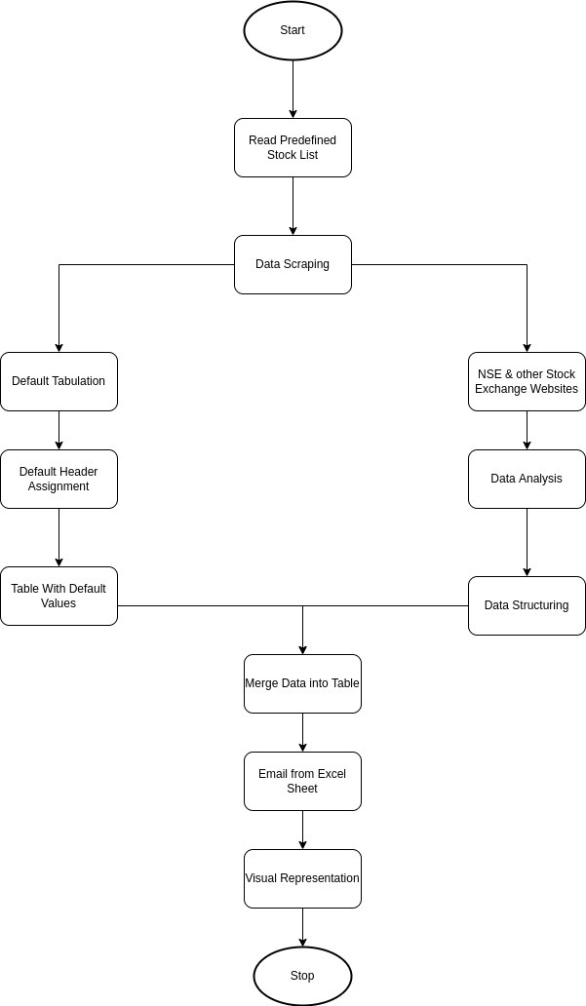

**Figure 4.4** Flow Chart

## 4.2 Entity Relationship Diagram

An Entity Relationship (ER) Diagram is a type of flowchart that illustrates how “entities” such as people, objects or concepts relate to each other within a system. ER Diagrams are most often used to design or debug relational databases in numerous fields.

ER Models use a defined set of symbols such ass rectangles, diamonds, ovals and connecting lines to depict the inter-connectedness of entities, relationships and their attributes.

They mirror grammatical structure, with entities as nouns and relationships as

verbs.

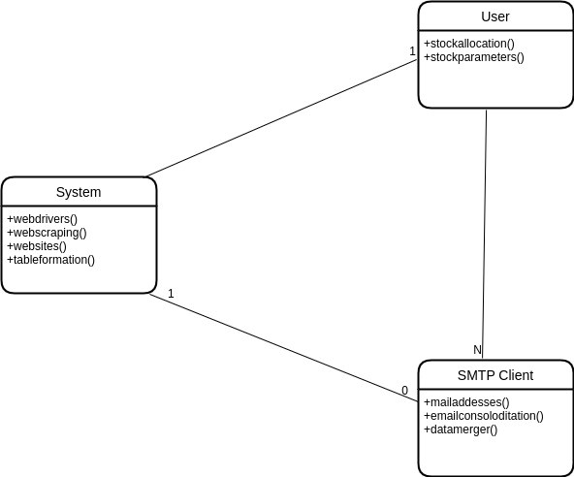

### **Figure 4.5** Relationship among various datasets of the system

**CHAPTER 5**

**SYSTEM ARCHITECTURE**

* 1. **System Architecture Overview:**

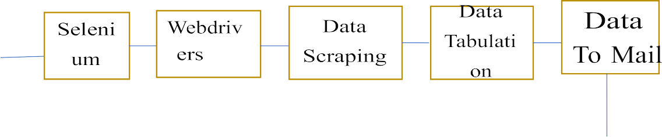

**Figure 5.1** System Architecture

## Description

**Python:**

Python is a computer programming language often used to build websites and software, automate tasks, and conduct data analysis. Python is a general-purpose language, meaning it can be used to create a variety of different programs and isn’t specialized for any specific problems. This versatility, along with its beginner friendliness, has made it one of the most-used programming languages today. A survey conducted by industry analyst firm Red Monk found that it was the second most popular programming language among developers in 2021.

In this project the core of the program is done with Python programming language.

## Selenium :

It is used to control web browsers and perform browser automation.

## Web drivers:

This Selenium Web Driver tool is used to automating web application testing to verify that it works as expected. It supports many browsers such as Firefox, Chrome, IE, and Safari.

## Data scrapping:

Web Scraping is the process of automatically downloading data displayed by websites to your computer or database. A Web Scraping Software can crawl multiple pages within a website and automate the tedious task of manually copying and pasting the data displayed. The data is usually downloaded in a spreadsheet (tabular) format. In this we will scrap the required data from the website that should be sent to mails. Ex: buy quantity, total, sell quantity, previous close, open price, change.

## Data Format using HTML:

In this step using HTML we will write a piece of code for data that was scrapped in the previous step. The data will be sent to mails in tabular form.

## Reading E-Mail ID’s:

Here in this step using pandas we will get the required mail ids from DataBase to which the above date should be sent.

## Sending Mails:

The above data will be mailed to mentioned email ids present in the database.

## Mail Sent:

The mails with the processed data have been sent successfully.

# CHAPTER 6

**6.1 Client-Side Code:**

from selenium import webdriver import datetime

import math import time import smtplib

import pandas as pd

from email.mime.multipart import MIMEMultipart # sending email from email.mime.text import MIMEText # constructing messages from email.mime.base import MIMEBase

from email import encoders

today_run_date= datetime.datetime.now().strftime("%d-%m-%Y") print("today date is",str(today_run_date)) pre_open="pre_open_market"

driver =

webdriver.Chrome(executable_path="C:\\Users\\91703\\Desktop\\driver\\chromedriv er.exe")

driver.implicitly_wait(5)

driver.get("https://[www.nseindia.com/get-quotes/equity?symbol=QUESS#info-](http://www.nseindia.com/get-quotes/equity?symbol=QUESS&info-) preopenmkt")

driver.implicitly_wait(10) driver.maximize_window() time.sleep(15)

PREV_CLOSE_QUESS =

driver.find_element_by_xpath('//*[@id="priceInfoTable"]/tbody/tr/td[1]').text driver.implicitly_wait(5)

print("PREV CLOSE VALUE of quess==",PREV_CLOSE_QUESS.replace(",",""))

OPEN_VALUE_QUESS =

driver.find_element_by_xpath('//*[@id="priceInfoTable"]/tbody/tr/td[2]').text driver.implicitly_wait(5)

print("OPEN PRICE VALUE of quess==",OPEN_VALUE_QUESS.replace(",","")) BUY_QTY_QUESS =

driver.find_element_by_xpath('//*[@id="preOpenAto"]/tbody/tr[2]/td[1]').text driver.implicitly_wait(5)

print("buy qty price of quess==",BUY_QTY_QUESS.replace(",",""))

SELL_QTY_QUESS =

driver.find_element_by_xpath('//*[@id="preOpenAto"]/tbody/tr[2]/td[3]').text driver.implicitly_wait(5)

print("sell qty value of quess==",SELL_QTY_QUESS.replace(",",""))

Percentage_Change_Quess =((float(OPEN_VALUE_QUESS.replace(",",""))- float(PREV_CLOSE_QUESS.replace(",","")))/float(PREV_CLOSE_QUESS.replace (",","")))*100

pquess=float(Percentage_Change_Quess) qqq="{0:.2f}".format(pquess)

print(qqq) time.sleep(10) driver.close()

driver =

webdriver.Chrome(executable_path="C:\\Users\\91703\\Desktop\\driver\\chromedriv er.exe")

driver.implicitly_wait(5)

driver.get("https://[www.nseindia.com/get-](http://www.nseindia.com/get-) quotes/equity?symbol=TEAMLEASE#info-preopenmkt") driver.maximize_window()

time.sleep(15)

PREV_CLOSE_TEAM =

driver.find_element_by_xpath('//*[@id="priceInfoTable"]/tbody/tr/td[1]').text driver.implicitly_wait(5)

print("PREV CLOSE VALUE of team is",PREV_CLOSE_TEAM.replace(",",""))

OPEN_VALUE_TEAM =

driver.find_element_by_xpath('//*[@id="priceInfoTable"]/tbody/tr/td[2]').text driver.implicitly_wait(5)

print("open value of team",OPEN_VALUE_TEAM.replace(",","")) BUY_QTY_TEAM =

driver.find_element_by_xpath('//*[@id="preOpenAto"]/tbody/tr[2]/td[1]').text driver.implicitly_wait(6)

print("buy qty team is",BUY_QTY_TEAM.replace(",",""))

SELL_QTY_TEAM =

driver.find_element_by_xpath('//*[@id="preOpenAto"]/tbody/tr[2]/td[3]').text driver.implicitly_wait(5)

print("sell qty team is",SELL_QTY_TEAM.replace(",",""))

Percentage_Change_team =((float(OPEN_VALUE_TEAM.replace(",",""))- float(PREV_CLOSE_TEAM.replace(",","")))/float(PREV_CLOSE_TEAM.replace("

,","")))*100

pteam=float(Percentage_Change_team) ttt="{0:.2f}".format(pteam)

print(ttt) time.sleep(10) driver.close()

driver =

webdriver.Chrome(executable_path="C:\\Users\\91703\\Desktop\\driver\\chromedriv er.exe")

driver.implicitly_wait(5)

driver.get("https://[www.nseindia.com/get-quotes/equity?symbol=SIS#info-](http://www.nseindia.com/get-quotes/equity?symbol=SIS&info-) preopenmkt")

driver.implicitly_wait(5) driver.maximize_window() time.sleep(15)

PREV_CLOSE_sis =

driver.find_element_by_xpath('//*[@id="priceInfoTable"]/tbody/tr/td[1]').text driver.implicitly_wait(5)

print("PREV CLOSE VALUE of sis is",PREV_CLOSE_sis.replace(",",""))

OPEN_VALUE_sis =

driver.find_element_by_xpath('//*[@id="priceInfoTable"]/tbody/tr/td[2]').text driver.implicitly_wait(5)

print("open value of sis",OPEN_VALUE_sis.replace(",",""))

BUY_QTY_sis =

driver.find_element_by_xpath('//*[@id="preOpenAto"]/tbody/tr[2]/td[1]').text driver.implicitly_wait(10)

print("buy qty sis is",BUY_QTY_sis.replace(",",""))

SELL_QTY_sis =

driver.find_element_by_xpath('//*[@id="preOpenAto"]/tbody/tr[2]/td[3]').text driver.implicitly_wait(5)

print("sell qty sis is",SELL_QTY_sis.replace(",",""))

Percentage_Change_sis =((float(OPEN_VALUE_sis.replace(",",""))- float(PREV_CLOSE_sis.replace(",","")))/float(PREV_CLOSE_sis.replace(",","")))*1 00

pteam=float(Percentage_Change_sis) sss="{0:.2f}".format(pteam) print(sss)

driver.close()

file_path = open("C:\\Users\\91703\\Desktop\\hold\\dashboard_template.txt") data=file_path.read()

print(data)

def substitute(key,value):

return data.replace(key,str(value))

def replace_cal_values(key,value): switcher={

'(?buy_quant_quess)':substitute(key,value), '(?sell_quantity_quess)':substitute(key,value), '(?previous_close_quess)':substitute(key,value), '(?open_price_quess)':substitute(key,value), '(?precentage_change_quess)':substitute(key,value), '(?buy_quant_teamlease)':substitute(key,value), '(?sell_quantity_teamlease)':substitute(key,value), '(?previous_close_teamlease)':substitute(key,value), '(?open_price_teamlease)':substitute(key,value), '(?precentage_change_teamlease)':substitute(key,value), '(?buy_quant_sis)':substitute(key,value), '(?sell_quantity_sis)':substitute(key,value), '(?previous_close_sis)':substitute(key,value), '(?open_price_sis)':substitute(key,value), '(?precentage_change_sis)':substitute(key,value), '(?todays_date)':substitute(key,value), '(?process_details)':substitute(key,value),

}

return switcher.get(key,"nothing")

data=replace_cal_values("(?buy_quant_quess)",BUY_QTY_QUESS) data=replace_cal_values("(?previous_close_quess)",PREV_CLOSE_QUESS) data=replace_cal_values("(?open_price_quess)",OPEN_VALUE_QUESS) data=replace_cal_values("(?sell_quantity_quess)",SELL_QTY_QUESS) data=replace_cal_values("(?precentage_change_quess)",qqq) data=replace_cal_values("(?previous_close_teamlease)",PREV_CLOSE_TEAM) data=replace_cal_values("(?open_price_teamlease)",OPEN_VALUE_TEAM) data=replace_cal_values("(?buy_quant_teamlease)",BUY_QTY_TEAM) data=replace_cal_values("(?sell_quantity_teamlease)",SELL_QTY_TEAM) data=replace_cal_values("(?precentage_change_teamlease)",ttt) data=replace_cal_values("(?previous_close_sis)",PREV_CLOSE_sis) data=replace_cal_values("(?open_price_sis)",OPEN_VALUE_sis)

data=replace_cal_values("(?buy_quant_sis)",BUY_QTY_sis) data=replace_cal_values("(?sell_quantity_sis)",SELL_QTY_sis) data=replace_cal_values("(?precentage_change_sis)",sss) data=replace_cal_values("(?todays_date)",today_run_date) data=replace_cal_values("(?process_details)",pre_open)

print(data)

msg = MIMEMultipart() html = data

subject = 'Pre - OpenMarket Details' sender = 'mahinaidu141@gmail.com' recipients = []

ex=pd.read_csv("C:\\Users\\91703\\Downloads\\mails.csv") head=ex.columns

for i,row in ex.iterrows(): for j in head:

recipients.append(row[j])

recipientscc = ['mahinaidu141@gmail.com'] BCC = []

msg['Subject'] = subject msg['From'] = sender msg['To'] = ", ".join(recipients)

msg['Cc'] = ", ".join(recipientscc)

# msg['Bcc'] = ", ".join(BCC)44444

# part1 = MIMEText(mailBody, 'plain') part2 = MIMEText(html, 'html')

# msg.attach(part1) msg.attach(part2)

s = smtplib.SMTP('smtp.office365.com', 587) s.starttls()

s.login(sender, "Mahi141@") recipients.extend(recipientscc) recipients.extend(BCC) s.sendmail(sender,recipients,msg.as_string()) print("Mail Sent")

s.quit()

# CHAPTER 7

* 1. **Unit Testing**

The first module of the program with the details of one company is tested and the resultant test case company data as non-tabulated but processed is shown in the console with no bugs or errors. The company that is considered have lesser number of stocks so as to ease the system to find and assess the data correctly.

The same is done for various companies with a wide range of stocks to test the core module of the program.

The resultant data is as below shown:

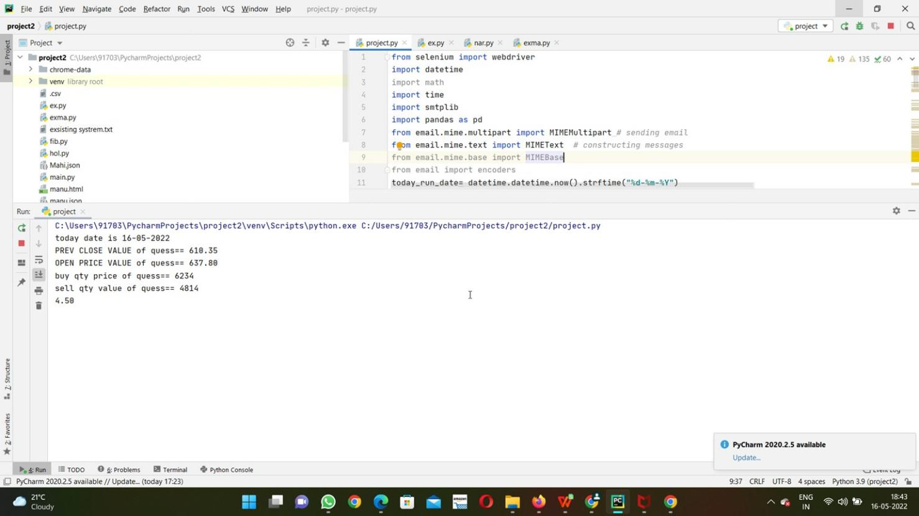

**Figure 7.1** Module1 Output

## Integrated Testing

This module of testing focuses on the major part of the system to work on major companies i.e., companies with huge number of stocks and are in a constant state of flux throughout the day from opening of the stock market till it closes down.

Here all the companies are combined from the above module to test the integrity of the program.

The module executed with no errors but took a minute to process the data from source. The data is then sent to tabulation but here for the sake of testing the processed data is shown in raw format.

Below is the reference for the non-tabulated processed data:

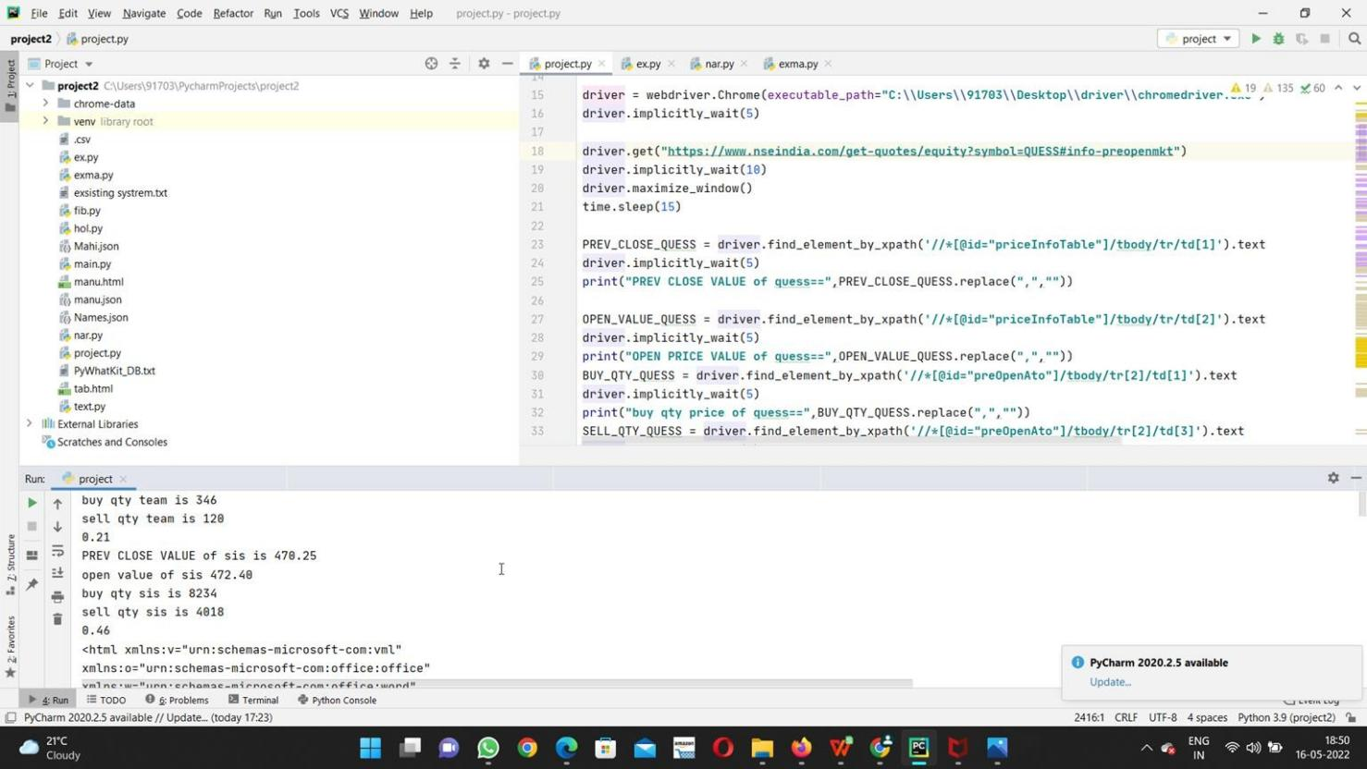

**Figure 7.2** Module2 Output

## Data Source:

The data is referred mainly from the National Stock Exchange website as it is officially recognized and is maintained by the Government of India.

Reference Picture:

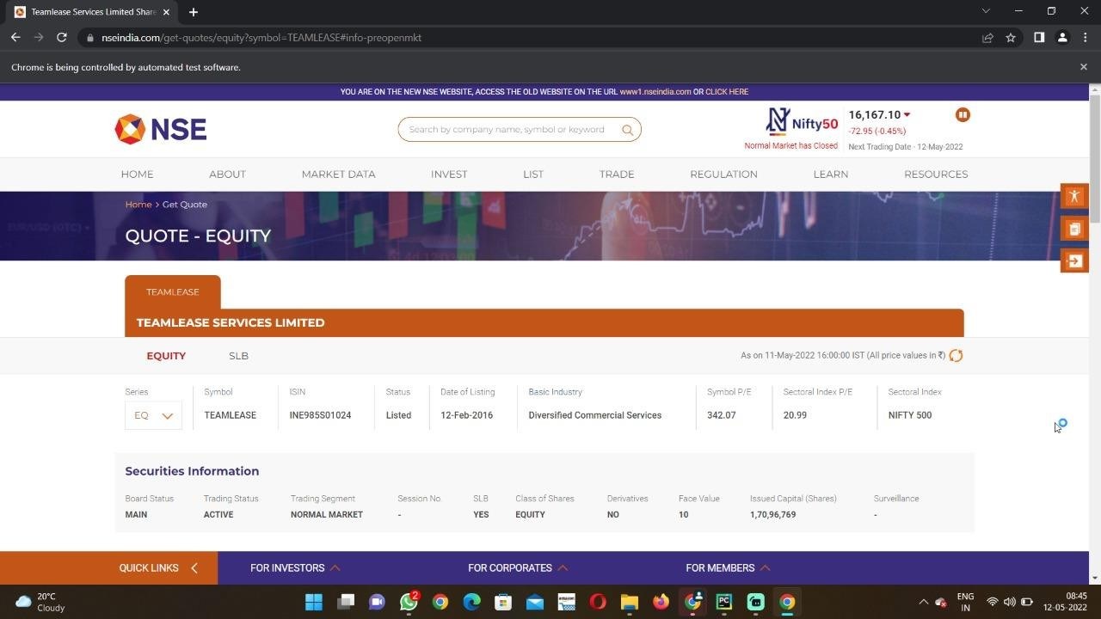

**Figure 7.3** NSE Website

## Final Output:

Once all the modules are tested and executed with no errors, the final resultant output is complete table with processed data from the referral website in a neat and organized format. This table is sent to the list of E-Mails that are entered in the Excel sheet automatically at any particular mentioned time in a day.

Final Data Table:

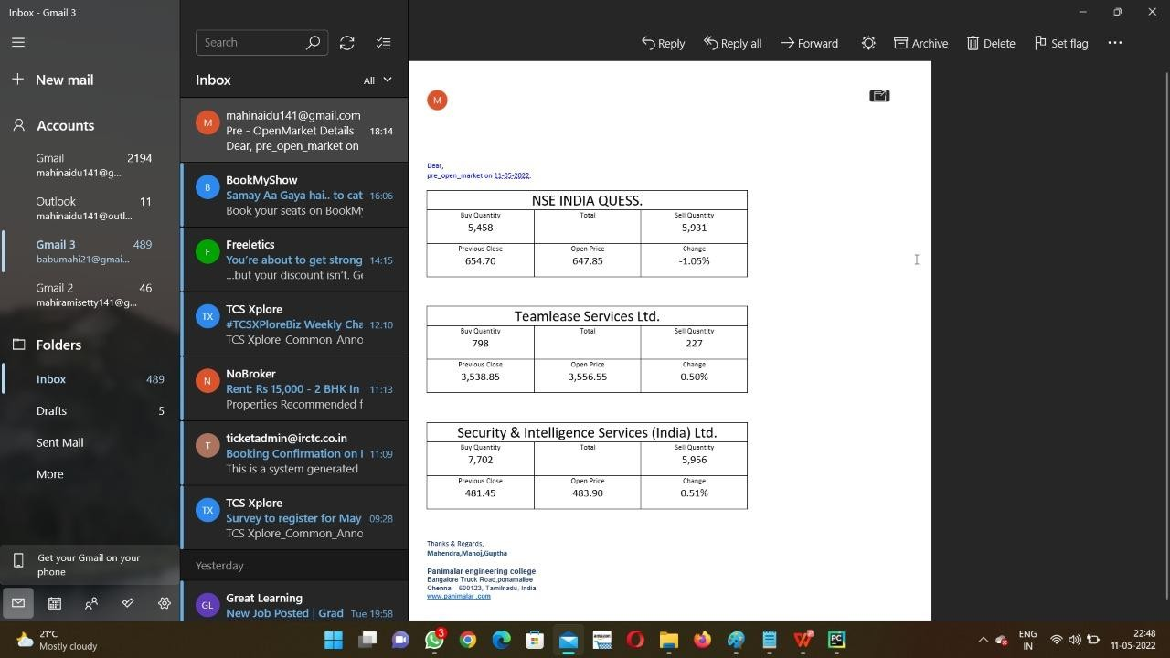

**Figure 7.4** Output

# CHAPTER 8

**Conclusion and Future Work**

## Conclusion

In this project, we are extraction the details of given number of stocks with specified details and imprinting them on a table with the help of a pre-defined format of HTML code with required number of values

## Future Work

* + - We plan to extend this automation to Whats App and general messaging apps.
* We want to extend customization to user end through an integrated UI.

# REFERENCES

### Datasets : Nifty 50 data

1. Manh Ha Duong Boriss Siliverstovs June 2006 - The Stock Market and Investment.
2. Antoniou, A.P Holmes and R Priestley (1998): “The Effects of Stock Index Futures Trading on stock index volatility: An Analysis of the Asymmetric Response of Volatility to News?” The Journal of Futures Markets, 18 (2), 151-166.
3. Stock Market Volatility – Conceptual Perspective through Literature Survey

D. Mamtha, Research Scholar, VIT Business School, VIT University, Vellore,

Tamil Nadu, India

1. A Study on Stock Market Volatility Pattern of BSE and NSE in India Goutham Tanty and Dr. P K Patjoshi, Assistant Professsor, RIMS, Rourkela,

Centurian University, Bhubanashwar

1. Thenmozhi M (2002): “Futures Trading, Information and Spot Price Volatility of NSE-50 Index Futures Contract” NSE Research Initiative, Paper no. 18.
2. What Triggers National Stock Market Jumps?

Baker, Scott, Nicholas Bloom, Steve Davis, and Marco Sammon.

1. <https://onlinelibrary.wiley.com/doi/full/10.1111/j.1540-261.1989.tb02647>

[https://www.academia.edu/74047053/Impact_of_Unlock_1_0_on_Indian_Stock_Mar](https://www.academia.edu/74047053/Impact_of_Unlock_1_0_on_Indian_Stock_Market_An_Event_Study_with_Reference_to_Nifty_50) [ket_An_Event_Study_with_Reference_to_Nifty_50](https://www.academia.edu/74047053/Impact_of_Unlock_1_0_on_Indian_Stock_Market_An_Event_Study_with_Reference_to_Nifty_50)

https://[www.academia.edu/73985112/A_Study_On_Influence_Of_Behavioral_Factor](http://www.academia.edu/73985112/A_Study_On_Influence_Of_Behavioral_Factor) s_On_Investment_Satisf

action_Of_Individual_Investors_In_Kerala

1. https://[www.bloombergquint.com/markets/navigating-indias-markets-](http://www.bloombergquint.com/markets/navigating-indias-markets-)

**through-the-russia-ukraine-conflict**

**APPENDICES**

* 1. **Sample Screens:**

Information Source:



**FIG A.11** Information Source

### Code:

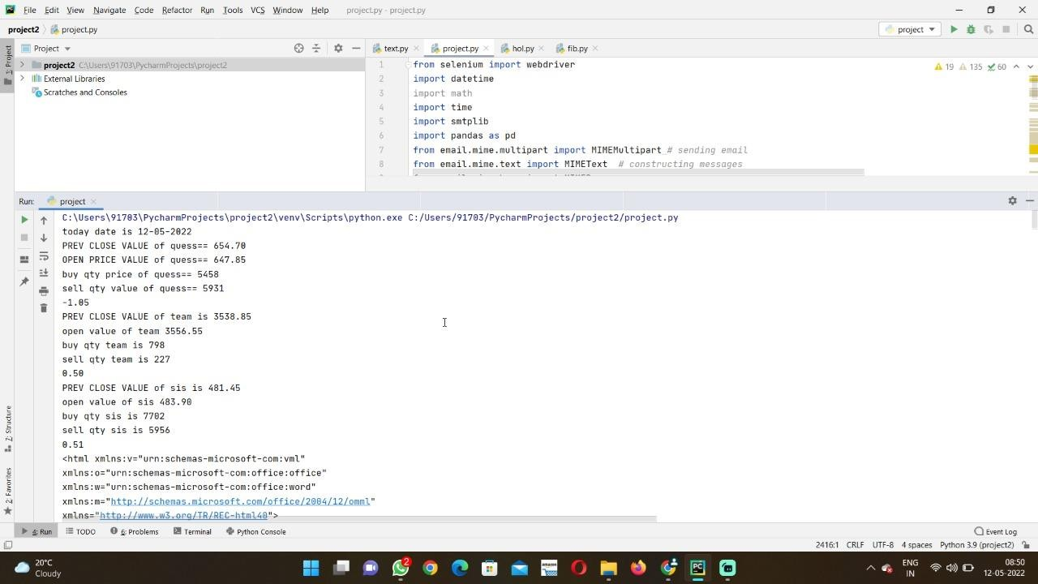

**FIG A.12** Client Side Code

### Output Screen:

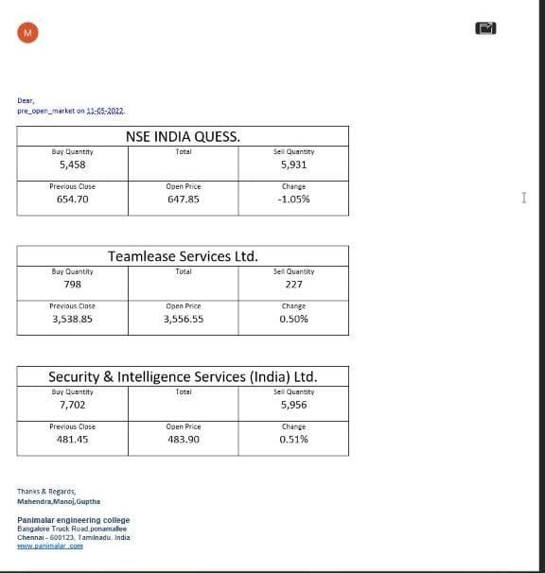

**FIG A.13** Final Output