Write a blog on Difference between HTTP1.1 vs HTTP2

HTTP/ 1.1

- It reuse the same TCP connection
- It uses plain text for communication
- http 1.1 also add pipelining
- And this allows the client to send multiple requests before waiting reach response.
- But the response must be received in the same order as to requests
- Requests on the same connection must wait for the previous requests to complete.
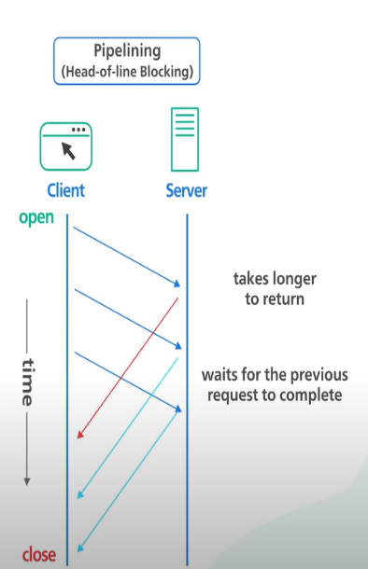

HTTP 2

- HTTP/2 introduces HTTP streams where multiple streams of requests could be sent to the same server On a Single TCP connection.
- Each stream is independent of each other and it does not need to be sent or received in order.
- http 2 have push request to allow servers to send updates to the clients whenever new data is available

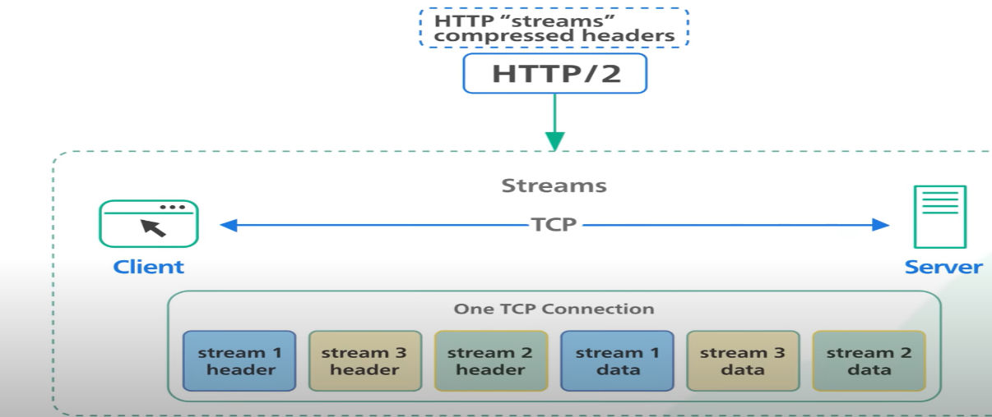
2:Write a blog about objects and its internal representation in Javascript
- objects
- An object is a reference data type. When you assign a value to a variable that is an object, you’re actually assigning a reference or pointer to the memory location where the object resides.
- The actual value is stored in memory, and the variable points to that location.
- Objects are essentially unordered collections of related data. They consist of properties (also known as keys) and their corresponding values.
- Properties can be variables or functions, and they define the characteristics of the object.
- To can create an object using either the object literal syntax or the new Object() constructor.
- For example:
// Using object literal syntax
const myCar = {
make: 'Ford',
model: 'Mustang',
year: 1969
};
console.log(myCar.make);
console.log(myCar.model);
console.log(myCar.year);
output:
ford
Mustang
1969

// Using the constructor
const anotherCar = new Object();
anotherCar.make = 'Toyota';
anotherCar.model = 'Camry';
anotherCar.year = 2022;
console.log(anotherCar['model']);
console.log(anotherCar['make']);
console.log(anotherCar['year']);

output;
camry
Toyota
2022
internal representation in Javascript
- Internally, JavaScript engines represent objects using various data structures.
- One common representation is the hash table, where keys (property names) are hashed to optimize property access.
- Each object has a pointer to a map, which describes its structure.
- The map contains information about the object’s properties and their locations in memory.

