Lesson 6 Demo 1: CI with Junit in Jenkins

This section will guide you to:
- Connect Git and GitHub repository with Jenkins along with Junit tests

This guide has four subsections, namely:
- Logging into Jenkins
- Adding Junit dependencies and classes in Maven project
- Creating a Jenkins job for Maven project
- Building the Jenkins job

Step 1: Logging into Jenkins
- Open your browser and navigate to localhost:8081
- Provide your username and password and click on Login
Step 2: Adding Junit dependencies and classes in Maven project
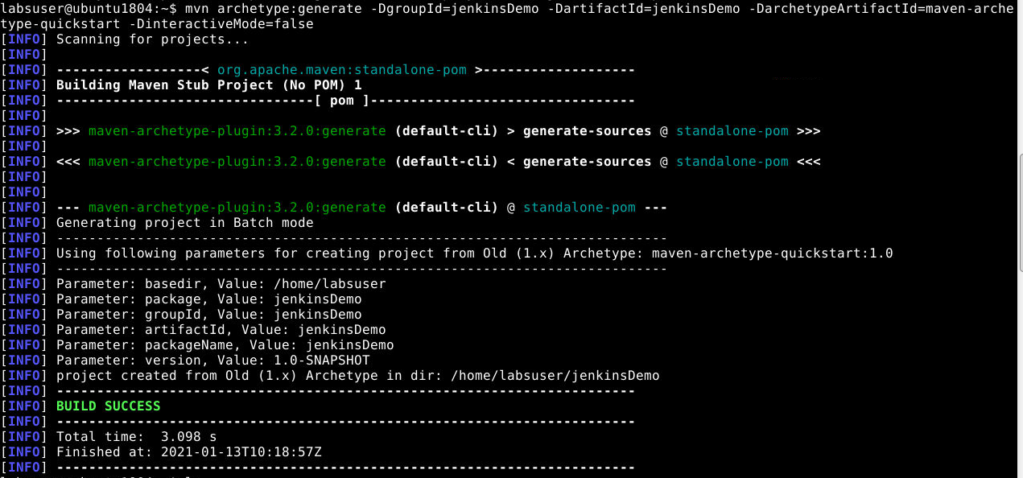
- Create a maven project by executing the following command in the terminal of your lab:
mvn archetype:generate -DgroupId=jenkinsDemo -DartifactId=jenkinsDemo -DarchetypeArtifactId=maven-archetype-quickstart -DinteractiveMode=false
- Run the below commands to navigate inside the maven project:
cd /home/labsuser/jenkinsDemo
vi pom.xml
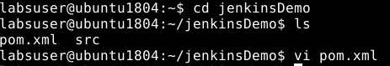
- Add the below code in the <dependencies> section of the pom.xml file of your Maven project
<dependency>
<groupId>junit</groupId>
<artifactId>junit</artifactId>
<version>4.12</version>
</dependency>
<dependency>
<groupId>org.seleniumhq.selenium</groupId>
<artifactId>selenium-java</artifactId>
<version>3.10.0</version>
</dependency>
- Save the file and exit using the command [esc] shift+:wq
- Delete the src/main folder using the commands given below:
cd /home/labsuser/jenkinsDemo/src
rm -r main
- Considering you are in the src folder, navigate to src/test/java, and create a file JenkinsDemo.java using the following commands:
cd /home/labsuser/jenkinsDemo/src/test/java
vi JenkinsDemo.java

- Add the following code in JenkinsDemo.java:
import org.junit.After;
import org.junit.Assert;
import org.junit.Before;
import org.junit.Ignore;
import org.junit.Test;
import org.openqa.selenium.By;
import org.openqa.selenium.WebDriver;
import org.openqa.selenium.chrome.ChromeDriver;
/**
* Created by
* Sample junit test code to integrate by
*/
public class JenkinsDemo
{
private static String Base_Url = "https://www.facebook.com";
private WebDriver driver;
@Before
public void setUp()
{
driver = new ChromeDriver();
driver.get(Base_Url);
}
@After
public void after()
{
driver.quit();
}
@Test
public void testCasePassed()
{
Assert.assertTrue(driver.findElement(By.xpath("//form[@id='login_form']")).isDisplayed());
}
@Test
public void testCaseFailed()
{
Assert.assertTrue(driver.findElement(By.xpath("//form[@id='failed case']")).isDisplayed());
}
@Ignore
@Test
public void testCaseIgnored()
{
Assert.assertTrue(driver.findElement(By.xpath("//form[@id='ignored case']")).isDisplayed());
}
}
- Save the file and exit using the command [esc] shift+:wq
- Your directory structure should only have these files.
- Run the following command to delete any unnecessary files or folder structures:
rm -r jenkinsDemo
Step 3: Creating a Jenkins job for Maven project

- To create a new job in Jenkins, open the Jenkins dashboard with your Jenkins URL.
For example, http://localhost:8081/
- Click on New Item. Enter the item name, select Maven Project, and click OK.
- Once you click OK, the page will be redirected to its project form.
- In the Build section of your job, for Root POM give the path of the pom.xml in your local system as shown:
/home/labsuser/jenkinsDemo/pom.xml

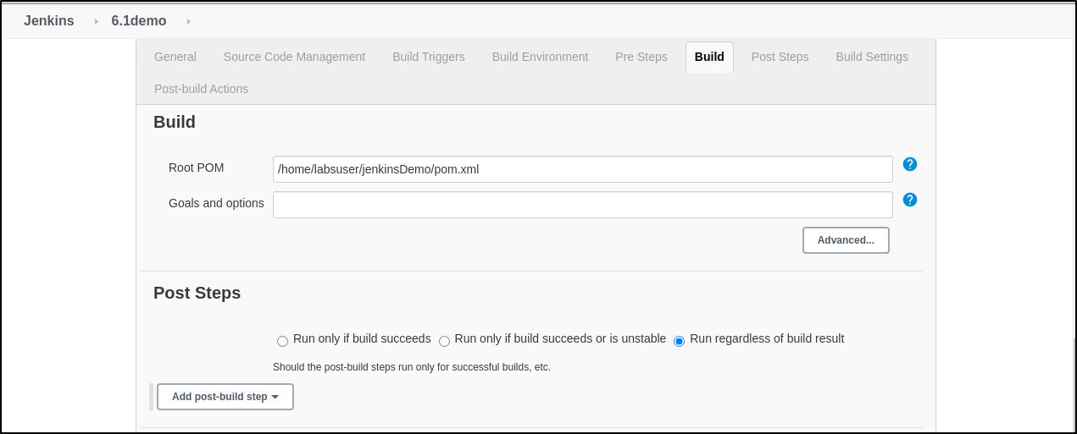

Step 4: Building the Jenkins job
- Build the job and check the status on the console for the test cases executed.
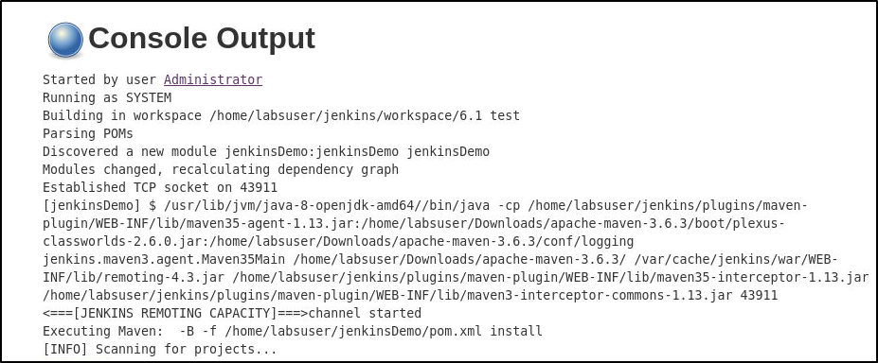

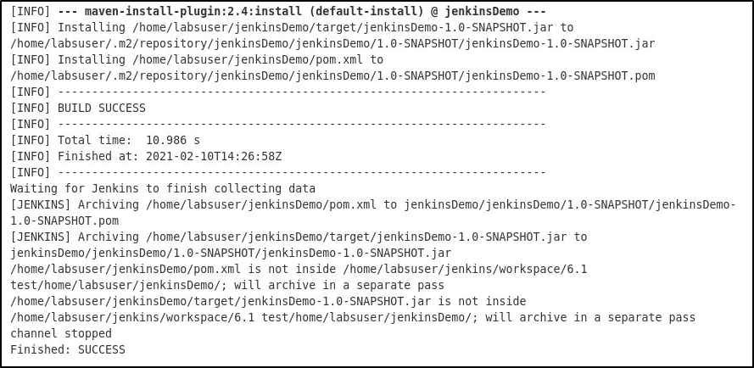

This is just for demo purpose. No use of this sentence.

