Modetest

- modetest is a user-land test program of libdrm.
- modetest is the test application available from libdrm
- Modetest is a test tool which can be found as part of the libdrm suite of test tools. We will use this tool to ensure proper configuration and operation of the Mixer IP.

modetest -h

usage: modetest [-acDdefMPpsCvrw]

Query options:

-c list connectors
-e list encoders
-f list framebuffers
-p list CRTCs and planes (pipes)

Test options:

-P <plane_id>@<crtc_id>:<w>x<h>[+<x>+<y>][*<scale>][@<format>] set a plane
-s <connector_id>[,<connector_id>][@<crtc_id>]:[#<mode index>]<mode>[-<vrefresh>][@<format>] set a mode
-C test hw cursor
-v test vsynced page flipping
-r set the preferred mode for all connectors
-w <obj_id>:<prop_name>:<value> set property
-a use atomic API
-F pattern1,pattern2 specify fill patterns

Generic options:

-d drop master after mode set
-M module use the given driver
-D device use the given device

Default is to dump all info.

[
- modetest -M vc4 -s {0}@{1}:{2}" .format(connector, crtc, resolution)
supp_res = ["1024x768-75"] # "1280x1024-0", 800x600-56, 640x480-73, 1024x768-75, 800x600 72, 1920x1080-75
- modetest -M vc4 -P {1}@{2}:{3}".format(time.asctime(), plane, crtc, size))

- Executing Command : modetest -M vc4 -s {1}@{2}:{3} - v" .format(time.asctime() , connector, crtc, resolution))

- modetest -M vc4 -s {0}@{1}:{2} -v" .format(connector, crtc, resolution), stdout = subprocess.PIPE , shell=True, preexec_fn=os.setsid)

- modetest -M vc4 -s {0}@{1}:{2} -C .format(connector, crtc, resolution), stdout = subprocess.PIPE , shell=True, preexec_fn=os.setsid)
- modetest -M vc4 -s {1}@{2}:{3} -C -v" .format(time.asctime(), connector, crtc, resolution))

]
modetest

trying to open device 'i915'...failed
trying to open device 'amdgpu'...failed
trying to open device 'radeon'...done
Encoders:
id crtc type possible crtcs possible clones
49 42 TMDS 0x0000000f 0x00000000
51 0 TMDS 0x0000000f 0x00000000
53 0 TVDAC 0x0000000f 0x00000000

Connectors:
id encoder status name size (mm) modes encoders
50 49 connected HDMI-A-1 480x270 26 49
modes:
index name refresh (Hz) hdisp hss hse htot vdisp vss vse vtot)
#0 1920x1080 60.00 1920 2008 2052 2200 1080 1084 1089 1125 148500 flags: phsync, pvsync; type: preferred, driver
#1 1920x1080 59.94 1920 2008 2052 2200 1080 1084 1089 1125 148352 flags: phsync, pvsync; type: driver
#2 1920x1080i 30.00 1920 2008 2052 2200 1080 1084 1094 1125 74250 flags: phsync, pvsync, interlace; type: driver
#3 1920x1080i 29.97 1920 2008 2052 2200 1080 1084 1094 1125 74176 flags: phsync, pvsync, interlace; type: driver
#4 1920x1080 50.00 1920 2448 2492 2640 1080 1084 1089 1125 148500 flags: phsync, pvsync; type: driver
#5 1920x1080i 25.00 1920 2448 2492 2640 1080 1084 1094 1125 74250 flags: phsync, pvsync, interlace; type: driver
#6 1280x1024 75.02 1280 1296 1440 1688 1024 1025 1028 1066 135000 flags: phsync, pvsync; type: driver
#7 1280x1024 60.02 1280 1328 1440 1688 1024 1025 1028 1066 108000 flags: phsync, pvsync; type: driver
#8 1152x864 75.00 1152 1216 1344 1600 864 865 868 900 108000 flags: phsync, pvsync; type: driver
#9 1280x720 60.00 1280 1390 1430 1650 720 725 730 750 74250 flags: phsync, pvsync; type: driver
#10 1280x720 59.94 1280 1390 1430 1650 720 725 730 750 74176 flags: phsync, pvsync; type: driver
#11 1280x720 50.00 1280 1720 1760 1980 720 725 730 750 74250 flags: phsync, pvsync; type: driver
#12 1024x768 75.03 1024 1040 1136 1312 768 769 772 800 78750 flags: phsync, pvsync; type: driver
#13 1024x768 60.00 1024 1048 1184 1344 768 771 777 806 65000 flags: nhsync, nvsync; type: driver
#14 800x600 75.00 800 816 896 1056 600 601 604 625 49500 flags: phsync, pvsync; type: driver
#15 800x600 60.32 800 840 968 1056 600 601 605 628 40000 flags: phsync, pvsync; type: driver
#16 720x576 50.00 720 732 796 864 576 581 586 625 27000 flags: nhsync, nvsync; type: driver
#17 720x576i 25.00 720 732 795 864 576 580 586 625 13500 flags: nhsync, nvsync, interlace, dblclk; type: driver
#18 720x480 60.00 720 736 798 858 480 489 495 525 27027 flags: nhsync, nvsync; type: driver
#19 720x480 59.94 720 736 798 858 480 489 495 525 27000 flags: nhsync, nvsync; type: driver
#20 720x480i 30.00 720 739 801 858 480 488 494 525 13514 flags: nhsync, nvsync, interlace, dblclk; type: driver
#21 720x480i 29.97 720 739 801 858 480 488 494 525 13500 flags: nhsync, nvsync, interlace, dblclk; type: driver
#22 640x480 75.00 640 656 720 840 480 481 484 500 31500 flags: nhsync, nvsync; type: driver
#23 640x480 60.00 640 656 752 800 480 490 492 525 25200 flags: nhsync, nvsync; type: driver
#24 640x480 59.94 640 656 752 800 480 490 492 525 25175 flags: nhsync, nvsync; type: driver
#25 720x400 70.08 720 738 846 900 400 412 414 449 28320 flags: nhsync, pvsync; type: driver
props:
1 EDID:
flags: immutable blob
blobs:

value:
00ffffffffffff0010ac54d054584a30
3218010380301b78ea16c5a456509f26
125054a54b00714f8180d1c001010101
010101010101023a801871382d40582c
4500dc0b1100001e000000ff00314d56
4431344339304a58540a000000fc0044
454c4c2053323234304c0a20000000fd
00384c1e5311000a202020202020010c
02031ff14c9005040302071601141f12
13230907078301000065030c00100002
3a801871382d40582c4500dc0b110000
1e011d8018711c1620582c2500dc0b11
00009e011d007251d01e206e285500dc
0b1100001e8c0ad08a20e02d10103e96
00dc0b11000018000000000000000000
000000000000000000000000000000b7
2 DPMS:
flags: enum
enums: On=0 Standby=1 Suspend=2 Off=3
value: 0
5 link-status:
flags: enum
enums: Good=0 Bad=1
value: 0
6 non-desktop:
flags: immutable range
values: 0 1
value: 0
4 TILE:
flags: immutable blob
blobs:

value:
31 coherent:
flags: range
values: 0 1
value: 1
35 underscan:
flags: enum
enums: off=0 on=1 auto=2
value: 0
36 underscan hborder:
flags: range
values: 0 128
value: 0
37 underscan vborder:
flags: range
values: 0 128
value: 0
39 dither:
flags: enum
enums: off=0 on=1
value: 0
33 scaling mode:
flags: enum
enums: None=0 Full=1 Center=2 Full aspect=3
value: 0
38 audio:
flags: enum
enums: off=0 on=1 auto=2
value: 2
40 output_csc:
flags: enum
enums: bypass=0 tvrgb=1 ycbcr601=2 ycbcr709=3
value: 0
52 0 disconnected DVI-D-1 0x0 0 51
props:
1 EDID:
flags: immutable blob
blobs:

value:
2 DPMS:
flags: enum
enums: On=0 Standby=1 Suspend=2 Off=3
value: 0
5 link-status:
flags: enum
enums: Good=0 Bad=1
value: 0
6 non-desktop:
flags: immutable range
values: 0 1
value: 0
4 TILE:
flags: immutable blob
blobs:

value:
31 coherent:
flags: range
values: 0 1
value: 1
35 underscan:
flags: enum
enums: off=0 on=1 auto=2
value: 0
36 underscan hborder:
flags: range
values: 0 128
value: 0
37 underscan vborder:
flags: range
values: 0 128
value: 0
39 dither:
flags: enum
enums: off=0 on=1
value: 0
33 scaling mode:
flags: enum
enums: None=0 Full=1 Center=2 Full aspect=3
value: 0
38 audio:
flags: enum
enums: off=0 on=1 auto=2
value: 2
40 output_csc:
flags: enum
enums: bypass=0 tvrgb=1 ycbcr601=2 ycbcr709=3
value: 0
54 0 disconnected VGA-1 0x0 0 53
props:
1 EDID:
flags: immutable blob
blobs:

value:
2 DPMS:
flags: enum
enums: On=0 Standby=1 Suspend=2 Off=3
value: 0
5 link-status:
flags: enum
enums: Good=0 Bad=1
value: 0
6 non-desktop:
flags: immutable range
values: 0 1
value: 0
4 TILE:
flags: immutable blob
blobs:

value:
32 load detection:
flags: range
values: 0 1
value: 1
33 scaling mode:
flags: enum
enums: None=0 Full=1 Center=2 Full aspect=3
value: 0
40 output_csc:
flags: enum
enums: bypass=0 tvrgb=1 ycbcr601=2 ycbcr709=3
value: 0

CRTCs:
id fb pos size
42 55 (0,0) (1920x1080)
#0 1920x1080 60.00 1920 2008 2052 2200 1080 1084 1089 1125 148500 flags: phsync, pvsync; type: preferred, driver
props:
44 0 (0,0) (0x0)
#0 nan 0 0 0 0 0 0 0 0 0 flags: ; type:
props:
46 0 (0,0) (0x0)
#0 nan 0 0 0 0 0 0 0 0 0 flags: ; type:
props:
48 0 (0,0) (0x0)
#0 nan 0 0 0 0 0 0 0 0 0 flags: ; type:
props:

Planes:
id crtc fb CRTC x,y x,y gamma size possible crtcs
41 42 55 0,0 0,0 0 0x00000001
formats: XR24 AR24
props:
8 type:
flags: immutable enum
enums: Overlay=0 Primary=1 Cursor=2
value: 1
43 0 0 0,0 0,0 0 0x00000002
formats: XR24 AR24
props:
8 type:
flags: immutable enum
enums: Overlay=0 Primary=1 Cursor=2
value: 1
45 0 0 0,0 0,0 0 0x00000004
formats: XR24 AR24
props:
8 type:
flags: immutable enum
enums: Overlay=0 Primary=1 Cursor=2
value: 1
47 0 0 0,0 0,0 0 0x00000008
formats: XR24 AR24
props:
8 type:
flags: immutable enum
enums: Overlay=0 Primary=1 Cursor=2
value: 1

Frame buffers:
id size pitch

modetest -c

trying to open device 'i915'...failed
trying to open device 'amdgpu'...failed
trying to open device 'radeon'...done
Connectors:
id encoder status name size (mm) modes encoders
50 49 connected HDMI-A-1 480x270 26 49
modes:
index name refresh (Hz) hdisp hss hse htot vdisp vss vse vtot)
#0 1920x1080 60.00 1920 2008 2052 2200 1080 1084 1089 1125 148500 flags: phsync, pvsync; type: preferred, driver
#1 1920x1080 59.94 1920 2008 2052 2200 1080 1084 1089 1125 148352 flags: phsync, pvsync; type: driver
#2 1920x1080i 30.00 1920 2008 2052 2200 1080 1084 1094 1125 74250 flags: phsync, pvsync, interlace; type: driver
#3 1920x1080i 29.97 1920 2008 2052 2200 1080 1084 1094 1125 74176 flags: phsync, pvsync, interlace; type: driver
#4 1920x1080 50.00 1920 2448 2492 2640 1080 1084 1089 1125 148500 flags: phsync, pvsync; type: driver
#5 1920x1080i 25.00 1920 2448 2492 2640 1080 1084 1094 1125 74250 flags: phsync, pvsync, interlace; type: driver
#6 1280x1024 75.02 1280 1296 1440 1688 1024 1025 1028 1066 135000 flags: phsync, pvsync; type: driver
#7 1280x1024 60.02 1280 1328 1440 1688 1024 1025 1028 1066 108000 flags: phsync, pvsync; type: driver
#8 1152x864 75.00 1152 1216 1344 1600 864 865 868 900 108000 flags: phsync, pvsync; type: driver
#9 1280x720 60.00 1280 1390 1430 1650 720 725 730 750 74250 flags: phsync, pvsync; type: driver
#10 1280x720 59.94 1280 1390 1430 1650 720 725 730 750 74176 flags: phsync, pvsync; type: driver
#11 1280x720 50.00 1280 1720 1760 1980 720 725 730 750 74250 flags: phsync, pvsync; type: driver
#12 1024x768 75.03 1024 1040 1136 1312 768 769 772 800 78750 flags: phsync, pvsync; type: driver
#13 1024x768 60.00 1024 1048 1184 1344 768 771 777 806 65000 flags: nhsync, nvsync; type: driver
#14 800x600 75.00 800 816 896 1056 600 601 604 625 49500 flags: phsync, pvsync; type: driver
#15 800x600 60.32 800 840 968 1056 600 601 605 628 40000 flags: phsync, pvsync; type: driver
#16 720x576 50.00 720 732 796 864 576 581 586 625 27000 flags: nhsync, nvsync; type: driver
#17 720x576i 25.00 720 732 795 864 576 580 586 625 13500 flags: nhsync, nvsync, interlace, dblclk; type: driver
#18 720x480 60.00 720 736 798 858 480 489 495 525 27027 flags: nhsync, nvsync; type: driver
#19 720x480 59.94 720 736 798 858 480 489 495 525 27000 flags: nhsync, nvsync; type: driver
#20 720x480i 30.00 720 739 801 858 480 488 494 525 13514 flags: nhsync, nvsync, interlace, dblclk; type: driver
#21 720x480i 29.97 720 739 801 858 480 488 494 525 13500 flags: nhsync, nvsync, interlace, dblclk; type: driver
#22 640x480 75.00 640 656 720 840 480 481 484 500 31500 flags: nhsync, nvsync; type: driver
#23 640x480 60.00 640 656 752 800 480 490 492 525 25200 flags: nhsync, nvsync; type: driver
#24 640x480 59.94 640 656 752 800 480 490 492 525 25175 flags: nhsync, nvsync; type: driver
#25 720x400 70.08 720 738 846 900 400 412 414 449 28320 flags: nhsync, pvsync; type: driver
props:
1 EDID:
flags: immutable blob
blobs:

value:
00ffffffffffff0010ac54d054584a30
3218010380301b78ea16c5a456509f26
125054a54b00714f8180d1c001010101
010101010101023a801871382d40582c
4500dc0b1100001e000000ff00314d56
4431344339304a58540a000000fc0044
454c4c2053323234304c0a20000000fd
00384c1e5311000a202020202020010c
02031ff14c9005040302071601141f12
13230907078301000065030c00100002
3a801871382d40582c4500dc0b110000
1e011d8018711c1620582c2500dc0b11
00009e011d007251d01e206e285500dc
0b1100001e8c0ad08a20e02d10103e96
00dc0b11000018000000000000000000
000000000000000000000000000000b7
2 DPMS:
flags: enum
enums: On=0 Standby=1 Suspend=2 Off=3
value: 0
5 link-status:
flags: enum
enums: Good=0 Bad=1
value: 0
6 non-desktop:
flags: immutable range
values: 0 1
value: 0
4 TILE:
flags: immutable blob
blobs:

value:
31 coherent:
flags: range
values: 0 1
value: 1
35 underscan:
flags: enum
enums: off=0 on=1 auto=2
value: 0
36 underscan hborder:
flags: range
values: 0 128
value: 0
37 underscan vborder:
flags: range
values: 0 128
value: 0
39 dither:
flags: enum
enums: off=0 on=1
value: 0
33 scaling mode:
flags: enum
enums: None=0 Full=1 Center=2 Full aspect=3
value: 0
38 audio:
flags: enum
enums: off=0 on=1 auto=2
value: 2
40 output_csc:
flags: enum
enums: bypass=0 tvrgb=1 ycbcr601=2 ycbcr709=3
value: 0
52 0 disconnected DVI-D-1 0x0 0 51
props:
1 EDID:
flags: immutable blob
blobs:

value:
2 DPMS:
flags: enum
enums: On=0 Standby=1 Suspend=2 Off=3
value: 0
5 link-status:
flags: enum
enums: Good=0 Bad=1
value: 0
6 non-desktop:
flags: immutable range
values: 0 1
value: 0
4 TILE:
flags: immutable blob
blobs:

value:
31 coherent:
flags: range
values: 0 1
value: 1
35 underscan:
flags: enum
enums: off=0 on=1 auto=2
value: 0
36 underscan hborder:
flags: range
values: 0 128
value: 0
37 underscan vborder:
flags: range
values: 0 128
value: 0
39 dither:
flags: enum
enums: off=0 on=1
value: 0
33 scaling mode:
flags: enum
enums: None=0 Full=1 Center=2 Full aspect=3
value: 0
38 audio:
flags: enum
enums: off=0 on=1 auto=2
value: 2
40 output_csc:
flags: enum
enums: bypass=0 tvrgb=1 ycbcr601=2 ycbcr709=3
value: 0
54 0 disconnected VGA-1 0x0 0 53
props:
1 EDID:
flags: immutable blob
blobs:

value:
2 DPMS:
flags: enum
enums: On=0 Standby=1 Suspend=2 Off=3
value: 0
5 link-status:
flags: enum
enums: Good=0 Bad=1
value: 0
6 non-desktop:
flags: immutable range
values: 0 1
value: 0
4 TILE:
flags: immutable blob
blobs:

value:
32 load detection:
flags: range
values: 0 1
value: 1
33 scaling mode:
flags: enum
enums: None=0 Full=1 Center=2 Full aspect=3
value: 0
40 output_csc:
flags: enum
enums: bypass=0 tvrgb=1 ycbcr601=2 ycbcr709=3
value: 0

modetest -e

trying to open device 'i915'...failed
trying to open device 'amdgpu'...failed
trying to open device 'radeon'...done
Encoders:
id crtc type possible crtcs possible clones
49 42 TMDS 0x0000000f 0x00000000
51 0 TMDS 0x0000000f 0x00000000
53 0 TVDAC 0x0000000f 0x00000000

modetest -f

trying to open device 'i915'...failed
trying to open device 'amdgpu'...failed
trying to open device 'radeon'...done
Frame buffers:
id size pitch
modetest -p

trying to open device 'i915'...failed
trying to open device 'amdgpu'...failed
trying to open device 'radeon'...done
CRTCs:
id fb pos size
42 55 (0,0) (1920x1080)
#0 1920x1080 60.00 1920 2008 2052 2200 1080 1084 1089 1125 148500 flags: phsync, pvsync; type: preferred, driver
props:
44 0 (0,0) (0x0)
#0 nan 0 0 0 0 0 0 0 0 0 flags: ; type:
props:
46 0 (0,0) (0x0)
#0 nan 0 0 0 0 0 0 0 0 0 flags: ; type:
props:
48 0 (0,0) (0x0)
#0 nan 0 0 0 0 0 0 0 0 0 flags: ; type:
props:

Planes:
id crtc fb CRTC x,y x,y gamma size possible crtcs
41 42 55 0,0 0,0 0 0x00000001
formats: XR24 AR24
props:
8 type:
flags: immutable enum
enums: Overlay=0 Primary=1 Cursor=2
value: 1
43 0 0 0,0 0,0 0 0x00000002
formats: XR24 AR24
props:
8 type:
flags: immutable enum
enums: Overlay=0 Primary=1 Cursor=2
value: 1
45 0 0 0,0 0,0 0 0x00000004
formats: XR24 AR24
props:
8 type:
flags: immutable enum
enums: Overlay=0 Primary=1 Cursor=2
value: 1
47 0 0 0,0 0,0 0 0x00000008
formats: XR24 AR24
props:
8 type:
flags: immutable enum
enums: Overlay=0 Primary=1 Cursor=2
value: 1

Introduction to libdrm
Libdrm provides a user space library for accessing the DRM, direct rendering manager, on operating systems that support the ioctl interface. libdrm is a low-level library, typically used by graphics drivers such as the Mesa DRI drivers, the X drivers, libva and similar projects.
This package is known to build and work properly using an LFS-11.0 platform.

libdrm Dependencies

Recommended
Xorg Libraries (for Intel KMS API support required by Mesa)

Installation of libdrm
Install libdrm by running the following commands:
mkdir build &&
cd build &&

meson --prefix=$XORG_PREFIX \
--buildtype=release \
-Dudev=true \
-Dvalgrind=false &&
ninja
To check the results, issue ninja test.
Now, as the root user:
ninja instal

Download (HTTP): https://dri.freedesktop.org/libdrm/libdrm-2.4.107.tar.xz

Command Explanations
--buildtype=release: Specify a buildtype suitable for stable releases of the package, as the default may produce unoptimized binaries.
-Dudev=true: This parameter enables support for using Udev instead of mknod.
-Dvalgrind=false: This parameter disables building libdrm with valgrind support. This fixes building sysprof and other packages that use libdrm. Change this parameter to "true" if you need support for valgrind.

Contents
Installed Programs:None
Installed Libraries:libdrm_amdgpu.so, libdrm_intel.so, libdrm_nouveau.so, libdrm_radeon.so, libdrm.so, and libkms.so
Installed Directories:/usr/include/libdrm, /usr/include/libkms, and /usr/share/libdrm

Short Descriptions
libdrm_amdgpu.so | contains the AMDGPU specific Direct Rendering Manager functions
libdrm_intel.so | contains the Intel specific Direct Rendering Manager functions
libdrm_nouveau.so | contains the open source nVidia (Nouveau) specific Direct Rendering Manager functions
libdrm_radeon.so | contains the AMD Radeon specific Direct Rendering Manager functions
libdrm.so | contains the Direct Rendering Manager API functions
libkms.so | contains API functions for kernel mode setting abstraction

- The Direct Rendering Manager (DRM) is a subsystem of the Linux kernel responsible for interfacing with GPUs of modern video cards.
- exposes an API that user-space programs can use to send commands and data to the GPU and perform operations such as configuring the mode setting of the display.
- User-space programs can use the DRM API to command the GPU to do hardware-accelerated 3D rendering and video decoding, as well as GPGPU computing.

{

Mode setting
Mode setting is a software operation that activates a display mode (screen resolution, color depth, and refresh rate) for a computer's display controller by using VESA BIOS Extensions or UEFI Graphics extensions (on more modern computers).
Kernel mode-setting is more flexible and allows displaying of an error in the case of a fatal system error in the kernel, even when using a user-space display server.
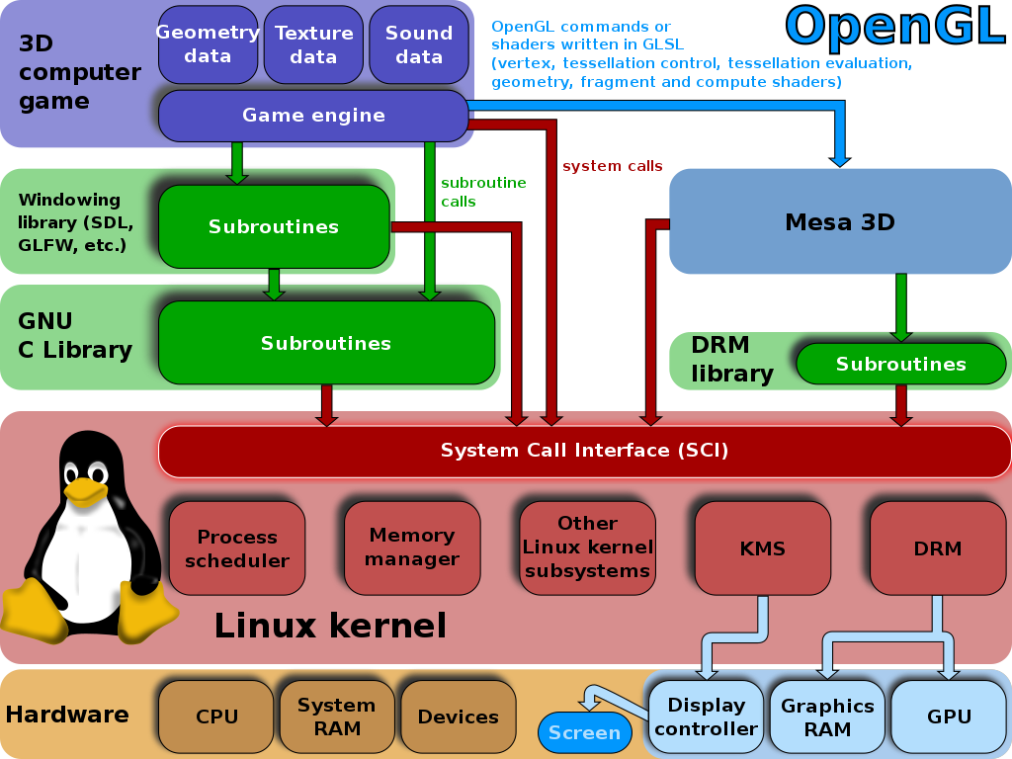

(Regulating access to the hardware is a fundamental kernel task. The Direct Rendering Manager and KMS are part of the Linux kernel. The KMS does only the mode setting.)

The Linux kernel got the prerequisite for kernel-based mode setting by accepting Intel GEM.

replaced by Tungstens Graphics TTM (Translation Table Maps) memory manager which supports the GEM API.[2] TTM was developed for the free and open-source drivers for Radeon and S3 Graphics graphic chipsets (see Free and open-source graphics device driver)

}

The Linux kernel already had an API called fbdev, used to manage the framebuffer of a graphics adapter,[2] but it couldn't be used to handle the needs of modern 3D-accelerated GPU-based video hardware.

user-space programs (such as the X Server) directly managed these resources, but they usually acted as if they were the only ones with access to them. When two or more programs tried to control the same hardware at the same time, and set its resources each one in its own way, most times they ended catastrophically

The DRM gets exclusive access to the GPU and is responsible for initializing and maintaining the command queue, memory, and any other hardware resource.

Without drm
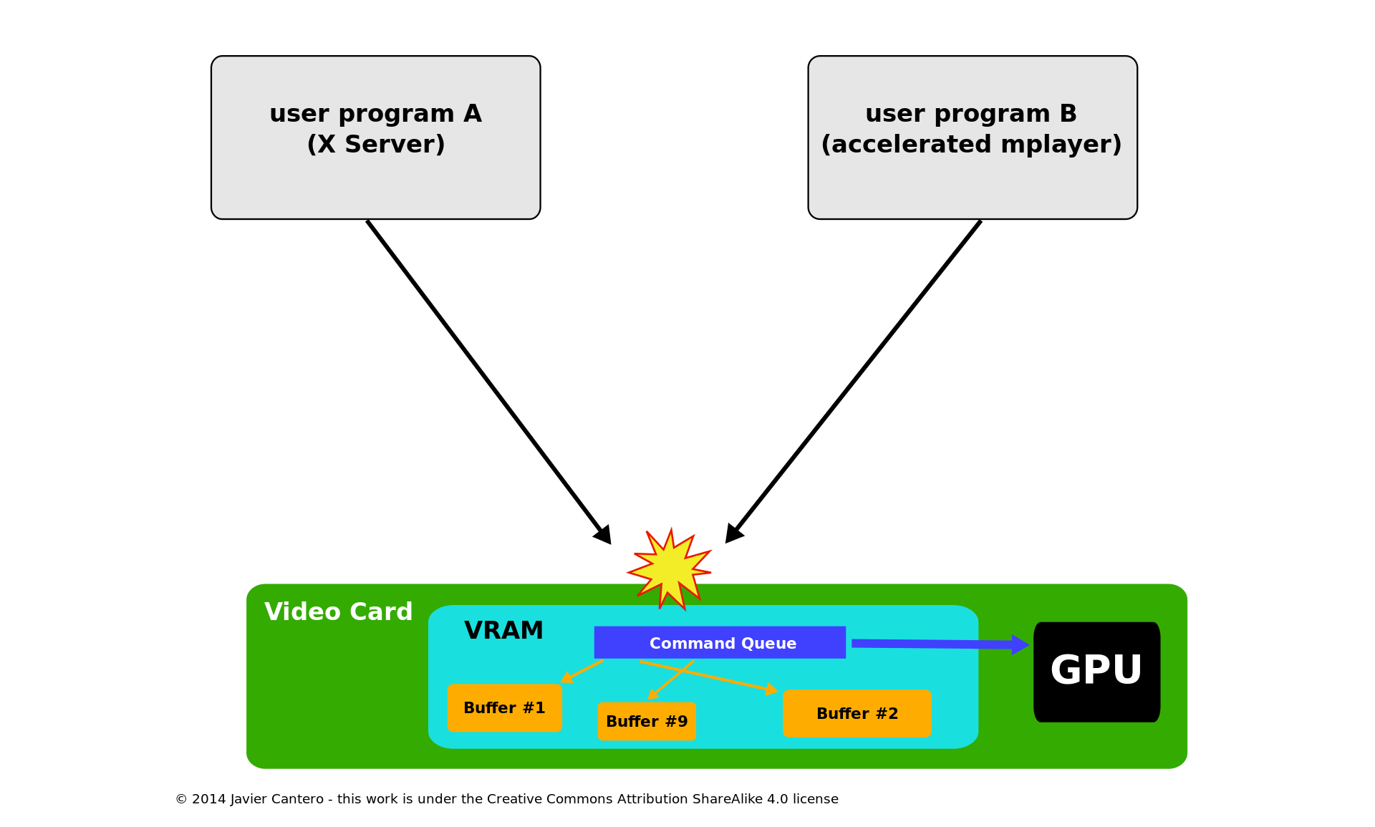
with drm
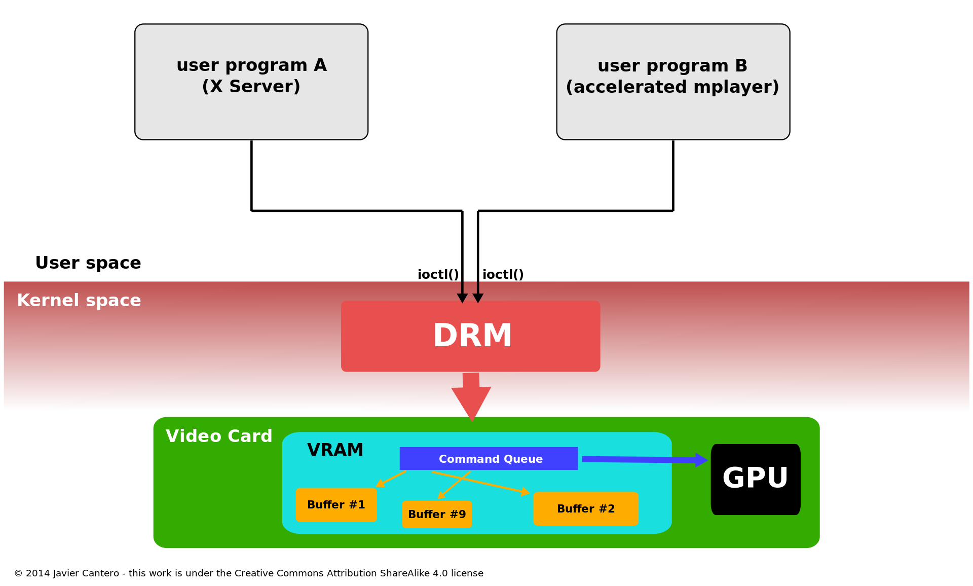

Some of these expansions were given specific names, such as Graphics Execution Manager (GEM) or kernel mode-setting (KMS), and the terminology prevails when the functionality they provide is specifically alluded. But they are really parts of the whole kernel DRM subsystem.

user-space programs must use kernel system calls to request its services.

Each GPU detected by DRM is referred to as a DRM device, and a device file /dev/dri/cardX (where X is a sequential number) is created to interface with it

A library called libdrm was created to facilitate the interface of user-space programs with the DRM subsystem. This library is merely a wrapper that provides a function written in C for every ioctl of the DRM API, as well as constants, structures and other helper elements

DRM consists of two parts: a generic "DRM core" and a specific one ("DRM driver") for each type of supported hardware.[11] DRM core provides the basic framework where different DRM drivers can register and also provides to user space a minimal set of ioctls with common, hardware-independent functionality.[8] A DRM driver, on the other hand, implements the hardware-dependent part of the API, specific to the type of GPU it supports; it should provide the implementation of the remaining ioctls not covered by DRM core, but it may also extend the API, offering additional ioctls with extra functionality only available on such hardware

KMS

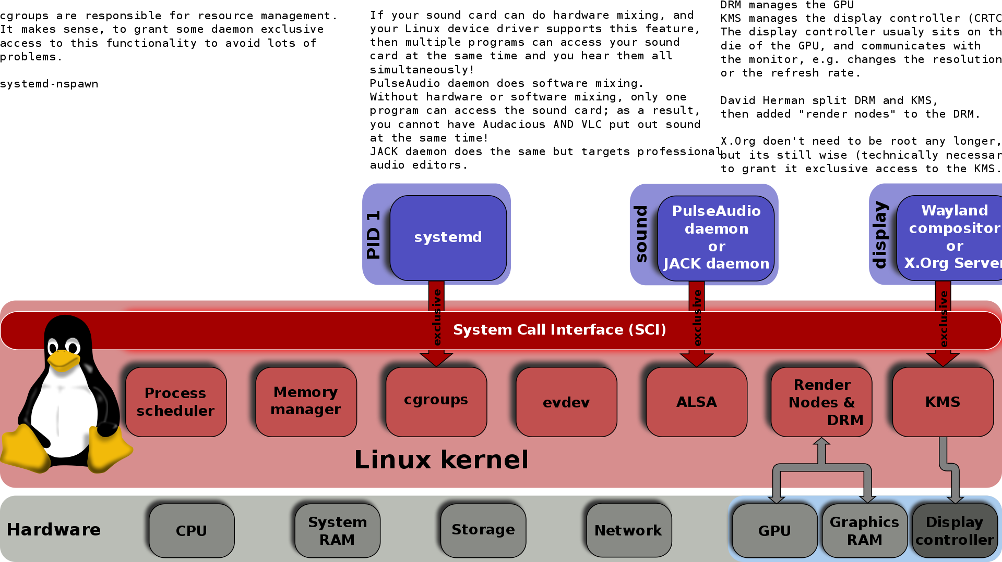
(There must be a "DRM master" in user-space, this program has exclusive access to KMS.)

In order to work properly, a video card or graphics adapter must set a mode—a combination of screen resolution, color depth and refresh rate—that is within the range of values supported by itself and the attached display screen. This operation is called mode-setting, A mode-setting operation must be performed before starting to use the framebuffer, and also when the mode is required to change by an application or the user.

early days - graphical framebuffer were also responsible for providing the mode-setting operations. In Unix-type operating systems, the X Server was the most prominent example, and its mode-setting implementation lived in the DDX driver for each specific type of video card
This approach, later referred as User space Mode-Setting or UMS
It not only breaks the isolation that operating systems should provide between programs and hardware, raising both stability and security concerns, but also could leave the graphics hardware in an inconsistent state if two or more user space programs try to do the mode-setting at the same time

Linux kernel framebuffer driver contained mode-setting code to configure framebuffer devices.[2] To avoid mode-setting conflicts, the XFree86 Server—and later the X.Org Server—handled the case when the user switched from the graphical environment to a text virtual console by saving its mode-setting state, and restoring it when the user switched back to X.[41] This process caused an annoying flicker in the transition, and also can fail, leading to a corrupted or unusable output display

The new kernel API and code added to the DRM module to perform these mode-setting operations was called Kernel Mode-Setting (KMS)

advt- The most immediate is of course the removal of duplicate mode-setting code, from both the kernel (Linux console, fbdev) and user space (X Server DDX drivers). KMS also makes it easier to write alternative graphics systems, which now don't need to implement their own mode-setting code.
The fact that KMS is part of the kernel allows it to use resources only available at kernel space such as interrupts.
For example, the mode recovery after a suspend/resume process simplifies a lot by being managed by the kernel itself, and incidentally improves security (no more user space tools requiring root permissions).

KMS has been adopted to such an extent that certain drivers which lack 3D acceleration (or for which the hardware vendor doesn't want to expose or implement it) nevertheless implement the KMS API without the rest of the DRM API.

Kms blocks are

CRTCs: each CRTC (from CRT Controller[48][33]) represents a scanout engine of the display controller, pointing to a scanout buffer (framebuffer).[47] The purpose of a CRTC is to read the pixel data currently in the scanout buffer and generate from it the video mode timing signal with the help of a PLL circuit.[49] The number of CRTCs available determines how many independent output devices can the hardware handle at the same time, so in order to use multi-head configurations at least one CRTC per display device is required.[47] Two—or more—CRTCs can also work in clone mode if they scan out from the same framebuffer to send the same image to several output devices.

Connectors: a connector represents where the display controller sends the video signal from a scanout operation to be displayed. Usually, the KMS concept of a connector corresponds to a physical connector (VGA, DVI, FPD-Link, HDMI, DisplayPort, S-Video, ...) in the hardware where an output device (monitor, laptop panel, ...) is permanently or can temporarily be attached. Information related to the current physically attached output device—such as connection status, EDID data, DPMS status or supported video modes—is also stored within the connector

{
Extended Display Identification Data (EDID) is a metadata format for display devices to describe their capabilities to a video source (e.g. graphics card or set-top box). The data format is defined by a standard published by the Video Electronics Standards Association (VESA).
The EDID data structure includes manufacturer name and serial number, product type, phosphor or filter type (as chromaticity data), timings supported by the display, display size, luminance data and (for digital displays only) pixel mapping data.
DisplayID is a VESA standard targeted to replace EDID and E-EDID extensions with a uniform format suited for both PC monitor and consumer electronics devices.

10ac – 1000010101100 - EL
All CTA standards are free to everyone since May 2018
VESA Display Power Management Signaling (or DPMS) is a standard from the VESA consortium for power management of video monitors. Example usage includes turning off, or putting the monitor into standby after a period of idle time to save power. Some commercial displays also incorporate this technology.
The standard defines how to signal the H-sync and V-sync pins in a standard SVGA monitor to trigger the monitor's power saving capabilities.
DPMS defines four modes; normal, standby, suspended and off. When in the "off" state some power may still be drawn in order to power indicator lights.
The standard is:
State | H-sync | V-sync | Power | Recovery Time[2]
On | On | On | 100% | n/a
Stand-by | Off | On | < 80% | ~1 Sec.
Suspend | On | Off | < 30W | ~5 Sec.
Off | Off | Off | < 8W | ~20 Sec.

}

Encoders: the display controller must encode the video mode timing signal from the CRTC using a format suitable for the intended connector.[47] An encoder represents the hardware block able to do one of these encodings. Examples of encodings—for digital outputs—are TMDS and LVDS; for analog outputs such as VGA and TV out, specific DAC blocks are generally used. A connector can only receive the signal from one encoder at a time,[47] and each type of connector only supports some encodings. There also might be additional physical restrictions by which not every CRTC is connected to every available encoder, limiting the possible combinations of CRTC-encoder-connector.

DRM_MODE_ENCODER_DAC for VGA and analog on DVI-I/DVI-A
- DRM_MODE_ENCODER_TMDS for DV I, HDMI and (embedded) DisplayPort
- DRM_MODE_ENCODER_LVDS for display panels
- DRM_MODE_ENCODER_TVDAC for TV output (Composite, S-Video, Component, SCART)
- DRM_MODE_ENCODER_VIRTUAL for virtual machine displays
Encoders must be attached to a CRTC to be used. DRM drivers leave encoders unattached at initialization time. Applications (or the fbdev compatibility layer when implemented) are responsible for attaching the encoders they want to use to a CRTC.

Planes: a plane is not a hardware block but a memory object containing a buffer from which a scanout engine (a CRTC) is fed. The plane that holds the framebuffer is called the primary plane,
Each CRTC must have one associated,[47] since it's the source for the CRTC to determine the video mode—display resolution (width and height), pixel size, pixel format, refresh rate, etc.
A CRTC might have also cursor planes associated to it if the display controller supports hardware cursor overlays, or secondary planes if it's able to scan out from additional hardware overlays and compose or blend "on the fly" the final image sent to the output device

fbset
[sudo] password for manoj:

mode "1920x1080"
geometry 1920 1080 1920 1080 32
timings 0 0 0 0 0 0 0
accel true
rgba 8/16,8/8,8/0,0/0
endmode

fbset [options] [mode]

Valid options:
General options:
-h, --help : display this usage information
--test : don't change, just test whether the mode is valid
-s, --show : display video mode settings
-i, --info : display all frame buffer information
-v, --verbose : verbose mode
-V, --version : print version information
-x, --xfree86 : XFree86 compatibility mode
-a, --all : change all virtual consoles on this device
Frame buffer special device nodes:
-fb <device> : processed frame buffer device
(default is /dev/fb0)
Video mode database:
-db <file> : video mode database file
(default is /etc/fb.modes)
Display geometry:
-xres <value> : horizontal resolution (in pixels)
-yres <value> : vertical resolution (in pixels)
-vxres <value> : virtual horizontal resolution (in pixels)
-vyres <value> : virtual vertical resolution (in pixels)
-depth <value> : display depth (in bits per pixel)
-nonstd <value> : select nonstandard video mode
-g, --geometry ... : set all geometry parameters at once
-match : set virtual vertical resolution by virtual resolution
Display timings:
-pixclock <value> : pixel clock (in picoseconds)
-left <value> : left margin (in pixels)
-right <value> : right margin (in pixels)
-upper <value> : upper margin (in pixel lines)
-lower <value> : lower margin (in pixel lines)
-hslen <value> : horizontal sync length (in pixels)
-vslen <value> : vertical sync length (in pixel lines)
-t, --timings ... : set all timing parameters at once
Display flags:
-accel <value> : hardware text acceleration enable (false or true)
-hsync <value> : horizontal sync polarity (low or high)
-vsync <value> : vertical sync polarity (low or high)
-csync <value> : composite sync polarity (low or high)
-gsync <value> : synch on green (false or true)
-extsync <value> : external sync enable (false or true)
-sync <value> : custom (driver specific) sync value
-bcast <value> : broadcast enable (false or true)
-laced <value> : interlace enable (false or true)
-double <value> : doublescan enable (false or true)
-rgba <r,g,b,a> : recommended length of color entries
-grayscale <value> : grayscale enable (false or true)
Display positioning:
-move <direction> : move the visible part (left, right, up or down)
-step <value> : step increment (in pixels or pixel lines)
(default is 8 horizontal, 2 vertical)
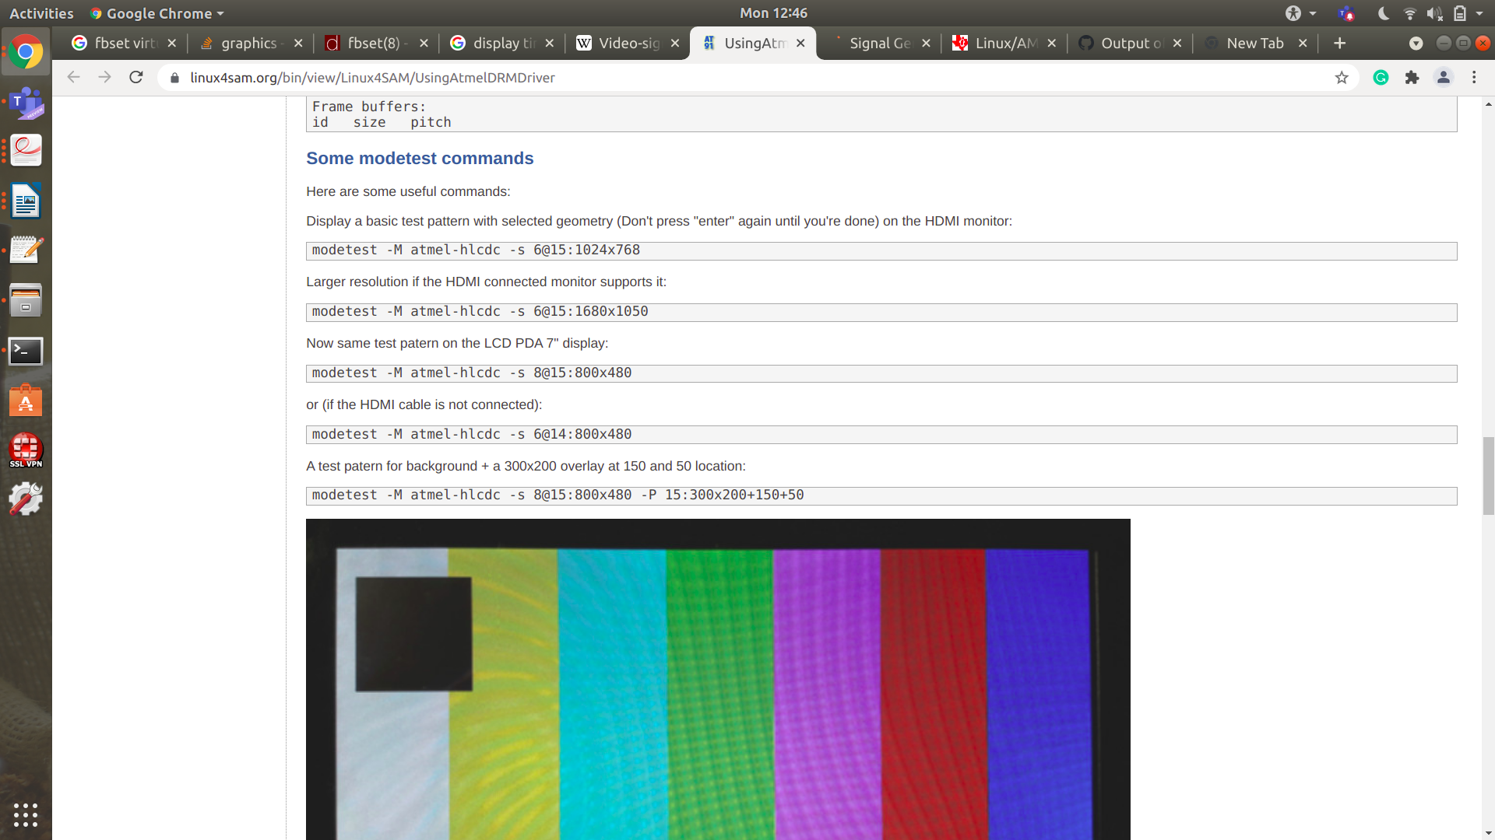

Some modetest commands
Here are some useful commands:
Display a basic test pattern with selected geometry (Don't press "enter" again until you're done) on the HDMI monitor:
modetest -M atmel-hlcdc -s 6@15:1024x768
Larger resolution if the HDMI connected monitor supports it:
modetest -M atmel-hlcdc -s 6@15:1680x1050
Now same test patern on the LCD PDA 7" display:
modetest -M atmel-hlcdc -s 8@15:800x480
or (if the HDMI cable is not connected):
modetest -M atmel-hlcdc -s 6@14:800x480
A test patern for background + a 300x200 overlay at 150 and 50 location:
modetest -M atmel-hlcdc -s 8@15:800x480 -P 15:300x200+150+50
Here is the output of this last command (HDMI screen unplugged):
root@sama5d4ek:~# modetest -M atmel-hlcdc -s 8@15:800x480 -P 15:300x200+150+50
setting mode 800x480@XR24 on connectors 8, crtc 15
testing 300x200@XR24 overlay plane 12
PDA 4" on sama5d2:
modetest -M atmel-hlcdc -s 6@13:480x272

root@mixer_proj:~# modetest -M xlnx
Output should include information about the Encoder, Connector, CRTC (the Mixer), Planes (Mixer layers). All Mixer layers will be deactivate by invoking modetest so the screen should become a solid hue of blue (the default background color).
Below is a Sample output of 2019.1 SDI-Tx with 10bpc as the encoder (edited for brevity and clarity):
root@zcu106-zynqmp:~# modetest -M xlnx
Encoders:
id crtc type possible crtcs possible clones
48 0 TMDS 0x00000001 0x00000000

Connectors:
id encoder status name size (mm) modes encoders
49 0 connected unknown-1 0x0 49 48
modes:
name refresh (Hz) hdisp hss hse htot vdisp vss vse vtot)
4096x2160 60 4096 4184 4272 4400 2160 2168 2178 2250 593408 flags: phsync, pvsync; type: driver
4096x2160 50 4096 5064 5152 5280 2160 2168 2178 2250 594000 flags: phsync, pvsync; type: driver
<snip>
1280x720 24 1280 2250 3155 4125 720 725 730 750 74250 flags: phsync, pvsync; type: driver
720x576i 50 720 732 795 864 288 290 293 312 13500 flags: phsync, pvsync, interlace, dblclk; type: driver
720x486i 60 720 739 801 858 243 247 250 262 13500 flags: phsync, pvsync, interlace, dblclk; type: driver
props:
1 EDID:
flags: immutable blob
blobs:

value:
2 DPMS:
flags: enum
enums: On=0 Standby=1 Suspend=2 Off=3
value: 3
5 link-status:
flags: enum
enums: Good=0 Bad=1
value: 0 <snip>
51 sdi_mode:
flags: range
values: 0 5
value: 2
52 sdi_data_stream:
flags: range
values: 2 8
value: 4

CRTCs:
id fb pos size
47 0 (0,0) (0x0)
0 0 0 0 0 0 0 0 0 0 flags: ; type:
props:

Planes:
id crtc fb CRTC x,y x,y gamma size possible crtcs
29 0 0 0,0 0,0 0 0x00000001
formats: RA24
props:
6 type:
flags: immutable enum
enums: Overlay=0 Primary=1 Cursor=2
value: 2
27 scale:
flags: range
values: 0 2
value: 0
28 alpha:
flags: range
values: 0 256
value: 256 30 0 0 0,0 0,0 0 0x00000001
formats: YUYV
props:
6 type:
flags: immutable enum
enums: Overlay=0 Primary=1 Cursor=2
value: 0
27 scale:
flags: range
values: 0 2
value: 0
28 alpha:
flags: range
values: 0 256
value: 256 31 0 0 0,0 0,0 0 0x00000001
formats: XV15
props:
6 type:
flags: immutable enum
enums: Overlay=0 Primary=1 Cursor=2
value: 0
27 scale:
flags: range
values: 0 2
value: 0
28 alpha:
flags: range
values: 0 256
value: 256 32 0 0 0,0 0,0 0 0x00000001
formats: AB24
props:
6 type:
flags: immutable enum
enums: Overlay=0 Primary=1 Cursor=2
value: 0
27 scale:
flags: range
values: 0 2
value: 0
28 alpha:
flags: range
values: 0 256
value: 256 33 0 0 0,0 0,0 0 0x00000001
formats: BG24
props:
6 type:
flags: immutable enum
enums: Overlay=0 Primary=1 Cursor=2
value: 0
27 scale:
flags: range
values: 0 2
value: 0
28 alpha:
flags: range
values: 0 256
value: 256 34 0 0 0,0 0,0 0 0x00000001
formats: XB24
props:
6 type:
flags: immutable enum
enums: Overlay=0 Primary=1 Cursor=2
value: 0
27 scale:
flags: range
values: 0 2
value: 0
28 alpha:
flags: range
values: 0 256
value: 256 35 0 0 0,0 0,0 0 0x00000001
formats: NV12
props:
6 type:
flags: immutable enum
enums: Overlay=0 Primary=1 Cursor=2
value: 0
27 scale:
flags: range
values: 0 2
value: 0
28 alpha:
flags: range
values: 0 256
value: 256 36 0 0 0,0 0,0 0 0x00000001
formats: XV20
props:
6 type:
flags: immutable enum
enums: Overlay=0 Primary=1 Cursor=2
value: 0
27 scale:
flags: range
values: 0 2
value: 0
28 alpha:
flags: range
values: 0 256
value: 256 37 0 0 0,0 0,0 0 0x00000001
formats: BG24
props:
6 type:
flags: immutable enum
enums: Overlay=0 Primary=1 Cursor=2
value: 0
27 scale:
flags: range
values: 0 2
value: 0
28 alpha:
flags: range
values: 0 256
value: 256 38 0 0 0,0 0,0 0 0x00000001
formats: RG24
props:
6 type:
flags: immutable enum
enums: Overlay=0 Primary=1 Cursor=2
value: 0
28 alpha:
flags: range
values: 0 256
value: 256 39 0 0 0,0 0,0 0 0x00000001
formats: RG24
props:
6 type:
flags: immutable enum
enums: Overlay=0 Primary=1 Cursor=2
value: 0
28 alpha:
flags: range
values: 0 256
value: 256 40 0 0 0,0 0,0 0 0x00000001
formats: RG24
props:
6 type:
flags: immutable enum
enums: Overlay=0 Primary=1 Cursor=2
value: 0
28 alpha:
flags: range
values: 0 256
value: 256 41 0 0 0,0 0,0 0 0x00000001
formats: RG24
props:
6 type:
flags: immutable enum
enums: Overlay=0 Primary=1 Cursor=2
value: 0
28 alpha:
flags: range
values: 0 256
value: 256 42 0 0 0,0 0,0 0 0x00000001
formats: RG24
props:
6 type:
flags: immutable enum
enums: Overlay=0 Primary=1 Cursor=2
value: 0
28 alpha:
flags: range
values: 0 256
value: 256 43 0 0 0,0 0,0 0 0x00000001
formats: RG24
props:
6 type:
flags: immutable enum
enums: Overlay=0 Primary=1 Cursor=2
value: 0
28 alpha:
flags: range
values: 0 256
value: 256 44 0 0 0,0 0,0 0 0x00000001
formats: RG24
props:
6 type:
flags: immutable enum
enums: Overlay=0 Primary=1 Cursor=2
value: 0
28 alpha:
flags: range
values: 0 256
value: 256 45 0 0 0,0 0,0 0 0x00000001
formats: RG24
props:
6 type:
flags: immutable enum
enums: Overlay=0 Primary=1 Cursor=2
value: 0
28 alpha:
flags: range
values: 0 256
value: 256 46 0 0 0,0 0,0 0 0x00000001
formats: XV20
props:
6 type:
flags: immutable enum
enums: Overlay=0 Primary=1 Cursor=2
value: 1

Frame buffers:
id size pitch
Test 2 - Activate an overlay layer
We will activate an overlay plane (RGB in this case) and position it to the top left corner while the background color is being generated using the following command:
root@mixer_proj:~# modetest -M xlnx -P 33@47:640x480+0+0@BG24
Output should indicate the plane id that was activated:

testing 640x480@BG24 overlay plane 33
Additionally, the plane should be presented with diagonally stripped color pattern on screen.

Test 3 - Scale the layer (if enabled for the layer)
From within another console window (and/or if the previous test was run in the background), adjust the layer scale property using modetest. The plane id (33 in case of the example above) will be needed to adjust overlay properties like scale, alpha or background color

root@mixer_proj:~# modetest -M xlnx -w 33:scale:1
Note that the range of possible values for a property appears in the output of modetest. For example, in the case of plane id 33:

33 0 0 0,0 0,0 0 0x00000001
formats: BG24
props:
5 type:
flags: immutable enum
enums: Overlay=0 Primary=1 Cursor=2
value: 0
23 scale:
flags: range
values: 0 2
value: 0
24 alpha:
flags: range
values: 0 256
value: 256
Assuming the up-scaled version of the plane image will fit within the screen, the plane data should be doubled in size by setting the scale property to '1'.

Test 4 - Change layer alpha (if enabled for the layer)
Changing the layer alpha will make an existing overlay layer appear more or less transparent. An alpha value of '0' will render the overlay invisible and a value of '256' will be completely opaque. With an existing layer being displayed (see test 2), change the alpha property to '0' to render the layer invisible.

root@mixer_proj:~# modetest -M xlnx -w 33:alpha:0
The layer should disappear.
Changing the alpha property back to 256 by repeating the above command with a value of 256 should render it visible again.

root@mixer_proj:~# modetest -M xlnx -w 33:alpha:256

Test 5 - Change the background color
The Mixer generates a background color when the primary layer is inactive. By default, this is blue. The color is controlled by an internal RGB-based register and is represented by modetest as a decimal value. The most significant bits represent 'blue' and the least 'red'. As such, by default, only the upper 8 bits are set to generate a solid blue (0xFF0000) resulting in a default value of 16711680.

root@mixer_proj:~# modetest -M xlnx -w 34:bg_color:255
The background color should be a pure red and the new value of the bg_color property will be 255 (0x0000FF).
Test 6 - Change the output resolution
To change Mixer output to a new resolution, modetest must be invoked with the connector id and new resolution. In this example, we change to output 1920x1080:
root@mixer_proj:~# modetest -M xlnx -s 49:1920x1080@BG24

The output should be an SMPTE color bar pattern on the screen in the new resolution specified (note: an optional refresh rate can be added to the above command when multiple options are available via the monitor's EDID).
setting mode 1920x1080-60Hz@BG24 on connectors 49, crtc 47

Vbltest
vbltest is a test tool which is part of the libdrm suite of test tools. It is used to ensure vertical blanking interrupts are properly sent by the DRM driver.

Test 7- Vbltest - Testing vertical blanking interrupts
root@mixer_proj:~# vbltest -M xlnx
starting count: 0
freq: 60.49Hz
freq: 60.00Hz
freq: 60.00Hz
freq: 60.00Hz
The exact frequency output reported should correspond to the display refresh rate (60 Hz in this example). Simply terminate the test when satisfied.

