PROJECT DOCUMENTATION
AI SMART GRIEVANCE ANALYZER
FOR SUSTAINABLE CAMPUS MANAGEMENT
Smart Grievance Analyzer (SGA)
Developed as part of:
1M1B AI for Sustainability Virtual Internship
In collaboration with:
1M1B × IBM SkillsBuild × AICTE
Presented by
MANOJ KUMAR POCHAMOLLA
Institution
Guru Nanak Institute of Technology
Primary Sustainable Development Goal
SDG 11 — Sustainable Cities and Communities
Table of Contents
Abstract 4
1. Introduction 5
2. Problem Statement 6
How Might We? 6
3. Objectives 7
4. SDG Alignment 8
4.1 Primary SDG 8
4.2 Secondary SDGs 8
5. Existing Problem / Current Approach 9
6. Proposed Solution 10
Grievance Analyzer 10
Admin Dashboard 10
7. System Architecture 11
8. System Workflow 12
9. AI Features 13
9.1 Grievance Classification 13
9.2 Priority Detection 13
9.3 Information Extraction 13
9.4 Department Routing 14
9.5 Recurring Issue Detection 14
9.6 Sustainability Analysis 14
9.7 Recommended Actions 14
9.8 AI Summary 14
10. Grievance Analyzer 15
11. Admin Dashboard 17
12. Grievance Tracking 19
13. Database Design 20
14. Technology Stack 21
15. IBM Granite and IBM watsonx.ai Integration……………………………………………………………………………..22
15.1 IBM Granite 4 H Small…………………………………………………………………………………………………………..22
15.2 IBM watsonx.ai…………………………………………………………………………………………………………………….23
15.3 AI Integration in SGA…………………………………………………………………………………………………………….24
15.4 Security Consideration………………………………………………………………………………………………………….24
16. Project Structure 25
17. Implementation 26
18. Sample Input and Output 27
Sample Input 27
Sample Output 27
19. Testing and Results 28
20. Responsible AI 29
Fairness 29
Transparency 29
Privacy 29
Human Review 29
Uncertainty 29
Controlled Output 29
21. Expected Impact 30
22. Limitations 31
23. Future Scope 32
24. Project Benefits 33
For Students and Staff 33
For Administrators 33
For Campus Sustainability 33
25. Conclusion 34
26. Project Information 35

Abstract
Smart Grievance Analyzer (SGA) is an AI-powered decision-support system designed to improve the way campus grievances are analyzed and managed. In educational institutions, students and staff submit grievances related to water leakage, waste management, electricity, infrastructure, cleanliness, transportation, maintenance, and technical issues. When these grievances are submitted as unstructured text, it can be difficult for administrators to quickly understand, prioritize, and route them.
SGA uses IBM Granite through IBM watsonx.ai to analyze natural-language grievances and convert them into structured information. The system identifies the grievance category, priority, issue, location, duration, responsible department, sustainability impact, recommended action, and a concise summary.
The system also includes a recurring issue detection mechanism that compares new grievances with previously submitted grievances to identify potentially recurring problems. This helps administrators recognize repeated campus issues and take more effective corrective actions.
SGA consists of two separate interfaces: a Grievance Analyzer for students and staff, and an Admin Dashboard for college administrators. The system also provides unique Grievance IDs and status tracking, allowing users to check whether their grievance is Pending, In Progress, or Resolved.
The project supports SDG 11 – Sustainable Cities and Communities, with additional alignment to SDG 6, SDG 7, and SDG 12. By combining AI-based analysis, recurring issue detection, sustainability insights, and administrative decision support, SGA aims to contribute to more responsive, efficient, and sustainable campus management.

1. Introduction
Educational institutions manage a large number of day-to-day issues reported by students, faculty, and staff. These issues may include water leakage, overflowing waste bins, electricity wastage, damaged infrastructure, cleanliness problems, transportation concerns, and technical difficulties.
Traditionally, grievance management depends heavily on manual reading and classification of complaints. When the number of grievances increases, administrators may spend significant time identifying the nature and urgency of each issue. Repeated problems may also be difficult to recognize when complaints are submitted at different times using different descriptions.
Artificial Intelligence can help address these challenges by analyzing natural-language grievances and extracting meaningful information automatically.
The Smart Grievance Analyzer (SGA) applies AI to campus grievance management. It uses IBM Granite through IBM watsonx.ai to classify grievances, determine priority, extract important information, recommend responsible departments, identify sustainability impacts, and detect potentially recurring issues.
The objective is not to replace administrators but to provide them with structured information and decision-support capabilities that can help improve campus management.

2. Problem Statement
Campus grievances are often submitted as unstructured text. This makes it difficult for administrators to quickly identify the type, urgency, responsible department, and potential sustainability impact of an issue.
Common problems include:
- Difficulty in manually categorizing grievances
- Difficulty in identifying urgent issues
- Inefficient routing to responsible departments
- Difficulty detecting recurring problems
- Limited understanding of sustainability impacts
- Delays in taking corrective action
- Limited visibility into grievance status

How Might We?
How might we use AI to analyze, prioritize, and identify patterns in campus grievances so that campus services and communities can become more sustainable?

3. Objectives
The main objectives of Smart Grievance Analyzer are:
- To analyze campus grievances using Artificial Intelligence.
- To automatically classify grievances into predefined categories.
- To determine the priority of each grievance.
- To extract important information such as issue, location, and duration.
- To identify the department responsible for handling the grievance.
- To detect potentially recurring grievances.
- To identify sustainability and environmental impacts.
- To generate practical recommended actions.
- To provide a unique Grievance ID for every submitted grievance.
- To allow students and staff to check grievance status.
- To provide administrators with a separate dashboard for grievance management.
- To support data-driven and sustainability-focused campus decision-making.

4. SDG Alignment

4.1 Primary SDG
SDG 11 – Sustainable Cities and Communities
Smart Grievance Analyzer primarily supports SDG 11: Sustainable Cities and Communities by helping educational institutions identify and address recurring infrastructure, waste, water, energy, cleanliness, and environmental problems.
Although the project is designed for a campus environment, a college can be viewed as a small community where efficient resource management and responsive services contribute to sustainability.

4.2 Secondary SDGs
SDG 6 – Clean Water and Sanitation
SGA can help identify water leakage, sanitation problems, and other water-related grievances.
SDG 7 – Affordable and Clean Energy
Electricity-related grievances can help identify unnecessary energy consumption and equipment-related problems.
SDG 12 – Responsible Consumption and Production
Waste management and resource-efficiency grievances can support responsible consumption and waste reduction.

5. Existing Problem / Current Approach
In a conventional grievance management process, users submit complaints through forms, messages, emails, or other channels. Administrators then manually read the complaints, identify their categories, determine urgency, and forward them to the appropriate department.
This approach can create several challenges:
- Manual classification requires time.
- Similar complaints may be treated as separate incidents.
- Urgent grievances may not always be identified quickly.
- Sustainability impacts may not be immediately visible.
- Administrators may lack structured information for decision-making.
- Users may have limited visibility into grievance status.
SGA addresses these challenges by introducing AI-assisted analysis and structured grievance management.

6. Proposed Solution
Smart Grievance Analyzer provides an AI-assisted workflow for campus grievance management.
The system consists of two separate interfaces:

Grievance Analyzer
Designed for students and staff to submit grievances and receive structured AI analysis.

Admin Dashboard
Designed for college administrators to review analyzed grievances, identify important issues, view sustainability insights, and update grievance status.
Both interfaces are connected through a Flask backend and a shared SQLite database.
The AI analysis is performed using IBM Granite through IBM watsonx.ai.

7. System Architecture
The system follows a simple architecture consisting of the frontend interfaces, Flask backend, IBM Granite AI model, and SQLite database.
SGA SYSTEM
|
+-----------+-----------+
| |
v v
Grievance Analyzer Admin Dashboard
Students / Staff College Admin
| |
+-----------+-----------+
|
v
Flask Backend
|
+---------+---------+
| |
v v
IBM Granite SQLite
|
v
AI Analysis
The Grievance Analyzer allows students and staff to submit grievances.
The Flask backend processes requests and communicates with IBM Granite.
IBM Granite analyzes the grievance and generates structured information.
The SQLite database stores the analyzed grievance information.
The Admin Dashboard retrieves stored grievances and provides administrators with management and status-update functionality.

8. System Workflow
The complete workflow of SGA is:
Student / Staff
|
v
Grievance Analyzer
|
v
Flask Backend
|
v
IBM Granite
|
v
AI Analysis
|
+----------------------+
| |
v v
Structured Analysis Recurring Detection
| |
+----------+-----------+
|
v
SQLite Database
|
v
Admin Dashboard
|
v
Admin Reviews Issue
|
v
Pending / In Progress /
Resolved
|
v
Student Checks Status
Using Grievance ID

9. AI Features

9.1 Grievance Classification
IBM Granite categorizes each grievance into one of the predefined categories:
- Water & Sanitation
- Waste Management
- Electricity & Energy
- Infrastructure
- Maintenance
- Transportation
- Environment
- IT/Technical
- Cleanliness
- Other
Predefined categories help maintain consistent classification.

9.2 Priority Detection
The system classifies grievances as:
- High
- Medium
- Low
Priority is determined using factors such as:
- Safety risk
- Health risk
- Service disruption
- Urgency
- Environmental impact
- Resource wastage

9.3 Information Extraction
The AI extracts important information from the submitted grievance, including:
- Issue
- Location
- Duration
If information is not available, the system is instructed not to invent it.

9.4 Department Routing
Based on the nature of the grievance, the AI identifies the responsible department that should handle the issue.

9.5 Recurring Issue Detection
SGA compares the newly analyzed grievance with previous grievances.
The comparison uses similarity between the issue and location information while also considering the grievance category.
If a sufficiently similar previous grievance is found, the system identifies it as a Potentially Recurring Issue and provides a similarity score and matched grievance ID.
The system treats this as a potential match rather than absolute certainty.

9.6 Sustainability Analysis
The AI identifies environmental and resource-related impacts associated with the grievance.
Examples include:
- Water wastage
- Energy wastage
- Waste accumulation
- Environmental pollution
- Resource inefficiency

9.7 Recommended Actions
The system generates a practical recommended action that administrators can consider when addressing the grievance.

9.8 AI Summary
The system generates a concise summary of each grievance to make administrative review easier.

10. Grievance Analyzer
The Grievance Analyzer is the user-facing interface of SGA.
Students and staff can enter a grievance in natural language. For example:
“There is a water leakage near the girls hostel for the last 3 days, and a large amount of water is being wasted.”
The AI analyzes the submitted text and produces structured information such as:
Category: Water & Sanitation
Priority: High
Location: Girls Hostel
Duration: 3 days
Responsible Department: Facilities Management
Sustainability Impact: Water wastage due to the ongoing leakage.
Recommended Action: Inspect and repair the leakage immediately.
The system also generates a unique Grievance ID.

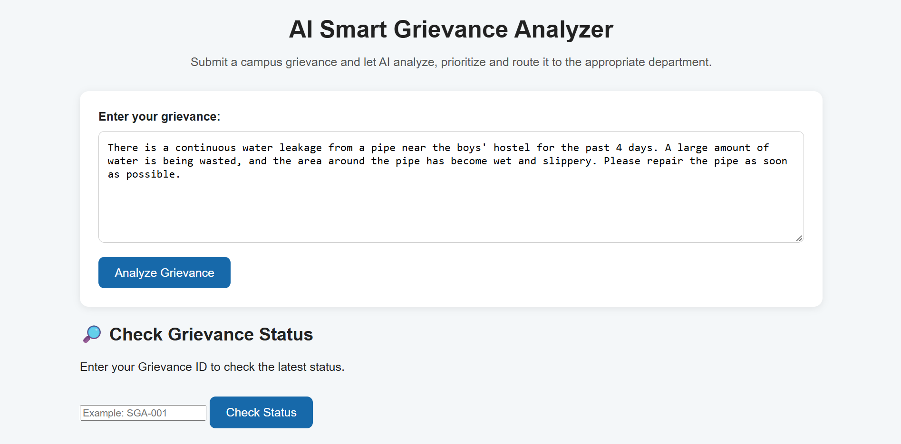

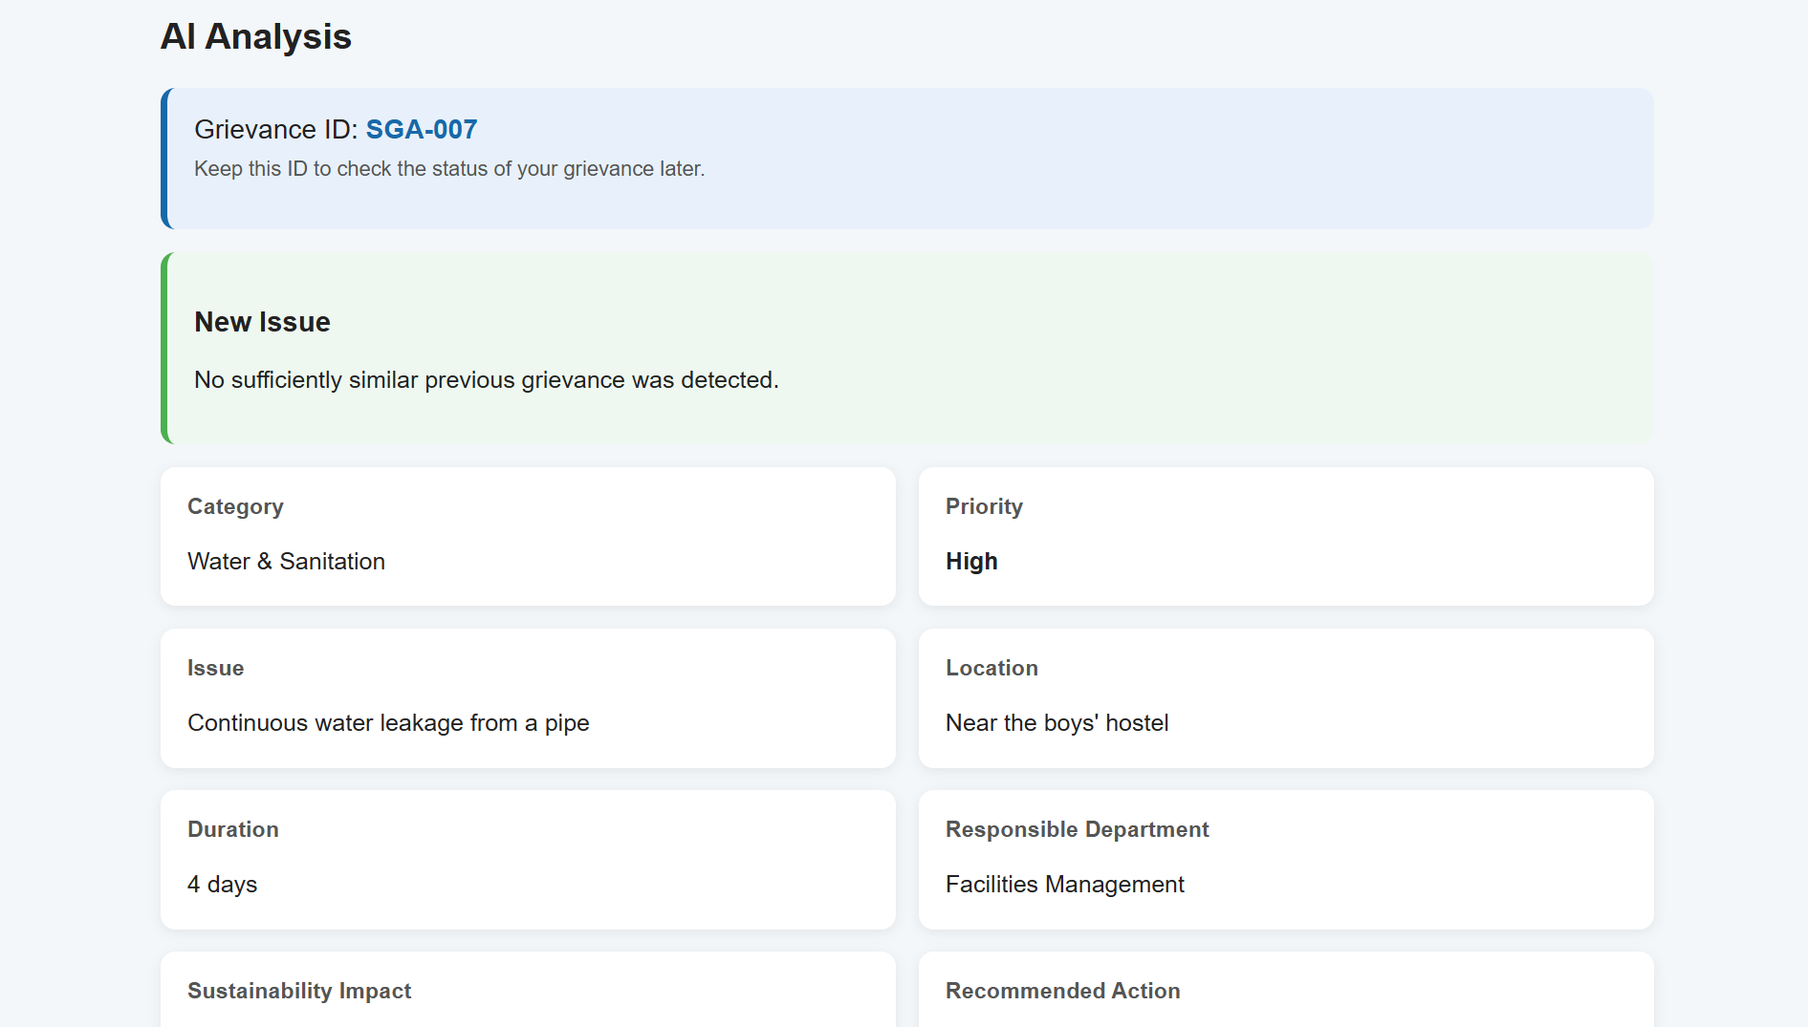

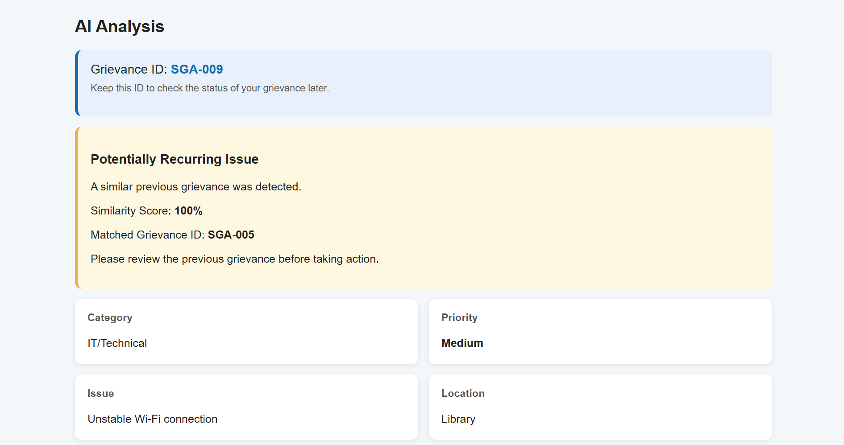

11. Admin Dashboard
The Admin Dashboard is a separate interface designed for college administrators.
It provides an overview of the grievance database and helps administrators monitor campus issues.
The dashboard provides:
- Total grievance count
- High-priority grievance count
- Medium-priority grievance count
- Low-priority grievance count
- Recurring issue count
- Category distribution
- Recent grievances
- Sustainability insights
- Recommended actions
- Grievance status management
Administrators can update the status of grievances using:
Pending → In Progress → Resolved

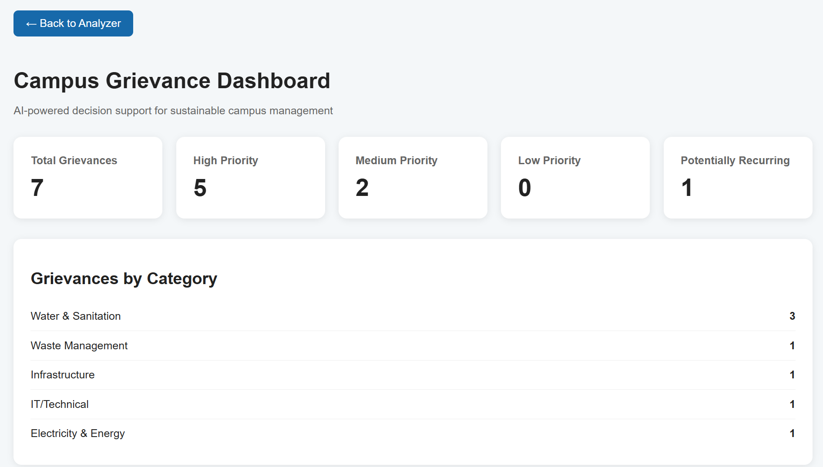
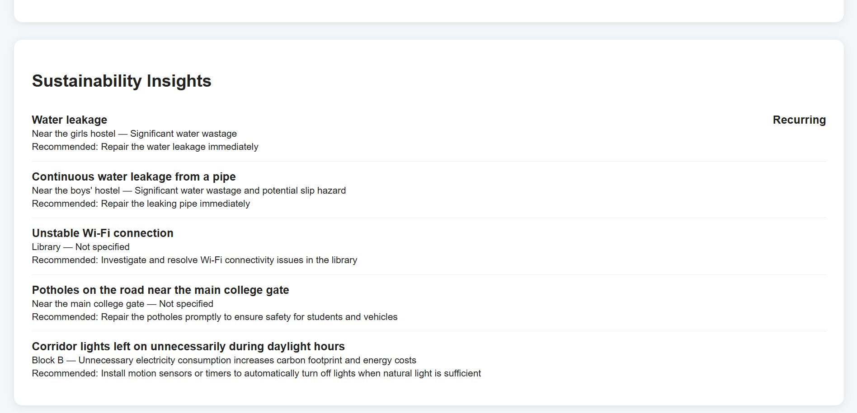
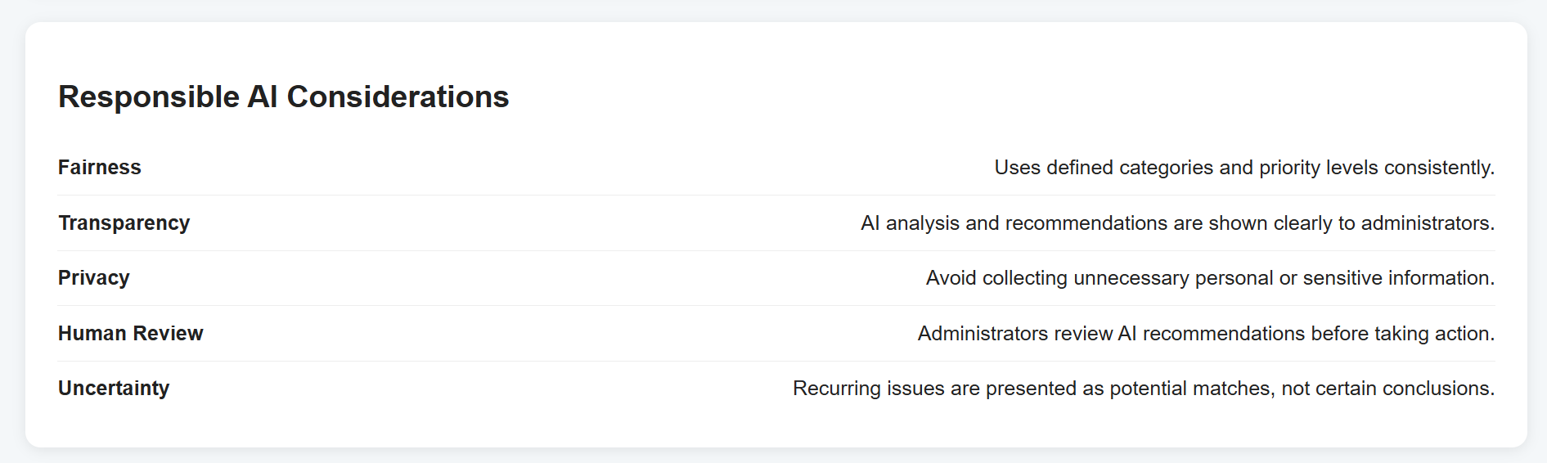
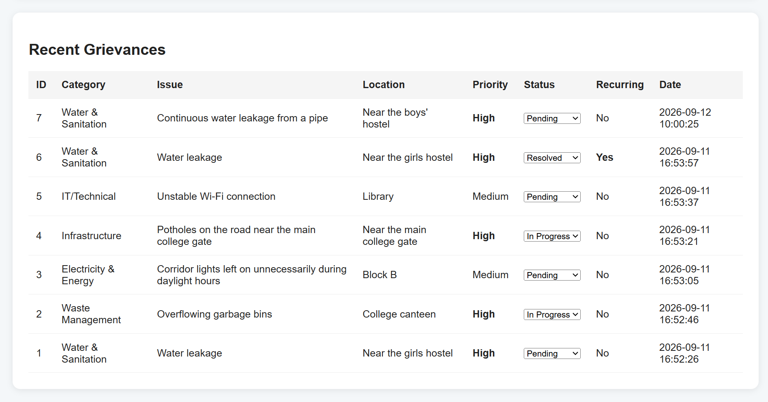

12. Grievance Tracking
Each submitted grievance receives a unique Grievance ID. Examples:
- SGA-001
- SGA-002
- SGA-003
The Grievance ID allows users to check the current status of their submitted grievance. For example:
Grievance ID: SGA-006
Status: Resolved
This provides better transparency between grievance submission and resolution.

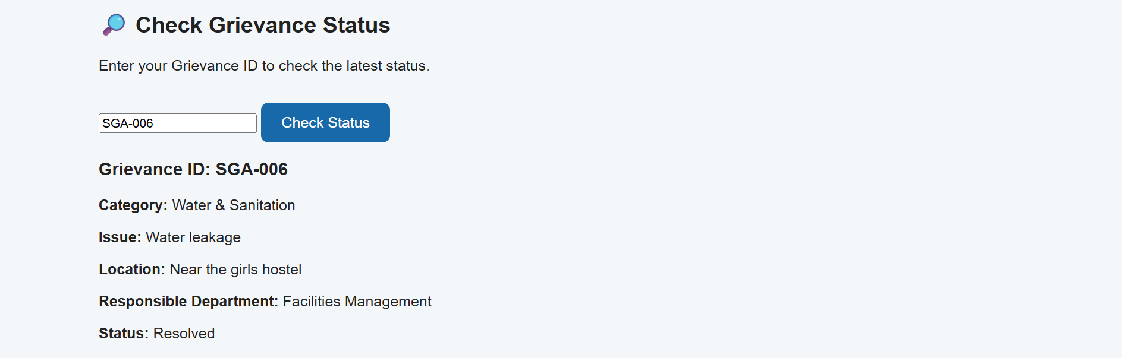

13. Database Design
SGA uses SQLite for storing grievance information.
The database stores important information including:
- Grievance ID
- Original grievance
- Category
- Issue
- Location
- Duration
- Priority
- Responsible department
- Sustainability impact
- Recommended action
- Summary
- Recurring issue indicator
- Matched grievance ID
- Similarity score
- Status
- Creation time
The database allows the system to retain previous grievances for recurring issue detection and administrative review.
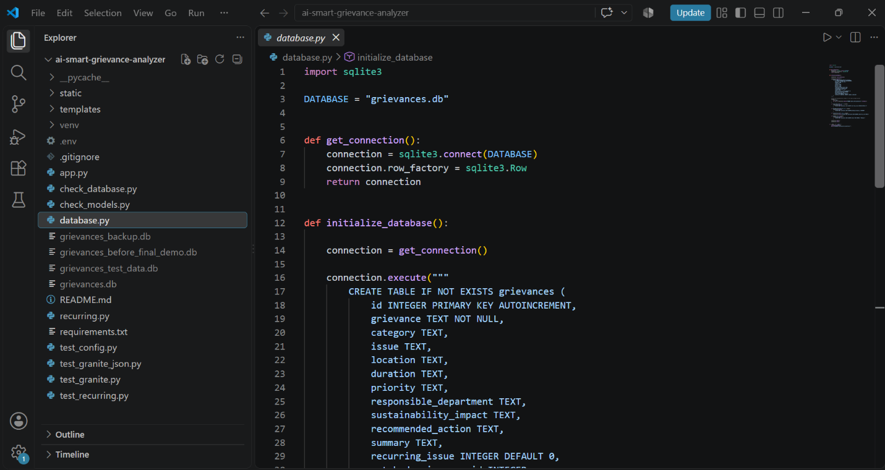

14. Technology Stack
Component | Technology
Programming Language | Python
Frontend | HTML, CSS, JavaScript
Backend Framework | Flask
AI Model | IBM Granite 4 H Small
AI Platform | IBM watsonx.ai
Database | SQLite
Development Environment | Visual Studio Code
Version Control | Git
Code Repository | GitHub

15. IBM Granite and IBM watsonx.ai Integration

The Smart Grievance Analyzer uses IBM Granite as the core artificial intelligence model for analyzing campus grievances. The model is integrated into the application through IBM watsonx.ai, which provides the environment for accessing and using the Granite model.

15.1 IBM Granite 4 H Small
The project uses the IBM Granite 4 H Small (ibm/granite-4-h-small) model. It is responsible for processing the natural-language grievance submitted by a student or staff member and converting the unstructured text into structured and actionable information.
When a grievance is submitted, the Flask backend sends the grievance to the IBM Granite model through the watsonx.ai environment. The model analyzes the content according to predefined instructions and returns information such as:
- Category of the grievance
- Issue description
- Location
- Duration
- Priority level
- Responsible department
- Sustainability impact
- Recommended action
- Short AI-generated summary
The model is also instructed to use predefined categories and priority levels and to avoid inventing information that is not available in the submitted grievance. This helps maintain consistent and controlled AI output.

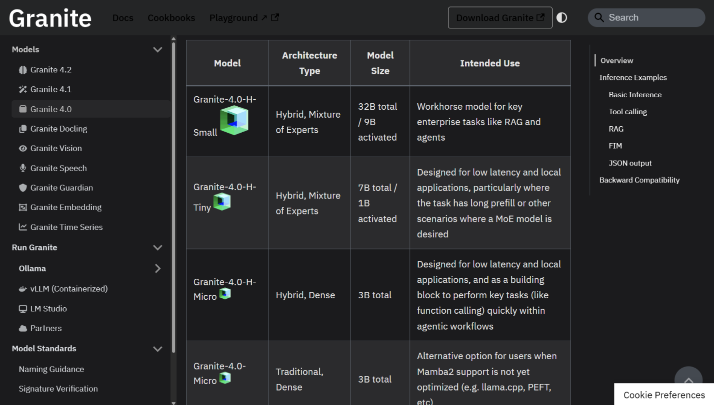
Figure: IBM Granite 4 H Small Foundation Model
15.2 IBM watsonx.ai
IBM watsonx.ai is used as the AI development and runtime platform for integrating the Granite model with the Smart Grievance Analyzer. The project is configured in the Frankfurt region, and the application communicates with the watsonx.ai runtime through the Flask backend.
The watsonx.ai environment provides the connection between the application and the selected IBM Granite model. When a user submits a grievance, the Flask application sends the input to the configured Granite model and receives the generated analysis. The returned information is then processed by the application and stored in the SQLite database.
The integration follows this flow:
Student / Staff
|
v
Grievance Analyzer
|
v
Flask Backend
|
v
IBM watsonx.ai
|
v
IBM Granite 4 H Small
|
v
Structured AI Analysis
|
v
SQLite Database
|
v
Admin Dashboard
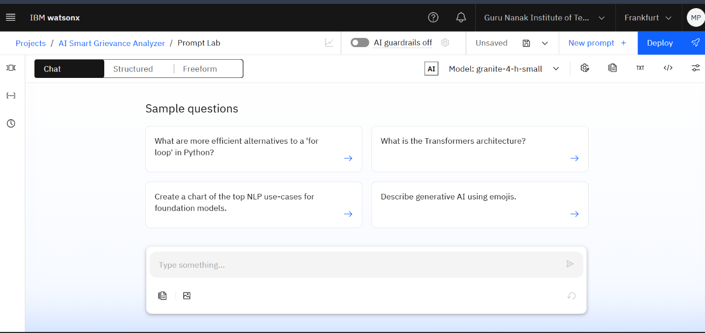
Figure: IBM watsonx.ai Project and Runtime Configuration
15.3 AI Integration in SGA
The integration of IBM Granite with the SGA application enables the system to perform AI-based grievance classification, priority detection, information extraction, sustainability analysis, recurring issue identification, and recommendation generation.
The AI-generated results are not treated as final administrative decisions. Instead, they are provided as decision-support information for campus administrators. Administrators can review the analyzed grievance through the separate Admin Dashboard and take appropriate action.
The application also uses controlled AI instructions to improve reliability. The model is given a fixed set of categories and priority levels, and missing information is represented as “Not specified” rather than being unnecessarily generated.

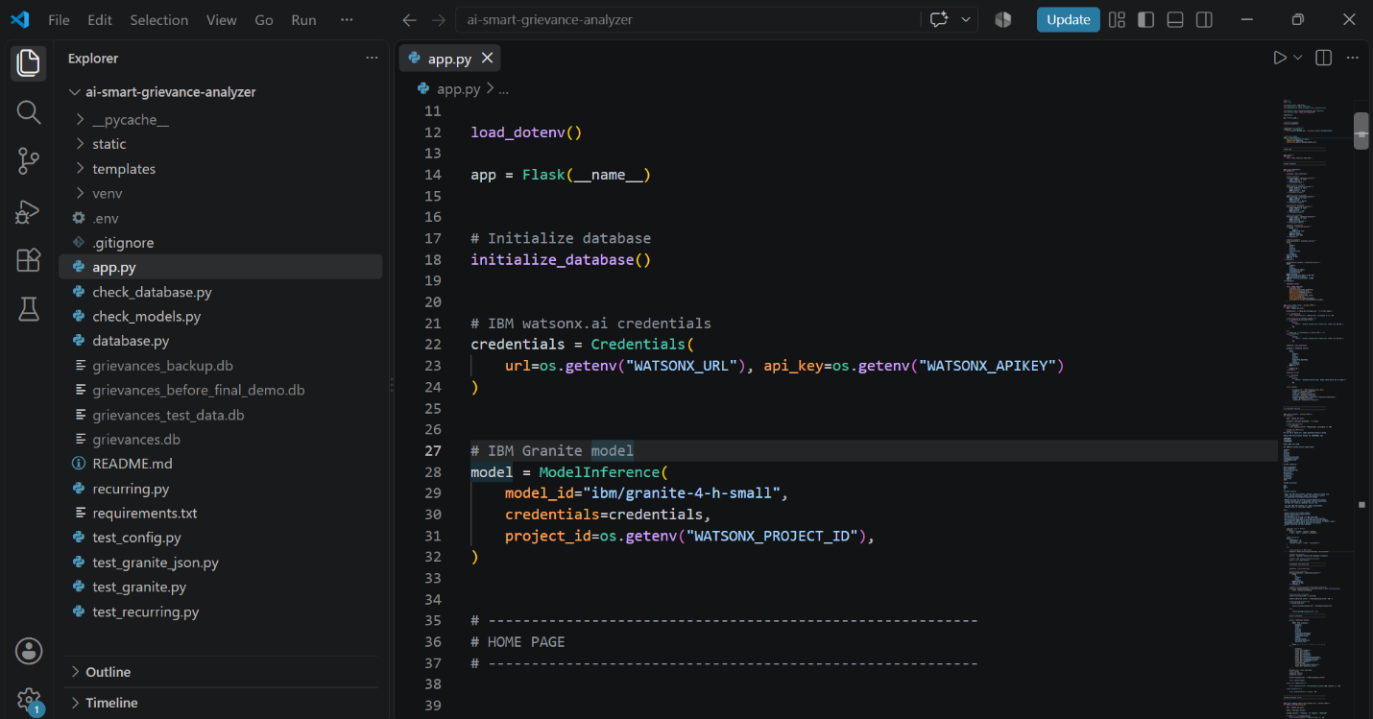
Figure:IBM Granite 4 H Small Integration in the Flask Backend

15.4 Security Consideration
The application uses environment variables to store sensitive configuration information such as the watsonx.ai API key and project configuration. Sensitive credentials are not included in the source code or uploaded to the GitHub repository.
This approach helps protect the AI service credentials while allowing the application to securely communicate with IBM watsonx.ai during execution.

16. Project Structure
smart-grievance-analyzer/
│
├── static/
│
├── templates/
│ ├── index.html
│ └── dashboard.html
│
├── app.py
├── database.py
├── recurring.py
│
├── check_database.py
├── check_models.py
├── test_config.py
├── test_granite.py
├── test_granite_json.py
├── test_recurring.py
│
├── requirements.txt
├── README.md
└── .gitignore

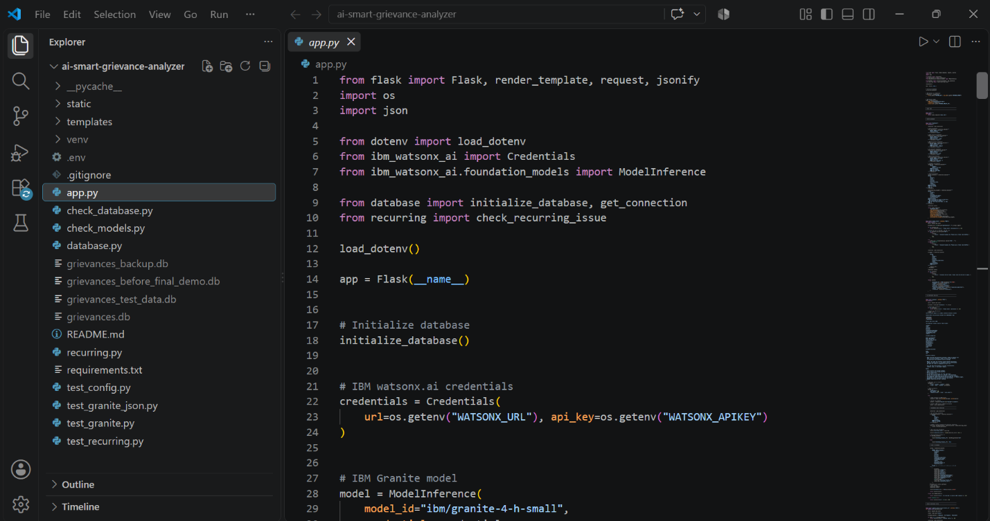

17. Implementation
The backend of SGA is implemented using Python and Flask.
The Flask application provides separate routes for:
- Grievance Analyzer
- Admin Dashboard
- Grievance analysis
- Grievance status checking
- Grievance status updating
When a grievance is submitted, the backend sends the grievance to IBM Granite through the watsonx.ai API.
The AI response is processed as structured JSON and stored in the SQLite database.
The recurring issue detection module then compares the new grievance with previous grievances.
The resulting information is displayed to the user and made available through the Admin Dashboard.

18. Sample Input and Output

Sample Input
“There is a water leakage near the girls hostel for the last 3 days, and a large amount of water is being wasted.”

Sample Output
Category: Water & Sanitation
Issue: Water leakage near the girls hostel
Location: Girls Hostel
Duration: 3 days
Priority: High
Responsible Department: Facilities Management
Sustainability Impact: Water wastage due to the ongoing leakage.
Recommended Action: Inspect and repair the leakage immediately.
Summary: Water leakage near the girls hostel for 3 days is causing water wastage.
If a similar grievance exists in the database, the system can also identify it as a Potentially Recurring Issue.

19. Testing and Results
The prototype was tested using different types of campus grievances.
The demonstration dataset included grievances related to:
- Water leakage
- Waste management
- Electricity usage
- Infrastructure
- IT/Technical issues
- A repeated water leakage grievance
The system successfully demonstrated:
- AI-based classification
- Priority detection
- Information extraction
- Department routing
- Sustainability analysis
- Recommended actions
- Recurring issue detection
- Grievance ID generation
- Status tracking
- Admin Dashboard functionality
The prototype also demonstrated different grievance statuses including Pending, In Progress, and Resolved.

20. Responsible AI
Responsible AI is an important part of SGA because AI-generated classifications and recommendations can influence administrative decisions.

Fairness
Predefined categories and priority levels are used to promote consistent grievance classification.

Transparency
AI-generated analysis and recommendations are clearly displayed to users and administrators.

Privacy
Users are encouraged not to include unnecessary personal or sensitive information in grievances.

Human Review
The AI provides decision support but does not replace human decision-making. Administrators remain responsible for reviewing and acting on grievances.

Uncertainty
Recurring issue detection is presented as a potential match instead of claiming absolute certainty.

Controlled Output
The AI is instructed to use predefined categories and priorities and avoid inventing missing information.

21. Expected Impact
SGA aims to help educational institutions move from reactive complaint handling toward data-driven and sustainability-focused campus management.
Potential benefits include:
- Faster grievance classification
- Better prioritization of urgent issues
- More efficient department routing
- Identification of recurring problems
- Improved resource management
- Reduced water wastage
- Reduced energy wastage
- Better waste management
- Improved grievance transparency
- Data-supported administrative decisions
For example, repeated water leakage complaints can indicate the need for a permanent infrastructure repair rather than repeated temporary fixes.
Similarly, recurring electricity-related grievances may indicate equipment or usage problems that require further investigation.

22. Limitations
The current prototype has some limitations:
- It depends on the quality and clarity of submitted grievance text.
- AI-generated recommendations require human review.
- Recurring issue detection is based on similarity matching and may not identify every semantically similar grievance.
- The current prototype uses SQLite and is intended primarily for demonstration and development.
- The current system does not include authentication or role-based access control.
- The prototype does not currently provide automated email or mobile notifications.
These limitations provide opportunities for future development.

23. Future Scope
Future versions of SGA could include:
- Email and notification alerts
- Mobile application
- Authentication and role-based access
- Advanced analytics
- Trend prediction
- Geographical visualization of recurring issues
- Integration with institutional ticketing systems
- Multilingual grievance submission
- Advanced sustainability metrics
- Automated escalation of unresolved high-priority grievances
These improvements could make the system more suitable for larger institutional deployments.

24. Project Benefits
The major benefits of SGA include:

For Students and Staff
- Simple natural-language grievance submission
- Unique Grievance ID
- Transparent status checking
- Better visibility into grievance progress

For Administrators
- Faster grievance analysis
- Structured information
- Priority-based identification
- Department routing
- Recurring issue detection
- Sustainability insights
- Centralized grievance monitoring

For Campus Sustainability
- Identification of water wastage
- Identification of energy wastage
- Improved waste management
- Detection of recurring infrastructure problems
- Data-supported sustainability decisions

25. Conclusion
Smart Grievance Analyzer demonstrates how Artificial Intelligence can be applied to a practical campus management problem.
By using IBM Granite through IBM watsonx.ai, the system converts unstructured grievances into structured information that can support classification, prioritization, department routing, recurring issue detection, sustainability analysis, and recommended actions.
The system's two-interface design provides a Grievance Analyzer for students and staff and a separate Admin Dashboard for college administrators.
The addition of Grievance IDs and status tracking improves transparency, while recurring issue detection helps administrators identify problems that may require long-term solutions.
Overall, SGA demonstrates how AI can support more responsive, efficient, and sustainability-focused campus management while keeping human administrators involved in the final decision-making process.

26. Project Information
Project Name: Smart Grievance Analyzer (SGA)
Project Title: AI Smart Grievance Analyzer for Sustainable Campus Management
Program: 1M1B AI for Sustainability Virtual Internship
Collaboration: 1M1B × IBM SkillsBuild × AICTE
Institution: Guru Nanak Institute of Technology
Developer: Manoj Kumar Pochamolla
Primary SDG: SDG 11 – Sustainable Cities and Communities
Technology: Python, Flask, SQLite, IBM Granite, IBM watsonx.ai
GitHub Repository: https://github.com/Manoj29981/smart-grievance-analyzer

