GSK Scholars Programme 2022-23

**Eligibility**

* Students must be pursuing the first-year of MBBS programme from government colleges
* Applicants must have obtained at least 65% marks in Class 12 board examinations
* Annual family income of the applicants should be below INR 6,00,000 from all sources
* Children of employees of GSK, GiveIndia and Buddy4Study are not eligible
* Open for Indian nationals only

**Benefits:**

Up to INR 1,00,000 per year for students pursuing MBBS, with a total of up to INR 4.5 lakh over four and a half years.

**Note**: *Scholarship funds can be utilised only for academic expenses which include tuition fees, exam fees, books, hostel fees, food and seminars. If funds still remain, they will be used for stationery, online learning, and payment of internet/data pack bills.*

**Documents**

* Marksheet of Class 12
* A government-issued identity proof (Aadhaar card/voter identity card/driving license/PAN card)
* Current year admission proof (fee receipt/admission letter/institution identity card/bonafide certificate)
* Family income proof (salary slip, Form 16, Income Certificate, ITR)
* Bank account details of applicant
* Photograph of the applicant

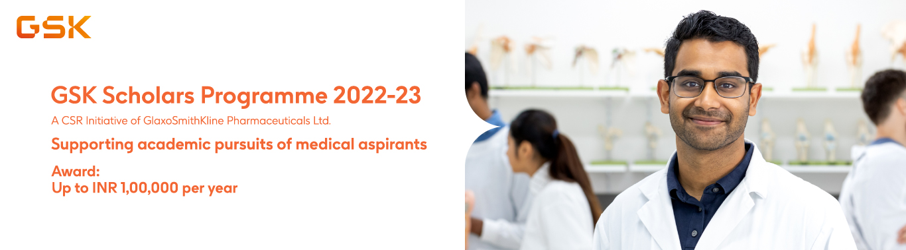

BYPL SASHAKT Scholarship 2022-23

**Eligibility**

* Open for Indian nationals residing in Delhi only.
* Applicants must be studying in the final year of undergraduate programme (any stream) in any government institute in Delhi.
* Must have secured more than 55% marks in their last appeared examination.
* Annual family income of the applicant must not be more than INR 6,00,000 (6 lakhs) from all sources.
* Children of employees of BSES Yamuna Power Limited (BYPL) and Buddy4Study are not eligible.

**Benefits:**

Up to INR 30,000*

*\*The amount of scholarship can vary on a case-to-case basis at the discretion of BYPL. It can be utilized only for academic expense purposes which includes tuition fees, food, hostel fee, internet, books, stationery, online learning, etc.*

**Documents**

* Passport size photograph
* Aadhaar card
* Family income proof (Salary Slip, Form 16, Income Certificate, ITR, etc.)
* Marksheets of last qualifying examination and Class 12
* Latest college fee receipt (for current academic year)
* Fee structure (for current academic year)
* Bank account details of the scholarship applicant (cancelled cheque/passbook copy)

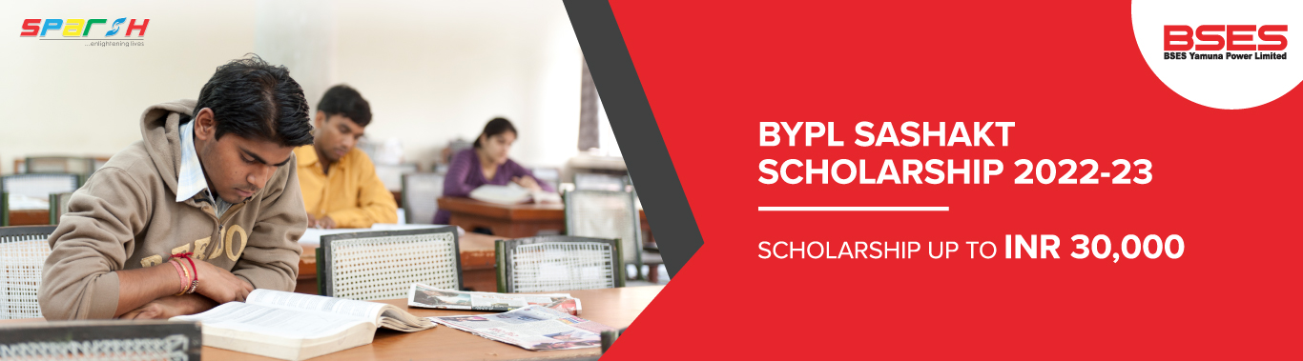

Sensodyne IDA Shining Star Scholarship Programme

**Eligibility**

* Open for students pursuing their first-year Bachelor of Dental Surgery (BDS) programme only from government and government-funded colleges.
* Applicant must have scored a minimum of 60% in their Higher Secondary Education. (**NOTE:** Successful applicant has to maintain a minimum 60% score in each semester/year to continue availing the benefits for their 4 years course.)
* Annual family income of the applicants should not be more than INR 8,00,000/- from all sources.
* Children or family members of employees of HALEON India (erstwhile GlaxoSmithKline Consumer Healthcare), IDA, Goodera & Buddy4Study are not eligible.
* Students from pan-India can apply.

**Benefits:**

Each successfully selected student will receive INR 1,05,000 per year for 4 years of BDS Course.

***NOTE****: The scholarship amount can be utilized only for academic expenses such as tuition fees, hostel fees, food, internet, mobile, laptop, books, stationery, online learning, etc.*

**Documents**

* Marksheet of the previous class/semester
* Photo identity proof (Aadhaar Card/voter id card/driving license/PAN card)
* Current year admission proof (fee receipt/admission letter/institution ID card/bonafide certificate)
* Family income proof (Government-issued documents such as tax return, income certificate from local administration, EWS (Economic Weaker Section) certificate)
* Bank account details of the applicant or parent
* Photograph of the applicant

***Note****: From the second year onwards, the scholar needs to submit a character certificate from College.*

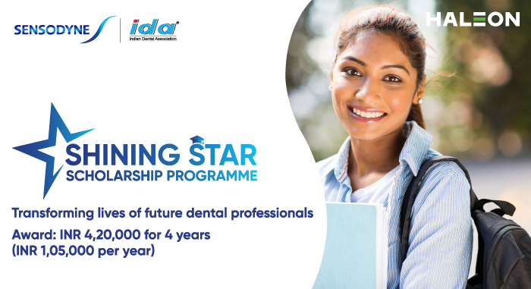

Schaeffler India Hope Engineering Scholarship 2022-23

**Eligibility**

* Open for students from Gujarat, Maharashtra, and Tamil Nadu only.
* Applicants must have scored more than 60% marks in Class 12 (Science) in academic session 2021-22.
* Only applicants enrolled in 1st year of the engineering program at any recognized colleges in India can apply.
* Engineering branches that shall be given preference include -
  + Electronics
  + Electrical
  + Telecommunication
  + Metallurgy
  + IT
  + Mechanical
  + Production
  + Instrumentation
  + Mechatronics
  + Automobile
* Annual family income of the applicants must be less than INR 5,00,000.
* Children of employees of Schaeffler India or Buddy4Study are not eligible for this scholarship program.

**Benefits:**

Up to INR 75,000 per year for the complete duration of the engineering program

**Documents**

* Passport size photograph
* Aadhaar Card
* Family income proof
* Bank passbook
* Class 10 marksheet
* Class 12 marksheet
* Admission letter
* Latest school/college fee receipt

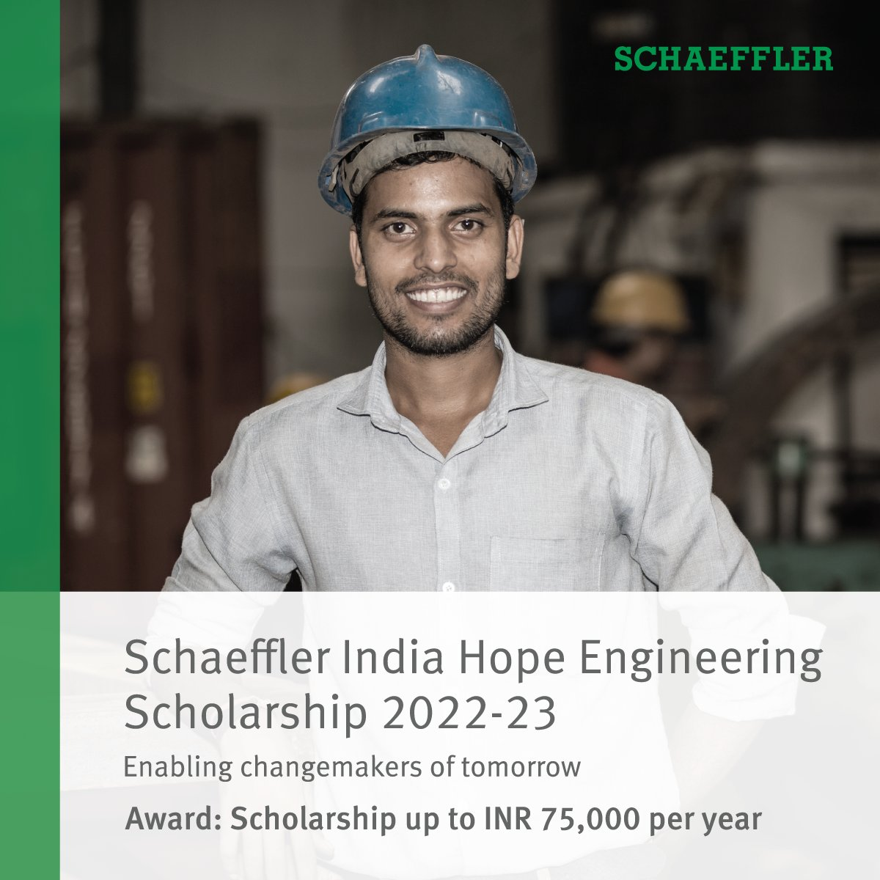

Virchow Scholarship Program 2022

**Eligibility**

* Open for girl students only.
* Students must be residents of Telangana or Andhra Pradesh.
* Applicants must be currently studying in Class 11 (any stream) or first year of graduation/diploma (any stream) from government schools/colleges only after their Class 10 and 12 examinations.
* Applicants must have scored at least 70% marks in their Class 10/12 examinations.
* Annual family income of the applicants should be less than INR 6 lakh from all sources.
* Children of employees of Virchow & Buddy4Study are not eligible.

**Benefits:**

**For Class 10 Passed Students (studying in Class 11)**: INR 10,000 per year  
**For Class 12 Passed Students (studying in Graduation/Diploma)**: INR 15,000 per year  
***Note****: The scholarship fund can be utilized only to cover academic expenses.*

**Documents**

* Marksheet of Class 10 or 12
* A government-issued identity proof (Aadhaar card/voter identity card/driving license/PAN card)
* Current year admission proof (fee receipt/admission letter/institution identity card/bonafide certificate)
* Family income proof (Salary Slip, Form 16, Income Certificate, ITR, etc.)
* Bank account details of applicant
* Photograph of the applicant

