SIMATS ENGINEERING
ASSESSMENT TOOL 1: Agent Design Assessment
COURSE NAME: ARTIFICIAL INTELLIGENCE COURSE CODE: MLA0102
AND EXPERT SYSTEMS

COURSE OUTCOME COVERED

CO1: Apply search algorithms and heuristic techniques to solve state-space search and optimization problems. (BTL 3)

Assessment Tool Weightage: 55 %

Total Marks: 50 Time: 60 Mins
No. of Questions: 1
Annexure A
Agent Design Assessment

Code of Conduct:

I Kanchamreddy Manoj Kumar Reddy/192425266 (Name / Reg No) certify that this submission is my original work and that I have adhered to the guidelines specified for this assessment. I understand that any violation of academic integrity rules will result in disciplinary action.

Signature of the student: K. Manoj Kumar reddy

Question | Problem  Understanding  & AI Concept Identification | Dialogflow Agent Design &  Implementation | Problem  Formulation  &  Conversation  Flow Design | Application of  AI Techniques  & Reasoning | Testing,  Evaluation &  Documentation | Total
Weightage | 20% | 30% | 20% | 20% | 10% | 100%
Q1

Signature of the Faculty Total Marks Awarded

Scenario
A university wants to develop an AI-based Student Support Assistant to provide instant responses to student queries related to course registration, timetable, examination schedules, attendance details, and campus services.
As an AI developer, design and implement a conversational agent using Dialogflow that can understand user requests, process intents, and provide appropriate responses.

Q. No. | Criteria to be evaluated | BL | Marks
1 | Problem Analysis and Agent Design: Analyze the student support problem and explain how Artificial Intelligence can solve the problem. Design the conversational agent by defining its objective, users, environment, inputs, outputs, and expected performance measures. | BL3 | 10
2 | Dialogflow Agent Development: Create a Dialogflow agent by designing appropriate Intents, Entities, Training Phrases, Responses, and Contexts. Explain how the agent perceives user queries and generates responses. Provide screenshots of the implementation. | BL5 | 10
3 | Problem Formulation and Decision Flow: Represent the chatbot interaction as a problem-solving process by defining the initial state, user goal, possible actions, state transitions, and goal completion conditions. Draw the conversation flow diagram. | BL6 | 10
4 | Search Strategy Application: Analyze how search techniques used in AI problem solving can support conversational agents. Apply a suitable search approach (such as Breadth First Search or heuristic-based search) to model intent selection or dialogue navigation and justify your choice. | BL5 | 10
5 | Testing and Evaluation: Test the Dialogflow agent with different user queries. Evaluate accuracy, response quality, handling of unknown queries, and suggest improvements. | BL6 | 10

Question 1: Problem Analysis and Agent Design
1. Problem Analysis
Students often have queries about course registration, timetables, exams, attendance, and campus services. Manual support takes time and is not available 24/7. An AI chatbot can answer these queries instantly and reduce staff workload.
2. AI Solution
A Dialog flow chatbot uses Artificial Intelligence and Natural Language Processing (NLP) to understand student questions and provide accurate responses automatically.
3. Agent Objective
To provide quick and accurate answers to student queries related to university services.
4. Users
- Students
- Faculty
- University Administration
5. Environment
- Dialogflow platform
- University website/mobile app
- Internet connection
- University database
6. Inputs
- Course registration queries
- Timetable requests
- Exam schedule queries
- Attendance queries
- Campus service questions
7. Outputs
- Registration details
- Timetable information
- Exam schedule
- Attendance details
- Campus service information
8. Performance Measures
Measure | Description
Accuracy | Correct responses
Response Time | Fast replies
Availability | 24×7 support
User Satisfaction | Better student experience
9. PEAS Model
Component | Description
Performance | Accurate and fast responses
Environment | University website/app
Actuators | Chatbot replies
Sensors | Student text input
10. Working
- Student enters a question.
- Dialogflow identifies the intent.
- The chatbot searches for the correct information.
- The chatbot sends the appropriate response.
11. Conclusion
The AI-based Student Support Assistant provides instant, accurate, and 24×7 support for students, improving efficiency and reducing manual work.

Question 2: Dialogflow Agent Development (10 Marks)
1. Dialogflow Agent Development
A Dialogflow agent named "Student Support Assistant" is created to answer student queries related to course registration, timetable, examination schedule, attendance, and campus services. The chatbot uses Intents, Entities, Training Phrases, Responses, and Contexts to understand user requests and provide appropriate responses.
2. Intents
The chatbot contains the following intents:
Intent Name | Purpose
Default Welcome Intent | Greets the user
Course Registration | Provides registration information
Timetable | Displays class timetable
Examination Schedule | Shows exam dates
Attendance | Provides attendance details
Campus Services | Gives information about library, hostel, transport, etc.
Default Fallback Intent | Handles unknown queries

3. Entities
Entities help the chatbot identify important information from the user's query.
Entity | Example
@course | AI, DBMS, Java
@semester | Semester 5
@department | CSE
@service | Library, Hostel, Transport

4. Training Phrases
Course Registration
- How do I register for courses?
- Register my course.
- Course registration details.
Timetable
- Show my timetable.
- What are today's classes?
Examination Schedule
- When is my exam?
- Show exam timetable.
Attendance
- Show my attendance.
- What is my attendance percentage?

5. Responses
User: How do I register for courses?
Bot: You can register for courses through the university student portal during the registration period.
User: Show my timetable.
Bot: Your timetable is available from Monday to Friday between 9:00 AM and 4:00 PM.

6. Contexts
Contexts help the chatbot continue the conversation. For example, after answering an exam-related question, the chatbot understands follow-up questions about examinations without asking the user to repeat the topic.

7. Working of the Dialogflow Agent
- The student enters a query.
- Dialogflow receives and analyzes the query using NLP.
- The chatbot identifies the correct intent and entity.
- It retrieves the appropriate information.
- The chatbot sends the correct response to the student.

8. Screenshots
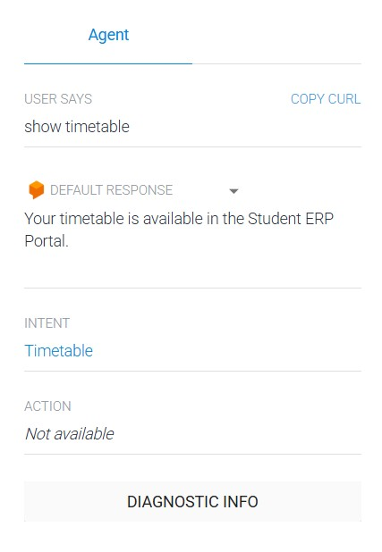
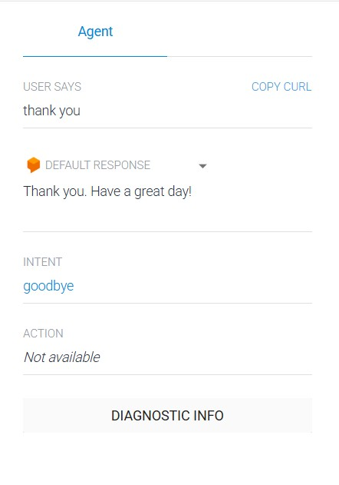
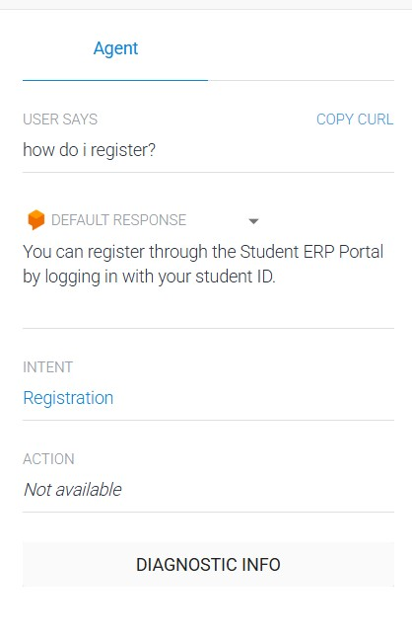

9. Conclusion
The Dialogflow Student Support Assistant understands student queries using intents and entities and provides quick, accurate, and automated responses. It improves communication, reduces manual effort, and offers 24×7 student support.

Question 3: Problem Formulation and Decision Flow
1. Problem Formulation
The Student Support Assistant is designed to solve student queries related to course registration, timetable, examination schedule, attendance, and campus services. The chatbot receives a student's query, identifies the intent, and provides the appropriate response using Dialogflow.

2. Initial State
The student opens the chatbot and enters a question.

3. User Goal
The goal is to obtain accurate information about university services such as registration, timetable, exams, attendance, or campus facilities.

4. Possible Actions
The chatbot can perform the following actions:
- Answer course registration queries.
- Display timetable information.
- Provide examination schedules.
- Show attendance details.
- Give campus service information.
- Handle unknown queries using the fallback intent.

5. State Transitions
The chatbot moves through different states during the conversation:
Initial State → User Query → Intent Detection → Information Retrieval → Response Generation → Goal State

6. Goal Completion Conditions
The goal is completed when:
- The chatbot identifies the correct intent.
- The correct information is retrieved.
- The student receives the required response successfully.

7. Conclusion
The problem formulation clearly defines how the chatbot processes a student's query from the initial state to the goal state. The conversation flow enables the chatbot to provide accurate and quick responses, improving the overall student support system.

Question 4: Search Strategy Application (10 Marks)
1. Search Strategy Application
Search techniques in Artificial Intelligence help a chatbot identify the correct intent and generate an appropriate response. For the Student Support Assistant, Breadth First Search (BFS) is used because it explores all possible intents level by level and selects the best matching intent for the user's query.

2. Selected Search Technique – Breadth First Search (BFS)
Breadth First Search (BFS) is an AI search algorithm that explores all nodes at the current level before moving to the next level. It helps the chatbot find the correct intent quickly and accurately.

3. Application of BFS in the Chatbot
When a student enters a query, the chatbot checks all available intents such as Course Registration, Timetable, Examination Schedule, Attendance, and Campus Services. After finding the best matching intent, it retrieves the corresponding response and displays it to the user.

4. Justification
BFS is suitable for the Student Support Assistant because:
- It searches all possible intents systematically.
- It quickly finds the correct intent.
- It improves response accuracy.
- It reduces incorrect responses.
- It is simple and efficient for chatbot navigation.

5. Advantages of BFS
- Finds the correct intent quickly.
- Provides accurate responses.
- Easy to implement.
- Improves user experience.
- Supports efficient dialogue navigation.

6. Conclusion
Breadth First Search (BFS) is an effective search strategy for the Student Support Assistant. It helps the chatbot identify the correct intent efficiently and provide fast, accurate, and reliable responses to student queries.

Question 5: Testing and Evaluation (10 Marks)
1. Testing and Evaluation
The Dialogflow Student Support Assistant was tested using different student queries to verify whether it provides correct and accurate responses. The chatbot successfully identified user intents and responded appropriately.

2. Test Cases
Test Case | User Query | Expected Response | Result
1 | Hello | Welcome message | Pass
2 | How do I register for courses? | Registration details | Pass
3 | Show my timetable | Timetable information | Pass
4 | When is my exam? | Examination schedule | Pass
5 | What is my attendance? | Attendance details | Pass
6 | Where is the library? | Campus service information | Pass
7 | Random question | Default fallback response | Pass

3. Evaluation
Parameter | Observation
Accuracy | Correctly answered most queries
Response Quality | Clear and relevant responses
Response Time | Fast (within a few seconds)
Unknown Query Handling | Used Default Fallback Intent
User Satisfaction | Easy and user-friendly interaction

4. Handling Unknown Queries
When the chatbot receives a question that is not available in its knowledge base, it activates the Default Fallback Intent and responds politely.
Example:
User: What is the weather today?
Bot: Sorry, I couldn't understand your question. Please try asking about registration, timetable, exams, attendance, or campus services.

5. Suggested Improvements
- Add voice input support.
- Support multiple languages.
- Connect with the university database for real-time information.
- Improve NLP by adding more training phrases.
- Provide personalized responses based on student login.

6. Conclusion
The Dialogflow Student Support Assistant was successfully tested with different user queries. It provides accurate, fast, and reliable responses while effectively handling unknown queries using the fallback intent. With additional features such as voice support and database integration, the chatbot can further improve the student support system.

Evaluation Rubrics

Criteria | Weightage  (%) | Excellent (Full Marks) | Good | Average | Poor
Problem  Understanding &  AI Concept  Identification | 20% | 10 – Clearly analyzes the student support problem, defines AI application, agent objective, users, environment, inputs, outputs, and performance measures with proper justification. | 7.5 – Identifies most components of the agent design with minor omissions. | 5 – Provides basic problem analysis with limited explanation of agent components. | 0–2.5 – Incomplete understanding of problem and agent design.
Dialogflow Agent  Design &  Implementation | 30% | 10 – Successfully creates a functional Dialogflow agent with appropriate intents, entities, training phrases, responses, contexts, and explains interaction flow with screenshots. | 7.5 – Develops major Dialogflow components with minor configuration errors. | 5 – Creates basic intents and responses with limited entity/context utilization. | 0–2.5 – Incomplete or incorrect  Dialogflow implementation  .
Problem  Formulation &  Conversation  Flow Design | 20% | 10 – Clearly represents chatbot interaction using initial state, goal state, actions, state transitions, goal conditions, and a well-designed conversation flow diagram. | 7.5 – Provides a structured flow with minor missing details. | 5 – Provides basic flow representation with limited explanation. | 0–2.5 – Poor or missing problem formulation and decision flow.
Application of AI  Techniques &  Reasoning | 20% | 10 – Correctly analyzes and applies suitable search strategies (BFS/heuristic search) for intent selection or dialogue navigation with strong justification. | 7.5 – Applies appropriate search strategy with reasonable explanation. | 5 – Provides basic understanding of search strategy application. | 0–2.5 – Unable to relate search concepts with conversational agent.
Testing,  Evaluation &  Documentation | 10% | 10 – Performs comprehensive testing using multiple user queries, evaluates accuracy, response quality, unknown query handling, and suggests meaningful improvements. | 7.5 – Performs adequate testing and provides evaluation with minor gaps. | 5 – Conducts limited testing with basic observations. | 0–2.5 – Insufficient testing and evaluation.

