Computer Networks
Project – 1
MultiThreaded WebClient And Server

ENVIRONMENT :

Operating System: Windows 10
Browsers : Internet Explorer v9, Mozilla Firefox v38.0.5
Development Platform:Python 2.7
Tool: Command prompt

PROJECT DESCRIPTION :
• The program can run on any available port of the system.
• Multiple requests can be handled by the server at the same time. Client requests are handled in separate threads.
• If the file exists on the server, the server responds with "HTTP/1.1 200 OK” along with the contents of the file.
• If the file is not found, server responds with a "HTTP/1.0 404 Not Found” message.

PROGRAM EXECUTION INSTRUCTIONS :

• Install Python 2.7
• Unzipthefile‘1001359921_MekapotulaManoj.zip’ ?
• Open the command prompt and navigate to the path where the zipped folder is extracted.
• For compiling Client Server communication compile following
python WebServer.py
python WebClient.py

• For compiling Client multithreadServer communication compile following
python WebMultiThreadServer.py
python WebClient.py

Screen Shots of Execution:

1) compiling server and that is ready for connection.

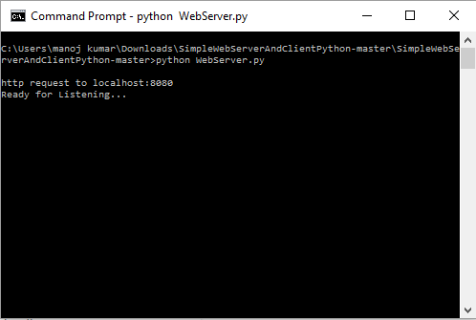

2) Compiling the clinent, connection was established with the server with help of socket connection.
If the out put shows HTTP/1.1 200 OK for successful execution.

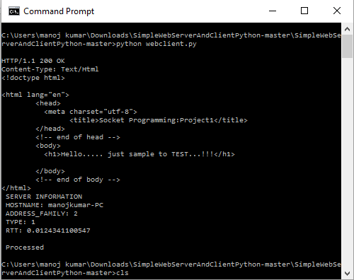

3) Showing client parameters of successful execution

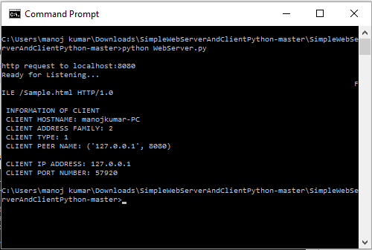

4) On successful execution while calling the server through web browser.

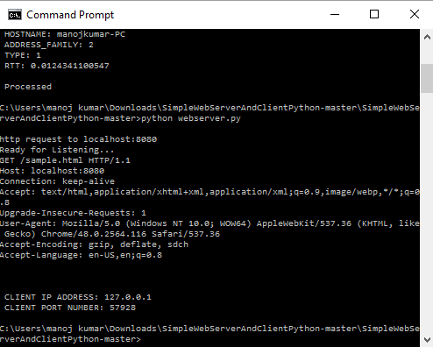

5) Output through the browser.....

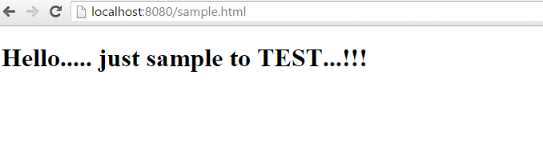

References:

1) http://www.tutorialspoint.com/python/python_multithreading.htm

2) https://docs.python.org/2/contents.html

3) https://docs.python.org/2/howto/sockets.html

