Design a java program to add two matrix using multi-dimensional arrays, pass two-dimensional arrays as parameter to the method

Code:

import java.util.Scanner;

public class matrixmulti

{

public void sum(int[][] array1,int[][] array2,int m,int n)

{

int res[][]=new int[m][n];

for(int i=0;i<m;i++)

{

for(int j=0;j<n;j++)

{

res[i][j]=array1[i][j]+array2[i][j];

}

}

System.out.println("Matrix after addition is:");

for(int i=0;i<m;i++)

{

for(int j=0;j<n;j++)

{

System.out.print(res[i][j]+"\t");

}

System.out.print("\n");

}

}

public static void main(String[] args)

{

int rows,columns;

Scanner object=new Scanner(System.in);

System.out.print("\nEnter the rows of the matrix:");

rows=object.nextInt();

System.out.print("\nEnter the columns of the matrix:");

columns=object.nextInt();

int array1[][]=new int[rows][columns];

int array2[][]=new int[rows][columns];

System.out.println("Enter the array1 elements:");

for(int iter1=0;iter1<rows;iter1++)

{

for(int iter2=0;iter2<columns;iter2++)

{

array1[iter1][iter2]=object.nextInt();

}

}

System.out.println("Enter the array2 elements:");

for(int iter1=0;iter1<rows;iter1++)

{

for(int iter2=0;iter2<columns;iter2++)

{

array2[iter1][iter2]=object.nextInt();

}

}

matrixmulti add=new matrixmulti();

add.sum(array1,array2,rows,columns);

}

}

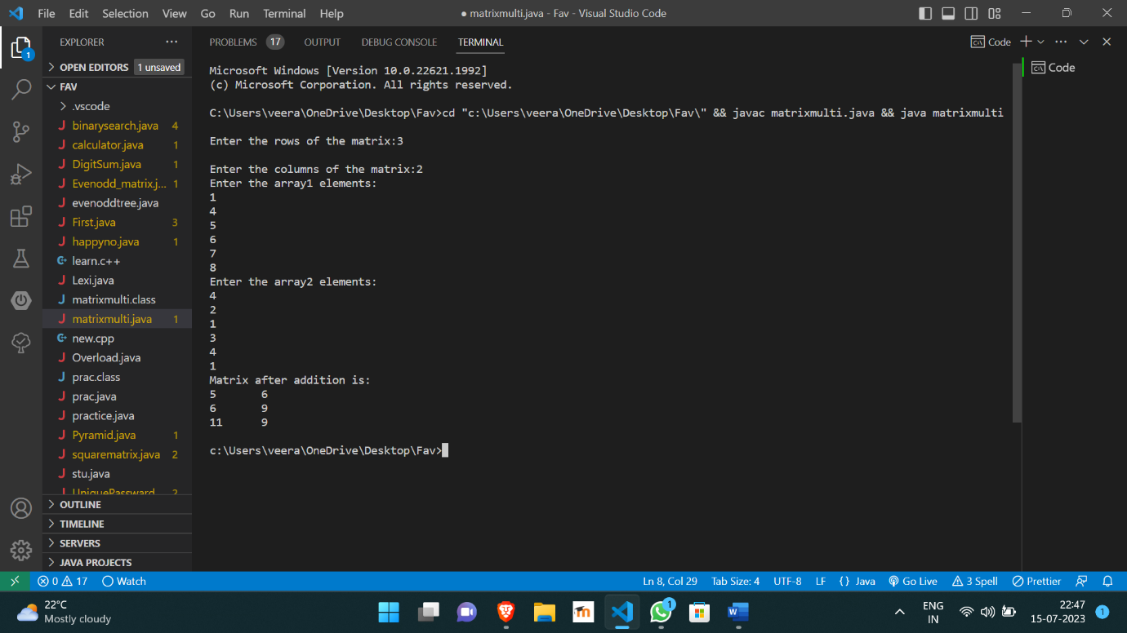

https://github.com/Veeragoutham04/Java_Lab/blob/main/MatrixAdd