Design a java code which accepts a room number and name of the customer and generate 6 character unique password

import java.util.Scanner;

public class UniquePassward

{

public static void main(String[] args)

{

Scanner s=new Scanner(System.in);

String name;

String pw=new String();

long ph;int rno,rem,sum=0;

System.out.println("Enter the name : ");

name=s.next();

System.out.println("Enter the room no : ");

rno=s.nextInt();

int rno1=rno;

System.out.println("Enter the phone number : ");

ph=s.nextLong();

char []sym={')','!','@','#','$','%','^','&','*','('};

do

{

while(rno!=0)

{

rem=rno%10;

sum=sum+rem;

rno=rno/10;

}

if(sum>=10)

{

rno=sum;

sum=0;

}

}while(rno!=0);

int c=rno1/100;

int len=name.length();

int pos=0;

for(int i=0;i<len;i++)

{

if(c==i)

{

pos=i;

System.out.println("Password is : ");

}

}

pw=""+name.charAt(0)+(ph%10)+sum+sym[c]+name.charAt(len-1);

System.out.println(pw);

}

}

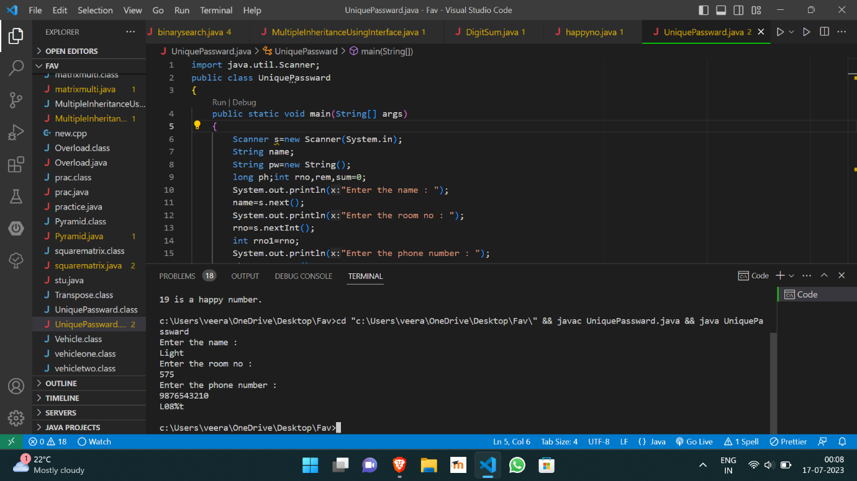

https://github.com/Veeragoutham04/Java_Lab/blob/main/Unique%20passward